

American International University-Bangladesh

Faculty of Science and Technology

Department of Mathematics

MATH 4 (Matrices, Vectors and Fourier Analysis)

**Sample questions for summer semester’22**

Midterm Examination Summer:2021-22

Total Marks: 40 Time: 2 hours

Coordinators: Dr. Dilruba Yasmin & Prof. Dr. Kh. Abdul Maleque

Short Questions

1. If $A=\left[\begin{matrix}2 & 2 \\ 1 & -1\end{matrix}\right]$, $B=\left[\begin{matrix}0 & 5 \\ -7 & 1\end{matrix}\right]$, $C=\left[\begin{matrix}3 & 3 -4 \\ 0 & -3 6\end{matrix}\right]$ and $D=\left[\begin{matrix}3 & 3 \\ 0 & -3\end{matrix}\right]$, then find (1) $A-B$; (2) $2A-3B$; (3) $AC$; (4) $2A-3B+C$; (5) $-BD$.

1. For which value(s) of $β$, will the matrix $B=\left[\begin{matrix}-1 & 0 \\ -1 & β-1\end{matrix}\right]$ be singular?

1. What is the cofactor of $a_{32}$ of the matrix, $A=\left[\begin{matrix}7 & -2 & -5 \\ 5 & 0 & 1 \\ 9 & 1 & 1\end{matrix}\right]$?
2. What is the rank of a matrix $\left[\begin{matrix}5 & 2 & -5 \\ 1 & 0 & -3 \\ 0 & 1 & 1\end{matrix}\right]$?
3. Sketch the figure of the system of linear equations (Geometrical/physical representation) and make the comment(s) about the system of linear equations:

(a) $x+2y=5 \& x+y=3$; (b) $2x+3y=5 \& 4x+6y=8$;

(c) $x+3y=5 \& 2x+6y=10$; (d) $x+2y=0;x+y=0$;

(e) $x+y=0 \& 4x+4y=0$.

1. Write the system of linear equations from the following diagram at the points A, B, C and D.

.

1. What is the value of Fourier discrete function $δ\left[k\right]$ at $k=1$?
2. Find $N$-point DFT for $h_{k}=δ\left[k\right]+0.9 δ\left[k-6\right]$ where the unit impulse function, $δ[k]$, is defined as $δ[k]=\left\{\begin{aligned}1 for k=0 \\ 0 for k≠0.\end{aligned}\right.$ Assume that $t_{k}=kΔ=k$ for $Δ=1$.
3. Determine the period of the following functions:

$f\left(x\right)=cosx, sinx, \cos\left(5x\right), \sin\left(2x\right), sin2x, \sin\left(\frac{x}{2}\right), \cos\left(\frac{x}{3}\right) etc.$

1. Determine whether the following functions are even or odd or neither.

$f\left(x\right)=\sin{x}, f\left(x\right)=x^{3}-x, g\left(x\right)=\cos\left(5x\right),f\left(x\right)=\frac{e^{x}-e^{-x}}{2} etc.$

1. Find the Fourier coefficient $a_{0}$ of the function $f\left(x\right)=x+x^{2}$ in $-π≤x≤π$.
2. Find the Fourier coefficient $b_{n}$ of the function $f\left(x\right)=x^{2}$ in $-π≤x≤π$.
3. Find the Fourier coefficient $a_{n}$ of the function $f\left(x\right)=x^{2}$ in $-π≤x≤π$.
4. Write down the functions corresponding to the following figures. Also compute the first few components of the trigonometric Fourier series.
5. (b) (c)

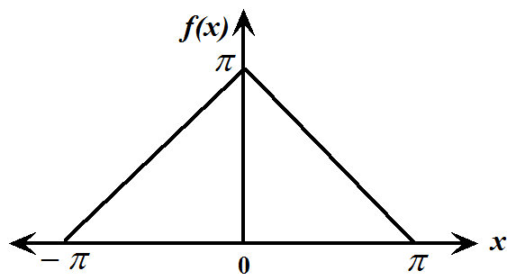 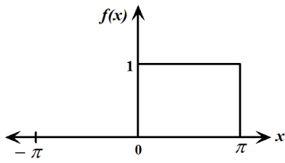 fourier21.tif

-

**Broad Questions**

1. Test the consistency of the following system of linear equations:

 .

If consistent, solve the above system of linear equations.

1. Solve the following system of linear equations by either matrix inversion or Cramer’s rule :

$$\begin{matrix}9x+3y-3z=-10 \\ -2x -z =-1 \\ x -9y +3z=9\end{matrix}$$

.

1. Determine the values of $μ,λ$ such that the following system has (a) a unique solution, (b) no solution and (c) more than one solution.
$$\begin{matrix}2x+3y+z=5 \\ 3x-y+λz=2 \\ x+7y-6z=μ\end{matrix}$$

2. Encode the message “DO PRACTICE” by using matrix,

“24 43 32 59 18 36 25 41 32 59 42 63 16 32”

Where A B C D … Y Z space

1 2 3 4 25 26 0

1. The encoded message is 35 55 73 10 20 14 32 46 77. Decode original message by using matrix, “A” given below

**.**

“24 43 32 59 18 36 25 41 32 59 42 63 16 32”

Where A B C D … Y Z space

1 2 3 4 25 26 0

1. Find the Fourier series of the following functions

$\left(i\right) f\left(x\right)=x$, $-1<x<1$. $\left(ii\right) f\left(x\right)=x+x^{2}, -2≤x≤2$

$$\left(iii\right) f\left(x\right)=x^{2}-x, -π<x<π , etc$$

1. Find half range Fourier sine series of 

1. Find half range Fourier cosine series of 
2. Find the half range Fourier cosine/sine series of the following functions:
$f\left(x\right)=2x;0≤x≤2$

3. $f\left(x\right)=x^{2};0≤x≤π$.
4. Find the finite Fourier sine transform of the function,

.

1. Find the finite Fourier cosine transform of 
2. Find the Fourier transform of the following functions and also write the Fourier integral.



1. Find the Fourier integral of $f\left(x\right)=e^{-kx}$; .
2. Find the Fourier integral of $f\left(x\right)=e^{-kx}$ ; .
3. Solve the following Boundary Value Problem (BVP):

$\frac{∂T}{∂t}=k\frac{∂^{2}T}{∂x^{2}}$; $T\left(0,t\right)=given, T\left(L,t\right)=given, T\left(x,0\right)=given, 0<x<L, where L=given.$