

# AMERICAN INTERNATIONAL UNIVERSITY BANGLADESH(AIUB)

**FACULTY OF ENGINEERING**

# DEPARTMENT OF ELECTRICAL AND ELECTRONIC ENGINEERING MICROPROCESSOR AND EMBEDDED SYSTEM

**Spring 2023-2024 Section: F Group: 06**

**REPORT ON**

***LED light control using IR receiver.***

## Supervised By

**MD. SAJID HOSSAIN**

## Submitted By

|  |  |  |
| --- | --- | --- |
| **Name** | **ID** | **Contribution** |
| **S.M. FAYSAL MAHMUD** | **19-40315-1** | **Title, Abstract, Hardware Implementation** |
| **TRIDIB SARKAR** | **22-46444-1** | **Theory and Methodology, Apparatus, Precautions** |
| **MD. IMTIAZ HOSSAIN** | **19-41203-1** | **Experimental procedure, Results/Finding(s), Discussion** |
| **AZMINUR RAHMAN** | **22-46588-1** | **Simulation and measurement** |
| **KOWSHIK HALDER** | **21-45408-3** | **Code snippet for the System** |
| **AVISHEK CHANDA PRATYAY** | **21-45489-3** | **Code snippet for the System** |
| **SOWRABH CHANDRA DAS** | **21-45397-3** | **Introduction, Conclusions, References** |

**Title:** LED light control using IR receiver.

## Abstract:

This experiment introduces participants to LED light control using an IR receiver with the Arduino platform. Beginning with the blink test for LED control, the experiment progresses to implementing a remote-controlled LED system. Participants learn to wire Red, Green, and Yellow LEDs to an Arduino Uno along with a IR receiver. Each LED corresponds to buttons on an IR remote, showcasing IR signal capture, Arduino processing, and LED activation. This hands-on experience provides a basic understanding of IR technology integration with microcontrollers for remote LED control. The report includes equipment, circuits, programming, and observed outcomes, laying the foundation for future microcontroller projects.

## Introduction:

The objective of this experiment with LED light control using an IR receiver are as follows:

* To familiarize with the integration of an IR (Infrared) receiver module (such as VS1838B) with a microcontroller (Arduino Uno).
* To develop an understanding of capturing IR signals and processing them using pinMode(), digitalWrite(), and delay() functions.
* To implement the basic concept of LED control through remote commands, mapping specific IR signals to actions for Red, Green, and Yellow LEDs.
* To develop the functionality of turning individual LEDs on/off and creating a system where multiple LEDs can be controlled simultaneously.
* To implement a remote-controlled LED system where an IR remote (with buttons 1, 2, 3, and a power button) is used to turn LEDs on/off, simulating a practical application of IR receiver integration.

## Theory and Methodology:

In the realm of LED light control using an IR receiver with Arduino, the VS1838B IR receiver module plays a pivotal role as it captures and translates modulated IR signals from a compatible remote control. This module, when properly connected to the Arduino Uno, allows for the reception of IR commands, each associated with specific LED actions. The Arduino's programming logic utilizes the IRremote library to decode these signals, enabling precise control over individual LEDs such as Red, Green, and Yellow. Moreover, the versatility of the system extends to simultaneous control, enabling users to turn multiple LEDs on or off with a single IR command. This experiment provides not only a practical application of IR technology in the realm of microcontrollers but also a foundation for more complex projects, highlighting the seamless interaction between hardware and software in creating responsive and interactive LED lighting systems.

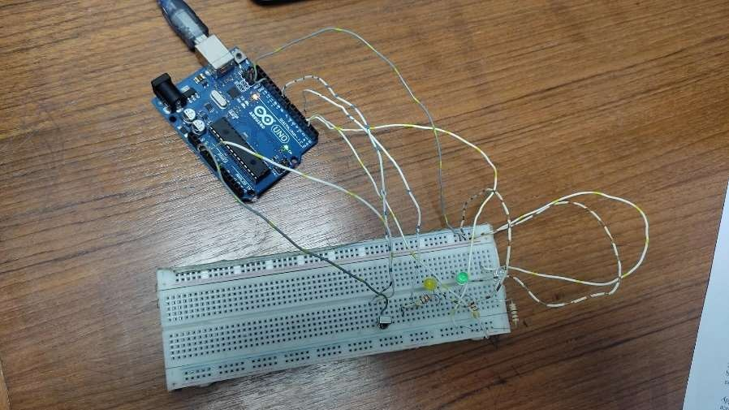

**Figure 1:** Experimental setup for LED light control using IR receiver.

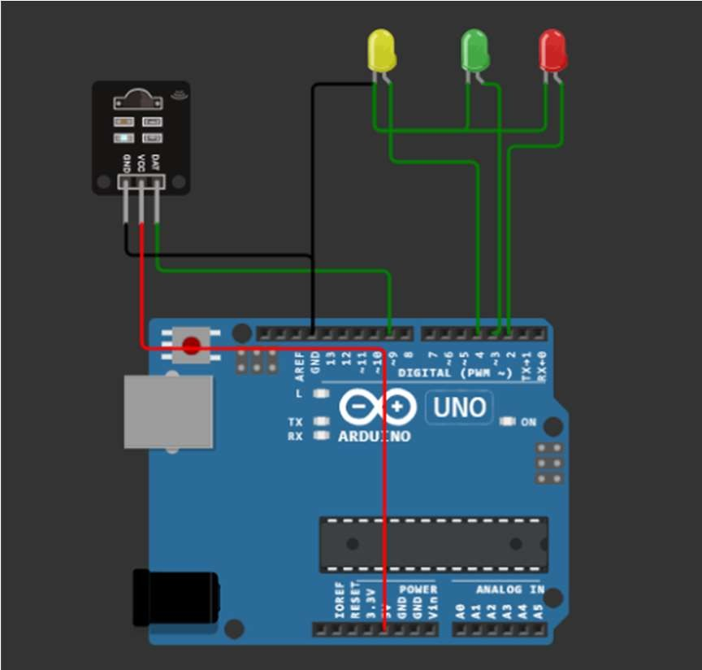 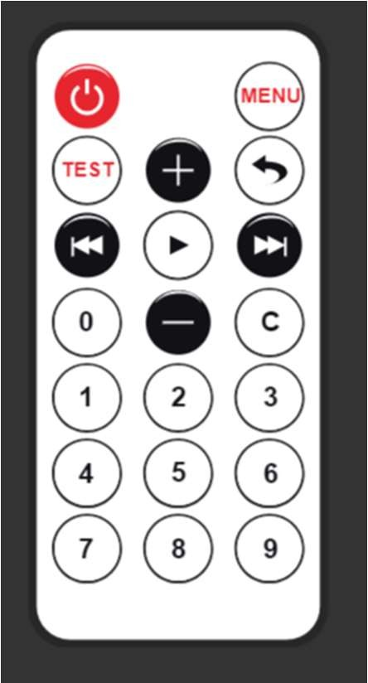

**Figure 2:** Simulation setup for LED light control using IR receiver [2].

**Apparatus:**

1. Arduino Uno.
2. VS 1838B IR Receiver.
3. Three LED lights (Red, Green, Yellow).
4. Three Resistors.
5. Connecting wires.
6. Remote Controller.

## Precautions:

1. Safety precautions were rigorously followed throughout the experiment to ensure the safe handling of electronic components and materials, reducing the risk of accidents or damage.
2. Careful attention was given to wiring and connections to mitigate the potential for short circuits or incorrect wiring configurations, promoting the reliability of the circuit.
3. Prior to physical implementation, simulations were conducted using wokwi.com online software to validate both the circuit design and the code. This preemptive measure helped identify and rectify any potential errors or issues, enhancing the efficiency of the experiment.
4. Whenever modifications or adjustments were made to the circuit, power sources were promptly disconnected. This practice minimized the risk of electrical hazards and ensured a safe working environment for all participants involved in the experiment.

## Experimental Procedure:

1. The circuit was set up on a breadboard for LED light control using an IR receiver, an Arduino Uno, VS1838B IR receiver module, and Red, Green, and Yellow LEDs.
2. The VS1838B IR receiver was connected to the Arduino Uno.
3. VCC pin of the IR receiver was connected to the 5V pin on the Arduino.
4. GND pin of the IR receiver was connected to the GND pin on the Arduino.
5. OUT pin of the IR receiver was connected to digital pin 11 on the Arduino.
6. Red, Green, and Yellow LEDs were connected to digital pins on the breadboard.
7. The Arduino IDE was launched on a computer.
8. The IRremote library was included in the Arduino IDE.
9. Observations were recorded on the behavior of LEDs based on IR remote commands.
10. Results were compiled, including circuit diagrams, code snippets, observations, and any improvements or modifications made during testing.
11. The experiment was concluded by summarizing the successful implementation of LED light control using an IR receiver and Arduino Uno.

## Simulation and Measurement:

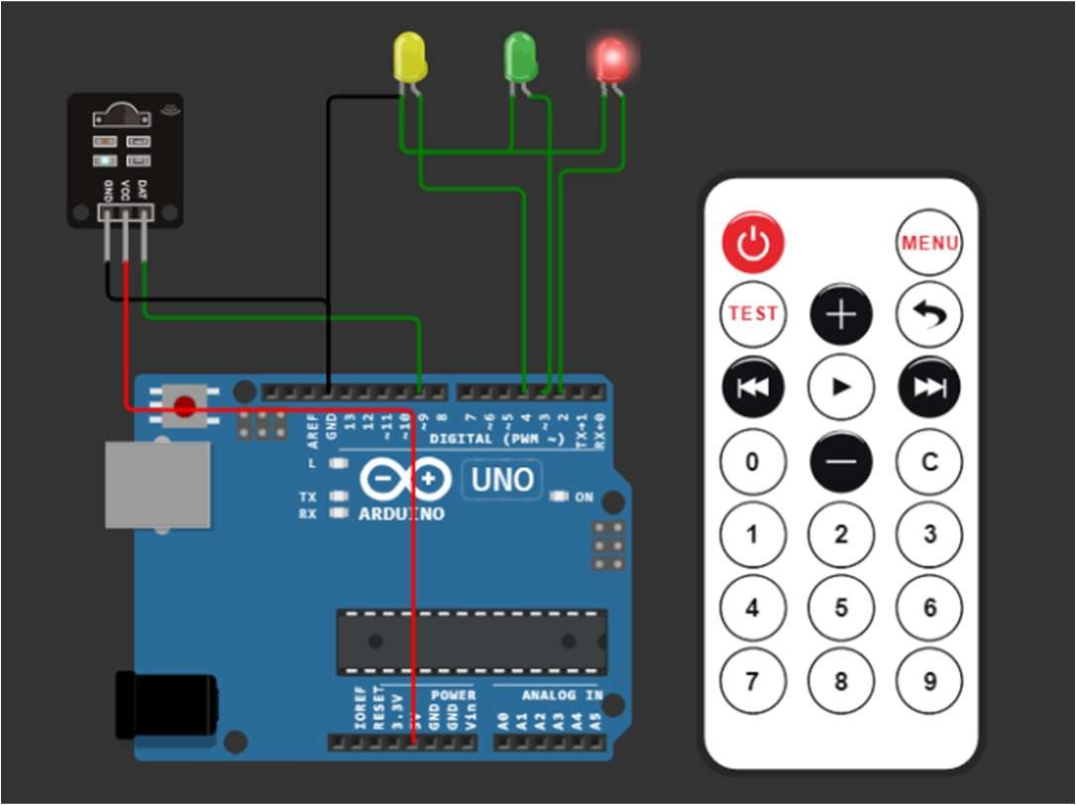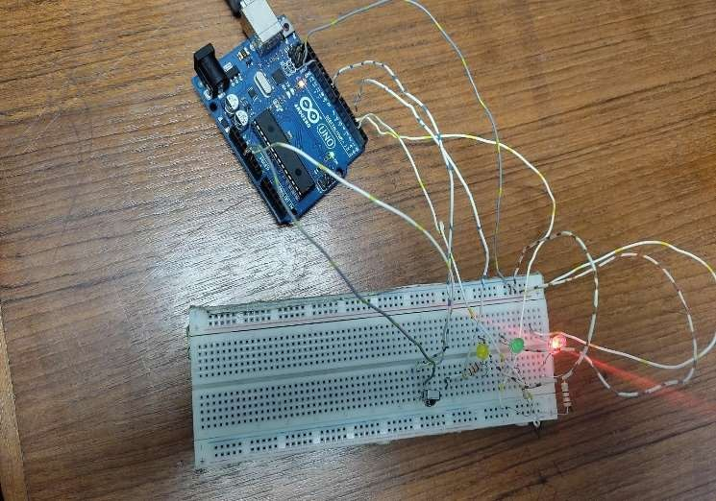

**Figure 3:** Simulation of Red LED is on [2]. **Figure 4:** Image Red LED is on.

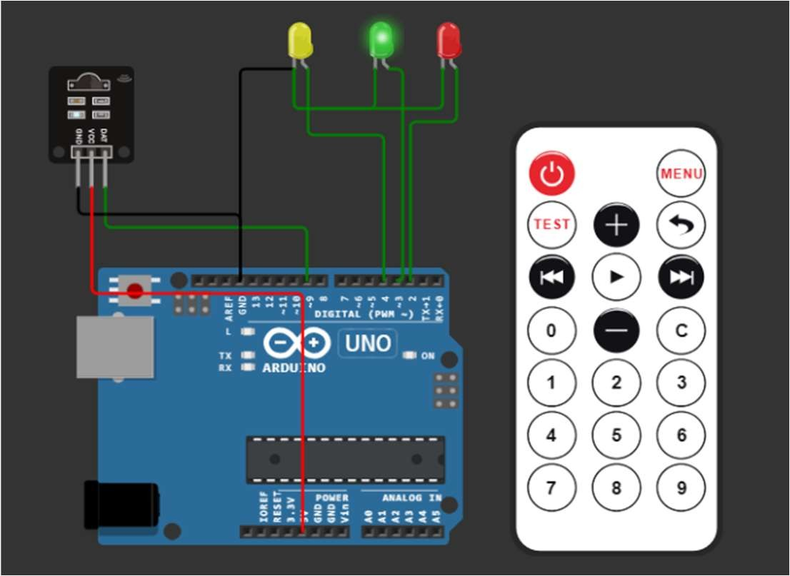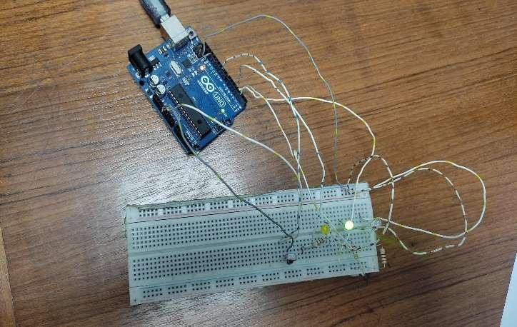

**Figure 5:** Simulation of Green LED is on [2]. **Figure 6:** Image of Green LED is on.

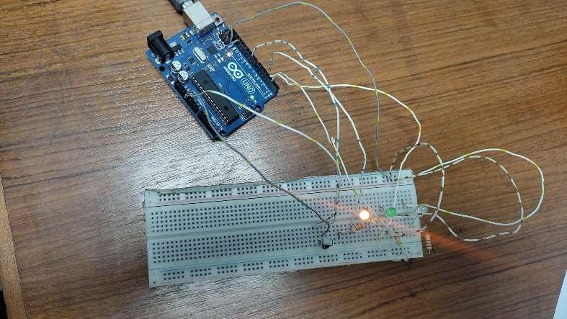

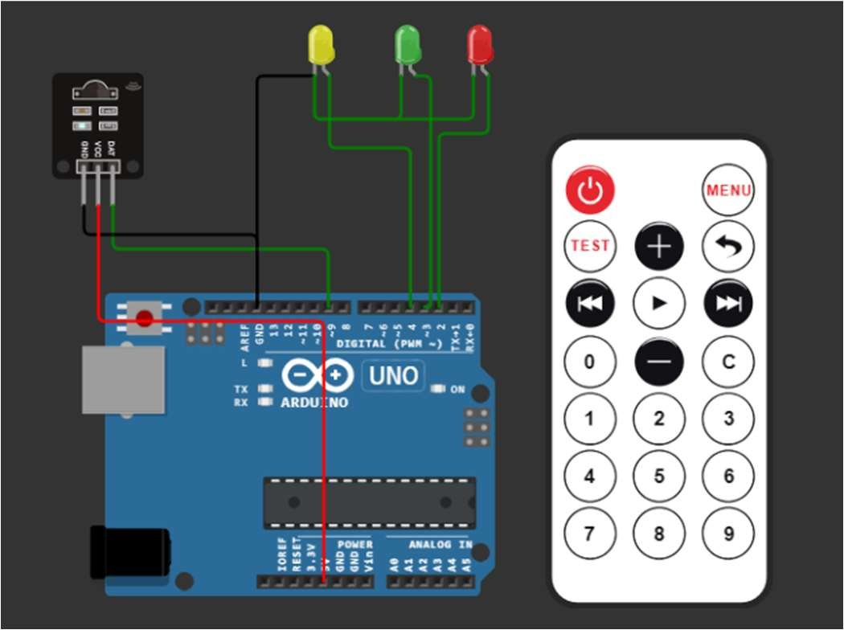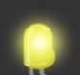

**Figure 7:** Simulation of Yellow LED is on [2]. **Figure 8:** Image of Yellow LED is on.

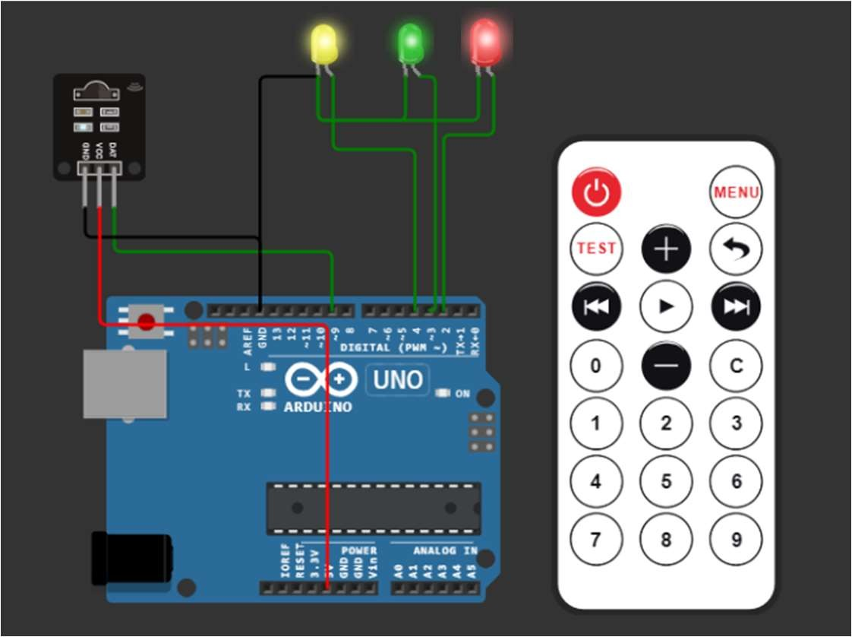

**Figure 9:** Simulation of Red, Green and Yellow LED is on [2].

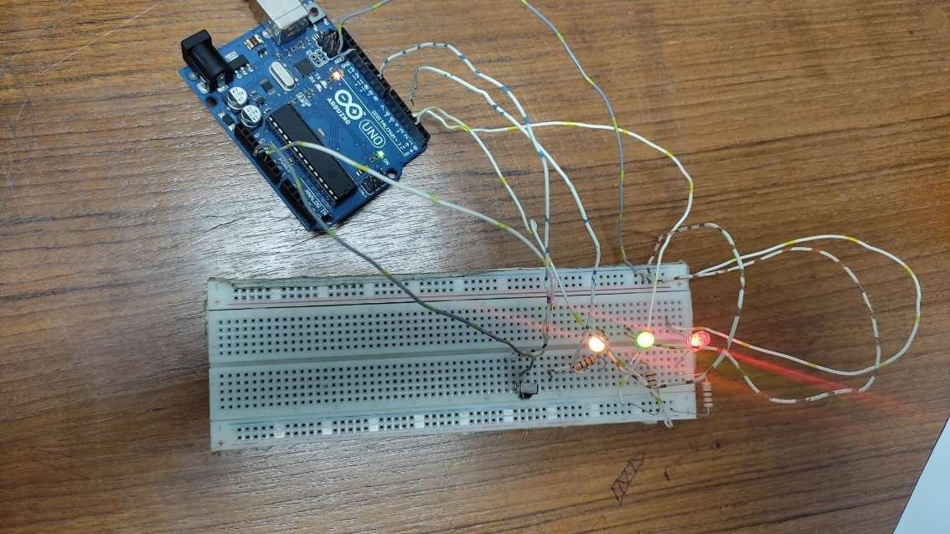

**Figure 10:** Image of Red, Green and Yellow LED is on.

## Code snippet for the System:

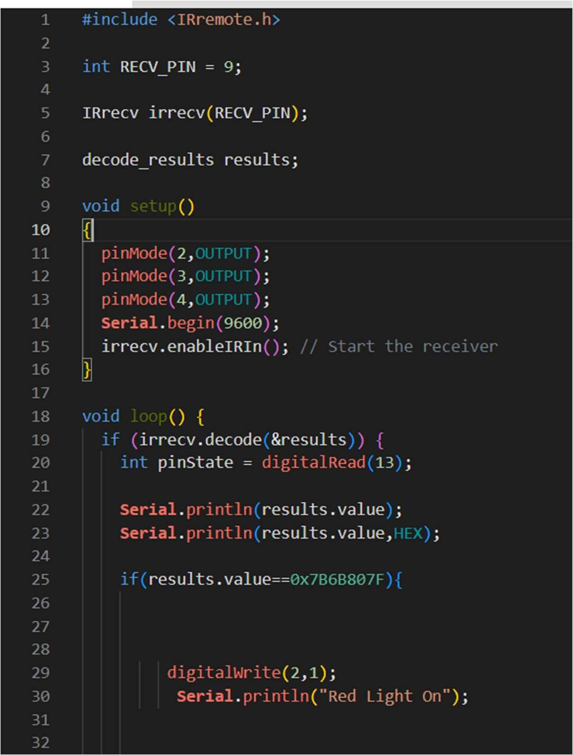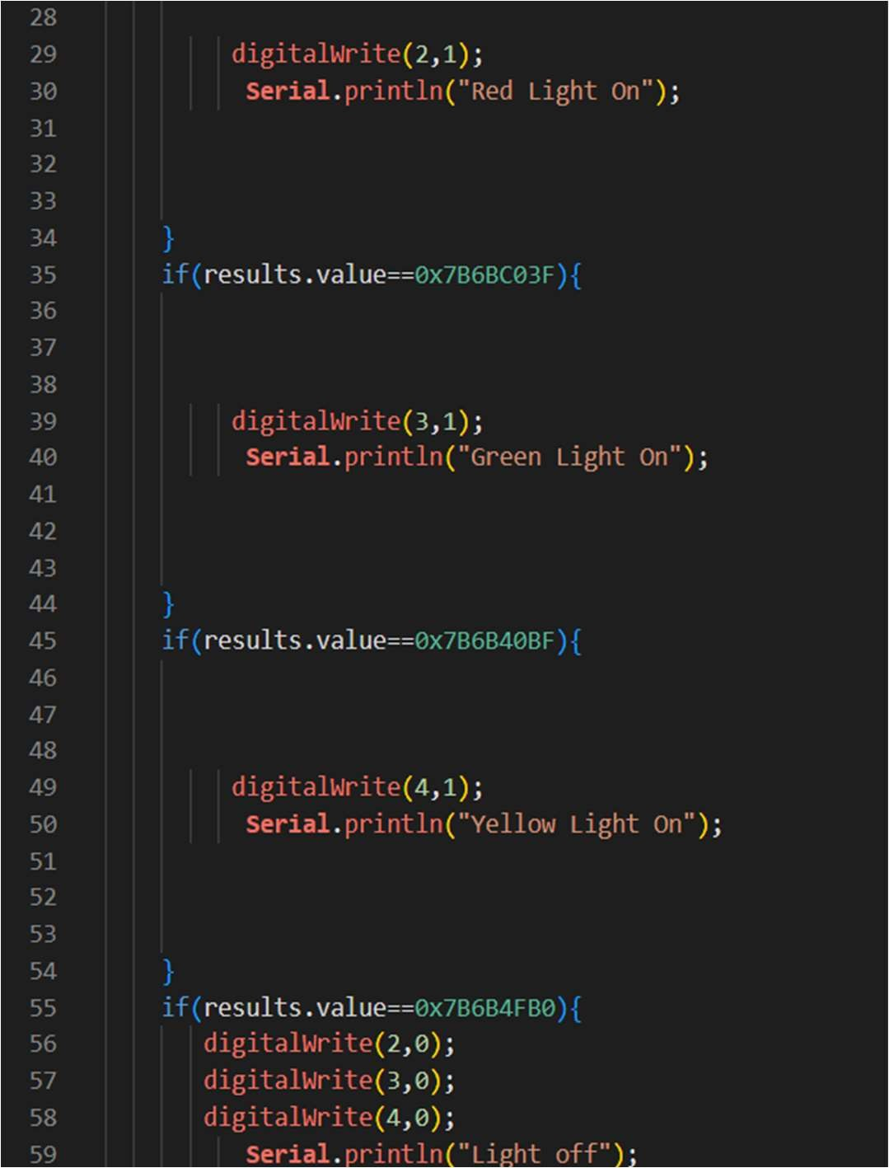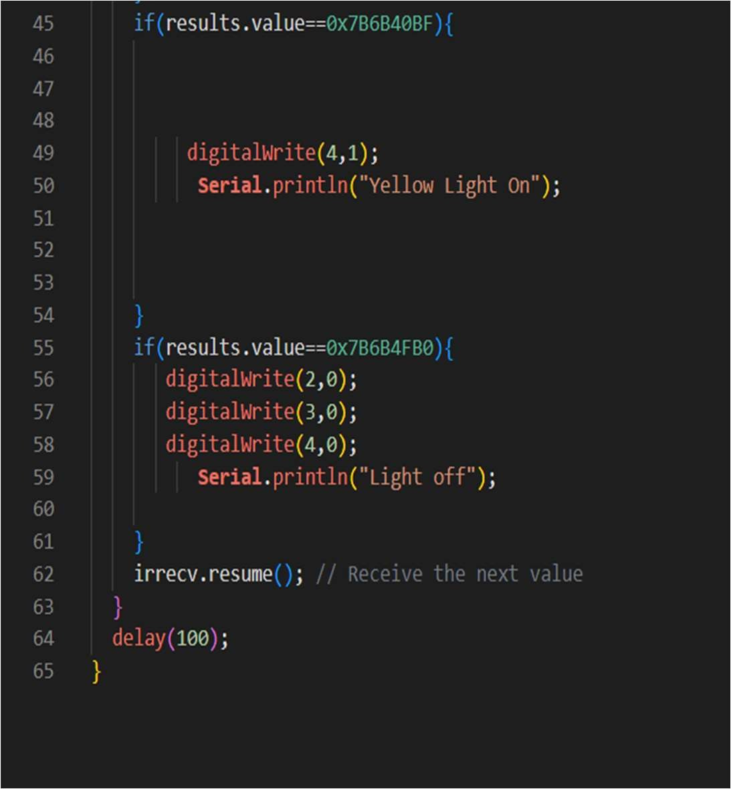

**Figure 11:** Code snippet for LED light control using IR receiver [2].

## Results/Finding(s):

1. All code snippets were provided.
2. WOKWI online simulation was included in the simulation, complete with detailed views.

## Discussion:

The LED light control project using an IR receiver exemplifies a significant application of Arduino technology for creating efficient and interactive LED systems. By integrating the VS1838B IR receiver module with the Arduino Uno, this experiment enables the reception and interpretation of IR signals from a remote control. Each button presses on the IR remote triggers a specific LED action: Button 1 illuminates the Red LED, Button 2 activates the Green LED, Button 3 lights up the Yellow LED, and the Power Button toggles all LEDs on or off. In the Arduino code, the IRremote library is utilized for seamless signal processing, while the precise digitalWrite() functions ensure accurate LED control without freezing Arduino's state, unlike the delay() function. This project not only offers a hands-on learning experience in IR technology integration but also provides practical insights into creating responsive and user-friendly LED control systems. The successful testing and verification of LED behavior underscore the project's value as a versatile tool for illumination control, with potential applications ranging from home automation to innovative lighting displays. Overall, the LED light control experiment using an IR receiver serves as an invaluable introduction to the fusion of hardware and software, showcasing Arduino's capabilities in facilitating user-friendly and efficient LED systems.

## Conclusions:

The LED light control project using an IR receiver was a successful endeavor, achieving its objectives of introducing participants to IR technology integration with Arduino for LED systems. Through practical implementation, participants gained valuable insights into signal processing, remote control mechanisms, and LED control logic. The project effectively demonstrated precise control of Red, Green, and Yellow LEDs using specific IR codes from an IR remote. Successful testing and verification underscored the project's effectiveness in providing a tangible application of Arduino technology. This experiment serves as a starting point for further exploration in home automation and remote-controlled systems, showcasing Arduino's capabilities in real-world applications. Overall, the LED light control project using an IR receiver provided a concise and engaging introduction to hardware-software integration for remote-controlled LED systems, enhancing participants' understanding of Arduino's practical use.

## Reference(s):

1. WOKWI (Simulation). Available: https://wokwi.com/projects/390945896791956481, Accessed on 29-Feb-24. [Online].
2. Arduino, "Arduino - Home," Available: https://[www.arduino.cc,](http://www.arduino.cc/) Accessed On: 29-Feb-24. [Online].
3. J. Blum, "Exploring Arduino: Tools and Techniques for Engineering Wizardry," 1st ed. Indianapolis, IN: Wiley, 2013, ISBN: 978-1118549360.