

1. **Project Title:** Government Regulated Price Hike Control Application.

# Background to the Problem:

Bangladesh, a country rich in agricultural resources, relies heavily on agriculture as the backbone of its economy. Given this context, one would expect stability and abundance in the market, particularly for food-related products. However, this is far from reality as severe price hikes are a common issue in daily life. Despite the government providing statistical data showing ample domestic food production, these figures do not align with market conditions, often due to internal manipulations leading to price inflation.

A primary cause of these price hikes is the presence of syndicates. These groups hoard essential goods, artificially inflating demand, and then release the products at elevated prices. This manipulation allows them to control prices arbitrarily, bypassing government oversight. This volatility in prices creates significant challenges for consumers, making it difficult for them to plan their purchases. The hardest hit are the lower and middle-class populations, as well as students who are striving to balance their education and living expenses. As an underdeveloped country, Bangladesh's economic stability heavily depends on these segments of the population. Therefore, government intervention is crucial to regulate and stabilize prices, ensuring the economic well- being of the majority and preventing further economic decline.

# Solution to the Problem:

Our project aims to develop a technology-based solution to mitigate price hikes in the market. We propose a government-regulated web application to monitor and control the prices of essential commodities.

Leveraging widespread internet access in Bangladesh, this web-based application will provide real-time updates on government-approved prices. This allows consumers to plan their purchases based on accurate cost information, while the government can monitor market trends and identify anomalies, such as syndicate activities. The lightweight application will utilize existing government infrastructure, making it a cost-effective solution.

# 1.3 Literature Review:

Government intervention and dynamic monitoring systems are essential for controlling price hikes of essential commodities, emphasizing the need for real-time data and collaborative efforts to maintain market stability [1]. Government intervention and market mechanisms play crucial roles in regulating commodity prices, as highlighted in studies on floating pricing policies and web- based applications for price monitoring [2]. Government involvement and market mechanisms play crucial roles in regulating commodity prices, as highlighted in studies on floating pricing policies and web-based applications for price monitoring [3]. In the agricultural sector of Bangladesh, the implementation of e-governance aims to address issues such as price hikes, where farmers often lose out on profits due to intermediary involvement. This parallels the goal of a government-regulated price hike control application, which aligns with efforts to ensure fair pricing and better governance in agricultural markets, ultimately benefiting both

farmers and consumers [4]. Analysis of food price hikes in Bangladesh underscores the pivotal role of government intervention and market mechanisms in regulating commodity prices, echoing findings from studies on floating pricing policies and web-based applications for price monitoring [5].

# 1.4 Functionalities:

**Real-Time Price Monitoring**

* Users can access real-time updates on the prices of essential commodities.
* Government-regulated prices are displayed to ensure transparency.

# Price Comparison

* Users can compare prices of commodities across different regions and retailers.
* Visual representation of price trends over time to help consumers make informed decisions.

# User Reports and Complaints

* Consumers can report price gouging or discrepancies through the app.
* Users can attach receipts or photos as evidence for their complaints.

# Government Alerts and Notifications

* Users receive alerts about sudden price changes or shortages in the market.
* Notifications about government interventions or policy changes affecting prices.

# Data Analytics and Insights:

* The app analyzes price data to detect unusual patterns or potential syndicates.
* Insights are provided to the government for proactive measures.

# Licensing and Trade Number Verification

* The app verifies the license or trade number of shops and retailers.
* Ensures that only registered entities can list their prices.

# Consumer Education

* Provides information on fair pricing and consumer rights.
* Educational content on how to use the app and report issues.

# Market Trend Visualization

* Graphs and charts to visualize market trends and price fluctuations.
* Helps users understand the broader market context and seasonal variations.

# Inventory and Stock Updates

* Retailers can update their inventory status to reflect stock availability.
* Users can see which items are in stock and their current prices.

# Feedback and Suggestions

* Consumers can provide feedback on the app's functionality and usability.
* Suggestions for improving the system are collected and reviewed.

# Secure Data Handling

* Ensures that all user data is securely stored and transmitted.
* Compliance with data privacy regulations to protect consumer information.

# User-Friendly Interface

* Intuitive and easy-to-navigate interface for both mobile and desktop users.
* Multilingual support to cater to diverse user demographics.

# Integration with Other Government Services

* Seamless integration with other e-governance platforms for comprehensive service delivery.
* Cross-referencing with agricultural and consumer protection databases.

# Predictive Modeling and Alerts

* Uses predictive analytics to forecast potential price hikes or shortages.
* Alerts are sent to the government and consumers in advance to prepare accordingly.

# Retailer and Producer Registration

* Allows retailers and producers to register and list their products.
* Ensures a broad and diverse database of prices for accurate monitoring.

# Compliance and Regulatory Reporting

* Generates reports for government agencies to track compliance and market health.
* Provides data-driven insights to support regulatory decisions.

# 1.5 Target User:

1. Low-Income Families: The application helps low-income families access accurate and up- to-date information on essential commodity prices. This ensures they can make informed purchasing decisions and avoid being overcharged, thereby managing their limited budgets effectively.
2. Middle-Class Consumers: Middle-class consumers benefit from the app’s price comparison and trend analysis features, which allow them to find the best prices for their needs. This helps them save money and manage their household expenses more efficiently.
3. Students: Students, often on tight budgets, can use the app to monitor price changes and find the most affordable options for their everyday necessities. The app also educates them on consumer rights and market practices.
4. Farmers and Small Producers: Farmers and small producers can use the app to track market prices for their products, ensuring they receive fair compensation. The app also provides them with information on government policies and support programs.
5. Retailers and Shop Owners: Retailers and shop owners can update their inventory and price information through the app, ensuring transparency and compliance with government regulations. This helps build trust with consumers and avoids legal issues related to price gouging.
6. Government Officials and Regulators: Government officials and regulators use the app to monitor market prices and detect irregularities or price manipulation. The app provides them with data analytics and reporting tools to make informed decisions and enforce regulations effectively.
7. Consumer Rights Organizations: Consumer rights organizations leverage the app to gather data on price trends and consumer complaints. This helps them advocate for fair pricing policies and protect consumer interests more effectively.
8. General Public: The general public benefits from the app by gaining access to reliable price information and educational resources on market practices. This empowers them to make better purchasing decisions and be more vigilant against price gouging.

These target users reflect the diverse range of stakeholders who would benefit from the Government Regulated Price Hike Control Application, ensuring fair pricing and better market practices for all.

**Conclusion:** The Government Regulated Price Hike Control Application revolutionizes market transparency and fairness by providing a comprehensive solution for diverse consumer needs. With features like real-time price monitoring, consumer feedback mechanisms, government collaboration, and educational resources, it addresses the challenges faced by low-income families, middle-class consumers, students, and farmers. By facilitating secure data sharing, ensuring price transparency, and offering tailored features for market analysis and consumer protection, the application promotes equitable market practices. It empowers users to make informed purchasing decisions, ensuring fair pricing and protecting consumer interests. As technology advances, this application exemplifies innovation, enhancing market fairness and promoting economic justice. It represents a new era of accessible market regulation, empowering individuals to navigate their purchasing decisions confidently and effectively.

# Reference:

1. A. C. Chen, "A market-based and synthesized approach to controlling price gouging," International Journal of Private Law, vol. 4, no. 1, pp. 128-142, 2011.
2. J. H. Wu, Y. L. Huang, and C. C. Liu, "Effect of floating pricing policy: an application of system dynamics on oil market after liberalization," Energy Policy, vol. 39, no. 7, pp. 4235- 4252, 2011.
3. R. A. Posner, "Theories of economic regulation," National Bureau of Economic Research, Tech. Rep. No. W0041, 1974.
4. V. Tsap, "IMPLEMENTATION OF E-GOVERNANCE IN THE AGRICULTURAL SECTOR OF BANGLADESH."
5. M. M. Rahman, "Food price hike in Bangladesh: A supply side approach to its determinants and solutions," Asian Journal of Humanities and Social Sciences (AJHSS), vol. 3, no. 1, pp. 120-141, 2015.

# Objective: The objective is to select an appropriate process model for the software development of the Government Regulated Price Hike Control Application. Through thorough analysis and evaluation, we aim to identify a hybrid methodology that integrates elements of Scrum and Kanban to effectively manage the development process, streamline workflow, and enhance productivity. The selected process model should align closely with the project's requirements, promote collaboration among team members, and ensure efficient delivery of high-quality software solutions. Additionally, we seek to assess the rationale and consistency of the chosen methodology using appropriate tools and techniques, such as expert review, comparative analysis, and prototyping. The goal is to establish a robust and adaptive software development process that enables the successful delivery of the Government Regulated Price Hike Control Application, ensuring transparency, fairness, and consumer protection in market pricing while meeting stakeholder expectations and project objectives.

# Software Development Life Cycle

## **Process Model**

We believe the **Agile Method** is ideal for this project. Agile excels in dynamic and flexible environments where real-life problems necessitate ongoing adjustments due to a multitude of possible scenarios. This method also supports collaboration and continuous improvement, which are crucial for addressing the issue of price hikes.

Software development projects are inherently dynamic, subject to changes in requirements, circumstances, and stakeholders [1]. In response to this need for adaptability, various agile methodologies have been devised to cater to market demands for shorter development cycles, reduced costs, and enhanced flexibility [2, 3]. Among these agile approaches, Scrum and Kanban stand out as popular methods within the software industry [4], valued for their efficacy in managing the software development process [3, 5, 6]. The emergence of the Scrumban method, a hybrid of Scrum and Kanban, is rooted in these foundational agile principles, emphasizing the delivery of working software, collaboration among individuals, customer engagement, and responsiveness to change [7].

While Scrum offers significant benefits, such as improved team collaboration and iterative development, it also presents limitations that can impact project outcomes, including limited work visibility, challenges with scalability, and shifting task priorities [8, 9, 10]. Similarly, Kanban faces its own set of challenges, such as workflow bottlenecks and difficulties in managing large-scale implementations [11, 12]. Recognizing the individual constraints of each methodology, there is growing consensus that integrating multiple approaches may yield superior results compared to their standalone usage. For example, blending Kanban with Scrum has been proposed as a means to address the shortcomings of Scrum, leveraging the strengths of both methods to complement each other effectively [9, 13, 14, 15].

For this project, we will implement the **SCRUM Method**, a subset of **Agile Method**. After analyzing the problem's nature, we identified several key reasons for choosing Agile:

* Real-time Monitoring and Updates: The application must provide consumers with real-time price updates, necessitating frequent data monitoring.
* User-Centric Interface: The app should be user-friendly, catering to the needs of lower-class, middle-class, and student users.
* Collaboration with Government and Consumers: Effective collaboration between the government and consumers is essential for reporting issues and gathering feedback, requiring a flexible development approach.
* Dynamic Market Conditions: The software must adapt to ever-changing market and pricing conditions.
* Continuous Improvement: The application should evolve based on user feedback and changing requirements.

**Reasons for Selecting Agile Development (Scrum):**

* Iterative and Incremental Development: Scrum's iterative approach allows for continuous improvement and frequent software releases, aligning with the need for real-time updates and user-centricity.
* Flexibility for Changing Requirements: Scrum is known for its adaptability to changing requirements, crucial for managing dynamic market conditions.
* Collaboration and Communication: Scrum promotes open communication among all stakeholders, ensuring effective collaboration and quick feedback loops.
* Transparency and Visibility: Regular meetings and progress tracking in Scrum provide transparency, keeping stakeholders informed and involved.
* Continuous Testing and Integration: Scrum encourages continuous testing and integration, ensuring the application remains stable and functional.
* Empowering Development Team: Scrum empowers the development team to make decisions and self-organize, enhancing motivation and productivity.

**Evidence Supporting Scrum Method:**

* Scrum's iterative approach supports the need for real-time updates.
* The collaboration aspect enables effective communication between government officials and consumers.
* Scrum's flexibility is essential for adapting to changing market conditions.
* Continuous improvement ensures the application evolves based on user feedback.
* Scrum's transparency keeps stakeholders engaged, leading to better decision-making and project success.

In conclusion, Agile development, specifically Scrum, is the best choice for developing the proposed web-based application to mitigate price hikes. The presented evidence supports Scrum as an effective approach to deliver a valuable solution.

## **Project Role Identification and Responsibilities**

**Scrum Master: (MD. MEHEDI HASAN POLASH)**

* Role: Facilitates the Agile development process and ensures adherence to the Scrum framework.
* Responsibilities:
  + Guide the team in implementing Scrum practices.
  + Facilitate Scrum ceremonies (sprint planning, daily stand-ups, sprint review, sprint retrospective).
  + Remove impediments hindering progress.
  + Ensure adherence to Scrum roles, artifacts, and rules.
  + Coach the team on continuous improvement and self-organization.
  + Collaborate with the Product Owner and team for a smooth development process.

**Product Owner: (TRIDIB SARKAR)**

* Role: Represents stakeholders and maximizes the product's value.
* Responsibilities:
  + Define and prioritize the product backlog.
  + Communicate product vision and requirements.
  + Decide on the release plan and sprint content.
  + Accept or reject work results based on acceptance criteria.
  + Gather feedback and refine the product backlog.
  + Ensure the team understands the product vision and goals.

**Scrum Team: (CHAYAN ADHIKARY)**

* Role: A self-organizing, cross-functional group responsible for product development.
* Responsibilities:
  + Work on sprint backlog items collaboratively.
  + Estimate effort for user stories during sprint planning.
  + Hold daily stand-ups to synchronize progress.
  + Conduct sprint reviews to showcase completed work.
  + Engage in sprint retrospectives for improvement.
  + Ensure product quality and meet the Definition of Done.

**Customer (Stakeholders): (PROGGA PAROMITA DAS)**

* Role: Represents end-users or consumers of the product.
* Responsibilities:
  + Provide input and feedback on product features.
  + Review and accept completed work during sprint reviews.
  + Collaborate to ensure the product meets expectations.
  + Share user feedback for product improvements.
  + Communicate progress and timelines with the team.

**Management: (MD. YASIR ARAFAT TAMIM)**

* Role: Represents the organization or project sponsors.
* Responsibilities:
  + Support Agile practices and Scrum framework adoption.
  + Remove organizational impediments and provide resources.
  + Set project objectives, budget, and timelines.
  + Participate in sprint reviews and provide feedback.
  + Align project goals with business objectives.
  + Support the Scrum Team's continuous improvement efforts.

Each role in Scrum plays a crucial part in the project's success. The Scrum Master, Product Owner, and Scrum Team collaborate closely, while the Customer and Management provide essential input and support to ensure the project meets its objectives and delivers value to end-users.

* 1. **Impact:**

a. Societal Impact:

1. Improved Market Transparency:

* The Government Regulated Price Hike Control Application can provide real-time pricing information, reducing information asymmetry between producers, consumers, and intermediaries across various sectors, including agriculture, energy, and consumer goods.
* By making market data accessible, it empowers stakeholders to negotiate better prices and helps consumers make informed purchasing decisions.

1. Reduced Price Volatility:

* The application can help stabilize market prices by monitoring and regulating price hikes, ensuring fair pricing practices.
* This can lead to a more predictable and stable market environment, benefiting producers, consumers, and businesses in multiple sectors.

b. Economic Impact:

1. Enhanced Income for Producers:

* By providing direct market access and reducing intermediary influence, the application can ensure that producers receive fair prices for their goods and services.
* This can lead to an increase in incomes for small businesses, farmers, and manufacturers, contributing to broader economic development and poverty reduction.

1. Market Efficiency:

* The application promotes market efficiency by reducing transaction costs and minimizing market distortions caused by price manipulation.
* Efficient markets can lead to optimal resource allocation and improved overall economic performance, benefiting a wide range of industries.

c. Consumer Impact:

1. Fair Pricing for Consumers:

* Consumers benefit from fair and transparent pricing, which helps protect them from exploitation by intermediaries.
* This can lead to increased consumer trust and satisfaction in various markets, including food, energy, and consumer goods.

1. Improved Access to Essential Goods:

* By ensuring fair prices and reducing price volatility, the application can contribute to improved access to essential goods and services.
* Stable and fair prices can make critical items like food, fuel, and healthcare more affordable for the broader population.

d. Technological Impact:

1. Adoption of Digital Tools:

* The application promotes the adoption of digital tools and e-governance across different sectors, fostering technological innovation.
* It encourages the use of mobile and web-based platforms among all stakeholders, enhancing digital literacy and accessibility.

1. Data-Driven Decision Making:

* The application collects and analyzes market data, providing valuable insights for policymakers and stakeholders.
* Data-driven approaches can lead to more informed and effective policy decisions, benefiting multiple sectors.

e. Regulatory Impact:

1. Strengthened Regulatory Framework:

* The application supports the enforcement of market regulations and policies aimed at protecting all market participants.
* It helps monitor compliance with pricing regulations, reducing market abuses and enhancing regulatory oversight.

1. Enhanced Accountability:

* By providing transparent and accessible pricing data, the application promotes accountability among market participants.
* It enables authorities to track and address instances of price manipulation or unfair practices more effectively.

f. Environmental Impact:

1. Sustainable Practices:

* By ensuring fair pricing, the application can incentivize producers to invest in sustainable practices across various industries.
* Higher incomes allow businesses and individuals to adopt environmentally friendly technologies and practices, contributing to environmental conservation.

1. Reduced Waste:

* Fair pricing and market stability can reduce the likelihood of waste caused by market imbalances and price fluctuations.
* Efficient markets ensure that goods and services are utilized and consumed in a timely manner, reducing waste.

g. Cultural Impact:

1. Empowerment of Marginalized Groups:

* The application can empower small and marginalized producers by providing them with market access and fair pricing.
* It fosters inclusivity and equity across different sectors, promoting social and economic empowerment.

1. Promotion of Local Markets:

* By supporting fair pricing and market stability, the application can encourage the growth of local markets and small-scale businesses.
* It helps preserve local traditions and promotes the cultural heritage of communities involved in various industries.

**References:**

1. P. Henderson, "Why large IT projects fail," ACM Transactions on Programming Languages and Systems, vol. 15, no. 5, pp. 795-825, 2006.
2. S. Conn, "A New Teaching Paradigm in Information Systems Education: An Investigation and Report on the Origins, Significance, and Efficacy of the Agile Development Movement," Information Systems Education Journal, vol. 2, no. 15, pp. 3-18, 2004.
3. W. Zayat and O. Senvar, "Framework study for agile software development via scrum and Kanban," International Journal of Innovation and Technology Management, vol. 17, no. 4, 2020.
4. E. Weflen, C. A. MacKenzie, and I. V. Rivero, "An influence diagram approach to automating lead time estimation in Agile Kanban project management," Expert Systems with Applications, vol. 187, 2022.
5. H. Alaidaros and M. Omar, "Software project management approaches for monitoring work-in-progress: A review," Journal of Engineering and Applied Sciences, vol. 12, no. 15, pp. 3851-3857, 2017.
6. H. Lei, F. Ganjeizadeh, P. K. Jayachandran, and P. Ozcan, "A statistical analysis of the effects of Scrum and Kanban on software development projects," Robotics and Computer-Integrated Manufacturing, vol. 43, pp. 59-67, 2017.
7. S. W. Ambler, "The Non-Existent Software Crisis: Debunking the Chaos Report," 2014. [Online]. Available: http://www.drdobbs.com/architecture-and-design/the-non-existentsoftware-crisis-debunki/240165910.
8. N. Tripathi, P. Rodriguez, M. O. Ahmad, and M. Oivo, "Scaling kanban for software development in a multisite organization: Challenges and potential solutions," in Agile Processes, in Software Engineering, and Extreme Programming, pp. 1783-190, 2015.
9. P. Rodriguez, J. Partanen, P. Kuvaja, and M. Oivo, "Combining lean thinking and agile methods for software development: a case study of a Finnish provider of wireless embedded systems," in 47th Hawaii International Conference on System Sciences (HICSS), pp. 4770-34779, IEEE, 2014.
10. N. Ozkan and M. _. Gök, "How Scrum Inhibits Agility," in 15th Turkish National Software Engineering Symposium (UYMS), pp. 1-6, IEEE, 2021.
11. M. O. Ahmad, D. Dennehy, K. Conboy, and M. Oivo, "Kanban in software engineering: A systematic mapping study," Journal of Systems and Software, vol. 137, pp. 96-113, 2018.
12. E. L. C. Law and M. K. Lárusdóttir, "Whose experience do we care about? Analysis of the fitness of scrum and kanban to user experience," International Journal of Human-Computer Interaction, vol. 31, no. 9, pp. 584-602, 2015.
13. A. Banijamali, R. Dawadi, M. O. Ahmad, J. Similä, M. Oivo, and K. Liukkunen, "An empirical study on the impact of Scrumban on geographically distributed software development," in 4th international conference on model driven engineering and software development (MODELSWARD), pp. 567-577, IEEE, 2016.
14. C. Ladas, Scrumban-essays on kanban systems for lean software development. Modus Cooperandi Press, 2009.
15. M. Alqudah and R. Razali, "A comparison of scrum and Kanban for identifying their selection factors," in 6th International Conference on Electrical Engineering and Informatics (ICEEI), pp. 1-6, IEEE, 2017.
16. **Software Requirements Specification (SRS) Document for Government Regulated Price Hike Control Application.**
    1. **Functional Requirements:**
17. **Real-Time Price Monitoring:**

* Users can access real-time updates on the prices of essential commodities.
* Government-regulated prices are displayed to ensure transparency**.**

**Priority Level:** High.

**Precondition:** User access to the Government Regulated Price Hike Control Application platform.

1. **Price Comparison:**

* Users can compare prices of commodities across different regions and retailers.
* Visual representation of price trends over time to help consumers make informed decisions.

**Priority Level:** Medium.

**Precondition:** User registration on the Government Regulated Price Hike Control Application.

1. **User Reports and Complaints:**

* Consumers can report price gouging or discrepancies through the app.
* Users can attach receipts or photos as evidence for their complaints**.**

**Priority Level:** High.

**Precondition:** User registration on the platform.

1. **Government Alerts and Notifications:**

* Users receive alerts about sudden price changes or shortages in the market.
* Notifications about government interventions or policy changes affecting prices**.**

**Priority Level:** High.

**Precondition:** User registration on the platform.

1. **Data Analytics and Insights:**

* The app analyzes price data to detect unusual patterns or potential syndicates.
* Insights are provided to the government for proactive measures**.**

**Priority Level:** High

**Precondition:** Continuous data collection and user participation.

1. **Licensing and Trade Number Verification:**

* The app verifies the license or trade number of shops and retailers.
* Ensures that only registered entities can list their prices**.**

**Priority Level:** Medium.

**Precondition:** Access to a database of registered shops and retailers.

1. **Consumer Education:**

* Provides information on fair pricing and consumer rights.
* Educational content on how to use the app and report issues**.**

**Priority Level:** Low.

**Precondition:** Availability of educational materials on fair pricing and consumer rights.

1. **Market Trend Visualization:**

* Graphs and charts to visualize market trends and price fluctuations.
* Helps users understand the broader market context and seasonal variations**.**

**Priority Level:** Medium.

**Precondition:** Availability of historical price data and market trend analysis algorithms.

1. **Inventory and Stock Updates:**

* Retailers can update their inventory status to reflect stock availability.
* Users can see which items are in stock and their current prices.

**Priority Level:** High.

**Precondition:** Retailers have access to the platform to update their inventory status.

1. **Feedback and Suggestions:**

* Consumers can provide feedback on the app's functionality and usability.
* Suggestions for improving the system are collected and reviewed**.**

**Priority Level:** Medium.

**Precondition:** Users have access to the feedback section within the app.

1. **Secure Data Handling:**

* Ensures that all user data is securely stored and transmitted.
* Compliance with data privacy regulations to protect consumer information**.**

**Priority Level:** High.

**Precondition:** Users provide personal data or engage in transactions within the app.

1. **User-Friendly Interface:**

* Intuitive and easy-to-navigate interface for both mobile and desktop users.
* Multilingual support to cater to diverse user demographics**.**

**Priority Level:** High.

**Precondition:** Users access the application on mobile devices or desktop computers.

1. **Integration with Other Government Services:**

* Seamless integration with other e-governance platforms for comprehensive service

delivery.

* Cross-referencing with agricultural and consumer protection databases.

**Priority Level:** High.

**Precondition:** Availability of relevant e-governance platforms and databases.

1. **Predictive Modeling and Alerts:**

* Uses predictive analytics to forecast potential price hikes or shortages.
* Alerts are sent to the government and consumers in advance to prepare accordingly**.**

**Priority Level:** High.

**Precondition:** Availability of historical price data and predictive analytics algorithms.

1. **Retailer and Producer Registration:**

* Allows retailers and producers to register and list their products.
* Ensures a broad and diverse database of prices for accurate monitoring.

**Priority Level:** High.

**Precondition:** Verification process for retailer and producer registration.

1. **Compliance and Regulatory Reporting:**

* Generates reports for government agencies to track compliance and market health.
* Provides data-driven insights to support regulatory decisions**.**

**Priority Level:** High.

**Precondition:** Data collection and analysis for regulatory reporting.

* 1. **Non-Functional Requirements:**

**Usability:**

1. The system should ensure a responsive user interface that provides timely feedback to user queries and actions, with a maximum response time of 3 seconds for standard operations.

**Priority:** High.

1. The user interface should be intuitive, employing familiar design patterns and navigation structures to enhance user experience. The layout should prioritize essential functions and information, promoting ease of use for users of varying technical proficiency**.**

**Priority:** Medium.

1. The system should incorporate clear and concise error messages, guiding users in troubleshooting issues and providing actionable steps for resolution.

**Priority:** Medium.

1. User interactions should follow established usability principles, including consistency, predictability, and feedback mechanisms, to minimize cognitive load and promote efficient task completion.

**Priority:** Medium.

1. User documentation and onboarding materials should be readily accessible and comprehensive, offering clear instructions and guidance on system functionality and features.

**Priority:** Low.

1. The system should support customization and personalization options, allowing users to tailor their experience based on individual preferences and requirements.

**Priority:** Low.

1. Continuous user feedback mechanisms should be implemented to gather insights into user satisfaction, identify pain points, and inform iterative improvements to the system's usability over time.

**Priority:**Medium.

* 1. **Project Development Constraints:**

**Project Development Constraints:**

**1. Hybrid Development Methodology:** This constraint emphasizes the adoption of a hybrid development methodology that integrates aspects of Agile and Waterfall, ensuring a balance between flexibility and structure in project management. Given its foundational role in guiding the development process, it's prioritized as high.

**2. Clear Definition of Roles and Responsibilities:** This constraint ensures clarity in roles and responsibilities within the development team, promoting effective communication and collaboration. Prioritized as high, it's fundamental to team efficiency and cohesion, essential for project success.

**3. Continuous Delivery of Features:** Emphasizing continuous delivery ensures that the project maintains momentum and delivers value incrementally. This constraint is prioritized as high, reflecting its importance in meeting project goals efficiently and effectively**.**

**4. Flexibility and Adaptability:** This constraint acknowledges the dynamic nature of project requirements and priorities, highlighting the need for adaptability. Prioritized as high, adaptability is crucial for responding to changing circumstances and ensuring project success in a rapidly evolving environment.

* 1. **Use Case Diagram:**

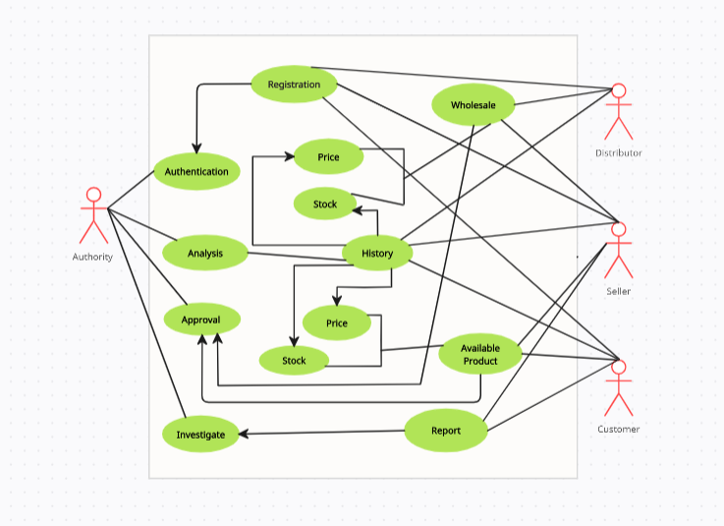

* 1. **Class Diagram:**

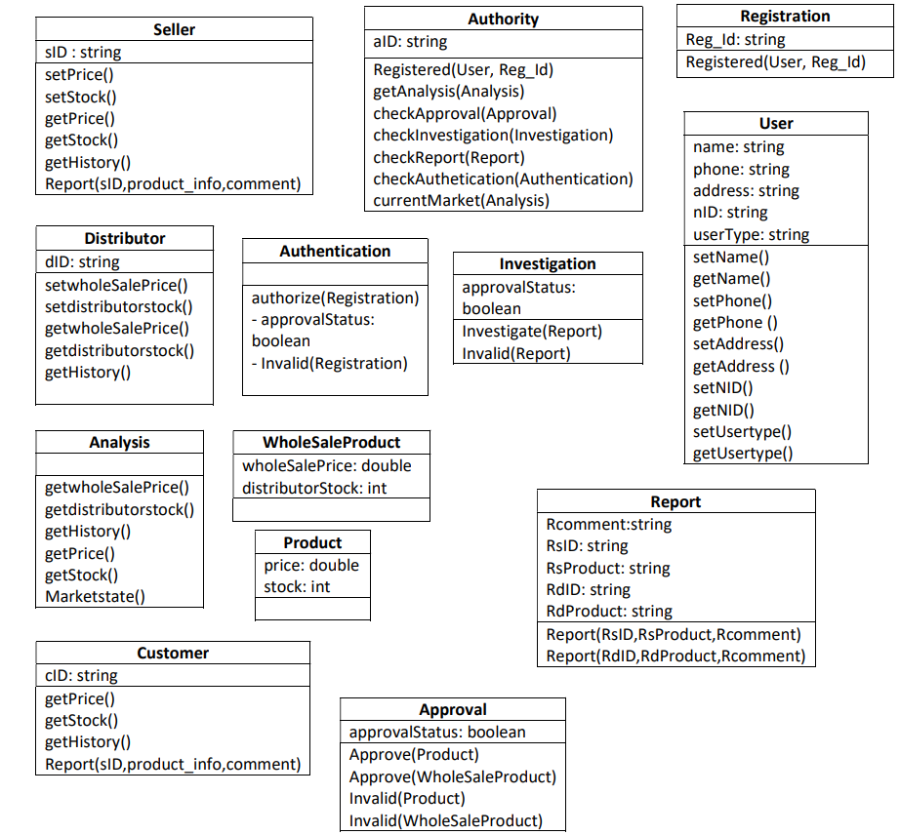

* 1. **Sequence Diagram:**

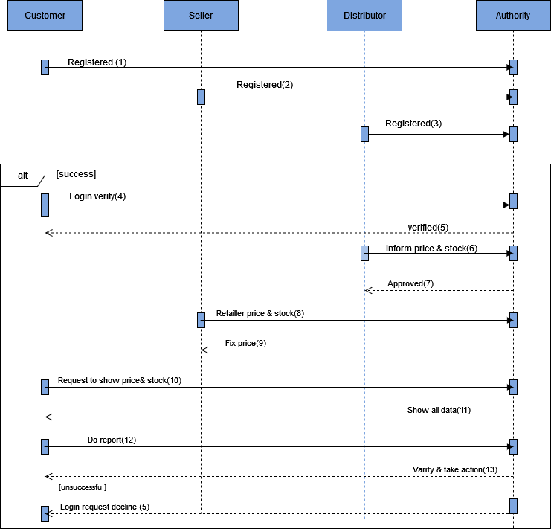

* 1. **ER Diagram:**

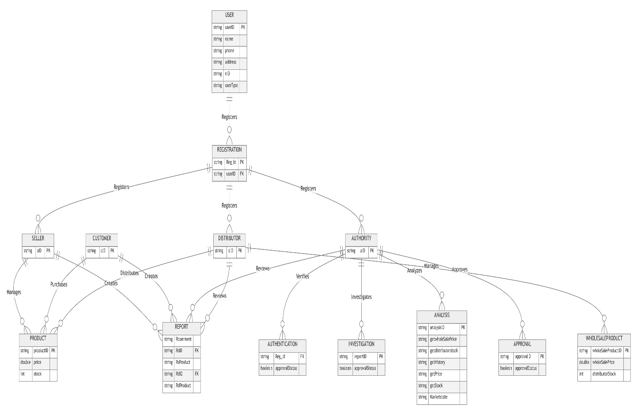

* 1. **State Diagram:**

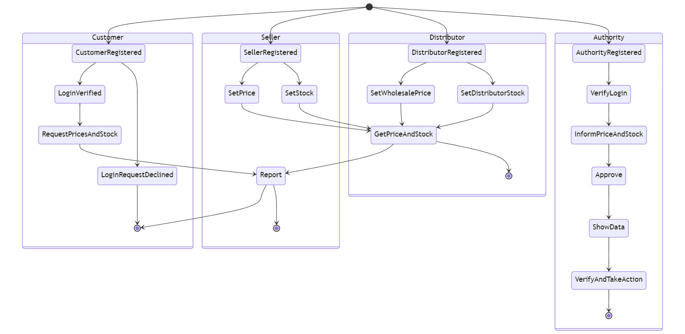

* 1. **Activity Diagram:**

