# BG3ModMaker – Post Install Setup Guide

Thank you for installing **BG3ModMaker**! **BG3ModMaker** is a suite of*Baldur’s Gate 3* modding tools. Out of the box, you can immediately **create mods**, **edit files**, and **build PAKs**, but certain features — such as **searching game objects, text, and icons** — will not work until you generate the needed indexes and databases.

**BG3ModMaker**’s indexes and databases are generated from the original *Baldur’s Gate 3* game data. Because these contain information extracted from Larian’s proprietary .pak files, they are considered **derivative works** of Larian content and therefore **cannot be distributed** with BG3ModMaker. Each user must generate their own **index**, **catalog**, and **icon database** locally using the provided tools. This process reads data from your legally installed copy of *Baldur’s Gate 3* but does not modify or redistribute any game assets.

The suite of tools include:

1. **BG3ModStudio.exe** – The GUI app used to create mods.
2. **Index.exe** – a command line utility used to index game .PAK files into a full-text searchable index
3. **Catalog.exe** – a command line utility used to create a catalog database of “item” game objects organized by UUID.
4. **Iconizer.exe** – a command line utility used to create a database of icons organized by UUID.

## BG3ModStudio

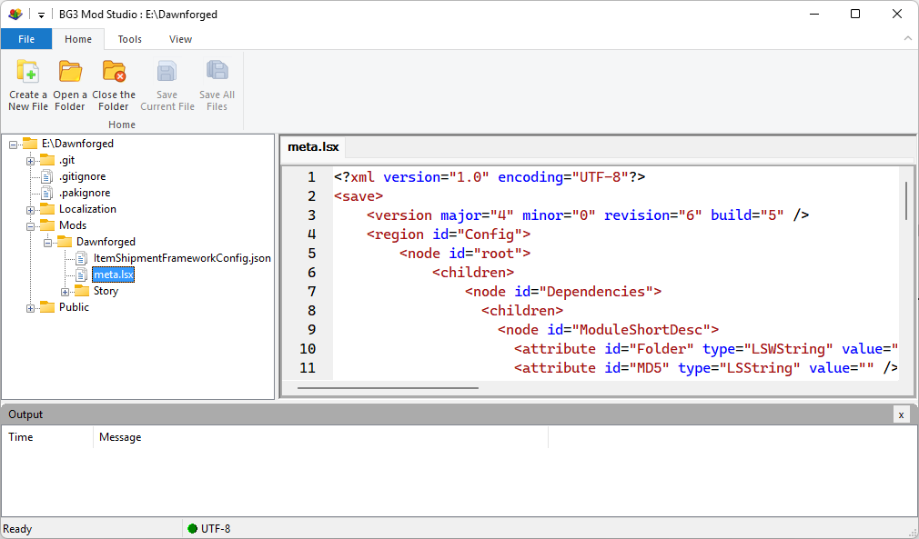

This is the main GUI application. Its purpose is to allow you to open a mod folder and create and edit files in your folder. When you are ready to test out your mod, you can choose “**Tools->Create a PAK file**”, to launch the **PAK builder wizard**, which will allow you to generate a PAK file from your mod.

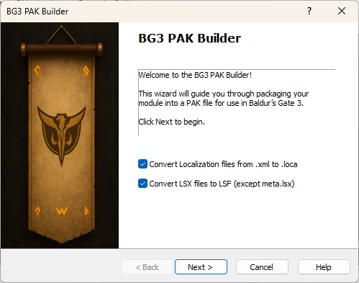

## Indexing Game Content

The most important feature of **BG3ModStudio** is the ability to search game content by keywords. To enable this feature, you must run **Index.exe** like this:  
  
**index.exe {package-path} {index-path} <overwrite: true/false>**

For example:



This may take quite a while, perhaps up to an hour or more, to index very large PAKs such as **Gustav.pak** which is over 12GB. This is a one-time operation.

I usually only ever index **Gustav.pak** and **Shared.pak**.  
  
Once, the index has been generated, you will be able to search the index by keywords:

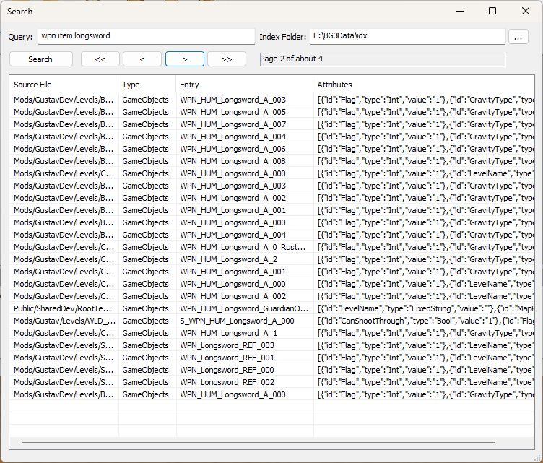

You can view attributes, by double clicking a row. You will also be able to copy values to the clipboard using a right-click context menu.  
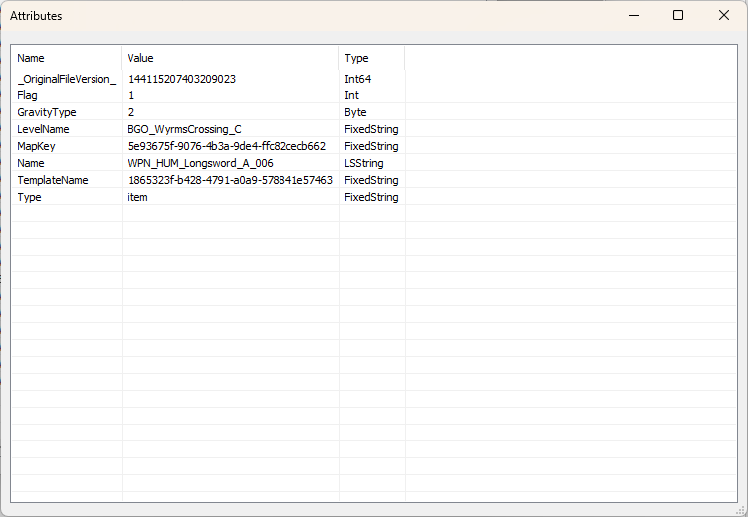

## Generating an icon database

Generating a database of icons is really important in **BG3ModStudio**. It allows you to quickly view an icon when referenced in the index or game object database. For example, by clicking the “Icon” attribute, the icon will display, which is “zoomable” via Ctrl+MouseZoom.  
  
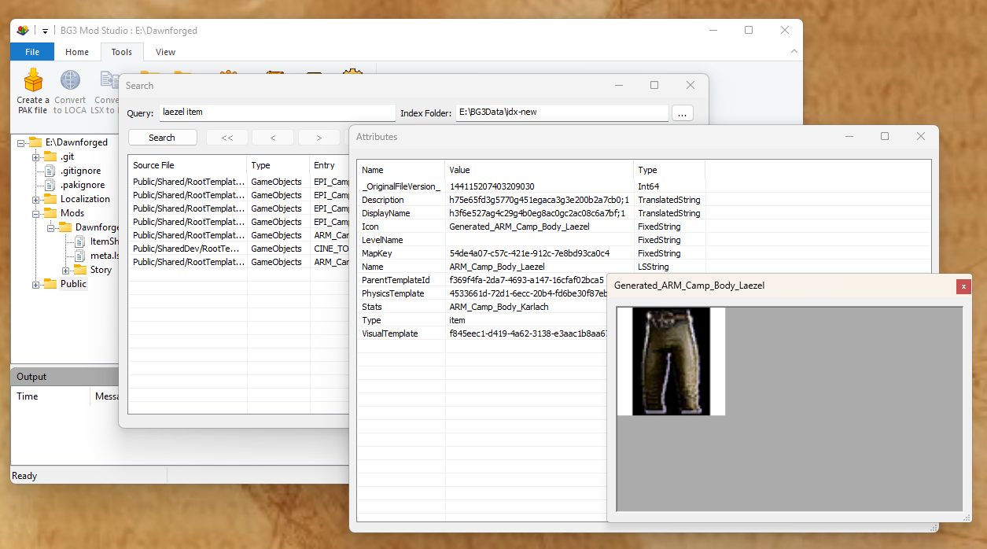

You can generate the icon database like this:  
  
**Iconizer {package-path} {db-path} <overwrite: true/false>**

For example:  


I usually only generate icons for **Gustav.pak** and **Shared.pak** at the moment.

## Cataloging game object items

You may want to catalog game object items by UUID for quick retrieval. I find this feature to be useful, but not critical. This application will construct a database of “item” game objects organized by UUID. You can generate the game object database like this:

**Catalog.exe {package-path} {db-path} <overwrite: true/false>**

For example:



I usually only generate a game object catalog for **Gustav.pak** and **Shared.pak** at the moment.

Once the catalog has been generated, you can open the **Game Object Explorer** to navigate these objects and search by UUID:  
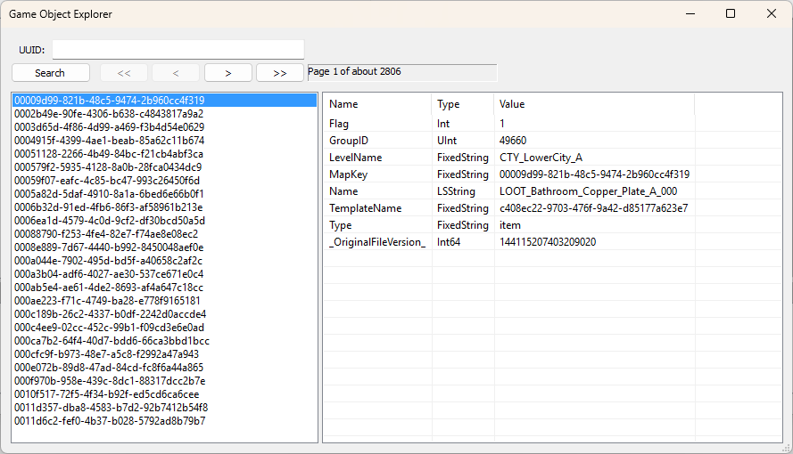

# Settings

Once, you have completed all of these steps, you will need to open **BG3ModStudio** and enter the proper settings for the application. For example:  
  
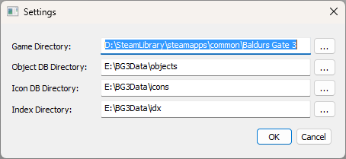

Thanks for installing!

Tom