**Chapter 1: Introduction**

**Project Context**

The current attendance monitoring process in the Institute of Information and Computing Sciences is done manually by their staff. The staff would make rounds in their respective rooms every hour to check the attendance of the faculty members, the staff would record it then on a sheet of paper. This makes it hard for the person in charge in checking the attendance of the faculty to keep track of each faculty member’s time in and time out.

Requesting for make-up classes in the said institute are also done manually up until today. The students or the faculty member would fill up a make-up class form containing the following details: date of make-up class, course code, time of make-up class, room number, section, original schedule, the faculty member's name and signature, and the remarks (approved/disapproved). The student or the faculty member would find an available room through the whole schedule of the faculty members, this would be approved by the Director afterwards.

The team had come up with a solution which is to make a web and mobile application that will log each faculty member’s time in and time out for each class using a barcode scanner and the faculty members id. The admin will have access to all the logs of the faculty members including their class schedule, and the online approval for make-up classes. For the make-up class request, the faculty member can request through and online form where the availability of rooms are easily accessed through a tracker. This will notify the admin whenever a new request has been made, making it easier to track and to approve or disapprove a request.

**Purpose and Description**

This system will benefit the faculty members, the staff, and administrator of the IICS office. The faculty member can track his own logs/attendance and also request for a make-up class through the mobile application. The faculty member will also be notified once the make-up class request has been approved or disapproved.

The staff or the administrator will track the requests, and then approve if applicable. The application allows the faculty member to request for a make-up class without the reservation form. It can also display the list of requests through the admin's computer.

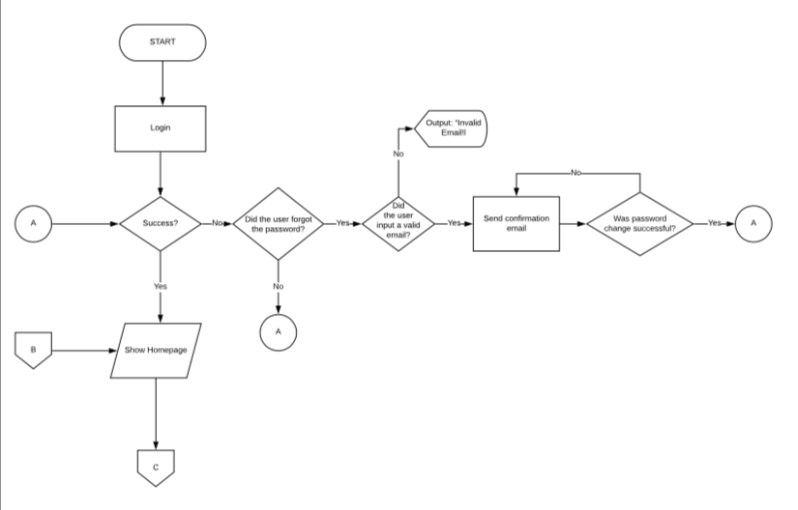

***User - Forgot Password***

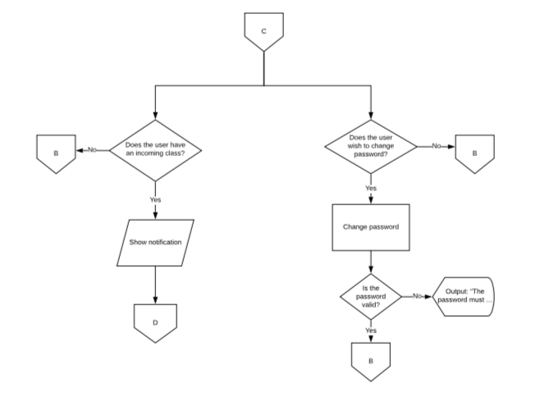

***User - Change Password***

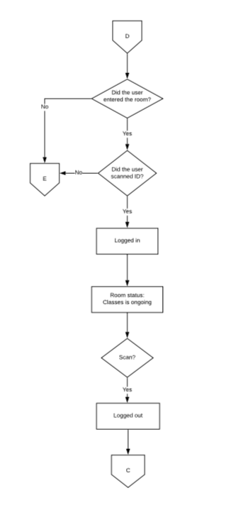

***User - Time In/Time Out***

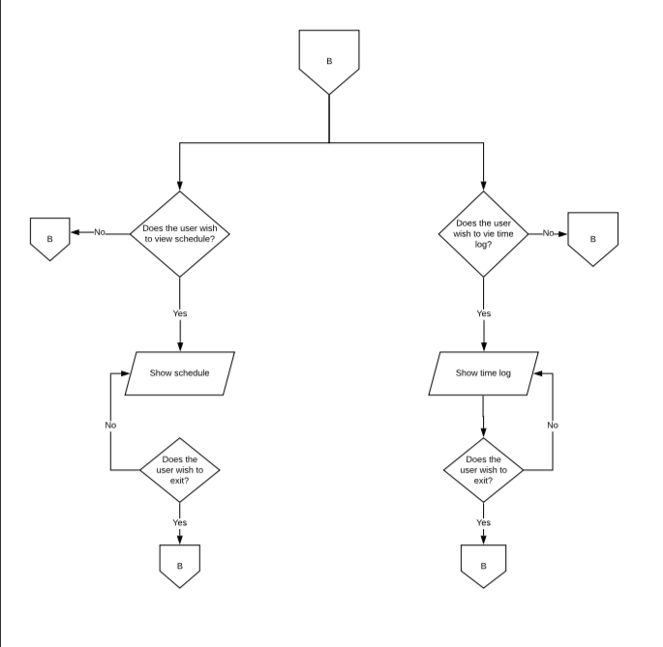

***User/Admin - View schedule/Time Log***

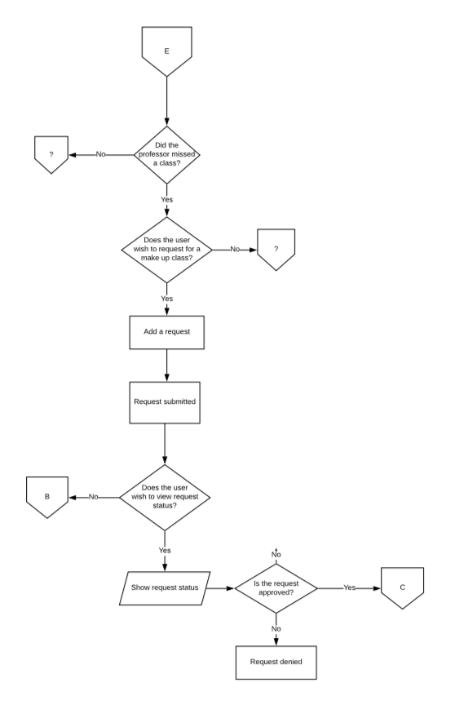

***User - Makeup class request***

**General Objective**

The project aims to develop a web and mobile system that will monitor the attendance of faculty members from the Institute of Information and Computing Sciences.

**Specific Objectives**

The Project specifically aims

1. To allow Users to time in and time out using the barcode on their respective identification cards.
2. To display current Room Status
3. To enable Users to Request for Make-up classes
4. To manage Room Schedules (add, edit, and delete)
5. To display the time log of users
6. To assign a substitute teacher

**Scope and Limitations**

1. The System has 4 Access Levels (Director, Secretary, Admin and User).
2. Only the Director and Secretary accounts are able to Approve and Disapprove Make-up class requests.
3. The Time in and Time out input will be received from the barcode scanner.
4. Admin accounts are able to view the Time log of all users.
5. User Accounts can only view their own Time Log
6. Data transmission of input device depends on its product specification.