TéléLoisirs for Android
Technical Design document

REVISION

Version | Date | Authors | Reviewers | Comments
V1.0 | Dec 21st, 2010 | Tran Khai Xuyen | Nicolas Robert | Draft
V1.1 | Dec 22nd, 2010 | Bui Minh Triet |  | Correct structure of this TDD
V1.2 | Dec 30th, 2010 | Bui Minh Triet |  | Add “business” components
V1.3 | Dec 30th, 2010 | Tran Khai Xuyen |  | Reformat, spell check.
V1.4 | Jan 03rd, 2011 | Bui Minh Triet |  | - Correct TDD as Valentine’s remarks.  - Add design of database structures.  - Use cases diagram with more detail.
V1.5 | Jan 05^{rth} 2011 | Bui Minh Triet |  | - Correct TDD as Nicolas's comment.  - Add sequence diagram  - Add specifications for web services + error handling

TABLE OF CONTENT

REVISION 2
TABLE OF CONTENT 3
DESCRIPTION OF THE DOCUMENT 5
APPLICATION OVERVIEW 6
Group: 6
Home: 6
Channels: 7
TV news: 7
Option page: 7
GLOSSARY 8
LIST OF PERSONS INVOLVED 10
PROJECT ORGANIZATION 11
TARGET PLATFORM 12
TECHNICAL ARCHITECTURE OVERVIEW 13
TECHNICAL ENVIRONMENT OVERVIEW 14
SOFTWARE ARCHITECTURE OVERVIEW 15
USES CASE DIAGRAM 15
SEQUENCE DIAGRAM 17
For the first time launch application 18
From the second launch of application 19
LIST OF “TRANSVERSE” COMPONENTS TO BE DEVELOPED 22
LIST OF BUSINESS COMPONENTS TO BE DEVELOPED 23
CHANNEL PROGRAM SCREEN 24
BROADCAST 27
TV NEWS 28
CUSTOMIZE FAVORITE LIST 29
CACHE PROGRAM-OF-THE-WEEK 29
SHARE VIA FACEBOOK / TWITTER / EMAIL 30
ADVERTISING 30
DEFINITION OF COMMUNICATION FLOWS 31
Error handling 32
Channel 33
GetChannelStatus 33
GetChannelInfo 34
Group 35
GetGroup (1) 35
GetGroupStatus 36
GetGroup (2) 36
Broadcast 38
GetBroadcastIDList 38
GetBroadcastInfo 38
GetBroadcastStatus 40
News 42
getNews 42
getCurrentDate 43
DESIGN OF DATA STRUCTURES 44

DESCRIPTION OF THE DOCUMENT
The purpose of the Technical Design Document (TDD) is to give a fairly complete description of the application, while maintaining a high-level view of the software, giving the software development team an overall guidance of the architecture of the project and making it possible for the team members to share a single vision. The TDD outlines all parts of the software and how they will work; it includes an architecture diagram with pointers to detailed feature specifications of smaller pieces of the design.

APPLICATION OVERVIEW
TeleLoisirs is an application help people keep track of program of TV channels in 24/7. Most of all channels are in France, but there are some channels in Swiss and Belgian. Main parts of this application are:

Group:
- The list of groups of al broadcasting channels.
- Currently we have 7 groups:
  - Grand channels: TF1, France 2, France 3, Canal+, France 5, M6, Arte…
  - TNT: (digital terrestrial television): TF1, France 2, France 3, Canal+, France 5, M6, Arte, Dierct8, W9, TMC, NT1…
  - TNT payante: (commercial digital terrestrial television): TF1, France 2, France 3, France 5, M6, Arte, Direct 8, W9, TMC, NT1, France 4…
  - Cable / Satellite / ADSL: TF1, France 2, France 3, Canal+, M6, Arte…
  - Canal+: Canal+ Décalé, Canal+ Cinéma, Canal+ Sport…
  - Belgique: the Belgium TV channels.
  - Suisse: the Sweden TV channels.
- As we see above, each group consists of many channels. And each channel can belong to more than 1 Group. But pay attention that number of Group can be changed later.

Home:
- Contains the most popular TV channels. Actually HOME is a special case of GROUP, but its channels can be customizable (content of group) on the client “size” .
- For Home screen, we assume a day is divided into 12 equal – periods of 2 hours, or time slice, e.g. 0h – 2h (time slice 0), 2h – 4h (time slice 1), and so on... Each day has 12 time slice, and time slice is number from 0 to 11.
- Each channel display two programs, depending of what time the user select in the menu button, by default it’ll be tonight so the 8pm-10pm+10pm-midnight programs. But it can also be “now”.

Channels:
- List all channels of groups in alphabetical order.
- User can use search bar for finding channel.
- User can view all details from selected channel (list of program, by default today’s program, but he can change the date using the calendar button accessible in the android button option.

TV news:
- News feed.
- Share news article via Facebook/ Twitter / Email with others.

Option page:
- Description/ About of this application.
- Share this application via Facebook/ Twitter / Email with others.
- Download program of selected channels for offline viewing (in case user have no internet connection).


GLOSSARY
- TeleLoisirs: this application
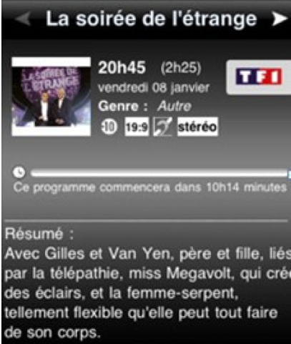
- OBS: Orange BackOffice Services
- Channel: a television station contains several television programs. Each channel is consisted of name, icon and id.
- Broadcast: is a segment of content broadcast on television. It may be a one-off broadcast or a part of periodically recurring television series.
- Short description: instead of displaying all information of this program, in the channel list, we often display a short description of this program. If user wants to view this program, they can go to the “full description” (Broadcast).
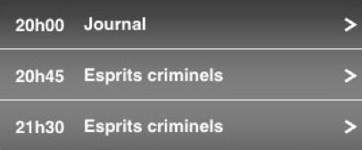
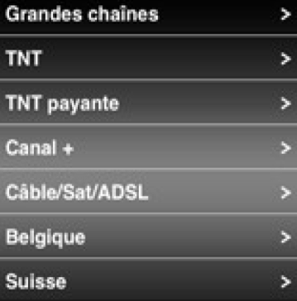
- Program (of a channel): the list of broadcast time of this channel, include data, time, and which program is broadcasted on this date/time. Normally, program contains a list of “short description”.
- Group (Bouquets): a group of channels. In France, all channels are grouped into several channel lists. At the moment, all these Group are are: Grand channel, TNT, TNT payente, Canal+, Cable/Sat/ADSL, Belgian and Swiss (7 Groups – but can change later).
- Time slice: we assume a day is divided into 12 equal parts of 2 hours, numbered from 0, 1, 2...
- Program-Of-The-Week (PotW): is the collection of program for some channels in user’s “favorite list”. It’s stored (cache) in local storage. Using this cache, user can browse all “favorite” programs without internet connection. Default channels to cache is in “favorite list”, but user can change these channels later.
- Last updated time (LUT): indicate the latest time this item (News, Program, Broadcast…) is updated.
- Cache Period: is the time from today to a finite amount days that we can preview program. Normally, this duration is 7 days (as in iPhone version).

LIST OF PERSONS INVOLVED
Producer | Valetin Paquot
Local Producer | Raphael Moutot
Developer | Minh Triet, Bui
Supporter | Nicolas Robert  Khai Xuyen, Tran
GFX
QA

PROJECT ORGANIZATION
Structure on SVN repository
TeleLoisirs_android
|---- 01_research
|---- 02_doc
<<Here is the place we put TDD>>
|---- 03_art
|---- 04_code
<<Here is the place where we put source code>>
|---- 05_sale

TARGET PLATFORM
LIST OF DEVICES
Develop for the following Android devices: (items in bold are primary targets):
Name | Android OS | Screen resolution | Note
Xperia X10 mini pro | 1.6 | 240 x 320
Xperia X10 mini | 1.6 | 240 x 320
HTC Tattoo | 1.6 | 240 x 320
HTC Wildfire | 2.1 | 240 x 320
Samsung Galaxy S | 2.1 | 480 x 800
HTC Desire | 2.1 | 480 x 800
Motorola Milestone | 2.1 | 480 x 854
Acer Liquid | 1.6 | 480 x 800
HTC Legend | 2.1 | 320 x 480
Samsung Galaxy Spica | 2.1 | 320 x 480
LG Optimus GT540 | 1.6 | 320 x 480 | Master
Xperia X10 | 1.6 | 480 x 854 | Master
Samsung Galaxy Teos | 2.1 | 240x400

FRAMEWORKS
We will use:
- Android SDK (Java) as the primary development platform
- JSON as the client/server communication language
- Use both database and flat file to store data.

TECHNICAL ARCHITECTURE OVERVIEW

SOFTWARE ARCHITECTURE OVERVIEW

USES CASE DIAGRAM

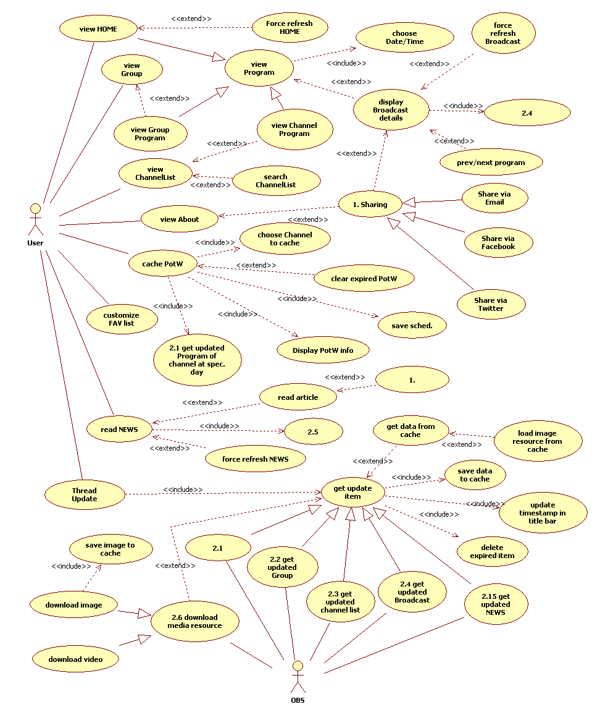

(For a higher resolution diagram, check the attached diagram sent with this TDD).
As we see in this diagram, there are two main actors in TeleLoisirs system: User and OBS (Orange BackOffice System).

User: Has the following main action:
- Choose to view HOME screen.
  - HOME screen contains 2 nearest programs of all channels in the “favorite list” of user.
  - Also there is an option for user refresh this HOME screen.
- View Group (Bouquets): at this time, there are 7 groups here.
  - User can choose their interesting group to see. Each group contains several channels.
  - For each group, they can see all current programs of all channels in this group at the current time slice.
  - They can also choose to view program at any time slice of day in Cache Period.
- If user wants to see all channels instead of channels in a specific Group, they can take other tab - Channels.
  - Browse all channels, or
  - Search for quickly see their desired channel.
  - Choosing any channels will bring user to the full-day program of this channel.
  - Same in group of channels, user can choose which day (in Cache Period) to view channel’s program.
- Finally, from program, we can see there are many programs. So, user can choose any program to view its details (title, content, length, image...). If like, user can shares this program with friends via Facebook, Twitter or email.
- There is a News section, cover related information of TV program news. While reading TV News article, user can share this article with friend via Facebook, Twitter or email.
OBS: In charge of supplying data for TeleLoisirs system:
- HOME content.
- Group List
- Get all channels.
- Get all channels’ program on specific day.
- Get Broadcast.
- Get TV News.
- Get Program-of-the-Week.

SEQUENCE DIAGRAM
At first, we define some terminology here:
# | Terminology | Meaning
1 | N | Is the number of day to cache program
2 | Caching Period (CP) | The period to cache Broadcast, from current day to the next N days.
3 | Old Caching Period (OCP) | The period to cache Broadcast, from the last used app to the next N days.
4 | Now | Current day
5 | TODAY1 | It’s tomorrow
6 | TODAY2 | It's the next day of tomorrow
7 | TODAY3 | The next next day of tomorrow
8 | TODAYN | The (N-1) next day of tomorrow
9 | Upper bound in Caching (UBIC) | the last day in the caching period
10 | Upper bound in Old Caching (UBIOC) | the last day in the old caching period
11 | Last updated time (LUT) | The last time when this data is updated.
13 | WS | Web services

For the first time launch application
We use 2 Threads to handle updated data from WS: Thread1 and Thread2. Also implement an priority queue to manage the order of download data: get channel list, get broadcast data for favorite channel for today, for TODAY2, for TODAY3, …, get broadcast data for other channels for today, for TODAY2, for TODAY3,…
- The first time user launches this application.
- Thread1: send a request to WS to get all channels’ info (Channel ID, name, icon’s hash, LUT):
  - URL: /getChannelInfo.php
  - WS: return the list of Channel (ID, name, icon’s hash, LUT)
  - Save data of Channel to database.
- Thread2: (run parellel with Thread1) send a request to WS to get Broadcast list (BroadcastID) in Cache Period:
  - URL: /getBroadcastIDList.php
  - WS: return list of Broadcast (BroadcastID).
- Divide this list into 2 smaller list: list1 (contains broadcastIDs of channels in favorite list) and list2 (contains broadcastIDs of channels not in favorite list).
- Loop for each date in Cache Period:
Foreach(Date THIS_DATE in Cache Period)
Thread2: send request to WS to get broadcasts’ info of all broadcastID in list1 for THIS_DATE. URL sent to WS likes this: /getBroadcastInfo.php?BroadcastID=BrF1,BrF2,..&StartDate=THIS_DATE
WS: return data for each BroadcastID in list1 for THIS_DATE. Returned data likes this: Broadcast (ID, hash, LUT, Time Begin, Time End, Title, Sub title, …)
Save returned data to database & flat file.
Foreach(Date THIS_DATE in Cache Period)
Thread2: send request to WS to get broadcasts’ info of all broadcastID in list2 for THIS_DATE. URL sent to WS likes this: /getBroadcastInfo.php?BroadcastID=Br1,Br2,..&StartDate=THIS_DATE
WS: return data for each BroadcastID in list2 for THIS_DATE. Returned data likes this: Broadcast (ID, hash, LUT, Time Begin, Time End, Title, Sub title, …)
Save returned data to database & flat file.
- While Thread2 is getting Broadcast data, Thread1 continue sending request to WS to get Group data.
  - URL: /getGroup.php
  - WS: return data: Group (Name, ID, LUT, listOfChannelIdInThisGroup).
  - Save Group data to Group table.

From the second launch of application
- Thread1: send request to WS to get updated status of Channel.
  - URL: /getChannelStatus.php?ChannelID=Ch1,Ch2,.. &LastUpdate=LUT1,LUT2,…
  - WS: return the list of changed Channel ID: CHANGED_CHANNEL_LIST( Channel ID)
- Thread1: send request to WS to get updated data of changed channels:
  - URL: /getChannelInfo.php?ChannelID= CHANGED_CHANNEL_LIST
  - WS: return CHANGED_CHANNEL_LIST_DATA for these Channel ID. CHANGED_CHANNEL_LIST_DATA( ID, Name, Icon Hash, LUT).
  - Save this info to Channel table.
- While Thread1 is getting updated data for Channel, Thread2 will get Broadcast status by sending request to WS to check if Broadcast info in server has been changed?
  - URL: /getBroadcastStatus.php?BroadcastID=Br1,Br2,… &Hash=h1,h2,... &StartDate=TODAY &EndDate=UBIOC
  - WS: return list of changed Broadcast: CHANGED_BROADCAST (ID, hash, time begin, time end, LUT).
- All Broadcast records in Broadcast table have Time End smaller than TODAY is old, and will be remove from both table Broadcast (database) and flat file.
- We get updated broadcast info in 2 phase: phase1 (get small updated of broadcast information duration TODAY – UBIOC) and phase 2 (get large data of broadcast information during UBIOC – UBIC).
  - Loop through all date from TODAY to UBIOC (get small updated data)
Foreach(Date THIS_DATE from TODAY to UBIOC)
    - Create a TEMP_BROADCAST_LIST with element is the BroadcastID in CHANGED_BROADCAST has timestamp is THIS_DATE (it means in server side, this Broadcast has changed in THIS_DATE).
    - Thread2: send request to WS to get updated data for broadcast in TEMP_BROADCAST_LIST: /getBroadcastInfo.php?BroadcastID=TEMP_BROADCAST_LIST &StartDate=THIS_DATE
    - WS: return updated data for these broadcasts in format: Broadcast (ID, hash, LUT, Time Begin, Time End, Title, Sub title, …)
    - Save updated data for flat file and table Broadcast.
  - Loop through all date from TODAY to UBIOC (get new & large data)
Foreach(Date THIS_DATE from UBIOC to UBIC)
    - Thread2: send request to WS to get all broadcast data in THIS_DAY: /getBroadcastInfo.php?StartDate=THIS_DATE
    - WS: return data for these broadcasts in format: Broadcast (ID, hash, LUT, Time Begin, Time End, Title, Sub title, …)
    - Save data for flat file and table Broadcast.
- While Thread2 is getting broadcast data, Thread1 continue on Group.
  - URL: /getGroupStatus.php?GroupID=Gr1, Gr2,..., &LastUpdate=LUT1, LUT2,...
  - Group data returned: GROUP_CHANGED (Group ID).
  - Send request to WS to get updated data for each Groupp ID in GROUP_CHANGED.
  - URL: /getGroupData.php?GroupID=GROUP_CHANGED
  - WS: return updated data for these Group ID. GROUP_CHANGED_DATA (Name, ID, LUT, listOfChannelIdInGroup).
  - Save new data to table Group.

LIST OF “TRANSVERSE” COMPONENTS TO BE DEVELOPED

LIST OF BUSINESS COMPONENTS TO BE DEVELOPED
MAIN COMPONENTS
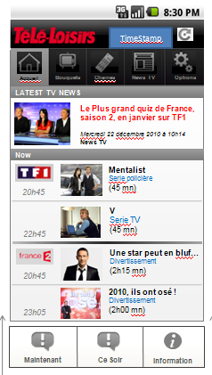
HOME SCREEN
HOME screen has 2 parts: Latest TV News and Current program.
Latest TV News contains 1 (or more?) latest news get from TV News. For this news, only show an thumbnail, title and recent date/time updated. [Question: click this news, user will go to tab “News TV”?]

Each channel of HOME displays two programs, depending of what time the user select in the menu button, by default it’ll be tonight so the 8pm-10pm+10pm-midnight programs. But it can also be “now”.

At the moment, “short description” of each channel in HOME screen consists of: Icon of channel, name of program, time when program will start, and category of this program.
All channels of HOME is gotten from user’s “favorite list” (same as in iPhone version). But as we said, this “favorite list” can be customized in client size. And user also can customize the order of channel in “favorite list”.
If user chooses any program, the broadcast window will be shown, display all information of this broadcast.
HOME is a special case of Group List – HOME only display program at the current time slice while in Group List, user can choose to display program at any time slice of any day (in Cache Period). Therefore, we can use the same mechanism to get programs data for HOME as well as for other Group.
In Android menu for HOME screen, there are 2 options for user quick access Now program or Tonight program. Choosing one of the items will bring user to the second tab program (Group List).
In the top-right of HOME screen is the date/time of last update.
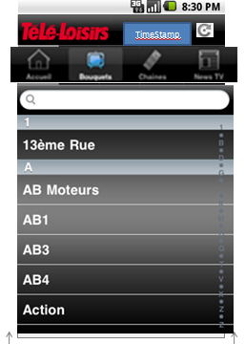
CHANNEL LIST
Channel List contains all channels in alphabetical order. These channels are fixed and rarely changed.
Herein, each channel only need to channel_name.
When application starts up, we will send a request to web services to check if there are any updated data for Channel List. If have, we’ll download this updated data.
User can use search bar for quickly find his interesting channel. The search list will work with a function “like %$%” [Do we need to search in real-time (type and auto-search, don’t need to press “Search” button)?]
Choosing any channel will bring user to channel program screen.
In the top-right of Channel List screen is the date/time of last update.

CHANNEL PROGRAM SCREEN
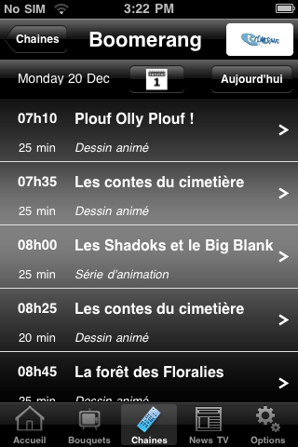
This screen display program of whole day for chosen channel.
All information need to display here is: current date (for user knows which day), and a list of “short description” of each program, include time and name of program.
Each time application starts up, we will send a request to web services to check if there are any updated data for program of all channels in Channels List for all days in Cache Period. If have, we’ll download this updated data and save in cache. So, next time when need to show program, only get it from cache and display – without needing network connection.
In the title bar is the logo of this channel.
Below is a “toolbar”: date of displayed program, a Calendar button and a Today button. Press Calendar button will open a list of days in Cache Period. Choose any day and channel program of this day will be showed. Press Today button to show program of today.

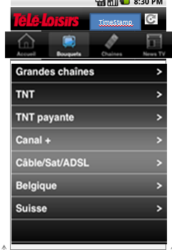
GROUP
Group displays all groups of channel available. These groups are nearly fixed and rarely changed.
In the first time application starts up, we need to send a request to web services to get data of Group List: group_id and group_name.
After that, from the second launch, we only send request to web services to check if there is any updated of Group. If have, download this data and save to cache.
Click any group list to enter detail of this group (Channel List).
In the top-right of Group screen is the date/time of last update.

GROUP PROGRAM

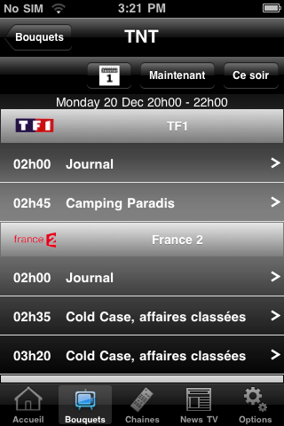
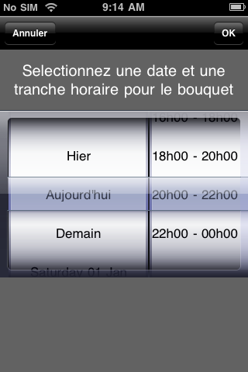
Channel List of Group displays all channels in this group.
The differentiability between Channel List of Group and Channel List is in Channel List of Group, we only display channels be long to this Group, while in Channel List, we display all available channels.
In the first time application starts up, we need to send a request to web services to determine which channels is belong to this Group.
After that, from the second launch, we only send request to web services to check if there is any updated of channels belongs to this Group. If have, download this data and save to cache.
For each channel here, we'll show channel icon and channel name. Also displaying program for current time slice of this channel. In each “Short description” of program is the time to start and name of program. When viewing any Channel List of Group, TeleLoisirs will send a request to web services to update program for current time slice.
These button in “toolbar” below title is: a Calendar button, a Now button and a Tonight button. There is also a label shows current date & time slice.
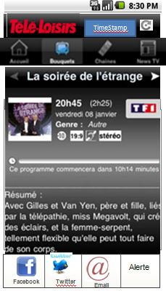
Press Calendar button to open window to choose date (any day from current to the next 7 days) & time slice (see right image above). Press OK button in this window to close this window and display program of selected date at selected time slice.
2 remain button is the “shortcut” to quick access program at current time slice (Now button) or program at night (Tonight button).
In the top-right of Group program screen is the date/time of last update.

BROADCAST
All information need to show in broadcast is:
- Picture (with a default picture by category if the program don’t have one in Back-office)
- Program Title
- Programe Sub-title (optional)
- Category of program
- Length
- Season (optional, handy for tv shows and reality tv)
- Aimed Category (Everyone, -10, -15, etc)
- Summary
- Casting (optional)
  - Host (0-n)
  - Guest (0-n)
  - Director (0-n)
  - Actors (0-n) / Play …
If user come to Broadcast page from Group Program, there are 2 button “Next” and “Prev” so that he can go to the next/previous Broadcast in the Group Program of viewing channel.
There is a sharing option for Broadcast when user press Android menu. Using this feature to share this broadcast (via Facebook, Twitter or email) with his friends.
There will also be the « Alerte » button. When user click on it it’ll allow him to add this program into his phone Agenda and choose when to be alerted (2 hours before start, etc). [Will need to discuss more about this function].

TV NEWS
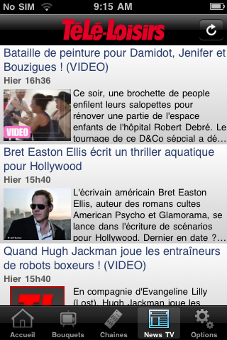
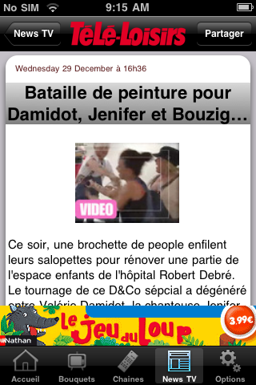
You will get all TV-related news in this section.
News is gotten from a RSS feed supplied by TeleLoisirs website.
Each news article in “short form” contains title, date, time, an thumbnail of article resource (image or video), and a short description of this article.
In “short form”, if the date of the news matches today then display “Aujourd’hui” and if the date of the news matches yesterday then display “Hier”, else display the date in number.
“Full form” of an article will show the date/time this article is updated, title, media resource (image, video), and full content of this article.
In both form, if media resource is not available, we’ll display a default picture instead. There will be two default picture, one for regular news, one for video.
There will be two kind of news, plain text or news with media in it.
If the news has media (video) then there will be a click on the picto to launch a related video.
If the user is on « plane » mode then the icon will be grayed and not clickable (online use only).
In the top-right of TV News screen is the date/time of last update.

CUSTOMIZE FAVORITE LIST
In this section the user will be able to change channels in his « favorite list » as well as order of display of these channel.

CACHE PROGRAM-OF-THE-WEEK
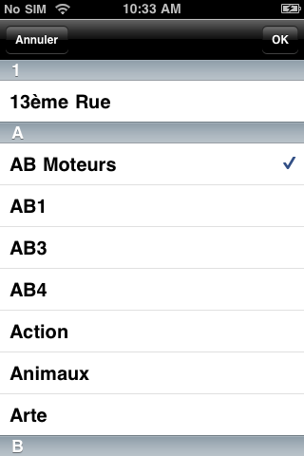
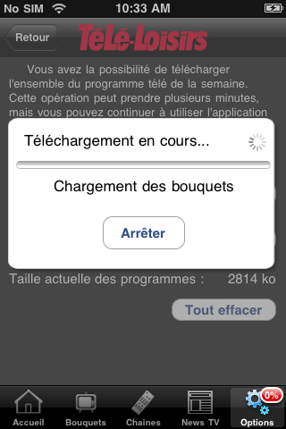
User can cache some “favorite channels” in order to view its program in case there is no internet connection. After caching “favorite channels”, user can view these channels' program offline during the Cache Period.

SHARE VIA FACEBOOK / TWITTER / EMAIL
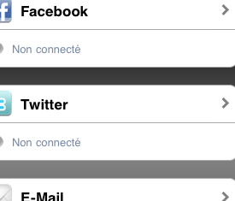
If user sees this broadcast / news article / application is interesting, he can use the “Share” feature to share it with his friends.

ADVERTISING
I see “Jeu de loop” advertising banner in iPhone version of Tele Loisirs. How about advertising for Android version?

DEFINITION OF COMMUNICATION FLOWS
This section describes in details the communication between the application TéléLoisirs (TL) and the BackOffice’s web service (WS). TL makes use of the WS to retrieved TV program information in an organized manner. All information is divided into the following units:
GROUP: (bouquet) collection of channels sharing a certain characteristic: technical, geographical, economical… This helps users browsing through the data more conveniently. Currently we’re having the following group:
- Grande Chaîne (grand channels): TF1, France 2, France 3, Canal+, France 5, M6, Arte…
- TNT (Télévision Numérique Terrestre): TF1, France 2, France 3, Canal+, France 5, M6, Arte, Dierct8, W9, TMC, NT1…
- TNT payante: TF1, France 2, France 3, France 5, M6, Arte, Direct 8, W9, TMC, NT1, France 4…
- Canal+: Canal+ Décalé, Canal+ Cinéma, Canal+ Sport…
- Câble/Sat/ADSL: TF1, France 2, France 3, Canal+, M6, Arte…
- Belgique: La Une, La Deux, RTL TVI, Club RTL, TF1, France 2
- Suisse: TSR1, TSR2, France 2, France 3, Arte, TF1…
HOME: a special group for display programs on popular channels (most-viewed) TF1, France 2, France 3, Canal+, Arte, France 5, Direct 8… used as the default view when user first launch TL… This list is initially the main French channels, but its channels list is customizable on the client side.
CHANNEL: basic unit of broadcasting information: listing the programs with their time, duration…
BROADCAST: contains all detail information: time, duration, video audio format, content summary, casting…
WS’ functions helps retrieving broadcasting information following the above – defined units. Internal implementation of the WS is abstracted to the TL side. But method calling convention is expected to be normal HTTP GET and returned data is expected to be a document of contentType=application/json. This output is gzip-ed, to reduced transfering data size. The WS functions, however would deal with textual data only, for other types (e.g: images, video...), it’s server side to define the location where to host those data.
Date: all exchanged date, time data is in Unix timestamp format if otherwise specified. Since WS functions would mainly deal with day (rather time), date(s) are rounded to the beginning of the day. It’s the client side to handle DST (Daylight Saving Time) which is specific to client locale setting, time used in client/server information exchanges is defined as GMT-0 timezone with no consideration to DST. See: getCurrentDate function for time synchronization.
In all cases, broadcasting data should be available for today (current day) and 6 next days. So the minimum available is 7 days of data.
All id used in returned data (e.g: group_id, channel_id, program_id…) should have global - valid value so that it can be used as input parameters in other methods.

Error handling
In case of errors in processing WS requests, the returned document should contain data field to justify for that error. In case of no errors, these data fields should be absent. It’s WS side to define all error code & description needed.
 | Error code name | Value | Meaning
Channel | CHANNEL_NO_UPDATE | 101 | there is no update of any channel in server
Channel | CHANNEL_HAS_UPDATE | 102 | there is update information of channel in server
Channel | CHANNEL_ID_INVALID | 103 | invalid channel id
Channel | CHANNEL_GET_INFO_SUCCESS | 104 | Get information of channel success
Broadcast | BROADCAST_NO_UPDATE | 201 | there is no update of any Broadcast in server
Broadcast | BROADCAST_HAS_UPDATE | 202 | there is update information of broadcast in server
Broadcast | BROADCAST_GET_LIST_SUCCESS | 203 | Get list of broadcast ID success
Broadcast | BROADCAST_ID_INVALID | 204 | Invalid broadcast ID
Broadcast | BROADCAST_GET_INFO_SUCCESS | 205 | Get list of broadcast data success
Broadcast | BROADCAST_DATE_RANGE_INVALID | 206 | The StartDate value is larger than EndDate
Group | GROUP_GET_INFO_SUCESS | 301 | Get list of group data success
Group | GROUP_ID_INVALID | 302 | Invalid group id
Timestamps | INVALID_TIMESTAMPS_FORMAT | 401 | Format of Unix timestamps is not correct

Channel

GetChannelStatus
Check all these channels in CHANNEL_LIST_ID, which channel has been updated in server.
URL: geChannelStatus.php?ChannelID=CHANNEL_LIST_ID &LastUpdate=LUT_LIST
Parameters:
- ChannelID=CHANNEL_LIST_ID: list of all channels need to get updated status, separate by the comma. This parameter cannot be NULL.
- LastUpdate=LUT_LIST: list of LUT (last updated time), in correspondent with CHANNEL_LIST_ID, separate by the comma too. This parameter cannot be NULL. Each element of LUT_LIST is an integer, represent an Unix timestamps.
Output:
{
“result_code”: RESULT_CODE,
“channels”:
{
“channel”:
{
“id”: 12345, // number
},
“channel”:
{
“id”: 12346,
},
//......
}
}
RESULT_CODE can be: CHANNEL_NO_UPDATE, CHANNEL_HAS_UPDATE, CHANNEL_ID_INVALID or INVALID_TIMESTAMPS_FORMAT.
In case RESULT_CODE is CHANNEL_NO_UPDATE, INVALID_TIMESTAMPS_FORMAT or CHANNEL_ID_INVALID, don't need to add content of “channels” to output.

GetChannelInfo
Get information of all channels in CHANNEL_LIST_ID.
URL: getChannelInfo.php?ChannelID=CHANNEL_LIST_ID
Parameters:
- ChannelID=CHANNEL_LIST_ID: list of channels ID we need to get information, , separate by the comma. In case this parameter is NULL, its default value if the list of all available channels in server.
Output:
{
“result_code”: RESULT_CODE,
“channels”:
{
“channel”:
{
“id”: 12345, // number
“name”: “TF1”, // string
“logo”: “http://webservice.com/tf1.png”
“LUT”: 1262304000
},
“channel”:
{
“id”: 12346,
“name”: “TV5”,
“logo”: “http://webservice.com/tv5.png”
“LUT”: 1263304000
},
//......
}
}
RESULT_CODE can be: CHANNEL_GET_INFO_SUCCESS or CHANNEL_ID_INVALID.
In case RESULT_CODE is CHANNEL_ID_INVALID, don't need to add content of “channels” to output.

Group

GetGroup (1)
Get a list of all available groups. Each group should have a global unique id, and a list of all channels associated to the group (channel are specified by another id, see: getChannels).
URL: getGroup.php
Parameter: none
Output:
{
“result_code”: RESULT_CODE,
“groups”:
{
“group”:
{
“id”: 2, // number
“name”: “TNT”, // string
“LUT”: 1262304000
“channels”: // list of all associated channels
{
“id”: 12345,
“id”: 12346,
“id”: 12347,
//...
}
},
“group”:
{
“id”: 3, // number
“name”: “TNT payente”, // string
“LUT”: 1262302000
“channels”: // list of all associated channels
{
“id”: 12445,
“id”: 12546,
“id”: 12647,
//...
}
},
//......
}
}
RESULT_CODE is always be GROUP_GET_INFO_SUCESS.

GetGroupStatus
Check among GROUP_LIST_ID, which GroupID has changed in server.
URL: getGroupStatus.php?GroupID=GROUP_LIST_ID&LastUpdate=LUT_LIST
URL: getGroupStatus.php?GroupID=GROUP_LIST_ID&LastUpdate=LUT_LIST
Parameters:
- GroupID=GROUP_LIST_ID: list of all GroupID need to get updated status, separate by the comma. This parameter cannot be NULL.
- LastUpdate=LUT_LIST: list of LUT (last updated time), in correspondent with GROUP_LIST_ID, separate by the comma too. This parameter cannot be NULL. Each element of LUT_LIST is an integer, represent an Unix timestamps.
Output:
{
“result_code”: RESULT_CODE,
“groups”:
{
“group”:
{
“id”: 2, // number
},
“group”:
{
“id”: 5, // number
},
//......
}
}
RESULT_CODE can be GROUP_GET_INFO_SUCESS, INVALID_TIMESTAMPS_FORMAT or GROUP_ID_INVALID.
In case RESULT_CODE is GROUP_ID_INVALID or INVALID_TIMESTAMPS_FORMAT, don't need to add content of “groups” to output.

GetGroup (2)
Get info of all Group in GROUP_LIST_ID.
URL: getGroup.php?GroupID=GROUP_LIST_ID
Parameter:
- GroupID=GROUP_LIST_ID: list of all GroupID need to get data, separate by the comma. In case this parameter is NULL, we have function getGroup (1) – get data of all available groups in server.
Output:
{
“result_code”: RESULT_CODE,
“groups”:
{
“group”:
{
“id”: 2, // number
“name”: “TNT”, // string
“LUT”: 1262304000
“channels”: // list of all associated channels
{
“id”: 12345,
“id”: 12346,
“id”: 12347,
//...
}
},
“group”:
{
“id”: 3, // number
“name”: “TNT payente”, // string
“LUT”: 1262302000
“channels”: // list of all associated channels
{
“id”: 12445,
“id”: 12546,
“id”: 12647,
//...
}
},
//......
}
}
RESULT_CODE can be GROUP_GET_INFO_SUCESS or GROUP_ID_INVALID.
In case RESULT_CODE is GROUP_ID_INVALID, don't need to add content of “groups” to output.

Broadcast

GetBroadcastIDList
Get all BroadcastID in Cache Period (the period from TODAY to UBIC).
URL:getBroadcastIDList.php
Parameters: None.
Output:
{
“result_code”: RESULT_CODE,
“broadcasts”:
{
“broadcast”:
{
“id”: 4548635, // number
},
“broadcast”:
{
“id”: 4548655, // number
},
“broadcast”:
{
“id”: 4548235, // number
},
//......
}
}
RESULT_CODE is always BROADCAST_GET_LIST_SUCCESS.

GetBroadcastInfo
Get broadcast information for all BroadcastID in BROADCAST_LIST_ID for a date, or for a duration.
URL:getBroadcastInfo.php?BroadcastID=BROADCAST_LIST_ID &StartDate=THIS_DATE [ &EndDate=END_DATE ]
Parameters:
- BroadcastID=BROADCAST_LIST_ID: is the list of BroadcastID we need to get data, separate by the comma. This parameter cannot be NULL.
- StartDate=THIS_DATE: is the date we want to get broadcast data for. This parameter cannot be NULL too, because Broadcast data is large, we must use StartDate parameter to limit the amount of returned data. THIS_DATE is an integer, represent an Unix timestamps.
- EndDate=END_DATE (optional): if this parameter is not NULL, we'll get broadcast data for all day from StartDate to EndDate. Passing wrong value of EndDate (smaller than StartDate), you'll get BROADCAST_DATE_RANGE_INVALID error. END_DATE is an integer, represent an Unix timestamps.
Output:
{
“result_code”: RESULT_CODE,
"broadcasts"
{
"broadcast"
{
"ID": 375892,
"LUT": 1245643000,
"Hash": e7c531efe53f802171f596dd88b7a1b6,
"ChannelID": 3532,
"TimeBegin": 1245643000,
"TimeEnd": 1245693000,
"Picture": "http://img.org/001.png",
"Title": "Sample title",
"Subtitle": "Sample subtitle",
"Category": 3,
"Length": 50,
"Season": 4,
"AimedCategory": 6,
"Summary": "This is a sample summary",
"Casting"
{
"Host": 1,
"Guest": 0,
"Director": 3,
"Actors": 1
}
},
//...

}
}
RESULT_CODE can be BROADCAST_GET_INFO_SUCCESS, BROADCAST_ID_INVALID, INVALID_TIMESTAMPS_FORMAT or BROADCAST_DATE_RANGE_INVALID.
In case RESULT_CODE is BROADCAST_ID_INVALID, INVALID_TIMESTAMPS_FORMAT or BROADCAST_DATE_RANGE_INVALID, don't need to add content of “broadcasts” to output.

GetBroadcastStatus
Check if among BROADCAST_LIST_ID, which broadcast ID has changed in server.
URL: getBroadcastStatus.php?BroadcastID=BROADCAST_LIST_ID &Hash=HASH_LIST &StartDate=START_DATE [& EndDate=END_DATE]

Parameters:
- BroadcastID=BROADCAST_ILIST_ID: is the list of BroadcastID we need to get status, separate by the comma. This parameter cannot be NULL.
- Hash=HASH_LIST: list of hash value, in correspondent with BROADCASH_LIST_ID, separate by the comma too. This parameter cannot be NULL too.
- StartDate=THIS_DATE: is the date we want to get broadcast data for. This parameter cannot be NULL too, because Broadcast data is large, we must use StartDate parameter to limit the amount of returned data. THIS_DATE is an integer, represent an Unix timestamps.
- EndDate=END_DATE (optional): if this parameter is not NULL, we'll get broadcast data for all day from StartDate to EndDate. Passing wrong value of EndDate (smaller than StartDate), you'll get BROADCAST_DATE_RANGE_INVALID error. END_DATE is an integer, represent an Unix timestamps.
Output: return the list of broadcastID has changed in server.
{
“result_code”: RESULT_CODE,
"broadcasts"
{
"broadcast"
{
"ID": 375892,
},
"broadcast"
{
"ID": 375894,
},
"broadcast"
{
"ID": 375592,
},
//...

}
}
RESULT_CODE can be BROADCAST_NO_UPDATE, BROADCAST_ID_INVALID, INVALID_TIMESTAMPS_FORMAT , BROADCAST_DATE_RANGE_INVALID or BROADCAST_HAS_UPDATE.
In case RESULT_CODE is BROADCAST_ID_INVALID, INVALID_TIMESTAMPS_FORMAT, BROADCAST_DATE_RANGE_INVALID or BROADCAST_NO_UPDATE don't need to add content of “broadcasts” to output.

News

getNews
This WS function (getNews) returns a full list of news at the current time. Each news item is a full feed, which means: there would be no need to get individually news details (all is in this document). Each news entry consists of text contents and one picture (or one video). In case there’s no picture (or video) available, the default picture (for image or video) will be displayed instead. The amount of news available in the list is to be defined (maybe news of the last 3 days?). The function has no input parameter, news are sorted by publishing time and contains the following fields:
Input: none
Output:
{
“gid”: “ebd805cf9698a9f5a94218f0582abb4c”,
“title”: “TV News on Tele-Loisir.fr”,
“description”: “TV programs on different channels: cable, tnt...”,
“copyright”: “Prissma Presse”,
“language”: “fr-FR”,
“link”: “http://www.programme-tv.net/news”
“news_list”:
{
“news”:
{
“publish_date”: “1263798000000”,
“title”: “LG Optimus 2X: first dual-core Android phone”,
“link”: “http://www.engadget.com/2010/12/15/lg-optimus-2x-first-dual-core-smartphone-launches-with-android/”,
“description”: “That’s right, it’s official. Needless to say, that this monster has picked up the Optimus 2X name as it morphs from a prototype into brutally fast, overpowered reality.”,
“resource”:
{
“url”: http://webservice.com/images001.jpg,
“type”: “image/jpeg”,
“size”: 13679,
// for video there should be a field: thumbnail
“thumbnail”: “http://webservice.com/thumbnail.jpg
}
},
//......
}
}
resource.type: this is the contentType, can be video (video/mpg, video/ogg...) or image (image/jpeg, image/gif...).
size: the file size (in byte) of the media content. Video type need to be defined, for video a thumbnail (representing image) is also required.

getCurrentDate
This is a utility function used for time synchronization between client and server. Usually the first of a WS’ API set should be some ping function. This getCurrentDate also operates as a ping, and is first called when the application starts to check server reachability and synchronize time.
URL: getCurrentDate.php
Input: none
Output: current day in Unix timestamp format.
{
“current_date”: “1263798000000”
}

DESIGN OF DATA STRUCTURES
Normally, we have 2 mechanisms to store data for application, this is:
- Database, or
- Flat file
Database is suitable for data with many relationships between tables, because using SQL, we can perform complex query statements to retrieve desired data. But using database to store data with many text is wasteful, we should use flat file instead.
Both of 2 these approach have pros and cons. In case of this application, we’ll use the “hybrid approach” – combination of both database and flat file. This means:
- Using flat file to store all data of Broadcast (ID, title, length, category, description…) in JSON format.
- Using database to describe relationships between all tables (Group, Channels and Broadcast) as well as it data.
Different between Broadcast in database and in flat file is: in database, Broadcast is in short-format, only contains information for performing query statement & reference. While Broadcast in flat file is full-format, it contains all information about this Broadcast.
Take a look at database diagram of Tele Loisirs System.
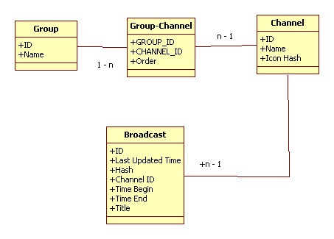
And here is an example of Program in flat file (in JSON format):
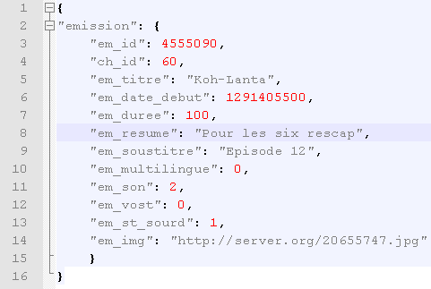
Now, take a look at table Program in database again. You see field MD5_hash, but where does it come from? Actually, after get Program content and save it to flat file, we can easily calculate MD5 hash of this file. We keep this MD5_hash in table Program and name this flat file is MD5_hash.json.
Serialization / deserialization problem.
After get Program content from web services, we write this data to flat file (still keep JSON format). Only need to deserialize when user want to view content of Program.
For special object (media resource: image, video), if resource is image, we cache it’s in phone’s local storage. But due to large size of video, we’ll bypass it. If user would like to watch video, they should have internet connection to download and view.
Data size limit of Android platform.
We know Android platform has some limit of data:
We cannot install application with database larger than 1MB (although after install application, we can insert data to database, make database larger than 1MB).
Application size is limit to 50MB.
Both of these limit has not any effect on our application. Our database is empty at first. After enter program for the first time, data is downloaded and inserted to database. Actually, because most of our data is Broadcast – that we save in flat file, so size of database is very small.

