Télé Loisirs for Android
Technical Design document

REVISION
Version | Date | Authors | Reviewers | Comments
V1.0 | Dec 21st, 2010 | Tran Khai Xuyen | Nicolas Robert | Draft
V1.1 | Dec 22nd, 2010 | Bui Minh Triet | Nicolas Robert | Correct structure of this TDD
V1.2 | Dec 30th, 2010 | Bui Minh Triet |  | Add “business” components
V1.3 | Dec 30th, 2010 | Tran Khai Xuyen | Nicolas Robert | Reformat, spell check.
V1.4 | Jan 03rd, 2011 | Bui Minh Triet | Valentin Paquot | - Correct TDD as Valentin’s remarks.  - Add design of database structures.  - Use cases diagram with more detail.
V1.5 | Jan 05^{rth} 2011 | Bui Minh Triet | Nicolas Robert | - Correct TDD as Nicolas's comment.  - Add sequence diagram  - Add specifications for web services + error handling
V1.6 | Jan 06^{rth} 2011 | Bui Minh Triet | Nicolas Robert | - Correct TDD as Nicolas's comment.  - Update Web services Specifications  - Split Web services Specification into an appendix.
V1.7 | Jan 07^{rth} 2011 | Bui Minh Triet |  | - Correct TDD as Nicolas's comment.  - Add Technical Architect overview.

TABLE OF CONTENT

REVISION 2
TABLE OF CONTENT 3
DESCRIPTION OF THE DOCUMENT 5
APPLICATION OVERVIEW 6
Group: 6
Home: 6
Channels: 6
TV news: 7
Option page: 7
GLOSSARY 8
LIST OF PERSONS INVOLVED 10
PROJECT ORGANIZATION 11
TARGET PLATFORM 12
TECHNICAL ARCHITECTURE OVERVIEW 13
SOFTWARE ARCHITECTURE OVERVIEW 15
USES CASE DIAGRAM 15
SEQUENCE DIAGRAM 17
1. Update time 17
2. Update Channel 18
3. Update Broadcast 18
3 Clean old broadcast 22
4 Update Group 22
LIST OF “TRANSVERSE” COMPONENTS TO BE DEVELOPED 23
LIST OF BUSINESS COMPONENTS TO BE DEVELOPED 24
CHANNEL PROGRAM SCREEN 25
BROADCAST 28
TV NEWS 29
CUSTOMIZE FAVORITE LIST 30
CACHE PROGRAM-OF-THE-WEEK 30
SHARE VIA FACEBOOK / TWITTER / EMAIL 31
ADVERTISING 31
DEFINITION OF COMMUNICATION FLOWS 32
Clarification about threading 32
Note about data integrity 32
Note about cleaning 32
Web services specification 32
DESIGN OF DATA STRUCTURES 33
Database structures 33
Database 33
Flat files 34
Serialization / deserialization problem. 35
Data size limit of Android platform. 36

DESCRIPTION OF THE DOCUMENT
The purpose of the Technical Design Document (TDD) is to give a fairly complete description of the application, while maintaining a high-level view of the software, giving the software development team an overall guidance of the architecture of the project and making it possible for the team members to share a single vision. The TDD outlines all parts of the software and how they will work; it includes an architecture diagram with pointers to detailed feature specifications of smaller pieces of the design.

APPLICATION OVERVIEW
Tele Loisirs is an application help people keep track of program of TV channels in 24/7. Most of all channels are in France, but there are some channels in Swiss and Belgian. Main parts of this application are:

Group:
- The list of groups of al broadcasting channels.
- Currently we have 7 groups:
  - Grand channels: TF1, France 2, France 3, Canal+, France 5, M6, Arte…
  - TNT: (digital terrestrial television): TF1, France 2, France 3, Canal+, France 5, M6, Arte, Dierct8, W9, TMC, NT1…
  - TNT payante: (commercial digital terrestrial television): TF1, France 2, France 3, France 5, M6, Arte, Direct 8, W9, TMC, NT1, France 4…
  - Cable / Satellite / ADSL: TF1, France 2, France 3, Canal+, M6, Arte…
  - Canal+: Canal+ Décalé, Canal+ Cinéma, Canal+ Sport…
  - Belgique: the Belgium TV channels.
  - Suisse: the Sweden TV channels.
- As we see above, each group consists of many channels. And each channel can belong to more than 1 Group. But pay attention that number of Group can be changed later.

Home:
- Contains the most popular TV channels. Actually HOME is a special case of GROUP, but its channels can be customizable (content of group) on the client side.
- For Home screen, we assume a day is divided into 12 equal – periods of 2 hours, or time slice, e.g. 0h – 2h (time slice 0), 2h – 4h (time slice 1), and so on... Each day has 12 time slice, and time slice is number from 0 to 11.
- Each channel display two programs, depending of what time the user select in the menu button, by default it’ll be tonight so the 8pm-10pm+10pm-midnight programs. But it can also be “now”.

Channels:
- List all channels of groups in alphabetical order.
- User can use search bar for finding channel.
- User can view all details from selected channel (list of broadcasts, by default it's today’s program, but he can change the date using the calendar button accessible in the android button option.

TV news:
- News feed.
- Share news article via Facebook/ Twitter / Email with others.

Option page:
- Description/ About of this application.
- Share this application via Facebook/ Twitter / Email with others.
- Download program of selected channels for offline viewing (in case user have no internet connection).


GLOSSARY
- Tele Loisirs: this application
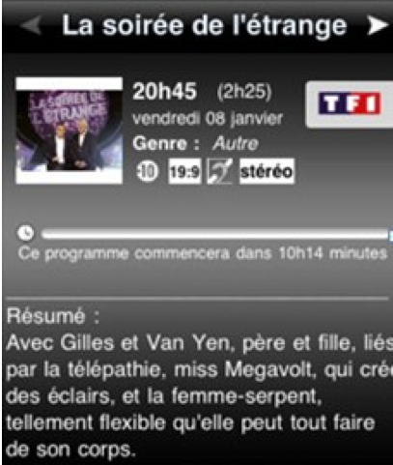
- OBS: Orange BackOffice Services
- Channel: a television station contains several television programs. Each channel is consisted of name, icon and id.
- Broadcast: is a segment of content broadcast on television. It may be a one-off broadcast or a part of periodically recurring television series.
- Short description: instead of displaying all information of this broadcast, in the channel list, we often display a short description of this program. If user wants to view this program, they can go to the “full description” (Broadcast).
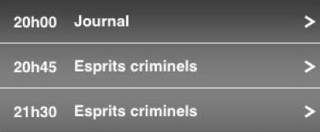
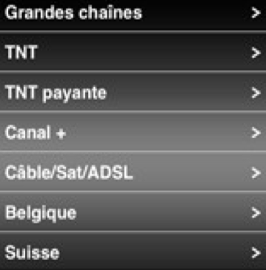
- Program (of a channel): the list of broadcast time of this channel, include data, time, and which program is broadcasted on this date/time. Normally, program contains a list of “short description”.
- Group (Bouquets): a group of channels. In France, all channels are grouped into several channel lists. At the moment, all these Group are are: Grandes chaines, TNT, TNT payante, Canal+, Cable/Sat/ADSL, Belgian and Swiss (7 Groups – but these groups can be changed later).
- Time slice: we assume a day is divided into 12 equal parts of 2 hours, numbered from 0, 1, 2...
- Program-Of-The-Week (PotW): is the collection of program for some channels in user’s “favorite list”. It’s stored (cache) in local storage. Using this cache, user can browse all “favorite” programs without internet connection. Default channels to cache is in “favorite list”, but user can change these channels later.
- Last updated time (LUT): indicate the latest time this item (News, Program, Broadcast…) is updated.
- Cache Period: is the time from today to a finite amount days that we can preview program. Normally, this duration is 7 days (as in iPhone version).

LIST OF PERSONS INVOLVED
Producer | Valentin Paquot
Local Producer | Raphael Moutot
Developer | Minh Triet, Bui
Supporter | Nicolas Robert  Khai Xuyen, Tran
GFX
QA

PROJECT ORGANIZATION
Structure on SVN repository
Tele Loisirs
|---- 01_sales
|---- 02_design
|---- 03_producing
|---- 04_artists
|---- 05_developers
|---- android
| |---- trunk
| |---- src
| <<All source here, in packages>>
| |---- assets
| <<All pre-created database is put here>>
| |---- res
| |---- drawable
| |---- drawable-hdpi
| |---- drawable-mdpi
| |---- drawable-ldpi
| <<All image resources is stored in drawable/-* folder>>
| |---- layout
| <<Defined layout is stored in layout folder>>
| |---- value
| <<Color & pre-defined variable & localization resource>>
| |---- AndroidManifest.xml
| |---- mockups
|---- backoffice
|---- 05_qa

TARGET PLATFORM
LIST OF DEVICES
Develop for the following Android devices: (items in bold are primary targets):
Name | Android OS | Screen resolution | Note
Xperia X10 mini pro | 1.6 | 240 x 320
Xperia X10 mini | 1.6 | 240 x 320
HTC Tattoo | 1.6 | 240 x 320
HTC Wildfire | 2.1 | 240 x 320
Samsung Galaxy S | 2.1 | 480 x 800
HTC Desire | 2.1 | 480 x 800
Motorola Milestone | 2.1 | 480 x 854
Acer Liquid | 1.6 | 480 x 800
HTC Legend | 2.1 | 320 x 480
Samsung Galaxy Spica | 2.1 | 320 x 480
LG Optimus GT540 | 1.6 | 320 x 480 | Master
Xperia X10 | 1.6 | 480 x 854 | Master
Samsung Galaxy Teos | 2.1 | 240x400

FRAMEWORKS
We will use:
- Android SDK (Java) as the primary development platform
- JSON as the client/server communication language
- Use both database (SQLite) and flat file to store data.

TECHNICAL ARCHITECTURE OVERVIEW
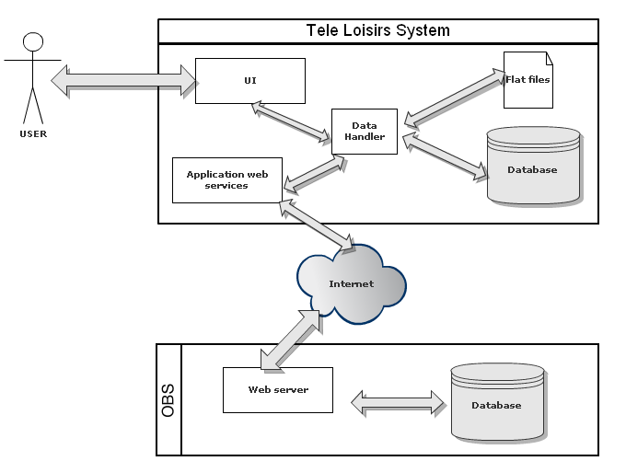
- User interacts with Application via UI component.
- Data Handler component is in charge of getting data from flat files and database, suppy this data for UI.
- Data Handler will ask Application web services component to get new/updated data.
- Application Web services send the request to get needed data to OBS.
- OBS's Web server will process this request, perform query in server database to get the needed data. After that, return data for Application Web services.
- Application Web services provided these data for Data Handler. Data Handler will supply this data for UI (displaying) and save these data for Database and Flat files.

SOFTWARE ARCHITECTURE OVERVIEW

USES CASE DIAGRAM

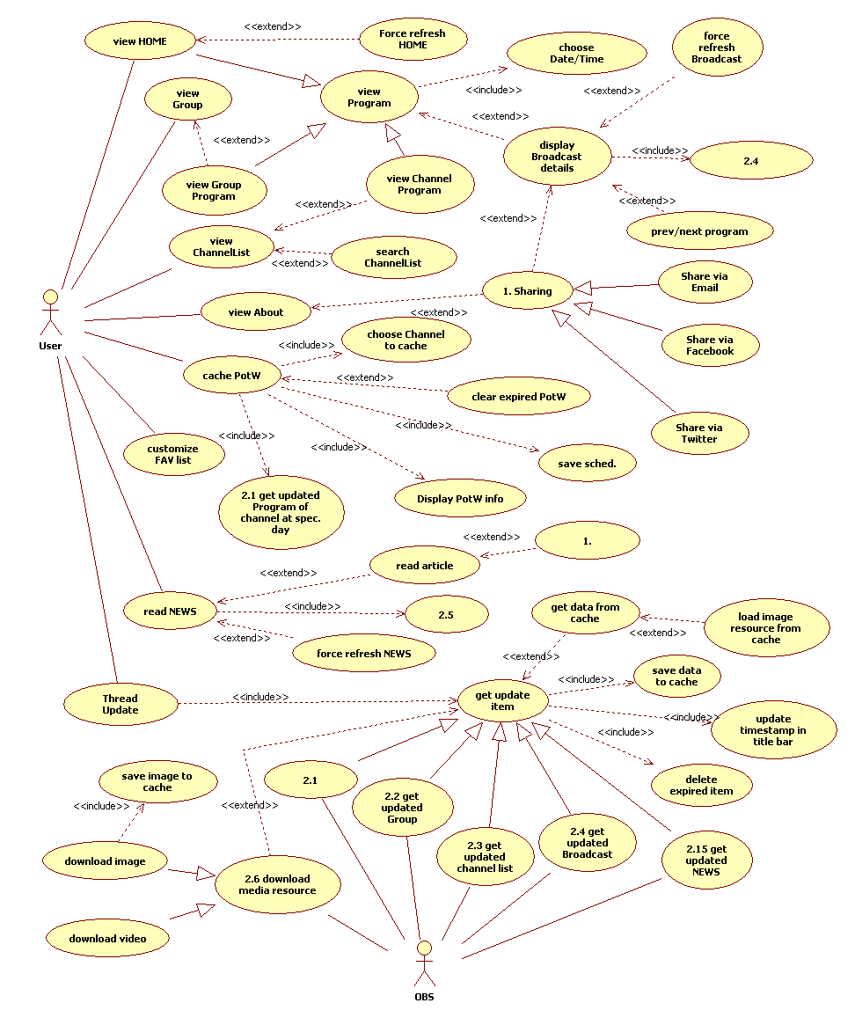

(For a higher resolution diagram, check the attached diagram sent with this TDD).
As we see in this diagram, there are two main actors in Tele Loisirs system: User and OBS (Orange BackOffice System).
User: Has the following main action:
- Choose to view HOME screen.
  - HOME screen contains 2 nearest programs of all channels in the “favorite list” of user.
  - Also there is an option for user refresh this HOME screen.
- View Group (Bouquets): at this time, there are 7 groups here.
  - User can choose their interesting group to see. Each group contains several channels.
  - For each group, they can see all current programs of all channels in this group at the current time slice.
  - They can also choose to view program at any time slice of day in Cache Period.
- If user wants to see all channels instead of channels in a specific Group, they can take other tab - Channels.
  - Browse all channels, or
  - Search for quickly see their desired channel.
  - Choosing any channels will bring user to the full-day program of this channel.
  - Same in group of channels, user can choose which day (in Cache Period) to view channel’s program.
- Finally, from program, we can see there are many broadcasts. So, user can choose any broadcast to view its details (title, content, length, image...). If like, user can shares this broadcast with friends via Facebook, Twitter or email.
- There is a News section, cover related information of TV program news. While reading TV News article, user can share this article with friend via Facebook, Twitter or email.
OBS: In charge of supplying data for Tele Loisirs system:
- HOME content.
- Group List
- Get all channels.
- Get all channels’ program on specific day.
- Get Broadcast.
- Get TV News.
- Get Program-of-the-Week.

SEQUENCE DIAGRAM
At first, we define some terminology here:
# | Terminology | Meaning
1 | N | Is the number of day to cache program
2 | Caching Period (CP) | The period to cache Broadcast, from current day to the next N days.
3 | Old Caching Period (OCP) | The period to cache Broadcast, from the last used app to the next N days.
4 | Now | Current day
5 | DAY1 | It’s tomorrow
6 | DAY2 | It's the next day of tomorrow
7 | DAY3 | The next next day of tomorrow
8 | DAYN | The (N-1) next day of tomorrow
9 | Upper bound in Caching (UBIC) | the last day in the caching period
10 | Upper bound in Old Caching (UBIOC) | the last day in the old caching period
11 | Last update time (LUT) | The last time when this data is updated.
13 | WS | Web services

We use 1 Thread to handle updated data from WS. Also implement an priority queue to manage the order of download data: get channel list, get broadcast data for favorite channel for today, for DAY1, for DAY2, …, get broadcast data for other channels for today, for DAY2, for DAY3,…
- The first time user launches this application.

1. Update time
- Thread: send request to WS to get the current timestamp of the server.
  - URL: getCurrentDate.php
  - Parameters: none.
  - Output: return the current timestamp of the server in Unix timestamp format.

2. Update Channel
- Thread: continue send other request to WS to get channel information.
  - URL: getChannelInfo.php ?LUT=LUT&ChannelList=CHANNEL_LIST
  - Parameters:
    - LUT (optional): the latest update timestamp of channel in local. Ignore this parameter if this is the first time we launch this application.
    - ChannelList (optional): list of all channel ID we need to get information. If this parameter is missed (e.g. in case the first time we launch this application), server will apply this function for all available channels in server.
  - Output: return information of all channel in parameter in format: Channel(Id, Name, Logo URL, Logo Hash, LUT).
  - Update correspondent data to database (table Channel) – except for Logo, because we'll updated Logo data in the next separated step (in the next).
- Update Channel Logo: after getting the returned ChannelList, we compare return Logo Hash value with local Logo hash value, as well as returned Logo URL with local Logo URL. If one of 2 is different, its means Logo is changed (change data – in the first case, or change URL – in the second case). In both two case, we only need to update the correspondent data.
- We divide returned Channel List into 2 sub-list: Fav-Channel-List (contains all channels in user's favorite list) and Non-Fav-Channel-List (contains all channels not in user's favorite list).
- We know for days in Cache Period, we can divide this period into 2 sub-period: Period1 (from current day to UBIOC) and Period2 (from UBIOC to UBIC). Broadcast data of broadcast in Period1 have already in cache, we only need to check for update for only some broadcasts. However, broadcast data of broadcasts in Period2 is totally new, we need to download data for all broadcasts in this period.

3. Update Broadcast
3.1 Update Broadcast in Period1
- Thread: check for any broadcast ID in Fav-Channel-List has an update in server:
  - URL: getBroadcastId.php ?LUT=LUT [&ChannelID=Fav-Channel-List] &StartDate=TODAY&EndDate=UBIOC
  - Parameters:
    - LUT (optional): the latest update timestamp of channel in local. Ignore this parameter if this is the first time we launch this application.
    - ChannelID: list of all channels. We only need to check for update of broadcast in this channel.
    - StartDate & EndDate: the period we need to limit the query – only need to check for any update of broadcast in this period.
  - Output: return the list of (BroadcastID, hash) in Fav-Channel-List from TODAY to UBIOC.
  - Using the return hash value, we check if this broadcast file stored sin file system has changed or not. After checking, we have a Broadcast-change-list.
- Thread: get update information of each broadcast ID in Broadcast-change-list (Fav-Channel-List):
  - URL: getBroadcastInfo.php?BroadcastID=Broadcast-change-list
  - Parameters:
    - BroadcastID: list of broadcast ID we need to get updated.
  - Output: list of information of each broadcast ID in Broadcast-change-list. All information is: (Id, Hash, ChannelID, LUT, TimeBegin, TimeEnd, main image URL, hash of main image URL, thumbnail URL, hash of thumbnail URL, category, title,...).
  - After receive updated data of Broadcast-change-list, we save data to database (table Broadcast) and flat file.
  - One important thing is to update data image. In returned Broadcast List, we have Main Image URL and Hash of Main Image URL. Compare these returned values with these in local, we can easily know if Main Image has changed or not. If it changes, get updated image from server. Same for Thumbnail URL.
- Thread: check for any broadcast ID in Non-Fav-Channel-List has an update in server:
  - URL: getBroadcastId.php ?LUT=LUT [&ChannelID=Fav-Channel-List & ChannelFilterInverted=YES] &StartDate=TODAY&EndDate=UBIOC
  - Parameters:
    - LUT (optional): the latest update timestamp of broadcast in local. Ignore this parameter if this is the first time we launch this application.
    - ChannelID: list of all channels. We only need to check for update of broadcast in this channel. If ChannelFilterInverted=YES, we apply this function for only broadcast not in ChannelID.
    - StartDate & EndDate: the period we need to limit the query – only need to check for any update of broadcast in this period.
  - Output: return the list of (BroadcastID, hash) in Non-Fav-Channel-List from TODAY to UBIOC.
  - Using the return hash value, we check if this broadcast file stored in file system has changed or not. After checking, we have a Broadcast-change-list.
- Thread: get update information of each broadcast ID in Broadcast-change-list (Non-Fav-Channel-List):
  - URL: getBroadcastInfo.php?BroadcastID=Broadcast-change-list
  - Parameters:
    - BroadcastID: list of broadcast ID we need to get updated.
  - Output: list of information of each broadcast ID in Broadcast-change-list. All information is: (Id, Hash, ChannelID, LUT, TimeBegin, TimeEnd, main image URL, hash of main image URL, thumbnail URL, hash of thumbnail URL, category, title,...).
  - After receive updated data of Broadcast-change-list, we save data to database (table Broadcast) and flat file.
  - One important thing is to update data image. In returned Broadcast List, we have Main Image URL and Hash of Main Image URL. Compare these returned values with these in local, we can easily know if Main Image has changed or not. If it changes, get updated image from server. Same for Thumbnail URL.
3.2 Update Broadcast in Period2
- For Period2, all data is new. We don't need to check which broadcastID has an update. Only send request to WS to get all new broadcast data.
- Thread: get new information of each broadcast ID in Fav-Channel-List in Period2:
  - URL: getBroadcastInfo.php ?LUT=LUT &ChannelID=Fav-Channel-List &StartDate=UBIOC&EndDate=UBIC
  - Parameters:
    - LUT (optional): the latest update timestamp of broadcast in local. Ignore this parameter if this is the first time we launch this application.
    - ChannelID: list of all channels. We only need to check for update of broadcast in this channel.
    - StartDate & EndDate: the period we need to limit the query – only need to check for any update of broadcast in this period.
  - Output: list of information of each broadcast ID in Broadcast-change-list. All information is: (Id, Hash, ChannelID, LUT, TimeBegin, TimeEnd, URL picture, hash of URL picture, category, title,...).
  - After receive updated data of all broadcasts belongs to Fav-Channel-List in Period2, we save data to database (table Broadcast) and flat file.
  - One important thing is to update data image. In returned Broadcast List, we have Main Image URL and Hash of Main Image URL. Don't need to compare for any changes, because all Main Image here is new, Download all them. Same as for Thumbnail image.
- Thread: get new information of each broadcast ID in Non-Fav-Channel-List:
  - URL: getBroadcastInfo.php ?LUT=LUT &ChannelID=Fav-Channel-List &ChannelFilterInverted=YES &StartDate=UBIOC&EndDate=UBIC
  - Parameters:
    - LUT (optional): the latest update timestamp of broadcast in local. Ignore this parameter if this is the first time we launch this application.
    - ChannelID: list of all channels. We only need to check for update of broadcast in this channel. If ChannelFilterInverted=YES, it means we apply this function for all broadcast not in this ChannelID.
    - StartDate & EndDate: the period we need to limit the query – only need to check for any update of broadcast in this period.
  - Output: list of information of each broadcast ID in Broadcast-change-list. All information is: (Id, Hash, ChannelID, LUT, TimeBegin, TimeEnd, URL picture, hash of URL picture, category, title,...).
  - After receive updated data of all broadcasts belongs to Non-Fav-Channel-List in Period2, we save data to database (table Broadcast) and flat file.
  - One important thing is to update data image. In returned Broadcast List, we have Main Image URL and Hash of Main Image URL. Don't need to compare for any changes, because all Main Image here is new, Download all them. Same as for Thumbnail image.

3 Clean old broadcast
  - Remove from database all broadcasts which EndDate is after 0:00 today (these are old broadcasts).
  - Remove from file system all broadcasts has filename (hash) is not in the database.

4 Update Group
- After all, we need to get new data of Group.
  - URL: getGroupInfo.php?LUT=LUT
  - Parameters:
    - LUT (optional): the latest update timestamp of Group in local. Ignore this parameter if this is the first time we launch this application.
  - Output: return Group information (Id, Name, List of channel belongs to this Group, LUT).
  - Save data to database (table Group).

LIST OF “TRANSVERSE” COMPONENTS TO BE DEVELOPED

LIST OF BUSINESS COMPONENTS TO BE DEVELOPED
MAIN COMPONENTS
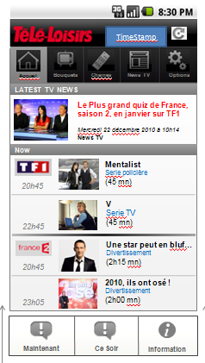
HOME SCREEN
HOME screen has 2 parts: Latest TV News and Current program.
Latest TV News contains 1 (or more?) latest news get from TV News. For this news, only show an thumbnail, title and recent date/time updated. [Question: click this news, user will go to tab “News TV”?]

Each channel of HOME displays two programs, depending of what time the user select in the menu button, by default it’ll be tonight so the 8pm-10pm+10pm-midnight programs. But it can also be “now”.

At the moment, “short description” of each channel in HOME screen consists of: Icon of channel, name of program, time when program will start, and category of this program.
All channels of HOME is gotten from user’s “favorite list” (same as in iPhone version). But as we said, this “favorite list” can be customized in client size. And user also can customize the order of channel in “favorite list”.
If user chooses any program, the broadcast window will be shown, display all information of this broadcast.
HOME is a special case of Group List – HOME only display program at the current time slice while in Group List, user can choose to display program at any time slice of any day (in Cache Period). Therefore, we can use the same mechanism to get programs data for HOME as well as for other Group.
In Android menu for HOME screen, there are 2 options for user quick access Now program or Tonight program. Choosing one of the items will bring user to the second tab program (Group List).
In the top-right of HOME screen is the date/time of last update.
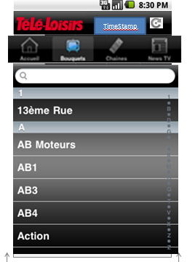
CHANNEL LIST
Channel List contains all channels in alphabetical order. These channels are fixed and rarely changed.
Herein, each channel only need to channel_name.
When application starts up, we will send a request to web services to check if there are any updated data for Channel List. If have, we’ll download this updated data.
User can use search bar for quickly find his interesting channel. The search list will work with a function “like %$%” [Do we need to search in real-time (type and auto-search, don’t need to press “Search” button)?]
Choosing any channel will bring user to channel program screen.
In the top-right of Channel List screen is the date/time of last update.

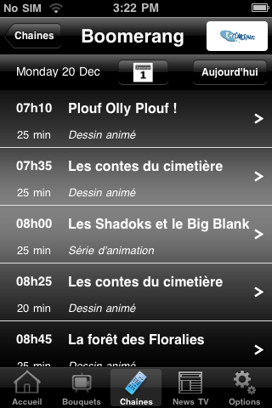
CHANNEL PROGRAM SCREEN
This screen display program of whole day for chosen channel.
All information need to display here is: current date (for user knows which day), and a list of “short description” of each program, include time and name of program.
Each time application starts up, we will send a request to web services to check if there are any updated data for program of all channels in Channels List for all days in Cache Period. If have, we’ll download this updated data and save in cache. So, next time when need to show program, only get it from cache and display – without needing network connection.
In the title bar is the logo of this channel.
Below is a “toolbar”: date of displayed program, a Calendar button and a Today button. Press Calendar button will open a list of days in Cache Period. Choose any day and channel program of this day will be showed. Press Today button to show program of today.

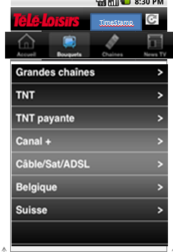
GROUP
Group displays all groups of channel available. These groups are nearly fixed and rarely changed.
In the first time application starts up, we need to send a request to web services to get data of Group List: group_id and group_name.
After that, from the second launch, we only send request to web services to check if there is any updated of Group. If have, download this data and save to cache.
Click any group list to enter detail of this group (Channel List).
In the top-right of Group screen is the date/time of last update.

GROUP PROGRAM

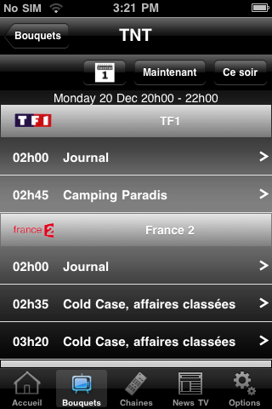
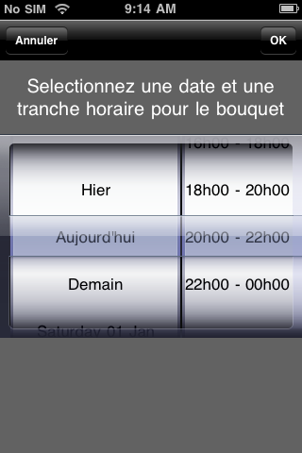
Channel List of Group displays all channels in this group.
The differentiability between Channel List of Group and Channel List is in Channel List of Group, we only display channels be long to this Group, while in Channel List, we display all available channels.
In the first time application starts up, we need to send a request to web services to determine which channels is belong to this Group.
After that, from the second launch, we only send request to web services to check if there is any updated of channels belongs to this Group. If have, download this data and save to cache.
For each channel here, we'll show channel icon and channel name. Also displaying program for current time slice of this channel. In each “Short description” of program is the time to start and name of program. When viewing any Channel List of Group, Tele Loisirs will send a request to web services to update program for current time slice.
These button in “toolbar” below title is: a Calendar button, a Now button and a Tonight button. There is also a label shows current date & time slice.
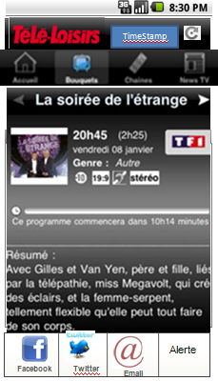
Press Calendar button to open window to choose date (any day from current to the next 7 days) & time slice (see right image above). Press OK button in this window to close this window and display program of selected date at selected time slice.
2 remain button is the “shortcut” to quick access program at current time slice (Now button) or program at night (Tonight button).
In the top-right of Group program screen is the date/time of last update.

BROADCAST
All information need to show in broadcast is:
- Picture (with a default picture by category if the program don’t have one in Back-office)
- Program Title
- Programe Sub-title (optional)
- Category of program
- Length
- Season (optional, handy for tv shows and reality tv)
- Aimed Category (Everyone, -10, -15, etc)
- Summary
- Casting (optional)
  - Host (0-n)
  - Guest (0-n)
  - Director (0-n)
  - Actors (0-n) / Play …
If user come to Broadcast page from Group Program, there are 2 button “Next” and “Prev” so that he can go to the next/previous Broadcast in the Group Program of viewing channel.
There is a sharing option for Broadcast when user press Android menu. Using this feature to share this broadcast (via Facebook, Twitter or email) with his friends.
There will also be the « Alerte » button. When user click on it it’ll allow him to add this program into his phone Agenda and choose when to be alerted (2 hours before start, etc). [Will need to discuss more about this function].

TV NEWS
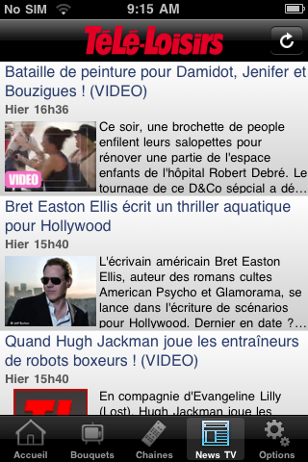
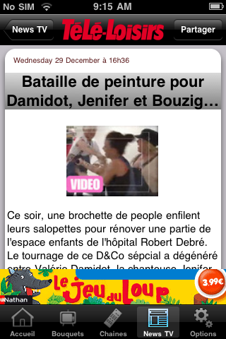
You will get all TV-related news in this section.
News is gotten from a RSS feed supplied by Tele Loisirs website.
Each news article in “short form” contains title, date, time, an thumbnail of article resource (image or video), and a short description of this article.
In “short form”, if the date of the news matches today then display “Aujourd’hui” and if the date of the news matches yesterday then display “Hier”, else display the date in number.
“Full form” of an article will show the date/time this article is updated, title, media resource (image, video), and full content of this article.
In both form, if media resource is not available, we’ll display a default picture instead. There will be two default picture, one for regular news, one for video.
There will be two kind of news, plain text or news with media in it.
If the news has media (video) then there will be a click on the picto to launch a related video.
If the user is on « plane » mode then the icon will be grayed and not clickable (online use only).
In the top-right of TV News screen is the date/time of last update.

CUSTOMIZE FAVORITE LIST
In this section the user will be able to change channels in his « favorite list » as well as order of display of these channel.

CACHE PROGRAM-OF-THE-WEEK
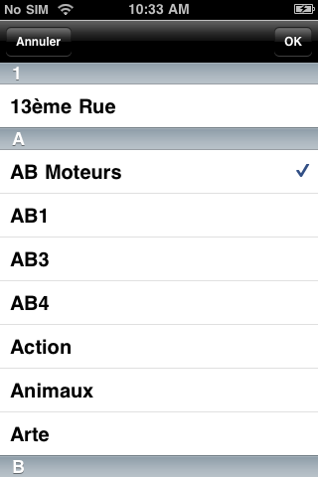
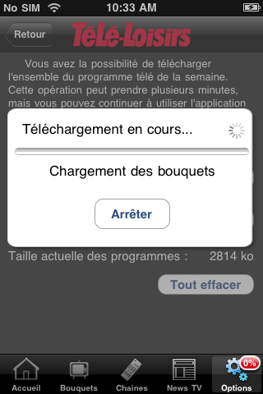
User can cache some “favorite channels” in order to view its program in case there is no internet connection. After caching “favorite channels”, user can view these channels' program offline during the Cache Period.

SHARE VIA FACEBOOK / TWITTER / EMAIL
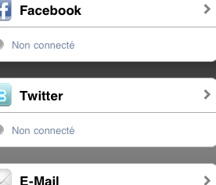
If user sees this broadcast / news article / application is interesting, he can use the “Share” feature to share it with his friends.

ADVERTISING
I see “Jeu de loop” advertising banner in iPhone version of Tele Loisirs. How about advertising for Android version?

DEFINITION OF COMMUNICATION FLOWS

Clarification about threading
The proposal in the TDD is that in addition to the main thread, which is dedicated to handle UI and user interactions, there will be 2 dedicated threads to handle the data update (connection to server, parsing, etc.). But to make it simpler and avoid potential integrity issues (e.g. we get a broadcast for a channel which we haven't got the information yet), we could simply have a single thread to handle the whole update mechanism (get channels, get groups, get broadcasts, get news)...

Note about data integrity
We shall always make sure that foreign keys (ID in a table that points to another table) do exist. Example: when we receive a list of broadcasts, we shall make sure that the channelID does correspond to an existing channel (or else we shall discard the broadcast).

Note about cleaning
The update thread(s) shall also be responsible for the cleaning of the data, i.e. after the updates are completed, it shall check for broadcasts that need to be deleted from the database and the file system:
- Remove from database all the broadcasts which the end date is after 0:00 today;
- Remove from the file system all the broadcasts which the name (hash) isn't in the database.

Web services specification
For details of Web services specification, please refer the “Télé Loisirs - Web Service Specifications” document attached with this TDD.

DESIGN OF DATA STRUCTURES

Database structures
Normally, we have 2 mechanisms to store data for application, this is:
- Database, or
- Flat file

Database
Database is suitable for data with many relationships between tables, because using SQL, we can perform complex query statements to retrieve desired data. But using database to store data with many text is wasteful, we should use flat file instead.
Both of 2 these approach have pros and cons. In case of this application, we’ll use the “hybrid approach” – combination of both database and flat file. This means:
- Using flat file to store all data of Broadcast (ID, title, length, category, description…) in JSON format.
- Using database to describe relationships between all tables (Group, Channels and Broadcast) as well as it data.
Different between Broadcast in database and in flat file is: in database, Broadcast is in short-format, only contains information for performing query statement & reference. While Broadcast in flat file is full-format, it contains all information about this Broadcast.
Take a look at database diagram of Tele Loisirs System.
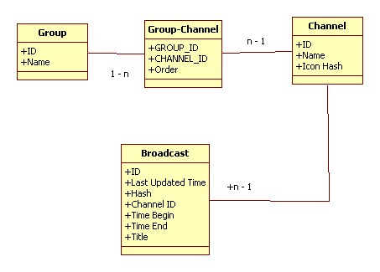

Flat files
Here is an example of Program in flat file (in JSON format):
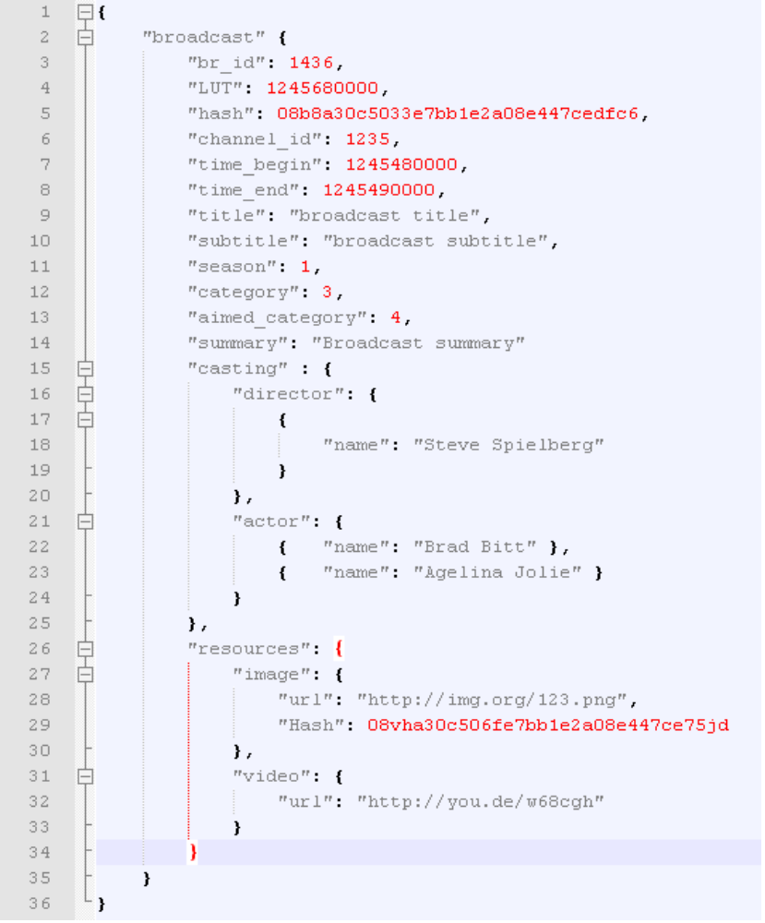

Serialization / deserialization problem.
After get Program content from web services, we write this data to flat file (still keep JSON format). Only need to deserialize when user want to view content of Program.
For special object (media resource: image, video), if resource is image, we cache it’s in phone’s local storage. But due to large size of video, we’ll bypass it. If user would like to watch video, they should have internet connection to download and view.

Data size limit of Android platform.
We know Android platform has some limit of data:
We cannot install application with database larger than 1MB (although after install application, we can insert data to database, make database larger than 1MB).
Application size is limit to 50MB.
Both of these limit has not any effect on our application. Our database is empty at first. After enter program for the first time, data is downloaded and inserted to database. Actually, because most of our data is Broadcast – that we save in flat file, so size of database is very small.

