VIETNAM GENERAL CONFEDERATION OF LABOR

**TON DUC THANG UNIVERSITY**

**FACULTY OF INFORMATION TECHNOLOGY**



**Agents' Retail Stores POS System**

**Requirements Analysis & Design (RAD)**

**By Students:**

**Nguyễn Minh Triết-521k0035**

**SOFTWARE ENGINEERING**

**HO CHI MINH CITY, 2023**

VIETNAM GENERAL CONFEDERATION OF LABOR

**TON DUC THANG UNIVERSITY**

**FACULTY OF INFORMATION TECHNOLOGY**



**Agents' Retail Stores POS System**

**Requirements Analysis & Design (RAD)**

**By Students:**

**Nguyễn Minh Triết-521k0035**

**SOFTWARE ENGINEERING**

|  |  |  |
| --- | --- | --- |
| Reference: | Team_XX_RAD_Requirements_Modelling_v0.1 | |
| Audience: | Mr. Pham Thai Ky Trung |

**HO CHI MINH CITY, 2023**

**ACKNOWLEDGEMENT**

### We would like to express our sincere gratitude to Mr. Phạm Thái Kỳ Trung, our instructor and mentor, for his valuable guidance and support throughout the final report of our project. He has been very helpful and patient in providing us with constructive feedback and suggestions to improve our work. He has also encouraged us to explore new technologies and techniques to enhance our system's functionality and performance. We have learned a lot from his expertise and experience in web development and software engineering. We are honored and privileged to have him as our teacher and supervisor.

*Ho Chi Minh city, 27th December 2023.*

*Author*

*(Signature and full name)*

**Triết**

Nguyễn Minh Triết

**TABLE OF CONTENT**

# Executive Summary……………………………………………………………….i

# I.Business Requirements………………………………………………………….1

# II.System Requirements Analysis………………………………………………..2

# III.System Requirements Design…………………………………………………5

# References………………………………………………………………………….8

# Executive Summary

# This document outlines the proposed Customer Management and Sales Management modules for the POS system, detailing their design using an Object-Oriented approach. Not only does it provide a user-friendly view for customers, emphasizing improved interactions and personalized service through the Customer Management module but also offers the development team enough information and reasoning, including diagrams, to guide software development effectively.

# The goal is making the system understandable for end customers while ensuring the development team has the necessary insights.

# Business Requirements

# Org Chart

# 

# Business Model

# 

# System Requirements Analysis

# 2.1 Use case descriptions

# 2.2.1 Use Case: Manage Customer Information

# System sequence diagram for Use Case: Manage Customer Information

# 

# 2.2.2 Use Case: Manage Sales Transaction

# System sequence diagram for Use Case: Manage Sales Transaction

# 

# Test Case for Use Case: Manage Customer Information

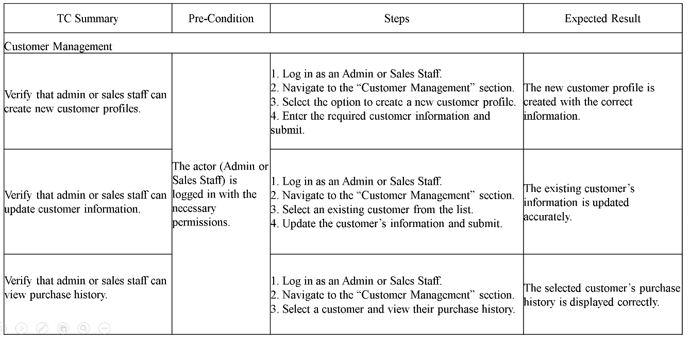

# Test Case for Use Case: Manage Sales Transaction

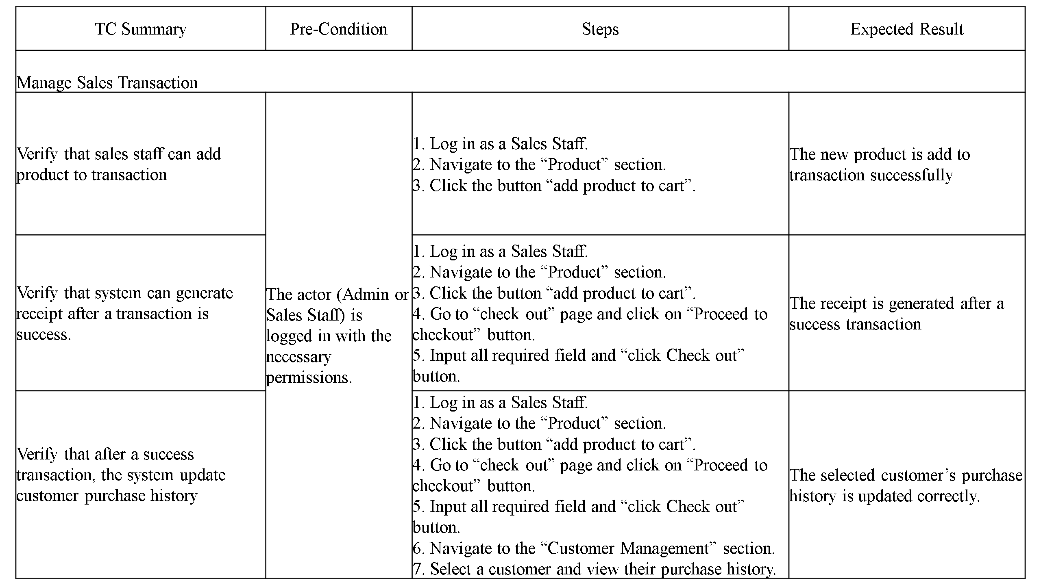

# System Requirements Design

* + 1. Design class Diagram for use case Manage Customer Information

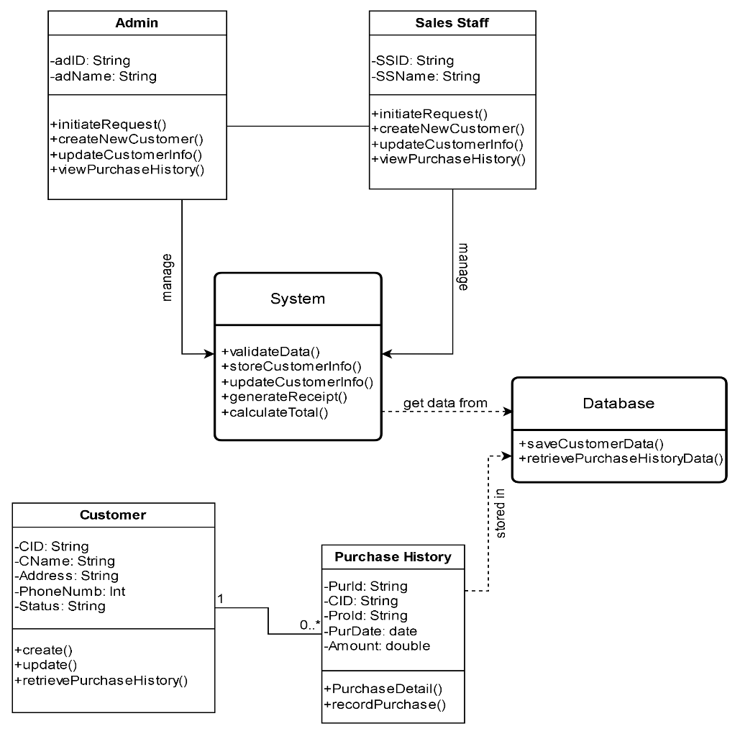

* + 1. Design class Diagram for use case Manage Sales Transaction

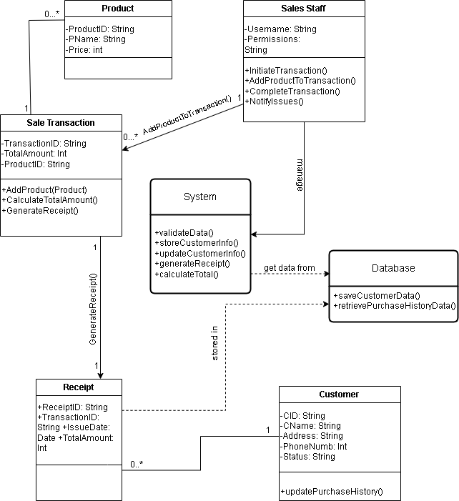

# REFERENCES

B.1. Slide Requirements Modelling

B.2. Book-MultiAuthor, Grady Booch, Robert A. Maksimchuk, Michael W. Engle, Bobbi J.

Young, Ph.D.Jim Conallen, Kelli A. HoustonObject-Oriented Analysis and Design with

Applications – Third Edition, Pearson Education Inc, 2007

B.3. Book – Single Author, Mike O’Docherty, Object-Oriented Analysis and Design -

Understanding System Development with UML 2.0, John Wiley & Sons Ltd, 2005, iCoot

Case Study