Russinvecchi guide

Contents

I. Website config 1

1. Global colors 3

2. Global fonts 7

3. Typography 10

4. Site Identity 12

II. Page 15

5. Edit a page 15

III. Heading 3 17

# Website config

Please following picture below

First go to Site settings under Edit with Elementor

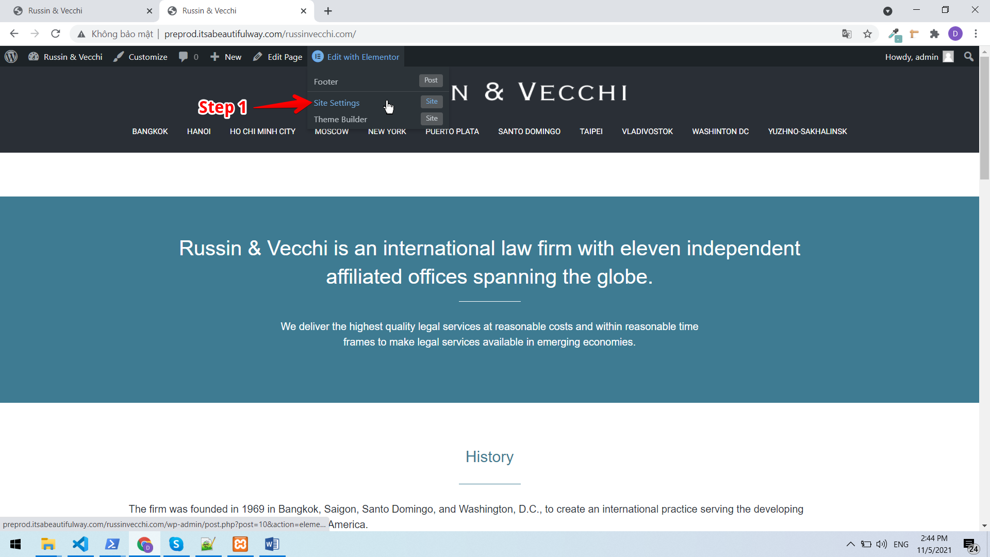

## Global colors

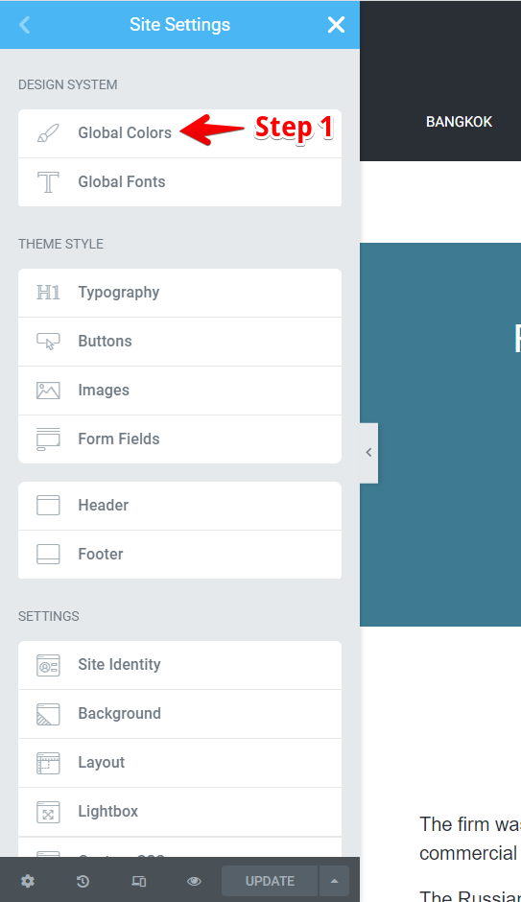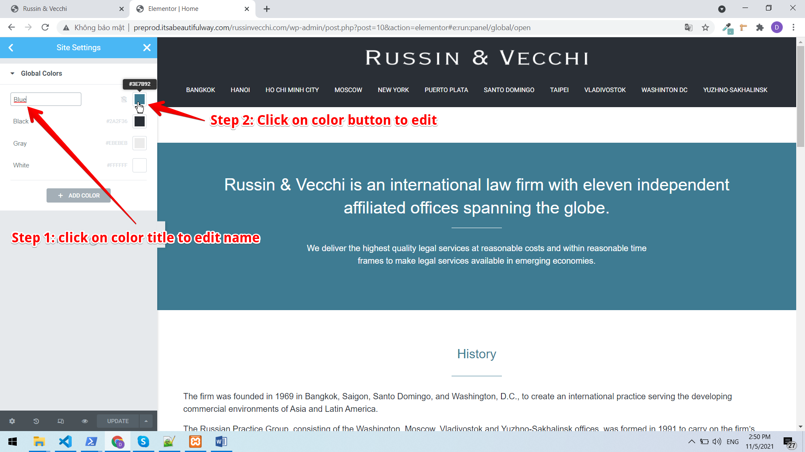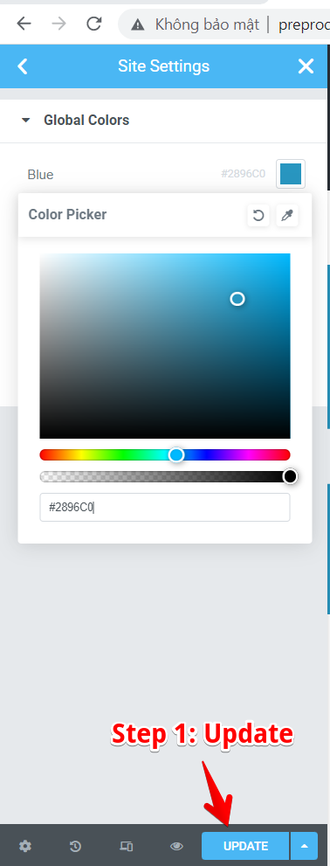

## Global fonts

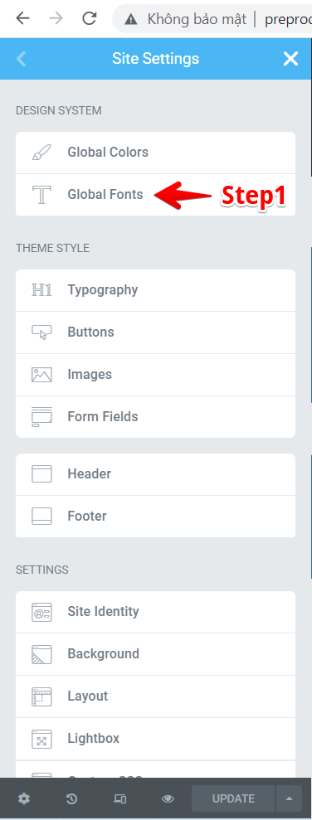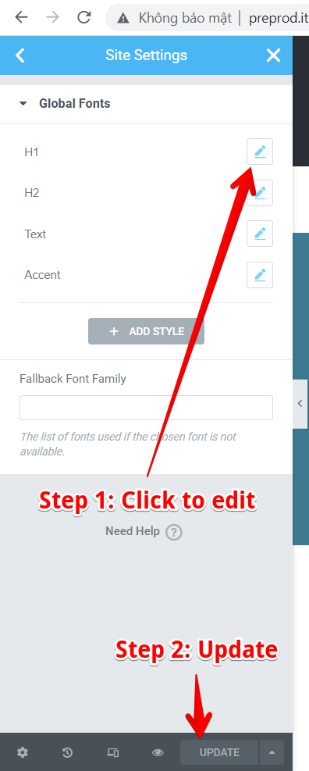

## Typography

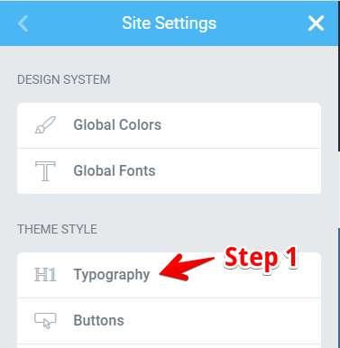

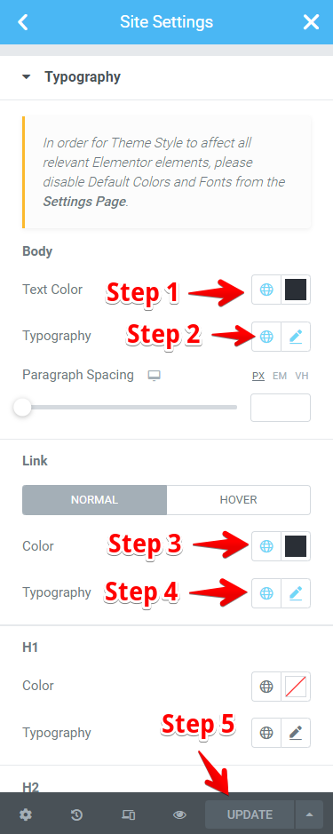

## Site Identity

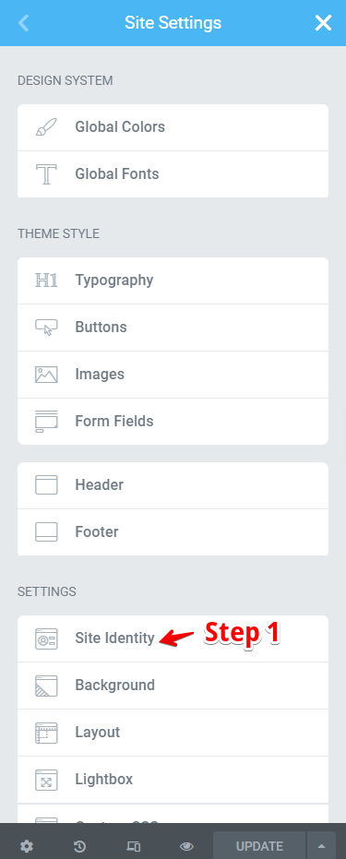

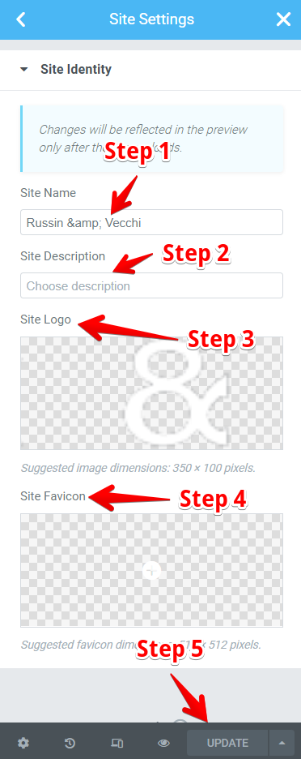

# Page

## Edit a page

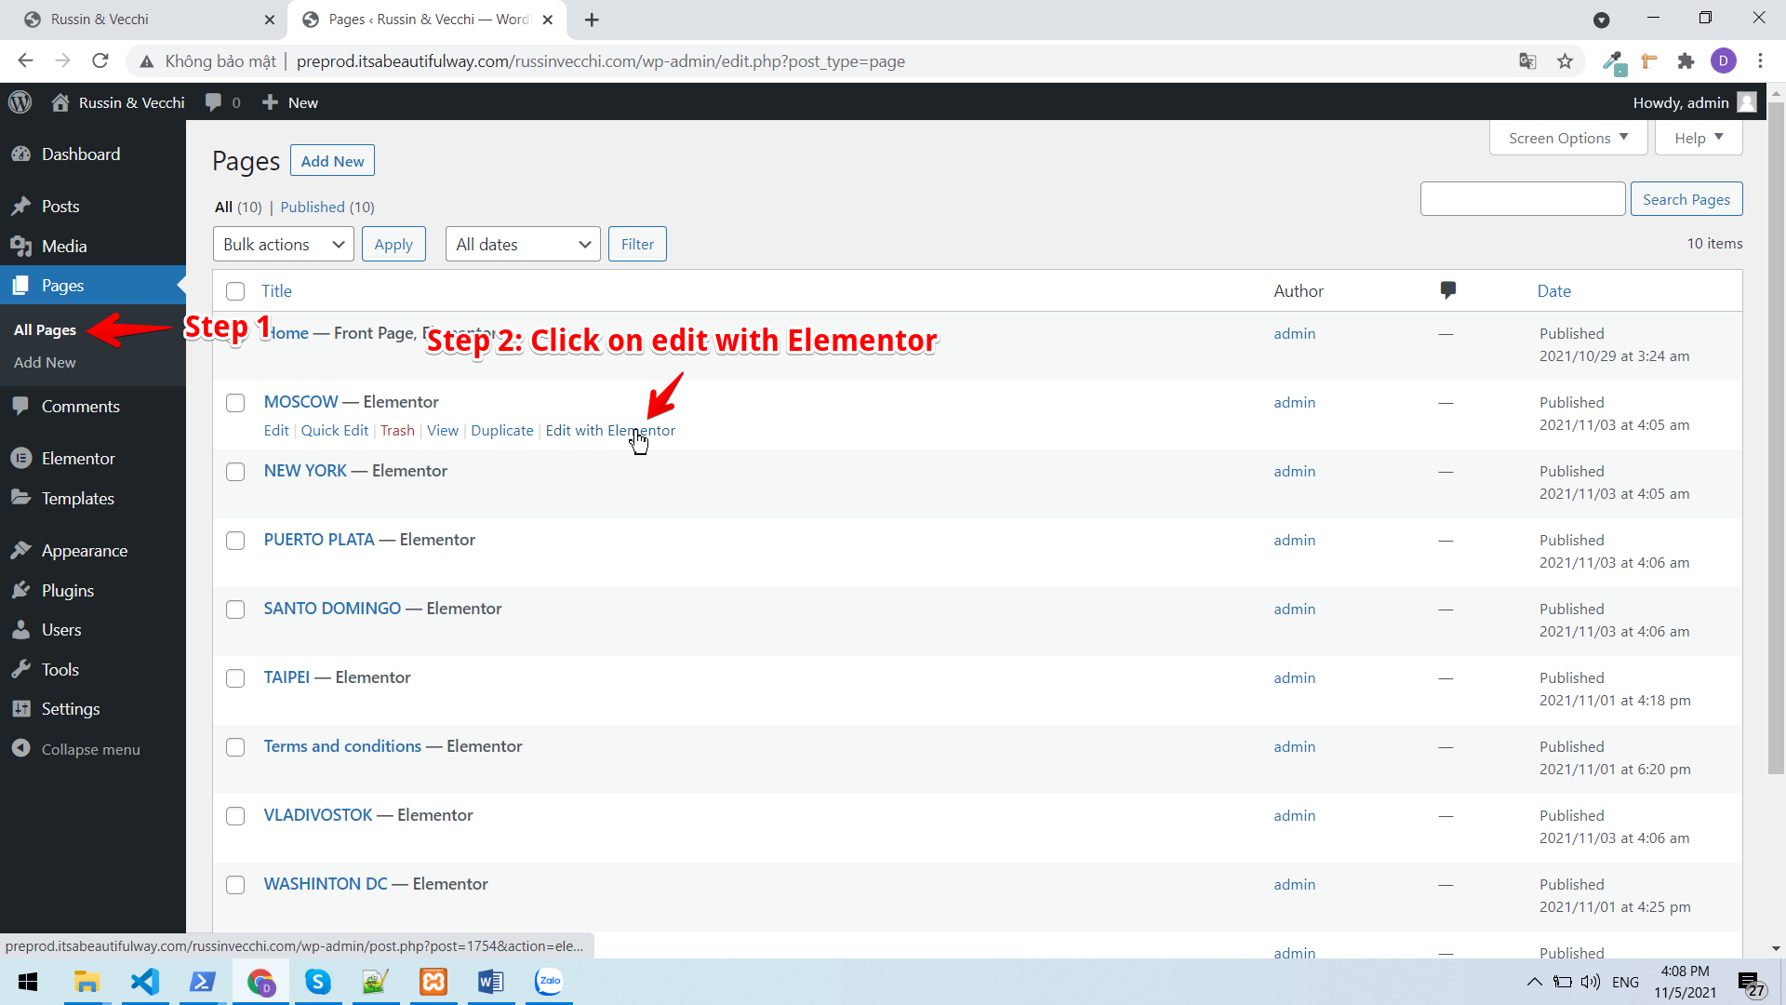

You can edit a city page by diffirent page below

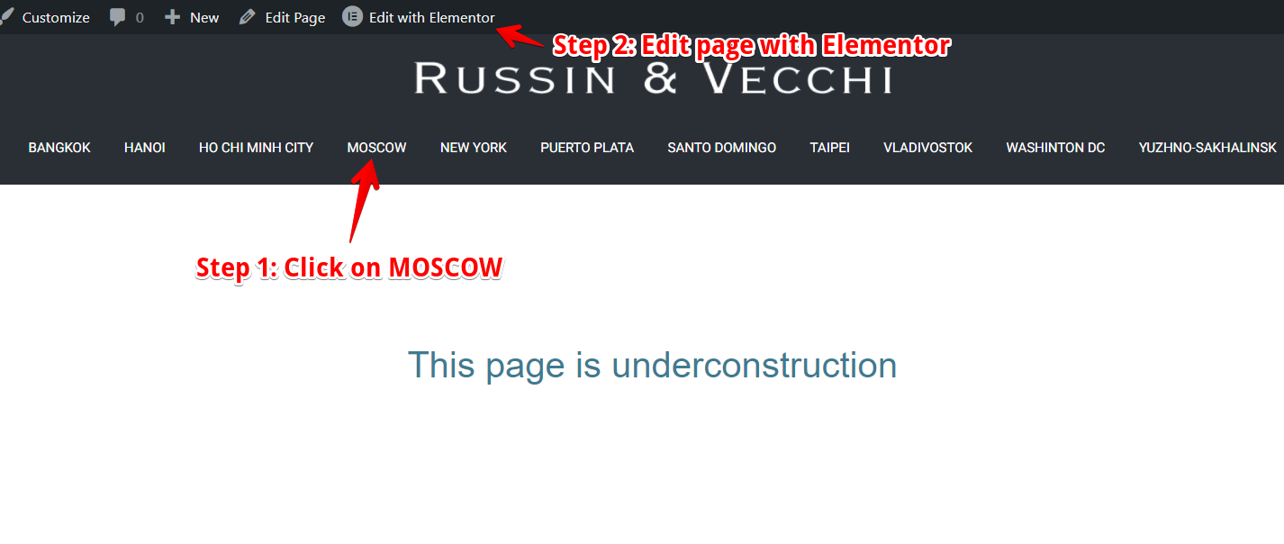

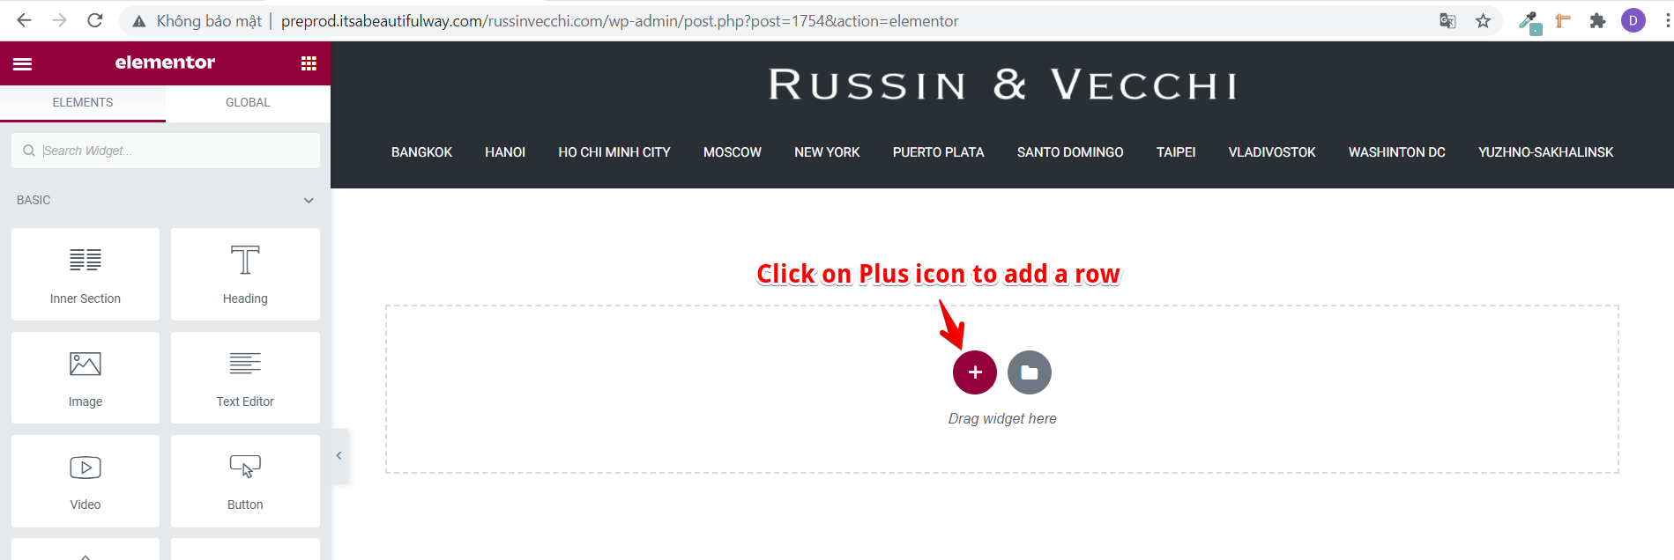

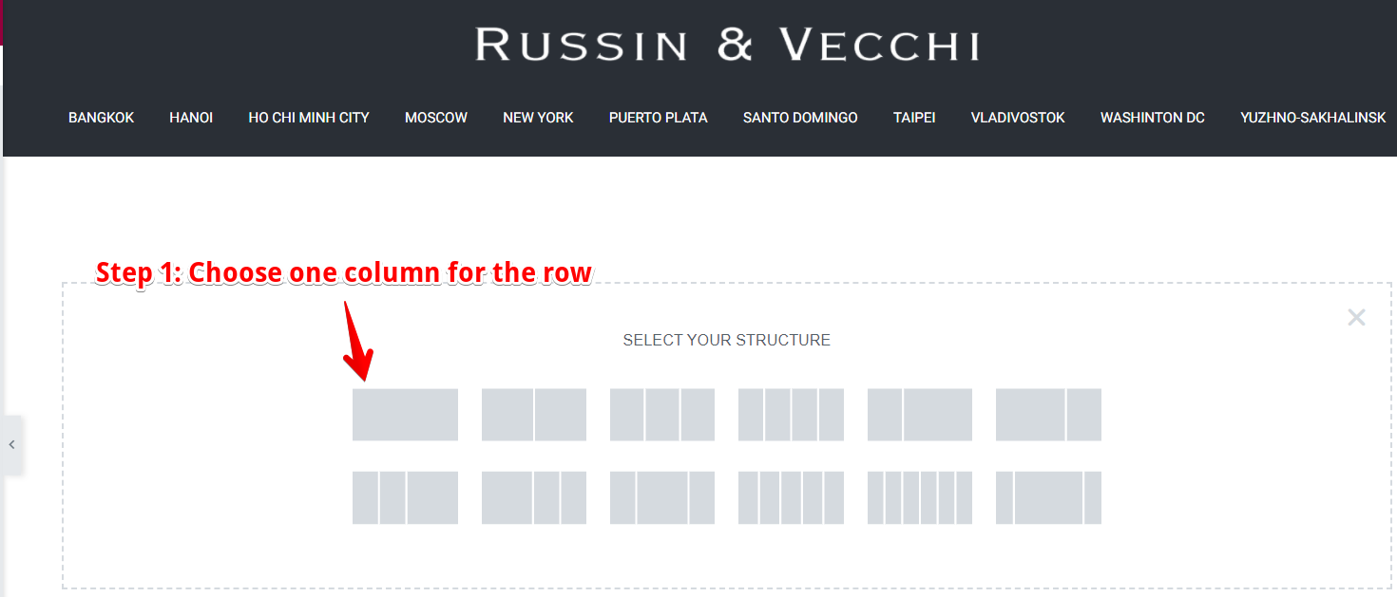

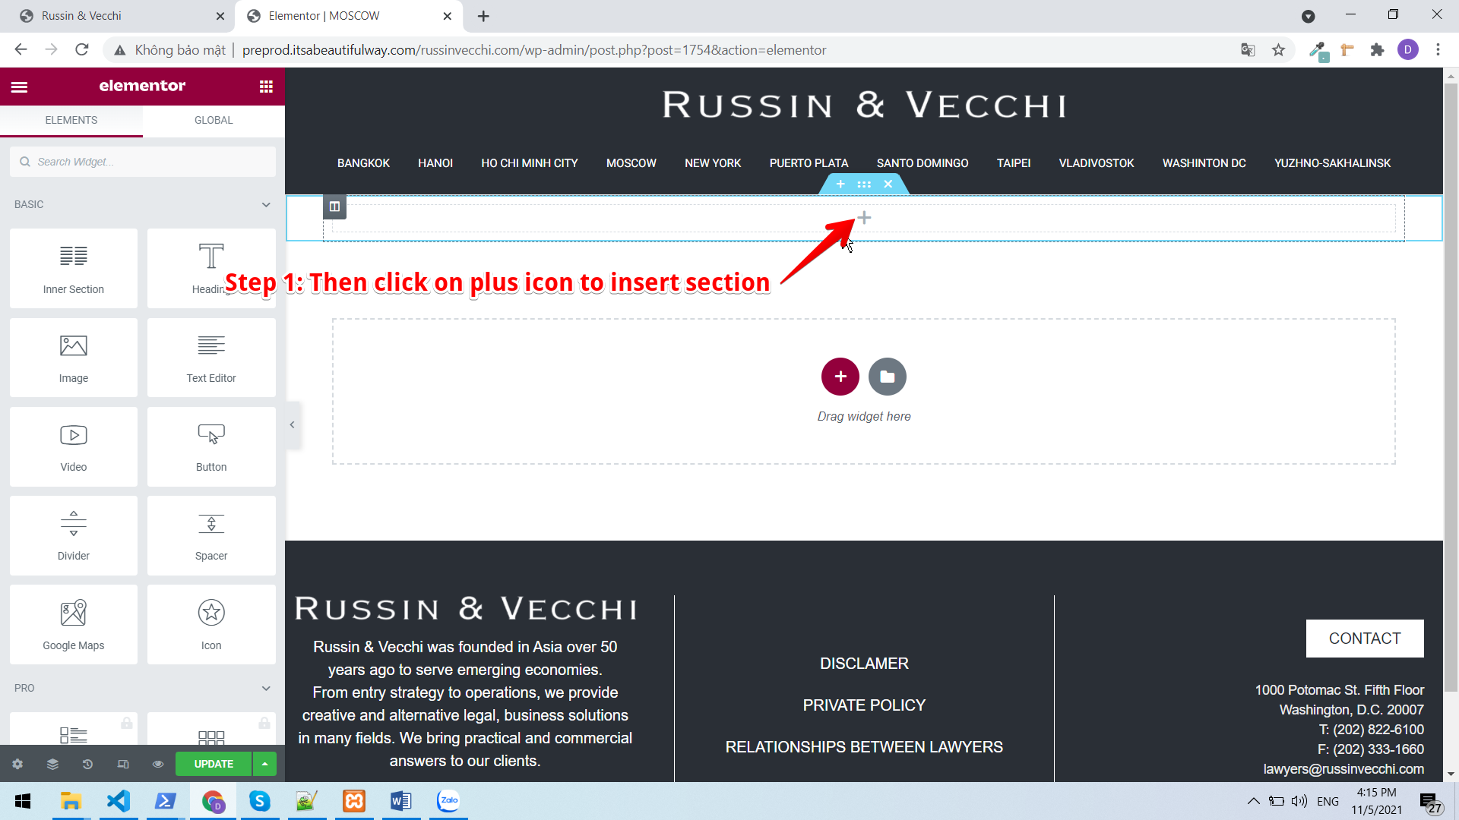

# Heading 3