A* Hierarchical tree Pruning Parsing in VietNamese Text-to-speech

Le Quang Thang
International Reseach Institut MICA CNRS UMI 2954 – Hanoi University of Science and Technology, INPG
1 Dai Co Viet, Hanoi, Vietnam
+84 (0)4 38.68.25.95

Thu-Trang Thi Nguyen
School of Information and Communication Technology – Hanoi University of Technology and Science
1 Dai Co Viet, Hanoi, Vietnam
+84 (0)4 38.68.25.95
trangntt@soict.hut.edu.vn
Do-Dat Tran
International Reseach Institut MICA CNRS UMI 2954 – Hanoi University of Science and Technology, INPG
1 Dai Co Viet, Hanoi, Vietnam
+84 (0)4 38.68.30.87
Do-Dat.Tran@mica.edu.vn

ABSTRACT
. This paper describes how to improve the speed of Vietnam Speech Synthesizer by improving the speed of the parser of it. First, a briefly chapter about A* parser will be introduced. After that, we will discuss about our ideal for increasing the speed of parser, the hierarchical tree algorithm. With this algorithm, the speed of parser can be optimal.

Categories and Subject Descriptors
Knowledge-based and information systems
General Terms
Algorithm, languages.
Keywords
A*, parsing, hierarchical tree

INTRODUCTION
There are many parsers which have been researched in Vietnam [references]. In our knowledge, there is no research about the A*algorithm for parsing. The other best-first-search algorithm like beam search, Dijkstra… were implemented and got the nice result [references], but not the optimal. These algorithms are still lame and got some trouble in parsing technique. Not in parsing, but in the searching algorithm, A* is always considered higher than those algorithm. So, A* parser is a good choice to research and development.
A* algorithm is a well-known algorithm in the best-first-search branch, which is one of the best searching algorithm in the world. Unlike the other best-first-search, the perfect of A* algorithm makes it become the algorithm model which researched and improved by many scientists. A* algorithm for parsing has been proposed by Dan Klein and Christopher D. Manning (2003) and got some good result. But the speed of A* is really optimal, isn’t it? Is there some case or situation that the speed will be declined? That must be some potential error, and we have to optimize it. There is no real optimize algorithm, but if we can find out and correct it, we take one step to “the perfect”, a relatively perfect [references].

A* ALGORITHM FOR PARSING

A* algorithm operates on basically parsing items called node. A node includes three attributes: tag, start and end. Tag just indicates the current node POS tag (known as syntactic tag), and (start, end) denote a start-end position of the string which the node generates in the sentence. The parser maintains two data structures: a chart or table (note as CHART), which records edges for which (best) parses have already been found, and an agenda of newly-formed edges waiting to be processed (note as AGENDA).

The A* parsing process.

First, the input sentence is processed by a tokenizer and a tagger to provide a set of node, it is AGENDA.
Second, the maximum candidate node is popped out from AGENDA for processing. If it isn’t contained in CHART, it will combine with these nodes in the CHART. These combinations generate more nodes to append to AGENDA. And the last, the candidate will be added to the CHART.
The loop of second step will be repeated until one of those conditions is met (or reached): (1) the AGENDA is empty or (2) the node S (1, n) is found in CHART (with n is the number of tokens in the input sentence)

A* estimates for parsing.
It’s plain to see the most important thing in the A* parsing algorithm would be the estimates for the maximum candidate.
The detail of the A* estimates for parsing have been described in [reference] Dan Klein and Christopher D. Manning (2003) ^{[5]},.

HIERARCHICAL TREE ALGORITHM

The problem
In the second step, the candidate will combine with the element node in the CHART. But the problem here is how to combine and how the speed of combination is. A lame combination algorithm will form a lame parsing.
The classic method for this combination was to use the virtual node processing. It means the parser will combine the candidate one-on-one with each node in the CHART. There are two situations that happened:
The founded grammar rule is a Chomsky-form, mean that the rule have no more than two elements on the right part. So everything it’s so easy. These nodes have just been combined in ordinary way.
The founded grammar rule is not a Chomsky-form, the grammar rule have more than two elements on the right part. When this case happened, the parser uses a virtual node with the wait parameter which denotes the lack part to complete the rule. It means when use rule E → A B C D to combine A and B will form the node (E, wait = “CD”). Later, if the virtual node (E, wait=”CD”) meet C node with relevant position, two nodes will combine together and form the node (E, wait=“D”).
So, when the parsing process end, if the node (S, 1, n, wait=“”) is founded in CHART, the parsing process would be failed and vice versa.
That’s it! The virtual node can solve the problem how to combine but not the speed of combination. Cause of the complication of the grammar rule set (approximately over 900 rules!!), the combination using virtual node will generate a very large number of redundant node.
Table 1 – all the nodes was formed when combined N(2,7) and V(7,8)
NP(2,8, wait="") | NP(2,8, wait=", A")
NP(2,8, wait="AP") | NP(2,8, wait="AP NP")
NP(2,8, wait="AP PP") | NP(2,8, wait="MP")
NP(2,8, wait="N") | NP(2,8, wait="NP")
NP(2,8, wait="NP PP") | NP(2,8, wait="NP VP")
NP(2,8, wait="P") | NP(2,8, wait="PP")
NP(2,8, wait="PP PP") | NP(2,8, wait="VP")

Fundamental hierarchical tree algorithm (HTA)

Make an idea.
Instead of using virtual node method, hierarchical tree algorithm processes all the position-combinable chain of the candidate with CHART. All the position-continuous chain includes the candidate node and node in the CHART will be checked to be the right part of any grammar rule or not? The right-checked-chain will form the new nodes using the relevant grammar rule. Differ from virtual node method, hierarchical tree algorithm won’t form the redundant nodes and decrease the loop step of A* algorithm.
For instance, if the candidate has the start-end position as X(7-10) and the CHART has the content like a below table:
Table 2 – All the start-end pos of CHART nodes
X₁  (1-8) | X₂  (6-16) | X₃  (15-35) | X₄  (5-20) | X₅  (2-7) | X₆  (10-11)
X₇  (8-27) | X₈  (2-21) | X₉  (9-11) | X₁₀  (2-13) | X₁₁  (6-14) | X₁₂  (15-26)
X₁₃  (14-23) | X₁₄  (5-18) | X₁₅  (1-7) | X₁₆  (9-16) | X₁₇  (12-17) | X₁₈  (7-18)
X₁₉  (6-25) | X₂₀  (13-26) | X₂₁  (11-16) | X₂₂  (9-24) | X₂₃  (11-20) | X₂₄  (8-18)
X₂₅  (7-16) | X₂₆  (14-16) | X₂₇  (4-6) | X₂₈  (13-21) | X₂₉  (4-8) | X₃₀  (11-13)

With the input (candidate and CHART nodes position) like that, hierarchical tree algorithm will process and provide the output chain to check like this:

Table 3 – all the combinable chain of the candidate and CHART nodes.
1 | Position | node
2 | [2-7] [7-10] | X₅X
3 | [1-7] [7-10] | X₁₅X
4 | [1-7] [7-10] [10-11] [11-13] | X₁₅ X X₆ X₃₀
5 | [2-7][7-10][10-11] [11-13] [13-26] | X₅ X X₆ X₃₀ X₂₀
6 | [7-10] [10-11] [11-20] | X X₆ X₂₃
7 | [7-10] [10-11] [11-13] | X X₆ X₃₀
8 | [7-10] [10-11] [11-13] [13-26] | X X₆ X₃₀ X₂₀
9 | [7-10] [10-11] [11-13] [13-21] | X X₆ X₃₀ X₂₈
10 | [2-7] [7-10] [10-11] | X₅ X X₆
11 | [2-7] [7-10] [10-11] [11-16] | X₅ X X₆ X₂₁
12 | [2-7] [7-10] [10-11] [11-20] | X₅ X X₆ X₂₃
13 | [2-7] [7-10] [10-11] [11-13] | X₅ X X₆ X₃₀
14 | [7-10] [10-11] [11-16] | X X₆ X₂₁
15 | [1-7] [7-10] [10-11] | X₁₅ X X₆
16 | [2-7] [7-10] [10-11] [11-13] [13-21] | X₅ X X₆ X₃₀ X₂₈
17 | [1-7] [7-10] [10-11] [11-16] | X₁₅ X X₆ X₂₁
18 | [1-7] [7-10] [10-11] [11-20] | X₁₅ X X₆ X₂₃
19 | [7-10] [10-11] | X X₆
20 | [1-7] [7-10] [10-11] [11-13] [13-26] | X₁₅ X X₆ X₃₀ X₂₀
21 | [1-7] [7-10] [10-11] [11-13] [13-21] | X₁₅ X X₆ X₃₀ X₂₈
So, assume that there is a rule as A → X₅ X X₆ X₃₀ X₂₈ relevant to the chain 16, the node A(2,21) will form with the relevant position.

The HTA model.
HTA includes two steps: classification and generate the combination chains.
Classification: the period when the parser classifies the nodes of CHART into the difference block. This classification is a preparation for chain generating period.
Generate the combination chains: the parser will generate all the combinable chain and process each of them for the next stage.

Classification
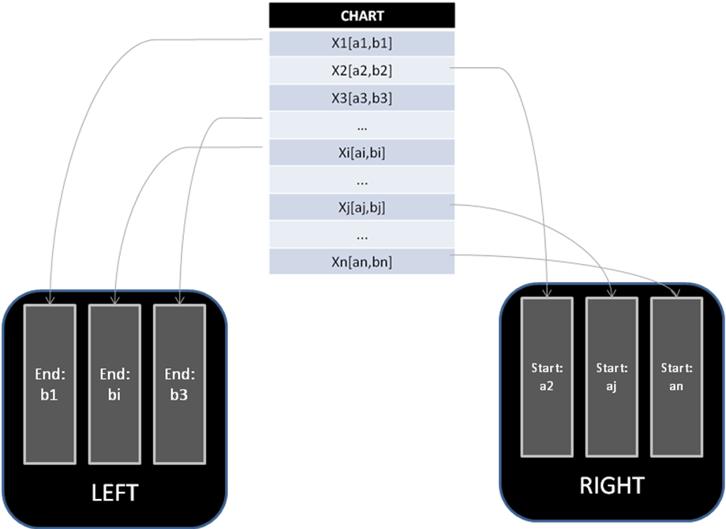
Picture 1 – Classification model in hierarchical tree.

The Hierarchical tree classification based on pigeon hole sort algorithm ideal. Hierarchical tree create the holes for adding pigeon, too. Difference is not for sorting, but to generate chain.
The holes in hierarchical tree are divided into two type: the left holes and the right holes. Let assume that X is candidate node.
- Left holes: This is a set of nodes that have their end position <= start position of X. All the nodes with the same end position equals e will be added in the one block labeled as e. And all of the blocks lay in the bigger “left holes”.
- Right holes: This is a set of nodes that have their start position >= end position of X. All the nodes with the same start position equals s will be added in the one block labeled as s. And all of the blocks lay in the bigger “right holes”.

Generate the combination chains.
With the input as the classified CHART, the parser will begin generating the chain. It includes three parts: “generate left chain”, “generate right chain” and “generate chain”.
Generate left chain: this module will generate all the combinable chain ends with candidate X, described as:
- Access to the left block labeled as “start position of X”, called the left combination nodes of X, note as SX block.
- Process the entire node in SX recursively. With each node, generate a chain relevant to that node.
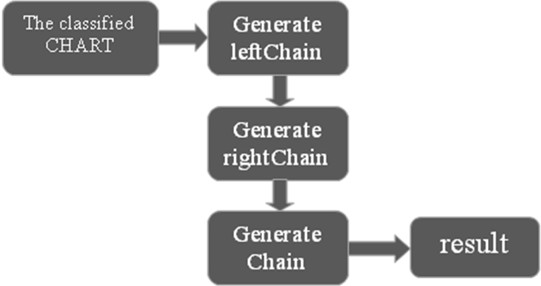
Picture 2 – the HTA chain generator.

On the other hand, “generate left chain” process resemble to the tree processing with root as X. When the node Y is processed, the generated chain is the path from Y to X on the tree.
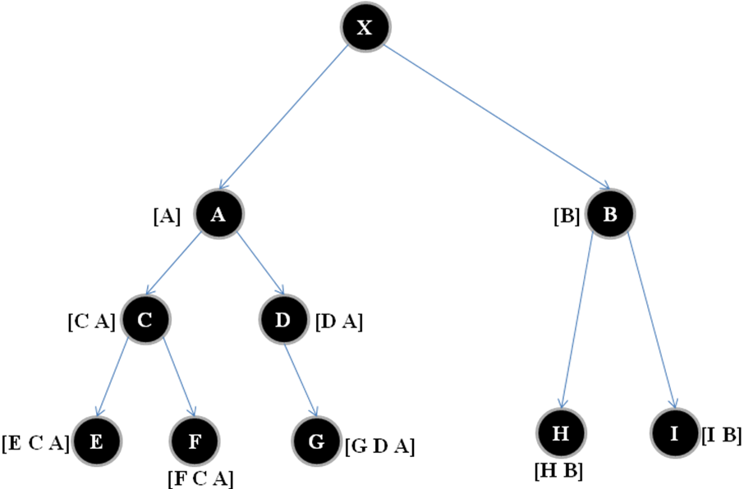
Pictures 3 – The instance example for generate left chain.

Generate right chain: same method as the “generate left chain”, only differ from the dimension.
- Access to the right block labeled as “end position of X”, called right combination nodes of X, note as EX block.
- Process all of the nodes in EX recursively. With each node, generate a chain relevant to that node.
Resemble to the left chain, “generate right chain” process resemble to the tree processing with root as X, too. But when the node Y is processed, the generated chain is the path from X to Y on the tree.
Generate chain: so now we got the left chain and right chain of the candidate. It’s a perfect preparation for the party. The connection of three factors “left chain”, “right chain” and X will form the real combinable chain of X.
First, we will generate the chain ends with X using the left chain.
For ( left in leftChain)
Generate chaini = [left X];
Chain. Add (chaini);
End for;
Second, we will generate the chain starts with X using the right chain.
For (right in rightChain)
Generate chainj =[X right];
Chain. Add (chainj);
End for;

And the last, we will generate the chain with X in the mid using both left and right chain.
For (right in rightChain)
For (left in leftChain)
Generate chaink = [left X right];
Chain. Add (chaink);
End for;
End for;
After three stages like above, we got the real combinable chain to process and perform the A* hierarchical tree algorithm.

Pruning for hierarchical tree algorithm
As mentioned above, hierarchical tree algorithm is proposed to increase the speed, to decrease the step of the A* algorithm. However, with all thing was described, hierarchical tree algorithm is not optimal cause of the processing time for each step. A* hierarchical tree has less step than the A* - virtual node but the processing time for the step of hierarchical tree can be so long because the parser must process all the combinable chain of the candidate with CHART.
In fact, there are approximately 8% of the generated chains that could be combined by the grammar rule. About this stuff, virtual node algorithm and hierarchical tree algorithm has the same feature: redundancy! The A* virtual node got the redundancy of the loop step, but the A* hierarchical tree got the redundancy of the processing chains. Because of this, hierarchical tree algorithm is not only slower than virtual in some case, but also very slow when the number of CHART nodes up to 500 elements. In addition, the system could be out of memory in case the number of chains is up to billions!
To solve this problem, the paper writer proposed the pruning method for the hierarchical tree algorithm, note as “hierarchical tree pruning”. Instead of processing all the generated chains, the parser will prune the chains that don’t make sense; it means they’re not relevant to any rule. This algorithm is not only increase the speed of parser but also optimize it.
From now on, we will use some symbol; it's convenient for audience to allow.
R_{chain} – A set of grammar rules, each rule contains “chain” in the right part.
F_{chain} – A set of grammar rules, each rule have the right part starts with “chain”.
The fundamental hierarchical tree algorithm only uses the node position to generate chain, but not the node tag. For instance, if the node has the tag as “PP”, so what kind of its tag will be? It’s plain to see that hierarchical tree algorithm make a big mistake when it doesn’t calculate this case.
Through the analysis above, the tag of node is also very important in the chain generating process. So the pruner of hierarchical tree will use the information about the tag of node in the grammar rule to optimize the algorithm.
The pruner of hierarchical tree includes two parts:
- Statistic training: this is a very important work. Because of this stage, the parser will decide whether to prune the branch of processing tree
- Pruning: start processing the hierarchical tree; use the pruner which was trained from data to prune the wrong branch.

Statistic training period
The stuff required for each trainer is a training data. And in this case, the training data is a syntactic grammar rule set.
Specifically, with each POS tag in the grammar rule, the system will create a corresponding data tree. The data tree of each tag T will store the information about all tags that can be stood on the left or right of tag T.

The left-side data tree.
The left data tree of tag T is the data structure which store the information about all tags are on the left side of T.
Specified as the picture below:
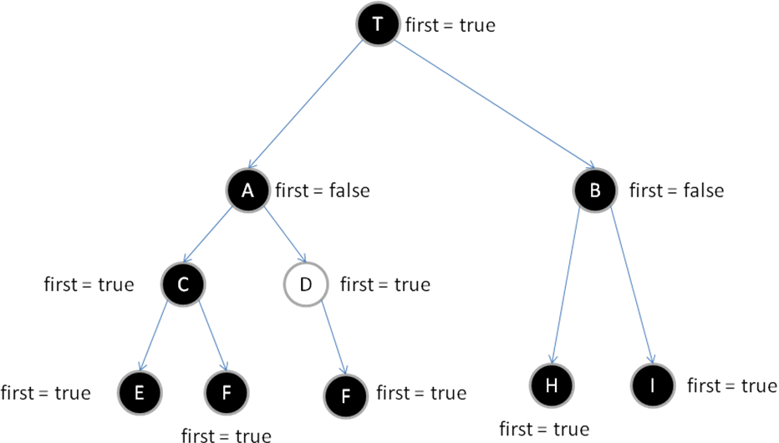
Picture 4 – the left data tree of T.
There are three steps to create this data structure:
- First, the trainer will process R _{[T]}. The two sub nodes A and B of T are created as the tags that adjacent to the left of T in the R_{[T]} rules right side.
- Second, C and D are created as the sub node of A which are the tags that adjacent to the left of A in the set R_{leftTag(A)}. Similarly, H and I are the tags that adjacent to the left of B in the set R_{leftTag(B)} rules right side.
leftTag(node) = path from node to root
- And the last, process recursively with the entire sub node C, D, H, I and their sub nodes until it ends.
And one more thing, each node of the tree has a very important thing, the first parameter. It’s a Boolean type. If the first of tag C equals true, it message that the grammar rule has a existence of at least rule which have leftTag(C) heading in its right side. The tag node has the first equals true which called the first node.
So, the purpose of this work is to control the information about the tag of left chain that can be created by T.

The right-side data tree.
With each first node in the left data tree will have the right-side data tree. The right data tree will have the information about the tags which stand on the right of that first node leftTag.
For example, the D tag node in the left tree data shown as picture 4. Its right data tree will help us controlling information about all the grammar rules that D leftTag heads in their right side. leftTag(D) = [D A T], the rule set which have each rule starts with [D A T] or leftTag(D), we note it as F_{[D A T]}.
The picture below will show us a perspective visual about the right-side data tree.
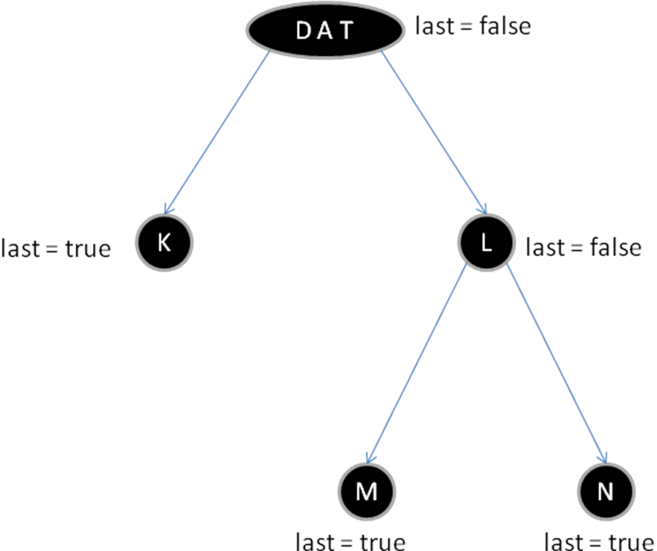
Picture 5 – the right-side data tree of D tag node.
The root node has two children K and L which are the tags adjacent to the right of T in F_{[D A T]}. Resemble to the left data tree, M and N are the tags adjacent to the right of L in F_{rightTag(L)}.
rightTag(node) = leftTag(root) + path from root to that node.
rightTag(L) = [D A T L]
The right data tree also has the critical parameter: last. It’s a Boolean type, too. If the last of node equals true, it message that rightTag(node) must be right side of at least one rule in the grammar rule set. For instance, M has the true last, it indicate that rightTag(M) = [D A T L M] is a right side of one or some grammar rule.
So, after creating the left and right data trees, we have the information about all the tags in grammar rule and we can control their relation to prune the redundancy branch in hierarchical tree algorithm, the pruner has begun.

Pruning period
The input is still the classified CHART; the hierarchical tree algorithm will perform normal, except the support of hierarchical tree pruner.
The pruner will not only prun all the redundancy branch, but also indicate when we got the exactly we got the right side of any rule due to first and last parameter.
For instance, as the picture shown below which express the left chain generation of hierarchical tree algorithm. In the process, the C node was prunned because it didn’t appear in children set of A in the left data tree of X, so it wan’s any tag that adjacent to the left of A in the grammar rule, and it was prunned. This can be useful because most of tree node in the chain generating process will be prunned for the redundancy, and increase the speed of hierarchical tree parser to the best of it.
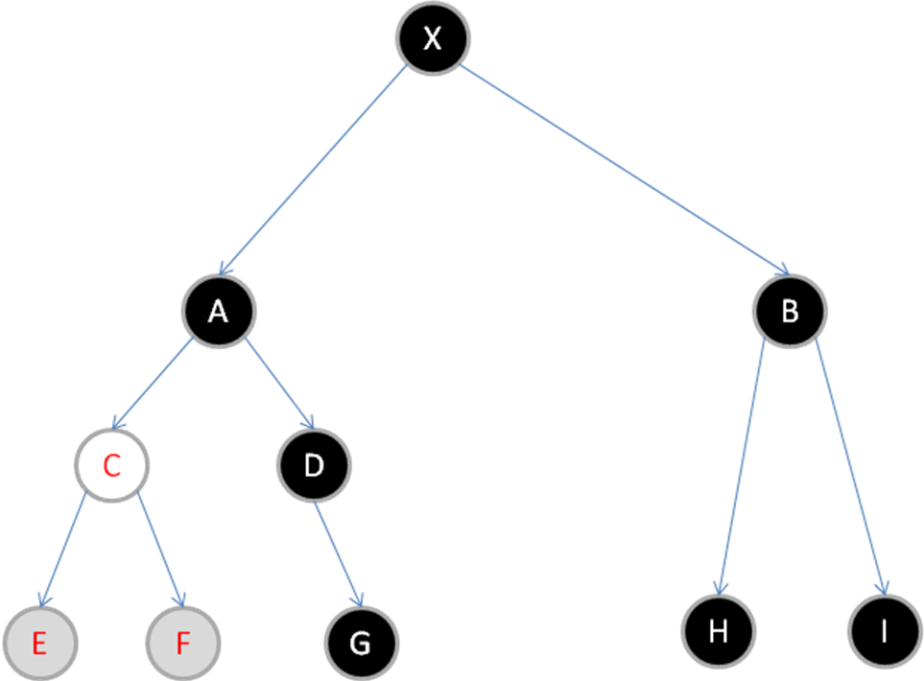
Picture 6 – the hierarchical tree pruning algorithm process.
Here it’s a pseudocode of hierarchical tree pruning algorithm:
Main
  - call method HTA (X, Tree(X)).
Method Tree(tag E)
  - Return the left data tree correspond to the tag of E
Method HTA(tag E, tree T)
  - Check out whether the first parameter E equals true or not?
  - If (first(E) == true) then call method HTA_sub(E, subTree(E, T)).
  - Process the left combination nodes of E in the classified CHART; all the nodes which don’t have the tag in the children set of E in T tree will be pruned.
  - For (Z in “E left combination nodes”)
Call recursively the method
HTA (Z, T).
End for;
Method subTree(tag E, tree T)
  - Return the corresponding right data tree of E in the T tree.
Method HTA_sub(node E, tree T)
  - In T, Check out if last(E) == true?
If true then combine the rightTag(E) to form the new node with relevant position and add it to AGENDA.
  - Access to the right combination nodes of E in the classified CHART, all the nodes which doesn’t have the tag in the children set of E in T tree will be pruned.
  - For (Y in “E right combination nodes”)
Call recursively the method
HTA_sub(Y, T).
End for;

EXPERIMENT AND RESULT
This section presents the preparation and the result of experiment to demonstrate the A* parsing algorithm performance. These two subsections below will summarize our activities and results for experiment.

Preparation for experiment.
As described, the most important thing of parsing system in our target is to increasing the speed up to maximum as it can, and the second one is accuracy. So, the writer has made two tests for the parsing system due to those two goals:
- First: the test with 630 Vietnamese sentences in mica database - vnSpeechCorpus to test the speed of A* parser. This dataset includes long and difficult sentences which is a challenge to any parsing system.
- Second: The accuracy testing corpus which we choose is extracted from the training set of system – VietTreeBank. VietTreeBank has been built by VLSP Groupment, has included 20.000 sentences of Vietnamese which has been parsed by hand. Within a range of this paper, the quantity we used is about 200 sentences.
And one last thing, in order to presenting the audience the performance, we also make a comparison between A* parsing algorithm with very well-known search parsing algorithm: CYK-Beam search.

Results of experiment.
The first test:
Algorithm | Processing time | Number of parsed sentence
A* | 15 minutes | 92%
CYK-Beam search | 45 minutes | 75%
The second test:
algorithm | Accuracy | Number of parsed sentence
A* | 70% | 92%
CYK-Beam search | 50% | 75%
As you can see, A* parsing is better than CYK-beam search in all field. With high speed, significantly number of parsed sentence and an acceptable accuracy, the A* parser is really a good parser.
These test based on the A* algorithm without the support of hierarchical tree algorithm. Due to rush time, we haven’t finished it yet, but to proposed its ideal. This stuff show that if the A* hierarchical tree is completed, it will bring us a much better result than originally A* algorithm. The time could be decreased down to a few minutes with the same testing set above.

CONCLUSION
The paper presented all ideal about our proposed algorithm: hierarchical tree. A hierarchical tree algorithm was implementing in java and makes some test. Its speed is so amazing, but it still independent to the A*. The hierarchical tree algorithm will make a new speed generation of the parser. With the most important thing that a real-time Vietnam speech synthesizer system needs is a speed, A* hierarchical tree algorithm is really an excellent idea.

REFERENCE
- Fei Xia, “Inside-Outside algorithm”, LING 572.
- Christopher D.Manning and Hinrich Schutze. “Probabilistic Grammars”, Chapter11, 1999.
- Michael Collins, “Head-Driven Statistical Models for Natural Language Parsing”, MIT Computer Science and Artificial Intelligence Laboratory.
- Dan Klein and Christopher D. Manning. 2003. “A* parsing: Fast exact Viterbi parse selection. In Proceedings of the Human Language Technology Conference and the North American Association for Computational Linguistics”(HLT-NAACL).
- Dan Klein and Christopher D. Manning. 2002. “A* parsing: Fast exact Viterbi parse selection”. Technical Report dbpubs/2002-16, Stanford University, Stanford, CA.
- Adam Pauls and Dan Klein, “K-Best A* Parsing”, Computer Science Division University of California, Berkeley.
- Hoàng Anh Việt, “Phân tích cú pháp tiếng Việt sử dụng mô hình xác suất PCFG”, đồ án tốt nghiệp đại học năm 2006.
- Phạm Thị Nhung, “Phân tích cú pháp tiếng Việt sử dụng beam search”, đồ án tốt nghiệp đại học năm 2009.
- Đỗ Bá Lâm, Lê Thanh Hương, “Implementing a Vietnamese syntactic parser using HPSG”, Khoa Công nghệ thông tin, trường Đại học Bách khoa Hà Nội.
- Diệp Quang Ban, Hoàng Văn Thung, “Ngữ pháp tiếng Việt”, tập 1,2, Nhà xuất bản giáo dục, 1991-1992.
- Trung tâm khoa học xã hội và nhân văn Quốc Gia. “Ngữ pháp tiếng Việt”. Nhà xuất bản Khoa học Xã hội – 2000.
- Nguyễn Phương Thái, Vũ Xuân Lương, Nguyễn Thị Minh Huyền. “Xây dựng treebank tiếng Việt”.

