A model of F0 contour for Vietnamese questions, applied in speech synthesis

Anh-Tú LÊ
School of Information and Communication Technology –
Hanoi University of Science and Technology
1 Dai Co Viet, Hanoi, VIETNAM
+84 (0)9.15.89.85.84
hover.88@live.com
Đỗ-Đạt TRẦN
International Research Center MICA
CNRS UMI 2954 - Hanoi University of Science and Technology
1 Dai Co Viet, Hanoi, VIETNAM
+84 (0)4 38.68.30.87
Do-Dat.Tran@mica.edu.vn
Thu-Trang Thị NGUYỄN
School of Information and Communication Technology –
Hanoi University of Science and Technology
1 Dai Co Viet, Hanoi, VIETNAM
+84 (0)4 38.68.25.95
trangntt@soict.hut.edu.vn

ABSTRACT
This paper presents some initial results in modeling F0 contour for Vietnamese question, which can be applied in speech synthesis. Based on the results of our studies [11] [12], perceptual tests were carried out to find out the pertinent parameters which have an important influence on intonation. The intonation of Vietnamese question is generated by using the result of our study [10][11] and two new parameters which are estimated from the perceptual tests. Firstly, an intonation contour for the sentence is generated using our intonation model for the statement sentence. The whole contour is then raised by a number of percentages of the mean F0 called alpha (normalized register ratio). And finally, the contour of the last syllable is raised by a number of percentages of the mean F0 called beta (increasing slope). Some experiments were carried out to prove and verify for the proposed model.
Categories and Subject Descriptors
Image Processing and Computer Vision.
General Terms
Measurement, Experimentation, Languages.
Keywords
F0 Model, Intonation, Prosody, Question, Vietnamese Tone, Speech Synthesis, Text To Speech.

INTRODUCTION
In a speech synthesis or Text-To-Speech (TTS) system (Figure 1), the naturalness of the synthesized sound depends greatly on its prosody, especially fundamental frequency (F0) evolution. For a tonal language; like Vietnamese, Chinese; F0 contours of utterances are composed of tonal local features (tones and the co-articulation between adjacent tones) and the global intonation (corresponding to higher-level structures). Thus F0 evolution of sentence in tonal languages is much more complicated than in non-tonal languages, such as English and French.
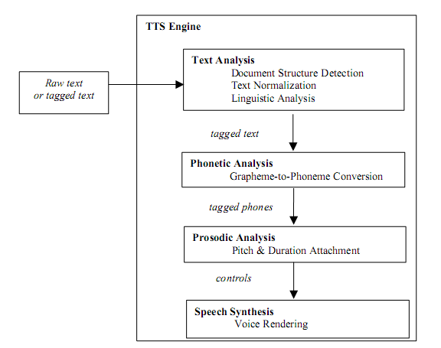
Figure 1. Basic system architecture of a TTS system [15].
There have been some researches on modeling F0 contour in Vietnamese presented in [1][11]. However, the model of [1], using Fujisaki model to generate the F0 contour of 6 tones, encountered some difficulties in modeling the variation of contour of tone 3 and tone 6. The model of [11] used tone patterns with consideration of relative register ratios between two adjacent tones. Both of them haven’t concerned sentence type yet.
Conference’10, Month 1–2, 2010, City, State, Country.
Copyright 2010 ACM 1-58113-000-0/00/0010…$10.00.

Permission to make digital or hard copies of all or part of this work for personal or classroom use is granted without fee provided that copies are not made or distributed for profit or commercial advantage and that copies bear this notice and the full citation on the first page. To copy otherwise, or republish, to post on servers or to redistribute to lists, requires prior specific permission and/or a fee.
There have also been several researches on characteristic of F0 contours of three types of sentences in Vietnamese, including question [3][8][9][10][12]. The studies [3][8][9] stated that questions are pronounced with a higher register then statements. Our studies [10] [12] confirmed this characteristic. Besides, we found out that the main part of differences in intonation is at the end of the sentence: the F0 contour of the last syllable or of its second half tends to increase for questions. Both of these studies haven’t proposed an F0 model for Vietnamese question explicitly.
These characteristics are similar to those of many other languages. For Cantonese, [2][5][6] noted that questions were marked by an increase in the overall F0 level, and a rising F0 contour was observed for all tones at the final position, regardless of the canonical form. Similar results are also obtained for Mandarin [13][14]. These results are also applied to non-tonal language, such as English [4], Romanian [7].
Thus, in our research, firstly three speech corpuses were built. Using these corpuses, three perception experiments were carried out to analyze the results in comparison with the results presented in [10] [12]. The obtained results help us determine and evaluate (assessment) the parameters which have an important role in generating intonation of question sentence. Finally an F0 model for Vietnamese question based on the differences between F0 contours of Vietnamese statement and question is proposed, and a perception test was taken to evaluate the performance of the model.
This paper is organized as follows. Section 2 presents our study on the differences between F0 contours of Vietnamese statement and question, and two factors for these differences (alpha and beta) were proposed. In Section 3, the alpha and beta factors are verified by a perceptual test and the F0 model for Vietnamese question is proposed. Some preparations and results of the experiment is given in Section 4. Our conclusion is presented in Section 5. And finally, our future works are shown in Section 6.

INFLUENCE OF REGISTER AND INCREASING SLOPE ON PERCEPTION OF QUESTION SENTENCES

The Differences between F0 Contours of Statements and Questions
According to the studies [3][8][9] and our previous studies [10] [12], there are two main differences between F0 contours of statement and question in Vietnamese: (1) the F0 mean value (or the register) of question utterances are higher than that of statements, and (2) the contour of the last syllable tends to increase for questions (Figure 2).
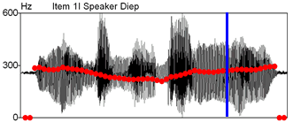
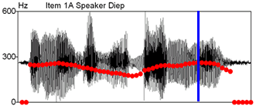
Figure 2. Two sentences having the same number of syllables and the same tone. F0 contour is in red. Figure on top: interrogative sentence, on bottom: affirmative sentence [12].

Corpus
In order to study the influence of these factors (register, called as alpha factor and the increasing slope, called as beta factor), three perceptual tests were implemented. In these tests, one shared speech corpus composed of 25 statement sentences was used to create three test corpora by manipulating their intonation contours in different ways. The manipulation of F0 contour was done automatically using PRAAT by changing the value of alpha and beta factors (Figure 3).
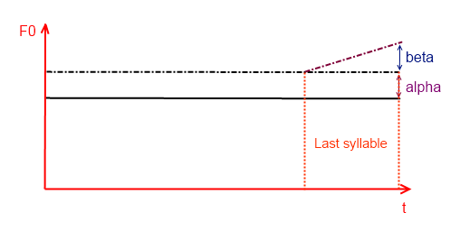
Figure 3. The method to manipulate F0 contour of the corpus.
The shared speech corpus was extracted from the dialogs in VNSpeechCorpus [10]. Since the statements were put into contexts, the naturalness of the speech sentences is ensured, and all of them originally have statement intonation. Besides, according to the meaning, these sentences could be either statement or question. If their intonations are changed properly, they can be treated as questions.
For example, the sentence “Đây là nhà mới của tôi.” can be understood as:
- a statement: “This is my new house.”
- a question: “Is this my new house?”
This selection helped the perception test participants’ judge the sentences based on their intonations only, without being affected by their meanings.

Perceptual Tests
Twenty people (10 men and 10 women) participated in three experiments corresponding to three corpuses. The listeners were asked to give their opinions after listening each perceptual sentence of each corpus:
- Answer the question: “Does it sound like a question?” There are two options: “Yes” and “No”.
- Answer the question: “How confident are you in your answer?” There are three options: “100%”, “80%”, and “60%”.
The first question helped us in estimating how good the chosen values of alpha and beta are. But it didn’t provide enough information on how to distinguish the differences between “Yes” answers. The second question helped us classify these answers. The three options for this question represent three levels: “100%” is “excellent”, “80%” is “good”, and “60%” is “fair”.
Based on the results of the perception tests, we can analyze the effects of alpha and beta factors on the F0 contours of the sentences in the corpus, thus choosing the appropriate values for the factors.

Influence of Alpha Factor
To evaluation the influence of the F0 mean on F0 contour of question, we examine two values of alpha: 10%, and 20%. Beta is set to 0%. Thus, we had three groups of sentences in the first experiment:
- Group 1 contains 25 original sentences (alpha = 0%).
- Group 2 contains 25 re-synthetic sentences (alpha = 10%).
- Group 3 contains 25 re-synthetic sentences (alpha = 20%).
Figure 4 shows the result of the experiment. The ratio of “Yes” choice in case of alpha = 20% is 75.40% while the ratio of “Yes” choice in case of alpha = 10% is only 43.40%. The confidence of “Yes” choice in case alpha = 20% is also higher than that in case alpha = 10%. We can conclude that when alpha (or the average) is higher, the ratio of “Yes” choice is also higher, thus the F0 contour is closer to that of a question.
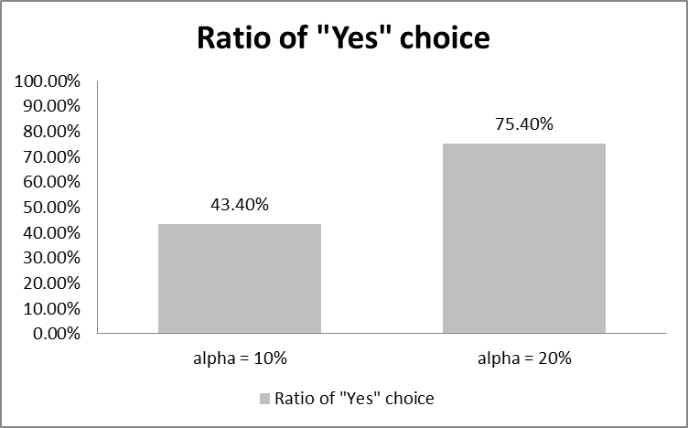
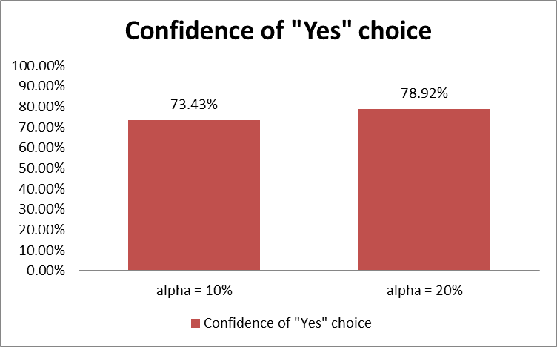
Figure 4. The result of the experiment for the F0 mean of the whole sentence (alpha factor).

Influence of Beta Factor
To evaluation the influence of the F0 contour of the last syllable on F0 contour of question, we examine two values of beta: 10%, and 20%. Alpha is set to 0%. Thus, we had three groups of sentences in the second experiment:
- Group 1 contains 25 original sentences (beta = 0%).
- Group 2 contains 25 re-synthetic sentences (beta = 10%).
- Group 3 contains 25 re-synthetic sentences (beta = 20%).
Figure 5 shows the result of the experiment. The ratio of “Yes” choice in case of beta = 20% is 77.80% while the ratio of “Yes” choice in case of beta = 10% is only 49.80%. The confidence of “Yes” choice in case beta = 20% is also higher than that in case beta = 10%. The result of this experiment is slightly better than that of the previous experiment. This result shows that when beta (or the F0 contour of the last syllable) is higher, the ratio of “Yes” choice is also higher, thus the F0 contour is closer to that of a question. And the F0 contour of the last syllable has more influence on F0 contour of question than that of the average F0.
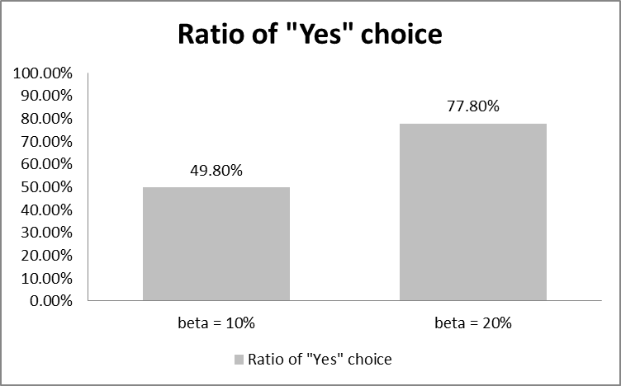
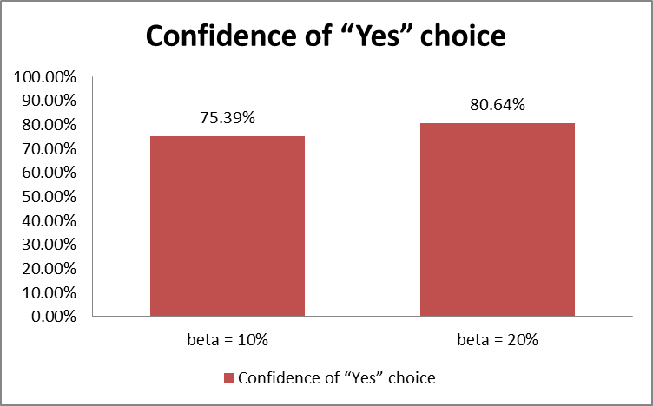
Figure 5. The result of the experiment for the F0 contour of the last syllable (beta factor).

The Influences of both Alpha and Beta Factors
The findings of the two previous experiments suggests that when we raise the values of alpha and beta, the ratio of “Yes” choice increases, giving us a better F0 contour. But we didn’t know that how the performance would be when we raised both alpha and beta at the same time. So we carried out the third experiment. This time, we have five groups of sentences:
- Group 1 contains 25 original sentences (alpha = beta = 0%).
- Group 2 contains 25 re-synthetic sentences (alpha = 10%, beta = 10%).
- Group 3 contains 25 re-synthetic sentences (alpha = 10%, beta = 20%).
- Group 4 contains 25 re-synthetic sentences (alpha = 20%, beta = 10%).
- Group 5 contains 25 re-synthetic sentences (alpha = 20%, beta = 20%).
Figure 6 shows the result of this experiment. The ratio of “Yes” choice in case alpha = beta = 10% is only 54.11%. The ratio of “Yes” choice in case alpha = beta = 20% is highest, 90.32%. This is a good result, but in fact, the sentences in this group sounded not really naturally. It is because the F0 contour of the last syllable was raised up to 40%. Thus we cannot use alpha and beta too large, because of the distortion of quality of the synthetic sentence.
In the remaining two cases, the results are similar. The case alpha = 20%, beta = 10% has a slightly better results. But when we considered each sentence in the two case, we can see that the sentences with high original register has better results in case alpha = 10%, beta = 20% while sentences with low original register has better results in case alpha = 20%, beta = 10%. We suggest that alpha should be chosen accordingly to the F0 average of the original F0 contour. It should be 15% in an average situation.
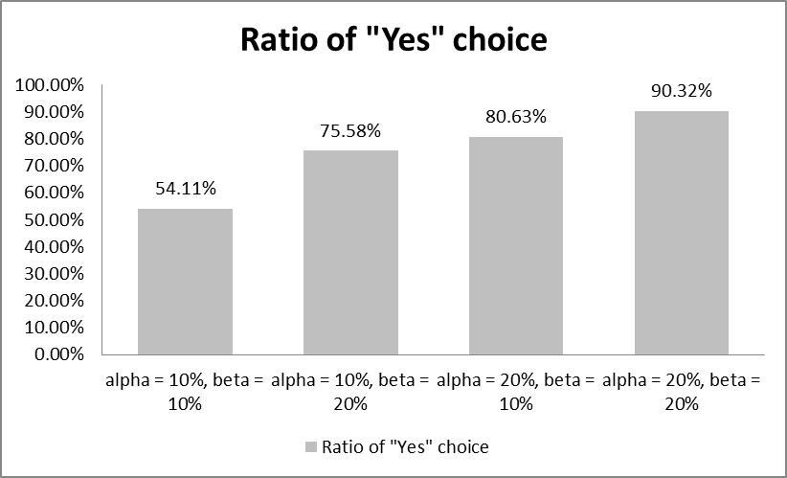
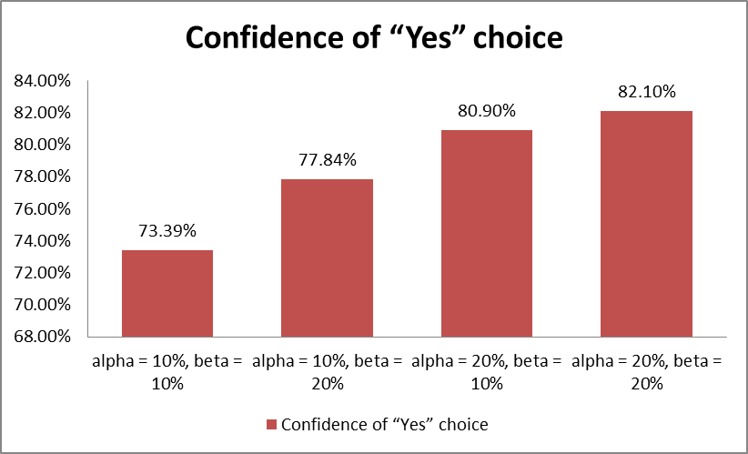
Figure 6. The results of the experiment for the F0 mean of the whole sentence and the F0 contour of the last syllable (both alpha and beta factors).

PROPOSED MODEL

The Proposed Alpha and Beta Factors
When we used our intonation model presented in [10][11] to generate the F0 contour of 123 statements from daily life dialogs without scaling with an initial F0, the average normalized F0 values of these statements is 0.96. If we limit the average F0 (F_{m}) of a question to 1.1, the average alpha will be:
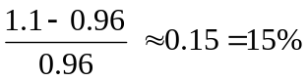
Based on this analysis, we chose:
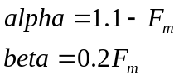
If alpha < 0, alpha is set to 0.

The Verification Test for the Alpha and Beta Factors
In the previous section, we have proposed how to choose alpha and beta. But this choice is just based on our analysis, so a test was carried out to verify the result in case of proposed alpha and beta. In this test, we have three groups of sentences:
- Group 1 contains 25 original sentences (alpha = beta = 0%)
- Group 2 contains 25 re-synthetic sentences (proposed alpha and beta).
- Group 3 contains 25 re-synthetic sentences (alpha = beta = 20%).
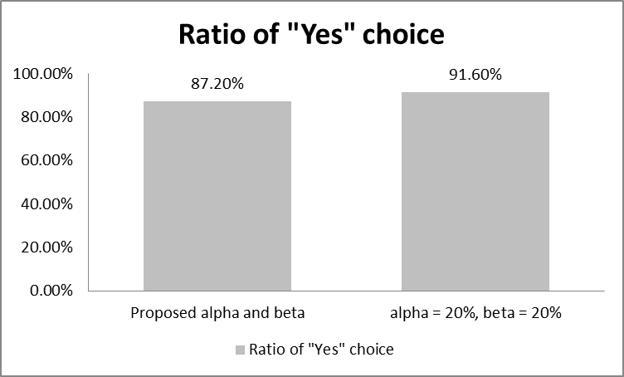
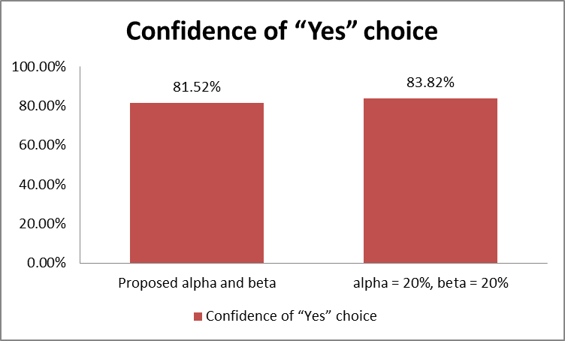
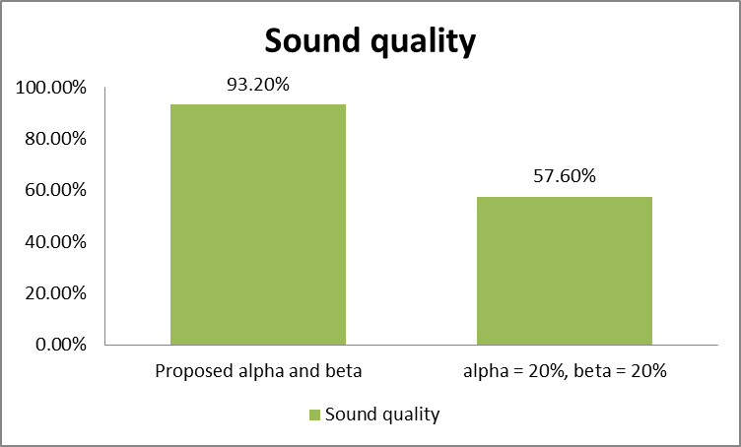
Figure 7. The results of the experiment for verification of the proposed alpha and beta.
The case alpha = beta = 20% was used because it has the best result in the previous perception tests.
This time, the listeners were asked to do 3 tasks with each perceptual sentences of each corpus:
- Answer the question: “Does it sound like a question?”. There are two options: “Yes” and “No”.
- Answer the question: “How confident are you in your answer?”. There are three options: “100%”, “80%”, and “60%”.
- Answer the question: “Does it sound naturally?”. There are two options: “Yes” and “No”.
The third task was to verify the quality of the re-synthetic sentences. Figure 7 shows the results of the experiment.
We can see that the proposed alpha and beta has a good result. It is better than all other cases except the case of alpha = beta = 20%. But this case has a bad quality result, only 57.60%. While the proposed alpha and beta has a much better result, about 93.20%. These results show that we can use the proposed alpha and beta.

The Proposed F0 Model for Vietnamese Questions
Based on these differences, a method was proposed to generate the F0 contour of a question. Suppose that one phrase of N syllables (S₁ S₂ …S_{N}) will be synthesized. Each syllable is represented by a series of F0 points. The number of F0 points for a syllable is directly proportional to its length. Let us assume that the numbers of points of S₁ S₂ …S_{N} is L₁ L₂ …L_{N}, respectively. The result is obtained through three steps:
Step 1: The F0 contour of the sentence is generated using the method proposed in [11]. This method is composed of 3 steps. Firstly the contour of tonal register, which is calculated from relative register ratios between two adjacent tones, is produced. And then the tone patterns are superimposed on it. Finally, the F0 contour is smoothed and scaled with a specific factor.
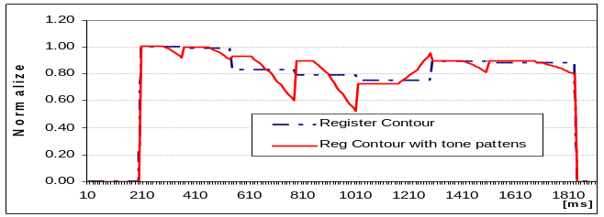
(a)
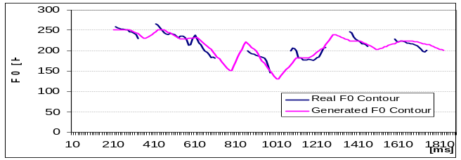
(b)

Figure 8. (a) Generated register contour (dashed line) and the superimposed tone patterns. (b) F0 contour generated by the proposed model and the F0 contour of target speech.

Step 2: The whole F0 contour is raised equally by an amount which is proportional to alpha.
The mean F0 value of the whole sentence:
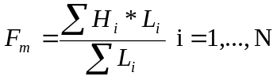

All F0 points are raised by an equal amount F_{a}:
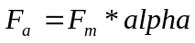
With 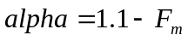
If alpha < 0, alpha is set to 0.
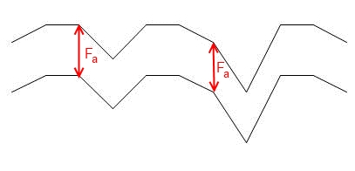
(a)

(b)

Figure 9. The F0 contour raised using alpha (a) F0 contour generated using method proposed in [11](b) Raised F0 contour.
Step 3: The F0 contour of the last syllable is raised by an amount which is proportional to beta.
The i-th F0 point of the last syllable is raised by an amount F_{bi}:
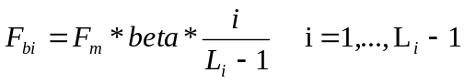
With 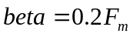
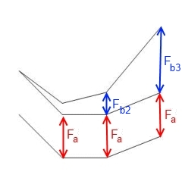
(a)

(b)

Figure 10. The F0 contour of the last syllable raised using alpha and beta (a) F0 contour generated using method proposed in [11] (b) Raised F0 contour.

EXPERIMENT

Preparations
To do the experiment for the model, we have to prepare the following items:
- A testing corpus, which will be discussed in more detail in the next subsection.
- Implementing the model into the TTS Hoa Sung developed by Research Center MICA.
- Implementing the model into an individual program written in Java.

Corpus
The text corpus composed of 16 single questions was extracted from text corpus of [11]. These questions belong to two types of questions:
- ‘Wh’ question: it always contains a question tool (“đâu”, “gì”, “mấy”, etc.). The question tool may be at the beginning or at the end of the question. For example: “Bây giờ anh ở đâu?” (“Where are you now?”), “Mấy giờ các anh đi?” (“What time are you going?”).
- ‘Yes/No’ question: the answer to this type of question usually starts with ‘Yes’ or ‘No’. For example: “Bà có nhìn rõ không?” (“Do you see things clearly?”).
The 16 sentence were re-synthesized and synthesized in different ways. Thus, a speech corpus which contains 5 groups of 16 sentences was built.
- Group 1 contains 16 natural sentences.
- Group 2 contains 16 re-synthetic sentences. The contour of F0 is generated using the original model of [11].
- Group 3 contains 16 re-synthetic sentences. The contour of F0 is generated using the proposed model.
- Group 4 contains 16 synthetic sentences. The contour of F0 is generated using the original model of [11].
- Group 5 contains 16 synthetic sentences. The contour of F0 is generated using the proposed model.
The F0 contours of natural sentences were manipulated using PRAAT to produced re-synthetic sentences of group 2 and group 3. The duration for each syllable of the re-synthetic sentences are manually addressed based on the natural sentences, so it correctness is ensured. The sentences of group 4 and group 5 were synthesized using the TTS Hoa Sung developed by Research Center MICA, theirs durations are generated using the duration model of the TTS.

Results of Experiment
Ten persons (5 men and 5 women) participated into the test. The listeners were asked to rate the speech quality (particularly on question prosody) of each perceptual sentences of five groups on a scale 1-5, where 1 is bad and 5 is completely natural.
The result of the experiment is showed in Figure 11. Group 1 which contains natural sentences has the highest score, this is a predictable result. By comparing the score of group 2 and group 3, group 4 and group 5, we can see that the naturalness score of the proposed model is higher than that of the original model.
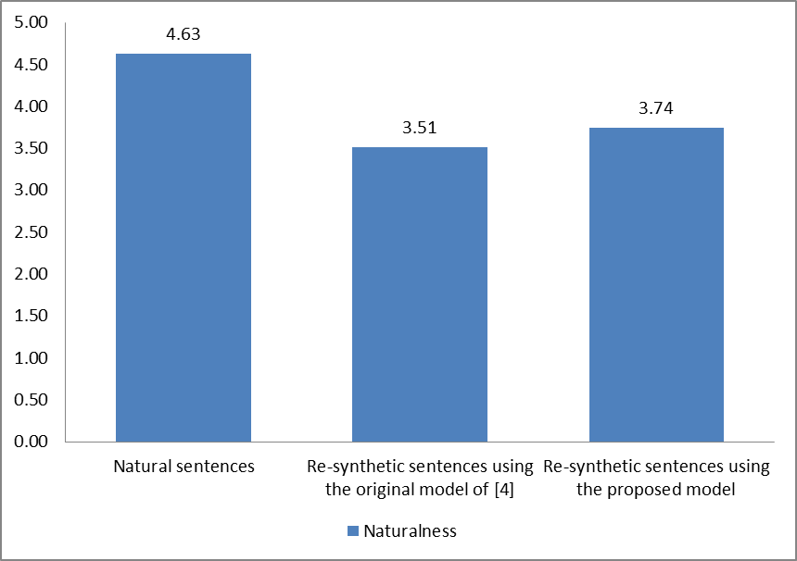
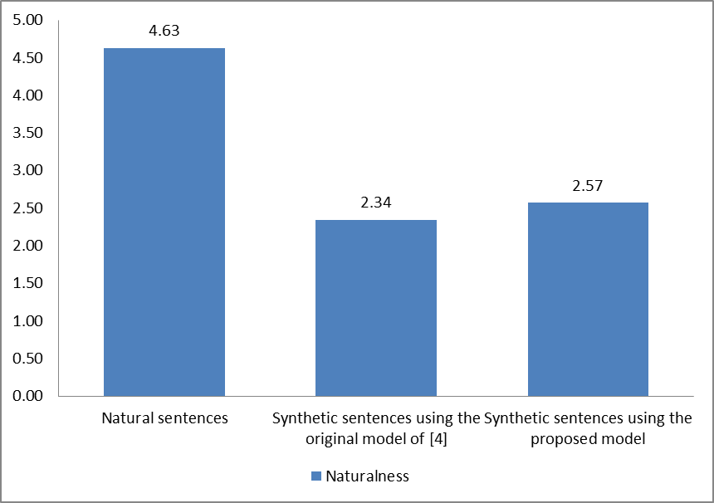
Figure 11. The result of the perceptual test for evaluation the proposed model.

CONCLUSION
The paper presented our research on the differences between F0 contours of Vietnamese statement and question, particularly on the average F0 and the F0 contour of the last syllable. Based on this analysis, a model for generating F0 contour for Vietnamese question was proposed. The score of the perceptual test shows that this model can be used to generate F0 contour for Vietnamese question except some special cases. Thus, we have to consider other differences between two types of F0 contour in the future researches. The tone of the last syllable is also another concern to generate a more accurate F0 contour.

FUTURE WORKS
The proposed model has improved the naturalness of the synthetic questions. However in some cases, such as tone 4 at the final position, the results are not good. One of the reason is the beta factor is still fixed (20%). Thus, we will build a larger corpus which concerns types of tones of the last syllables. This enables us to study the last syllable more deeply and improve our model. As the F0 contour relates to the duration, we also have to study to propose a duration model for Vietnamese question. Based on these studies, we can research on other types of Vietnamese sentences, such as imperative and exclamation.

ACKNOWLEDGEMENTS
We would like to thank Research Center MICA for helping us with mechanisms and rooms for the research. We also want to thank MICA staffs and our friends who willingly participated in our tests and experiments.

REFERENCES
- Nguyen, D.T., Mixdorff, H., et al., "Fujisaki Model based F0 contours in Vietnamese TTS”, ICSLP2004, Korea, pp. 1429-1432, 2004.
- Chang, C. Y. F. 2003, Intonation in Cantonese. Muchen: LINCOM Europa. ISBN 3895869864. LINCOM Studies in Asian Linguistics 49. 150pp.
- Do, T. D., Tran, T. H., Boulakia, G. 1998, Intonation in Vietnamese, Intonation systems: A survey of 22 languages, Hirst & Di Cristo (ed.), Cambridge U.P.
- Eady, S. J., & Cooper, W. E. 1986, Speech intonation and focus location in matched statements and questions. Journal of Acoustical Society of America, 80, 402-415.
- Joan, K. Y. M., Ciocca, V., Whitehill, T. L. 2008, Quantitative analysis of intonation patterns in statements and questions in Cantonese, INTERSPEECH 2008, 9th Annual Conference of the International Speech Communication Association Brisbane, Australia, September 22-26, 2008.
- Joan, K. Y. M., Ciocca, V., Whitehill, T. L. 2004. The effects of intonation patterns on lexical tone production in Cantonese by acoustic analysis. Paper presented at the International Symposium on Tonal Aspects of Languages, Beijing, China.
- Manolescu, A., Declarative and Interrogative. Intonation in Romanian, www.utexas.edu/courses/lin393p/manolescu.pdf, University of Texas at Austin.
- Nguyen, T. T. H. 2004, Contribution à l’étude de la prosodie du vietnamien. Variations de l’intonation dans les modalités: assertive, interrogative et impérative, PhD. thesis, Doctorat de Linguistique Théorique, Formelle et Automatique, Paris.
- Nguyen, T. T. H., Boulakia, G. 1999, Another look at Vietnamese intonation, ICPhS San Francisco 1999.
- Tran, D. D. 2007, Synthèse de la parole a partir du texte en langue Vietnamienne, PhD. thesis INP-Grenoble, France, December.
- Tran, D. D., Eric Castelli, “Generation of F0 contours for Vietnamese speech synthesis”. In proceeding of the Third International Conference on Communications and Electronics (ICCE2010). Nha Trang, Vietnam 11-13 Aug, 2010. pp. 158 - 162,
- Vu M.Q., Tran D. D., Castelli E. 2006, Prosody of Interrogative and Affirmative Sentences in Vietnamese Language:Analysis and Perceptive Results, The Nineth International Conference on Spoken Language Processing – INTERSPEECH 2006 - ICSLP, Pittsburgh, Pennsylvania, USA, September 2006
- Yuan, J. H., Mechanisms of Question Intonation in Mandarin, Department of Linguistics, University of Pennsylvania Philadelphia, PA 19104, USA.
- Yuan, J. H., Shih, C., Kochanski, G.P. 2002, Comparison of declarative and interrogative intonation in Chinese. In Proceedings of Speech Prosody 2002. Aix-en-Provence, France (2002) 711-714.
- Sproat, R., Black, A., Chen, S., Kumar, S., Ostendorf, M., and Richards, C. 2001, Normalization of Non-StandardWords. Computer Speech and Language, Volume 15, Issue 3. July 2001, pp. 287-333.

