Internet Explorer Forensics: Reconstructing Internet Activity Using Pasco and Galleta

By
Samuel Pyne
Term Project
CIS 5390
Digital Forensics
Dr. Hongmei Chi, Professor
Fall 2007

Abstract
Web browser forensics is an increasingly important field within computer forensics. This is because an increasing number of criminal and civil cases may depend on evidence related to a users Internet activities. In this paper the reconstruction of web browsing activity using the open-source tools Pasco and Galleta is investigated. Both tools are used to analyze index.dat files and cookie files. The nature of index.dat and cookie files are describes and the installation and usage of Pasco and Gallate is illustrated.

Table of Contents
Abstract …………………………………………………………………………………ii
Table of Contents………………………………………………………………………iii
Introduction……………………………………………………………………………….1
Project Description………………………………………………………………………1
Description of Tools………………………………………………………………………2
Theoretical Foundations………………………………………………………………….3
The index.dat File……………………………………………………………………….4
The index.dat File Structure……………………………………………………………5
Internet Explorer Cookies…………………………………………………………………7
The Structure of an Internet Explorer Cookie………………………………………... 8
Demo: Using the Tools……………………………………………………………………9
Installing Pasco…………………………………………………………………………..10
Using Pasco………………………………………………………………………………10
Installing Galleta………………………………………………………………………….11
Using Galleta …………………………………………………………………………….13
Conclusion and Lessons Learned ……………………………………………………….15
References………………………………………………………………………………….16

Introduction
Over the past several years, electronic evidence has often shaped the outcome of high-profile civil law suits and criminal investigations ranging from theft of intellectual property and insider trading that violates SEC regulations to proving employee misconduct resulting in termination of employment under unfavorable circumstances.
A very important step in computer forensics is investigating the web usage of a suspect. This information may be useful in everything from examining a company’s policy violation to detecting corporate espionage and federal offences.
Examining a suspect’s web browsing history could provide critical clues to solving a case since criminal, corporate or civil investigations involving illegal or improper web usage usually requires expert analysis of the information stored by a web browser as a result of a suspect’s Internet activity. Many people browse the Internet each day using common web browsers such as Microsoft Internet Explorer, Mozilla Firefox, Netscape Navigator, Opera and Safari with Internet Explorer being by far the most common of these browsers. During Forensic Analysis it is therefore usually relevant to analyze the information in Internet Explorer into a human readable format. Pasco and Galleta are two open source tools that are used to reconstruct a person’s web usage activities. Both Pasco and Galleta are built to work on multiple platforms and will execute on Windows (through Cygwin), Mac OS X, Linux, and *BSD platforms.
Project Description
A monumental task facing the forensic analyst is to determine the web browsing habits for the person that is being investigated. In order to do this, the investigator must analyze the internal structures of the web browser cache files as well as reconstruct a subject's cookie files for Internet Explorer . Unfortunately, the internal structures for the cache files are not well preserved.
The goal of the project is to use the open source tools Pasco and Galleta to reconstruct a users web usage activity in Internet Explorer. Pasco and Galleta are powerful forensic tools that may be used to recover critical electronic evidence that is often found in the suspect's web browsing history in the form of received emails, sites visited and attempted Internet searches. Galleta will parse the information in a cookie file while Pasco on the other hand will. will parse the information in an index.dat file. Both programs will output the results in a field delimited manner so that they may be imported into a spreadsheet program.

Description of Tools
Pasco
Pasco is a Internet Explorer activity forensic analysis tool that was developed by Keith J. Jones, a Principal Computer Forensic Consultant at Foundstone, Inc. Since many important files within Microsoft Windows have structures that are undocumented, one of the principles of computer forensics is that all analysis methodologies must be well documented and repeatable, and they must have an acceptable margin of error. Currently, there are a lack of open source methods and tools that forensic analysts can rely upon to examine the data found in proprietary Microsoft files.
Many computer crime investigations require the reconstruction of a subject's internet activity. Pasco, the latin word meaning "browse", was developed to examine the contents of Internet Explorer's cache files. The foundation of Pasco's examination is based upon parsing the information in an index.dat file and outputting the results in a field delimited manner so that it may be imported into a spreadsheet program. Pasco is built to work on multiple platforms and will execute on Windows (through Cygwin), Mac OS X, Linux, and *BSD platforms.
Galleta
Galleta is an Internet Explorer Cookie Forensic Analysis Tool that was also developed by Keith J. Jones, a Principal Computer Forensic Consultant at Foundstone, Inc. Many computer crime investigations require the reconstruction of a subject's Internet Explorer Cookie files and since this analysis technique is executed regularly, Galleta analyses the structure of the data found in the cookie files. Galleta, the Spanish word meaning "cookie", was developed to automate this process and the foundation of Galleta's examination methodology is based upon parsing the information in a Cookie file and outputting the results in a field delimited manner so that it may also be opened in a spreadsheet program. Galleta is built to work on multiple platforms and will execute on Windows (through Cygwin), Mac OS X, Linux, and *BSD platforms.

Theoretical Foundations
The Index.dat File
Internet Explorer saves numerous files named “index.dat” within each
user’s home directory on the computer system. Each user will generate multiple Index.dat files that may be found in multiple directories as indicated below. This file maps web sites visited to locally saved cache files in randomly named directories so that the next time the user visits the same web site, he will not have to download the same graphics and web pages all over again. The following figures illustrates where an “index.dat” file resides:

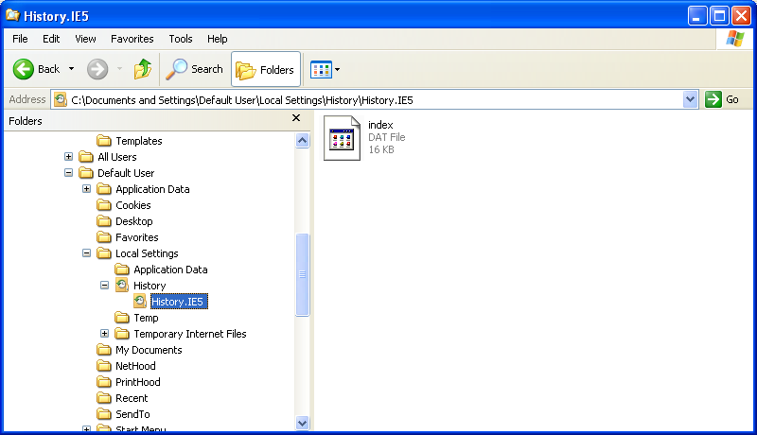
Fig. 1 – One Location for Index.dat File

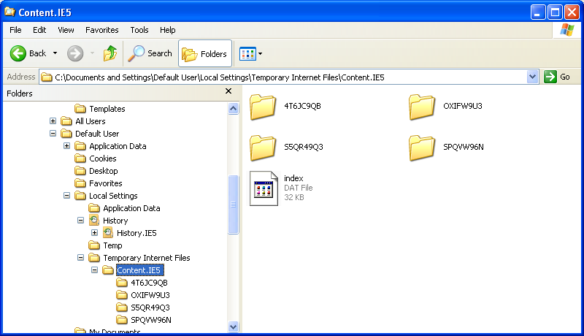
Fig. 2 – A Second Location for Index.dat File with Randomly Named Folders

The following table lists additional areas of the file system where other index.dat files may be located for Internet Explorer running on different versions of Windows:

OperatingSystem | File Path(s)
Windows  95/98/Me | \Windows\Temporary Internet Files\Content.IE5\  \Windows\Cookies\ \Windows\History\History.IE5\
Windows NT | \Winnt\Profiles\<username>\Local Settings\Temporary Internet Files\Content.IE5\  \Winnt\Profiles\<username>\Cookies\  \Winnt\Profiles\<username>\Local Settings\History\History.IE5\
Windows 2K/XP | \Documents and Settings\<username>\Local Settings\Temporary Internet Files\Content.IE5\  \Documents and Settings\<username>\Cookies\ \Document and Settings\<username>\Local Settings\History\History.IE5\  C:\WINDOWS\system32\config\systemprofile\Local Settings\History\History.IE5
Table 1 - Locations of Index.dat Files

Index.dat File Structure
A forensic investigator may use the information found in the index.dat file to retrace the web activity of a suspect. The structures identified during forensic analysis of Index.dat that are relevant to constructing internet activity include the following types of Internet Explorer activity records:

- REDR – The REDR type of activity record indicates when the subject’s browser was redirected to another site.
- URL – The URL activity record is a set of data that represents a URL, or website, a user visited.

- LEAK - The LEAK activity record also indicates the website that the user visited.

Examples of these is show in the figure below:
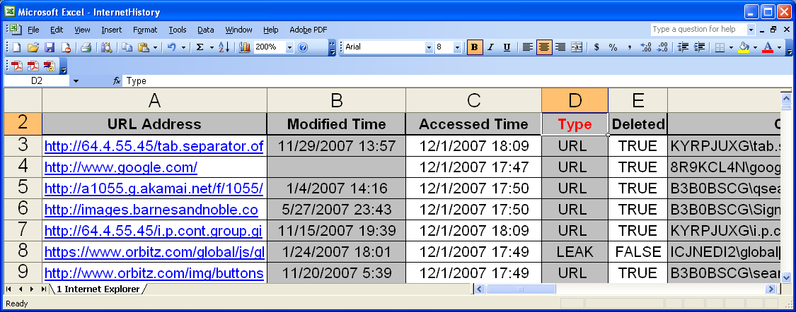Figure 3 – Pasco’s Output

These index.dat data types represent the most relevant information for analyzing a suspects web usage. These will be used to reconstruct a suspects browsing habits.

Internet Explorer Cookies

A cookie is a small file containing data that the web server places on a user’s computer so it may request back at a later date. During forensic analysis it is often relevant to parse the information in Internet Explorer’s cookie files into a human readable format. Cookies aid forensic analysts during the investigation by providing insight to a suspect’s internet activity.
But why are cookies necessary for browsing the internet? Cookies are necessary because HTTP is a stateless protocol therefore websites must place information on a user’s computer if it needs to save information about a web session. For instance, whenever a person purchases a book from amazon.com and adds it to his shopping cart, the information can be saved on the clients computer.

Structure of an Internet Explorer Cookie File
After visiting a website such as http://www.arstechnica.com, a cookie will be generated on the user’s computer that resembles the following:

atechnica
home
arstechnica.com/
0
1238799232
29570658
1484443312
29552553
*

Table 2 – Contents of an Internet Explorer Cookie

This cookie contains the information meant to be saved on the client’s machine from the web server, the domain name that is responsible for this cookie, and the relevant time/date stamps. The file will be created in the user’s IE Cookie directory, typically located in the
following places:

Operating System | Cookie File Location
Windows 2000/XP | C:\Documents and  Settings\<username>\Cookies
Table 3 – Location of Internet Explorer Cookies
Since the file is in ASCII format, it is easy to analyze the function of each line in the file.
- The first line contains the variable name. In this case, the variable is named atechnica.
- The second line contains the value for the variable. In this example, the variable atechnica has the value of home.
- The third line contains the website that issued the cookie.
- The fourth line contains flags, which are zero in this case.
- The next two lines (lines five and six) contain the expiration time for the cookie.
- The next two lines (lines 7 and 8) are the creation time for the cookie.
- The last line (line 9) will always contain a * since it is the record delimiter when this text file contains more than one cookie. A new cookie would start on the next line (line 10)

Using the Tools
Both tools require a Unix environment to Cygwin needs to be installed to simulate the Unix OS. This will allow both tools to be installed and access the necessary files.
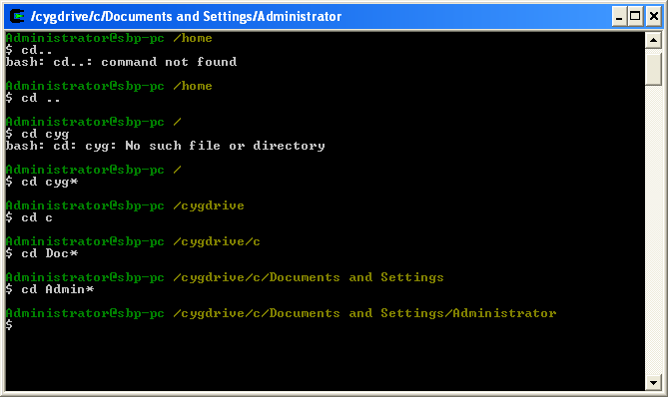
Figure 4- Cygwin Installed

Installing Pasco
Before using, Pasco has to be recompiled from source.
To recompile from source:
- Enter the "src" directory.
- Type "make installwin" within Cygwin to make Pasco for Windows.
OR
- Type "make install" to make Pasco for Unix.
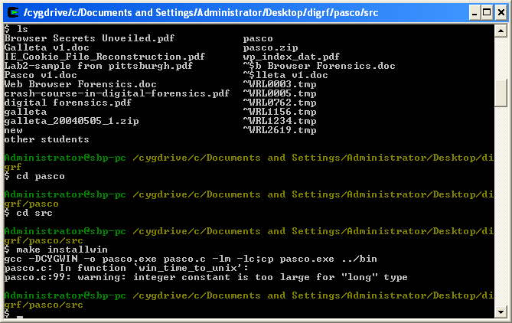
Figure 5 – Compiling Pasco from Source

The binaries will be located in the "bin" directory.
Using Pasco
The commands for using Pasco is relatively simple:
./pasco index.dat > index.txt

Once index.txt is created, the results can be imported into a spreadsheet like Microsoft
Excel for further viewing, sorting, and formatting:

Installing Galleta
Before using, Galleta also has to be recompiled from source.
To recompile from source the procedure is similar to that for Pasco:
- Enter the "src" directory.
- Type "make installwin" within Cygwin to make Galleta for Windows.
OR
- Type "make install" to make Galleta for Unix.

Using Galleta
The commands for using Galleta are also relatively simple:
./galleta administrator@arstechnica.txt > arstechnica_galleta.txt

It is important to note that Galleta’s output can be also be easily imported into your favorite spreadsheet program so that you may sort, search, and filter the data. Furthermore, a spreadsheet will allow you to format the data so that it is appropriate for a report.

Conclusion and Scope for Further Research:
Pasco and Galleta are both powerful tools that are indispensable to a forensic investigator tracking Internet activity. These tools automate the analysis of the Index.dat as well as cookie files generated by Internet Explorer. The main shortcoming of both tools are their lack of support for Internet Explorer 7 as well as Opera, Firefox and other non-IE browsers. Future research to develop both tools to work with other browser as well as Internet Explorer would extend their capabilities immensely. Extending the capabilities of both tools in this respect is is quite feasible given the open source nature of the source code. However, extending the tools to utilize native windows support would be beyond the scope of this project

References
IT Unready for New Rules on Electronic Evidence. http://www.computerworld.com/action/article.do?command=viewArticleBasic&articleId=274762
The Electronic Evidence Information Center - http://www.e-evidence.info/biblio.html
http://www.google.com/search?hl=en&client=firefox-a&rls=org.mozilla%3Aen-US%3Aofficial&hs=DOM&q=galleta+forensics+web&btnG=Search - google search
Web Browser Forensics, Part 1 -- http://www.securityfocus.com/infocus/1827
Browser Secrets Unveiled! -- http://www.niiconsulting.com/checkmate/2006/01/browser-secrets-unveiled/
http://www.laborlawtalk.com/showthread.php?t=95330
http://www.securityfocus.com/infocus/1827
http://www.bandwidthco.com/whitepapers/netforensics/methodology/Browser%20Secrets%20Unveiled.pdf

http://www.foundstone.com/us/resources-free-tools.asp

http://www.opensourceforensics.org/tools/windows.html

