Robust Face Presentation Attack Detection for eKYC
Under Image Quality Degradations
[Author Names]
Abstract. Face presentation attack detection (PAD) safeguards facial electronic know-your-customer (eKYC) systems, yet real capture conditions degrade input quality through compression, resolution loss, blur, noise, and illumination changes. We empirically study how a lightweight MobileNetV2 PAD model responds to such degradations and whether quality-aware augmentation improves robustness. A baseline and a robust model were trained identically on a 203,215-image CelebA-Spoof subset (subject-disjoint split: 142,250/20,322/40,643); the robust model additionally applied randomized JPEG, resize, blur, noise, and brightness augmentations. Both models were evaluated, using best-validation-epoch weights (epoch 18), on the same fixed test set across sixteen degradation conditions. On clean inputs the models are essentially equal (F1 0.9868 vs 0.9831; ACER 0.0211 vs 0.0256). Averaged over degradations, the robust model raises mean F1 0.9226→0.9743 and cuts mean ACER 0.1153→0.0390; worst-case F1 improves 0.7985→0.9446 and worst-case ACER 0.3310→0.1012, at a negligible clean-test cost (F1 -0.0037, ROC-AUC -0.0008).
Keywords. face anti-spoofing, face presentation attack detection, image quality degradation, MobileNetV2, quality-aware augmentation, robust face PAD

1. Introduction

1.1 Face PAD in eKYC and Image Quality
Remote identity verification (eKYC) is a standard step in onboarding users for financial services. Its central component is face presentation attack detection (PAD): classifying a captured face as bona fide or as a presentation attack such as a printed photo, a replayed screen, or a mask [1]. PAD failures directly enable identity fraud, so reliability under realistic capture conditions is of practical importance [1], [2]. Detectors rely on subtle cues such as micro-texture and color statistics [3], [4] — precisely the signal components most sensitive to quality loss. In deployed pipelines, captured images undergo camera compression, resolution limits, motion blur, sensor noise, and illumination variation, all of which can attenuate the very artifacts PAD models exploit.

1.2 Motivation, Research Questions, and Contributions
Deep PAD models are typically trained on curated datasets and evaluated on clean, well-aligned images, yet robustness to quality degradation is not guaranteed by strong clean-test performance [11]. A practical and inexpensive remedy is quality-aware augmentation: during training, each image is randomly transformed with simulated quality degradations, so the model learns features that are less dependent on pristine image quality, without any architectural modification. This work investigates two questions on a controlled 203,215-image subset of CelebA-Spoof [5]: (i) how does a lightweight MobileNetV2 PAD baseline degrade as input quality decreases under JPEG compression, resolution reduction, blur, noise, and brightness changes; and (ii) does a robust model trained with quality-aware augmentation maintain higher detection performance under the same degradations while preserving clean-test performance? The contributions are: (1) a reproducible MobileNetV2 baseline on this subset; (2) a robust-training pipeline of five quality augmentations applied with controlled probability; (3) a systematic sixteen-condition stress-test protocol on a fixed test set; and (4) a quantitative comparison of baseline and robust models showing improved degradation robustness with negligible clean-test cost.

2. Related Work

2.1 Texture-Based and Mobile Face PAD
Classical PAD methods rely on hand-crafted texture cues: local binary patterns distinguish printed photographs from live faces via micro-texture [3], and texture descriptors were systematically evaluated for anti-spoofing in [4]. These works established that spoofing artifacts are encoded in fine image statistics, which also makes them vulnerable to quality loss. Mobile capture settings were addressed by the OULU-NPU database [6], which provides real-world variations in illumination and capture devices, and smartphone spoof detection [2] highlighted the deployment constraints that motivate lightweight solutions.

2.2 Deep Binary Supervision and Lightweight Architectures
Deep learning improved accuracy over hand-crafted features: binary supervision was shown sufficient for anti-spoofing [7], including pixel-wise binary supervision [8]. Motivated by these results and by deployment constraints, we adopt MobileNetV2 [9] as our baseline: its inverted residuals with linear bottlenecks give strong accuracy at low parameter counts [10] (2,225,153 parameters, 8.62 MB in our configuration).

2.3 Corruption Robustness and Data Augmentation
Corruption benchmarks show that accuracy degrades substantially under noise and blur even for strong clean-test models [11]. Data augmentation is a standard regularizer [12], and learned policies such as AutoAugment demonstrate that augmentation choices strongly affect generalization [13]. Following the same principle, we use augmentation not as a generic regularizer but as explicit quality simulation. CelebA-Spoof [5] provides 625,537 images from 10,177 subjects; its challenge report [14] summarizes protocols and baselines. ImageNet statistics are used for input normalization [15].

3. Methodology

3.1 Pipeline and Dataset
The pipeline has six stages: (i) dataset preparation and a subject-disjoint train/validation/test split (seed 123) with a fixed test set; (ii) face crop (bounding box + 10% margin), resizing to 224×224, ImageNet normalization [15]; (iii) MobileNetV2 binary training, clean (E01) or quality-augmented (E07); (iv) selection of the best validation-loss checkpoint; (v) evaluation on the clean test set; and (vi) stress testing under sixteen degradation conditions without retraining (Fig. 1).
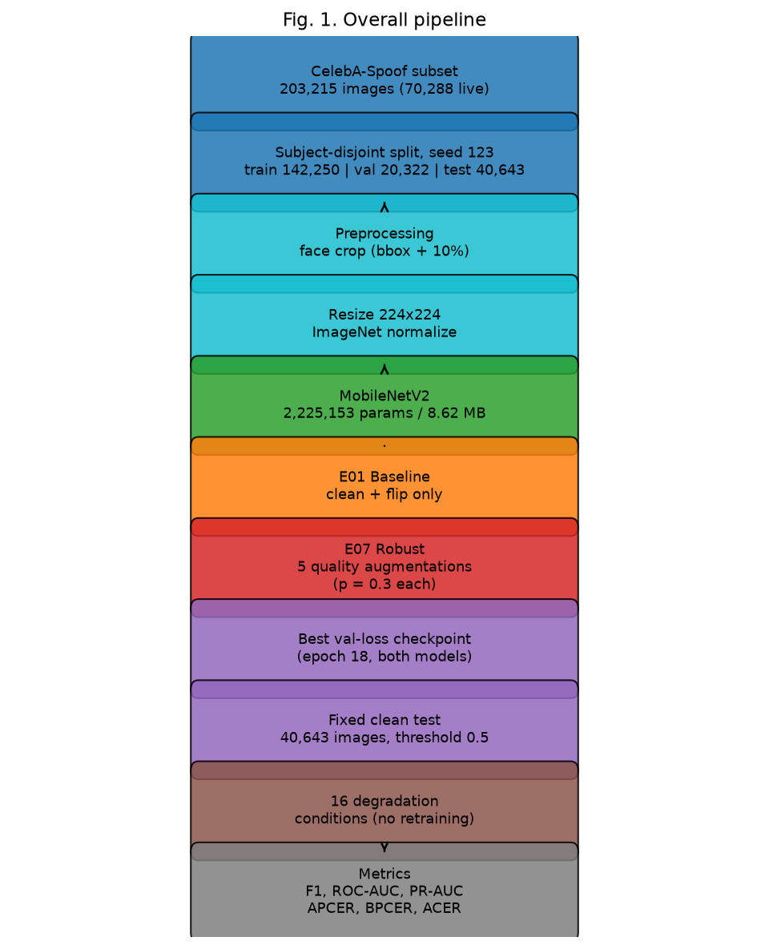
Fig. 1. Overall pipeline: CelebA-Spoof subset (203,215) → subject-disjoint split (142,250/20,322/40,643) → face crop + 224×224 + ImageNet normalization → MobileNetV2 (2,225,153 params) → E01 clean / E07 quality-augmented training → best-val checkpoint (epoch 18) → fixed clean test (40,643) → 16 degradation conditions → metrics (F1, ROC-AUC, PR-AUC, APCER, BPCER, ACER).
The dataset is a public HuggingFace mirror (Ar4ikov/celebA_spoof) of CelebA-Spoof [5]. A controlled subset of 203,215 images (70,288 live, 132,927 spoof) was downloaded and split subject-disjointly with seed 123 into 142,250 training, 20,322 validation, and 40,643 test images; no subject appears in more than one partition (subject identity derived from image filename prefixes). The split was fixed before training and never modified, and both models were evaluated on exactly these 40,643 test images. Only binary labels are available in this mirror.

3.2 Model and Training Procedure
The PAD model is MobileNetV2 [9] with the classifier replaced by a single logit (2,225,153 parameters, 8.62 MB); a sigmoid yields the spoof probability, and training uses BCEWithLogitsLoss without class weighting. Both models are trained for 20 epochs with batch size 64, Adam (learning rate 1e-4, weight decay 1e-5), and seed 123 on an NVIDIA GeForce RTX 5060 Laptop GPU. Training took 18,111 s (5.0 h) for E01 and 34,404 s (9.6 h) for E07. The checkpoint with the lowest validation loss is retained — epoch 18 for both models (validation loss 0.0586 / 0.0681) — and every metric reported in this paper is computed with these best-epoch weights.

3.3 Robust Training (Quality-Aware Augmentation)
The robust model differs from the baseline only in training-time augmentation. Five quality degradations are applied to each image independently, each with probability p = 0.3, with severity sampled uniformly from the configured ranges: JPEG quality U[50,90]; resize scale U[0.5,1.0]; Gaussian blur sigma U[0.5,2.0]; Gaussian noise std U[0.005,0.03]; brightness factor U[0.7,1.3]. Crop is disabled so that the augmentation set matches the five degradation types used in evaluation. Multiple degradations can stack on the same image; the number of stacked augmentations follows B(5, 0.3), so 16.8% of images remain clean and 1.5 augmentations are expected per image (Table I).
Table I. Augmentation stacking distribution (B(5, 0.3)).
Augmentations per image | 0 | 1 | 2 | 3 | 4 | 5
Probability | 0.1681 | 0.3601 | 0.3087 | 0.1323 | 0.0283 | 0.0024

3.4 Evaluation Protocol and Metrics
All evaluations use the fixed 40,643-image test set and a constant decision threshold of 0.5. Degradation evaluation never updates model weights: one deterministic degradation is applied to each test image before the standard evaluation transform, with explicit parameters recorded per experiment, and the identical grid is used for the baseline (E02–E06) and the robust model (E08–E12). With spoof as the positive class, let TP/FP/FN/TN denote the confusion counts at the threshold; Accuracy, Precision, Recall, and F1 are threshold-based, ROC-AUC and PR-AUC are threshold-independent ranking metrics, APCER = FN/(FN+TP) (attacks accepted), BPCER = FP/(FP+TN) (live presentations rejected), and ACER = (APCER+BPCER)/2. Lower APCER/BPCER/ACER is better; higher is better for the other metrics.

4. Experimental Setup
Python 3.14.7, PyTorch 2.14.0+cu130, torchvision 0.29.0+cu130, NumPy 2.5.2, Windows 11, RTX 5060 Laptop GPU (8 GB); repository state git commit 296643e1ec9194e4cb5d4c6023fa5e3fd574e40f. Table II summarizes the training configuration. Table III defines the degradation test matrix, whose levels model lossy transfer/storage (JPEG), client-side downscaling (resize), motion/out-of-focus capture (blur), low-light sensor noise (noise), and illumination variation (brightness); Table IV maps each category to its real-world analogue, and Fig. 2 shows degraded examples.
Table II. Training configuration (identical for E01 and E07).
Parameter | Value | Parameter | Value
Model | MobileNetV2 (2,225,153) | Epochs / batch | 20 / 64
Input | 224×224, ImageNet norm. | Optimizer | Adam
Learning rate | 1e-4 | Weight decay | 1e-5
Loss | BCEWithLogitsLoss | Class weighting | none
Seed | 123 | Threshold | 0.5
Train / val / test | 142,250 / 20,322 / 40,643 | Aug. (E01) | flip only
Table III. Degradation test matrix (16 conditions).
Category | Levels | Parameters
JPEG | 90 / 70 / 50 / 30 | quality
Resize | 75% / 50% / 25% | scale 0.75 / 0.50 / 0.25
Blur | light / medium / strong | k3σ0.6 / k7σ1.8 / k11σ3.0
Noise | low / medium / high | std 0.005 / 0.015 / 0.03
Brightness | dark / normal / bright | factor 0.6 / 1.0 / 1.4
Table IV. Test scenarios and real-world analogues.
Condition | Real-world analogue | Relevance to face PAD
JPEG | lossy compression in transfer/storage | destroys fine spoof textures
Resize | client-side downscaling | removes high-frequency detail
Blur | motion / out-of-focus capture | smooths texture and edges
Noise | low-light sensor noise | masks artifacts with noise
Brightness | illumination variation | alters contrast and color statistics
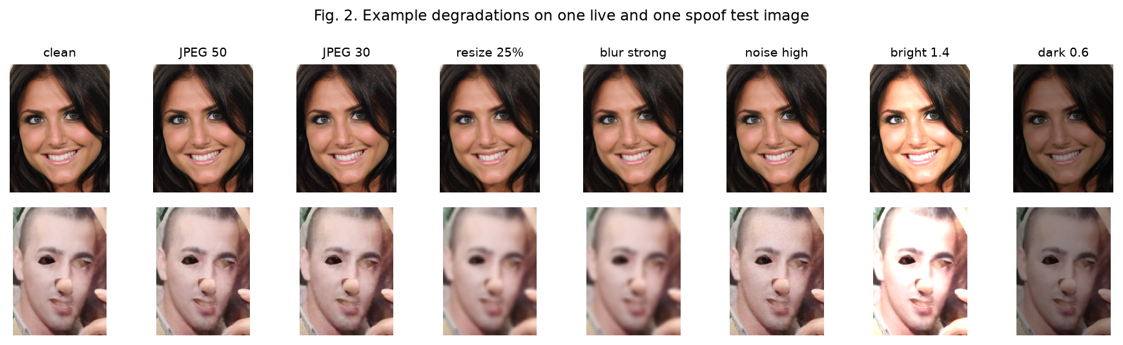
Fig. 2. One live and one spoof test image under selected degradations (clean, JPEG 50, JPEG 30, resize 25%, blur strong, noise high, brightness 1.4, 0.6).

5. Results and Discussion

5.1 Clean Performance
Table V. Clean test performance (40,643 images, threshold 0.5, best-epoch weights).
Metric | E01 Baseline | E07 Robust
Accuracy | 0.9826 | 0.9778
Precision | 0.9827 | 0.9810
Recall | 0.9909 | 0.9851
F1 | 0.9868 | 0.9831
ROC-AUC | 0.9978 | 0.9969
PR-AUC | 0.9987 | 0.9983
APCER | 0.0091 | 0.0149
BPCER | 0.0331 | 0.0362
ACER | 0.0211 | 0.0256
Clean-test performance is essentially preserved: the robust model's F1 is 0.0037 lower and its ACER 0.0044 higher, while ROC-AUC decreases by only 0.0008. Both error rates remain low for both models (APCER 0.0091 vs 0.0149; BPCER 0.0331 vs 0.0362). Confusion matrices (positive = spoof): E01 TN 13557 / FN 243 / FP 464 / TP 26379; E07 TN 13513 / FN 396 / FP 508 / TP 26226 (Table XI). ROC curves are compared in Fig. 3.
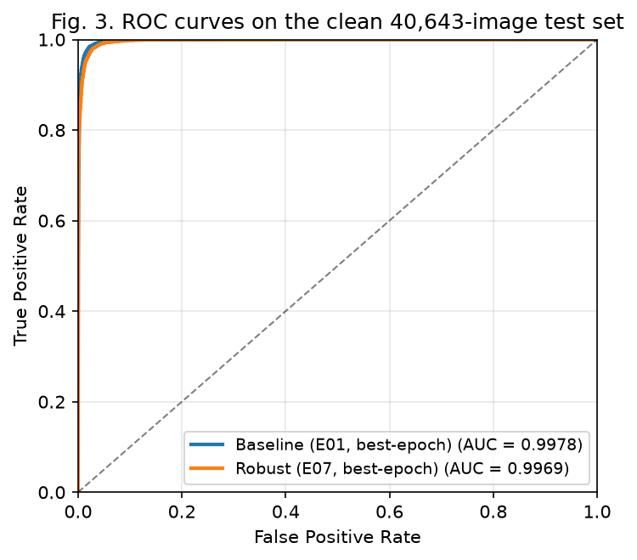
Fig. 3. ROC curves on the clean test set (E01 AUC 0.9978, E07 AUC 0.9969).

5.2 Degradation Performance
Table VI reports all metrics for both models under the sixteen degradation conditions; Fig. 4 plots F1 and ACER against severity for each category.
Table VI. E01 vs E07 under all 16 degradation conditions (best-epoch weights).
Condition | Severity | E01 F1 | E07 F1 | ΔF1 | E01 AUC | E07 AUC | ΔAUC | E01 PR-AUC | E07 PR-AUC | ΔPR-AUC | E01 APCER | E07 APCER | E01 BPCER | E07 BPCER | E01 ACER | E07 ACER | ΔACER
blur | light | 0.9785 | 0.9815 | +0.0030 | 0.9964 | 0.9964 | +0.0000 | 0.9979 | 0.9980 | +0.0001 | 0.0054 | 0.0130 | 0.0725 | 0.0460 | 0.0390 | 0.0295 | -0.0095
blur | medium | 0.8967 | 0.9757 | +0.0791 | 0.9646 | 0.9947 | +0.0301 | 0.9802 | 0.9970 | +0.0168 | 0.0067 | 0.0146 | 0.4218 | 0.0653 | 0.2143 | 0.0400 | -0.1743
blur | strong | 0.8489 | 0.9677 | +0.1188 | 0.9161 | 0.9906 | +0.0745 | 0.9523 | 0.9947 | +0.0424 | 0.0089 | 0.0221 | 0.6532 | 0.0821 | 0.3310 | 0.0521 | -0.2789
brightness | bright | 0.7985 | 0.9571 | +0.1586 | 0.9744 | 0.9876 | +0.0131 | 0.9848 | 0.9926 | +0.0078 | 0.3300 | 0.0578 | 0.0157 | 0.0505 | 0.1728 | 0.0542 | -0.1187
brightness | dark | 0.9190 | 0.9446 | +0.0255 | 0.9628 | 0.9805 | +0.0177 | 0.9788 | 0.9890 | +0.0102 | 0.0261 | 0.0184 | 0.2762 | 0.1839 | 0.1512 | 0.1012 | -0.0500
brightness | normal | 0.9868 | 0.9831 | -0.0037 | 0.9978 | 0.9969 | -0.0008 | 0.9987 | 0.9983 | -0.0004 | 0.0091 | 0.0149 | 0.0331 | 0.0362 | 0.0211 | 0.0256 | +0.0044
jpeg | 30 | 0.8911 | 0.9674 | +0.0763 | 0.9890 | 0.9943 | +0.0053 | 0.9934 | 0.9967 | +0.0034 | 0.1915 | 0.0501 | 0.0118 | 0.0265 | 0.1016 | 0.0383 | -0.0633
jpeg | 50 | 0.9507 | 0.9753 | +0.0246 | 0.9932 | 0.9955 | +0.0023 | 0.9959 | 0.9974 | +0.0015 | 0.0853 | 0.0332 | 0.0184 | 0.0300 | 0.0518 | 0.0316 | -0.0202
jpeg | 70 | 0.9747 | 0.9795 | +0.0049 | 0.9957 | 0.9962 | +0.0006 | 0.9974 | 0.9978 | +0.0004 | 0.0379 | 0.0234 | 0.0230 | 0.0331 | 0.0304 | 0.0282 | -0.0022
jpeg | 90 | 0.9866 | 0.9830 | -0.0036 | 0.9977 | 0.9969 | -0.0008 | 0.9987 | 0.9982 | -0.0004 | 0.0095 | 0.0151 | 0.0332 | 0.0362 | 0.0213 | 0.0256 | +0.0043
noise | high | 0.8487 | 0.9781 | +0.1294 | 0.9638 | 0.9957 | +0.0319 | 0.9799 | 0.9976 | +0.0177 | 0.2532 | 0.0251 | 0.0248 | 0.0352 | 0.1390 | 0.0302 | -0.1089
noise | low | 0.9849 | 0.9832 | -0.0017 | 0.9972 | 0.9969 | -0.0003 | 0.9983 | 0.9983 | -0.0001 | 0.0146 | 0.0146 | 0.0295 | 0.0363 | 0.0221 | 0.0255 | +0.0034
noise | medium | 0.9283 | 0.9828 | +0.0545 | 0.9869 | 0.9968 | +0.0099 | 0.9925 | 0.9982 | +0.0056 | 0.1242 | 0.0157 | 0.0212 | 0.0357 | 0.0727 | 0.0257 | -0.0470
resize | 25 | 0.8672 | 0.9704 | +0.1032 | 0.9405 | 0.9922 | +0.0517 | 0.9664 | 0.9956 | +0.0292 | 0.0078 | 0.0178 | 0.5622 | 0.0802 | 0.2850 | 0.0490 | -0.2360
resize | 50 | 0.9339 | 0.9783 | +0.0444 | 0.9849 | 0.9955 | +0.0107 | 0.9915 | 0.9975 | +0.0060 | 0.0060 | 0.0122 | 0.2558 | 0.0600 | 0.1309 | 0.0361 | -0.0948
resize | 75 | 0.9679 | 0.9806 | +0.0127 | 0.9944 | 0.9961 | +0.0017 | 0.9968 | 0.9978 | +0.0011 | 0.0053 | 0.0123 | 0.1153 | 0.0509 | 0.0603 | 0.0316 | -0.0287
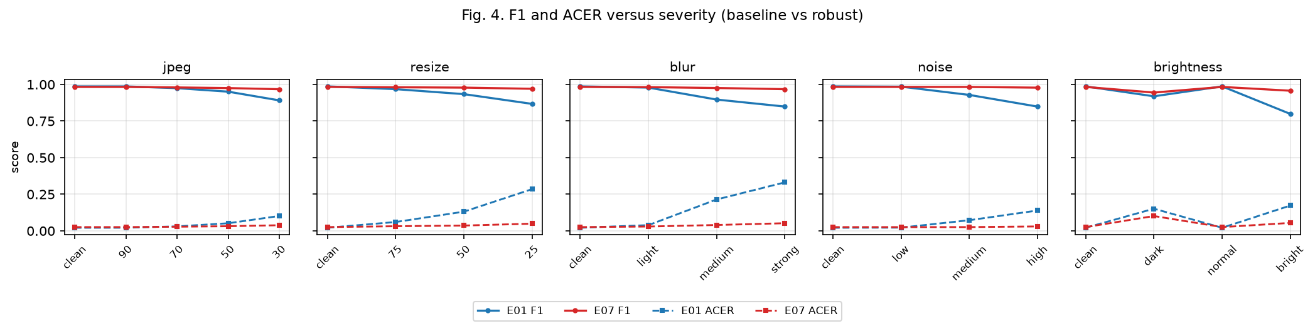
Fig. 4. F1 and ACER of E01 (baseline) and E07 (robust) versus severity for JPEG, resize, blur, noise, and brightness.

5.3 Aggregate and Worst-Case Performance
Table VII aggregates each metric over the sixteen degradation conditions and Table VIII reports worst cases; Fig. 5 summarizes the aggregate comparison.
Table VII. Aggregates over the 16 degradation conditions.
Metric | E01 | E07 | Δ
Mean F1 | 0.9226 | 0.9743 | +0.0516
Mean ROC-AUC | 0.9785 | 0.9939 | +0.0155
Mean PR-AUC | 0.9877 | 0.9965 | +0.0088
Mean APCER | 0.0701 | 0.0225 | -0.0476
Mean BPCER | 0.1605 | 0.0555 | -0.1050
Mean ACER | 0.1153 | 0.0390 | -0.0763
Table VIII. Worst-case performance over the 16 degradation conditions.
Metric | E01 | E07
Worst F1 | 0.7985 (brightness bright) | 0.9446 (brightness dark)
Worst ACER | 0.3310 (blur strong) | 0.1012 (brightness dark)
Robust training improves every aggregate metric: mean F1 +0.0516, mean ROC-AUC +0.0155, mean PR-AUC +0.0088, mean ACER -0.0763. The BPCER gain (-0.1050) exceeds the APCER gain (-0.0476): robustness mainly recovers live presentations misclassified under resolution loss and blur. The worst-case conditions shift from blur strong and brightness bright (baseline) to brightness dark (robust). The robust model's worst F1 (0.9446) exceeds the baseline's mean F1 (0.9226), and its worst ACER (0.1012) is lower than the baseline's mean ACER (0.1153).
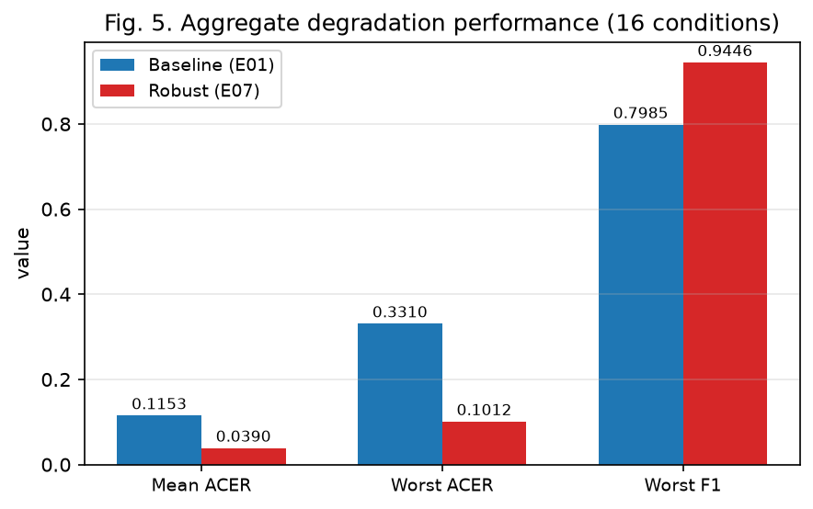
Fig. 5. Aggregate comparison over the 16 degradation conditions: mean ACER (0.1153 vs 0.0390), worst-case ACER (0.3310 vs 0.1012), and worst-case F1 (0.7985 vs 0.9446).

5.4 Per-Degradation Analysis
JPEG: both models degrade monotonically, but the gap favors the robust model: ΔF1 grows from -0.0036 at quality 90 to +0.0763 at quality 30 (ΔACER -0.0633); ROC-AUC improves at every level below 90.
Resize: the baseline exhibits a masking effect — F1 falls 0.9679→0.8672 while ROC-AUC collapses 0.9944→0.9405 and BPCER reaches 0.5622 at 25%. The robust model keeps F1 ≥0.9704, lifts ROC-AUC by up to +0.0517 and cuts BPCER to 0.0802 (ΔACER -0.2360).
Blur: baseline ranking declines sharply at medium/strong levels (ROC-AUC 0.9646/0.9161; BPCER 0.4218/0.6532; ACER 0.3310 at strong). The robust model recovers most of this (ΔAUC +0.0301/+0.0745; ΔBPCER -0.3565/-0.5711; ΔACER -0.2789 at strong — the largest absolute ACER improvement observed.
Noise: the baseline degrades visibly (F1 0.9849→0.9283→0.8487; APCER up to 0.2532), while the robust model is nearly flat (F1 0.9832→0.9828→0.9781; APCER ≤0.0251; ACER ≤0.0302; ΔF1 +0.1294 at high noise).
Brightness: both models are asymmetric between dark and bright. At factor 0.6 the baseline reports F1 0.9190 with BPCER 0.2762; at 1.4 its F1 drops to 0.7985 with APCER 0.3300. The robust model retains F1 0.9446/0.9571 (ΔACER -0.0500/-0.1187). Dark illumination is its weakest condition, still far above the baseline worst case.
Error-type structure per category (Table IX): for the baseline, JPEG and noise inflate APCER (category means 0.0810/0.1307) while resize and blur inflate BPCER (0.3111/0.3825). Robust training compresses both: blur BPCER 0.3825→0.0645, resize BPCER 0.3111→0.0637, noise APCER 0.1307→0.0185; in resize/blur its APCER is slightly higher (0.0141 vs 0.0064; 0.0165 vs 0.0070), so the error trade-off shifts rather than disappears.
Table IX. Mean error rates per degradation category.
Category | E01 F1 | E07 F1 | E01 ACER | E07 ACER | E01 APCER | E07 APCER | E01 BPCER | E07 BPCER
jpeg | 0.9507 | 0.9763 | 0.0513 | 0.0310 | 0.0810 | 0.0304 | 0.0216 | 0.0315
resize | 0.9230 | 0.9764 | 0.1587 | 0.0389 | 0.0064 | 0.0141 | 0.3111 | 0.0637
blur | 0.9080 | 0.9750 | 0.1948 | 0.0405 | 0.0070 | 0.0165 | 0.3825 | 0.0645
noise | 0.9206 | 0.9814 | 0.0779 | 0.0271 | 0.1307 | 0.0185 | 0.0252 | 0.0357
brightness | 0.9014 | 0.9616 | 0.1150 | 0.0603 | 0.1217 | 0.0304 | 0.1083 | 0.0902

5.5 Training Behavior and Discussion
Table X lists the training and validation loss per epoch; Fig. 6 plots the curves. Training loss decreases monotonically for both models, and the best validation epoch is 18 for both E01 (0.0586) and E07 (0.0681); the retained best-epoch checkpoints are used for every reported metric.
Table X. Training and validation loss per epoch.
Epoch | E01 train | E01 val | E07 train | E07 val
1 | 0.2757 | 0.2065 | 0.3215 | 0.2267
2 | 0.1827 | 0.1487 | 0.2326 | 0.1644
3 | 0.1407 | 0.1260 | 0.1920 | 0.1434
4 | 0.1163 | 0.1130 | 0.1678 | 0.1343
5 | 0.0992 | 0.1089 | 0.1486 | 0.1329
6 | 0.0865 | 0.0908 | 0.1356 | 0.1030
7 | 0.0759 | 0.0786 | 0.1238 | 0.1004
8 | 0.0675 | 0.0756 | 0.1143 | 0.0899
9 | 0.0601 | 0.0696 | 0.1059 | 0.0845
10 | 0.0550 | 0.0731 | 0.1005 | 0.0966
11 | 0.0486 | 0.0678 | 0.0952 | 0.0874
12 | 0.0441 | 0.0639 | 0.0872 | 0.0852
13 | 0.0405 | 0.0714 | 0.0820 | 0.0918
14 | 0.0362 | 0.0673 | 0.0782 | 0.0921
15 | 0.0342 | 0.0628 | 0.0756 | 0.0715
16 | 0.0310 | 0.0654 | 0.0718 | 0.0716
17 | 0.0282 | 0.0636 | 0.0675 | 0.0733
18 | 0.0265 | 0.0586 | 0.0651 | 0.0681
19 | 0.0258 | 0.0601 | 0.0610 | 0.0735
20 | 0.0234 | 0.0636 | 0.0592 | 0.0719
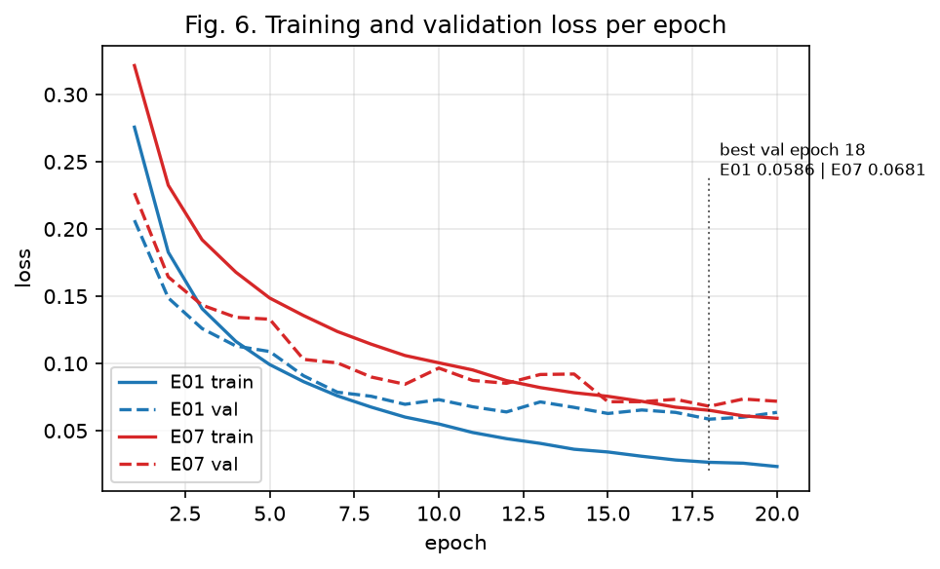
Fig. 6. Training and validation loss per epoch; best validation epoch 18 for both models (E01 0.0586, E07 0.0681).
The results are consistent with the hypothesis that quality-augmented training encourages features less dependent on fine, quality-sensitive image statistics: the largest gains occur at the most severe levels of blur, resize, brightness, and noise — the conditions where the baseline loses the most — while clean-test performance is essentially unchanged. The measured performance differences are demonstrated by the experiments; the feature-level explanation itself remains a hypothesis. Two further observations follow from Table VI. First, fixed-threshold F1 can mask ranking collapse: under resize and blur the baseline's F1 falls slowly while ROC-AUC drops sharply and BPCER rises, so PAD evaluations should report AUC and both error rates. Second, after robust training the residual gap is largest at dark illumination, indicating that augmentation alone does not fully equalize all conditions.

6. Limitations
(1) Only binary live/spoof labels are available in the dataset mirror, so per-attack-type (print/replay/mask) behavior cannot be analyzed. (2) Degradations are synthetic and do not fully reproduce real capture pipelines. (3) No cross-dataset or device-level evaluation was performed. (4) No formal latency benchmark was measured (model size: 2,225,153 parameters, 8.62 MB). (5) No per-augmentation ablation was performed at this scale. (6) Checkpoint selection uses validation loss rather than a validation error rate. (7) The threshold is fixed at 0.5 by protocol, with no threshold tuning on validation data. (8) A mild APCER/BPCER imbalance persists at the fixed threshold on clean data (E01 BPCER 0.0331 vs APCER 0.0091), reported as a protocol-level observation.

7. Conclusion
Quality-aware augmentation improves the robustness of a lightweight MobileNetV2 face PAD model under image quality degradations. The robust model improves ACER in 13 of 16 conditions and F1 in 13 of 16; mean F1 over the degradation grid rises 0.9226→0.9743 and mean ACER falls 0.1153→0.0390. Worst-case behavior improves markedly (F1 0.7985→0.9446; ACER 0.3310→0.1012), and clean-test performance is essentially unchanged (F1 0.9868→0.9831; ROC-AUC 0.9978→0.9969). Gains are largest where the baseline is weakest — strong blur, heavy downscaling, and bright or noisy capture. Future work includes real-device evaluation, latency benchmarking, per-augmentation ablation, threshold calibration on validation data, and cross-dataset evaluation.

References
[1] S. Ramachandra and C. Busch, "Presentation attack detection methods for face recognition systems: A comprehensive survey," ACM Comput. Surveys, vol. 50, no. 1, pp. 1–37, 2017. Available: https://doi.org/10.1145/3038924
[2] K. Patel, H. Han, and A. K. Jain, "Secure face unlock: Spoof detection on smartphones," IEEE Trans. Inf. Forensics Security, vol. 11, no. 10, pp. 2268–2283, 2016. Available: https://doi.org/10.1109/TIFS.2016.2578288
[3] J. Määttä, A. Hadid, and M. Pietikäinen, "Face spoofing detection from single images using micro-texture analysis," in Proc. IJCB, 2011, pp. 1–7. Available: https://doi.org/10.1109/IJCB.2011.6117510
[4] I. Chingovska, A. Anjos, and S. Marcel, "On the effectiveness of local binary patterns in face anti-spoofing," in Proc. BIOSIG, 2012, pp. 1–7. Available: https://publications.idiap.ch/index.php/publications/showcite/Chingovska_Idiap-RR-19-2012
[5] Y. Zhang et al., "CelebA-Spoof: Large-scale face anti-spoofing dataset with rich annotations," in Proc. ECCV, 2020. Available: https://arxiv.org/abs/2007.12342
[6] Z. Boulkenafet, J. Komulainen, L. Li, X. Feng, and A. Hadid, "OULU-NPU: A mobile face presentation attack database with real-world variations," in Proc. IEEE FG, 2017, pp. 612–618. Available: https://doi.org/10.1109/FG.2017.77
[7] Y. Liu, A. Jourabloo, and X. Liu, "Learning deep models for face anti-spoofing: Binary or auxiliary supervision," in Proc. CVPR, 2018, pp. 389–398. Available: https://doi.org/10.1109/CVPR.2018.00048
[8] A. George and S. Marcel, "Deep pixel-wise binary supervision for face presentation attack detection," in Proc. ICB, 2019, pp. 1–8. Available: https://doi.org/10.1109/ICB45273.2019.8987370
[9] M. Sandler, A. Howard, M. Zhu, A. Zhmoginov, and L.-C. Chen, "MobileNetV2: Inverted residuals and linear bottlenecks," in Proc. CVPR, 2018, pp. 4510–4520. Available: https://doi.org/10.1109/CVPR.2018.00474
[10] A. G. Howard et al., "MobileNets: Efficient convolutional neural networks for mobile vision applications," arXiv:1704.04861, 2017. Available: https://arxiv.org/abs/1704.04861
[11] D. Hendrycks and T. Dietterich, "Benchmarking neural network robustness to common corruptions and perturbations," in Proc. ICLR, 2019. Available: https://arxiv.org/abs/1903.12261
[12] C. Shorten and T. M. Khoshgoftaar, "A survey on image data augmentation for deep learning," J. Big Data, vol. 6, no. 60, 2019. Available: https://doi.org/10.1186/s40537-019-0197-0
[13] E. D. Cubuk, B. Zoph, D. Mane, V. Vasudevan, and Q. V. Le, "AutoAugment: Learning augmentation strategies from data," in Proc. CVPR, 2019, pp. 113–123. Available: https://doi.org/10.1109/CVPR.2019.00020
[14] Y. Zhang et al., "CelebA-Spoof Challenge 2020 on face anti-spoofing: Methods and results," arXiv:2102.12642, 2021. Available: https://arxiv.org/abs/2102.12642
[15] J. Deng, W. Dong, R. Socher, L.-J. Li, K. Li, and L. Fei-Fei, "ImageNet: A large-scale hierarchical image database," in Proc. CVPR, 2009, pp. 248–255. Available: https://doi.org/10.1109/CVPR.2009.5206848

Appendix
A. Reproducibility. Dataset: CelebA-Spoof mirror Ar4ikov/celebA_spoof; subject-disjoint split, seed 123 (142,250/20,322/40,643), fixed test set. Model: MobileNetV2 (2,225,153 parameters). Threshold 0.5. Weights: best validation-loss checkpoint (epoch 18 for both models). Evaluation: deterministic loader (no shuffling), identical degradation grid (Table III). Git commit 296643e1ec9194e4cb5d4c6023fa5e3fd574e40f.
B. Confusion Matrices. Clean test, threshold 0.5; positive class = spoof; rows = actual, columns = predicted (TN/FN/FP/TP).
Table XI. Confusion matrices on the clean test set.
Model | TN | FN | FP | TP | Total
E01 | 13557 | 243 | 464 | 26379 | 40,643
E07 | 13513 | 396 | 508 | 26226 | 40,643
C. Raw Results. results/raw/E01_baseline_seed123_bestepoch.json, results/raw/E07_robust_seed123_bestepoch.json, results/raw/E01_baseline_seed123.json and E07_robust_seed123.json (training history/runtime), results/raw/E02-E06_*_seed123.json, E08-E12_*_seed123.json, results/tables/degradation_baseline.csv, degradation_robust.csv, data/splits/celeba_spoof_seed123_subject_disjoint.json.

