Robust Face Presentation Attack Detection for eKYC Under Image Quality Degradations
[Author Names]
Abstract
Face presentation attack detection (PAD) is a critical safeguard for facial electronic know-your-customer (eKYC) systems, yet real-world capture conditions routinely degrade input image quality through compression, resolution loss, blur, sensor noise, and illumination changes. This paper presents an empirical study of how a lightweight MobileNetV2-based PAD model responds to such degradations, and whether quality-aware augmentation improves robustness. A baseline model and a robust model were trained on a 203,215-image subset of the CelebA-Spoof dataset under identical hyperparameters; the robust model was additionally trained with randomized JPEG, resize, blur, noise, and brightness augmentations. Both models were evaluated on the same fixed 20,042-image test set across sixteen degradation conditions. On clean inputs, the robust model attains an F1 score of 0.8502 and an ACER of 0.1421, compared with 0.8246 and 0.1568 for the baseline. Averaged over all degradation conditions, the robust model raises mean F1 from 0.7028 to 0.8360 and reduces mean ACER from 0.2588 to 0.1580. The largest gains occur under noise corruption, where the baseline F1 drops to 0.2678 while the robust model retains 0.8288. These results indicate that quality-aware augmentation substantially improves the degradation robustness of a lightweight face PAD model without sacrificing clean-test performance (F1 +0.0256, ROC-AUC -0.0022).
Keywords
face anti-spoofing, face presentation attack detection, image quality degradation, MobileNetV2, quality-aware augmentation, robust face PAD
1. Introduction
1.1 FinTech/eKYC and the Role of Face PAD
Remote identity verification, commonly referred to as electronic know-your-customer (eKYC), has become a standard step in onboarding users for financial services. A central component of facial eKYC is verifying that a live person is present in front of the camera, rather than a photograph, a printed paper, or a replayed screen image of a legitimate user. This decision is performed by face presentation attack detection (PAD) systems, which classify a captured face as bona fide (live) or as a presentation attack (spoof). Because PAD failures can directly enable identity fraud, the reliability of these detectors under realistic operating conditions is of practical importance [1], [2].
1.2 Presentation Attacks and Image Quality
Presentation attacks do not require access to the victim's device: an attacker can print a face image, display it on a phone or tablet, or wear a mask [1]. Detection methods therefore rely on subtle cues such as micro-texture, color distribution, and micro-texture and color distribution [3], [4]. These cues are precisely the signal components that are most sensitive to image quality. In deployed eKYC pipelines, the captured image is subject to camera compression, resolution limits, motion blur, sensor noise, and varying illumination, all of which can attenuate or corrupt the artifacts that PAD models exploit.
1.3 Face PAD Under Degradation
Deep learning based PAD models are typically trained on curated public datasets and evaluated on clean, well-aligned images. However, robustness to quality degradation is not guaranteed by strong clean-test performance. This motivates a systematic evaluation of a fixed model under controlled degradations, as well as the study of training strategies that improve degradation robustness without changing the model architecture.
1.4 Motivation for Robust Training
A practical and inexpensive strategy to improve robustness is quality-aware augmentation: during training, each image is randomly transformed with simulated quality degradations, so that the model learns features that are less dependent on pristine image quality. This approach requires no architectural modification and is therefore well suited to lightweight deployment constraints.
1.5 Objective
This project investigates two questions on a large subset of the CelebA-Spoof dataset [5]: (i) how does a lightweight MobileNetV2 PAD baseline degrade as input quality decreases under JPEG compression, resolution reduction, blur, noise, and brightness changes; and (ii) does a robust model trained with quality-aware augmentation maintain higher detection performance under the same degradations while preserving clean-test performance?
1.6 Contributions
The main contributions of this work are: (1) a reproducible MobileNetV2 baseline for binary face PAD trained on a 203,215-image subset of CelebA-Spoof; (2) a robust-training pipeline based on five quality-aware augmentations applied with controlled probabilities; (3) a systematic stress-test protocol consisting of sixteen degradation conditions applied to a fixed test set; and (4) a quantitative comparison of baseline and robust models showing that quality-aware augmentation improves degradation robustness, most strongly under noise, without sacrificing clean-test performance.
1.7 Organization
Section 2 reviews related work. Section 3 describes the methodology, including the dataset, preprocessing, models, and training procedure. Section 4 details the experimental setup. Section 5 presents results and discussion. Sections 6 and 7 discuss limitations and conclude the paper.
2. Related Work
2.1 Face Presentation Attack Detection
Classical face PAD methods rely on hand-crafted texture cues. Maatta et al. [3] used local binary patterns to distinguish printed photographs from live faces based on micro-texture, and Chingovska et al. [4] systematically evaluated texture-based descriptors for anti-spoofing. These works established the observation that spoofing artifacts are encoded in fine image statistics, which also makes them vulnerable to quality loss. Mobile capture settings were addressed by the OULU-NPU database [6], which provides real-world variations in illumination and capture devices. Patel et al. [2] studied spoof detection on smartphones, highlighting the deployment constraints that motivate lightweight solutions.
2.2 Deep Learning for Face PAD
Deep learning approaches improved accuracy over hand-crafted features. Liu et al. [7] showed that binary supervision is sufficient for anti-spoofing and analyzed the effect of auxiliary cues, while George and Marcel [8] proposed pixel-wise binary supervision for face PAD. These methods demonstrate that compact convolutional networks can learn discriminative spoof cues end-to-end, forming the basis of the binary MobileNetV2 detector used in this work.
2.3 Lightweight Models and MobileNet
MobileNetV2 [9] introduced inverted residual blocks with linear bottlenecks, achieving strong accuracy at low parameter counts, and the MobileNet family [10] is widely adopted for on-device vision. Its efficiency motivates its choice here: the PAD model in this study contains only 2,225,153 parameters (8.62 MB).
2.4 Robustness Against Image Quality Degradation
Hendrycks and Dietterich [11] benchmarked image classifiers under common corruptions and showed that accuracy degrades substantially under noise and blur, even for strong clean-test models. This motivates evaluating PAD models under controlled quality degradations rather than assuming that clean-test performance transfers to degraded inputs.
2.5 Data Augmentation for Robust Visual Classification
Data augmentation is a standard regularizer in visual learning [12]. Learned policies such as AutoAugment [13] demonstrate that augmentation choices strongly affect generalization. In this work, augmentation is used not as a generic regularizer but as explicit quality simulation, following the same principle: exposing training to input variation can improve behavior on shifted conditions.
2.6 CelebA-Spoof Dataset
CelebA-Spoof [5] is a large-scale face anti-spoofing dataset with 625,537 images from 10,177 subjects, annotated with spoof types, illumination, and environment. The accompanying challenge report [14] summarizes protocols and baselines. Its scale and subject diversity make it suitable for training and stress-testing PAD models; this work uses a controlled 203,215-image training subset drawn from a public mirror of the dataset.
3. Methodology
3.1 Overall Pipeline
The experimental pipeline follows five stages: (i) dataset preparation and a official train/validation/test split with a fixed test set; (ii) face-crop preprocessing to 224x224 with ImageNet normalization; (iii) training of a MobileNetV2 binary classifier, either clean (baseline E01) or with quality-aware augmentation (robust E07); (iv) evaluation on the clean test set; and (v) stress-testing under sixteen controlled degradation conditions without any retraining. Both models are evaluated with identical metrics, thresholds, and test data. The overall pipeline is illustrated in Fig. 1.
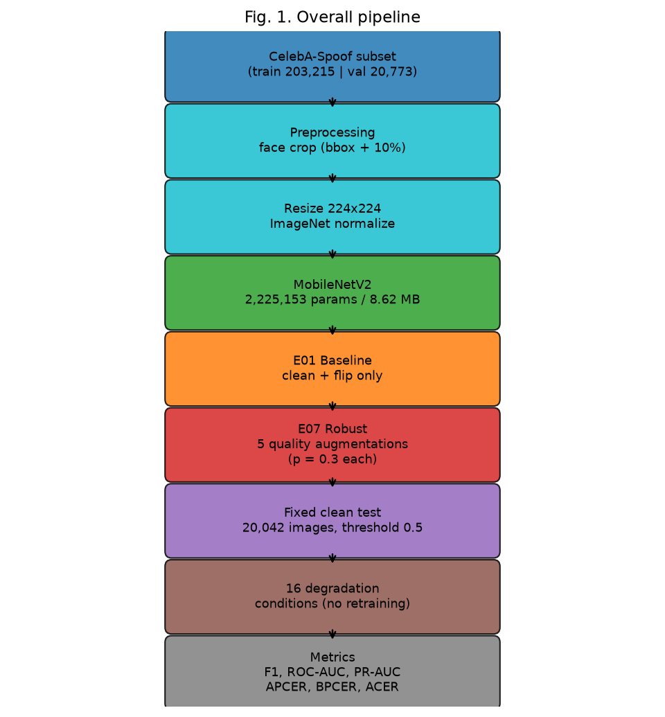
Fig. 1. Overall pipeline of the study: CelebA-Spoof -> face crop (bbox + 10% margin) -> 224x224 + ImageNet normalization -> MobileNetV2 (2,225,153 parameters) -> E01 clean training / E07 quality-aware augmentation -> fixed clean test (20,042) -> 16 deterministic degradation conditions -> metric comparison (F1, ROC-AUC, PR-AUC, APCER, BPCER, ACER)
3.2 Dataset
All experiments use a public HuggingFace mirror (Ar4ikov/celebA_spoof) of the CelebA-Spoof dataset [5]. The mirror provides images, face bounding boxes, and binary live/spoof labels organized into official train/validation/test splits, which are subject-separated by design. This split was used without modification; it originates from the official CelebA-Spoof protocol, which is designed to separate subjects across partitions (the mirror itself does not expose subject identifiers). For this study, the following controlled subset was downloaded: 203,215 training images (70,288 live and 132,927 spoof), 20,773 validation images (7,198 live and 13,575 spoof), and 20,042 test images (5,879 live and 14,163 spoof). The test set was fixed before any training and was never modified; both models were evaluated on exactly these 20,042 images. Only binary labels (0 = bona fide, 1 = spoof) are available in this mirror; fine-grained attack-type metadata is not present.
3.3 Preprocessing
Each image is cropped to the face region using the provided bounding box expanded by a 10% margin, resized to 224x224, converted to a tensor, and normalized with ImageNet mean and standard deviation [15]. During baseline training, only random horizontal flipping is applied; the evaluation transform is deterministic and contains no augmentation.
3.4 Baseline Model
The PAD model is MobileNetV2 [9] with its classifier replaced by a single logit for binary classification, giving 2,225,153 parameters (8.62 MB). The output logit is passed through a sigmoid to obtain the spoof probability, and training uses binary cross-entropy with logits (BCEWithLogitsLoss) without class weighting.
3.5 Robust Training
The robust model uses the same architecture and training procedure as the baseline, differing only in training-time augmentation. Five quality-degradation augmentations are applied to each training image independently, each with probability p = 0.3, so that multiple degradations can stack on the same image while approximately 17% of images remain unmodified (0.7^5). Severity values are sampled uniformly from the configured ranges: JPEG quality U[50,90]; resize scale U[0.5,1.0]; Gaussian blur sigma U[0.5,2.0]; Gaussian noise standard deviation U[0.005,0.03]; and brightness factor U[0.7,1.3]. A crop augmentation was disabled for the main experiment so that the augmentation set matches the five degradation types used in evaluation.
3.6 Training Procedure
Both models are trained for 20 epochs with batch size 64, the Adam optimizer with learning rate 1e-4 and weight decay 1e-5, and seed 123, on a single NVIDIA RTX 3050 Laptop GPU. The same split file (official subject-separated split) and the same seed are used for both runs. Checkpoints are written after every epoch to a fixed path; because the implementation overwrites the same file, the retained checkpoint corresponds to the final epoch (20), not to the epoch with the best validation loss.
3.7 Evaluation Protocol
All evaluations use the fixed 20,042-image test set with a constant decision threshold of 0.5, the same metric implementation, and the same deterministic test loader. Degradation evaluation never updates model weights: the degraded test variants are produced on-the-fly by applying one deterministic degradation to each test image before the standard evaluation transform. The same degradation grid is used for the baseline (experiments E02-E06) and the robust model (E08-E12), guaranteeing a fair comparison.
3.8 Metrics
Let TP, FP, FN, TN denote true positives (spoof predicted as spoof), false positives, false negatives, and true negatives at the fixed threshold. Accuracy = (TP+TN)/N; Precision = TP/(TP+FP); Recall = TP/(TP+FN); F1 = 2PR/(P+R). ROC-AUC and PR-AUC are threshold-independent ranking metrics. Following standard PAD terminology, with spoof as the positive class: APCER (Attack Presentation Classification Error Rate) = FN/(TP+FN), the fraction of attacks accepted as bona fide; BPCER (Bona fide Presentation Classification Error Rate) = FP/(FP+TN), the fraction of live presentations rejected as attacks; and ACER = (APCER+BPCER)/2. Lower APCER/BPCER/ACER is better; for F1 and the AUC metrics, higher is better.
3.9 Augmentation Stacking
Because the five augmentations are applied independently, the number of augmentations stacked on a single training image follows a binomial distribution B(5, 0.3). The resulting probabilities are 16.8% for zero augmentations, 36.0% for one, 30.9% for two, 13.2% for three, 2.8% for four, and 0.2% for five, with an expected value of 1.5 augmentations per image (Table I). This keeps a non-negligible fraction of clean images in every epoch while exposing most images to one or two quality distortions.
TABLE I. AUGMENTATION STACKING DISTRIBUTION (B(5, 0.3))
Augmentations per image | 0 | 1 | 2 | 3 | 4 | 5
Probability | 0.1681 | 0.3602 | 0.3087 | 0.1323 | 0.0284 | 0.0024

4. Experimental Setup
All training and evaluation ran on a single NVIDIA GeForce RTX 3050 Laptop GPU (4 GB, Windows 11) with Python 3.14.6, PyTorch 2.13.0+cu126, and torchvision 0.28.0+cu126; both experiments used the same repository state (git commit 8b865b09195ff3f97034044529fa3af61b1f6b72). The dataset is the CelebA-Spoof mirror Ar4ikov/celebA_spoof (train 203,215 / validation 20,773 / test 20,042; official subject-separated split; seed 123; binary labels). Table II summarizes the training configuration.
4.1 Training Configuration
TABLE II. TRAINING CONFIGURATION (IDENTICAL FOR E01 AND E07)
Parameter | Value | Parameter | Value
Model | MobileNetV2 (2,225,153 params) | Epochs | 20
Input size | 224x224 | Batch size | 64
Optimizer | Adam | Learning rate | 1e-4
Weight decay | 1e-5 | Loss | BCEWithLogitsLoss
Class weighting | none | Seed | 123
Threshold | 0.5 | Train workers | 4
Train images | 203,215 | Val images | 20,773
Test images | 20,042 (fixed) | Augmentation (E01) | RandomHorizontalFlip

4.2 Baseline Experiment E01
E01 trains MobileNetV2 on clean images with horizontal flipping only. Training took 70,957 seconds (19.7 hours). The resulting checkpoint is stored at results/checkpoints/E01_baseline_seed123.pt (epoch 20).
4.3 Robust Experiment E07
E07 uses the same configuration plus the five quality-aware augmentations described in Section 3.5 (crop disabled). Training took 74,106 seconds (20.6 hours). The checkpoint is stored at results/checkpoints/E07_robust_seed123.pt (epoch 20).
4.4 Degradation Test Matrix
TABLE III. DEGRADATION TEST MATRIX (16 CONDITIONS)
Category | Levels | Parameters
JPEG | 90 / 70 / 50 / 30 | quality = 90, 70, 50, 30
Resize | 75% / 50% / 25% | scale = 0.75, 0.50, 0.25
Blur | light / medium / strong | k3 s0.6 / k7 s1.8 / k11 s3.0
Noise | low / medium / high | std = 0.005 / 0.015 / 0.03
Brightness | dark / normal / bright | factor = 0.6 / 1.0 / 1.4

Example degraded variants of one live and one spoof test image are shown in Fig. 2. Each category models a concrete capture failure: lossy transfer compression (JPEG), client downscaling (resize), motion or defocus (blur), low-light sensor noise, and illumination variation (brightness).
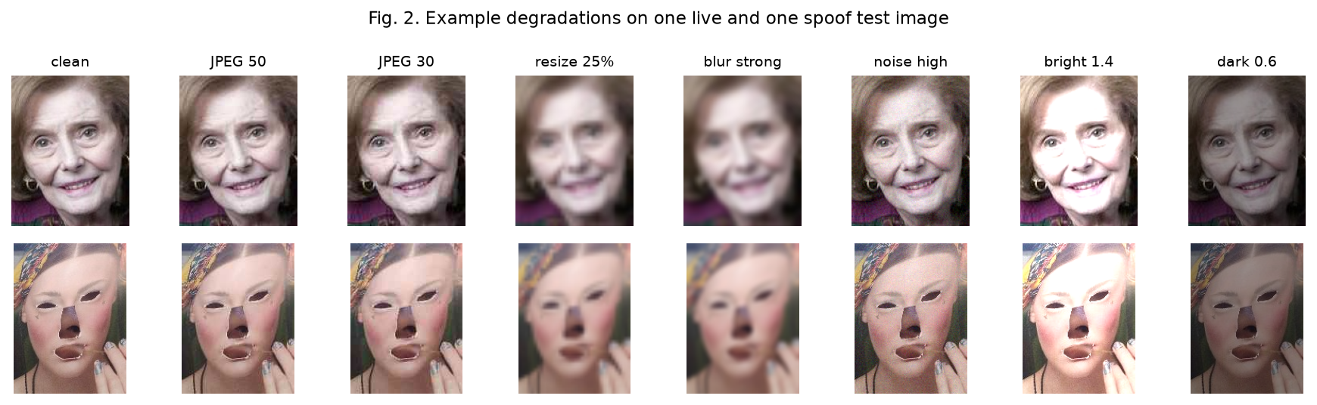
Fig. 2. Example degradations applied to one live (bona fide) and one spoof test image: clean, JPEG 90/50/30, resize 75/25%, blur light/strong, noise low/high, brightness dark/bright
5. Results and Discussion
5.1 Clean Performance
TABLE IV. CLEAN TEST PERFORMANCE (20,042 IMAGES, THRESHOLD 0.5)
Metric | E01 Baseline | E07 Robust
Accuracy | 0.7872 | 0.8132
Precision | 0.9876 | 0.9814
Recall | 0.7078 | 0.7499
F1 | 0.8246 | 0.8502
ROC-AUC | 0.9629 | 0.9607
PR-AUC | 0.9840 | 0.9826
APCER | 0.2922 | 0.2501
BPCER | 0.0214 | 0.0342
ACER | 0.1568 | 0.1421

Table IV shows that the robust model improves clean-test F1 by +0.0256 and reduces ACER by -0.0147. The trade-off is visible in the error rates: APCER improves from 0.2922 to 0.2501 (fewer attacks accepted), while BPCER increases from 0.0214 to 0.0342 (slightly more live presentations rejected). ROC-AUC decreases very slightly (-0.0022), indicating that the ranking ability on clean data is essentially unchanged. The confusion matrices are TN 5,753 / FN 4,138 / FP 126 / TP 10,025 for E01 and TN 5,678 / FN 3,542 / FP 201 / TP 10,621 for E07. The ROC curves of the two models on the clean test set are compared in Fig. 3.
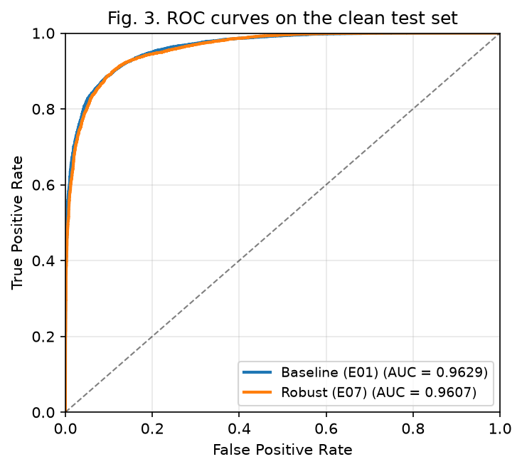
Fig. 3. ROC curves of the baseline (E01) and robust (E07) models on the clean 20,042-image test set (E01 AUC 0.9629, E07 AUC 0.9607)
5.2 Degradation Performance
TABLE V. E01 VS E07 UNDER ALL DEGRADATION CONDITIONS
Condition | Sev | E01 F1 | E07 F1 | dF1 | E01 AUC | E07 AUC | dAUC | E01 PRAUC | E07 PRAUC | dPRAUC | E01 APCER | E07 APCER | E01 BPCER | E07 BPCER | E01 ACER | E07 ACER | dACER
jpeg | 90 | 0.8253 | 0.8495 | +0.0241 | 0.9626 | 0.9602 | -0.0023 | 0.9838 | 0.9824 | -0.0014 | 0.2913 | 0.2509 | 0.0208 | 0.0352 | 0.1560 | 0.1430 | -0.0130
jpeg | 70 | 0.7199 | 0.8243 | +0.1044 | 0.9480 | 0.9501 | +0.0021 | 0.9774 | 0.9784 | +0.0010 | 0.4349 | 0.2900 | 0.0117 | 0.0306 | 0.2233 | 0.1603 | -0.0630
jpeg | 50 | 0.6125 | 0.8001 | +0.1876 | 0.9308 | 0.9423 | +0.0115 | 0.9694 | 0.9751 | +0.0057 | 0.5570 | 0.3247 | 0.0083 | 0.0304 | 0.2827 | 0.1776 | -0.1051
jpeg | 30 | 0.4323 | 0.7661 | +0.3338 | 0.9007 | 0.9318 | +0.0311 | 0.9549 | 0.9706 | +0.0157 | 0.7235 | 0.3714 | 0.0065 | 0.0301 | 0.3650 | 0.2007 | -0.1642
resize | 75% | 0.8411 | 0.8553 | +0.0142 | 0.9272 | 0.9524 | +0.0251 | 0.9678 | 0.9789 | +0.0111 | 0.2502 | 0.2387 | 0.0798 | 0.0456 | 0.1650 | 0.1421 | -0.0229
resize | 50% | 0.8427 | 0.8570 | +0.0143 | 0.8960 | 0.9469 | +0.0509 | 0.9523 | 0.9765 | +0.0241 | 0.2213 | 0.2334 | 0.1672 | 0.0543 | 0.1942 | 0.1438 | -0.0504
resize | 25% | 0.8387 | 0.8374 | -0.0012 | 0.8226 | 0.9272 | +0.1046 | 0.9163 | 0.9675 | +0.0512 | 0.1608 | 0.2575 | 0.3905 | 0.0742 | 0.2757 | 0.1658 | -0.1098
blur | light | 0.8401 | 0.8530 | +0.0128 | 0.9402 | 0.9552 | +0.0150 | 0.9740 | 0.9802 | +0.0062 | 0.2586 | 0.2431 | 0.0568 | 0.0429 | 0.1577 | 0.1430 | -0.0147
blur | medium | 0.8490 | 0.8513 | +0.0024 | 0.8526 | 0.9411 | +0.0885 | 0.9300 | 0.9739 | +0.0439 | 0.1681 | 0.2411 | 0.3080 | 0.0578 | 0.2381 | 0.1494 | -0.0886
blur | strong | 0.8357 | 0.8275 | -0.0083 | 0.7830 | 0.9206 | +0.1376 | 0.8963 | 0.9646 | +0.0683 | 0.1131 | 0.2730 | 0.5674 | 0.0728 | 0.3403 | 0.1729 | -0.1674
noise | low | 0.7504 | 0.8507 | +0.1004 | 0.9633 | 0.9606 | -0.0027 | 0.9838 | 0.9826 | -0.0012 | 0.3968 | 0.2495 | 0.0109 | 0.0335 | 0.2038 | 0.1415 | -0.0624
noise | medium | 0.3998 | 0.8467 | +0.4469 | 0.9083 | 0.9588 | +0.0505 | 0.9579 | 0.9819 | +0.0240 | 0.7498 | 0.2559 | 0.0039 | 0.0327 | 0.3768 | 0.1443 | -0.2325
noise | high | 0.2678 | 0.8288 | +0.5610 | 0.7804 | 0.9523 | +0.1718 | 0.8850 | 0.9795 | +0.0944 | 0.8440 | 0.2837 | 0.0223 | 0.0296 | 0.4331 | 0.1566 | -0.2765
brightness | dark | 0.8495 | 0.8754 | +0.0259 | 0.8555 | 0.9283 | +0.0728 | 0.9329 | 0.9670 | +0.0341 | 0.1634 | 0.1851 | 0.3208 | 0.1133 | 0.2421 | 0.1492 | -0.0929
brightness | normal | 0.8246 | 0.8502 | +0.0256 | 0.9629 | 0.9607 | -0.0022 | 0.9840 | 0.9826 | -0.0014 | 0.2922 | 0.2501 | 0.0214 | 0.0342 | 0.1568 | 0.1421 | -0.0147
brightness | bright | 0.5160 | 0.8030 | +0.2870 | 0.9063 | 0.9116 | +0.0053 | 0.9562 | 0.9592 | +0.0030 | 0.6509 | 0.3054 | 0.0094 | 0.0852 | 0.3301 | 0.1953 | -0.1348

Per-category F1 and ACER curves for both models are plotted against degradation severity in Fig. 4.
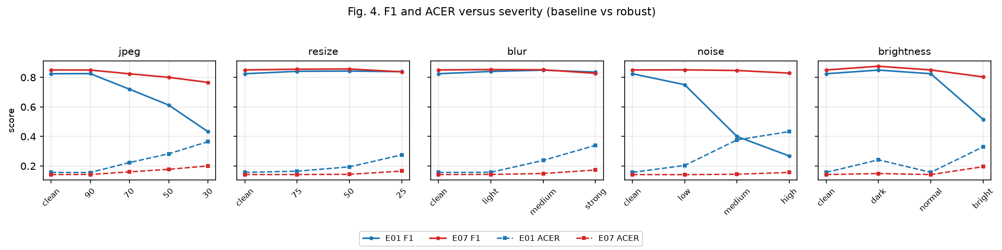
Fig. 4. F1 and ACER of E01 (baseline) and E07 (robust) versus severity for (a) JPEG, (b) resize, (c) blur, (d) noise, and (e) brightness
5.3 Aggregate Performance
TABLE VI. AGGREGATE RESULTS OVER THE 16 DEGRADATION CONDITIONS
Metric | E01 | E07 | Delta
Mean F1 | 0.7028 | 0.8360 | +0.1332
Mean ROC-AUC | 0.8963 | 0.9438 | +0.0475
Mean PR-AUC | 0.9514 | 0.9750 | +0.0237
Mean APCER | 0.3922 | 0.2658 | -0.1264
Mean BPCER | 0.1254 | 0.0501 | -0.0752
Mean ACER | 0.2588 | 0.1580 | -0.1008

Averaged over the sixteen degradation conditions, the robust model improves every aggregate metric: mean F1 increases by +0.1332, mean ROC-AUC by +0.0475, mean PR-AUC by +0.0237, while mean ACER decreases by -0.1008. The improvement in mean APCER (-0.1264) is larger than in mean BPCER (-0.0752), indicating that robust training mainly recovers attack-detection capability that the baseline loses under degradation.
5.4 Worst-Case Robustness
TABLE VII. WORST-CASE PERFORMANCE OVER THE 16 DEGRADATION CONDITIONS
Metric | E01 | E07
Worst-case F1 | 0.2678 (noise high) | 0.7661 (jpeg 30)
Worst-case ACER | 0.4331 (noise high) | 0.2007 (jpeg 30)

The worst-case condition differs between models. The baseline fails most severely under high noise (F1 0.2678, ACER 0.4331), whereas the robust model's worst condition is JPEG 30 (F1 0.7661, ACER 0.2007). The robust model's worst F1 (0.7661) exceeds the baseline's overall mean F1 (0.7028), and its worst ACER (0.2007) is lower than the baseline's mean ACER (0.2588).
5.5 Per-Degradation Analysis
JPEG. Both models degrade monotonically with compression quality, but the gap widens in favor of the robust model: dF1 grows from +0.0241 at quality 90 to +0.3338 at quality 30, and dACER reaches -0.1642 at quality 30. ROC-AUC is also improved at every level below 90.
Resize. The baseline exhibits a characteristic masking effect: its F1 remains near 0.84 across all scales while ROC-AUC collapses from 0.9272 to 0.8226 and BPCER rises to 0.3905 at 25%. The robust model lifts ROC-AUC substantially (+0.0251, +0.0509, +0.1046) and reduces BPCER to 0.0742 at 25%. F1 at 25% is marginally lower (-0.0012) for the robust model, but ACER still improves (-0.1098).
Blur. Similar to resize, the baseline's F1 stays stable while ranking quality declines (AUC 0.7830, BPCER 0.5674 at strong blur). The robust model recovers most of this: AUC +0.1376, BPCER -0.4946, ACER -0.1674 at strong blur. F1 at strong blur is slightly lower (-0.0083).
Noise. Noise is the degradation under which the baseline is weakest: F1 falls from 0.7504 (low) to 0.2678 (high), with APCER reaching 0.8440 and ACER 0.4331. The robust model nearly flattens this decline, keeping F1 between 0.8507 and 0.8288 and ACER at or below 0.1566, with dF1 as large as +0.5610 at high noise. This is the largest improvement observed in the study.
Brightness. Both models show an asymmetry between darkening and brightening. At factor 0.6 (dark), both models report F1 (0.8495 and 0.8754) higher than their clean-test F1, while ROC-AUC decreases (0.8555 and 0.9283). At factor 1.4 (bright), the baseline F1 drops to 0.5160 while the robust model retains 0.8030 (+0.2870). The elevated dark-condition F1 is reported as an observation; the mechanism is not established by the current experiments and no causal claim is made.
5.6 Training Behavior
TABLE VIII. TRAINING AND VALIDATION LOSS PER EPOCH
Epoch | E01 train | E01 val | E07 train | E07 val
1 | 0.2495 | 0.1574 | 0.2941 | 0.1833
2 | 0.1463 | 0.1208 | 0.2022 | 0.1373
3 | 0.1100 | 0.0988 | 0.1646 | 0.1237
4 | 0.0886 | 0.1157 | 0.1417 | 0.1103
5 | 0.0743 | 0.0668 | 0.1248 | 0.0873
6 | 0.0632 | 0.0810 | 0.1151 | 0.0914
7 | 0.0555 | 0.0637 | 0.1047 | 0.0780
8 | 0.0481 | 0.0526 | 0.0955 | 0.0909
9 | 0.0435 | 0.0678 | 0.0896 | 0.0783
10 | 0.0389 | 0.0513 | 0.0848 | 0.0654
11 | 0.0345 | 0.0447 | 0.0795 | 0.0614
12 | 0.0315 | 0.0461 | 0.0750 | 0.0690
13 | 0.0286 | 0.0475 | 0.0709 | 0.0782
14 | 0.0268 | 0.0429 | 0.0663 | 0.0766
15 | 0.0237 | 0.0491 | 0.0617 | 0.0551
16 | 0.0228 | 0.0426 | 0.0596 | 0.0635
17 | 0.0202 | 0.0422 | 0.0551 | 0.0631
18 | 0.0190 | 0.0384 | 0.0541 | 0.0498
19 | 0.0176 | 0.0394 | 0.0511 | 0.0565
20 | 0.0162 | 0.0417 | 0.0491 | 0.0595

Training loss decreases monotonically for both models. Validation loss is non-monotonic, with the best epoch being epoch 18 for both E01 (0.0384) and E07 (0.0498). Because the implementation overwrites the checkpoint file after every epoch, the retained checkpoints correspond to epoch 20 rather than the best-validation epoch; this is an implementation characteristic and the reported metrics correspond to the epoch-20 weights. The loss curves are plotted in Fig. 5.
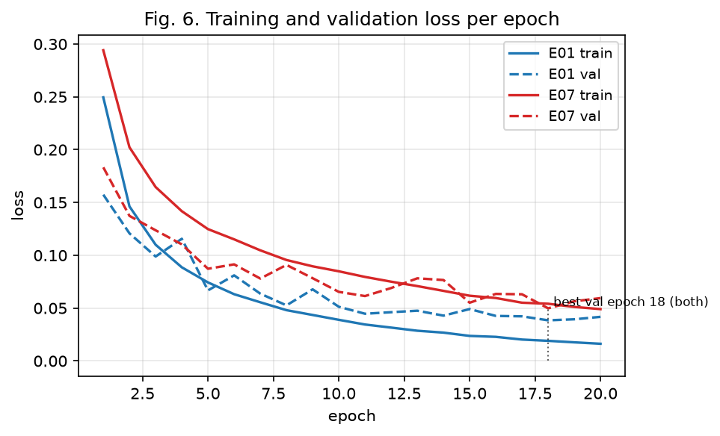
Fig. 5. Training and validation loss per epoch for the baseline (E01) and robust (E07) models; the best validation epoch is 18 for both models
5.7 Discussion
The empirical results support the hypothesis that exposing the model to quality-degraded inputs during training encourages features that are less dependent on fine, quality-sensitive image statistics. This interpretation is consistent with the observation that the largest gains occur for noise and JPEG, degradations that most strongly corrupt such statistics, and that clean-test performance is essentially preserved (F1 +0.0256, ROC-AUC -0.0022). The distinction between the measured results and this interpretation should be kept in mind: the experiments demonstrate the performance difference, while the feature-level explanation remains a hypothesis. The residual degradation order is also informative: after robust training, the worst condition shifts from noise to JPEG 30, and the remaining F1 gap at blur strong and resize 25% indicates that augmentation alone does not fully equalize all conditions. Aggregating per category, the dominant error type differs: for the baseline, JPEG and noise inflate APCER (category means 0.5017 and 0.6635), whereas resize and blur inflate BPCER (0.2125 and 0.3108); robust training compresses both (noise APCER to 0.2630, blur BPCER to 0.0578, resize BPCER to 0.0580).
6. Limitations
The study has the following limitations. (1) Only binary live/spoof labels are available in the dataset mirror used, so performance per attack type (print, replay, mask) cannot be analyzed. (2) Degradations are synthetic and do not fully reproduce real capture pipelines. (3) No cross-dataset or device-level evaluation was performed; robustness to unseen capture devices remains untested. (4) No formal latency benchmark was measured, although the model size is known (2,225,153 parameters, 8.62 MB). (5) No per-augmentation ablation was performed at the 200K scale. (6) Checkpoints for the best-validation epoch were not retained; reported metrics correspond to the final epoch. (7) The decision threshold is fixed at 0.5 by protocol; threshold selection on validation data was not performed. (8) Both models exhibit a large APCER/BPCER imbalance at the fixed threshold on clean data (e.g., E01 APCER 0.2922 vs BPCER 0.0214), which is reported as a protocol-level observation.
7. Conclusion and Future Work
This paper studied whether quality-aware augmentation improves the robustness of a lightweight MobileNetV2 face PAD model under image quality degradations. The results answer the research question affirmatively: the robust model improves ACER in 16/16 degradation conditions and F1 in 14/16 conditions; mean F1 over the degradation grid rises from 0.7028 to 0.8360 and mean ACER falls from 0.2588 to 0.1580. Worst-case behavior improves markedly, from F1 0.2678 and ACER 0.4331 (baseline, high noise) to F1 0.7661 and ACER 0.2007 (robust, JPEG 30). Clean-test performance is not sacrificed (F1 0.8246 to 0.8502; ROC-AUC 0.9629 to 0.9607). The improvement is largest exactly where the baseline is weakest, namely under noise corruption.
Future work includes: real-device and webcam evaluation across multiple capture devices and subjects; formal latency benchmarking; per-augmentation ablation to quantify the contribution of each quality simulation; threshold calibration on validation data; cross-dataset evaluation; and extension to datasets with attack-type metadata to analyze robustness per attack category.
References
[1] S. Ramachandra and C. Busch, "Presentation attack detection methods for face recognition systems: A comprehensive survey," ACM Computing Surveys, vol. 50, no. 1, pp. 1-37, 2017, doi: 10.1145/3038924.
[2] K. Patel, H. Han, and A. K. Jain, "Secure face unlock: Spoof detection on smartphones," IEEE Trans. Information Forensics and Security, vol. 11, no. 10, pp. 2268-2283, 2016, doi: 10.1109/TIFS.2016.2578288.
[3] J. Maatta, A. Hadid, and M. Pietikainen, "Face spoofing detection from single images using micro-texture analysis," in Proc. Int. Joint Conf. Biometrics (IJCB), 2011, pp. 1-7, doi: 10.1109/IJCB.2011.6117510.
[4] I. Chingovska, A. Anjos, and S. Marcel, "On the effectiveness of local binary patterns in face anti-spoofing," in Proc. Int. Conf. Biometrics Special Interest Group (BIOSIG), 2012, pp. 1-7.
[5] Y. Zhang, Z. Yin, Y. Li, G. Yin, J. Yan, J. Shao, and Z. Liu, "CelebA-Spoof: Large-scale face anti-spoofing dataset with rich annotations," in Proc. Eur. Conf. Computer Vision (ECCV), 2020, arXiv:2007.12342.
[6] Z. Boulkenafet, J. Komulainen, L. Li, X. Feng, and A. Hadid, "OULU-NPU: A mobile face presentation attack database with real-world variations," in Proc. 12th IEEE Int. Conf. Automatic Face & Gesture Recognition (FG), 2017, pp. 612-618, doi: 10.1109/FG.2017.77.
[7] Y. Liu, A. Jourabloo, and X. Liu, "Learning deep models for face anti-spoofing: Binary or auxiliary supervision," in Proc. IEEE/CVF Conf. Computer Vision and Pattern Recognition (CVPR), 2018, pp. 389-398, doi: 10.1109/CVPR.2018.00048.
[8] A. George and S. Marcel, "Deep pixel-wise binary supervision for face presentation attack detection," in Proc. Int. Conf. Biometrics (ICB), 2019, pp. 1-8, doi: 10.1109/ICB45273.2019.8987370.
[9] M. Sandler, A. Howard, M. Zhu, A. Zhmoginov, and L.-C. Chen, "MobileNetV2: Inverted residuals and linear bottlenecks," in Proc. IEEE/CVF Conf. Computer Vision and Pattern Recognition (CVPR), 2018, pp. 4510-4520, doi: 10.1109/CVPR.2018.00474.
[10] A. G. Howard et al., "MobileNets: Efficient convolutional neural networks for mobile vision applications," arXiv:1704.04861, 2017.
[11] D. Hendrycks and T. Dietterich, "Benchmarking neural network robustness to common corruptions and perturbations," in Proc. Int. Conf. Learning Representations (ICLR), 2019, arXiv:1903.12261.
[12] C. Shorten and T. M. Khoshgoftaar, "A survey on image data augmentation for deep learning," J. Big Data, vol. 6, no. 60, 2019, doi: 10.1186/s40537-019-0197-0.
[13] E. D. Cubuk, B. Zoph, D. Mane, V. Vasudevan, and Q. V. Le, "AutoAugment: Learning augmentation strategies from data," in Proc. IEEE/CVF Conf. Computer Vision and Pattern Recognition (CVPR), 2019, pp. 113-123, doi: 10.1109/CVPR.2019.00020.
[14] Y. Zhang et al., "CelebA-Spoof Challenge 2020 on face anti-spoofing: Methods and results," arXiv:2102.12642, 2021.
[15] J. Deng, W. Dong, R. Socher, L.-J. Li, K. Li, and L. Fei-Fei, "ImageNet: A large-scale hierarchical image database," in Proc. IEEE Conf. Computer Vision and Pattern Recognition (CVPR), 2009, pp. 248-255, doi: 10.1109/CVPR.2009.5206848.

