Robust Face Presentation Attack Detection for eKYC
Under Image Quality Degradations
[Author Names]
Abstract. Face presentation attack detection (PAD) protects facial electronic know-your-customer (eKYC) flows against spoofing, but the input to a PAD model is subject to image-quality degradations introduced by capture and transmission. This paper studies, on a 203,215-image subset of CelebA-Spoof, how a lightweight MobileNetV2 PAD model responds to controlled synthetic degradations (JPEG compression, resolution reduction, blur, noise, and brightness) and whether quality-aware augmentation improves robustness. A baseline and a robust model were trained from scratch under identical settings; the robust model additionally applied randomized quality degradations at probability 0.3. Both models, using best-validation-epoch weights, were evaluated on a fixed 40,643-image test set at a fixed decision threshold of 0.5 across sixteen degradation conditions. Robust training incurs a small clean-test cost (F1 0.9868 to 0.9831; ACER 0.0211 to 0.0256) while substantially improving degraded performance: mean F1 over the degradation grid rises from 0.9226 to 0.9743, mean ACER falls from 0.1153 to 0.0390, and worst-case ACER improves from 0.3310 to 0.1012, with statistically significant gains in 13 of 16 conditions. All experiments are based on a single training seed.
Keywords: face anti-spoofing, face presentation attack detection, image quality degradation, MobileNetV2, quality-aware augmentation
1 Introduction
Remote identity verification (eKYC) is a standard step in onboarding users for financial services. Its core security component is face presentation attack detection (PAD): classifying a captured face as bona fide or as a presentation attack such as a printed photograph, a replayed screen, or a mask [1], [2]. Detectors rely on subtle cues such as micro-texture and color statistics [3], [4]; these are precisely the signal components most sensitive to image-quality loss. In deployed pipelines, captured images undergo camera compression, resolution limits, motion blur, sensor noise, and illumination variation, all of which can attenuate the very artifacts that PAD models exploit.
Deep PAD models are typically trained on curated datasets and evaluated on clean images, yet robustness to quality degradation is not guaranteed by strong clean-test performance [11]. Quality-aware augmentation offers a practical, architecture-free remedy: degrading training images randomly so that the model learns features less dependent on pristine image quality [12], [13]. This work investigates two questions on a controlled subset of CelebA-Spoof [5]: (i) how does a lightweight MobileNetV2 PAD baseline degrade under JPEG compression, resolution reduction, blur, noise, and brightness changes; and (ii) does a robust model trained with quality-aware augmentation retain higher performance under the same degradations, and at what clean-test cost?
The contributions are: (1) a reproducible MobileNetV2 baseline trained from scratch on a 203,215-image subset of CelebA-Spoof; (2) a robust-training pipeline of five quality augmentations applied with controlled probability; (3) a systematic sixteen-condition stress-test protocol on a fixed test set, including degradations more severe than any seen during training; and (4) a quantitative baseline-versus-robust comparison with paired-bootstrap significance analysis. We emphasize that the reported robustness is robustness under controlled synthetic image-quality degradations, not a claim of production readiness for real-world eKYC deployment.
2 Related Work
Classical face PAD methods use hand-crafted texture cues: local binary patterns distinguish printed photographs from live faces via micro-texture [3], and texture descriptors were systematically evaluated for anti-spoofing [4]. Mobile capture conditions were addressed by the OULU-NPU database [6] and by smartphone spoof-detection studies [2]. Deep learning improved accuracy: binary supervision was shown sufficient for anti-spoofing [7], including pixel-wise binary supervision [8]. We adopt MobileNetV2 [9] for its low parameter count (2,225,153 parameters, 8.62 MB) and on-device efficiency [10].
A closely related line of work studies generalization of PAD models across domains: multi-adversarial domain generalization [16], single-side domain generalization [17], central difference convolutions for domain-invariant spoof cues [18], and separability-and-alignment objectives for domain generalization [19]; fine-grained patch recognition further improves robustness to unseen attack domains [20]. These works primarily target cross-dataset or cross-domain generalization, whereas our study targets a different, complementary axis: systematic degradation of input image quality within a single dataset. Corruption benchmarks show that accuracy drops substantially under noise and blur even for strong clean-test models [11]; data augmentation is a standard means to improve behavior on shifted conditions [12], [13]. CelebA-Spoof [5] provides 625,537 images from 10,177 subjects with established protocols [14], and ImageNet statistics are used for normalization [15].
3 Methodology
3.1 Dataset and Split
We use a public HuggingFace mirror (Ar4ikov/celebA_spoof) of CelebA-Spoof [5], which provides images, face bounding boxes, and binary live/spoof labels. A controlled subset of 203,215 images (70,288 live, 132,927 spoof) is split with seed 123 into 142,250 training, 20,322 validation, and 40,643 test images, fixed before training and never modified. Because the mirror does not expose real subject identities, samples are partitioned at the image level; consequently the split measures generalization to unseen images, not to unseen subjects. Only binary labels are available, so per-attack-type analysis is not possible.
3.2 Model and Training
The PAD model is MobileNetV2 [9] trained from scratch (no ImageNet-pretrained weights), with the classifier replaced by a single logit (2,225,153 parameters, 8.62 MB); a sigmoid yields the spoof probability and training uses BCEWithLogitsLoss without class weighting. Both models are trained for 20 epochs, batch size 64, Adam (learning rate 1e-4, weight decay 1e-5), seed 123, on an NVIDIA GeForce RTX 5060 Laptop GPU. Training took 18,111 s (5.0 h) for the baseline and 34,404 s (9.6 h) for the robust model. The checkpoint with the lowest validation loss is retained (epoch 18 for both models; validation loss 0.0586 and 0.0681) and every reported metric uses these best-epoch weights.
3.3 Quality-Aware Augmentation
The robust model differs from the baseline only in training-time augmentation. Five quality degradations are applied independently, each with probability p = 0.3 and severity sampled uniformly from a range: JPEG quality U[50,90]; resize scale U[0.5,1.0]; Gaussian blur sigma U[0.5,2.0]; Gaussian noise std U[0.005,0.03]; brightness factor U[0.7,1.3]. Crop is disabled so the augmentation set matches the five degradation types. Augmentations can stack; the number of stacked augmentations follows B(5,0.3), so 16.8% of images remain clean and 1.5 augmentations are expected per image.
3.4 Evaluation Protocol
All evaluations use the fixed 40,643-image test set and a constant decision threshold of 0.5, which is a fixed-threshold protocol and is not claimed to be an optimal operating point for eKYC. Degradation evaluation never updates the weights: one deterministic degradation is applied to each test image before the standard evaluation transform, and the identical grid is used for the baseline (E02-E06) and the robust model (E08-E12). Table 2 lists the sixteen conditions and marks which severities lie outside the training augmentation range; these out-of-range severities test whether robustness extrapolates beyond the training distribution.
3.5 Metrics
With spoof as the positive class, let TP/FP/FN/TN denote confusion counts at the threshold. Accuracy, precision, recall, and F1 are threshold-based; ROC-AUC and PR-AUC are threshold-independent. The PAD error rates are APCER = FN/(FN+TP) (attacks accepted as bona fide), BPCER = FP/(FP+TN) (bona fide rejected as attacks), and ACER = (APCER+BPCER)/2; lower is better for the error rates and higher for the other metrics.
4 Experimental Setup
Experiments ran on Windows 11, Python 3.14.7, PyTorch 2.14.0+cu130, torchvision 0.29.0+cu130, NVIDIA RTX 5060 Laptop GPU (8 GB), with single-process data loading; the repository state is git commit 296643e1ec9194e4cb5d4c6023fa5e3fd574e40f. Table 1 summarizes the training configuration and Table 2 the degradation matrix.
Table 1. Training configuration (identical for E01 and E07).
Parameter | Value | Parameter | Value
Model | MobileNetV2 (2,225,153 params, from scratch) | Epochs / batch | 20 / 64
Input | 224x224, ImageNet normalization | Optimizer | Adam (lr 1e-4, wd 1e-5)
Loss | BCEWithLogitsLoss, no class weighting | Seed | 123
Threshold | 0.5 (fixed) | Train / val / test | 142,250 / 20,322 / 40,643
Augmentation (E01) | random horizontal flip | Augmentation (E07) | 5 degradations, p=0.3, crop off

Table 2. Degradation test matrix; asterisk marks severities outside the training augmentation range.
Category | Levels (in training range) | Levels (out of range*)
JPEG quality | 90, 70, 50 | 30*
Resize scale | 0.75, 0.50 | 0.25*
Blur sigma | 0.6 (k3), 1.8 (k7) | 3.0 (k11)*
Noise std | 0.005, 0.015, 0.03 | -
Brightness factor | 1.0 | 0.6*, 1.4*

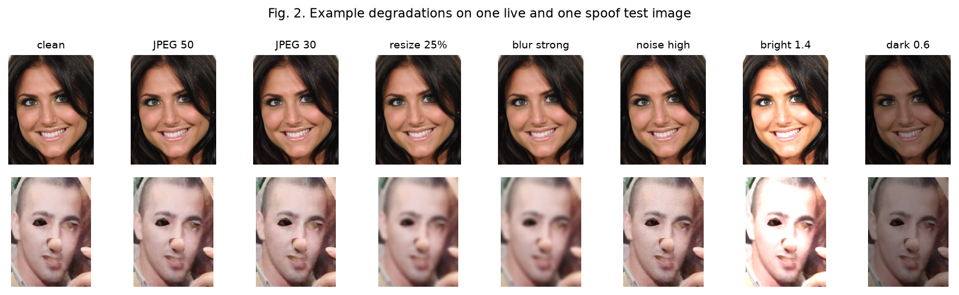
Fig. 1. Example degradations applied to one live and one spoof test image.
5 Results and Discussion
5.1 Clean Performance
Table 3. Clean test performance (40,643 images, threshold 0.5, best-epoch weights).
Metric | E01 Baseline | E07 Robust
Accuracy | 0.9826 | 0.9778
Precision | 0.9827 | 0.9810
Recall | 0.9909 | 0.9851
F1 | 0.9868 | 0.9831
ROC-AUC | 0.9978 | 0.9969
PR-AUC | 0.9987 | 0.9983
APCER | 0.0091 | 0.0149
BPCER | 0.0331 | 0.0362
ACER | 0.0211 | 0.0256

Robust training incurs a small clean-test cost: F1 decreases by 0.0037, ACER increases by 0.0044, and ROC-AUC decreases by 0.0008. Paired bootstrap (2,000 resamples) gives 95% confidence intervals of [-0.0063,-0.0027] for the ACER difference and [0.0005,0.0012] for the AUC difference, i.e., the cost is small but statistically significant. Confusion matrices (positive = spoof): E01 TN 13,557 / FN 243 / FP 464 / TP 26,379; E07 TN 13,513 / FN 396 / FP 508 / TP 26,226. ROC curves are shown in Fig. 2.
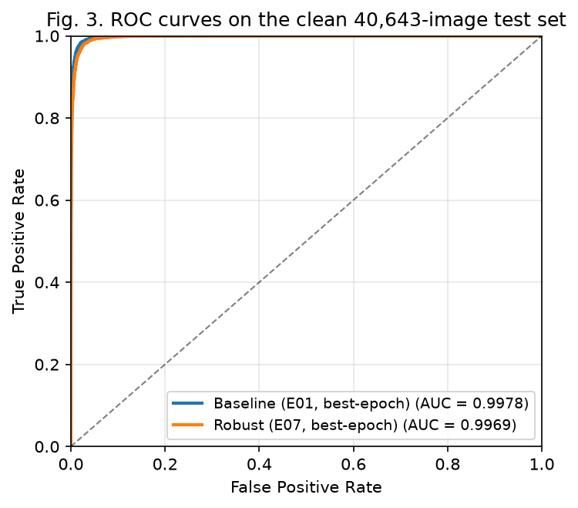
Fig. 2. ROC curves on the clean test set (E01 AUC 0.9978, E07 AUC 0.9969).
5.2 Degradation Performance
Table 4 reports F1, ROC-AUC, and the two error rates for both models under all sixteen degradation conditions; Fig. 3 plots F1 and ACER against severity. The full table with PR-AUC and per-condition deltas is available in the accompanying repository.
Table 4. E01 vs E07 under the 16 degradation conditions (best-epoch weights; threshold 0.5).
Condition | Sev | E01 F1 | E07 F1 | E01 AUC | E07 AUC | E01 APCER | E07 APCER | E01 BPCER | E07 BPCER | E01 ACER | E07 ACER
jpeg | 90 | 0.9866 | 0.9830 | 0.9977 | 0.9969 | 0.0095 | 0.0151 | 0.0332 | 0.0362 | 0.0213 | 0.0256
jpeg | 70 | 0.9747 | 0.9795 | 0.9957 | 0.9962 | 0.0379 | 0.0234 | 0.0230 | 0.0331 | 0.0304 | 0.0282
jpeg | 50 | 0.9507 | 0.9753 | 0.9932 | 0.9955 | 0.0853 | 0.0332 | 0.0184 | 0.0300 | 0.0518 | 0.0316
jpeg | 30 | 0.8911 | 0.9674 | 0.9890 | 0.9943 | 0.1915 | 0.0501 | 0.0118 | 0.0265 | 0.1016 | 0.0383
resize | 75% | 0.9679 | 0.9806 | 0.9944 | 0.9961 | 0.0053 | 0.0123 | 0.1153 | 0.0509 | 0.0603 | 0.0316
resize | 50% | 0.9339 | 0.9783 | 0.9849 | 0.9955 | 0.0060 | 0.0122 | 0.2558 | 0.0600 | 0.1309 | 0.0361
resize | 25% | 0.8672 | 0.9704 | 0.9405 | 0.9922 | 0.0078 | 0.0178 | 0.5622 | 0.0802 | 0.2850 | 0.0490
blur | light | 0.9785 | 0.9815 | 0.9964 | 0.9964 | 0.0054 | 0.0130 | 0.0725 | 0.0460 | 0.0390 | 0.0295
blur | medium | 0.8967 | 0.9757 | 0.9646 | 0.9947 | 0.0067 | 0.0146 | 0.4218 | 0.0653 | 0.2143 | 0.0400
blur | strong | 0.8489 | 0.9677 | 0.9161 | 0.9906 | 0.0089 | 0.0221 | 0.6532 | 0.0821 | 0.3310 | 0.0521
noise | low | 0.9849 | 0.9832 | 0.9972 | 0.9969 | 0.0146 | 0.0146 | 0.0295 | 0.0363 | 0.0221 | 0.0255
noise | medium | 0.9283 | 0.9828 | 0.9869 | 0.9968 | 0.1242 | 0.0157 | 0.0212 | 0.0357 | 0.0727 | 0.0257
noise | high | 0.8487 | 0.9781 | 0.9638 | 0.9957 | 0.2532 | 0.0251 | 0.0248 | 0.0352 | 0.1390 | 0.0302
brightness | dark | 0.9190 | 0.9446 | 0.9628 | 0.9805 | 0.0261 | 0.0184 | 0.2762 | 0.1839 | 0.1512 | 0.1012
brightness | normal | 0.9868 | 0.9831 | 0.9978 | 0.9969 | 0.0091 | 0.0149 | 0.0331 | 0.0362 | 0.0211 | 0.0256
brightness | bright | 0.7985 | 0.9571 | 0.9744 | 0.9876 | 0.3300 | 0.0578 | 0.0157 | 0.0505 | 0.1728 | 0.0542

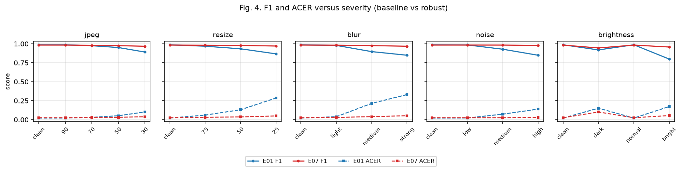
Fig. 3. F1 and ACER of E01 (baseline) and E07 (robust) versus severity for JPEG, resize, blur, noise, and brightness.
5.3 Aggregate and Worst-Case Performance
Table 5. Aggregates over the 16 degradation conditions.
Metric | E01 | E07 | Delta
Mean F1 | 0.9226 | 0.9743 | +0.0516
Mean ROC-AUC | 0.9785 | 0.9939 | +0.0155
Mean PR-AUC | 0.9877 | 0.9965 | +0.0088
Mean APCER | 0.0701 | 0.0225 | -0.0476
Mean BPCER | 0.1605 | 0.0555 | -0.1050
Mean ACER | 0.1153 | 0.0390 | -0.0763

Table 6. Worst-case performance over the 16 degradation conditions.
Metric | E01 | E07
Worst-case F1 | 0.7985 (brightness bright) | 0.9446 (brightness dark)
Worst-case ACER | 0.3310 (blur strong) | 0.1012 (brightness dark)

Robust training improves every aggregate metric: mean F1 +0.0516, mean ROC-AUC +0.0155, mean PR-AUC +0.0088, mean ACER -0.0763. The BPCER gain (-0.1050) exceeds the APCER gain (-0.0476), i.e., robustness mainly recovers live presentations misclassified under resolution loss and blur. The worst-case condition shifts from blur strong and brightness bright (baseline) to brightness dark (robust); the robust model's worst F1 (0.9446) exceeds the baseline's mean F1 (0.9226), and its worst ACER (0.1012) is lower than the baseline's mean ACER (0.1153).
5.4 In-Range vs Out-of-Range Degradations
Several test severities lie outside the training augmentation range (Table 2): JPEG 30, resize 25%, blur sigma 3.0, and brightness factors 0.6 and 1.4. The robust model still improves substantially at these out-of-range severities: ACER drops by 0.0633 (JPEG 30), 0.2360 (resize 25%), 0.2789 (blur strong), 0.0500 (brightness dark), and 0.1187 (brightness bright). This indicates that the learned robustness extends beyond the exact severity range seen during training, i.e., it is a form of severity extrapolation rather than mere memorization of the training range.
5.5 Statistical Significance
Paired bootstrap (2,000 resamples, threshold 0.5) on the fixed test set yields 95% confidence intervals for the per-condition ACER difference. The robust model is significantly better in 13 of 16 conditions, with the largest improvements at blur strong (ACER -0.279, CI [-0.283,-0.274]), resize 25% (-0.236, [-0.240,-0.231]), brightness bright (-0.119, [-0.122,-0.115]), and noise high (-0.109, [-0.112,-0.106]). In the three near-clean conditions (JPEG 90, noise low, brightness normal) the robust model is significantly but slightly worse, consistent with the clean-test cost of Section 5.1. This bootstrap analysis quantifies sampling uncertainty on the fixed test set; it does not account for training-run variability, which would require multiple training seeds.
5.6 Training Behavior and Discussion
Both models reached their minimum validation loss at epoch 18 (0.0586 for E01, 0.0681 for E07), and these best-epoch weights are used for every reported metric. The results are consistent with the hypothesis that quality-augmented training encourages features less dependent on fine, quality-sensitive image statistics: the largest gains occur at the most severe levels of blur, resize, brightness, and noise, exactly where the baseline loses the most. The measured differences are established by the experiments, while the feature-level explanation remains a hypothesis. Two observations follow. First, fixed-threshold F1 can mask ranking collapse: under resize and blur the baseline's F1 falls slowly while ROC-AUC drops sharply and BPCER rises, so PAD evaluations should report AUC and both error rates. Second, after robust training the residual gap is largest at dark illumination, indicating that augmentation alone does not fully equalize all conditions.
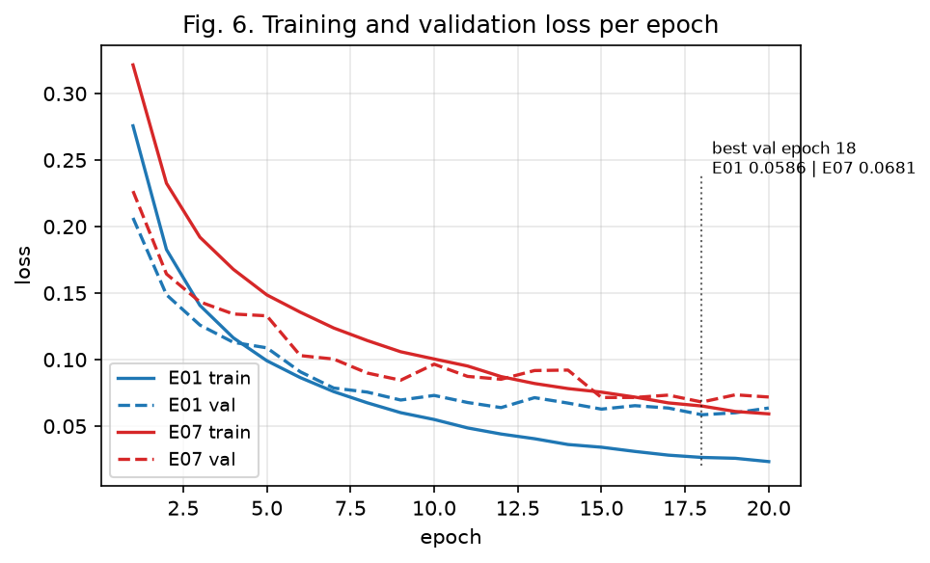
Fig. 4. Training and validation loss per epoch; the minimum validation loss occurs at epoch 18 for both models.
6 Limitations
(1) All experiments use a single training seed (123), so the reported differences do not capture training-run variability; multi-seed evaluation is left to future work. (2) Only binary live/spoof labels are available in the mirror, so per-attack-type behavior cannot be analyzed. (3) The mirror does not expose real subject identities, so the split is at the image level and does not measure generalization to unseen subjects. (4) Degradations are synthetic and do not fully reproduce real capture pipelines; no cross-dataset or device-level evaluation was performed. (5) The decision threshold is fixed at 0.5 by protocol and is not claimed to be an optimal operating point. (6) No latency benchmark was measured, so "lightweight" refers to the architecture (parameter count and model size) rather than to measured deployment efficiency. (7) No per-augmentation ablation was performed at this scale. (8) Checkpoint selection uses validation loss rather than a validation error rate.
7 Conclusion
We studied whether quality-aware augmentation improves the robustness of a lightweight MobileNetV2 face PAD model under controlled image-quality degradations. On a 203,215-image CelebA-Spoof subset, robust training incurs a small clean-test cost (F1 0.9868 to 0.9831, ACER 0.0211 to 0.0256) while improving degraded performance markedly: mean F1 over the degradation grid rises 0.9226 to 0.9743, mean ACER falls 0.1153 to 0.0390, and worst-case ACER improves from 0.3310 to 0.1012, with significant gains in 13 of 16 conditions, including degradations more severe than those seen during training. These results demonstrate robustness under controlled synthetic degradations relevant to eKYC capture conditions; they are based on a single seed and do not establish production readiness. Future work includes multi-seed training, real-device and cross-dataset evaluation, latency benchmarking, per-augmentation ablation, and threshold calibration on validation data.
References
1. Ramachandra, S., Busch, C.: Presentation attack detection methods for face recognition systems: A comprehensive survey. ACM Comput. Surv. 50(1), 8:1-8:37 (2017). https://doi.org/10.1145/3038924
2. Patel, K., Han, H., Jain, A.K.: Secure face unlock: Spoof detection on smartphones. IEEE Trans. Inf. Forensics Secur. 11(10), 2268-2283 (2016). https://doi.org/10.1109/TIFS.2016.2578288
3. Maatta, J., Hadid, A., Pietikainen, M.: Face spoofing detection from single images using micro-texture analysis. In: Proc. IJCB 2011, pp. 1-7 (2011). https://doi.org/10.1109/IJCB.2011.6117510
4. Chingovska, I., Anjos, A., Marcel, S.: On the effectiveness of local binary patterns in face anti-spoofing. In: Proc. BIOSIG 2012, pp. 1-7 (2012)
5. Zhang, Y., Yin, Z., Li, Y., Yin, G., Yan, J., Shao, J., Liu, Z.: CelebA-Spoof: Large-scale face anti-spoofing dataset with rich annotations. In: Proc. ECCV 2020 (2020). https://arxiv.org/abs/2007.12342
6. Boulkenafet, Z., Komulainen, J., Li, L., Feng, X., Hadid, A.: OULU-NPU: A mobile face presentation attack database with real-world variations. In: Proc. IEEE FG 2017, pp. 612-618 (2017). https://doi.org/10.1109/FG.2017.77
7. Liu, Y., Jourabloo, A., Liu, X.: Learning deep models for face anti-spoofing: Binary or auxiliary supervision. In: Proc. CVPR 2018, pp. 389-398 (2018). https://doi.org/10.1109/CVPR.2018.00048
8. George, A., Marcel, S.: Deep pixel-wise binary supervision for face presentation attack detection. In: Proc. ICB 2019 (2019). https://doi.org/10.1109/ICB45273.2019.8987370
9. Sandler, M., Howard, A., Zhu, M., Zhmoginov, A., Chen, L.-C.: MobileNetV2: Inverted residuals and linear bottlenecks. In: Proc. CVPR 2018, pp. 4510-4520 (2018). https://doi.org/10.1109/CVPR.2018.00474
10. Howard, A.G., et al.: MobileNets: Efficient convolutional neural networks for mobile vision applications. arXiv:1704.04861 (2017)
11. Hendrycks, D., Dietterich, T.: Benchmarking neural network robustness to common corruptions and perturbations. In: Proc. ICLR 2019 (2019). https://arxiv.org/abs/1903.12261
12. Shorten, C., Khoshgoftaar, T.M.: A survey on image data augmentation for deep learning. J. Big Data 6(60) (2019). https://doi.org/10.1186/s40537-019-0197-0
13. Cubuk, E.D., Zoph, B., Mane, D., Vasudevan, V., Le, Q.V.: AutoAugment: Learning augmentation strategies from data. In: Proc. CVPR 2019, pp. 113-123 (2019). https://doi.org/10.1109/CVPR.2019.00020
14. Zhang, Y., et al.: CelebA-Spoof Challenge 2020 on face anti-spoofing: Methods and results. arXiv:2102.12642 (2021)
15. Deng, J., Dong, W., Socher, R., Li, L.-J., Li, K., Fei-Fei, L.: ImageNet: A large-scale hierarchical image database. In: Proc. CVPR 2009, pp. 248-255 (2009). https://doi.org/10.1109/CVPR.2009.5206848
16. Jia, Y., Zhang, J., Shan, S., Chen, X.: Multi-adversarial discriminative deep domain generalization for face presentation attack detection. In: Proc. CVPR 2019 (2019)
17. Shao, R., Lan, X., Li, J., Yuen, P.C.: Single-side domain generalization for face anti-spoofing. In: Proc. CVPR 2020 (2020)
18. Yu, Z., Zhao, C., Wang, Z., Qin, Y., Su, Z., Li, X., Zhou, F., Zhao, G.: Searching central difference convolutional networks for face anti-spoofing. In: Proc. CVPR 2020 (2020)
19. Sun, Y., Liu, Y., Liu, X., Li, Y., Chu, W.-S.: Rethinking domain generalization for face anti-spoofing: Separability and alignment. In: Proc. CVPR 2023 (2023)
20. Wang, C.-Y., Lu, Y.-D., Yang, S.-T., Lai, S.-H.: PatchNet: A simple face anti-spoofing framework via fine-grained patch recognition. In: Proc. CVPR 2022 (2022)

