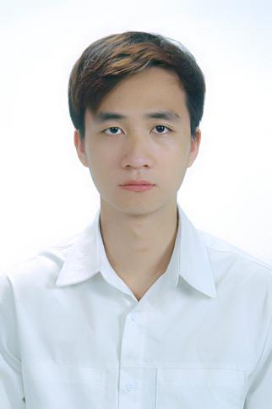

**HOANG DUC MINH TRIEU**

***Gender:*** *Male* • ***Date of birth****: 05/12/2000*

***Address*** *: No. 18/251 Tran Hung Dao, An Luu, Kinh Mon, Hai Duong*

***Email****: hoangducminhtrieu@gmail.com* • ***Phone:*** *0904 524 715*

**EDUCATION _**

**Hanoi University of Science and Technology *Ha Noi, Viet Nam***

*Mathematics and Informatics Engineer 08/2018 – 8/2023*

GPA: 7.26/10

**WORKEXPERIENCE _**

**Simulation Model Center – Viettel High Tech *Ha Noi, Viet Nam*** *Interns researching and developing artificial intelligence algorithms 05/2022–6/2023*

▪ **3DR VTO:**Having participated in the development of fashion product systems to try virtual costumes. Having builtHead Swap module with evaluation metrics used as EP, SSIM, LPIPS, PSNR, achieving corresponding results of 0.022, 0.90, 0.09, 34.82 on the test dataset (VoxCeleb2) and Viettel dataset. The current results are the state of the art,

submitted in the scientific journal Vol 29 No 2 (2023) MENDEL JOURNAL. Having been deployed into a product.

**Hanoi University of Science and Technology, ComVis Lab – MICA Research Center *Ha Noi, Viet Nam***

*Research assistant 09/2021 – 09/2022*

▪ **Researching**: AI algorithms for image processing. Building neural networks, convolutional neural networks, and Bayesian neural networks. Predicting the direction of human motion and velocity based on the influence of social interactions and surrounding environments.

*Teach assistant*

▪ **Image processing:** Support teaching, preparing papers and grading digital image processing subject exercises. Instructing programming of pixel-level operations, histogram equalization, image segmentation, feature extraction from images, and other related techniques.

**Fushan Technology Vietnam - Foxconn Bac Ninh*, Viet Nam***

*Test Engineer 09/2021 – 09/2022*

▪ **Google Project: Google Pixel 8, 8 Pro**: As a software engineer, my role includes operating, maintaining and being responsible for product testing stations using cameras, such as stations that identify product defects or analyze screen colors, etc. Customize scripts, scenario automation tests. Develop and improve test stations, handle and analyze errors that occur during production, analyze LOGs and work with customers. Optimize and refine test stations to serve production.

**Pegatron Viet Nam Hai Phong*, Viet Nam***

*Test Engineer 04/2024 – Present*

▪ **Application automatic NPI Test:** Cooperate with engineers in Taiwan and Suzhou to prepare and develop tools and software for product testing at NPI stage (EVT, DVT). Build stations such as quicktest, sensor, speaker, mmwave, OTA, provison, burn in. Write automatic test scripts, limits, scenarios. Synthesize LOG and data for analysis, perform SPC, GRR. Train relevant departments on testing procedures.

Develop Computer Vision, AI, Deep Learning, Image Processing Software for Visual Inspection, Product Defects, Classification, QRcode and Barcode, etc

Develop warehouse management software on computers and phones. Store and query data using SQL.

Software development for automated testing of hardware, software, control of test equipment: Testers and Fixtures for Performance Tests and specific algorithms for calibration through communication with sensors, cameras, PCs.

**SKILLS _**

▪ **Programming languages**: Python, SQL, C/C++.

▪ **Language proficiency:** English, Aptis B1.

▪ **Proficient in AI models and Image processing techniques, Computer vision:** YOLO, Object Detection, Color recognition, Segmentation, Image Classification, Data Augmentation and recognition techniques: OCR.

**ACHIEVEMENT _**

▪ **Publication:** Q1 article titled "*A hybrid photorealistic architecture based on generating facial features and body reshaping for Virtual Try-on Applications"* in Vol 29 No 2 (2023) MENDEL JOURNAL.

▪ **Winning:** The Creativity Award at the Student Research Conference 2023. Hanoi University of Science and

Technology.