IdeaTrack System — Complete Test Cases
Equivalence Partitioning (EP) & Boundary Value Analysis (BVA) Coverage
Legend: EP = Equivalence Partitioning | BVA = Boundary Value Analysis | PASS = Executed & Passed | — = Newly Added (Not Yet Executed)

1. Author Module

1.1 Create Initiative
Evidence Screenshot — Create Initiative Page:
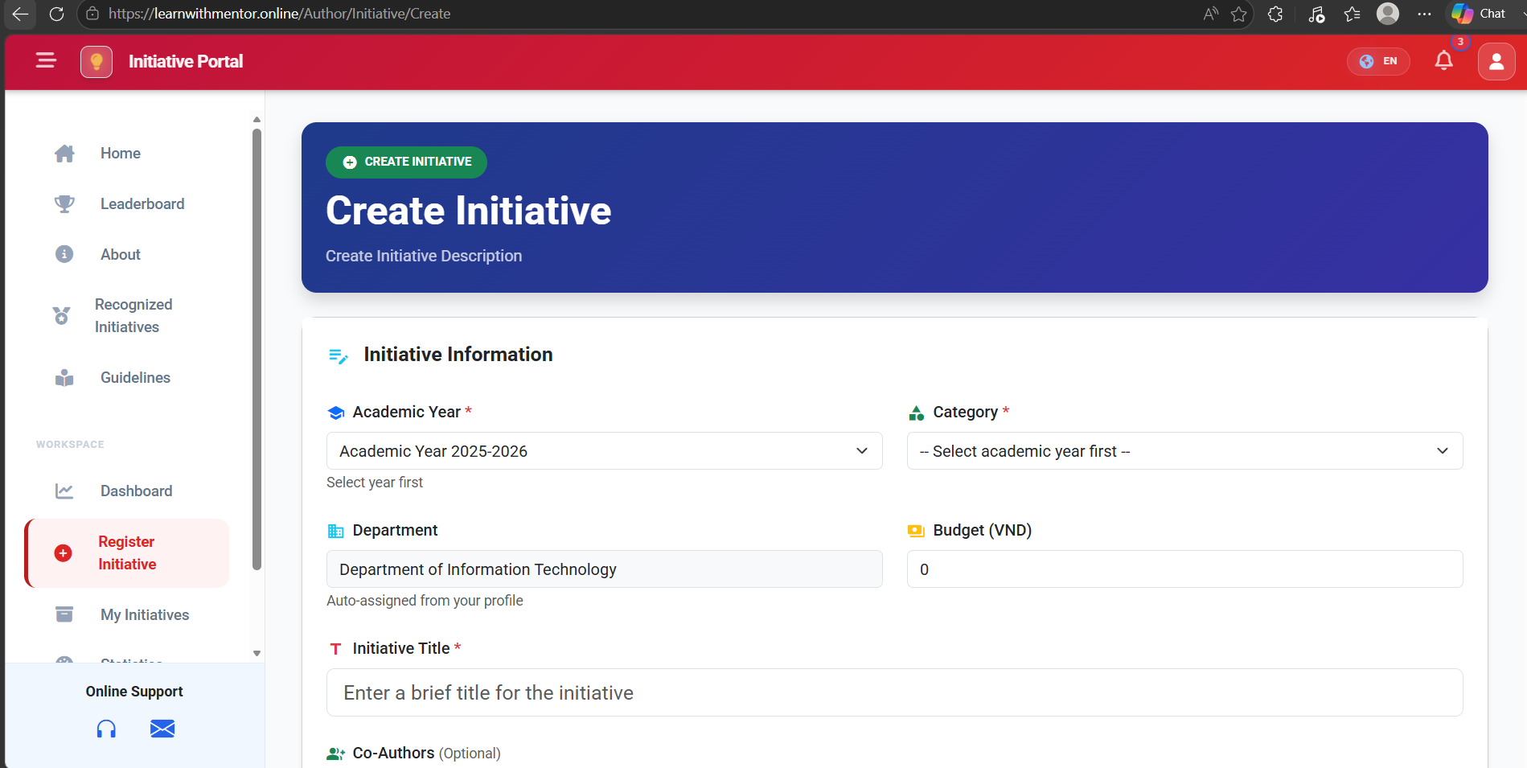
Figure: image1.png

ID | Title | Pre-conditions | Steps | Expected / Actual Results | Status
AU-CI-01 | Create Initiative — Valid Data  (EP: valid partition) | User is logged in as Author.  Academic Year and Category exist. | 1. Navigate to Register Initiative.  2. Fill: Title = "AI Solution", AcademicYearId = 1, CategoryId = 2, File = "tailieu.pdf", CoAuthorIds = [2, 3].  3. Click Submit. | System saves the initiative successfully and redirects to My Initiatives page. | PASS
AU-CI-02 | Create Initiative — Blank Title  (EP: invalid — empty string) | User is logged in as Author. | 1. Navigate to Register Initiative.  2. Leave Title blank, fill other fields.  3. Click Submit. | Validation error: "The Title field is required." Initiative is not saved. | PASS
AU-CI-03 | Create Initiative — Missing Academic Year  (EP: invalid — null selection) | User is logged in as Author. | 1. Navigate to Register Initiative.  2. Fill Title, do NOT select Academic Year.  3. Click Submit. | Submit button is disabled or server rejects with validation error "Please select an Academic Year." | PASS
AU-CI-04 | Create Initiative — Invalid File Type  (EP: invalid file extension) | User is logged in as Author. | 1. Navigate to Register Initiative.  2. Fill valid data, attach File = "script.exe".  3. Click Submit. | Validation error: "Invalid file format, only (.pdf, .docx, …) allowed." File is rejected. | PASS
AU-CI-05 | Create Initiative — File Size Exceeded  (BVA: above max limit) | User is logged in as Author.  Max file size = 10 MB. | 1. Navigate to Register Initiative.  2. Fill valid data, attach File = "video.mp4" (50 MB).  3. Click Submit. | Validation error: "File size exceeds the allowed limit (10 MB)." Submission blocked. | PASS
AU-CI-06 | Create Initiative — File Size at Boundary  (BVA: exactly 10 MB) | User is logged in as Author.  Max file size = 10 MB. | 1. Navigate to Register Initiative.  2. Fill valid data, attach a file exactly 10 MB.  3. Click Submit. | File is accepted and initiative is created successfully. | PASS
AU-CI-07 | Create Initiative — File Size Just Below Limit  (BVA: 9.99 MB) | User is logged in as Author.  Max file size = 10 MB. | 1. Navigate to Register Initiative.  2. Fill valid data, attach a file of 9.99 MB.  3. Click Submit. | File is accepted and initiative is created successfully. | PASS
AU-CI-08 | Create Initiative — File Size Just Above Limit  (BVA: 10.01 MB) | User is logged in as Author.  Max file size = 10 MB. | 1. Navigate to Register Initiative.  2. Fill valid data, attach a file of 10.01 MB.  3. Click Submit. | Validation error: "File size exceeds the allowed limit (10 MB)." | PASS
AU-CI-09 | Create Initiative — Title at Min Length  (BVA: 1 character) | User is logged in as Author. | 1. Navigate to Register Initiative.  2. Enter Title = "A".  3. Fill other required fields.  4. Click Submit. | Initiative is created successfully with single-character title. | PASS
AU-CI-10 | Create Initiative — Title at Max Length  (BVA: max allowed chars) | User is logged in as Author. | 1. Navigate to Register Initiative.  2. Enter Title with maximum allowed characters (e.g., 255 chars).  3. Fill other fields.  4. Click Submit. | Initiative is created successfully. Title is stored and displayed correctly. | PASS
AU-CI-11 | Create Initiative — Title Exceeds Max Length  (BVA: max + 1) | User is logged in as Author. | 1. Navigate to Register Initiative.  2. Enter Title with max + 1 characters.  3. Click Submit. | Validation error or title is truncated. Initiative is not saved with oversized title. | PASS
AU-CI-12 | Create Initiative — No File Attached  (EP: optional file = empty) | User is logged in as Author.  File is optional. | 1. Navigate to Register Initiative.  2. Fill Title, Academic Year, Category. Do NOT attach file.  3. Click Submit. | Initiative is created successfully without attachment. | PASS
AU-CI-13 | Create Initiative — Missing Category  (EP: invalid — null) | User is logged in as Author. | 1. Navigate to Register Initiative.  2. Fill Title, select Academic Year. Do NOT select Category.  3. Click Submit. | Validation error: "Category is required." | PASS
AU-CI-14 | Create Initiative — Budget = 0  (BVA: lower bound) | User is logged in as Author. | 1. Navigate to Register Initiative.  2. Fill all required fields, set Budget = 0.  3. Click Submit. | Initiative is created with Budget = 0. | PASS
AU-CI-15 | Create Initiative — Negative Budget  (EP: invalid numeric) | User is logged in as Author. | 1. Navigate to Register Initiative.  2. Fill all fields, set Budget = -1000.  3. Click Submit. | Validation error: "Budget must be a non-negative number." | PASS

1.2 My Initiatives (Activity History)
Evidence Screenshot — My Initiatives / Activity History Page:
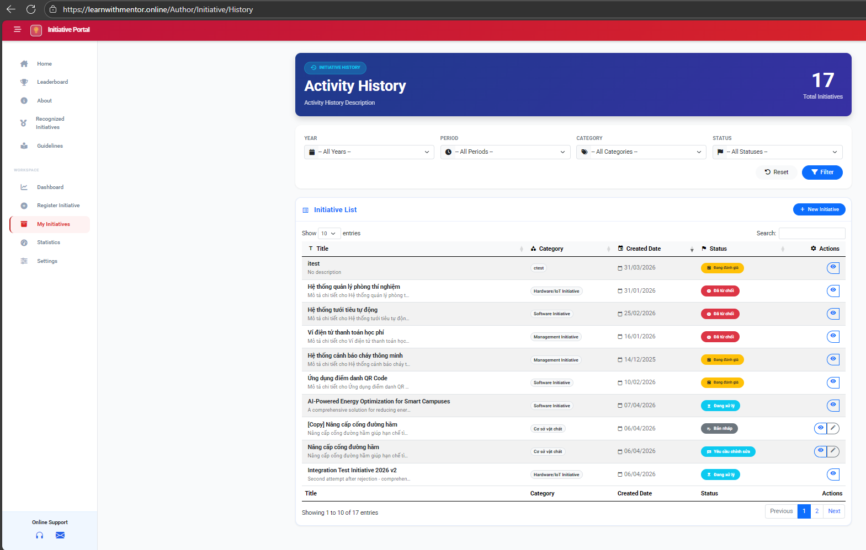
Figure: image2.png

ID | Title | Pre-conditions | Steps | Expected / Actual Results | Status
AU-MI-01 | View My Initiatives List  (EP: valid view) | Author is logged in.  Author has submitted initiatives. | 1. Navigate to My Initiatives. | Initiative list is displayed showing all author's initiatives with Title, Category, Created Date, Status, and Actions columns. Showing 1-10 of 17 entries. | PASS
AU-MI-02 | Filter Initiatives by Year  (EP: valid filter) | Author is logged in.  Multiple academic years exist. | 1. Navigate to My Initiatives.  2. Select Year dropdown.  3. Click "Filter". | Only initiatives from the selected academic year are displayed. | PASS
AU-MI-03 | Filter Initiatives by Period  (EP: valid filter) | Author is logged in.  Multiple periods exist. | 1. Navigate to My Initiatives.  2. Select Period dropdown.  3. Click "Filter". | Only initiatives from the selected period are displayed. | PASS
AU-MI-04 | Filter Initiatives by Category  (EP: valid filter) | Author is logged in.  Multiple categories exist. | 1. Navigate to My Initiatives.  2. Select Category dropdown (e.g., "Software Initiative").  3. Click "Filter". | Only initiatives with the selected category are displayed. | PASS
AU-MI-05 | Filter Initiatives by Status  (EP: valid filter) | Author is logged in.  Initiatives with various statuses exist. | 1. Navigate to My Initiatives.  2. Select Status dropdown (e.g., "Rejected").  3. Click "Filter". | Only initiatives with "Rejected" status are displayed. | PASS
AU-MI-06 | Search Initiatives in List  (EP: valid search) | Author is logged in.  Initiatives exist. | 1. Navigate to My Initiatives.  2. Type "AI" in the Search box. | Only initiatives with "AI" in their title are shown. | PASS
AU-MI-07 | Search with Non-Existent Keyword  (EP: no match) | Author is logged in. | 1. Navigate to My Initiatives.  2. Type "XYZNOTEXIST" in Search box. | No results displayed. Table shows empty or "No data available" message. | PASS
AU-MI-08 | Reset All Filters  (EP: reset action) | Author is logged in.  Filters are currently applied. | 1. Navigate to My Initiatives.  2. Apply some filters.  3. Click "Reset" button. | All filters are cleared. Full initiative list is displayed. | PASS
AU-MI-09 | Pagination — Navigate to Page 2  (BVA: page boundary) | Author is logged in.  More than 10 initiatives exist (17 total). | 1. Navigate to My Initiatives.  2. Click page "2" or "Next" in pagination. | Page 2 displays entries 11-17. Pagination updates correctly. | PASS
AU-MI-10 | Change Entries Per Page  (BVA: display count) | Author is logged in.  17 initiatives exist. | 1. Navigate to My Initiatives.  2. Change "Show entries" dropdown from 10 to 25. | All 17 initiatives are displayed on single page. | PASS
AU-MI-11 | Edit Draft Initiative  (EP: valid edit) | Author is logged in.  Draft initiative exists. | 1. Navigate to My Initiatives.  2. Click edit icon on a "Draft" initiative. | Initiative edit form is opened. Author can modify fields and re-submit. | PASS
AU-MI-12 | View Initiative Details  (EP: valid view) | Author is logged in.  Initiative exists. | 1. Navigate to My Initiatives.  2. Click view icon on any initiative. | Initiative detail page is displayed with full information. | PASS

1.3 Author Statistics (Innovation Metrics)
Evidence Screenshot — Innovation Metrics / Statistics Page:
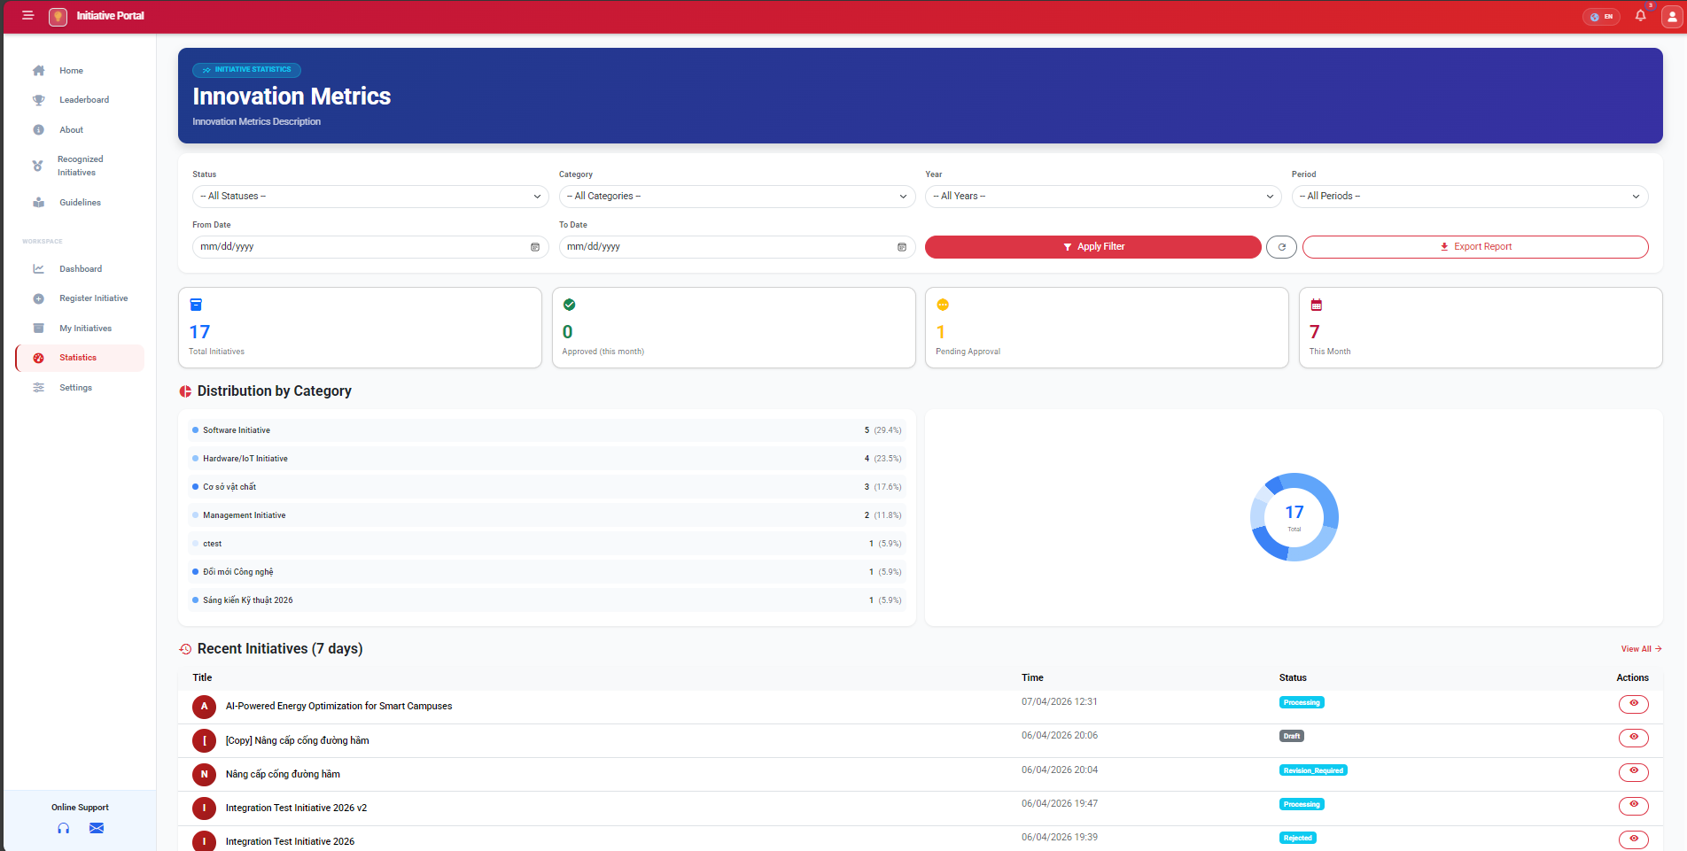
Figure: image3.png

ID | Title | Pre-conditions | Steps | Expected / Actual Results | Status
AU-ST-01 | View Statistics Dashboard  (EP: valid view) | Author is logged in.  Author has submitted initiatives. | 1. Navigate to Statistics page. | Statistics page displays: Total Initiatives = 17, Approved (this month) = 0, Pending Approval = 1, This Month = 7. | PASS
AU-ST-02 | View Distribution by Category Chart  (EP: valid chart) | Author is logged in.  Multiple categories used. | 1. Navigate to Statistics page.  2. View "Distribution by Category" section. | Pie chart and list show correct distribution: Software Initiative 5 (29.4%), Hardware/IoT 4 (23.5%), etc. | PASS
AU-ST-03 | View Recent Initiatives List  (EP: valid list) | Author is logged in.  Recent initiatives exist. | 1. Navigate to Statistics page.  2. View "Recent Initiatives (7 days)" section. | Recent initiatives are listed with Title, Time, Status, and Actions. Correct statuses shown (Processing, Draft, Revision_Required, etc.). | PASS
AU-ST-04 | Filter Statistics by Status  (EP: valid filter) | Author is logged in. | 1. Navigate to Statistics.  2. Select Status filter (e.g., "Processing").  3. Click "Apply Filter". | Statistics and charts update to show only data for "Processing" status. | PASS
AU-ST-05 | Filter Statistics by Category  (EP: valid filter) | Author is logged in. | 1. Navigate to Statistics.  2. Select Category filter (e.g., "Software Initiative").  3. Click "Apply Filter". | Statistics update to show only Software Initiative data. | PASS
AU-ST-06 | Filter Statistics by Year  (EP: valid filter) | Author is logged in. | 1. Navigate to Statistics.  2. Select Year filter.  3. Click "Apply Filter". | Statistics update to show only data from the selected year. | PASS
AU-ST-07 | Filter Statistics by Date Range  (BVA: valid range) | Author is logged in. | 1. Navigate to Statistics.  2. Set From Date and To Date.  3. Click "Apply Filter". | Statistics update to show only data within the date range. | PASS
AU-ST-08 | Filter with From Date > To Date  (BVA: invalid range) | Author is logged in. | 1. Set From Date = "2026-05-01".  2. Set To Date = "2026-04-01".  3. Click "Apply Filter". | Validation error or no results returned. System handles gracefully. | PASS
AU-ST-09 | Export Statistics Report  (EP: valid export) | Author is logged in.  Statistics data exists. | 1. Navigate to Statistics.  2. Click "Export Report" button. | Report file is downloaded containing author's initiative statistics. | PASS

1.4 Author Profile Update
Evidence Screenshot — Author Settings / Profile Page:
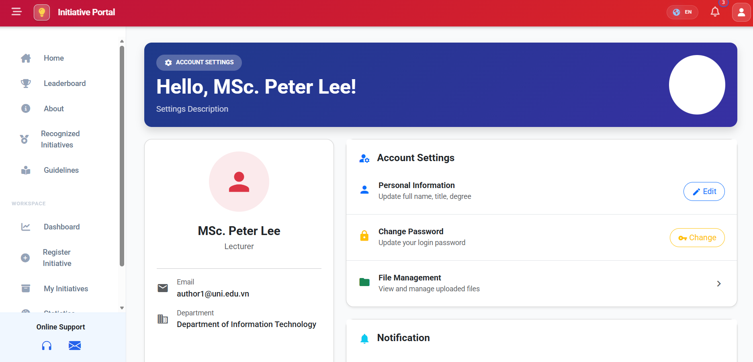
Figure: image4.png

ID | Title | Pre-conditions | Steps | Expected / Actual Results | Status
AU-PF-01 | Update Profile — Valid Data  (EP: valid partition) | User is logged in as Author (MSc. Peter Lee). | 1. Navigate to Settings > Personal Information > Edit.  2. Set FullName = "Nguyen Van A", Position = "Lecturer", Degree = "Master".  3. Click Save. | Profile is updated successfully. Notification: "Update successful." | PASS
AU-PF-02 | Update Profile — Blank FullName  (EP: invalid — empty) | User is logged in as Author. | 1. Navigate to Settings > Personal Information > Edit.  2. Clear FullName field.  3. Click Save. | Validation error: "Full name is required." Database state unchanged. | PASS
AU-PF-03 | Update Profile — FullName with Special Characters  (EP: edge) | User is logged in as Author. | 1. Navigate to Settings > Edit.  2. Set FullName = "Dr. O'Brien-Smith Jr.".  3. Click Save. | Profile is updated. Special characters are stored and displayed correctly. | PASS
AU-PF-04 | Update Profile — Very Long FullName  (BVA: max length) | User is logged in as Author. | 1. Navigate to Settings > Edit.  2. Enter FullName with 255 characters.  3. Click Save. | Profile is updated successfully or shows max-length validation error. | PASS

2. Faculty Module

2.1 Faculty Review Actions
Evidence Screenshot — Faculty Review Page:
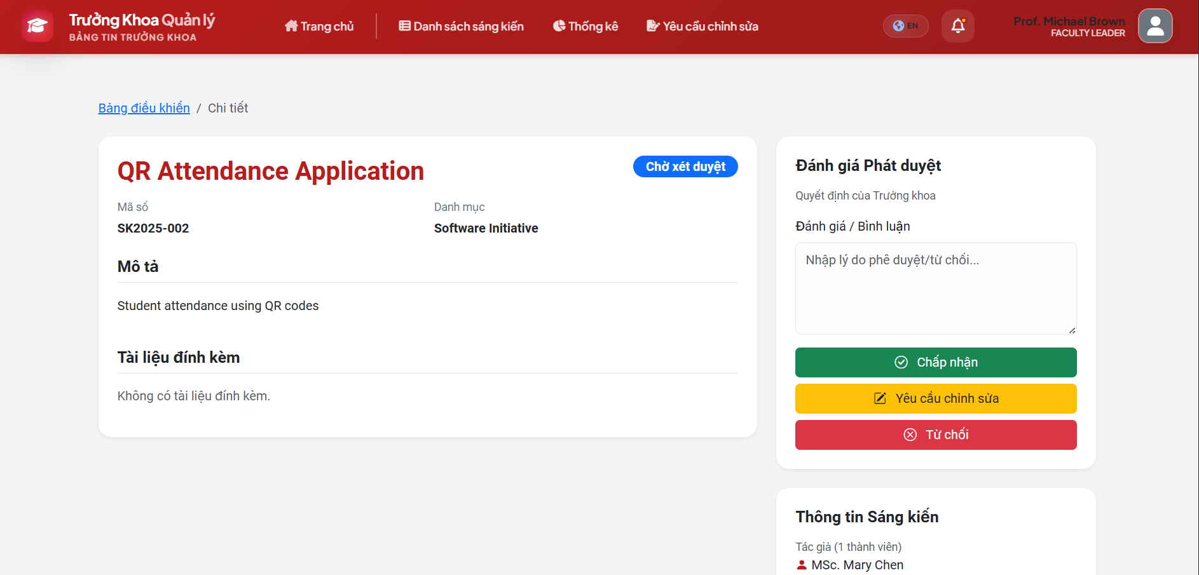
Figure: image5.png

ID | Title | Pre-conditions | Steps | Expected / Actual Results | Status
FA-RV-01 | Review — Accept Initiative  (EP: valid accept action) | Faculty user logged in.  Initiative status = Submitted.  Initiative exists (e.g., SK2025-002). | 1. Navigate to Initiative List.  2. Open initiative detail.  3. Enter comment: "Good initiative."  4. Click "Accept". | Status changes to Faculty_Approved. System notification: "Initiative accepted…" | PASS
FA-RV-02 | Review — Request Revision with Comment  (EP: valid revision request) | Faculty user logged in.  Initiative status = Submitted. | 1. Open initiative detail.  2. Enter comment: "Please add more data."  3. Click "Request Revision". | Status changes to Revision_Required. System records revision request and notifies author. | PASS
FA-RV-03 | Review — Request Revision with Blank Comment  (BVA: empty comment boundary) | Faculty user logged in.  Initiative status = Submitted. | 1. Open initiative detail.  2. Leave comment field blank.  3. Click "Request Revision". | If comment is required: validation error. If optional: revision request is submitted. | PASS
FA-RV-04 | Review — Reject Initiative  (EP: valid reject action) | Faculty user logged in.  Initiative status = Submitted. | 1. Open initiative detail.  2. Enter comment: "Not feasible."  3. Click "Reject". | Status changes to Rejected. System notification: "Initiative has been rejected." | PASS
FA-RV-05 | Review — Accept Without Comment  (EP: optional comment) | Faculty user logged in.  Initiative status = Submitted. | 1. Open initiative detail.  2. Leave comment empty.  3. Click "Accept". | Status changes to Faculty_Approved. Comment is stored as empty. | PASS
FA-RV-06 | Review — Reject Without Comment  (BVA: empty comment) | Faculty user logged in.  Initiative status = Submitted. | 1. Open initiative detail.  2. Leave comment empty.  3. Click "Reject". | Validation error if comment is required for rejection, else status changes to Rejected. | PASS
FA-RV-07 | Review — Comment with Max Length  (BVA: upper bound) | Faculty user logged in.  Initiative status = Submitted. | 1. Open initiative detail.  2. Enter comment with maximum allowed characters.  3. Click "Accept". | Comment is accepted and stored. Status changes to Faculty_Approved. | PASS

2.2 Faculty Dashboard & Search
ID | Title | Pre-conditions | Steps | Expected / Actual Results | Status
FA-DS-01 | Search Initiatives by Keyword  (EP: valid keyword) | Faculty user logged in.  Initiatives exist. | 1. Navigate to Dashboard.  2. Enter search string "AI Solution" in search bar.  3. Click Search / Apply. | List displays only initiatives matching "AI Solution." | PASS
FA-DS-02 | Filter by Academic Year / Period  (EP: valid filter) | Faculty user logged in.  Multiple years/periods exist. | 1. Navigate to Dashboard.  2. Select Year = "2025-2026", Period = "2025-2026".  3. Click Apply / Filter. | Initiative list and statistics charts update to show only data for the selected year/period. | PASS
FA-DS-03 | Export Dashboard to Excel  (EP: valid export) | Faculty user logged in.  Initiative data exists. | 1. Navigate to Dashboard.  2. Click "Export" button. | Browser downloads CSV file "Initiative_Stats_ddMMyyyy.csv" with correct faculty data. | PASS
FA-DS-04 | View File as PDF  (EP: valid file conversion) | Faculty user logged in.  Initiative has attachment "tailieu.docx". | 1. Navigate to initiative detail.  2. Click "View File" on attached document. | System converts docx to PDF via LibreOffice and opens in browser PDF viewer. | PASS
FA-DS-05 | Search with Empty Keyword  (BVA: empty string) | Faculty user logged in. | 1. Navigate to Dashboard.  2. Leave search bar empty.  3. Click Search. | All initiatives are displayed (no filter applied). | PASS
FA-DS-06 | Search with Non-Existent Keyword  (EP: no match) | Faculty user logged in. | 1. Navigate to Dashboard.  2. Enter "XYZNOTEXIST999".  3. Click Search. | No results found. Appropriate "No results" message displayed. | PASS
FA-DS-07 | Search with Special Characters  (EP: edge — SQL injection) | Faculty user logged in. | 1. Enter search string: "'; DROP TABLE --".  2. Click Search. | No results or safe handling. No database error or crash. | PASS

2.3 Faculty Profile Update
Evidence Screenshot — Faculty Profile Edit Page:
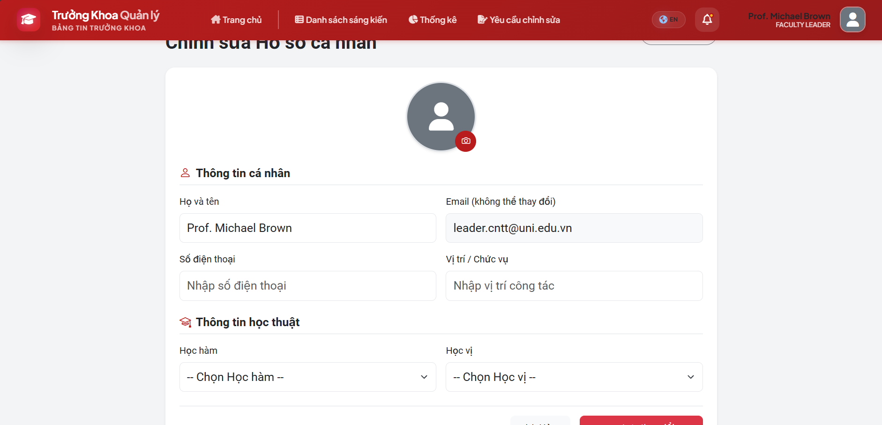
Figure: image6.png

ID | Title | Pre-conditions | Steps | Expected / Actual Results | Status
FA-PF-01 | Update Profile — Valid Data  (EP: valid partition) | Faculty user (Prof. Michael Brown) logged in. | 1. Navigate to Profile Edit.  2. Set FullName = "Dr. Le B", Email = "leb@truong.edu.vn", Phone = "0901234567".  3. Click Save. | Profile updated successfully. No errors. | PASS
FA-PF-02 | Update Profile — Invalid Email Format  (EP: invalid email) | Faculty user logged in. | 1. Navigate to Profile Edit.  2. Set Email = "leb-truong.edu.vn" (missing @).  3. Click Save. | Validation error: "Invalid email address." | PASS
FA-PF-03 | Update Profile — Missing FullName  (EP: invalid — empty) | Faculty user logged in. | 1. Navigate to Profile Edit.  2. Clear FullName field.  3. Click Save. | Validation error: "Full name is required." | PASS
FA-PF-04 | Update Profile — Phone with Letters  (EP: invalid phone) | Faculty user logged in. | 1. Navigate to Profile Edit.  2. Set Phone = "ABCDEF".  3. Click Save. | Validation error: "Invalid phone number format." | PASS
FA-PF-05 | Update Profile — Phone Exactly 10 Digits  (BVA: valid boundary) | Faculty user logged in. | 1. Set Phone = "0901234567" (10 digits).  2. Click Save. | Profile updated successfully. | PASS
FA-PF-06 | Update Profile — Phone with 9 Digits  (BVA: below minimum) | Faculty user logged in. | 1. Set Phone = "090123456" (9 digits).  2. Click Save. | Validation error: "Phone number must be 10-11 digits." | PASS

3. Councils Module

3.1 Council Authentication & Access
Evidence Screenshot — Council Assigned Initiatives Page:
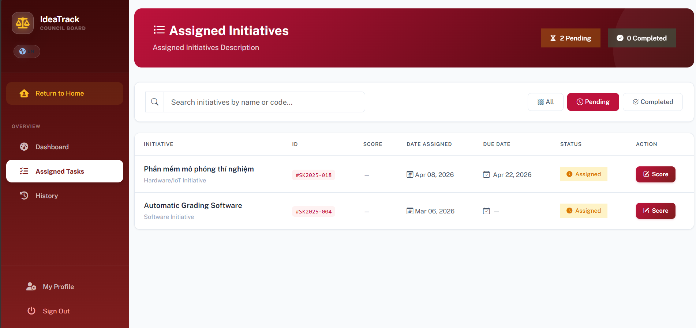
Figure: image7.png

ID | Title | Pre-conditions | Steps | Expected / Actual Results | Status
CO-AU-01 | Access Council Page Without Login  (EP: unauthenticated) | User is not logged in. | 1. Navigate to URL: /Councils/Page. | Redirected to Login page: /Identity/Account/Login?ReturnUrl=%2FCouncils%2FPage | PASS
CO-AU-02 | Login with Wrong Password  (EP: invalid credentials) | User exists: council1. | 1. Navigate to Login page.  2. Enter username = "council1", password = "WRONGPASS".  3. Click Login. | Error message: "Incorrect password." Login is denied. | PASS
CO-AU-03 | Login with Correct Credentials  (EP: valid credentials) | User exists: council1, password = 123456. | 1. Navigate to Login page.  2. Enter username = "council1", password = "123456".  3. Click Login. | Redirected to Council Dashboard. Dashboard shows Total Assigned = 1, Completed = 0, Pending = 1. | PASS
CO-AU-04 | Access Council Page with Non-Council Role  (EP: unauthorized role) | User is logged in as Author. | 1. Navigate to URL: /Councils/Page. | Access denied (403) or redirected to home/login page. | PASS
CO-AU-05 | Login with Empty Username  (BVA: empty field) | Login page is displayed. | 1. Leave username blank.  2. Enter password = "123456".  3. Click Login. | Validation error: "Username is required." | PASS
CO-AU-06 | Login with Empty Password  (BVA: empty field) | Login page is displayed. | 1. Enter username = "council1".  2. Leave password blank.  3. Click Login. | Validation error: "Password is required." | PASS
CO-AU-07 | Login with SQL Injection Attempt  (EP: security) | Login page is displayed. | 1. Enter username = "' OR 1=1 --".  2. Enter password = "anything".  3. Click Login. | Error: "Incorrect username or password." No security breach. | PASS

3.2 Council Assigned Tasks & History
Evidence Screenshot — Council Evaluation History Page:
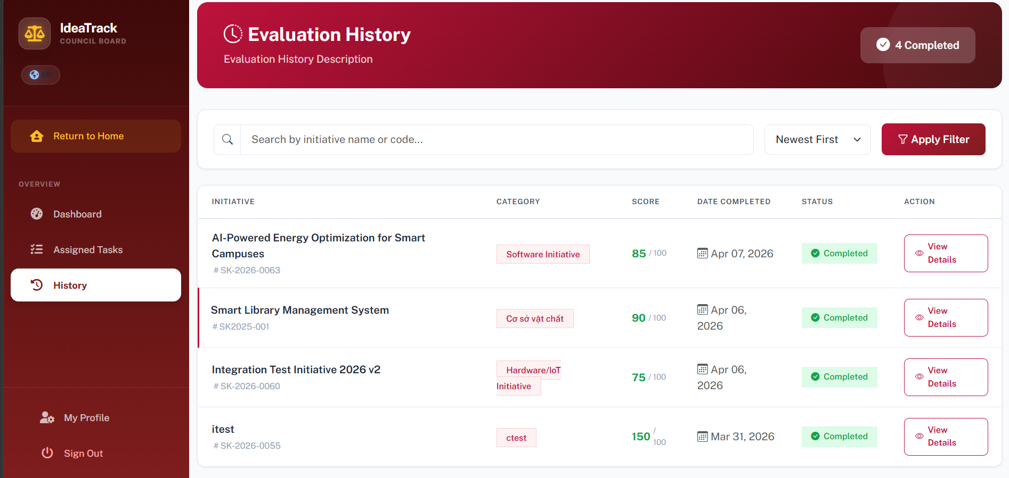
Figure: image8.png

ID | Title | Pre-conditions | Steps | Expected / Actual Results | Status
CO-AT-01 | View Assigned Tasks  (EP: valid view) | Council user (council1) logged in.  Has assigned initiatives. | 1. Navigate to Dashboard.  2. Click "Assigned Tasks" in the sidebar. | Assigned initiatives list is displayed, sorted by deadline. Shows SK2025-004 "Automatic Grading Software." | PASS
CO-HI-01 | View Evaluation History — Empty  (EP: no history) | Council user logged in.  No submissions completed yet. | 1. Navigate to Dashboard.  2. Click "History" in the sidebar. | Message: "No evaluation history found. Complete your first initiative to see it here!" | PASS
CO-HI-02 | Search History with Non-Existent Keyword  (EP: no match) | Council user logged in.  History page is displayed. | 1. Navigate to History.  2. Enter keyword = "XYZABC999NOTFOUND".  3. Click Search. | Message: "No evaluation history found." | PASS
CO-AT-02 | Filter Assigned Tasks — All Tab  (EP: valid filter) | Council user logged in.  Has mixed status initiatives. | 1. Navigate to Assigned Tasks.  2. Click "All" tab. | All assigned initiatives are displayed regardless of status. | PASS
CO-AT-03 | Filter Assigned Tasks — Completed Tab  (EP: valid filter) | Council user logged in. | 1. Navigate to Assigned Tasks.  2. Click "Completed" tab. | Only completed initiatives are displayed. If none, appropriate empty message shown. | PASS
CO-AT-04 | Search Assigned Tasks by Code  (EP: code search) | Council user logged in.  Initiative SK2025-004 assigned. | 1. Navigate to Assigned Tasks.  2. Enter "SK2025-004" in search bar. | Only initiative SK2025-004 is displayed. | PASS
CO-AT-05 | Search Assigned Tasks — Empty Keyword  (BVA: empty) | Council user logged in. | 1. Navigate to Assigned Tasks.  2. Leave search empty.  3. Click Search. | All assigned initiatives are displayed (no filter). | PASS

4. SciTech Module

4.1 SciTech Authentication & Dashboard
Evidence Screenshot — SciTech Dashboard:
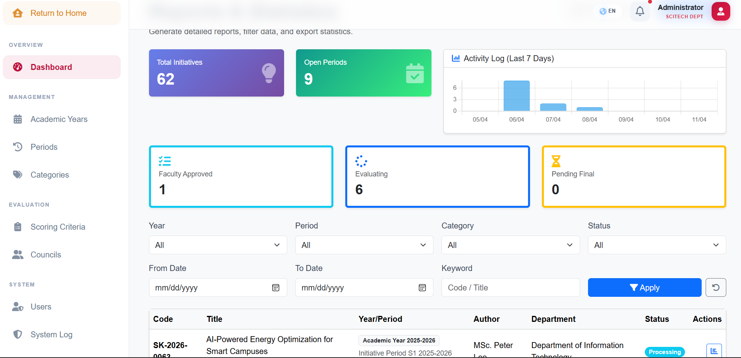
Figure: image9.png

ID | Title | Pre-conditions | Steps | Expected / Actual Results | Status
ST-AU-01 | Access SciTech Page Without Login  (EP: unauthenticated) | User is not logged in. | 1. Navigate to URL: /SciTech/Port. | Redirected to Login page. [Authorize(Roles="SciTech,Admin")] is enforced. | PASS
ST-AU-02 | Login with Correct SciTech Credentials  (EP: valid) | User exists: scitech1, password = 123456. | 1. Navigate to Login page.  2. Enter username = "scitech1", password = "123456".  3. Click Login. | Redirected to SciTech Dashboard. Shows: Total = 52 initiatives, 6 Open Periods, Faculty Approved = 4, Evaluating = 4. | PASS
ST-AU-03 | Access SciTech Page with Author Role  (EP: unauthorized) | User is logged in as Author. | 1. Navigate to URL: /SciTech/Port. | Access denied (403) or redirected to home page. | PASS

4.2 SciTech Dashboard Filters
ID | Title | Pre-conditions | Steps | Expected / Actual Results | Status
ST-FI-01 | Filter by Status = "Evaluating"  (EP: valid status filter) | SciTech user logged in.  Dashboard is displayed. | 1. In "Status" dropdown, select "Evaluating".  2. Click "Apply". | URL updates to status=Evaluating. List shows only "Evaluating" initiatives. | PASS
ST-FI-02 | Search by Keyword "IoT"  (EP: valid keyword match) | SciTech user logged in.  Dashboard is displayed. | 1. Enter "IoT" in Keyword field.  2. Click "Apply". | Returns 1 result: "IoT Environment Monitoring System" (SK2025-011). | PASS
ST-FI-03 | Filter by Date Range — Today Only  (BVA: FromDate = ToDate = Today) | SciTech user logged in. | 1. Set FromDate = today.  2. Set ToDate = today.  3. Click "Apply". | Only today's submissions are listed. | PASS
ST-FI-04 | Filter with FromDate > ToDate  (BVA: invalid range) | SciTech user logged in. | 1. Set FromDate = "2026-04-15".  2. Set ToDate = "2026-04-10".  3. Click "Apply". | Validation error or empty results returned. | PASS
ST-FI-05 | Filter by All Statuses  (EP: no filter = all) | SciTech user logged in. | 1. Select Status = "All".  2. Click "Apply". | All initiatives regardless of status are displayed. | PASS
ST-FI-06 | Search with Empty Keyword  (BVA: empty string) | SciTech user logged in. | 1. Leave Keyword field empty.  2. Click "Apply". | All initiatives are displayed (no keyword filter). | PASS
ST-FI-07 | Search with Very Long Keyword  (BVA: 500+ chars) | SciTech user logged in. | 1. Enter 500+ character string in Keyword.  2. Click "Apply". | System handles gracefully — no crash. Returns empty result or truncates input. | PASS

4.3 SciTech Export & Report
ID | Title | Pre-conditions | Steps | Expected / Actual Results | Status
ST-EX-01 | Export Data to Excel  (EP: valid export) | SciTech user logged in.  Dashboard is displayed. | 1. Click "Export Data" button. | File "BaoCaoHoSo.xlsx" is downloaded. Contains all 52 initiatives with columns: Code, Title, Creator, Status, etc. | PASS
ST-EX-02 | Print Report as PDF  (EP: valid PDF generation) | SciTech user logged in.  Dashboard is displayed. | 1. Click "Print Report (PDF)" button. | File "BaoCaoHoSo.pdf" is downloaded. Content is well-formatted with complete initiative list. | PASS
ST-EX-03 | Export Data with Active Filters  (EP: filtered export) | SciTech user logged in.  Status filter = "Evaluating". | 1. Set filter Status = "Evaluating".  2. Click "Export Data". | Exported file contains only initiatives with "Evaluating" status. | PASS

4.4 SciTech Initiative Processing & Finalization (Port Module)
Evidence Screenshots — Port Approve & Evaluation Results:
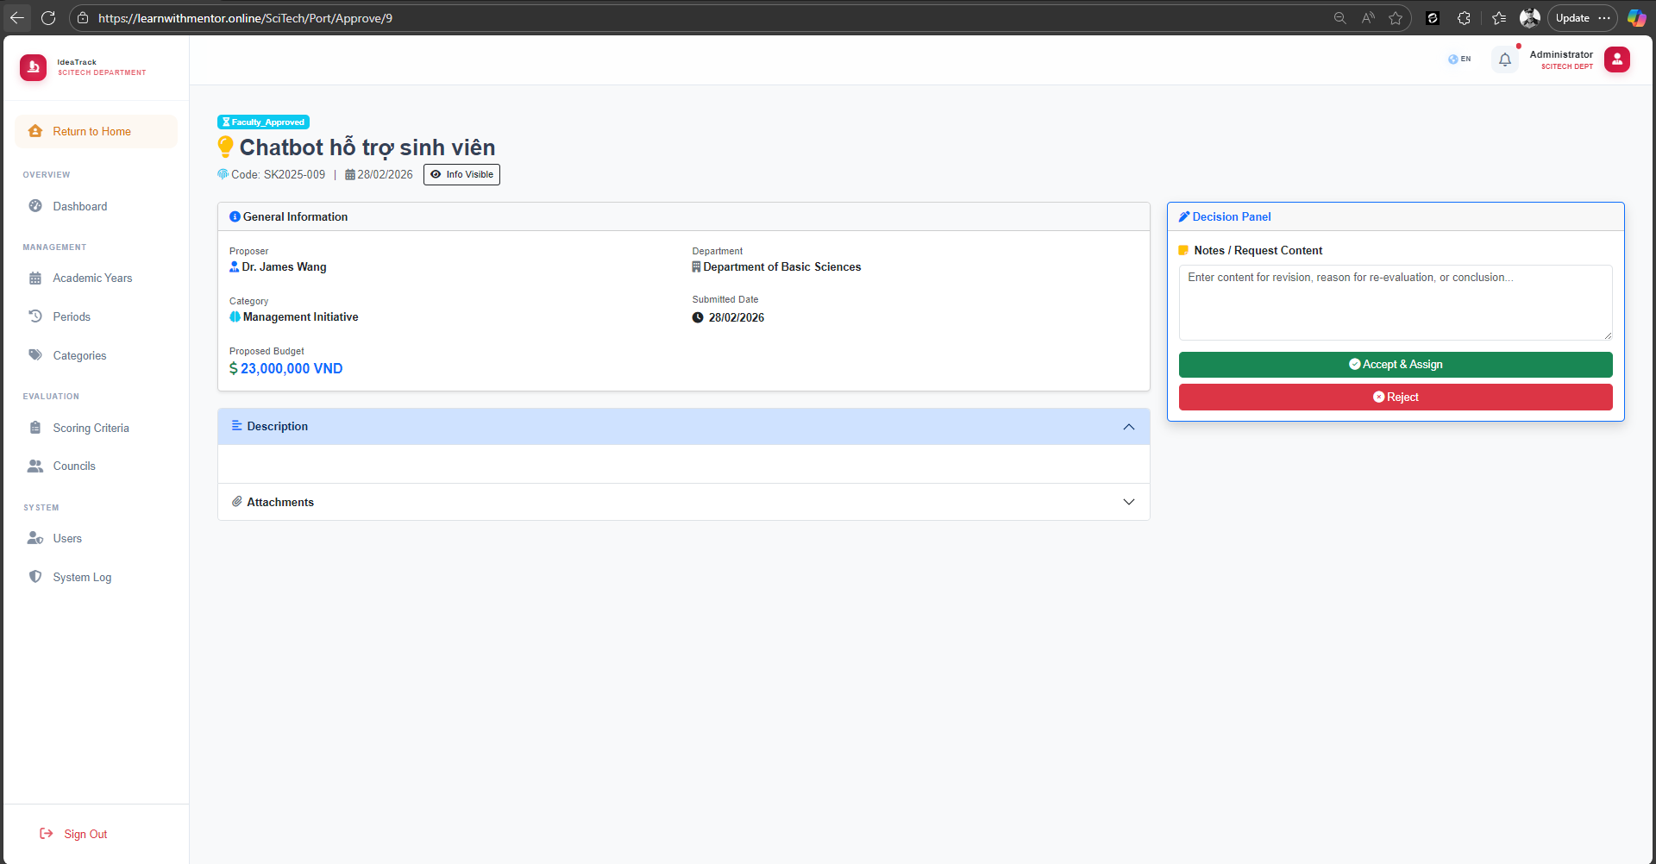
Figure: image11.png
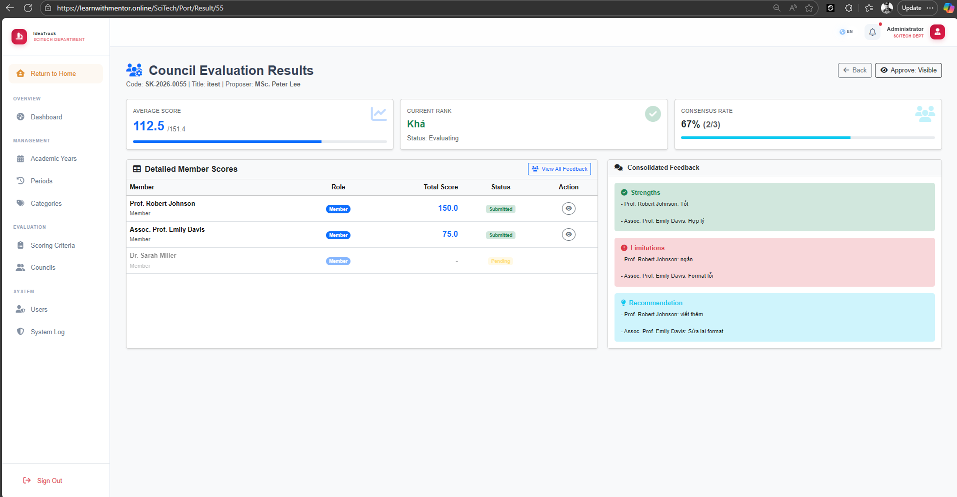
Figure: image10.png

ID | Title | Pre-conditions | Steps | Expected / Actual Results | Status
ST-INIT-01 | Approve New Initiative from Faculty  (EP: Status = Faculty_Approved) | SciTech user logged in.  Initiative status = Faculty_Approved. | 1. Navigate to Port > Approve.  2. Open Faculty_Approved initiative.  3. Click "Accept & Assign". | Status updates to Evaluating. Council members and scoring template are auto-assigned. | PASS
ST-INIT-02 | Reject Initiative at SciTech Stage  (EP: Faculty_Approved → Rejected) | SciTech user logged in.  Initiative status = Faculty_Approved. | 1. Navigate to Port > Approve.  2. Open initiative.  3. Enter rejection note.  4. Click "Reject". | Status updates to Rejected. User is notified via RevisionRequest log. | PASS
ST-INIT-03 | Request New Evaluation Round  (EP: Round 1 → Round 2) | SciTech user logged in.  Initiative CurrentRound = 1.  Status = Evaluating. | 1. Navigate to Port > Result.  2. Select initiative.  3. Click "Request New Round". | Status remains Evaluating or Re_Evaluating. CurrentRound incremented to 2. | PASS
ST-INIT-04 | Make Final Approve Decision  (EP: Status = Pending_Final) | SciTech user logged in.  Initiative status = Pending_Final. | 1. Navigate to Port > Result.  2. Select initiative.  3. Click "Approve" (Final Decision). | Status updates to Processing. Final report is generated. | PASS
ST-INIT-05 | Toggle Personal Info Visibility  (EP: Toggle Anonymization) | SciTech user logged in.  Initiative exists. | 1. Navigate to Port > Result.  2. Toggle HidePersonalInfo = True.  3. View evaluation. | Author names are hidden in evaluation view and PDF export. | PASS
ST-INIT-06 | Filter Initiatives by Date Range  (BVA: Today only) | SciTech user logged in. | 1. Set FromDate = Today, ToDate = Today.  2. Click "Apply". | Only today's submissions are listed. | PASS
ST-INIT-07 | Approve Initiative Without Notes  (BVA: empty notes) | SciTech user logged in.  Initiative status = Faculty_Approved. | 1. Navigate to Port > Approve.  2. Leave "Notes" empty.  3. Click "Accept & Assign". | Initiative is accepted successfully even without notes. | PASS
ST-INIT-08 | Reject Initiative Without Notes  (BVA: empty notes) | SciTech user logged in.  Initiative status = Faculty_Approved. | 1. Navigate to Port > Approve.  2. Leave "Notes" empty.  3. Click "Reject". | Validation error if notes are required, or rejection proceeds with empty notes. | PASS

4.5 Academic Year & Period Management
Evidence Screenshots — Academic Year & Period Management:
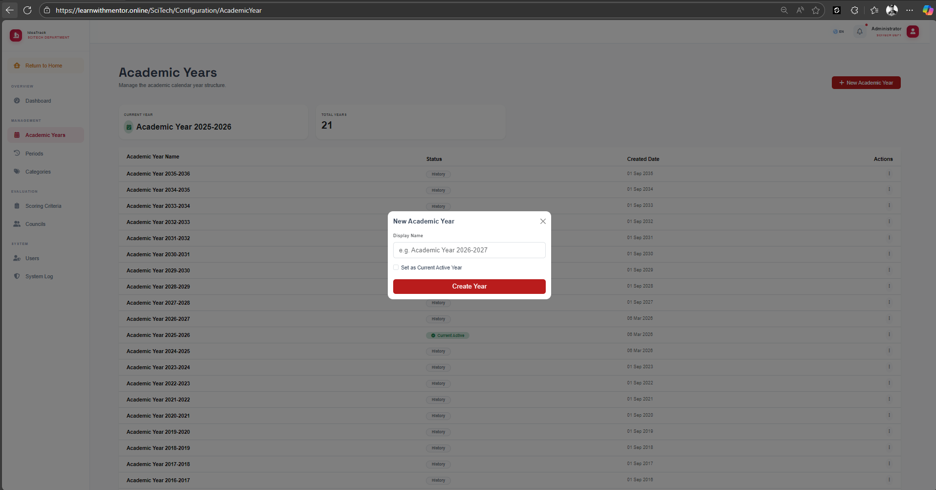
Figure: image12.png
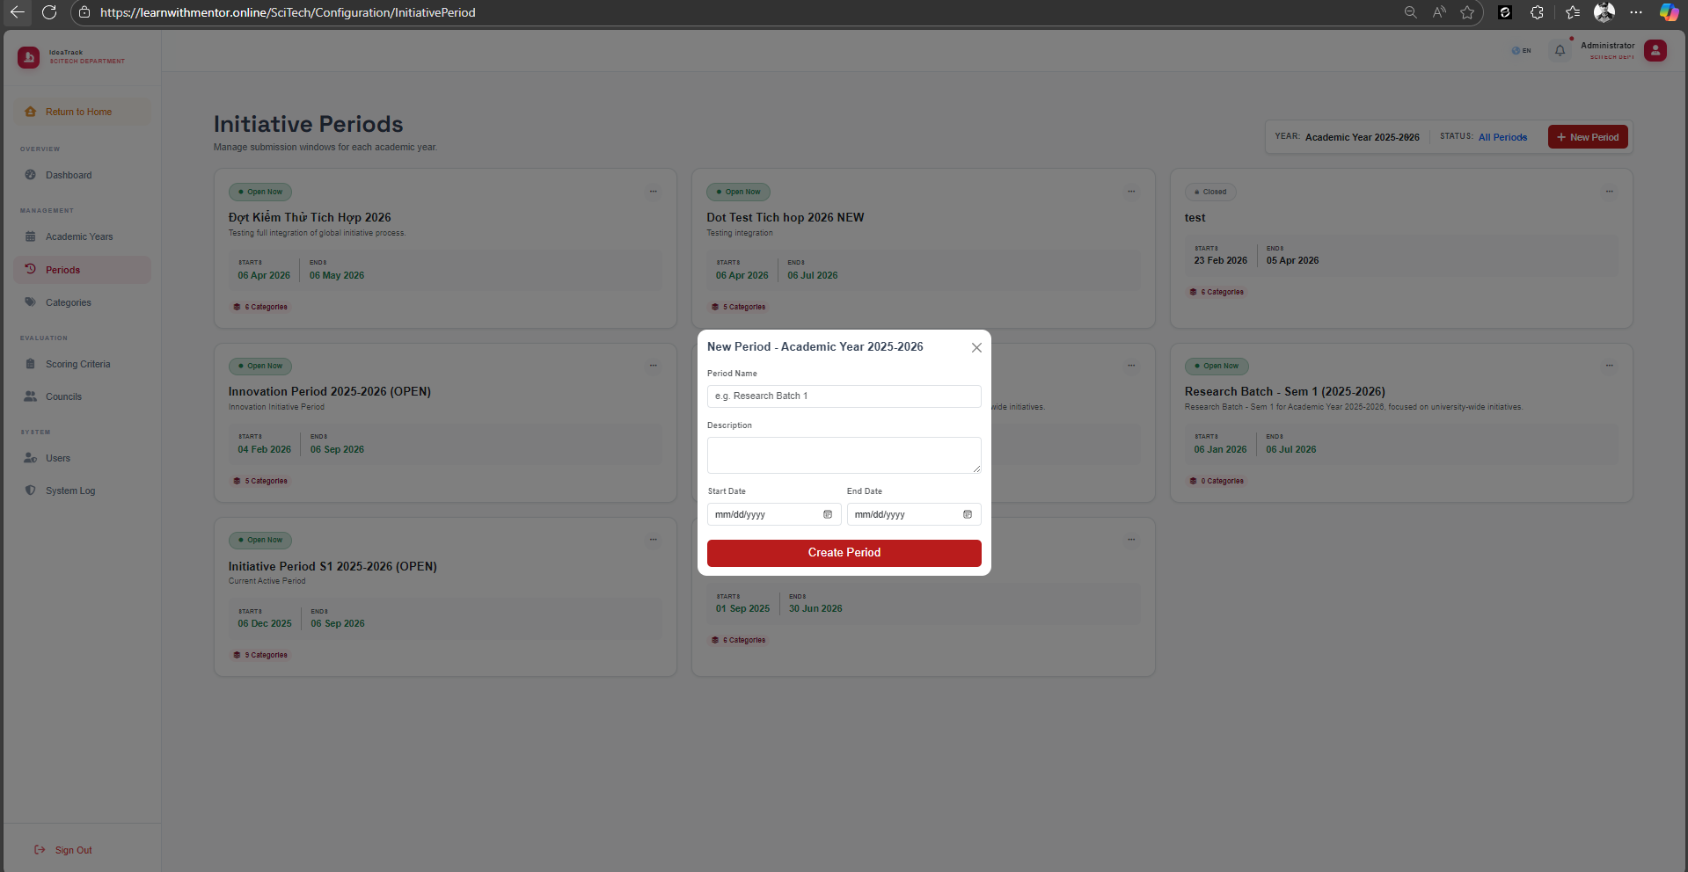
Figure: image13.png

ID | Title | Pre-conditions | Steps | Expected / Actual Results | Status
ST-PER-01 | Create Period with Valid Dates  (EP: StartDate < EndDate) | SciTech user logged in.  Academic Year exists. | 1. Navigate to Periods.  2. Click "+ New Period".  3. Enter name, StartDate = "2026-01-01", EndDate = "2026-06-30".  4. Click "Create Period". | Period is created and linked to the correct Academic Year. | PASS
ST-PER-02 | Create Period with Invalid Date Range  (BVA: StartDate = EndDate + 1 day) | SciTech user logged in. | 1. Navigate to Periods.  2. Click "+ New Period".  3. Set StartDate = "2026-07-01", EndDate = "2026-06-30".  4. Click "Create Period". | Validation error: "End date must be after Start date." | PASS
ST-PER-03 | Create Period Currently "Open"  (BVA: StartDate ≤ Today ≤ EndDate) | SciTech user logged in. | 1. Create period with StartDate in the past, EndDate in the future.  2. Click "Create Period". | Period is created. Badge shows "Open" on dashboard. | PASS
ST-PER-04 | Create Period "Upcoming"  (BVA: StartDate > Today) | SciTech user logged in. | 1. Create period with StartDate in the future.  2. Click "Create Period". | Period is created. Badge shows "Closed" (Upcoming). | PASS
ST-PER-05 | Clone Categories from Previous Period  (EP: valid clone) | SciTech user logged in.  Previous period with categories exists. | 1. Navigate to Periods.  2. Click "+ New Period".  3. Fill dates.  4. Select CloneFromPeriodId.  5. Click "Create Period". | New period created with all categories duplicated from the source period. | PASS
ST-PER-06 | Create Period with StartDate = EndDate  (BVA: same day) | SciTech user logged in. | 1. Click "+ New Period".  2. Set StartDate = EndDate = "2026-05-01".  3. Click Create. | Validation error or period created with 1-day duration. | PASS
ST-PER-07 | Create Period with Empty Name  (EP: invalid — blank) | SciTech user logged in. | 1. Click "+ New Period".  2. Leave Period Name blank.  3. Set valid dates.  4. Click Create. | Validation error: "Period name is required." | PASS
ST-PER-08 | Create Academic Year — Valid  (EP: valid) | SciTech user logged in.  Academic Years page displayed. | 1. Navigate to Academic Years.  2. Click "+ New Academic Year".  3. Enter "Academic Year 2026-2027".  4. Click "Create Year". | Academic Year is created and appears in the list. | PASS
ST-PER-09 | Create Academic Year — Duplicate Name  (EP: invalid — duplicate) | SciTech user logged in.  "Academic Year 2025-2026" already exists. | 1. Click "+ New Academic Year".  2. Enter "Academic Year 2025-2026".  3. Click "Create Year". | Validation error: "Academic Year already exists." | PASS
ST-PER-10 | Create Academic Year — Empty Name  (BVA: blank) | SciTech user logged in. | 1. Click "+ New Academic Year".  2. Leave Display Name empty.  3. Click "Create Year". | Validation error: "Display name is required." | PASS

4.6 Categories Management
Evidence Screenshots — Categories Management:
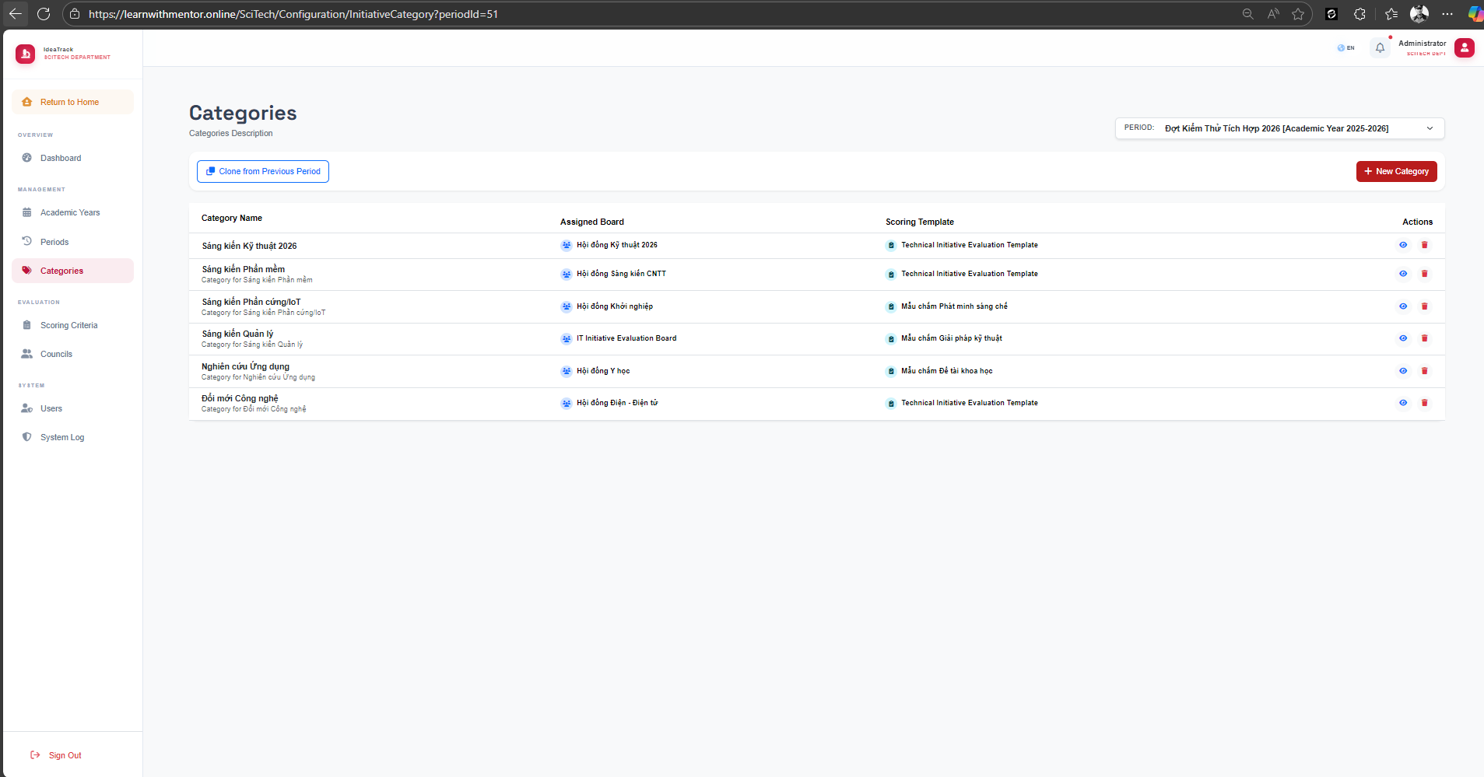
Figure: image14.png
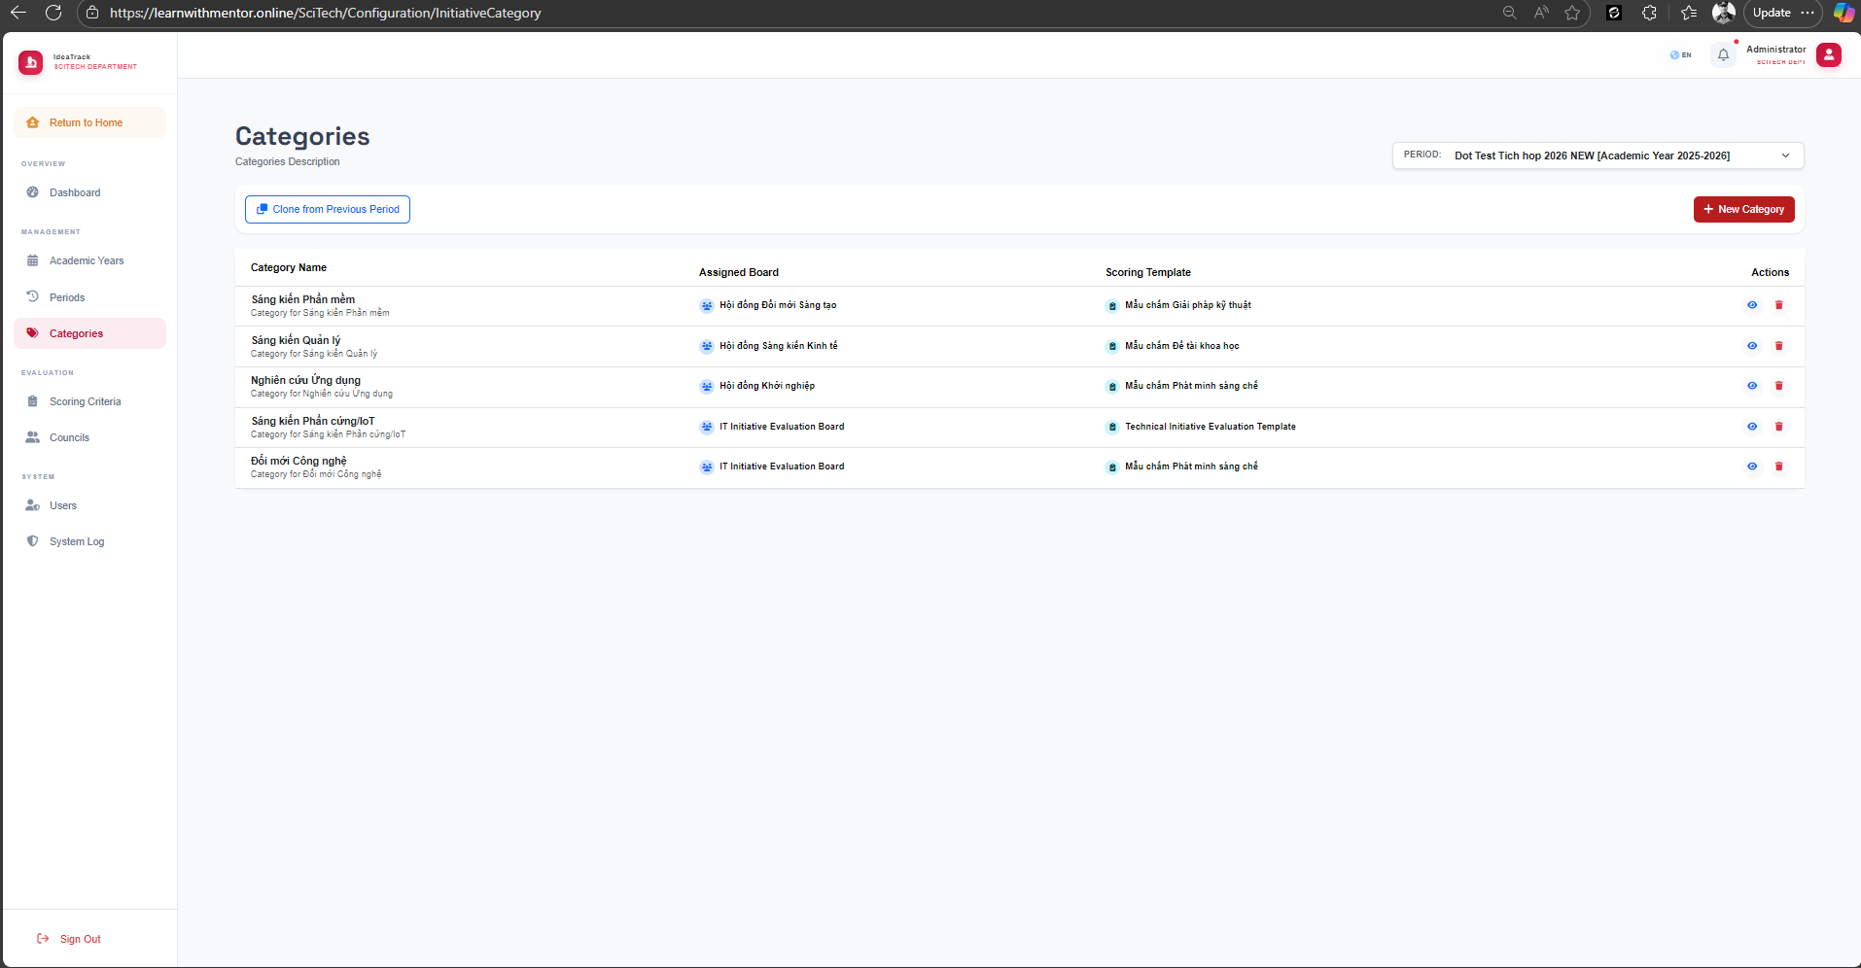
Figure: image15.png

ID | Title | Pre-conditions | Steps | Expected / Actual Results | Status
ST-CAT-01 | View Categories for a Period  (EP: valid view) | SciTech admin logged in.  Period with categories exists. | 1. Navigate to Categories.  2. Select Period from dropdown. | Category list is displayed with columns: Category Name, Assigned Board, Scoring Template, Actions. | PASS
ST-CAT-02 | Create New Category  (EP: valid creation) | SciTech admin logged in.  Period is selected. | 1. Navigate to Categories.  2. Click "+ New Category".  3. Enter category name, assign board and template.  4. Click Create. | Category is created and appears in the list with correct Assigned Board and Scoring Template. | PASS
ST-CAT-03 | Create Category — Empty Name  (BVA: blank) | SciTech admin logged in.  Period is selected. | 1. Click "+ New Category".  2. Leave Category Name blank.  3. Click Create. | Validation error: "Category name is required." | PASS
ST-CAT-04 | Create Category — Duplicate Name  (EP: duplicate within period) | SciTech admin logged in.  Category "Software Initiative" exists in current period. | 1. Click "+ New Category".  2. Enter name = "Software Initiative".  3. Click Create. | Validation error: "Category already exists in this period." | PASS
ST-CAT-05 | Clone Categories from Previous Period  (EP: valid clone) | SciTech admin logged in.  Previous period has categories. | 1. Navigate to Categories.  2. Click "Clone from Previous Period".  3. Select source period.  4. Confirm. | All categories from the source period are cloned into the current period with their assigned boards and templates. | PASS
ST-CAT-06 | Delete Category  (EP: valid deletion) | SciTech admin logged in.  Category exists in the selected period. | 1. Navigate to Categories.  2. Click delete icon (red trash) next to a category.  3. Confirm deletion. | Category is removed from the list. | PASS
ST-CAT-07 | View Category Details  (EP: valid view) | SciTech admin logged in.  Category exists. | 1. Navigate to Categories.  2. Click view icon (eye) next to a category. | Category detail page is displayed showing assigned board members, scoring template, and linked initiatives. | PASS
ST-CAT-08 | Edit Category — Change Assigned Board  (EP: valid edit) | SciTech admin logged in.  Category exists. | 1. Navigate to Categories.  2. Click edit icon next to a category.  3. Change Assigned Board.  4. Click Save. | Category is updated with new Assigned Board. Change is reflected in the list. | PASS
ST-CAT-09 | Edit Category — Change Scoring Template  (EP: valid edit) | SciTech admin logged in.  Category exists. Multiple templates available. | 1. Click edit icon next to a category.  2. Change Scoring Template.  3. Click Save. | Category is updated with new Scoring Template. | PASS
ST-CAT-10 | Switch Period in Dropdown  (EP: valid filter) | SciTech admin logged in.  Multiple periods exist. | 1. Navigate to Categories.  2. Change Period dropdown from one period to another. | Category list updates to show categories for the newly selected period. | PASS

4.7 Evaluation Template & Criteria Configuration
Evidence Screenshots — Scoring Templates & Criteria:
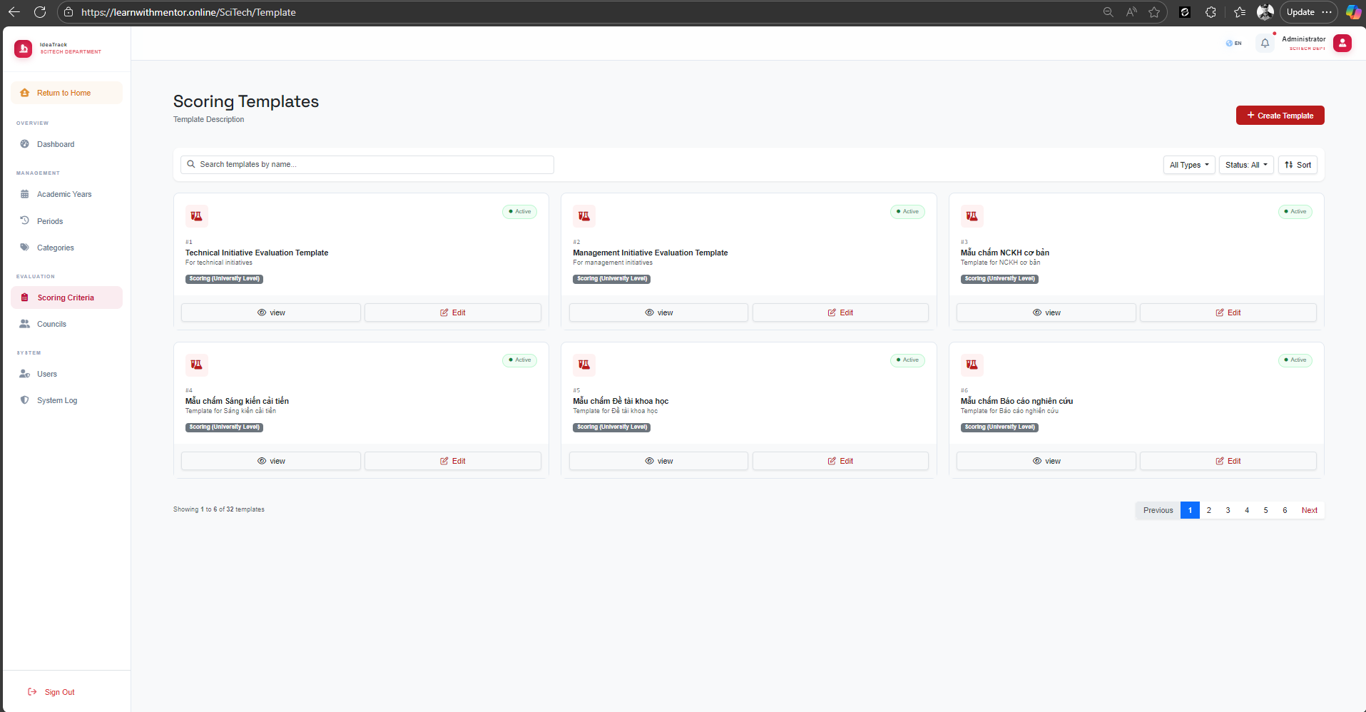
Figure: image16.png
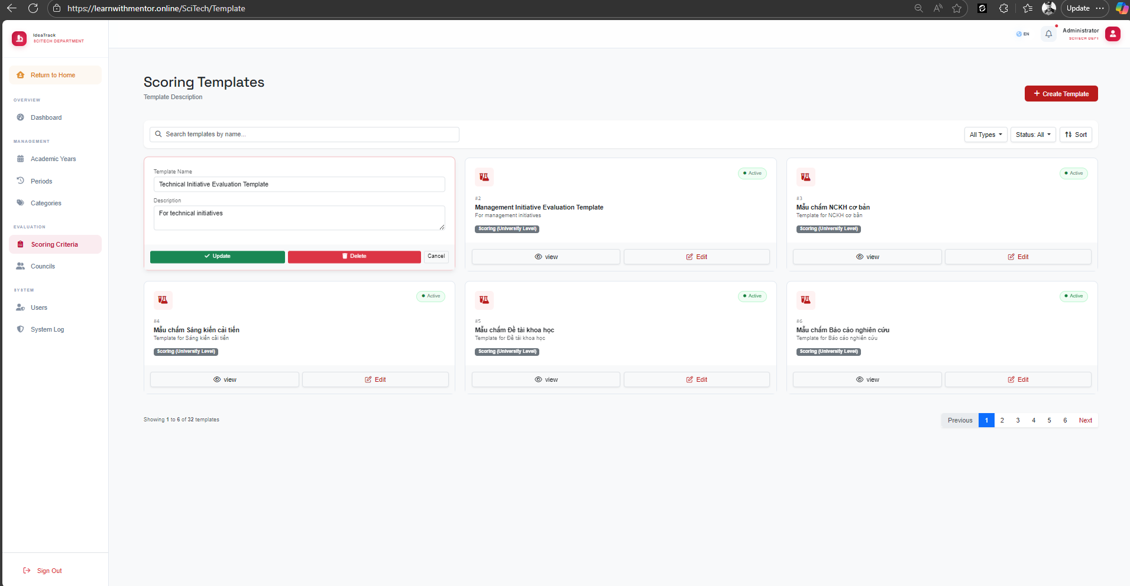
Figure: image17.png
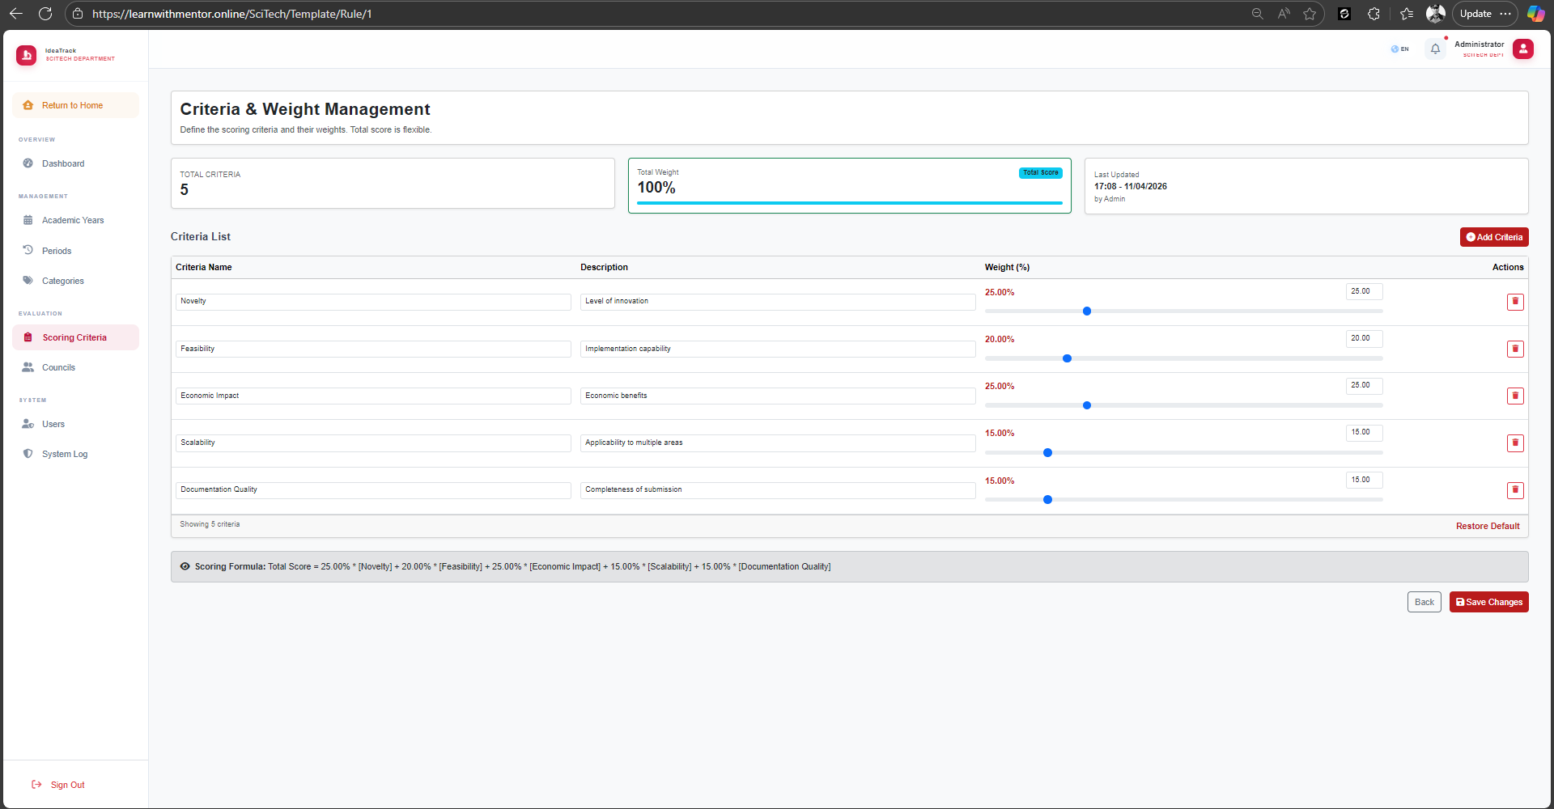
Figure: image18.png

ID | Title | Pre-conditions | Steps | Expected / Actual Results | Status
ST-TMP-01 | Create Scoring Template — Valid  (EP: valid string) | SciTech user logged in.  Template page displayed. | 1. Navigate to Scoring Criteria.  2. Click "+ Create Template".  3. Enter TemplateName.  4. Click Create. | Template is created with status Inactive by default. | PASS
ST-TMP-02 | Add Criteria with Boundary Scores  (BVA: MaxScore = 0 and 500+) | SciTech user logged in.  Template exists. | 1. Navigate to Template > Rules.  2. Add criteria with MaxScore = 0.  3. Add criteria with MaxScore = 500. | System accepts values ≥ 0. Values above 100 allowed for complex rubrics. | PASS
ST-TMP-03 | Activate Template  (EP: Toggle IsActive) | SciTech user logged in.  Inactive template exists. | 1. Navigate to Template Index.  2. Click "Edit" on inactive template.  3. Toggle IsActive to Active.  4. Save. | Template status changes to Active. Can be linked to Categories. | PASS
ST-TMP-04 | Create Template — Empty Name  (BVA: blank) | SciTech user logged in. | 1. Click "+ Create Template".  2. Leave TemplateName blank.  3. Click Create. | Validation error: "Template name is required." | PASS
ST-TMP-05 | Create Template — Duplicate Name  (EP: duplicate) | SciTech user logged in.  Template with same name exists. | 1. Click "+ Create Template".  2. Enter existing template name.  3. Click Create. | Validation error or template created (if duplicates allowed). | PASS
ST-TMP-06 | Add Criteria — Weight Sum > 100%  (BVA: over 100%) | SciTech user logged in.  Template has criteria totaling 100%. | 1. Add new criteria with Weight = 10%.  2. Click "Save Changes". | Validation error: "Total weight exceeds 100%." Or system allows flexible weights. | PASS
ST-TMP-07 | Add Criteria — Weight = 0%  (BVA: lower bound) | SciTech user logged in.  Template exists. | 1. Add new criteria with Weight = 0%.  2. Click "Save Changes". | Criteria is added with 0% weight (valid edge case). | PASS
ST-TMP-08 | Add Criteria — Negative MaxScore  (EP: invalid) | SciTech user logged in.  Template exists. | 1. Add criteria with MaxScore = -10.  2. Click Save. | Validation error: "Max score must be non-negative." | PASS
ST-TMP-09 | Delete Template  (EP: delete action) | SciTech user logged in.  Inactive template exists. | 1. Click "Edit" on template.  2. Click "Delete".  3. Confirm deletion. | Template is deleted. Removed from template list. | PASS

4.8 User & Access Administration
Evidence Screenshot — User Management Page:
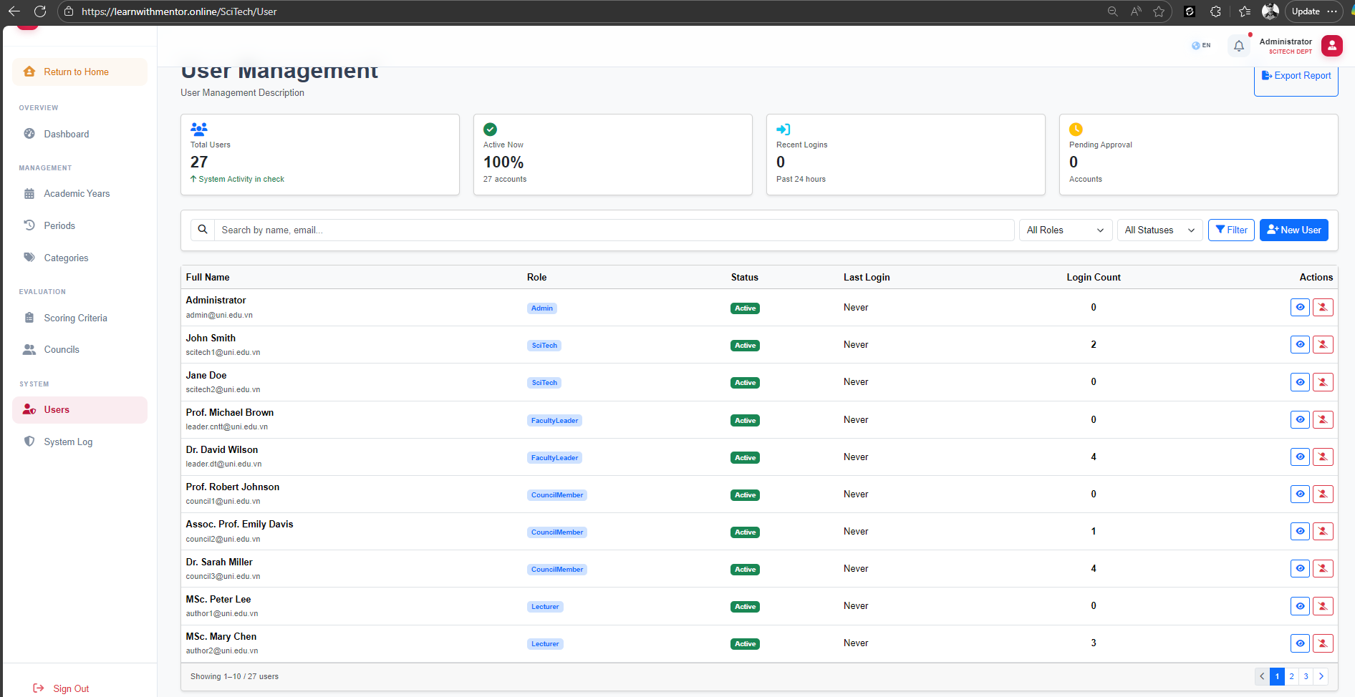
Figure: image20.png

ID | Title | Pre-conditions | Steps | Expected / Actual Results | Status
ST-USER-01 | Create User with Specific Role  (EP: valid roles) | SciTech admin logged in.  User management page displayed. | 1. Navigate to Users.  2. Click "+ New User".  3. Enter user details with Role = "Council".  4. Click Create. | User is created and assigned correct ASP.NET Identity Role. | PASS
ST-USER-02 | Lock Active User Account  (EP: IsActive = False) | SciTech admin logged in.  Active user exists. | 1. Navigate to Users.  2. Find active user.  3. Click Lock/Deactivate. | User status changes to Inactive. User can no longer log in. | PASS
ST-USER-03 | Export User List to Excel  (EP: filtered export) | SciTech admin logged in.  Users with various roles exist. | 1. Navigate to Users.  2. Filter by Role = "Council".  3. Click "Export Report". | Excel file downloaded containing only Council users. | PASS
ST-USER-04 | Create User — Invalid Email  (EP: invalid email) | SciTech admin logged in. | 1. Click "+ New User".  2. Enter email = "notanemail".  3. Click Create. | Validation error: "Invalid email address." | PASS
ST-USER-05 | Create User Without Role  (EP: missing required field) | SciTech admin logged in. | 1. Click "+ New User".  2. Enter user details.  3. Do NOT select a role.  4. Click Create. | Validation error: "Role is required." | PASS
ST-USER-06 | Unlock Locked User Account  (EP: IsActive = True) | SciTech admin logged in.  Locked user exists. | 1. Find locked user.  2. Click Unlock/Activate. | User status changes to Active. User can log in again. | PASS
ST-USER-07 | Search Users by Name  (EP: valid search) | SciTech admin logged in. | 1. Enter "Peter" in search bar.  2. Click Filter. | Only users with "Peter" in their name are displayed. | PASS
ST-USER-08 | Search Users by Email  (EP: valid search) | SciTech admin logged in. | 1. Enter "council" in search bar.  2. Click Filter. | Users with "council" in their name or email are displayed. | PASS
ST-USER-09 | Filter Users by Role and Status  (EP: combined filter) | SciTech admin logged in. | 1. Set Role = "Lecturer". Set Status = "Active".  2. Click Filter. | Only active Lecturer users are displayed. | PASS
ST-USER-10 | Create User — Duplicate Email  (EP: duplicate) | SciTech admin logged in.  User "author1@uni.edu.vn" exists. | 1. Click "+ New User".  2. Enter email = "author1@uni.edu.vn".  3. Click Create. | Validation error: "Email already exists." | PASS

4.9 Council Board Management
Evidence Screenshot — Council Management Page:
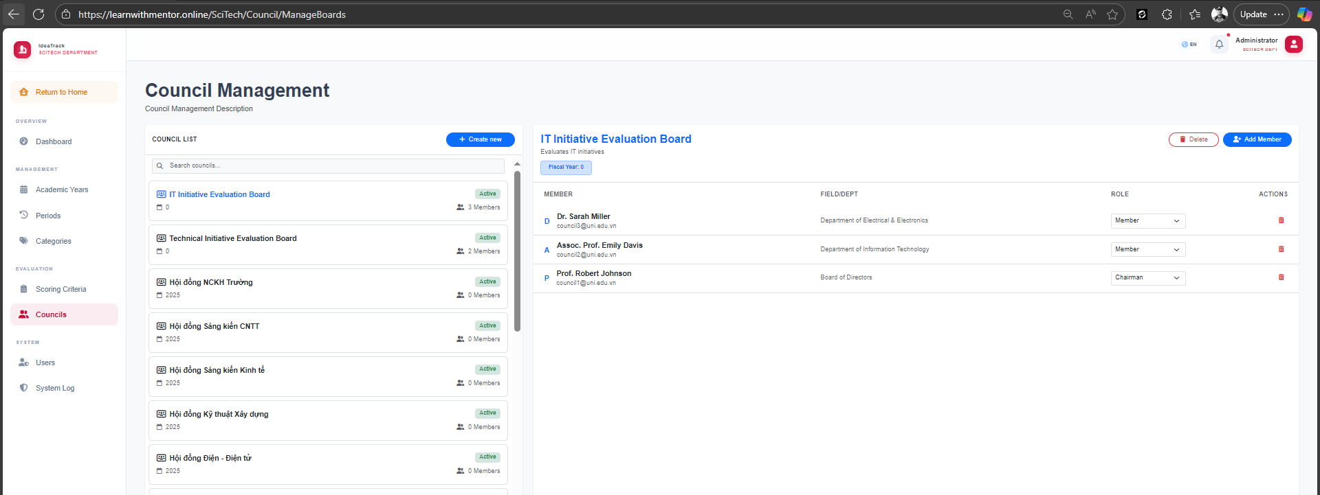
Figure: image19.png

ID | Title | Pre-conditions | Steps | Expected / Actual Results | Status
ST-CL-01 | Create New Council Board  (EP: valid creation) | SciTech admin logged in.  Council management page displayed. | 1. Navigate to Councils.  2. Click "+ Create new".  3. Enter council name.  4. Click Create. | Council board is created and appears in the council list. | PASS
ST-CL-02 | Add Member to Council Board  (EP: valid addition) | SciTech admin logged in.  Council board exists. | 1. Select a council board.  2. Click "+ Add Member".  3. Select user and role.  4. Click Save. | Member is added to the council. Role is correctly assigned. | PASS
ST-CL-03 | Remove Member from Council Board  (EP: valid removal) | SciTech admin logged in.  Council board has members. | 1. Select a council board.  2. Click delete icon next to a member.  3. Confirm removal. | Member is removed from the council board. | PASS
ST-CL-04 | Delete Council Board  (EP: valid deletion) | SciTech admin logged in.  Council board exists. | 1. Select a council board.  2. Click "Delete".  3. Confirm deletion. | Council board is deleted and removed from the list. | PASS
ST-CL-05 | Create Council Board — Empty Name  (BVA: blank) | SciTech admin logged in. | 1. Click "+ Create new".  2. Leave name blank.  3. Click Create. | Validation error: "Council name is required." | PASS
ST-CL-06 | Search Council Boards  (EP: valid search) | SciTech admin logged in.  Multiple councils exist. | 1. Enter "IT" in search bar. | Only councils matching "IT" are displayed. | PASS

4.10 System Log / Audit Log
Evidence Screenshot — Audit Log Page:
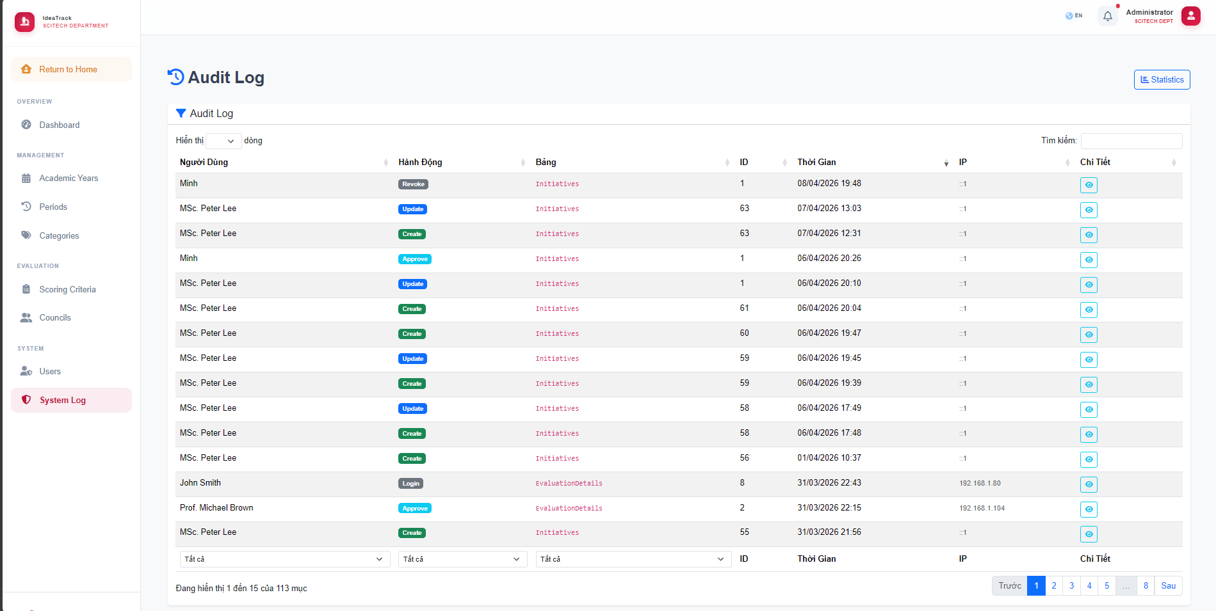
Figure: image21.png

ID | Title | Pre-conditions | Steps | Expected / Actual Results | Status
ST-LOG-01 | View Audit Log  (EP: valid view) | SciTech admin logged in.  System actions have been performed. | 1. Navigate to System Log. | Audit log is displayed with columns: User, Action, Table, ID, Timestamp, IP, Details. | PASS
ST-LOG-02 | Filter Audit Log by Action Type  (EP: valid filter) | SciTech admin logged in. | 1. Navigate to System Log.  2. Filter by Action = "Create". | Only "Create" actions are displayed. | PASS
ST-LOG-03 | Search Audit Log by User  (EP: valid search) | SciTech admin logged in. | 1. Navigate to System Log.  2. Enter "Peter Lee" in search bar. | Only logs for "MSc. Peter Lee" are displayed. | PASS
ST-LOG-04 | Audit Log Pagination  (EP: multi-page) | SciTech admin logged in.  More than 15 log entries exist. | 1. Navigate to System Log.  2. Verify pagination.  3. Click page 2. | Page 2 displays entries 16-30. Pagination works correctly. | PASS

Test Cases Summary
Module | Existing | Added (EP/BVA) | Total
Author — Create Initiative | 5 | 10 | 15
Author — My Initiatives | 0 | 12 | 12
Author — Statistics | 0 | 9 | 9
Author — Profile Update | 2 | 2 | 4
Faculty — Review Actions | 4 | 3 | 7
Faculty — Dashboard & Search | 4 | 3 | 7
Faculty — Profile Update | 3 | 3 | 6
Councils — Auth & Access | 3 | 4 | 7
Councils — Tasks & History | 3 | 4 | 7
SciTech — Auth & Dashboard | 2 | 1 | 3
SciTech — Filters | 2 | 5 | 7
SciTech — Export & Report | 2 | 1 | 3
SciTech — Initiative Processing | 6 | 2 | 8
SciTech — Period Management | 5 | 5 | 10
SciTech — Categories Mgmt | 0 | 10 | 10
SciTech — Template & Criteria | 3 | 6 | 9
SciTech — User Admin | 3 | 7 | 10
SciTech — Council Mgmt | 0 | 6 | 6
SciTech — Audit Log | 0 | 4 | 4
TOTAL | 47 | 97 | 144

