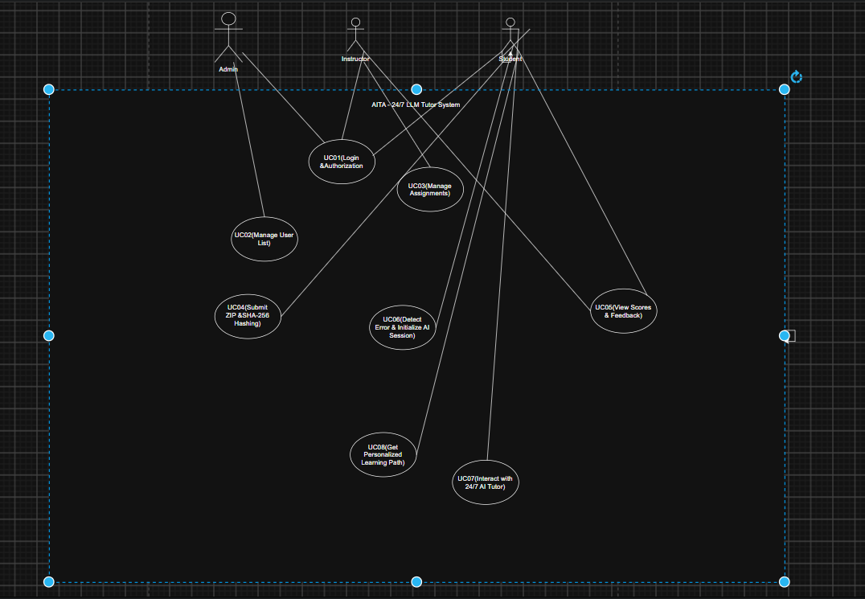

Detailed Use Case Descriptions
AITA – 24/7 LLM Tutor System

UC01 – Login & Authorization
Use Case ID: UC01
Use Case Name: Login & Authorization
Actors: Admin, Instructor, Student
Goal:
Allow users to log in and access the system based on their role.
Preconditions:
User has an account.
User is not logged in.
Postconditions:
User logs in successfully.
User is redirected to the correct dashboard.
Main Flow:
- User opens the Login page.
- User enters email and password.
- User clicks the Login button.
- System checks the email and password.
- System checks the user's role.
- System creates a secure session.
- System redirects the user to the correct dashboard.
Exception Flow:
E1: If the email or password is wrong, the system shows an error message.
E2: If a user is not logged in but tries to access a protected page, the system redirects the user to the Login page.

UC02 – Manage User List
Use Case ID: UC02
Use Case Name: Manage User List
Actor: Admin
Goal:
Allow Admin to manage student and instructor accounts.
Preconditions:
Admin is logged in.
Admin has permission to manage users.
Postconditions:
User information is added, updated, or deleted successfully.
Main Flow:
- Admin opens the User Management page.
- System shows the user list.
- Admin selects a user or chooses to add a new user.
- Admin chooses Add, Edit, or Delete.
- Admin enters or changes the user information.
- System checks the information.
- System saves the changes.
- System shows the updated user list.
Exception Flow:
E1: If some required information is missing, the system shows an error.
E2: If the selected user does not exist, the system shows an error.
E3: If Admin does not have permission, the system rejects the request.

UC03 – Manage Assignments
Use Case ID: UC03
Use Case Name: Manage Assignments
Actor: Instructor
Goal:
Allow Instructor to manage programming assignments.
Preconditions:
Instructor is logged in.
Instructor has permission to manage assignments.
Postconditions:
Assignment information is saved successfully.
Main Flow:
- Instructor opens the Assignment Management page.
- System shows the assignment list.
- Instructor chooses Create, Edit, or Delete.
- Instructor enters or changes assignment information.
- Instructor sets the deadline.
- Instructor sets the grading criteria.
- System checks the information.
- System saves the changes.
- System shows the updated assignment list.
Exception Flow:
E1: If required information is missing, the system shows an error.
E2: If the deadline is invalid, the system rejects the information.
E3: If the assignment does not exist, the system shows an error.

UC04 – Submit ZIP & SHA-256 Hashing
Use Case ID: UC04
Use Case Name: Submit ZIP & SHA-256 Hashing
Actor: Student
Goal:
Allow Student to submit an assignment safely.
Preconditions:
Student is logged in.
The assignment is available for submission.
Postconditions:
The ZIP file is stored.
The SHA-256 hash is stored.
The submission is sent to the grading queue.
Main Flow:
- Student opens an assignment.
- Student selects a ZIP file.
- Student uploads the file.
- System checks the file.
- System checks that the file is a ZIP file.
- System calculates the SHA-256 hash.
- System stores the file and hash.
- System sends the submission to the grading queue.
- System shows a successful submission message.
Exception Flow:
E1: If the submission is after the deadline, the system rejects it.
E2: If the file is not a ZIP file, the system rejects it.
E3: If the file is invalid, the system asks Student to upload another file.

UC05 – View Scores & Feedback
Use Case ID: UC05
Use Case Name: View Scores & Feedback
Actors: Student, Instructor
Goal:
Allow users to view scores and feedback.
Preconditions:
User is logged in.
Score or feedback information is available.
Postconditions:
The score and feedback are displayed to the user.
Main Flow:
- User opens the Scores and Feedback page.
- System gets the submission information.
- System shows the score.
- System shows the feedback.
- User reviews the score and feedback.
Exception Flow:
E1: If the submission has not been graded, the system shows that the score is not available.
E2: If feedback is not available, the system shows the available score.
E3: If the submission cannot be found, the system shows an error.

UC06 – Detect Error & Initialize AI Session
Use Case ID: UC06
Use Case Name: Detect Error & Initialize AI Session
Actors: System, Student
Goal:
Detect programming errors and prepare an AI Tutor session.
Preconditions:
Student has code in the Sandbox.
Student runs the code.
Postconditions:
System gets the error information.
The AI Tutor session can be started.
Main Flow:
- Student runs the code in the Sandbox.
- Sandbox executes the code.
- System detects a compile or runtime error.
- System gets the Error Log.
- System extracts the important error information.
- System prepares the error information for the AI Tutor.
- System shows the "Ask AI Tutor" button.
- Student clicks the button.
- System starts an AI Tutor session.
Exception Flow:
E1: If there is no error, the system does not start an error-based AI session.
E2: If the Error Log cannot be found, the system shows an error message.

UC07 – Interact with 24/7 AI Tutor
Use Case ID: UC07
Use Case Name: Interact with 24/7 AI Tutor
Actor: Student
Goal:
Help Student understand programming problems with the AI Tutor.
Preconditions:
Student is logged in.
AI Tutor is available.
Postconditions:
Student receives an AI response.
The conversation is saved in the current session.
Main Flow:
- Student opens the AI Tutor.
- Student enters a question.
- Student sends the question.
- System receives the question.
- System analyzes the question and code or error information.
- System sends the information to the AI Tutor.
- AI Tutor generates an explanation.
- System shows the answer to Student.
- Student can ask another question.
- System continues the conversation.
Exception Flow:
E1: If the question is empty or invalid, the system asks Student to enter a valid question.
E2: If the AI service is unavailable, the system shows an error and allows Student to try again.
E3: If the request exceeds the limit, the system stops processing the request.
Business Rule:
The AI Tutor should explain and guide Student's thinking. It should not directly complete the programming task for the Student.

UC08 – Get Personalized Learning Path
Use Case ID: UC08
Use Case Name: Get Personalized Learning Path
Actors: System, Student
Goal:
Give Student a learning path based on their errors and learning history.
Preconditions:
Student has error or AI Tutor history.
The system has enough data for analysis.
Postconditions:
System generates a personalized learning path.
Student can see recommended topics.
Main Flow:
- System collects Student's error history and AI Tutor session history.
- System analyzes the repeated errors.
- System identifies the weak knowledge areas.
- System creates a personalized learning path.
- System recommends topics or learning materials.
- Student opens the Personalized Learning Path.
- System shows the recommended topics.
- Student reviews the recommendations.
Exception Flow:
E1: If there is not enough learning history, the system informs Student that a learning path cannot be generated yet.
E2: If the analysis fails, the system shows an error message.

