# Bijels – Droplet Connectivity

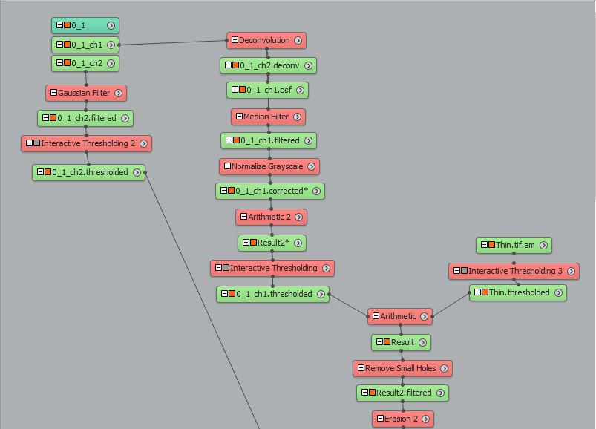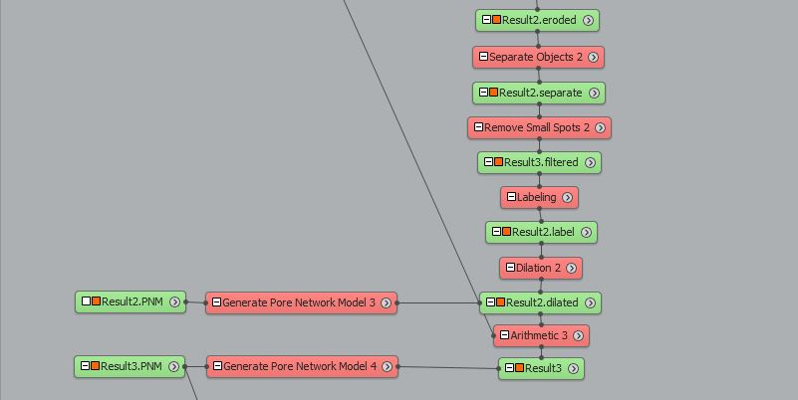

**Extract Subvolume (Stitched Images only)**

This module is used to extract a section of the image. It is used in stitched files as the images are too large to apply deconvolution.

**Deconvolution**

Blind deconvolution is used to remove out of focus light.

Settings:

* Iterations: 10
* Method: Blind
* PSF: from LAS X
* Mode: confocal

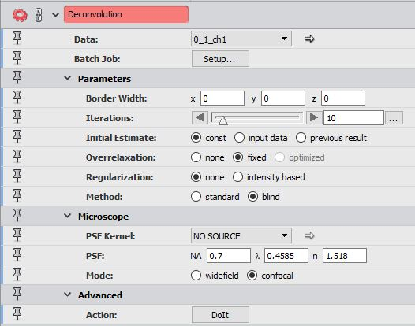

**Merge (Stitched Images Only)**

This module is used to recombine the extracted section in large files.

*for large, stitched images, the above steps can be done by updating and copying the text file “FinalStitched.txt”

**Median Filter**

The median filter averages small sections of pixels in grayscale images. This reduces contrast and softens the edges of objects in the images.

Settings:

* Interpretation: 3D
* Iterations: 5

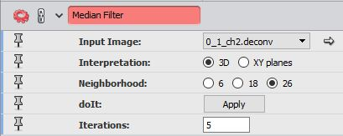

**Normalize Grayscale**

This module changes the range of pixel intensities to increase contrast, which makes binarization easier. It is applied to each XY-slice to maintain brightness throughout the z-stack.

Settings:

* Interpretation: XY planes
* Range Mode: percentile

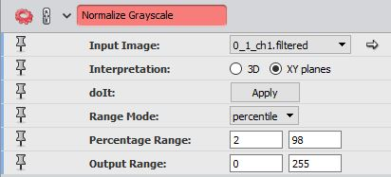

**Arithmetic**

This arithmetic is used to oversaturate the grayscale image by multiplying all values by a constant. This step is used to get rid of shadows in the image which makes separating droplets easier.

Settings:

* A: normalized image
* Expression: A*3

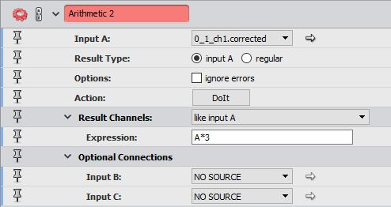

**Gaussian Filter**

This module is used to reduce the contrast and soften the edges of objects in a grayscale image. This filter is only applied to the particle channel.

Settings:

* Interpretation: 3D
* Kernel Type: standard

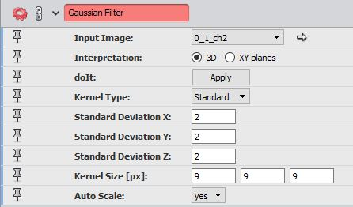

**Interactive Thresholding**

Thresholding transforms a grayscale image to a binary image. This module allows the user to interactively change the threshold and has a preview of the binarized image overlaid on the grayscale image. Attach an interactive thresholding module to both the droplet channel (after arithmetic) and the gaussian filtered particle channel.

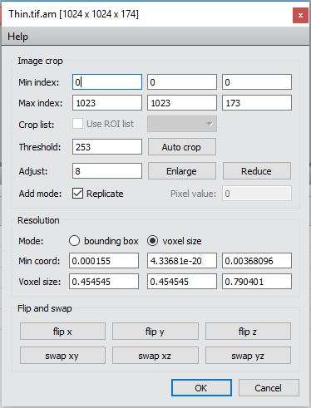

Export the binarized particle channel as a 2D .tif file.

Open and update the matlab file “Skeletonization” according to the sample and images that were exported. Run the program and a new 3D .tif will be saved as “Thin.tif”.

In Avizo, import the Thin.tif file and update the minimum coordinates and voxel size to match the original images.

Attach an interactive thresholding module to the new image, and set the lower threshold value to 1.

**Arithmetic**

This arithmetic subtracts the thinned image from the binarized droplet channel.

Settings:

* A:
* B: Thin.thresholded
* Expression: A-B

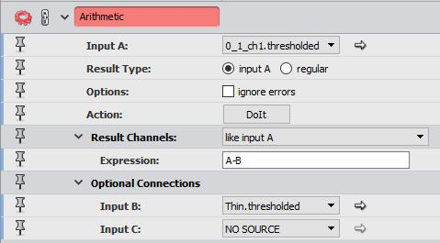

**Remove Small Holes**

This module removes the small holes in an image, based on the pixel size that is set. This is used to remove holes that would grow larger after applying erosion, and could lead to over separation later.

Settings:

* Interpretation: XY planes
* Size [px]:

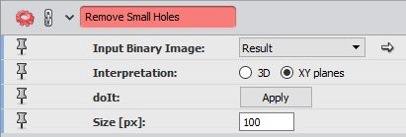

**Erosion**

This module removes a shell of pixels from any objects in the image. We are using sphere based erosion to erode a spherical shell.

Settings:

* Type: ball
* Size [px]:
* Precision: precise

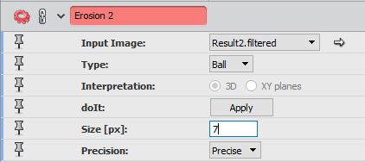

**Separate Objects**

This module uses watershedding to separate objects.

Settings:

* Marker Extent:

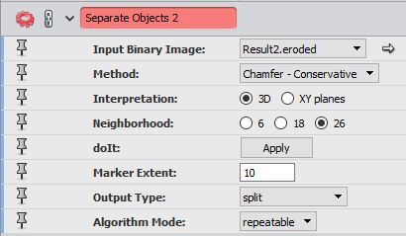

**Remove Small Spots**

This module is similar to remove small holes, however objects below a set volume are removed from the image. This is used to remove small specks in the image that are not large enough to be droplets.

Settings:

* Interpretation: 3D
* Size [px]:

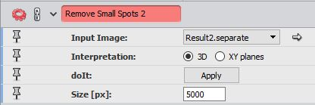

**Labeling**

This module differentiates distinct objects by giving the pixels of each objects a unique number and displays the image with a variety of colours.

**Dilation**

This module is similar to erosion, however it adds a shell of pixels to all object in an image. This module also preserves the labels.

Settings:

* Type: ball
* Size [px]:
* Precision: precise

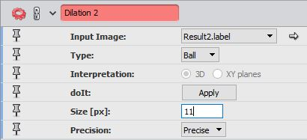

**Arithmetic**

This arithmetic is used to subtract the binarized particle channel (not thinned) from the dilated image. To do so, the particle channel is multiplied by the total number of objects (from labeling) before subtraction.

Settings:

* A: Dilated Image
* B: Binarized particle channel (not thinned)
* Expression: A - ( B * (# objects) )

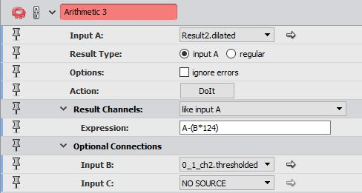

**Generate Pore Network Model**

This module measures data on areas where objects are connected. This data is given in a table and gives information on the pore size, throat size, and which objects are connected. This module is applied to both the dilated image and the final subtracted image. In the dilated image, the connections are areas with either jamming or a channel, whereas in the subtracted image, the connections are areas with only channels.

Export the data into an excel file. Make note of the number of throats in the pore network model attached to the dilated image. This value is referred to as the number of connections in the matlab program.

Create a new blank excel file to hold the results of the matlab program.

Update lines 5 to 14 in the matlab program “ConnectedDropletCounting_NetworkMethod” and run the program.