# Connectivity Analysis – 3D Confocal

This procedure was used to analyze the connectivity of both channels of a bicontinuous structure (specifically Rachel Malone’s bijels) for 3D LSCM images. It makes use of Avizo and Matlab, and all the required files should be included in the same folder as this document.

## Avizo Procedure

Open the desired image into a new file and apply the listed modules to the lutidine channel. Each module has a brief description of its purpose and the settings that need to be changed. Some settings may not work well for all images and may need to be different.

### Deconvolution

First, blind deconvolution is used to remove out of focus light.

Settings:

* Input image: original lutidine image
* Iterations: 10
* Method: blind
* PSF: use values from LAS X
* Mode: confocal

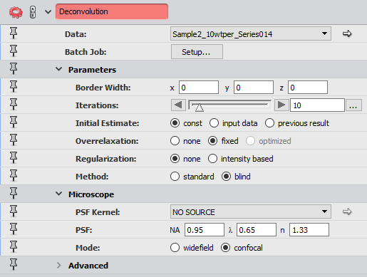

### Gaussian Filter (optional)

For images used with 63x objective, Gaussian filter can be used to further smooth the images. This reduces contrast and softens edges of objects.

Settings:

* Input image: deconvolution result
* Interpretation: 3D
* Kernel Type: standard

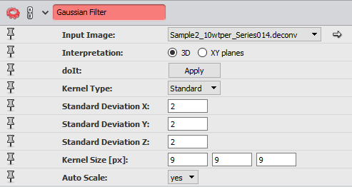

### Median Filter

The median filter averages small sections of pixels in grayscale images. This reduces contrast and softens the edges of objects in the images.

Settings:

* Input image: deconvolution or Gaussian filter result
* Interpretation: 3D
* Iterations: 3

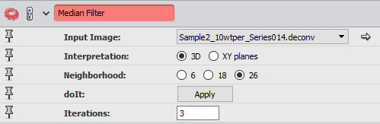

### Normalize Grayscale

This module normalizes the range of pixel intensities, which makes the image appear brighter and makes binarization easier. It is applied to each XY-slice to maintain brightness throughout the z-stack.

Settings:

* Input image: median filter result
* Interpretation: XY planes
* Range Mode: percentile

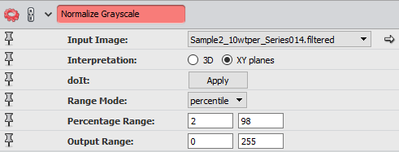

### Interactive Thresholding

Thresholding transforms a grayscale image to a binary image. This module allows the user to interactively change the threshold and has a preview of the binary image overlaid on the grayscale image.

Settings:

* Data: normalize grayscale output

### Remove Small Spots

This module is used to remove small spots on the images, based on the size input.

Settings:

* Data: interactive thresholding result
* Interpretation: 3D
* Size: 100

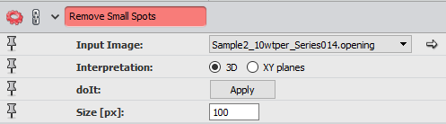

### Not

This module is used to generate a binary compliment image, which represents the water phase of the sample.

Settings:

* Data: remove small spots result

### Volume Fraction

This is used on each binary channel to get the volume of the labeled region.

Settings:

* Input Image: remove small spots and not result
* Interpretation: 3D

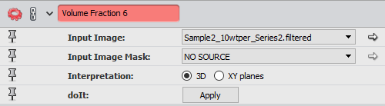

### Auto Skeleton

This module is used on both the binary image and the compliment to extract a centerline for each image. Output will be a set of data with information on the nodes and connecting segments that make up the centerline.

Settings:

* Data: remove small spots and not results

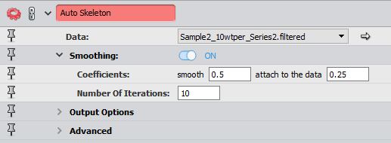

### Spatial Graph Statistics

This module is applied to the result of each auto skeleton in order to extract more data. This outputs a set of data with information on each node and segments.

Settings:

* Data: auto skeleton results

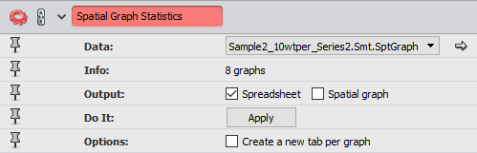

### Label Analysis

This module is used to label each individual object. This outputs a set of data with information on each objects area, position, etc.

Settings:

* Data: remove small spots and not result
* Interpretation: 3D

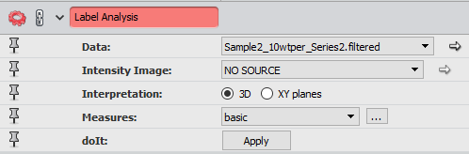

### Analysis Filter

Filters the result of label analysis based on the user’s set filter. This is used to only consider objects with a volume >0.1% of the total labeled volume for that channel in order to get the number of isolated objects.

Settings:

* Image: label analysis results
* Filter: Volume3D > (0.1% of material volume)

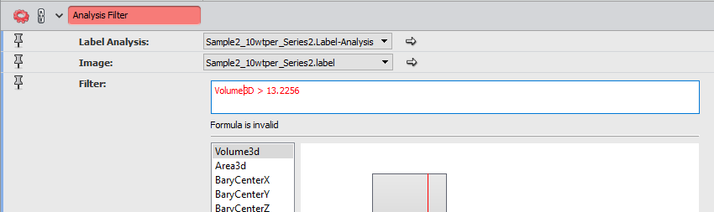

Once these modules are applied, the following data needs to be saved for use in the Matlab programs

1. Auto skeleton result for each binary channel, exported as excel files
2. Spatial graph statistics result for each binary channel, exported as excel files
3. Number of objects for each channel, taken from each analysis filter

## Matlab Procedure

Once the data has been saved from Avizo, the Matlab programs can be used. Open the following programs in Matlab:

* confocal_connectivity_3d_script
* confocal_connectivity_3d

Update confocal_connectivity_3d_script with series, file names, and number of isolated objects, as outlined in the code comments. Run the program and the results will be written to an excel file.