# Connectivity Analysis – SEM

This procedure was used to analyze the connectivity of the particle and void channel of a bicontinuous structure (specifically Rachel Malone’s bijels) for SEM images. It makes use of ImageJ, Avizo and Matlab, and all the required files should be included in the same folder as this document, as well as a sample script.

## ImageJ Procedure

Open the SEM image using file->open. Select the straight tool  and make a line on the scale bar. Select analyze->set scale and update the “known distance” to the length the scale bar represents; select ok. Once this is done, the real size of the image in the same units as the scale bar will be in the upper left corner of the image window (see below).

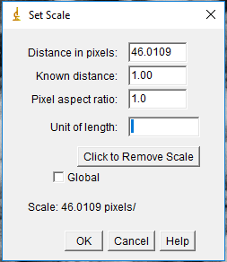

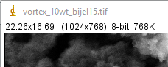

## Avizo Procedure

Open the desired image into a new file. Open the crop editor for this image , select “bounding box” for the resolution mode, and set “min coord” to 0 and “max coord” to the size from ImageJ. For the Z dimensions, set “min coord” to 0 and “max coord” to 1. The image will now have the appropriate dimensions.

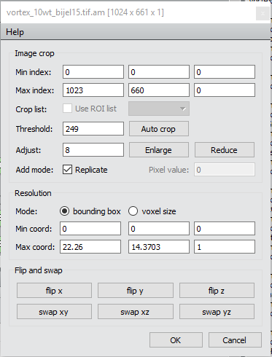

Once the scale is set, go back into the crop editor and crop the section of the image that you want to work with.

### Median Filter

The median filter averages small sections of pixels in grayscale images. This reduces contrast and softens the edges of objects in the images.

Settings:

* Input Image: cropped SEM image
* Interpretation: XY planes
* Iterations: 3

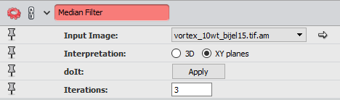

### Interactive Thresholding

Thresholding transforms a grayscale image to a binary image. This module allows the user to interactively change the threshold and has a preview of the binary image overlaid on the grayscale image.

Settings:

* Data: median filter result

### Closing

This module adds pixels around the object in the image and then removes the pixels. This is used to remove small holes and smooth object borders.

Settings:

* Input Image: interactive thresholding result
* Type: disc
* Interpretation: XY planes
* Size: 1

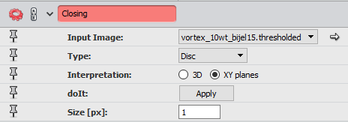

### Remove Small Spots

This module is used to remove small spots on the images.

Settings:

* Input Image: closing result
* Interpretation: 3D or XY Planes
* Size: 50

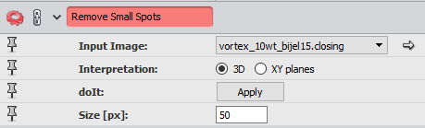

### Not

This module is used to create a binary compliment image. The result will be the area of void space in the image.

Settings:

* Input Image: remove small spots result

### Area

This is applied to both final binary image and its compliment to get the respective areas of the particle and void space.

Settings:

* Input Image: remove small spots and not results
* Interpretation: XY planes

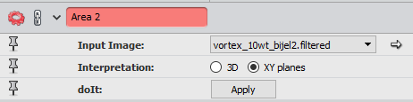

### Auto Skeleton

This module is used on both the binary image and the compliment to extract a centerline for each image. Output will be a set of data with information on the nodes and connecting segments that make up the centerline.

Settings:

* Data: remove small spots and not results

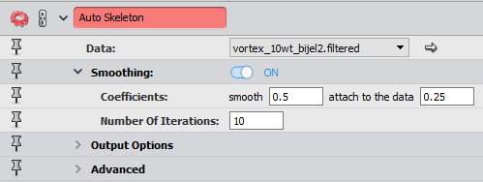

### Spatial Graph Statistics

This module is applied to each auto skeleton result in order to extract more data. This outputs a set of data with information on each node and segments.

Settings:

* Data: Auto skeleton results

### Label Analysis

The module is used to label each individual object. This outputs a set of data with data on each objects area, position, etc.

Settings:

* Data: remove small spots and not results
* Interpretation: 3D

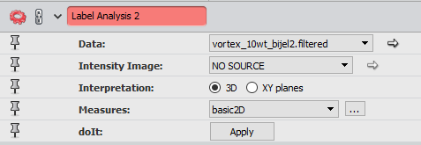

### Analysis Filter

Filters the result of label analysis based on the user’s filter. This is used to only consider objects with an area >0.1% of the total object volume for that channel, and get the number of isolated objects.

Settings:

* Image: label analysis result
* Filter: Area > (0.1% of labeled area)

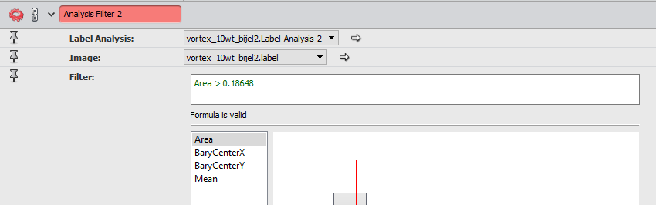

Once these modules are applied, the following data needs to be saved for use in the Matlab programs

1. Auto skeleton result for each binary channel, exported as excel files
2. Spatial graph statistics result for each binary channel, exported as excel files
3. Number of objects for each channel, from analysis filter

## Matlab Procedure

Once the data has been saved from Avizo, the Matlab programs can be used. Open the following programs in Matlab:

* sem_connectivity
* sem_connectivity_script

Update sem_connectivity_script with series, file names and number of isolated objects, as outlined in the code comments. Run the program and the results will be written to an excel file.