# Curvature Analysis Procedure

This procedure was completed for Rachel Malone’s paper “Deriving bimodal porous materials directly from network-strengthened bicontinuous interfacially jammed emulsion gels”. The procedure was completed with the use of Avizo 9.3 and Matlab. All the required files should be included in the same folder as this document, as well as a sample script.

This procedure was done in two different ways: either the whole sample was used to calculate curvature, or the sample was subdivided into quadrants to get curvature with a modified standard deviation. The second method was primarily used for the paper.

## Avizo Procedure

Open the desired image into a new file and apply the listed modules to the lutidine channel. Each Module has a brief description of its purpose and the settings that need to be changed.

### Deconvolution

First, blind deconvolution was used to remove out of focus light.

Settings:

* Input image: original lutidine image
* Iterations: 10
* Method: blind
* PSF: use values from LAS X
* Mode: confocal

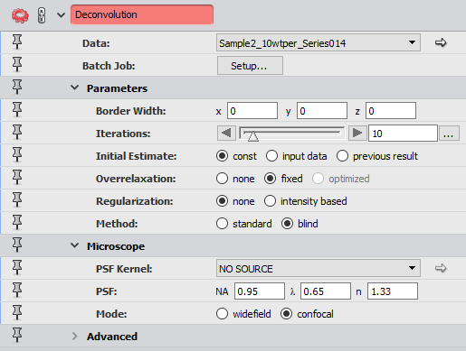

### Gaussian Filter (optional)

For images used with 63x objective, Gaussian filter is used to further smooth the images. This reduces contrast and soften edges of objects.

Settings:

* Input image: deconvolution result
* Interpretation: 3D
* Kernel Type: standard

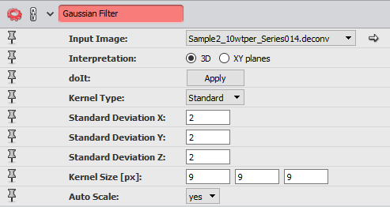

### Median Filter

The median filter averages small sections of pixels in grayscale images. This reduces contrast and softens the edges of objects in the images.

Settings:

* Input image: deconvolution or Gaussian filter result
* Interpretation: 3D
* Iterations: 3

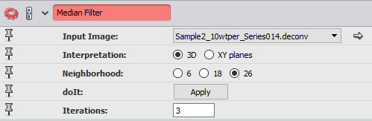

### Normalize Grayscale

This module changes the range of pixel intensities to increase contrast, which makes binarization easier. It is applied to each XY-slice to maintain brightness throughout the z-stack.

Settings:

* Input image: median filter result
* Interpretation: XY planes
* Range Mode: percentile

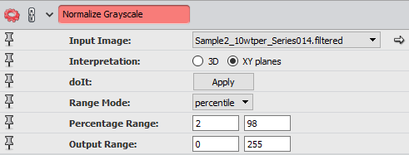

### Interactive Thresholding

Thresholding transforms a grayscale image to a binary image. This module allows the user to interactively change the threshold and has a preview of the binary image overlaid on the grayscale image.

Settings:

* Data: normalize grayscale output

### Remove Small Spots

This module is used to remove small spots on the images.

Settings:

* Data: interactive thresholding result
* Interpretation: 3D
* Size: 100

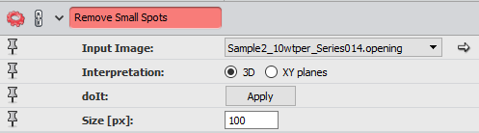

### Arithmetic (for quadrant method only)

This module is applied 4 times to make copies of the final binary image for cropping. Each of the 4 copies is then cropped manually to a different quarter of the sample.

Settings:

* Data: remove small spots result
* Result Type: input A
* Expression: “A”

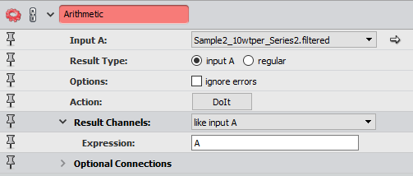

### Isosurface

This module is used on the whole binary image (for method not using quadrants) or each of the 4 quadrants (for quadrant method). This displays a surface without borders.

Settings:

* Data: remove small spots or arithmetic result
* Downsample: off for quadrants, 3-6 for whole surface (so outputted surface has under 200,000 faces or else remesh will not work)

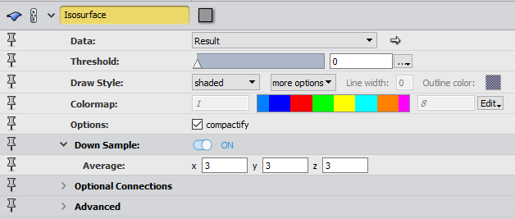

### Extract Surface

This module creates an object from the isosurface that can be used to apply other modules. This is applied to each isosurface.

Settings:

* Module1: isosurface

### Remesh Surface

This is used to achieve a better placement of triangles on a surface and lead to a more realistic depiction of the surface. This is applied for each extracted surface.

Settings:

* Data: extract surface result
* Objective: best isotropic vertex placement
* Desired size: 100%

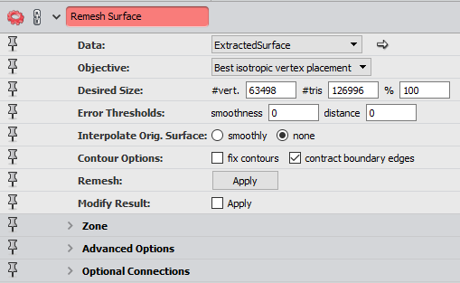

### Smooth Surface

This is used on each surface to further smooth the surface and appear more realistic.

Settings:

* Data: remesh surface result
* Iterations: 2
* Lambda: 0.6

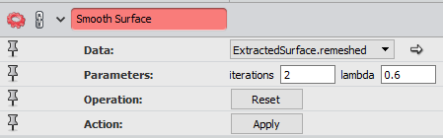

### Curvature

This module is used twice for each surface to calculate the mean and Gaussian curvatures. This calculates the respective curvatures for each triangle on the surface, and connecting a surface view module to the output allows for the curvatures to be visualized.

Settings:

* Data: smooth surface result
* Method: on triangles
* Output: Mean curvature & Gaussian curvature

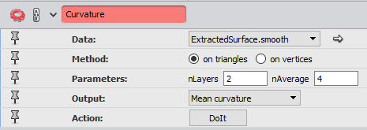

### Area

This is used on either the binary image (when not using quadrant method) or each of the arithmetic results (when using quadrants) to determine the area of the surface for calculating the surface area to volume ratio.

Settings:

* Input image: remove small spots or arithmetic result
* Interpretation: 3D

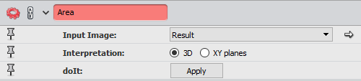

### Volume Fraction

This is used on either the binary image (when not using quadrant method) or each of the arithmetic results (when using quadrants) to determine the volume of the surface for calculating the surface area to volume ratio.

Settings:

* Input image: remove small spots or arithmetic result
* Interpretation: 3D

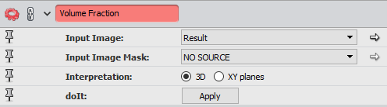

Once these modules are applied, the following data needs to be saved for use in the Matlab programs

1. Image area
2. Image label volume (from volume fraction result)
3. Export each smoothed surface as a separate .stl file
4. Save the mean and gaussian curvature values of each triangle to separate text files, with a different file for each surface (ex. A file for mean curvature for first quadrant, a file for Gaussian curvature for fourth quadrant). This must be done through the TCL console using the following style of code, which must be modified:

|  |
| --- |
| set fo [open “*D:/Amaahzing/sample1/surface1.txt*” w] set i 0 while {$i < [“*Curvature output*” nValues]} {  puts $fo [“*Curvature output*” getValue $i]  incr i } close $fo |

## Matlab Procedure

Once the data from Avizo is saved, the Matlab programs can be used.

If the whole image method is being used (not using quadrants), then the following programs need to be opened in Matlab:

* stlread.m
* Calculate_areas.m
* Bijel_Curvatures.m

Bijel_Curvatures.m will need to be updated with file names and extracted data; this is outlined in the code comments. Once this is modified, run the Bijel_Curvature.m file and the results will be saved in the form of images and excel files with the data.

If the quadrant method is being used, then the following programs need to be open in Matlab:

* stlread.m
* Calculate_areas.m
* ShadedError.m
* Bijel_Curvatures_quadrants.m

Only Bijel_Curvatures_quadrants.m will need to be updated with file names and extracted data; this is outlined in the code comments. Once this is modified, run the Bijel_Curvature_quadrants.m file and the results will be saved in the form of images and excel files with the data.

To achieve the 3D graph of the normalized curvatures (see below), first run the Bijel_Curvature_quadrants.m file. Open the CombineCurvesWTime3d.m file and update the code with the correct data as outlined in the comments. Once this is done, run this program and the graph will appear in the figure windows. Note that this does not save an image of the figure as we changed the angle of the viewer. We also commented out the axis labels and added our own in photoshop.

**QP(H)**

**Heating Time**

**(min)**

**H/Q**

