**BATTERY MANAGEMENT SYSTEM FOR SMALL ELECTRIC VEHICLE**

**Candidate: Robert-Nicolas, Trif**

**Scientific coordinator: Conf. dr. ing. Răzvan, Bogdan**

Session: June 2022

**REZUMAT**

Lucrarea prezentată în cadrul proiectului de diplomă se concetrează asupra dezvoltării unui sistem eficient și sigur de încărcare a ansamblului de baterii din interiorul unui vehicul electric. Scopul acestui sistem este să realizeze o încărcare echilibrată a celulelor bateriei, urmărind eliminarea factorilor de risc precum supraîncălzirea și supraîncărcarea. Acești factori pot reduce semnificativ durata de viață a bateriilor, afectând performanța și utilitatea genereală a autovehiculelor electrice. În plus, prototipul vehicului electric este dotat cu metode de siguranță și protecție pentru a asigura o deplasare în condiții optime.

Întregul sistem poate fi împărțit în două categorii distincte: sistemul de încărcare și monitorizare, precum și sistemul de deplasare în condiții de siguranță al vehiculului electric.

Sistemul de încărcare asigură o alimentare eficientă și sigură a bateriilor, utilizând un convertor de tip "step-down" controlat de un microcontroller ESP32 și alimentat de o sursa de tensiune de current continuu. În același timp, sistemul monitorizează constant tensiunea bateriilor și curentul în timpul încărcării cu ajutorul unui senzor de current dedicat. Temperatura bateriilor este monitorizată cu ajutorul a doi senzori de temperatură. De asemenea, sistemul de monitorizare este echipat cu o conexiune către cloud, facilitând analiza în timp real a parametrilor anamblului de baterii.

Deplasarea în condiții de siguranță este asigurată de către patru motoare electrice, care sunt conectate la un controler de motoare L298N și care funcționează în strânsă legătură cu un senzor ultrasonic, amplasat în partea frontală a vehiculului electric. Acest sistem permite vehiculului să detecteze și să evite obstacolele în timp real, contribuind la o conducere sigură și fără incidente.

Controlul motoarelor electrice și monitorizarea în timp real se va face cu ajutorul unei aplicații mobile construită pentru sistemul de operare Android. Prin intermediul aplicației, utitlizatorul poate primi notificări în momentul în care parametrii bateriilor despășesc anumite limite iar siguranța vehicului în timpul încărcării poate fi pusă în pericol.

**ABSTRACT**

The main focus of the project relies on the development of an efficient and safe charging system for the battery pack found inside of an electric vehicle. The purpose of this system is to achieve balanced charging of the battery cells, aiming to eliminate risk factors such as overheating and overcharging. These factors can significantly reduce the life span of the batteries, affecting the performance and the overall utility of electric vehicles. Additionally, the electric vehicle prototype incorporates safety measures in order to optimize driving conditions.

The entire system can be divided into two distinct categories: the charging and monitoring system and the safety driving system of the electric vehicle.

The charging system ensures an efficient and safe power supply to the batteries, using a step-down converter controlled by an ESP32 microcontroller and powered by a DC voltage source. At the same time, the system constantly monitors the battery voltage and current during charging using a dedicated current sensor. The battery temperature is monitored using two temperature sensors. The monitoring system is also equipped with a cloud connection, facilitating real-time analysis of the battery pack parameters.

Safe driving is ensured by four electric motors, which are connected to an L298N motor controller. They operate in close relation with an ultrasonic sensor located at the front of the electric vehicle. This system allows the vehicle to detect and avoid obstacles in real time, contributing to safe and incident-free driving.

Management of the electric motors and and real-time monitoring will be accomplished through a dedicated mobile application for the Android platform. This application enables users to promptly receive notifications in case the battery metrics exceed predefined thresholds or if there is a potential compromise to the vehicle's safety during the charging process.

**TABLE OF CONTENTS**

1. **INTRODUCTION……………………………………………………………………...5**
   1. Introduction………………………………………………………………………..5
   2. Context………………………………………………………………………….....6
   3. Motivation………………………...………………………………………………..8
2. **STATE OF THE ART……………………………………………………………..… 9**
3. **TECHNOLOGIES USED…………………………………………………………...11**
   1. Hardware…………………………………………………………………………12
      1. ESP32-DevKitC…………………………………………………………..
      2. INA219 Current Sensor…………………………………………………..
      3. L298N Motor Driver……………………………………………………….
      4. US-100 Ultrasonic Sensor……………………………………………….
      5. NiMH batteries…………………………………………………………….
      6. Step-Down Converter…………………………………………………….
   2. Software………………………………………………………………………….
      1. React-Native……………………………………………………………..
      2. Expo………………………………………………………………………
      3. Firebase …………………..……………………………………………..
      4. Android Operating System………………………………………………
      5. Python language…………………………………………………………
4. **DESIGN………………………………………………………………………………**
   1. System Architecture…………………………………………………………….
      1. Battery management system…………………………………………..
      2. Vehicle control system………………………………………………….
   2. Hardware Architecture………………………………………………………….
      1. Step-Down converter……………………………………………………
      2. ESP32-DevKitC subsystem ………………….………………………..
   3. Software Architecture…………………………………………………………...
      1. Arduino IDE software……………………………………………………
      2. Mobile Application……………………………………………………….
5. **IMPLEMENTATION…………………………………………………………………**
   1. Realization of the step-down converter………………………………………..
   2. Mobile application implementation..............................................................
6. **TESTING…………………………………………………………………………..…**
7. **CONCLUSIONS AND FUTURE IMPROVEMENTS……………………………..**

**REFERENCES…………………………………………………………………………..**

1. **INTRODUCTION**
   1. **INTRODUCTION**

A battery management system that ensures the safe charging of a pack of 2 NiMH batteries connected in parallel via a buck converter. This battery pack powers an L298N motor driver, which controls 4 electric motors and an ESP32-DevKitC development board, which serves as the control unit for the entire system.

To monitor and visualize the battery parameters, the system includes a mobile application specifically designed for Android users. The application displays relevant information related to the battery's charging process and its specific values and it offers an intuitive interface for controlling the actuators. The connection between the ESP32 and the application is supported by Google Cloud Services, specifically utilizing Firebase's Realtime Database APIs while the notifications are managed using Firebase Functions.

The system has a wide range of features based on the analysis of data collected from the sensors, providing dynamism and a touch of autonomy to the entire process. These features include:

* Monitoring the temperature of both batteries
* Monitoring battery level and voltage
* Monitoring the voltage value of the power source used for charging
* Dynamically charging the batteries using the step-down converter
* Ensuring precise movement of the electric vehicle using the motor driver and actuators
* Prevent unwanted collisions using an ultrasonic sensor
* Sending notifications in case of high battery temperature
* Sending notifications when the batteries are fully charged or close to 10%
* Providing overcharging protection
  1. **CONTEXT**

In today's era of advancing technology and growing environmental consciousness, moving toward sustainable transportation solutions is crucial. Electric vehicles (EVs) offer a promising alternative, significantly reducing emissions and improving energy efficiency. This initiative is very important in reducing pollution caused by internal combustion engine (ICE) vehicles, which heavily contribute to air pollution and greenhouse gas emissions. However, two critical challenges persists when reffering at electric vehicles: maximizing the lifespan of batteries and improving the overall autonomy and safety.

Legislative changes targeting stricter reductions of nitrogen oxides (NOx), hydrocarbons (HC), carbon monoxide (CO), and particulate matter (PM) in the exhaust emissions of newly sold vehicles (for example, the EURO VI standard in the European Union and European Economic Area, with EURO VII under development) [1], along with growing awareness among car users, have steered automotive development towards a new direction. This shift places significant emphasis on incorporating low-emission drive systems as a key factor [2]. These restrictions are based on the negative impact of exhaust gases on human health, particularly focusing on respiratory problems caused by inhaling these harmful particles.

Table 1: “Main pollutants together with their cause, effects, and magnitude” [3]

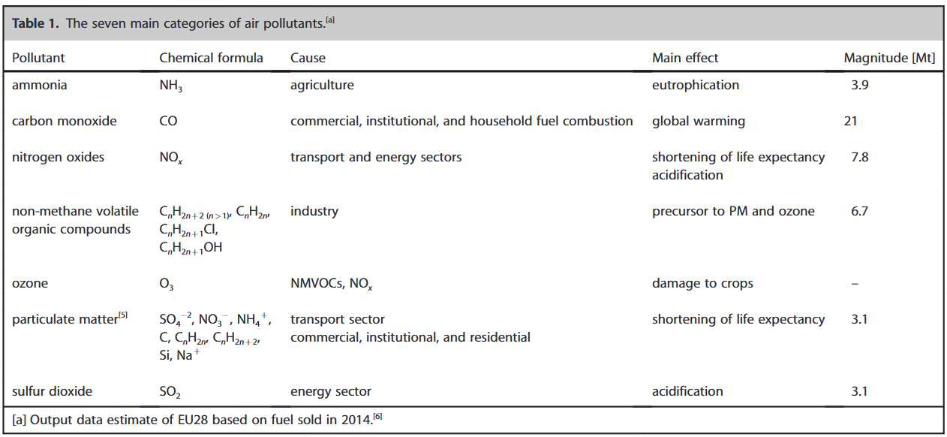

Studies have shown a growing trend in EV sales over the last few years, despite the broader market decline caused by the COVID-19 pandemic. In 2020, while global passenger car sales fell by 16%, electric car sales grew by 43%, resulting in approximately 3 million new electric cars worldwide. This significant increase has created a need for enhanced safety and fire protection measures. [2]

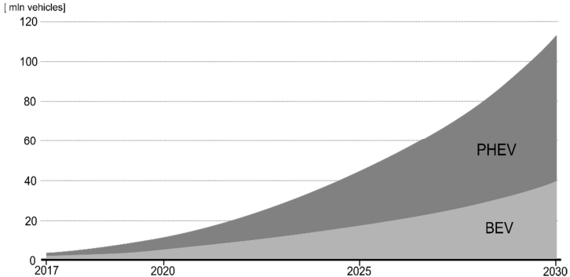Figure 1: “Worldwide car growth forecast by IEA” [4]

As EV adoption continues to rise, addressing the fire hazards associated with these vehicles has become a critical concern. There have been notable incidents of EV fires, indicating the importance of developing potent safety protocols and fire protection strategies.

There were some alarming fires involving Tesla Model S electric cars, some of the first mass-produced EVs. The first incident occurred in October 2013 on a highway in Washington state, where a piece of metal on the road punctured the car's battery, causing a fire. Two more Tesla fires happened that same month. In Mexico, a driver hit a tree and in Tennessee, a driver ran over a tow bar that damaged the battery compartment. Fortunately, no one was injured in these fires, but they raised concerns about electric car safety. [2]

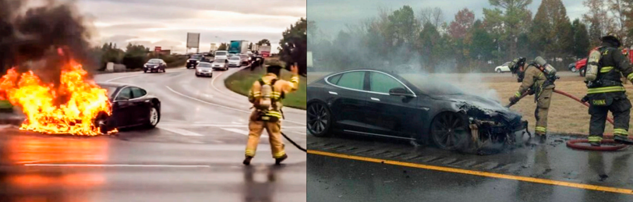

Image 1: Unwanted events with electric cars that involved fires [2]

Having in regard the points made by the studies shown below, it is straight-forward the importance of a close monitor and alert system. Essentially, the proposed solution tries to highlight the fact that electric cars are a good alternative for the future. However, both drivers and manufacturers must exercise great care in their use and construction.

* 1. **MOTIVATION**

As a young teenager, I graduated the national college and made the decision to pursue my dream of becoming an engineer. I started this journey by enrolling at the University Politehnica of Timisoara where I rediscovered myself and my passions. While my first year of university was not without challenges, particularly due to the pandemic, the following years proved to be an entire adventure.

During this time, I discovered my passion for cars and technolgy trends and so, my desire was to merge this interest with my enthusiasm for programming and software development.

Over the course of these four years, I dedicated myself in order to learn and grow. I extensively researched topics related to engineering, programming and software development through resources such as YouTube and specialized websites. Simultaneously, I progressed in my programming skills through my university studies.

Eventually, my dedication and expertise led to an employment opportunity at Vitesco Technologies, where I was hired to apply my knowledge and skills professionally in the Embedded Systems area.

The idea for my bachelor's project was inspired by my team leader, who noticed my burning desire and attraction for cars and my knowledge of the current literature in this field. Gradually, my focus shifted towards electric vehicles, based on current trends in the automotive industry and my previous experiences related to invention competitions in which I participated in the past.

My motivation was mainly focused on proving myself that I could create a complex system that combines software, electronics, and capabilities related to mobile and artificial intelligence fields.

One of the biggest challenges I faced while working on this project was adapting to the hardware aspect, specifically the electronics. Initially, I wanted my thesis project to focus on software development but creating a Battery Management System involves much more than that. Over time, I revisited concepts I learned in the early years of my studies and even gained a deeper understanding of them. The whole process was truly a challenge.

1. **STATE OF THE ART**

Nowadays, all electric cars have dedicated electronics to monitor the battery's parameters. It's well-known that electric vehicles rely on these components to manage the charging process and prevent battery degradation. This is why monitoring, protecting and optimizing the battery lifespan is crucial for such modern vehicle.

In addition, most of the car manufacturers prioritize the interaction between the driver and the vehicle, particularly in this case how all the information is presented to the user. It is also important to have a user interface or a "vehicle navigation" system that provides the driver all relevant information about the car (e.g. the battery temperature, battery voltage, charging estimates and more).

Although my project won't offer a complex charging process like those in EVs, it will provide full control over the charging current and voltage. BMSes use specially designed ICs that compute and process various values related to the charging process, making them relatively expensive. As an equivalent for the navigation systems, a mobile application was implemented which aims to closely replicate an information system that monitors battery and charging process.

Currently, there are two conventional methods of charging batteries using the conductive technique in electric car industry:

* Conventional AC on-board charger shown in figure 2, which focuses on converting AC power from a standard electrical outlet into DC power to charge the battery using the vehicle’s on-board charge.

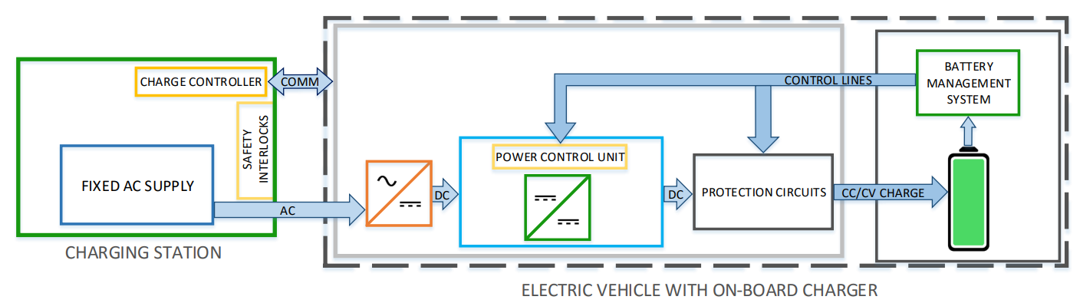

Figure 2: “Conventional AC on-board charger configuration” [5]

* Conventional DC off-board charger which directly supplies DC power to the battery from an external charging station, excluding the need for an on-board AC/DC converter and allowing for faster charging times (figure 3).

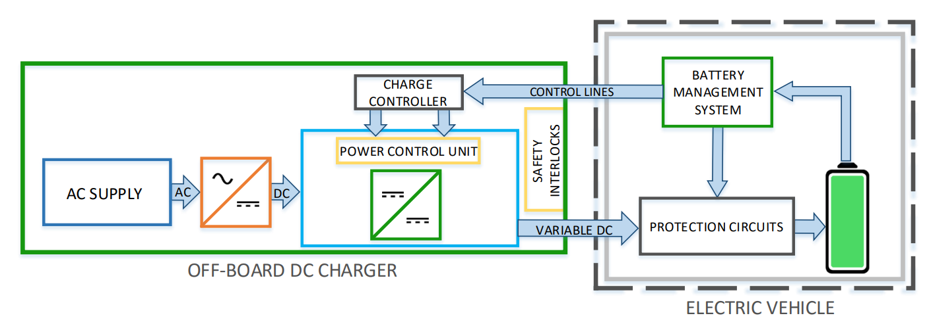Figure 3: “Conventional DC off-board charger configuration” [5]

Both configurations incorporate a BMS and circuits designed to protect the battery, such as overcharge protection, short-circuit protection and overheat protection. However, this thesis will focus on the on-board charging system. This focus is primarily because electric car drivers frequently opt to charge their batteries using standard home electrical outlets. This method is preferred due to the convenience and cost savings it offers. By using the existing household AC infrastructure, drivers avoid the need to invest in a separate, often expensive, off-board DC charger.

On-board charging systems rather offer flexibility, enabling users to charge their vehicles at various locations without relying on specialized charging stations. This approach enhances the practicality and accessibility of electric vehicles. Nevertheless, most EVs are designed to support both on-board and off-board charging methods, adapting to various circumstances and ensuring the EV is as reliable and versatile as possible.

Tesla, Inc., Volkswagen AG, BYD Auto Co., Ltd. and Bayerische Motoren Werke AG (BMW) are just a few of the most important competitors that offer a wide range of electric vehicles equipped with built-in charging systems and impressive monitor features.

1. **USED TECHONOLGIES**

**3.1 HARDWARE**

**3.1.1 ESP32-DevKitC**

The ESP32-DevKitC is a compact and entry-level development board within the ESP32 series, ideal for a wide range of IoT applications. It offers an extensive set of peripherals and a versatile pinout for flexible prototyping. The board includes Wi-Fi and Bluetooth capabilities, making it an excellent choice for developing connected electronic projects. Additionally, it supports multiple communication protocols such as UART, SPI and I2C.

It offers a powerful ESP32 240MHz DOWDQ6 microcontroller chip, the DevKitC provides high computational performance. The board also includes essential features such as voltage regulation, programming ICs and 38 GPIO pins (26 configurable pins), facilitating connections to various components.

Among the configurable pins, there are multiple 12-bit analog-to-digital converters (ADCs) for reading and interpreting input voltage values, function that will be presented late in the implementation part [7].

Another important aspect of the ESP32 is its nominal operating voltage of 3.3V. While this can make interfacing with devices requiring different voltage levels a bit challenging, it offers the significant advantage of reduced power consumption.

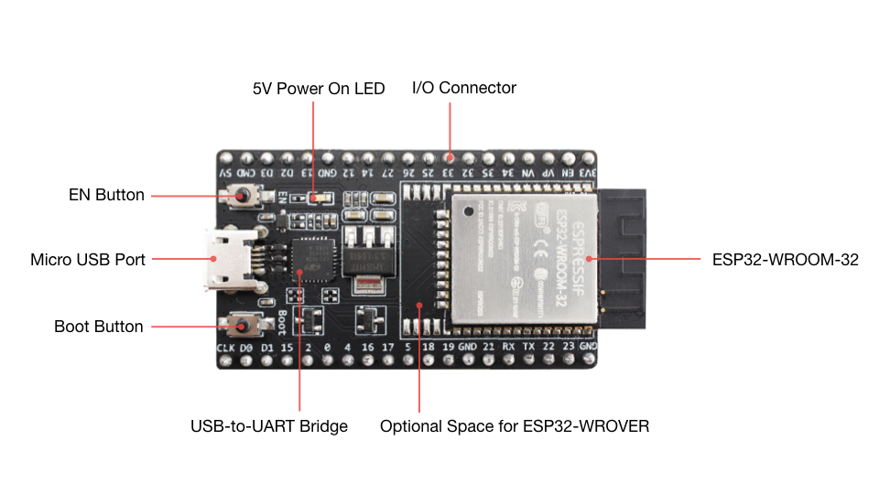

Image 2: “ESP32-DevKitC V4 with ESP32-WROOM-32” [7]

**3.1.2 INA219**

The INA219 is a high-side current shunt and power monitor equipped with an I2C interface. It can monitor both shunt voltage drop and supply voltage, featuring programmable conversion times and filtering options. With a programmable calibration value and an internal multiplier, the INA219 provides direct reads in amperes. Additionally, it includes a register that multiplies readings to calculate power in watts. The I2C interface supports 16 programmable addresses [8].

Module’s chip is connected to a shunt resistor on the bus of interest and is powered by a supply voltage between +3V and +5.5V. It can monitor bus voltages ranging from 0V to 26V without special power sequencing requirements.

In its normal operating mode, the INA219 continuously converts shunt and bus voltages using its internal analog-to-digital converter, which are then used to calculate current and power. These calculations occur in the background, ensuring efficient operation.

Within this project, the focus will be only on a few specific features to extract relevant insights: load voltage, current and power measurement.

**3.1.3 L298N Motor Driver**

The L298N motor driver is a versatile integrated circuit (IC) capable of independently controlling two DC or stepper motors in a standard configuration. This dual H-bridge driver provides two motor channels, allowing it to independently manage the speed and direction of each motor, which enables precise maneuvering of a prototype car.

Operating within a wide voltage range, the L298N typically supports input voltages from 5V to 35V, offering flexibility for different motor types and power requirements. It can handle up to 2A of total current per channel, ensuring sufficient power delivery for most small to medium-sized motors used in car prototypes.

The driver also features built-in protection mechanisms such as over-temperature shutdown and over-current protection, enhancing its reliability in complex applications. Additionally, it includes a 5V channel that can function either as a 5V input or a 5V output, thanks to the built-in voltage regulator, depending on the user's needs [9].

By interfacing with a development board such an ESP32 DevKitC, the L298N motor driver can be easily integrated into the car’s control system. This integration enables complex tasks like differential steering and precise vehicle navigation, making the L298N an essential component for developing functional and responsive car prototypes.

**3.1.4 US-100 Ultrasonic Sensor**

The US-100 ultrasonic sensor is a widely used distance measurement device that operates on the principle of echolocation. It emits ultrasonic waves through its transmitter and measures the time taken for the echo to return to its receiver. By calculating the time interval between emission and reception, the sensor accurately determines the distance to objects within its range.

This sensor is compatible with the 3.3V logic level of the ESP32 microcontroller, making it an ideal choice for integration in projects requiring precise distance measurements. It is not only convenient but also very practical, as it eliminates the need for an additional component to convert 5V signals (which is common in most ultrasonic sensors) to 3.3V signals and vice-versa.

In the context of my EV car prototype, the US-100 ultrasonic sensor is particularly suitable as it has been integrated for backward parking assistance. This integration helps in detecting obstacles behind the vehicle, ensuring safer and more efficient parking. The sensor's robust design and ease of use make it a valuable component in the overall functionality of my EV car, enhancing both safety and automation.

**3.1.5 NiMH batteries**

NiMH batteries or Nickel-Metal Hydride are a type of rechargeable battery that are well-known for their high energy density but essentially for their environmental friendly behaviour.

During charging, an electric current oxidizes nickel hydroxide in the positive electrode to nickel oxyhydroxide, while the negative electrode absorbs hydrogen ions, forming a hydride. Upon discharging, the process reverses, providing electric energy. This cycle can be repeated many times, making NiMH batteries highly suitable for applications requiring repeated charging and discharging.

One primary reason for choosing NiMH batteries is their safety. NiMH batteries are safer than lithium-ion batteries because they are less sensible to thermal exposure and do not require as protective measures against overcharging and overheating. This makes them simpler to manage in an electronic project environment.

For the second consideration, their compatibility with charging using a step-down converter is an important factor. Properly designed step-down converters can manage the voltage and current to ensure safe charging of NiMH batteries. It is also important to remember that NiMH batteries can tolerate light overcharging because they can transform excess charge into heat. This characteristic is beneficial for a charging system as it can indicate the end of the charging process.

Thirdly, the evolution of NiMH cells for commercial use highlights their increasing capacity and energy density. From around 1100 mAh in the early 1990s to 2610 mAh by 2005, and projected improvements targeting 3000 mAh, these advancements have made NiMH batteries a preferred choice for consumer electronics, power tools and electric vehicles, where reliable rechargeable power sources are essential [10].

Figure 4: Evolution of commercial NiMH batteries energy [10]

In my project, there are going to be used two 9V NiMH 200mAh batteries connected in parallel, providing a combined capacity of 400mAh. This setup is chosen for its simplicity ensuring manageable power for the battery management system (BMS).

**3.1.6 Step-Down Converter**

A step-down converter has the role to reduce the input voltage to a lower output voltage while maintaining the power balance.

The demand for step-down DC–DC converters is increasing rapidly, looking in the field of industrial applications such as industrial robotics, the Internet of Things (IoT) and embedded systems (automotive industry) [11].

Step-down converters operate on the principle of switching regulation. The basic operation involves charging an inductor when the switch is closed, storing energy in its magnetic field. When the switch opens, the inductor releases this stored energy to the output. The average voltage output is controlled by the duty cycle of the switching signal, effectively stepping down the input voltage.

Using a buck converter is an effective solution for charging a battery with relatively low voltage values. However, using a simple buck converter can result in power losses due to the diode and inductive filters [11]. Despite this, it remains a viable alternative for applications involving low charging currents. Here are a few examples of step-down converters, justifying the hierarchical placement of the converter I used:

Figure 5: Clasification of Step-Down converters [11]

The presence of a MOSFET and a transistor for controlling the switching action, along with an LC filter, aligns with the characteristics of an inductor switch cell converter in my project. The ESP32 controlling the PWM further confirms this classification, as it provides the necessary control signals to the switches in the converter.

**3.2 SOFTWARE**

**3.2.1 React-Native**

React Native is an open-source framework developed for building mobile applications using JavaScript and React. It allows developers to create natively rendered mobile apps for iOS and Android, significantly reducing development time and effort.

React Native offers a wide range of libraries and plugins to meet various development needs. It can be easily integrated with services from providers like Google and Amazon to achieve versatile features, including UI elements, navigation between screens, user authentication (login/register process), sending push notifications and accessing the device’s native hardware.

React Native operates within a Node.js environment, which serves as the backend for executing JavaScript on the server side of mobile applications. Node.js contributes to the development of high-performance APIs that facilitate automation and data exchange.

According to Statista, „*around 40% of developers have been using it during the last three years*” [12]. Here is a diagram which explains the evolution of React-Native through multiple cross-platform environments:

Figure 6: Cross-platform mobile frameworks used by software developers [13]

**3.2.2 Expo**

Expo is a toolchain built around React Native, designed to simplify the creation and distribution of cross-platform applications. It provides a managed build environment and tools for testing and debugging, along with a range of services for developing, building, and publishing React Native apps.

Expo includes a platform-neutral API that allows developers to access native device functions such as the camera, GPS and push notifications without writing platform-specific code. This makes it easier to create apps that function on both Android and iOS. Here are some dedicated tools that Expo offers in order to develop, test and deploy an application:

* **Expo SDK**: A set of libraries and services that provide access to native APIs for building apps without needing native code.
* Expo Go: A mobile app that allows developers to run and test their React Native projects instantly on their devices without needing to compile native code.
* **Expo CLI**: A command-line interface that simplifies project creation, development, and management, offering various commands to streamline the workflow.

Sometimes, React Native and Expo concepts are misunderstood by the developers as both technologies are strongly connected. To clarify, Expo is a framework and platform built on top of React Native that provides tools and services to simplify the development process while React-Native is a framework for building mobile applications using JavaScript and React [12]. Using each specific plaform brings advantages and disadvantages. The following table will better describe these two techonolgies:

|  |  |  |
| --- | --- | --- |
| **Aspect** | **Expo** | **React Native** |
| **Ease of Setup** | Simple setup with minimal configuration | More complex setup requiring configuration |
| **Development Speed** | Faster due to managed workflow and tools | Slower due to need for custom configurations |
| **Testing and debugging** | Built-in tools for streamlined testing | Requires separate setup for testing tools |
| **Performance** | Slightly lower due to abstraction layer | Higher performance with direct native access |
| **Dependencies** | Limited to Expo SDK version | Can use any compatible library or native module |

Table 1: Differences between Expo and React Native environments

**3.2.3 Firebase**

Firebase is a comprehensive app development platform created by Google, designed to help developers quickly build applications. It offers a variety of tools and services, including a Realtime Database, cloud storage, functions and machine learning capabilities. Firebase is particularly well-suited for mobile and web applications due to its easy integration with these platforms [12]. For my project I incorporated the following services:

*Realtime Database*: This NoSQL cloud database stores and synchronizes data in real-time between clients. It allows developers to create applications with immediate updates and consistent user experiences across different devices. The instant propagation of data changes makes Firebase Realtime Database ideal for applications needing live updates, such as chat applications, collaborative tools and IoT systems. In this project, the Realtime Database enables the mobile app to control the car prototype by updating the database with new commands.

*Firebase Functions*: This serverless framework allows developers to run backend code in response to events triggered by Firebase features. It extends application functionality without requiring server management. For example, Firebase Functions can be used to send notifications, perform complex data processing and integrate with third-party services, thereby automating workflows and enhancing app capabilities. In this project, Firebase Functions automate the system by sending notifications to the Android app whenever specific criteria are met, ensuring fast updates and responses.

**3.2.4 Android Operating System**

The Android Operating System is a widely-used mobile platform developed by Google, designed for smartphones, tablets and other devices. It is recognized for its extensive app ecosystem available through the Google Play Store. A huge advantage is that it supports a variety of hardware from different manufacturers. Android offers the possibility to create applications using Google services and is accessible for junior developers due to its simplified app creation and deployment process.

Being familiar with the React Native environment helped me develop the necessary mobile application for this operating system. Unlike other frameworks such as Android Studio, I wasn’t constrained to work with the native development process. React Native provides the necessary features to access the device's hardware components, permissions and other functionalities that Android Studio accesses using Java, Kotlin or other dedicated programming languages.

**3.2.5 Python language**

Python is a high-level, interpreted programming language known for its simplicity and readability. Created by Guido van Rossum and first released in 1991, Python has grown to become one of the most popular programming languages worldwide, used in a wide array of applications from web development and data analysis to artificial intelligence (AI) and automation [14].

Due to the popularity of Python, many libraries such as Pandas and Matplotlib have been developed for data analysis and deriving relevant insights. Python's readability and robust testing frameworks make it highly effective for testing. For these reasons, I have chosen Python for the testing phase of my project, utilizing Google's Python framework (Google Collaboratory). In a BMS project, Python can be used to test the integration of various subsystems, simulate sensor data inputs and ensure the reliability of control algorithms.

1. **DESIGN**

**4.1 SYSTEM ARCHITECTURE**

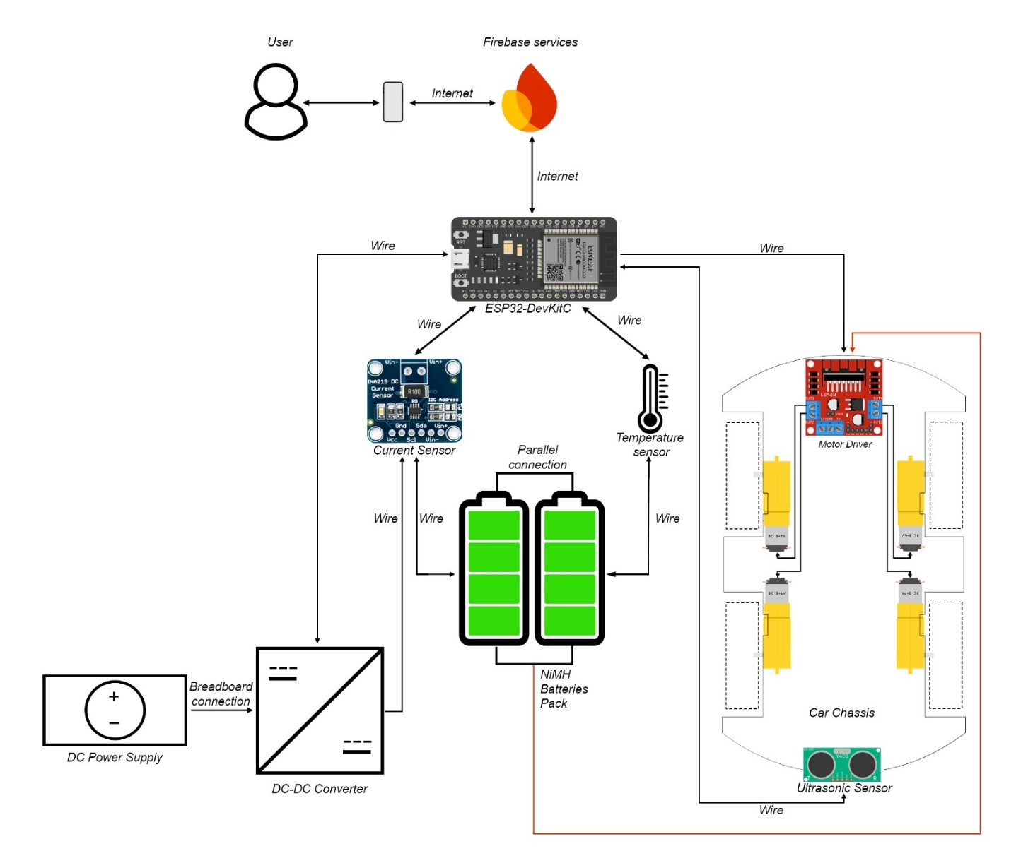

Figure 6: System architecture of the Battery Management System including the vehicle control system

In the above diagram, there is a useful schematic which explains the functioning flow of the project. It can be divided into two main subcategories:

1. Battery Management System
2. Vehicle Control System

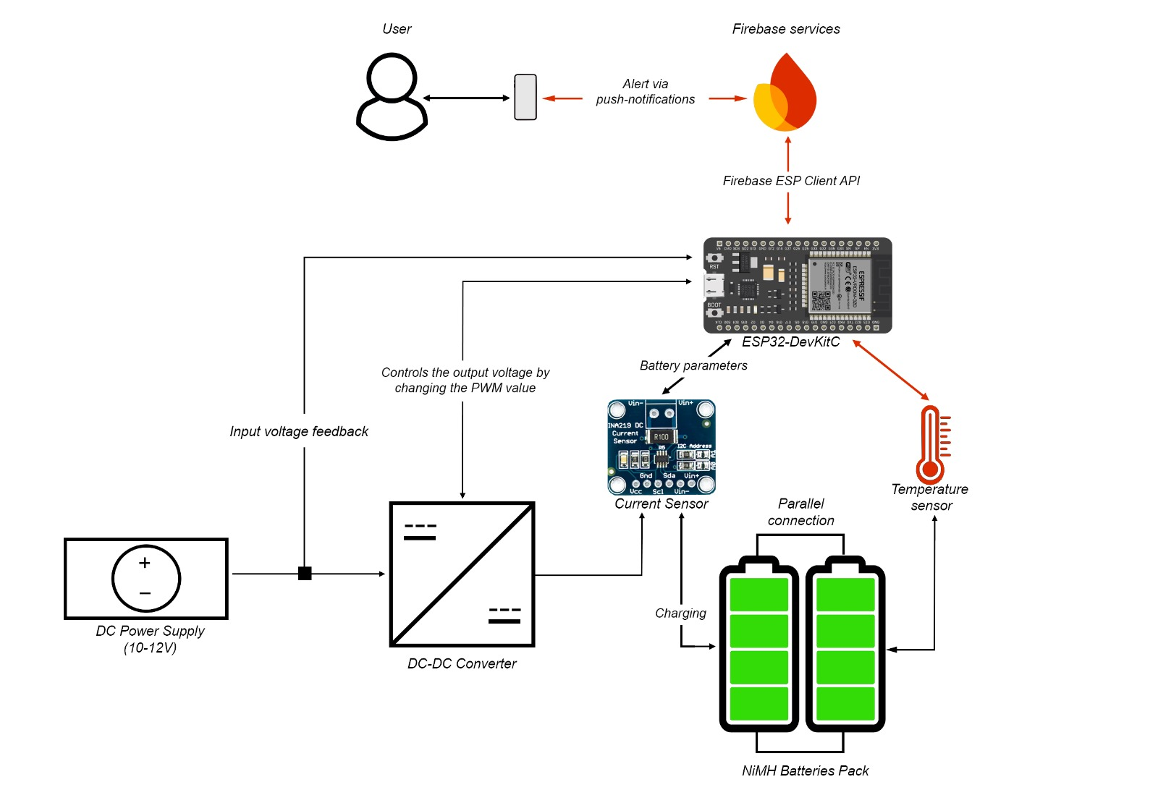**4.1.1 Battery Management System**

Figure 7: System architecture of the battery management system

The implemented BMS (Battery Management System) provides multiple essential functionalities:

* Continuous monitoring of the battery through an array of sensors with data accessible via a mobile application for real-time insights.
* Intelligent charging that adjusts based on the battery's current operating parameters, optimizing performance and longevity.
* User alerts through push notifications in situations where the battery is overheating, allowing for rapid intervention and prevention of potential damage.

By closely examining the system architecture diagram, we can deduce several scenarios. In the following, I will describe how each of these scenarios unfolds:

The vehicle driver will have the battery status constantly monitored. If the battery percentage drops below 10%, the driver will receive a notification to alert them of the low battery level. If the battery becomes fully discharged, the vehicle's on-board charging system offers maximum flexibility, allowing the battery to be recharged from any standard electrical outlet, notwithstanding the absence of a system to convert alternating current (AC) to direct current (DC). When the vehicle is connected to a power source, the charging process begins using a trickle-charge method, which ensures a slow and steady charge to the battery.

Throughout this process, the ESP32-DevKitC development board continuously monitors the charging parameters. This monitoring is facilitated by data sent from the INA219 current sensor and the DS18B20 temperature sensors mounted on each battery in the pack.

During the charging process, there are two primary scenarios that can occur:

1. Successful charging without incidents: In this scenario, the battery is charged successfully and efficiently. The user is notified through an automated push notification once the battery has reached a full 100% charge, ensuring that they are aware their vehicle is ready for use.
2. Charging with a risk of overheating: In this scenario, if the battery temperature exceeds a predetermined threshold during the charging process, the charging will be interrupted to prevent damage or possible fire hazards. The user will receive a push notification indicating that the critical temperature level has been surpassed. Before reaching this critical point, a warning notification will be sent to alert the user of the rising temperature. The charging process will only resume if and when the temperature falls back to an acceptable level, ensuring the safety and longevity of the battery.

Additionally, all the information about battery parameters can be viewed within a mobile application, allowing the driver to closely monitor the status in real-time. There is constant feedback sent to the application's user interface regarding the power outlet being used, providing comprehensive insights into the charging process. By maintaining constant monitoring and providing timely notifications, the system ensures that the driver is always informed of the battery's status, whether it be low charge, successful charging or potential overheating risks.

**4.1.2 VEHICLE CONTROL SYSTEM**

The control system of the small car built in this project can be divided into two main parts:

1. The subsystem responsible for maneuvering the car.
2. 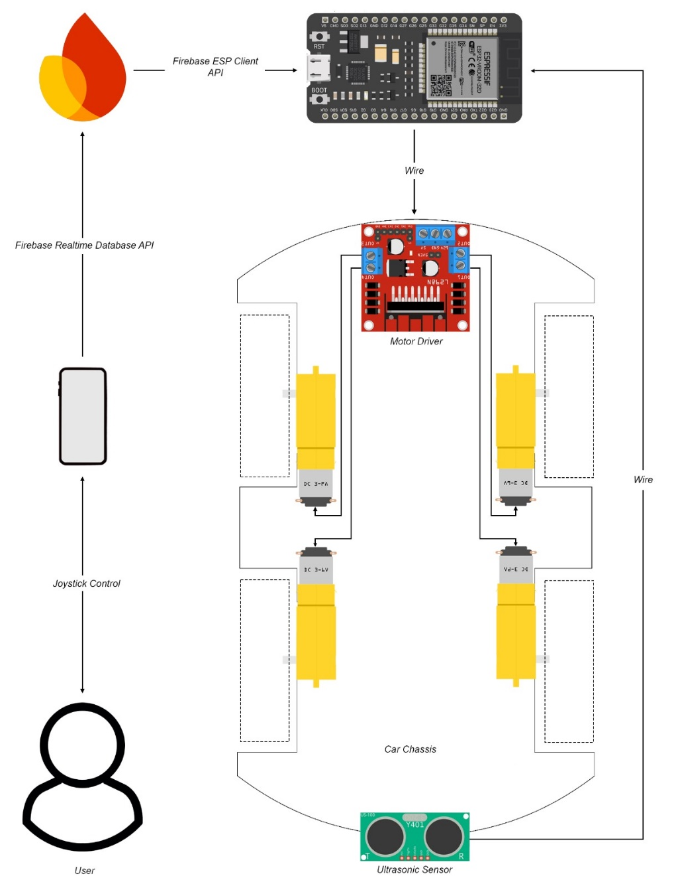The methods for driver assistance in case of danger.

Figure 8: Vehicle control system architecture

The process begins with user input from the mobile application. Within the app's user interface, there is a dedicated section specifically for controlling the car. Based on this input, data regarding the desired direction and movement are sent to a real-time database via the Firebase Realtime Database API. From there, the information is retrieved by the ESP32-DevKitC, interpreted and transmitted to the motor driver. The motor driver is then connected with the electric motors (two motors for each motor channel of driver)

Using this information, the car can move in the following directions: forward, backward, forward-right, forward-left, backward-right and backward-left. This capability allows for a high degree of maneuverability.

The entire experience is enhanced by the anti-collision protection provided by an ultrasonic sensor US-100 mounted at the rear of the vehicle. This sensor constantly measures the distance between the car and any objects behind. It interruputs the movement in the case an object is way to close. It is particularly useful when reversing, as it helps to avoid unwanted collisions.

**4.2 HARDWARE ARCHITECTURE**

In the following section, in order to present the hardware architecture, I will focus on explaining in detail the components, technologies and principles used in creating the buck converter. I will also explain how the ESP32 development board is connected and interacts with all the other hardware components within the created car.

**4.2.1 STEP-DOWN Converter**

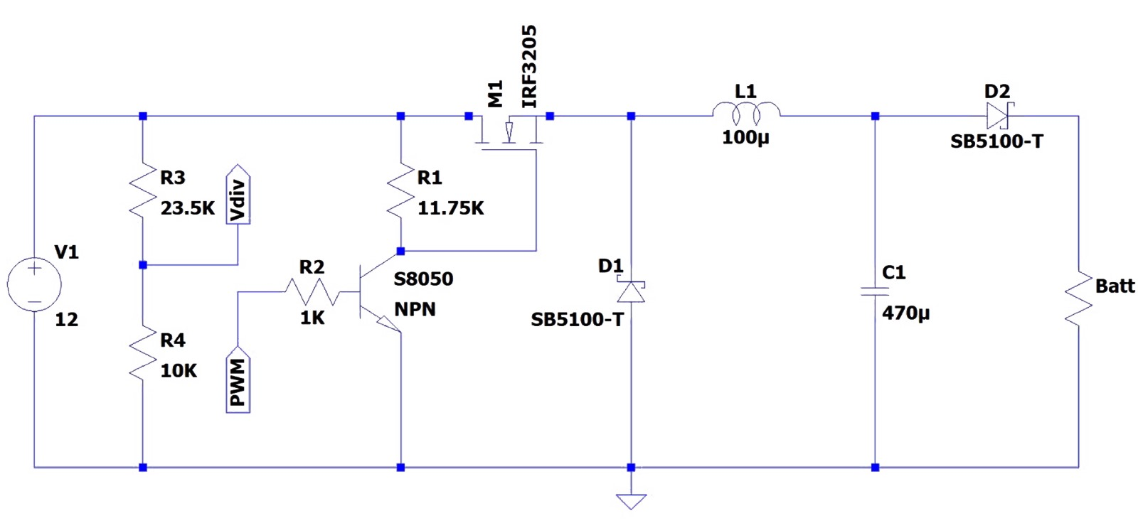

Figure 9: Step-down converter architecture

The converter is the most essential part of this project. Its purpose is to convert a higher input voltage into a lower voltage by increasing the current inside the circuit. It simulates the scenario of charging a real electric car. The design operates with an input voltage between 10 and 12V. This value meets the requirements of charging a NiMH battery, which needs a charging voltage higher than its nominal voltage (ranging between 8.4V and 9.6V for NiMH batteries).

Electrical components used:

* N-Type MOSFET “IRF3205”
* NPN Bipolar Junction Transistor “S8050”
* 2 x “SB5100-T” Schottky diodes
* 100 µH coil inductor
* 470 µF electrolytic capacitor
* 23.5kΩ, 11.75kΩ, 10kΩ, 1kΩ resistors

The current path within the converter is as it follows: from the power source to the MOSFET, which acts as a switch controlled by a PWM signal. By modifying the PWM value using the ESP32, a ripple is created that adjusts the voltage according to the needs of the electric car.

Figure 10: Behavior of system in response to high PWM value

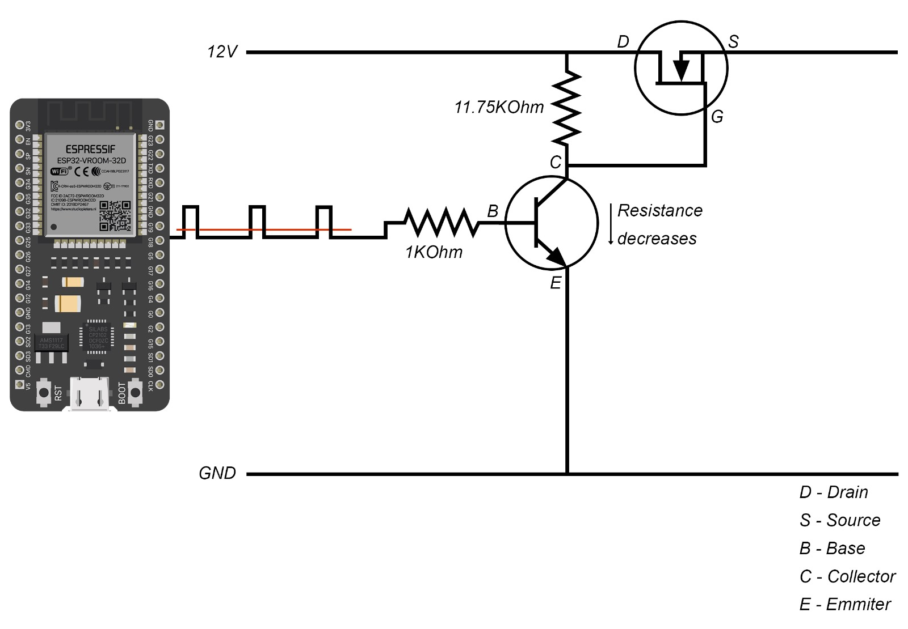

By using the software capabilities of the ESP32 along with its diverse pin functionality, an automated charging system can be effectively realized. In this setup, the created buck converter utilizes a PWM signal to control the charging process. The PWM signal ranges from 0 to 254, aligned with the ADC capabilities of the development board. Adjusting the PWM value allows us to alternate between the desired voltage and charging current. A higher PWM value will cause the transistor to act as a stronger resistance, resulting in a higher voltage at the gate pin of the N-Type MOSFET. This, in turn, makes the MOSFET open wider, delivering a higher output. Using a reverse analogy, a lower PWM value will have the opposite effect. Figure 10 and 11 will offer a graphical representation of both presented stages.

In the ON stage, the MOSFET switch is closed and the diode is reverse-biased (not conducting) because the voltage at the cathode is higher than at the anode. When the switch is closed, current begins to flow from the input source through the inductor () to the load. The inductor resists changes in current by generating an opposing voltage () across its terminals due to the changing current. This opposing voltage initially reduces the net voltage across the load.

As the current through the inductor increases, energy is stored in its magnetic field. The voltage across the inductor can be expressed as:

*where* ***L*** *is the inductance, is the rate of change of current through the inductor and* ***t*** *is time.*

In the OFF stage, the MOSFET switch is open, removing the input voltage source from the circuit. The current through the inductor starts to decrease, causing the inductor to generate a voltage that opposes the drop in current. This makes the inductor act as a current source, discharging its stored energy into the circuit.

During this stage, the diode becomes forward-biased (conducting), allowing current to flow from the inductor to the load and back through the diode. This maintains current flow through the load even though the input voltage source is disconnected. The energy stored in the inductor supports the current flow, ensuring a continuous current to the load. The voltage at the load is determined by the inductor discharging and can be expressed as:

The output voltage of the MOSFET is very noisy, containing lots of switching harmonics so an LC filter is needed to stabilize it. Only after this filtering process, the converter can effectively serve its purpose and charge the batteries efficently.

The circuit also presents a voltage divider that measures the input voltage and uses it for protection purposes, particularly to avoid fluctuations in the charging process that could damage the battery. The output voltage of this voltage divider targets to match the working voltage of the ESP32-DevKitC. The following formula is used in order to compute the accepted value:

where represents the actual voltage of the power supply, is the raw value read by the ADC of the board and are the resistors value.

In the schematic, a second Schottky diode is included to prevent reverse charging leaks from the battery, thereby protecting the rest of the circuit.

**4.2.2 ESP32-DevKitC subsystem**

The ESP32 acts as the central processor, receiving data from various sensors:

* 2 x “DS18B20” temperature sensors for monitoring battery temperatures,
* 1 x “INA219” current sensors for voltage measurement and charging current value
* 1 x “US-100” ultrasonic sensors for distance measurement to prevent accidents
* 1 x “L298N” motor drivers for controlling bidirectional motors of the chassis.
* 4 x “TT” DC gearbox motors

Figure 10: Architecture of ESP32-DevKitC hardware subsystem

The system architecture operates on 3.3V to minimize energy consumption. Using the ESP32 development board as the central controller for the sensor suite facilitates easier debugging and helps detect potential issues such as faulty connections, short circuits, or sensor malfunctions.

Despite these benefits, selecting the right sensors for the entire project has been a real challenge. The vast array of options available today can be overwhelming. Here are some principles used in selecting the components that form the hardware architecture:

Due to the need for the entire system to operate at 3.3V, I was unable to use a common distance measurement sensor like the HC-SR04. Fortunately, within the same family of sensors, there is the US-100, which provides the necessary compatibility and operates at a voltage range between 2.4V and 5.5V.

Additionally, I aimed to use a high-precision current sensor in this process. The INA219, with its integrated analog-digital converter (ADC) operating at a range of up to 26V, was a suitable choice. The current sensor is highly efficient, measuring current through a shunt resistor with a value of approximately 0.01 Ohms.

**4.3 SOFTWARE ARCHITECTURE**

The software architecture of this project plays a important role in ensuring the entire system functions correctly. This project is a synergy between hardware and software, meaning that the software dictates the behavior of the hardware to achieve optimal performance. This is essential for obtaining the desired behavior in both charging and sensor operation. The code can be splitted in two parts:

1. The code written for the ESP32 board using the Arduino IDE.
2. The mobile application developed using an Expo project.

**4.3.1 Arduino IDE software**

Figure 11: Software processes that run on ESP32-DevKitC

**The entry step in the software filed of this project is establishing an Internet connection**. This connection subsequently offers the access to Firebase which later provides multiple features to the system. Without this initial connection, none of the subsequent processes would be possible, making it the foundational step in the entire setup.

Initializing the real-time database is crucial within this architecture. The Firebase real-time database acts as a "buffer zone" between the board and the mobile application, managing the high data flow that the ESP32 sends or receives. Without successfully establishing this connection, the entire system's purpose would be compromised. To achieve this connection, the Firebase ESP Client library will be used, which handles the necessary configurations for connecting to Firebase. Authentication is done using a token, saved in the API configurations once the database URL and API key are validated. Upon successful authentication, the connection is established with the complete credential configuration.

To fully utilize the potential of the development board, a multi-threaded approach is adopted. During the early stages of the project, it was observed that executing and implementing the entire code using a single thread was highly inefficient. This inefficiency not only reduced the effectiveness of the buck converter but also impacted the car's movement system. Therefore, a multi-threaded approach was necessary to enhance the system's performance and responsiveness.

Currently, the software architecture is managed using two threads, which is the maximum number of threads supported by the ESP32. *sensorTask* and *firebaseTask* are the responabile threads in which the essential code of the control unit is incapsulated in.

The *sensorTask* is responsible for collecting and monitoring sensor values and making relevant decisions based on them. On the other hand, the *firebaseTask* focuses on sending and receiving new data to and from Firebase RTDB. This dual-thread approach ensures that both data collection and communication with the database are handled efficiently and effectively, thereby optimizing the overall system performance.

Incorporating a buck converter into a Battery Management System (BMS) like mine offers several advantages, especially for efficient battery charging. To initiate the charging process, the ESP32-DevKitC must first verify if the car is connected to a valid power supply. Under normal conditions, when the battery is not charging, the voltage on the feedback bus of the power supply should be close to or equal to 0. Once a voltage greater than 3.3V but less than 12V is detected, the charging process can begin. This precaution helps protect the battery from harmful voltage fluctuations that can reduce its lifespan.

Heat is a major concern when charging batteries, as it can significantly affect performance. Research indicates that it is not the charging power itself but the heat generated from using a specific charging power that impacts battery performance. This is particularly true for batteries charged with higher currents and voltages.

For the NiMH batteries used in my project, temperature sensors continuously monitor the battery temperature. The measured data is sent to the board for processing. The charging process will not begin if any of the batteries do not meet the required temperature conditions.

An underlying assumption of the system is that while the battery is charging, the car should remain stationary. This mirrors real-world scenarios where a driver would not move the vehicle while it is connected to a charging station or a normal AC outlet. Consequently, task priorities are set based on this assumption.

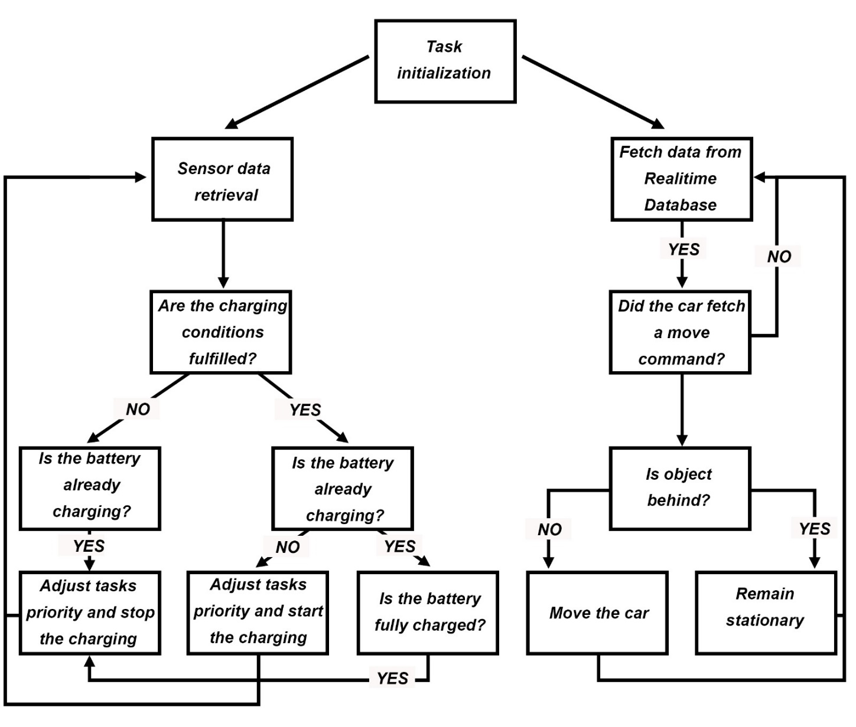The following diagram illustrates how the software manages these various use cases related to the car prototype:

Figure 12: Use cases managed by the software architecture

**4.3.2 Mobile Application**

In this chapter, I will discuss the functionality of the mobile application developed for monitoring and controlling the complete set of components in the electric vehicle, as well as the battery management system.

The mobile application is designed to handle the actuator control at the electric vehicle level and battery parameter monitoring. To achieve the desired functionality, the application will utilize technologies provided by Expo and React Native.

For this project, I opted to have Expo manage all the application's resources. This decision allows the Expo tools to handle the heavy lifting, requiring me only to write JavaScript code. The Expo Go app utilizes the Expo Runtime to offer a real-time preview of the application, so I don’t need to concern myself with native code or native modules.

**REFERENCES**

[1] - Commission Regulation (EU) No 459/2012 of 29 May 2012 amending Regulation (EC) No 715/2007 of the European Parliament and of the Council and Commission Regulation (EC) No 692/2008 as regards emissions from light passenger and commercial vehicles (Euro 6). Off. J. Eur. Union 2012, 48, 258–266.

[2] - Adam Dorsz and Mirosław Lewandowski, “Analysis of Fire Hazards Associated with the Operation of Electric Vehicles in Enclosed Structures”, 2021; [Online] Available: [Energies | Free Full-Text | Analysis of Fire Hazards Associated with the Operation of Electric Vehicles in Enclosed Structures (mdpi.com)](https://www.mdpi.com/1996-1073/15/1/11)

[3] - Cedric D. Koolen and Gadi Rothenberg, “Air Pollution in Europe”, 2018 ; [Online] Available: [Air Pollution in Europe - Koolen - 2019 - ChemSusChem - Wiley Online Library](https://chemistry-europe.onlinelibrary.wiley.com/doi/10.1002/cssc.201802292)

[4] - IEA Publications, 2021: [Online] Available: [Global EV Outlook 2021 – Analysis - IEA](https://www.iea.org/reports/global-ev-outlook-2021)

[5] - Deepak Ronanki, Apoorva Kelkar and Sheldon S. Williamson, “Extreme Fast Charging Technology - Prospects to Enhance Sustainable Electric Transportation”, 2019 ; [Online] Available: [Energies | Free Full-Text | Extreme Fast Charging Technology—Prospects to Enhance Sustainable Electric Transportation (mdpi.com)](https://www.mdpi.com/1996-1073/12/19/3721)

[6] - Syed Muhammad Arif, Tek Tjing Lie, Boon Chong Seet, Soumia Ayyadi and Kristian Jensen, “Review of Electric Vehicle Technologies, Charging Methods, Standards and Optimization Techniques”, 2021 ; [Online] Available: [Electronics | Free Full-Text | Review of Electric Vehicle Technologies, Charging Methods, Standards and Optimization Techniques (mdpi.com)](https://www.mdpi.com/2079-9292/10/16/1910)

[7] - Espressif, „ESP32-DevKitC V4 Getting Started Guide” ; [Online] Available: [ESP32-DevKitC V4 Getting Started Guide - ESP32 - — ESP-IDF Programming Guide latest documentation (espressif.com)](https://docs.espressif.com/projects/esp-idf/en/latest/esp32/hw-reference/esp32/get-started-devkitc.html)

[8] – Adafruit Datasheet, „Zerø-Drift, Bi-Directional CURRENT/POWER MONITOR with I2C™ Interface” ; [Online] Available: [Zerø-Drift, Bi-Directional CURRENT/POWER MONITOR with I2C™ Interface (Rev. F) (adafruit.com)](https://cdn-shop.adafruit.com/datasheets/ina219.pdf)

[9] – Sparkfun Datasheet, „L298 Dual Full-Bridge Driver” ; [Online] Available: [Dual full-bridge driver (sparkfun.com)](https://www.sparkfun.com/datasheets/Robotics/L298_H_Bridge.pdf)

[10] - M.A. Fetcenko, S.R. Ovshinsky, B. Reichman, K. Young, C. Fierro, J. Koch, A. Zallen, W. Mays, T. Ouchi in „Recent advances in NiMH battery technology” ; [Online] Available: [Recent advances in NiMH battery technology - ScienceDirect](https://www.sciencedirect.com/science/article/pii/S0378775306021215)

[11] - Dulika Nayanasiri and Yunwei Li, „Step-Down DC–DC Converters: An Overview and Outlook” ; [Online] Available: [Electronics | Free Full-Text | Step-Down DC&ndash;DC Converters: An Overview and Outlook (mdpi.com)](https://www.mdpi.com/2079-9292/11/11/1693)

[12] – Hugo Hutri, “Comparison of React Native and Expo” ; [Online] Available: [Comparison of React Native and Expo - LUTPub](https://lutpub.lut.fi/handle/10024/165256)

[13] - Statista, “Cross-platform mobile frameworks used by global developers” ; [Online] Available: [Cross-platform mobile frameworks used by global developers 2023 | Statista](https://www.statista.com/statistics/869224/worldwide-software-developer-working-hours/)

[14] – Firebase Official Documentaion ; [Online] Available: [Firebase Documentation (google.com)](https://firebase.google.com/docs)

[15] - M. F. Sanner, “Python: A programming language for software integration and development” ; [Online] Available: [10.1.1.35.6459-libre.pdf (d1wqtxts1xzle7.cloudfront.net)](https://d1wqtxts1xzle7.cloudfront.net/25505223/10.1.1.35.6459-libre.pdf?1390869360=&response-content-disposition=inline%3B+filename%3DPython_a_programming_language_for_softwa.pdf&Expires=1718612164&Signature=QS9~Ww8LVXAS7OquYN7Icl84xKeD3szqgXNrduQtwJQ0Bpl84SUrPnAxpUqmPZ4DkPaqHaoeIz5MVr3pH9sh00WJOfY5Bj2Q0CT00IyAPlEcyZl29ZAqghH6oR3~QMACdjLjEst-yGrLi7xFpM1QOOGI50WFP3rpPLZWsoSbwR5JMW4HBOsBoXozOsWw3faWKTm4yiTQ8WyK5MWgNAKq0OFLW~PUs3QPRj5aiGu3Q-YNvdDaPH6FvWvNdDuyT~t1daXbFOalMqX2zTr6q5DdZf-OAZg0skD23nomxZS17lHUgw9hQQdk-x5Sb6n6HY4h~BnedncRQZx3~mSQPEzQiA__&Key-Pair-Id=APKAJLOHF5GGSLRBV4ZA)