R7LITE+AD9361 Design Demo Guide

1 Reference manual and software
- All reference manual and sofeware can be found at analog ad9361 wiki site.
  - http://wiki.analog.com/resources/eval/user-guides/ad-fmcomms2-ebz
- Digital interface verilog code：
hdl-master\library\axi_ad9361\axi_ad9361_dev_if.v
- SPI register config software of PC：AD9361 Evaluation Software 2.1.1
- AD9361_Reference_Manual_UG-570.pdf
- AD9361_Register_Map_Reference_Manual_UG-671.pdf

2 Reference Program
Program name:adaloop_v3
Program files:
\src\adaloop.v top module
\src\axi_ad9361_dev_if digital interface
\src\ad9361_spi_drv.v spi config driver
\src\ad9361_spi_if.v spi timming generation
\src\ad9361_lut.v spi register initial lut table
\src\adaloop.ucf user design constrain
\ip_core\clk_wiz_v3_6 pll for ad9361 digital interface
\ip_core\dds1 generate sine and cosine wave
\ip_core\fifo_128x64 convert digital interface to baseband interface
\ip_core\frame36_4096 rom for ieee802.11a baseband data 36Mbps rate
\ip_core\icon1 chipscope
\ip_core\ila1 chipscope
\ip_core\vio1 chipscope for control tx rx gain and wave type
\adaloop.cpj chipscope project file
\adaloop.bit FPGA firmware tx rx loop
\adaloop_bist.bit FPGA firmware rx test mode sine and cosein

3 VIO control
- SEL[1:0] channel1 tx wave type
  - 0x0 ：0
  - 0x1 ：cosein and sine
  - 0x2 ：ieee802.11a 36Mbps rate
- SEL[3:2] channel2 tx wave type
  - 0x0 ：0
  - 0x1 ：cosein and sine
  - 0x2 ：ieee802.11a 36Mbps rate
- Phase dds output frequency control
- rx1_index channel1 MGC rxgain
- rx2_index channel2 MGC rxgain
- tx1_att channel1 tx attenuation
- tx2_att channel2 tx attenuation

4 characteristic of reference code
TX Frequency 2422MHz
RX Frequency 2422MHz
FDD mode
Tx and rx Sample rate 40MHz
2tx2rx mode
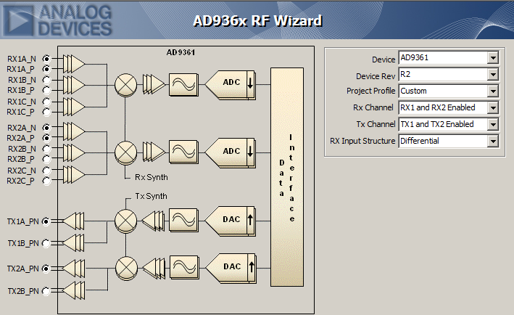
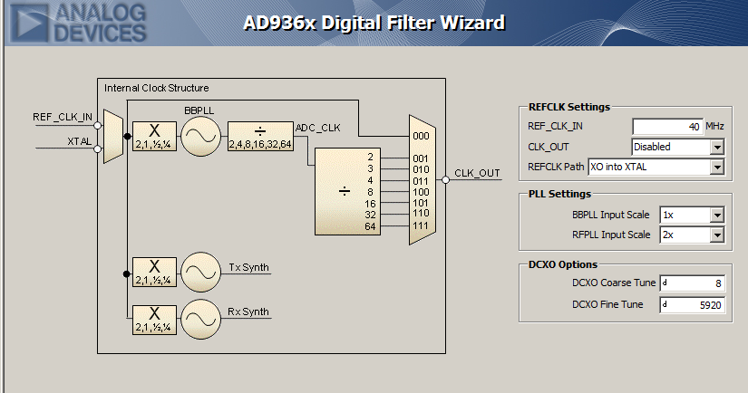
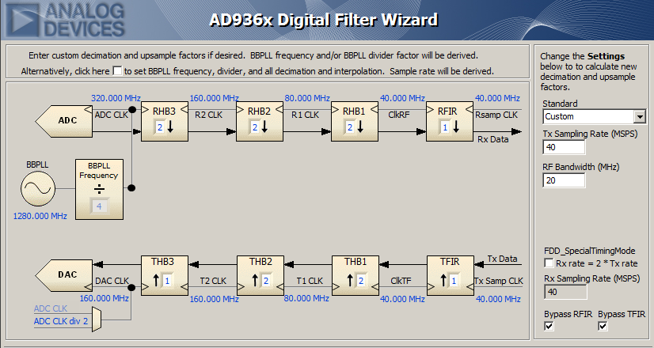
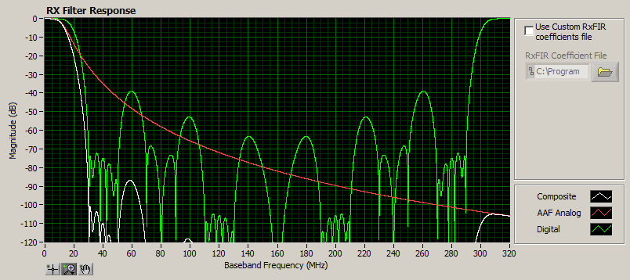
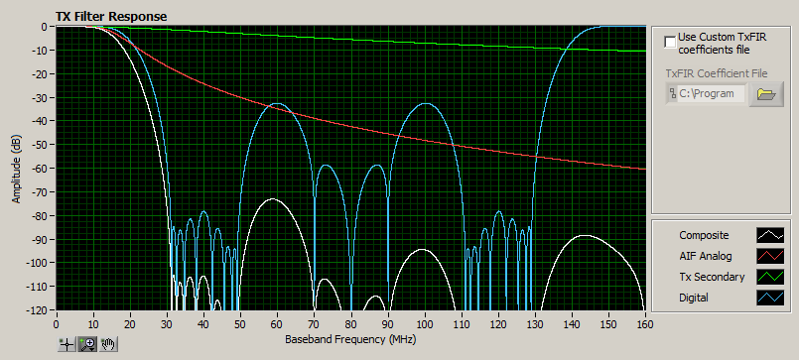
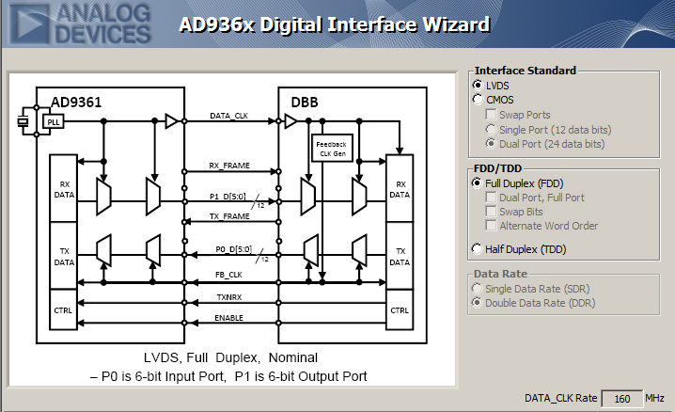
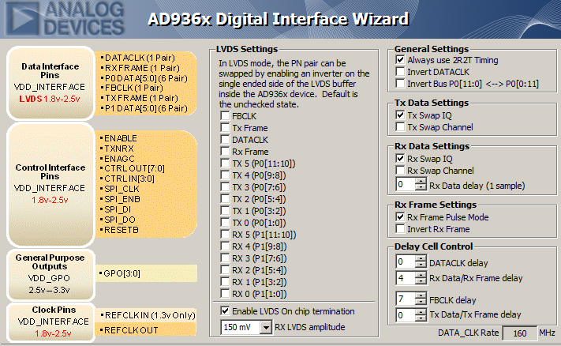
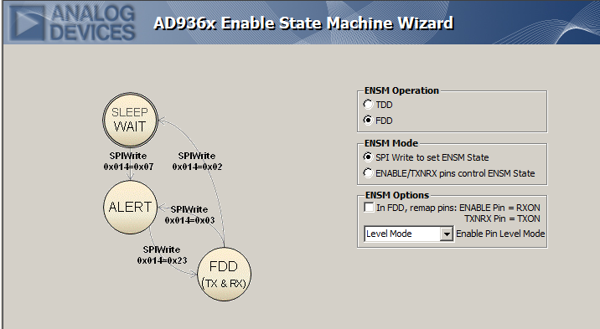

5 run shots
