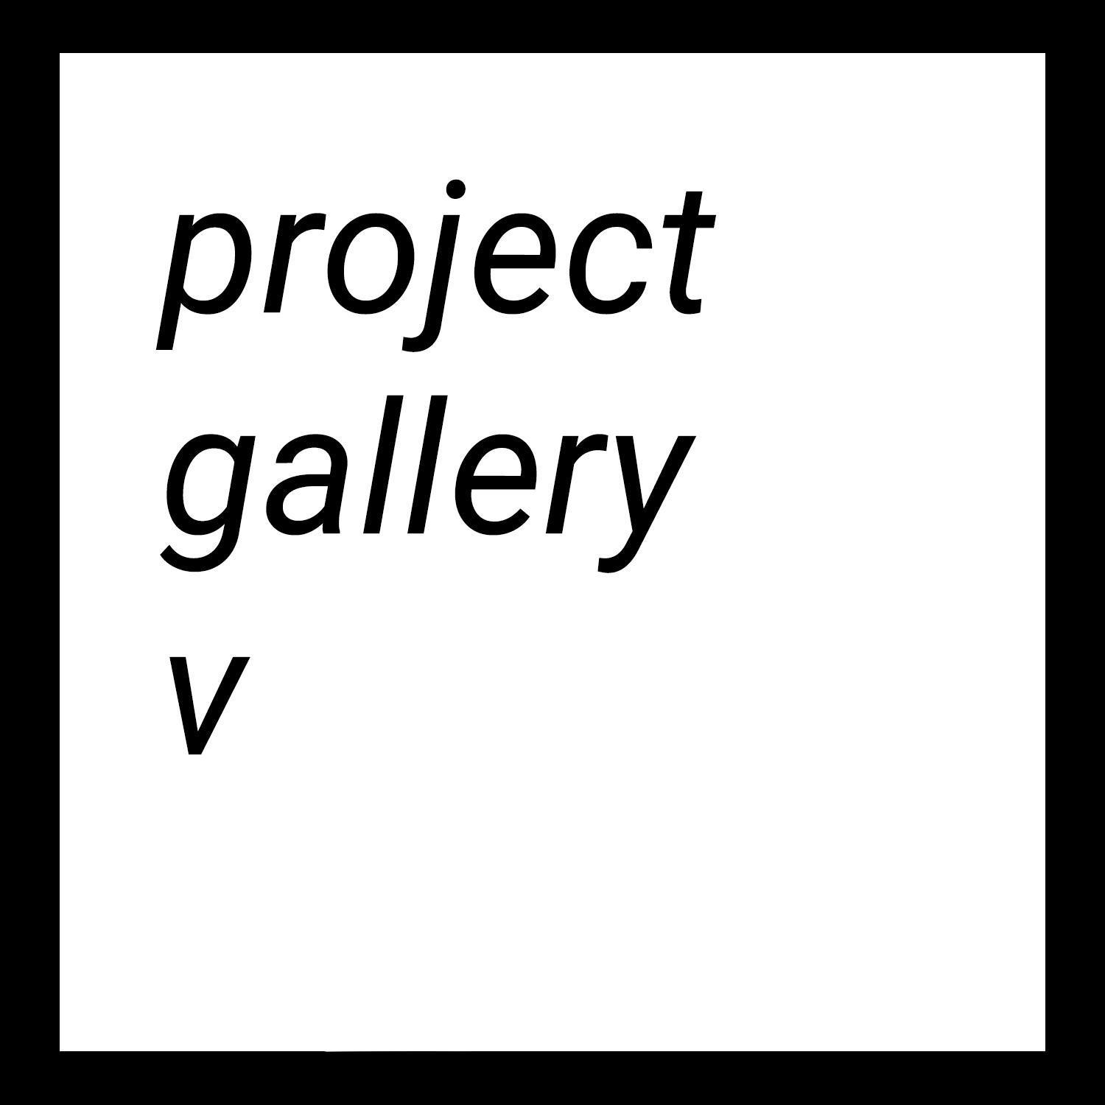

Syncretic: Religion and Ritual in Diaspora
May 2nd - June 30th, 2022
Project Gallery V
___________________________________

New York City, N.Y., May 1st, 2022 | Syncretic: Religion and Ritual in Diaspora is an online group exhibition curated by Dante Migone-Ojeda.

Featuring work from Priscilla Aleman, Ruhee Maknojia, Dante Migone-Ojeda, Shani Strand, and A young Yu.

“The cultivation of identity and community for second generation immigrants in the United States is necessarily a balancing act. On one hand, there exists an outsize pressure levelled by the dominant white power structures, brought to bear on processes of assimilation and outright rejection. On the other, there is the tenuous connection to a place of origin that is at once home and foreign. These two poles jostle and pull at each other, often colliding and slipping past one another in turn, leaving these hyphenated Americans caught in the gaps between. However, from within those gaps, there is room to push back, and generative potential for new alignments and transformations.

Within this schema, religion occupies a deeply meaningful role. The intertwined development of religion and culture means the two are inextricable, and the same holds true within immigrant communities in the US. Often, religious communities double as ethnic enclaves. Here, the religious becomes the cultural, serving as the strongest tether to one’s personal history. This comes with its own complications; religion is by nature about rules and stricture, culture about malleability and adaptation. What emerges from this mix is a new sort of syncretism, blending together cultural influences from the diasporic experience and the ritualism and tradition present in religion. By contrast, the relationship to religion in immigrant communities can also be more nuanced. Rather than the singular thread tying together a group, it is one of many within a larger fabric. Within these communities, one can buck the constraints of religion without becoming ostracized from the immigrant community writ large. In such a framework, a relationship to religion based on critique emerges more easily, rejecting or questioning the influence of religion over culture, and repositioning oneself more aggressively in relation to religion. While neither of these are mutually exclusive, as both can exist within the same community and their relationship to the individual is contextual, they do each bring a unique set of concerns to religion in diaspora, and to art emerging from these traditions. In the former, religion serves as a bridge to personal histories and family connections, albeit one modified by the pressures applied by the culture of the US. The traditions and rituals become sources of comfort, and allow for travel into and through one's ancestors and history. In the latter, religion underpins deeply uncomfortable histories of colonialism, patriarchy, and oppression. Thus, the work and syncretic practice that emerges takes a harder stance toward religion, probing and questioning its role in the broader construction of culture. These approaches are likewise not mutually exclusive, and exist on a spectrum within the work of the chosen artists for this exhibition. The works chosen for this exhibition resonate both with a longing for home, fraught as that concept is, and a genuine reckoning with what the traditions imposed by religious practice mean for identity construction in diaspora.

Ruhee Maknojia, Priscilla Aleman, Dante Migone-Ojeda, Shani Strand, and A young Yu each interact with the theme in varying ways. Maknojia’s paintings, which draw from the traditions of Islamic painting and South Asian folklore, use the language of religious art and folkloric culture to skewer both historic and modern concepts through the lens of religion and transgression. For Maknojia, religion serves as both a moral guide, and as a set of strict rules to be questioned. Priscilla Aleman’s installations, Origins of Devotion and Pre-Columbian, feature casts and artifacts directly related to Aleman’s family lineage. She positions herself and her grandmother as stand-ins for indigenous spiritual figures, and brings them together in ritual assemblage, weaving together indigenous and colonial religious practice seamlessly. Migone-Ojeda focuses largely on his Catholic upbringing. By employing the visual language of early colonial punishment and Catholic symbolism, he explores the nature of mestizaje through the lens of syncretic religious practice. Strands’ work reckons with both Yoruba and Christian religious traditions, and their influence on both Strand’s personal history and the history of Jamaica more broadly. Alternating between critique and homage, the works evoke a painful and beautiful history, and build a narrative that mirrors their personal history. Finally, A young Yu’s video works, Salpuri and Genesis. restage and recontextualize traditional folkloric and spiritual traditions within queer and diasporic contexts. They pose the question; what is the role of the second generation immigrant in passing down historical knowledge?”

— Dante Migone-Ojeda

You can view the exhibition by visiting our website here.

Contact: Trinity Lester and Cary Hulbert | Project Gallery V | projectgalleryv@gmail.com

