**Week 13- Tutorial Assignment**

**Sample programs to Construct NFA and DFA using Python**

**1. Write a Python program to create an NFA that accepts strings containing only the letter 'a'.**

def is_accepting_state(current_state):

return current_state == 1

def nfa_accepts(input_string):

current_state = 0

for char in input_string:

if current_state == 0 and char == 'a':

current_state = 1

elif current_state == 1 and char == 'a':

current_state = 1

return is_accepting_state(current_state)

# Get the input string from the user

input_string = input("Enter a string to check if it contains only 'a's: ")

if nfa_accepts(input_string):

print("Accepted: The string contains only 'a's.")

else:

print("Rejected: The string does not contain only 'a's.")

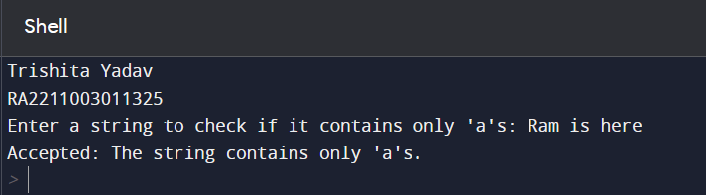

**2. Create a Python function to check if a given string is accepted by an NFA that recognizes the pattern "ab|ba" (either "ab" or "ba").**

def is_accepting_state(current_state):

return current_state in [2, 4]

def nfa_accepts(input_string):

current_state = 0

for char in input_string:

if current_state == 0 and char == 'a':

current_state = 1

elif current_state == 0 and char == 'b':

current_state = 3

elif current_state == 1 and char == 'b':

current_state = 2

elif current_state == 2:

break # Accept if "ab"

elif current_state == 3 and char == 'a':

current_state = 4

elif current_state == 4:

break # Accept if "ba"

else:

return False # Invalid transition

return is_accepting_state(current_state)

# Get the input string from the user

input_string = input("Enter a string to check if it matches 'ab|ba': ")

if nfa_accepts(input_string):

print("Accepted: The string matches 'ab|ba'.")

else:

print("Rejected: The string does not match 'ab|ba'.")

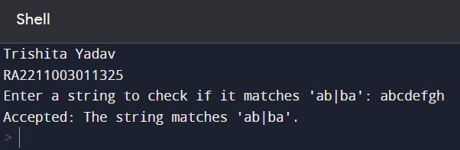

**3. Implement a Python script that converts a simple NFA into a DFA with two states.**

def nfa_transition(state, symbol):

if state == 0 and symbol == 'a':

return {0, 1}

elif state == 1 and symbol == 'a':

return {0}

else:

return set()

def nfa_to_dfa(nfa, alphabet):

dfa = {}

unprocessed_states = [frozenset({0})] # Start with the initial state

while unprocessed_states:

current_nfa_state = unprocessed_states.pop()

dfa_state = frozenset()

for symbol in alphabet:

nfa_transitions = set()

for nfa_state in current_nfa_state:

nfa_transitions |= nfa_transition(nfa_state, symbol)

dfa_state |= nfa_transitions

if dfa_state:

unprocessed_states.append(dfa_state)

dfa[current_nfa_state] = dfa_state

return dfa

# Define the NFA alphabet

nfa_alphabet = {'a'}

# Convert the NFA to a DFA

nfa = {

0: {'a': {0, 1}},

1: {'a': {0}}

}

dfa = nfa_to_dfa(nfa, nfa_alphabet)

# Print the resulting DFA

print("DFA State Transitions:")

for state, transitions in dfa.items():

print(f"State {state} -> {transitions}")

**4. Write a Python program to construct a DFA that accepts binary strings ending in '01'.**

def is_accepting_state(current_state):

return current_state == 2

def dfa_accepts(input_string):

current_state = 0

for char in input_string:

if current_state == 0 and char == '0':

current_state = 1

elif current_state == 1 and char == '1':

current_state = 2

else:

current_state = 0

return is_accepting_state(current_state)

# Get the input binary string from the user

input_string = input("Enter a binary string: ")

if dfa_accepts(input_string):

print("Accepted: The string ends with '01'.")

else:

print("Rejected: The string does not end with '01'.")

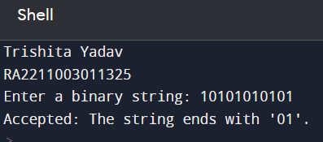

**5. Develop a Python function that takes an NFA and returns the set of states that can be reached from a given state on a specific input symbol.**

def nfa_transition(nfa, current_states, symbol):

next_states = set()

for state in current_states:

if state in nfa and symbol in nfa[state]:

next_states |= nfa[state][symbol]

return next_states

# Example NFA

nfa = {

0: {'a': {0, 1}},

1: {'b': {2}},

2: {'c': {3}},

3: {'d': {4}},

4: {'e': {5}},

}

# Function to get the set of states reached from a state on a specific input symbol

def get_reachable_states(nfa, current_states, symbol):

next_states = nfa_transition(nfa, current_states, symbol)

return next_states

# Test the function with a specific state and symbol

current_state = 0

input_symbol = 'a'

reachable_states = get_reachable_states(nfa, {current_state}, input_symbol)

print(f"From state {current_state} on symbol '{input_symbol}', we can reach states: {reachable_states}")

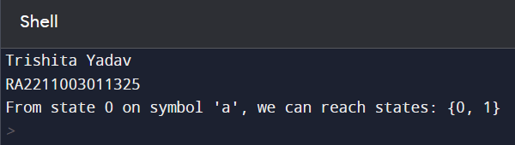

**6. Create a Python script to minimize a simple DFA with three states by merging equivalent states.**

def minimize_dfa(dfa, alphabet):

# Step 1: Initialize partition P0 into accepting and non-accepting states

accepting_states = set(state for state, is_accepting in dfa.items() if is_accepting)

non_accepting_states = set(dfa.keys()) - accepting_states

partitions = [accepting_states, non_accepting_states]

# Step 2: Refine the partition until it no longer changes

while True:

new_partitions = []

for partition in partitions:

for symbol in alphabet:

new_partition = set()

for state in partition:

next_state = dfa[state][symbol]

for sub_partition in partitions:

if next_state in sub_partition:

new_partition.add(state)

break

if new_partition:

new_partitions.append(new_partition)

if new_partitions == partitions:

break

partitions = new_partitions

# Step 3: Create a new minimized DFA

minimized_dfa = {}

for i, partition in enumerate(partitions):

state_name = f'q{i}'

for state in partition:

minimized_dfa[state_name] = {}

for symbol in alphabet:

next_state = dfa[state][symbol]

for j, sub_partition in enumerate(partitions):

if next_state in sub_partition:

minimized_dfa[state_name][symbol] = f'q{j}'

break

return minimized_dfa

# Define the DFA transitions and states (example with 3 states)

dfa = {

'q0': {'a': 'q1', 'b': 'q0'},

'q1': {'a': 'q1', 'b': 'q2'},

'q2': {'a': 'q2', 'b': 'q0'},

}

# Define the alphabet

alphabet = {'a', 'b'}

# Minimize the DFA

minimized_dfa = minimize_dfa(dfa, alphabet)

# Print the minimized DFA

print("Minimized DFA:")

for state, transitions in minimized_dfa.items():

print(f"State {state} -> {transitions}")

**7. Implement a Python function that checks if a given string is accepted by a DFA that recognizes the pattern "ab*c".**

def dfa_accepts(input_string):

current_state = 0

for char in input_string:

if current_state == 0 and char == 'a':

current_state = 1

elif current_state == 1:

if char == 'b':

current_state = 1

elif char == 'c':

current_state = 2

else:

current_state = 0

elif current_state == 2:

return False # After reaching the accepting state, no more characters are allowed

return current_state == 1

# Get the input string from the user

input_string = input("Enter a string to check if it matches 'ab*c': ")

if dfa_accepts(input_string):

print("Accepted: The string matches 'ab*c'.")

else:

print("Rejected: The string does not match 'ab*c'.")

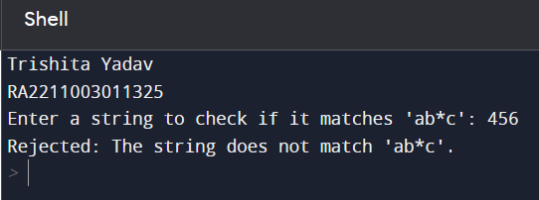

**8. Write a Python program to create an NFA that accepts strings with an odd number of '1's.**

def is_accepting_state(current_state):

return current_state == 'accept'

def nfa_accepts(input_string):

current_state = 'start'

for char in input_string:

if current_state == 'start' and char == '1':

current_state = 'odd'

elif current_state == 'odd' and char == '1':

current_state = 'even'

elif current_state == 'even' and char == '1':

current_state = 'odd'

return is_accepting_state(current_state)

# Get the input binary string from the user

input_string = input("Enter a binary string: ")

if nfa_accepts(input_string):

print("Accepted: The string has an odd number of '1's.")

else:

print("Rejected: The string does not have an odd number of '1's.")

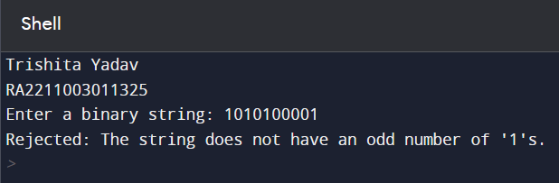

**9. Develop a Python function that converts a simple regular expression like "a(b|c)*" into an equivalent NFA.**

def create_nfa_from_regex(regex):

nfa = {}

states = 0

stack = []

def new_state():

nonlocal states

state = states

states += 1

return state

def epsilon_transition(from_state, to_state):

if from_state not in nfa:

nfa[from_state] = {}

if 'ε' not in nfa[from_state]:

nfa[from_state]['ε'] = set()

nfa[from_state]['ε'].add(to_state)

for char in regex:

if char == 'a':

start_state = new_state()

end_state = new_state()

epsilon_transition(start_state, end_state)

stack.append((start_state, end_state))

elif char == 'b':

start_state = new_state()

end_state = new_state()

epsilon_transition(start_state, end_state)

stack.append((start_state, end_state))

elif char == 'c':

start_state = new_state()

end_state = new_state()

epsilon_transition(start_state, end_state)

stack.append((start_state, end_state))

elif char == '|':

end1, start1 = stack.pop()

end2, start2 = stack.pop()

start_state = new_state()

end_state = new_state()

epsilon_transition(start_state, start1)

epsilon_transition(start_state, start2)

epsilon_transition(end1, end_state)

epsilon_transition(end2, end_state)

stack.append((start_state, end_state))

elif char == '*':

start, end = stack.pop()

start_state = new_state()

end_state = new_state()

epsilon_transition(start_state, start)

epsilon_transition(start_state, end_state)

epsilon_transition(end, start)

epsilon_transition(end, end_state)

stack.append((start_state, end_state))

if len(stack) != 1:

raise ValueError("Invalid regular expression")

return nfa

# Example regular expression

regex = "a(b|c)*"

# Convert the regular expression to an NFA

nfa = create_nfa_from_regex(regex)

# Print the resulting NFA

for state, transitions in nfa.items():

print(f"State {state} -> {transitions}")