**App week 14**

**Automata Programming Paradigm**

**DFA**

1. Draw a DFA and give the transition table for the language that accepts all and

only those strings that contain 00

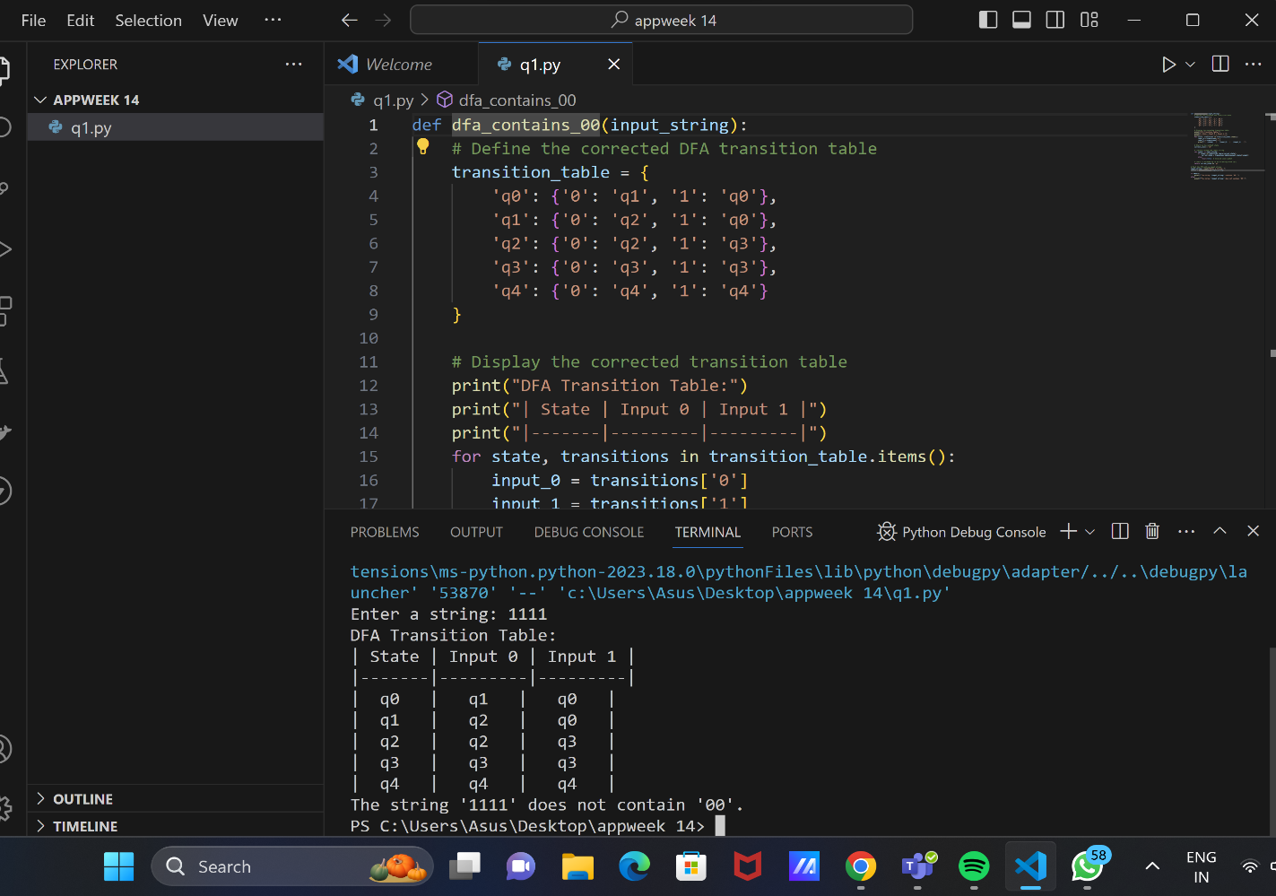

2. Draw a DFA and give the transition table for the language accepting strings

starting with ‘ab’ over input alphabets ∑ = {a, b}

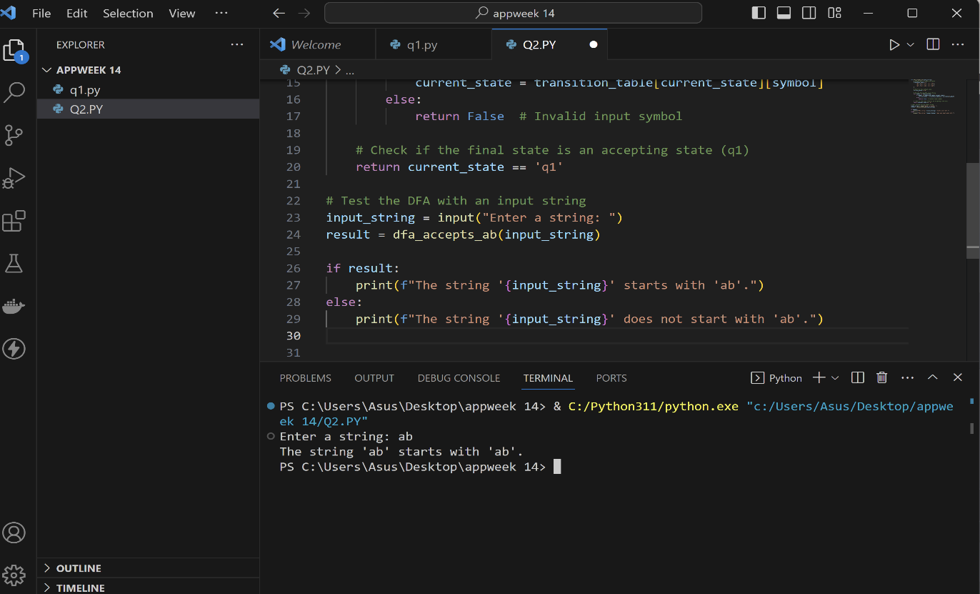

3. Construct a DFA with ∑ = {a, b} accepts the only input “aaab”.

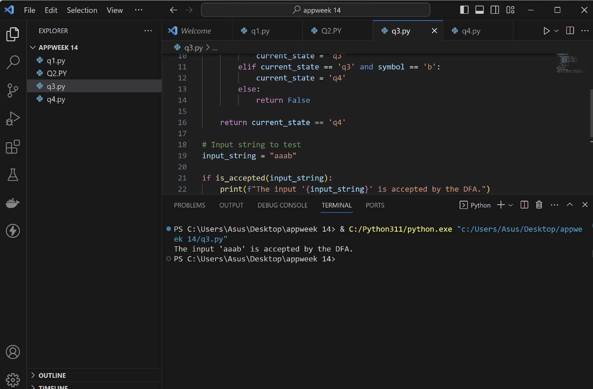

4. Draw a DFA and give the transition table for the language L(M)=a + aa*b. 5.

Draw a deterministic finite automate which accept 00 and 11 at the end of a

string containing 0, 1

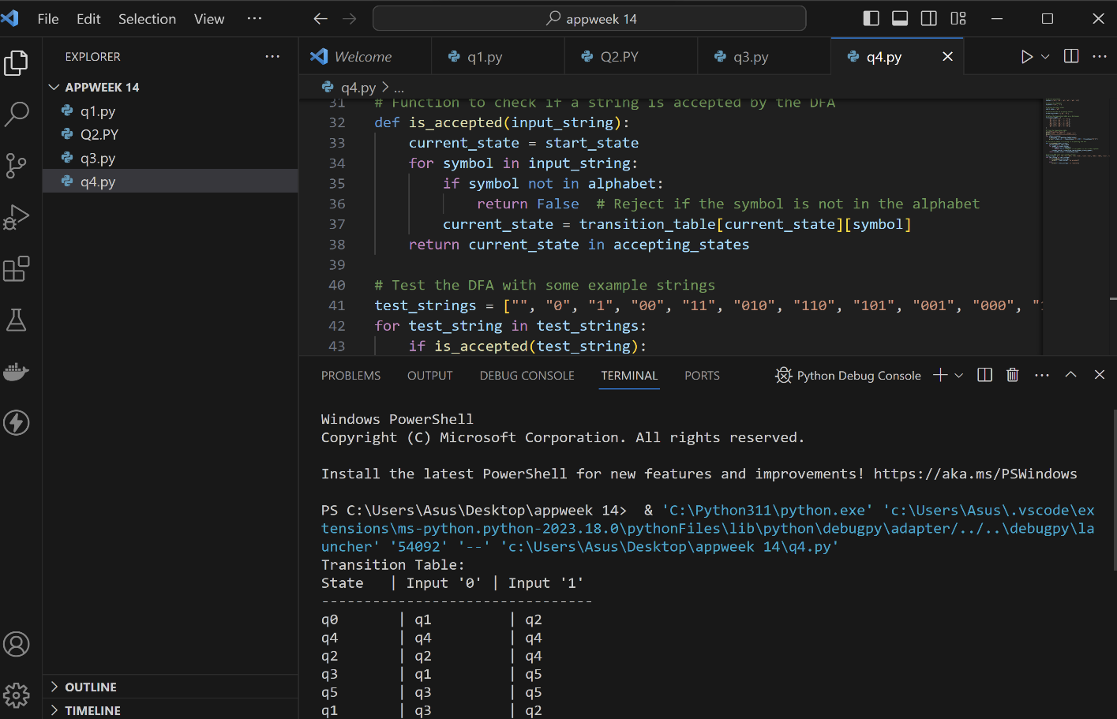

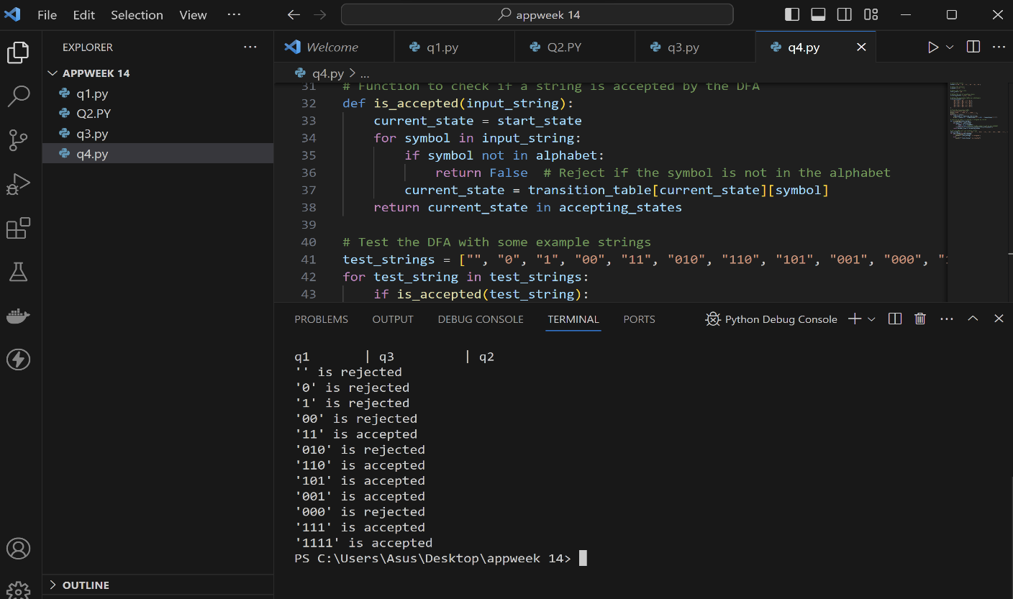

**NFA**

1. NFA recognizes all strings that contain two 0’s separated by a substring whose

length is a multiple of 3.

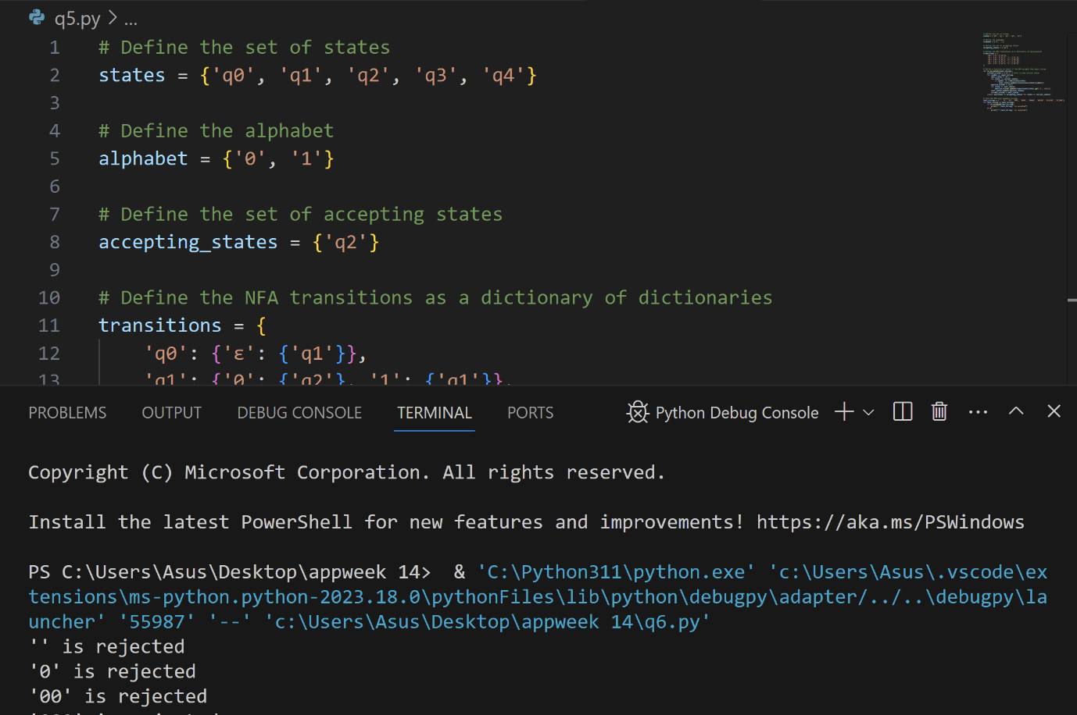

2. Construct a NFA and give the transition table for the following regular expression

for the given language =a + aa*b + a*b.

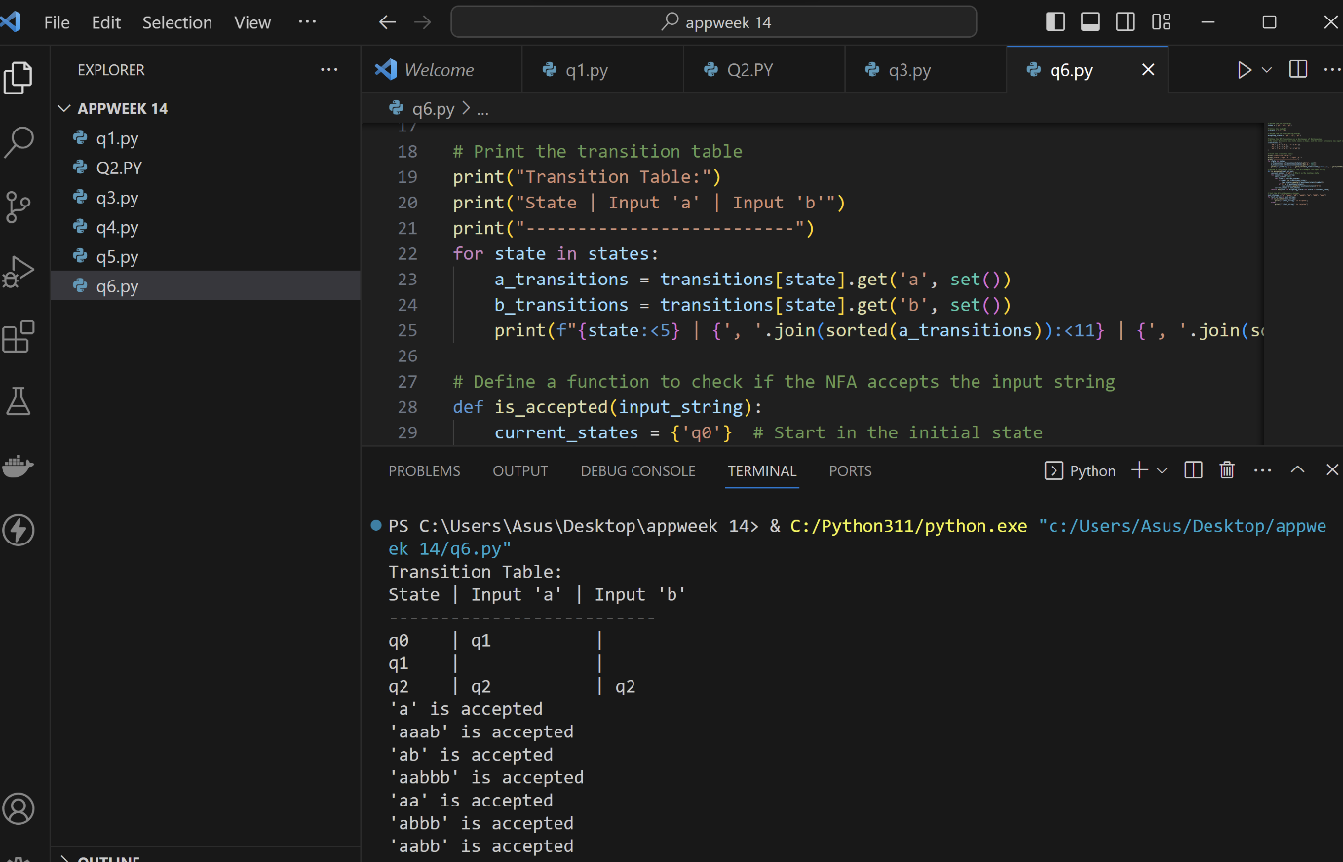

3. Construct a NFA and give the transition table for the following regular

expression for the given language =(a + ba)*bb(a + ab)*.

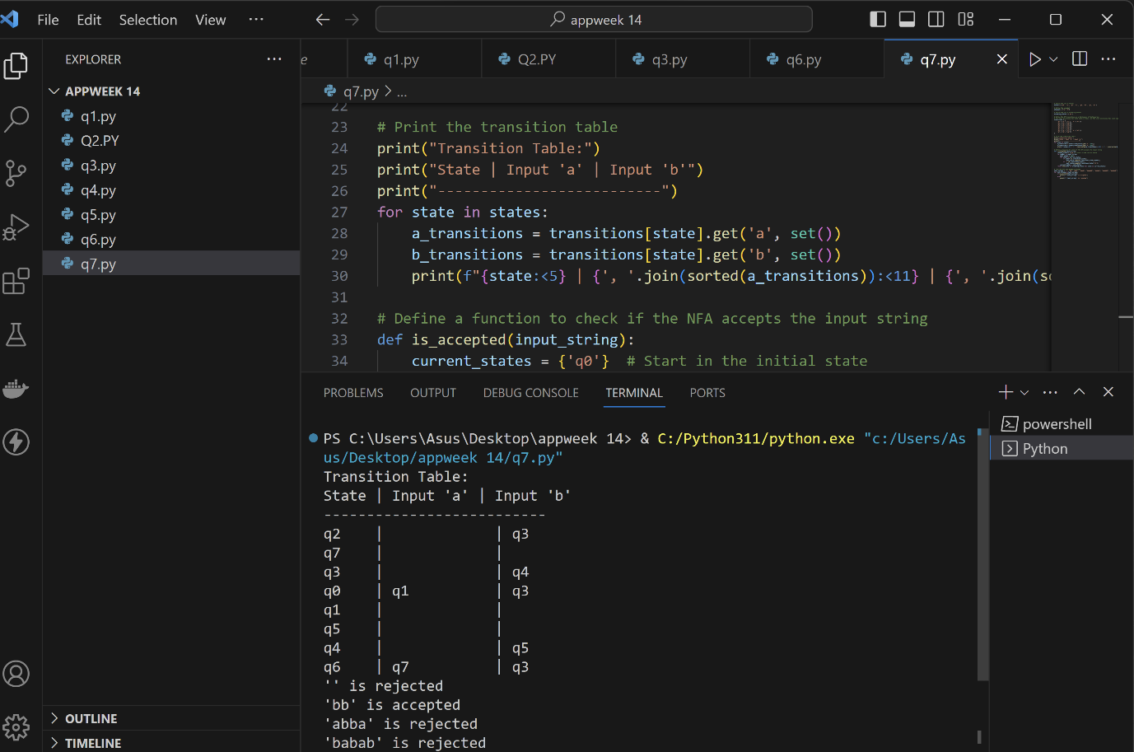

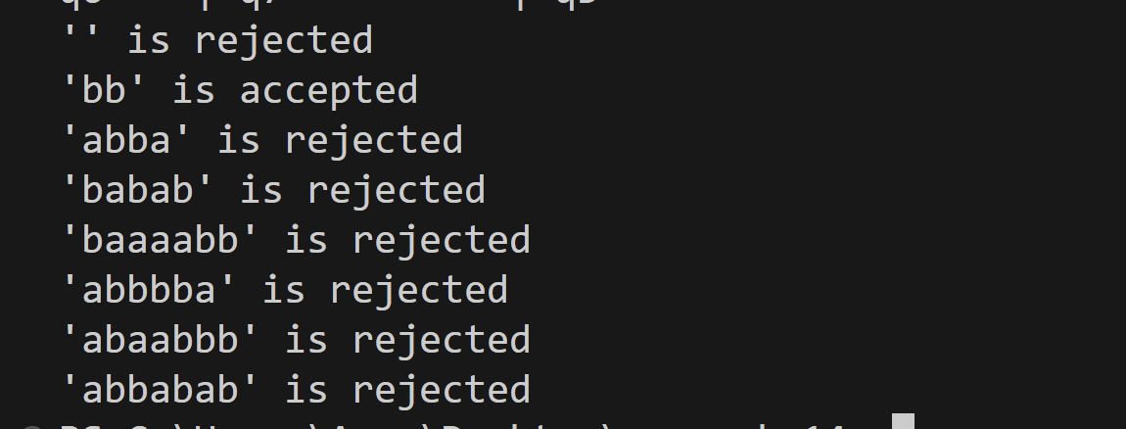

4. Construct a NFAs and give the transition table for {}, {ε}, {(ab)n | n ∈ N}, which

has regular expression (ab)*.

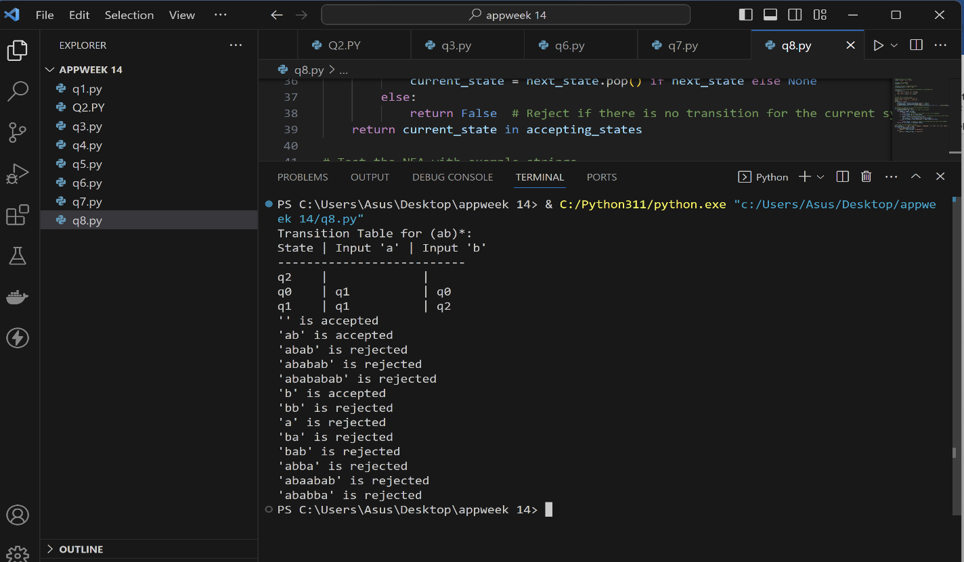

5. Construct a NFAs and give the transition table for the Language that accepts all

end with 01

