***21CSC203P Advanced Programming Practice***

***Tutorial Assignment 4***

**1.  Write a JAVA program to find those numbers which are divisible by 8 and multiple of 5, between 1000 and 2000 (both included)**

public class DivisibleBy8AndMultipleOf5{

    public static void main(String[]args){

        System.out.println("Numbers between 1000 and 2000 that are divisible by 8 and multiple of 5:");

        for(int i=1000;i<=2000;i++){

            if(i%8==0 && i%5==0) //condition to check number is divisible by 8 and multiple of 5

            {

                System.out.print(i+" ");

            }

        }

    }

}

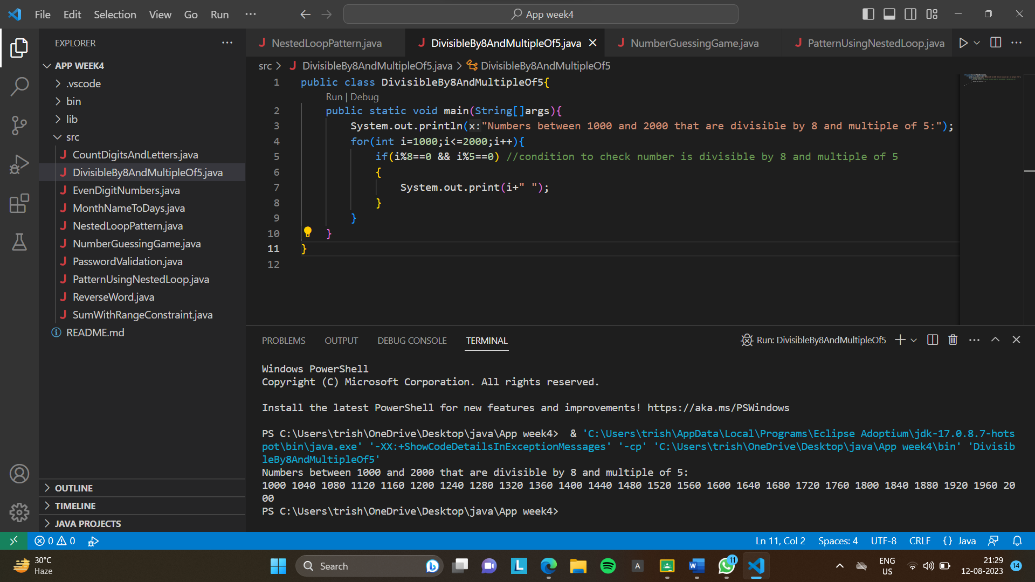

**2. Write a JAVA program to guess a number between 1 to 9. Note :User is prompted to enter a guess. If the user guesses wrong then the prompt appears again until the guess is correct, on successful guess, user will get a “Well guessed!” message, and the program will exit.**

import java.util.Scanner;

public class NumberGuessingGame{

    public static void main(String[]args){

        Scanner scanner=new Scanner(System.in);

        int targetNumber=(int)(Math.random()*9)+1; //target number is stored

        while(true){

            System.out.print("Guess a number between 1 and 9:");

            int guess=scanner.nextInt(); //guess number is stored

            if(guess==targetNumber) //condition to check if target no is equal to guess no

            {

                System.out.println("Well guessed!"); //if guess is coreect

                break;

            }

            else{

                System.out.println("Try again."); //if guess is wrong

            }

        }

        scanner.close();

    }

}

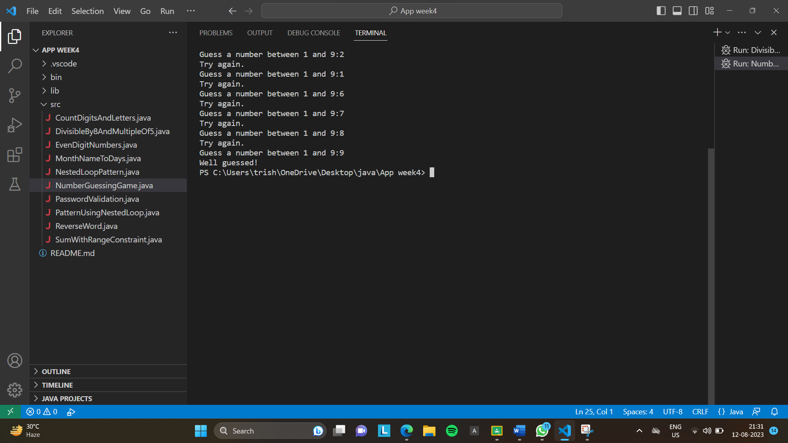

**3. Write a JAVA program to construct the following pattern, using a nested for loop.**

**\***

**\* \***

**\* * \***

**\* * * \***

**\* * * * \***

**\* * * \***

**\* * \***

**\* \***

**\***

public class PatternUsingNestedLoop{

    public static void main(String[]args){

        for(int i=1;i<=5;i++){

            for(int j=1;j<=i;j++){

                System.out.print("* ");

            }

            System.out.println();

        }

        for(int i=4;i>=1;i--){

            for(int j=1;j<=i;j++){

                System.out.print("* ");

            }

            System.out.println();

        }

    }

}

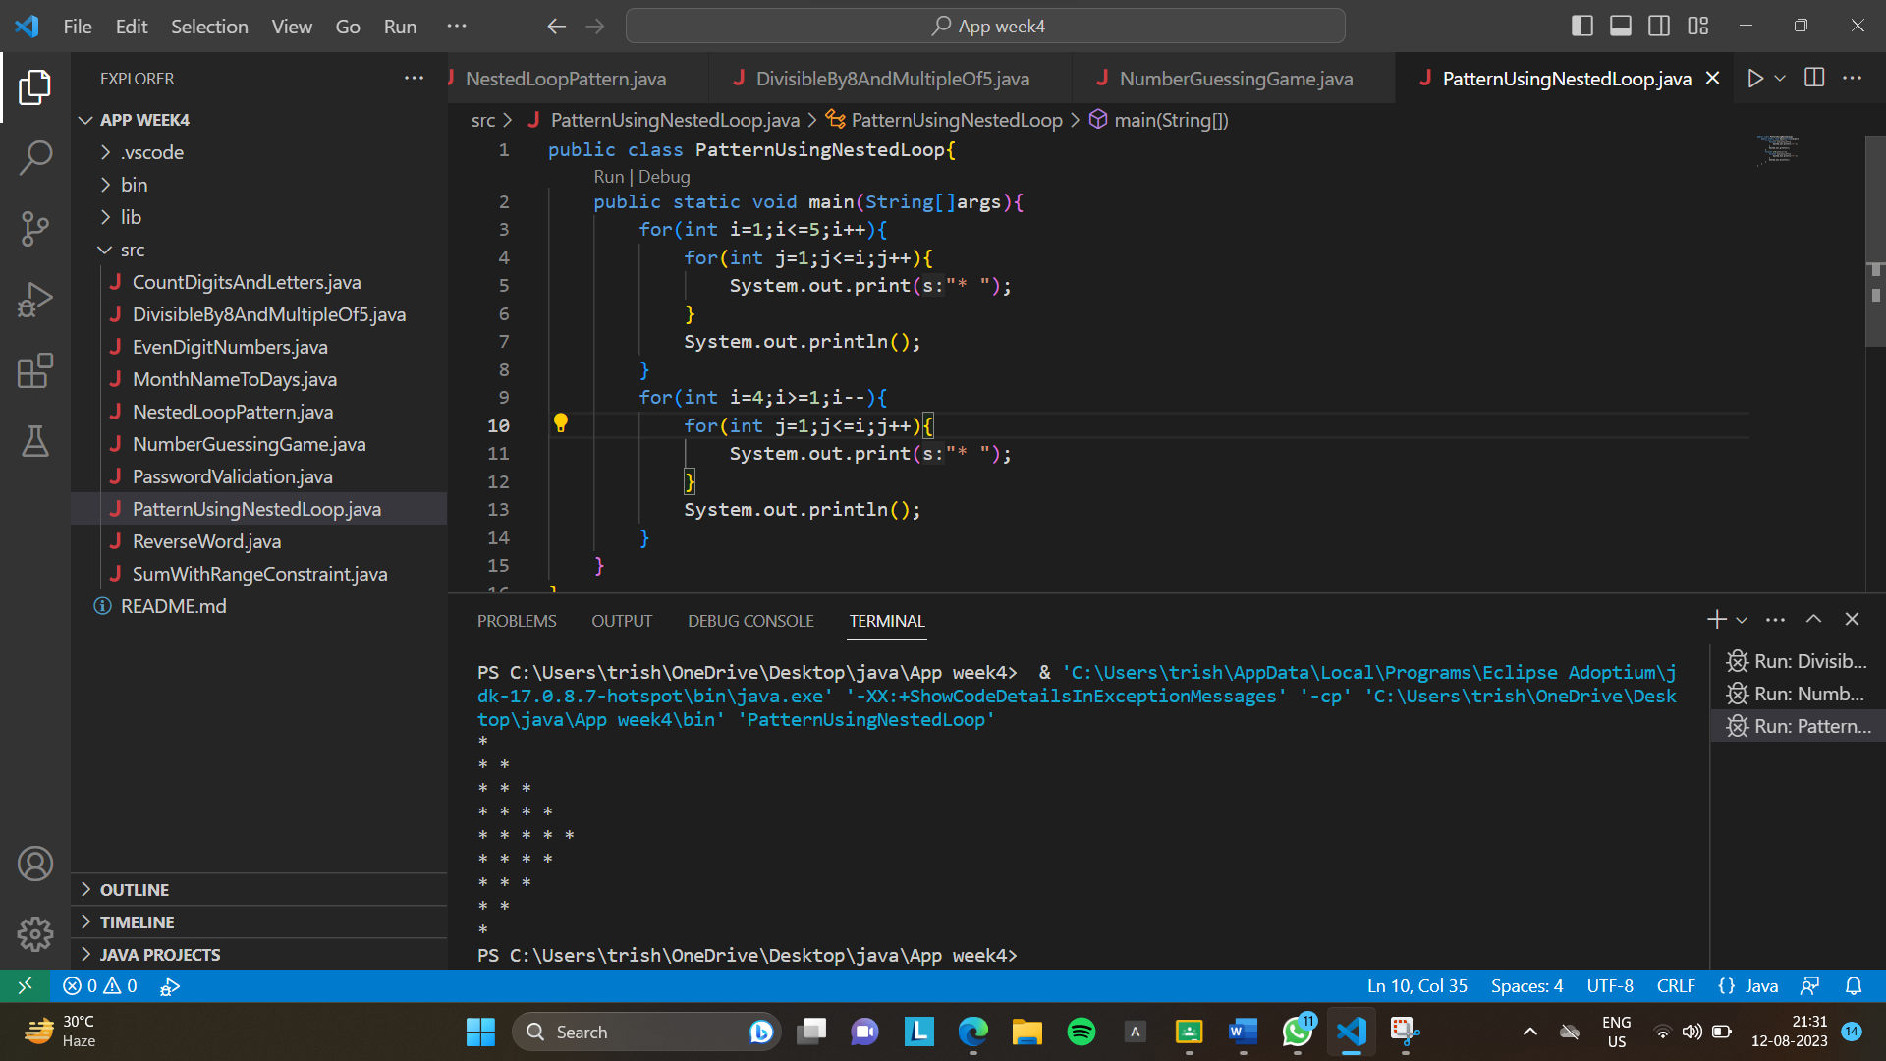

**4. Write a JAVA program that accepts a word from the user and reverse it.(should not use any functions)**

import java.util.Scanner;

public class ReverseWord{

    public static void main(String[]args){

        Scanner scanner=new Scanner(System.in);

        System.out.print("Enter a word:"); //input is taken from user

        String word=scanner.nextLine();

        String reversedWord="";

        for(int i=word.length()-1;i>=0;i--) //loop to reverse word

        {

            reversedWord+=word.charAt(i);

        }

        System.out.println("Reversed word:"+reversedWord); //reversed word is printed

        scanner.close();

    }

}

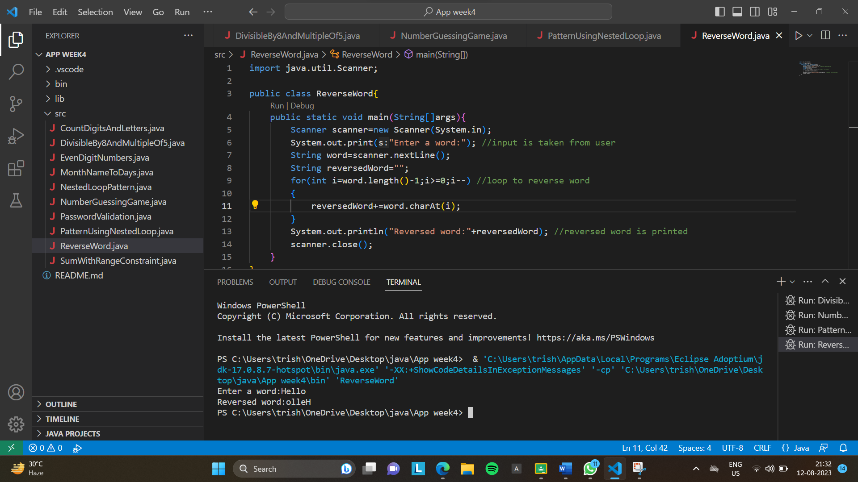

**5. Write a JAVA program that accepts a string and calculate the number of digits and letters.**

**Sample Data : SRMIST JULY 2023**

**Expected Output :**

**Letters 10**

**Digits 4**

import java.util.Scanner;

public class CountDigitsAndLetters{

    public static void main(String[]args){

        Scanner scanner=new Scanner(System.in);

        System.out.print("Enter a string:"); //input is taken from user

        String input=scanner.nextLine();

        int letterCount=0; //variable to store letter count

        int digitCount=0; //variable to store digit count

        for(char c:input.toCharArray()){

            if(Character.isLetter(c)){

                letterCount++;

            }

            else if(Character.isDigit(c)){

                digitCount++;

            }

        }

        System.out.println("Letters:"+letterCount);

        System.out.println("Digits:"+digitCount);

        scanner.close();

    }

}

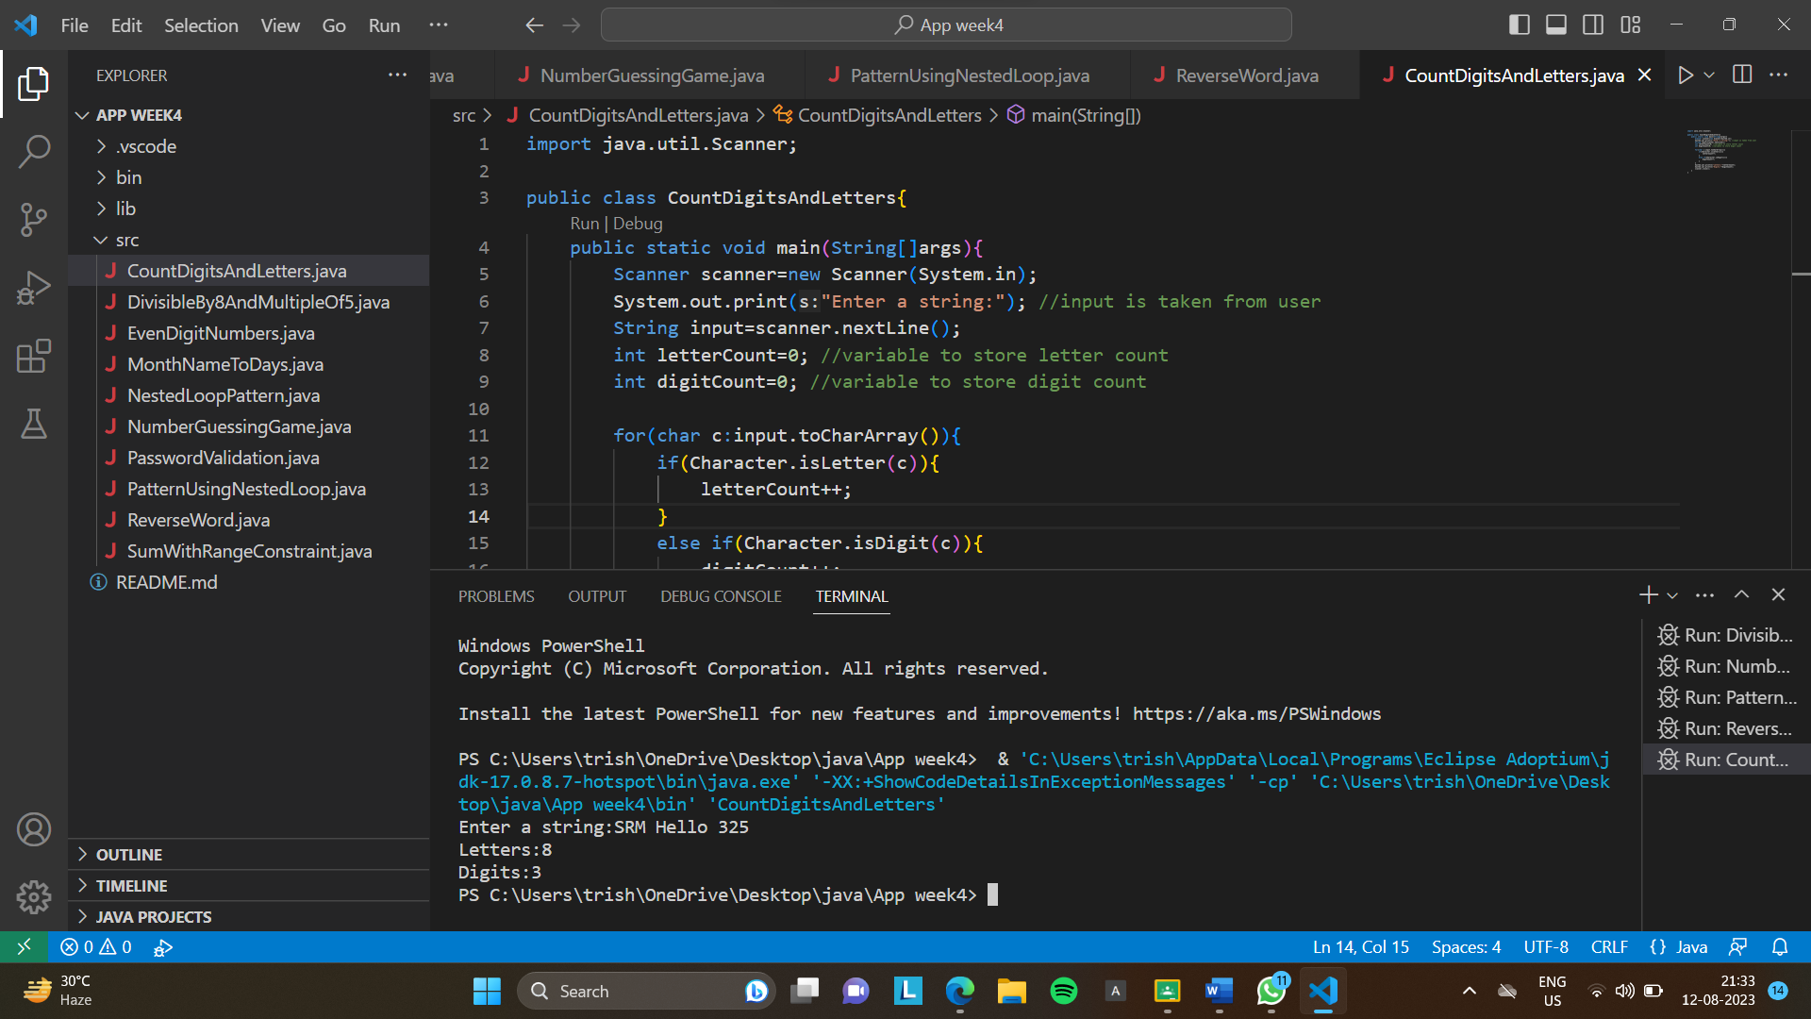

**6. Write a JAVA program to check the validity of password input by users.**

**Validation :**

**● At least 1 letter between [a-z] and 1 letter between [A-Z].**

**● At least 1 number between [0-9].**

**● At least 1 character from [$#@].**

**● Minimum length 6 characters.**

**● Maximum length 16 characters.**

**Sample output:**

**Input your password srmist@2017**

**Not a Valid Password**

**Input your password Srmist@2022**

**Valid Password**

import java.util.Scanner;

public class PasswordValidation{

    public static void main(String[]args){

        Scanner scanner=new Scanner(System.in);

        System.out.print("Input your password:"); //input password from user

        String password=scanner.nextLine();

        if(isValidPassword(password)){

            System.out.println("Valid Password"); //when password is valid

        }

        else{

            System.out.println("Not a Valid Password"); //when password is invalid

        }

        scanner.close();

    }

    public static boolean isValidPassword(String password){

        String regex= "^(?=.*[a-z])(?=.*[A-Z])(?=.*\\d)(?=.*[@$#])[A-Za-z\\d@$#]{6,16}$";

        return password.matches(regex); //regular expression used to check validity

    }

}

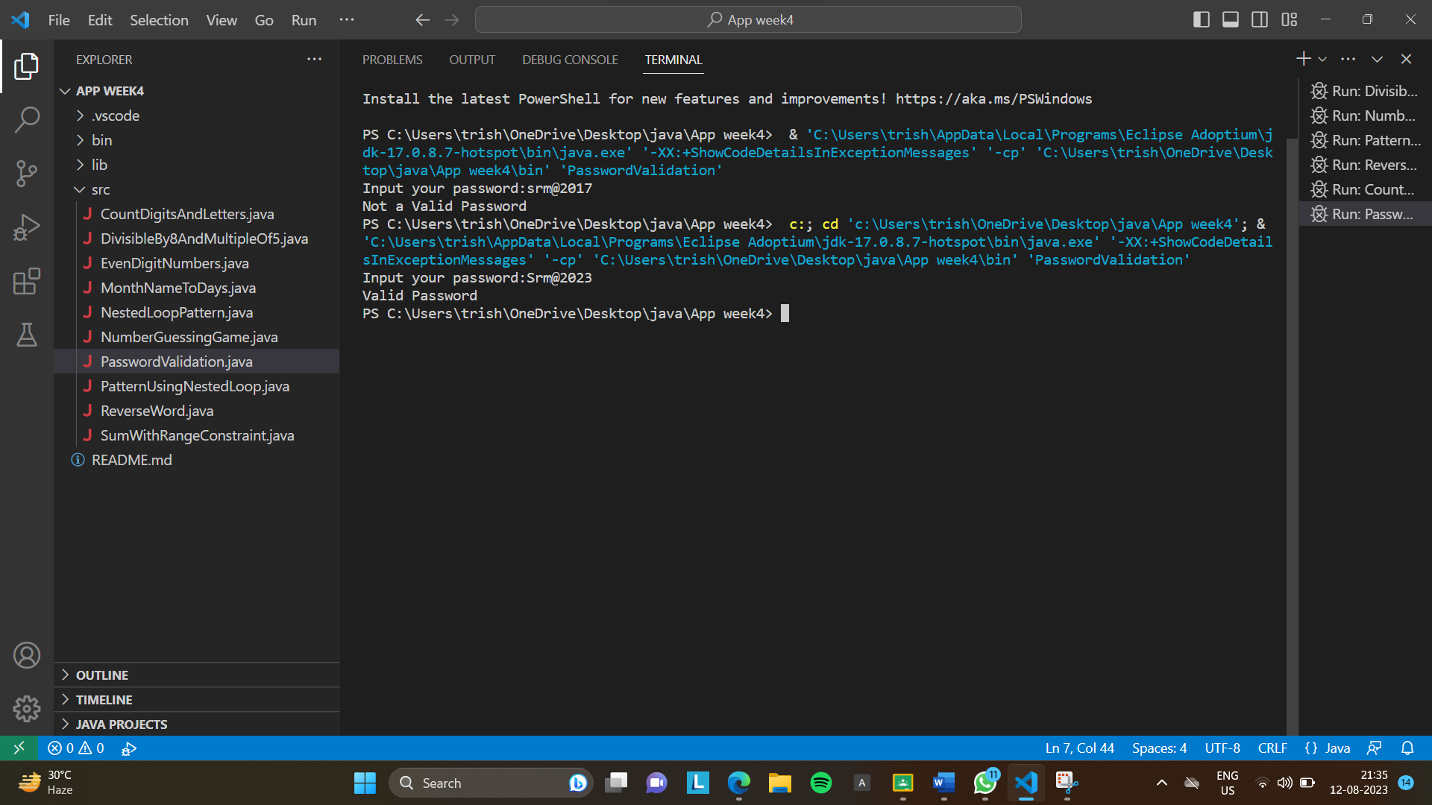

**7. Write a JAVA program to find numbers between 100 and 400 (both included) where each digit of a number is an even number. The numbers obtained should be printed in a comma-separated sequence.**

public class EvenDigitNumbers{

    public static void main(String[]args){

        System.out.println("Numbers between 100 and 400 with even digits:");

        for(int num=100;num<=400;num++){

            if(hasEvenDigits(num)){

                System.out.print(num+",");

            }

        }

    }

    public static boolean hasEvenDigits(int num){

        while(num>0){

            int digit=num%10;

            if(digit%2 !=0){

                return false;

            }

            num /= 10;

        }

        return true;

    }

}

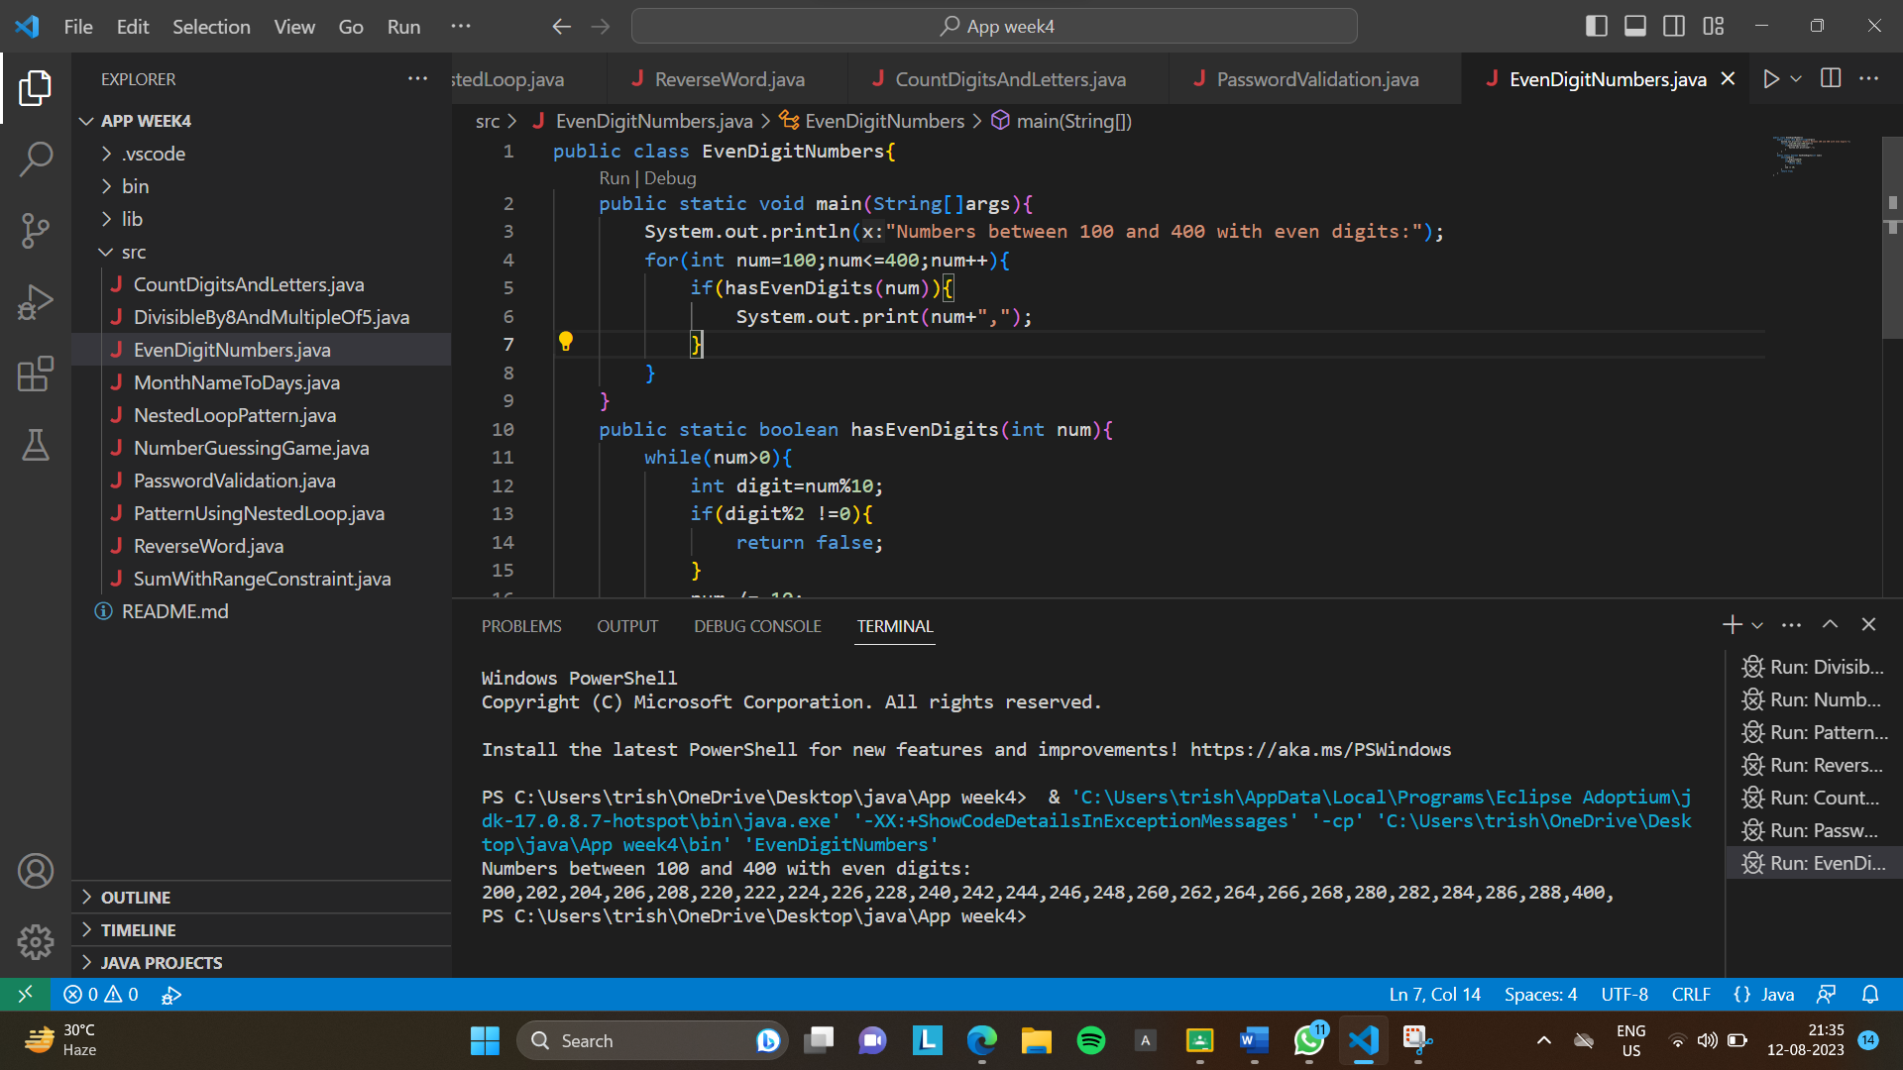

**8. Write a JAVA program to convert month name to a number of days.**

import java.util.Scanner;

public class MonthNameToDays{

    public static void main(String[]args){

        Scanner scanner=new Scanner(System.in);

        System.out.print("Enter a month name:"); //input month name from user

        String monthName=scanner.nextLine().toLowerCase();

        int days=getDaysInMonth(monthName);

        if (days>0){

            System.out.println(monthName+" has "+days+" days.");

        }

        else{

            System.out.println("Invalid month name.");

        }

        scanner.close();

    }

    public static int getDaysInMonth(String monthName){

        switch(monthName){

            case "january":case "march":case "may":case "july":case "august":case "october":case "december":

                return 31;

            case "april":case "june":case "september":case "november":

                return 30;

            case "february":

                return 28; //Assuming non-leap year

            default:

                return -1;

        }

    }

}

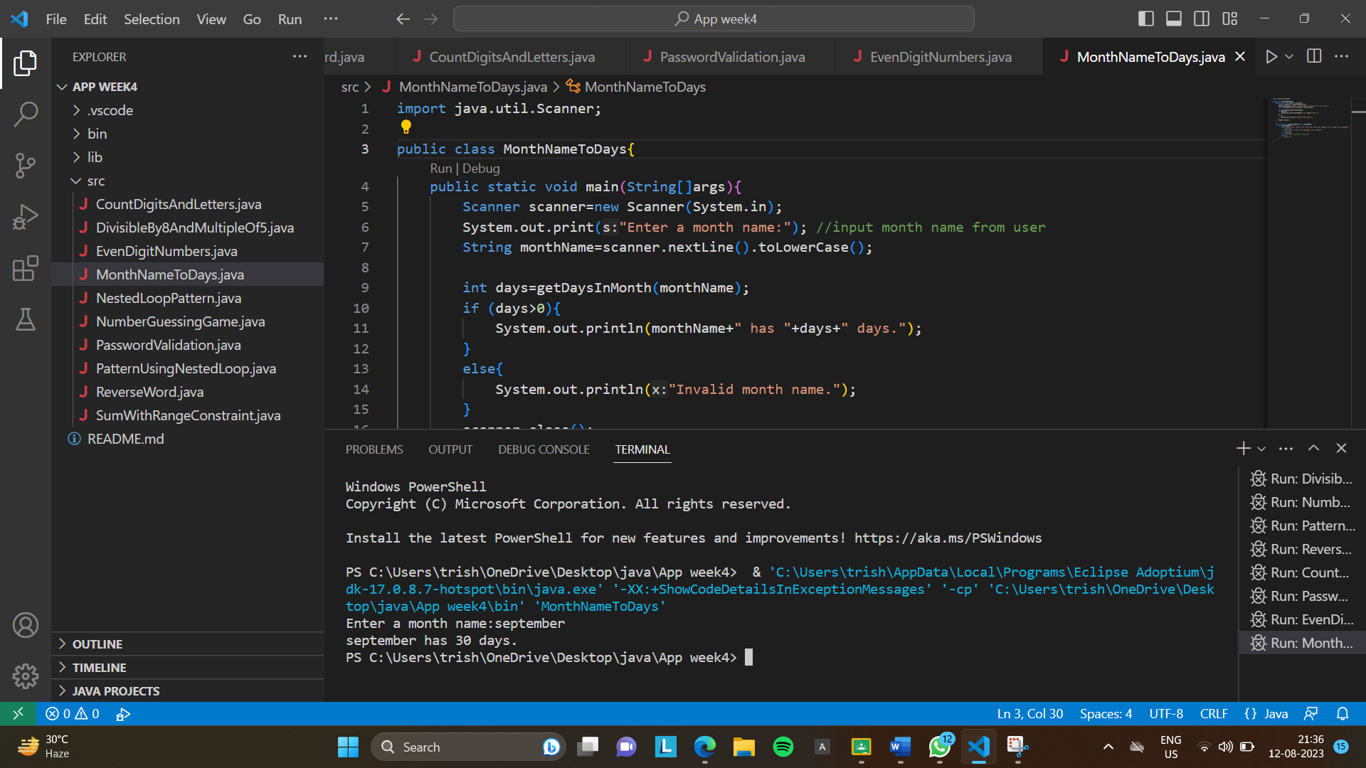

**9. Write a JAVA program to sum of two given integers. However, if the sum is between 105 to 200 it will return 200.**

import java.util.Scanner;

public class SumWithRangeConstraint{

    public static void main(String[]args){

        Scanner scanner=new Scanner(System.in);

        System.out.print("Enter the first integer:"); //input 1st integer value from user

        int num1=scanner.nextInt();

        System.out.print("Enter the second integer:"); //input 2nd integer value from user

        int num2=scanner.nextInt();

        int sum=num1+num2; //store sum of num1 and num2

        if (sum>=105 && sum<=200) //check if the sum is between 105 and 200

        {

            sum=200;

        }

        System.out.println("Sum:"+sum);

        scanner.close();

    }

}

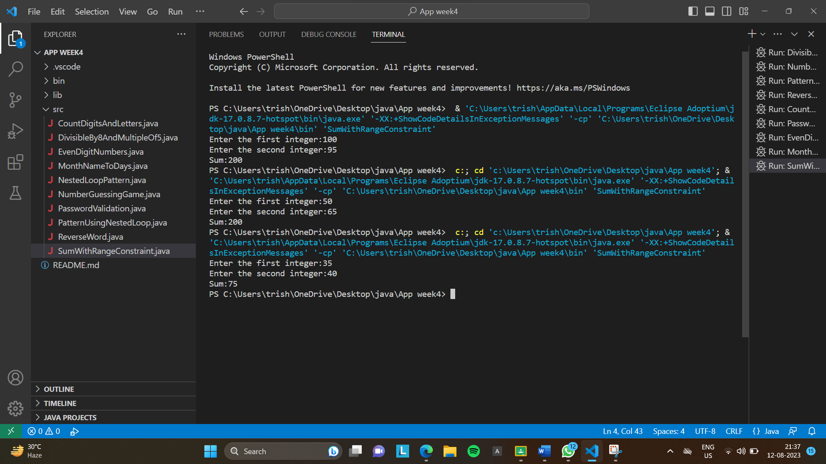

**10. Write a JAVA program to construct the following pattern, using a nested loop number.**

**Expected Output:**

**999999999**

**88888888**

**7777777**

**666666**

**55555**

**4444**

**333**

**22**

**1**

public class NestedLoopPattern{

    public static void main(String[]args){

        //Loop from 9 to 1

        for(int i=9;i>=1;i--){

            //Loop from i to 1

            for(int j=i;j>=1;j--){

                System.out.print(i); //Print i

            }

            System.out.println(); //Move to the next line

        }

    }

}

