***21CSC203P ADVANCED PROGRAMMING PRACTICE***

***Week 5 – Tutorial Assignment***

1. Write a Java program (using function) to print the mirror image of the given string.

import java.util.Scanner;

public class mirrorImage{

    //Function to generate the mirror image of a string

    static String generateMirrorImage(String str){

      int length=str.length(); //find length of string

      StringBuilder mirrorImage=new StringBuilder();

      for(int i=length-1;i>=0;i--){

        mirrorImage.append(str.charAt(i));

      }

      return mirrorImage.toString();

    }

    public static void main(String[] args){

      System.out.println("Trishita Yadav \nRA2211003011325");

      Scanner sc=new Scanner(System.in);

      System.out.print("Enter a string:"); //input string

      String input=sc.nextLine();

      String mirrorImage=generateMirrorImage(input);

      System.out.println("Mirror Image:"+mirrorImage); //display mirror image of string

      sc.close();

    }

}

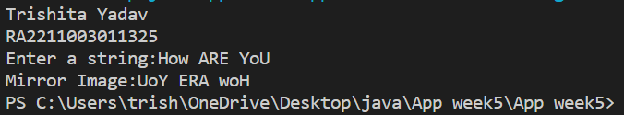

2. Write a Java program (using function) to check if two strings are rotationally equivalent.

Sample Output

string 1 is : srmist

string 2 is : tsrmis

import java.util.Scanner;

public class RotationalEquivalence{

    // Function to check if two strings are rotationally equivalent

    static boolean areRotationallyEquivalent(String str1,String str2){

        if(str1.length()!=str2.length()){

            return false;

        }

        String concatenated=str1+str1;

        //to find if string 2 is part of concatenated string

        return concatenated.contains(str2);

    }

    public static void main(String[] args){

        System.out.println("Trishita Yadav \nRA2211003011325");

        Scanner sc=new Scanner(System.in);

        System.out.print("Enter string 1:"); //input string 1

        String string1=sc.nextLine();

        System.out.print("Enter string 2:"); //input string 2

        String string2=sc.nextLine();

        boolean rotationalEquivalent=areRotationallyEquivalent(string1,string2);

        if(rotationalEquivalent) //if rotationally equivalent

        {

            System.out.println("The two strings are rotationally equivalent.");

        }

        else //if not rotationally equivalent

        {

            System.out.println("The two strings are not rotationally equivalent.");

        }

        sc.close();

    }

}

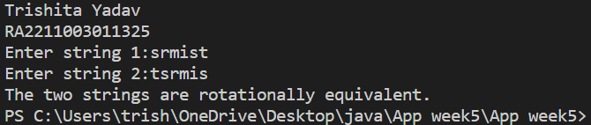

3. Write a Java program (using function) to print the even numbers from a given list.

import java.util.ArrayList;

import java.util.List;

import java.util.Scanner;

public class EvenNumbers{

    public static void main(String[] args){

        System.out.println("Trishita Yadav \nRA2211003011325");

        Scanner scanner=new Scanner(System.in);

        System.out.print("Enter the number of elements in the list:"); //input no. of elements in list

        int n=scanner.nextInt();

        List<Integer> numbers=new ArrayList<>(); //a list is declared

        for(int i=0;i<n;i++) //loop to get values of list elements

        {

            System.out.print("Enter element "+(i+1)+":");

            int num=scanner.nextInt();

            numbers.add(num);

        }

        System.out.println("Original list of numbers:" + numbers); //original list is displayed

        System.out.println("Even numbers in the list:"); //only even no. from the list are displayed

        printEvenNumbers(numbers);

        scanner.close();

    }

    //function to find even numbers in a list

    public static void printEvenNumbers(List<Integer> numbers){

        for(int num:numbers){

            if(num%2==0){

                System.out.println(num);

            }

        }

    }

}

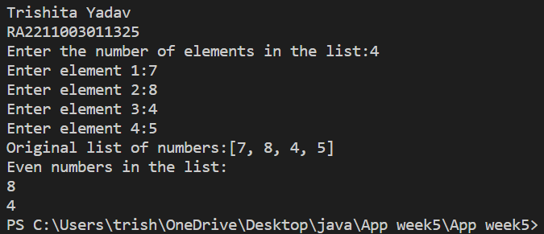

4. Write a Java function (using function) that checks whether a passed string is palindrome or not. (Note : function type - No arguments with return values)

import java.util.Scanner;

public class CheckPalindrome{

    public static void main(String[] args){

        System.out.println("Trishita Yadav \nRA2211003011325");

        Scanner scanner=new Scanner(System.in);

        System.out.print("Enter a string:"); //String is inputed from user

        String input=scanner.nextLine();

        //boolean function to check if string is palindrome or not

        boolean isPalindrome=checkPalindrome(input);

        if(isPalindrome==true) //if string is palindrome

        {

            System.out.println("String is Palindrome");

        }

        else //if string is not palindrome

        {

            System.out.println("String is not Palindrome");

        }

        scanner.close();

    }

    //function to check if given string is palindrome or not

    public static boolean checkPalindrome(String str)

    {

        int left=0;

        int right=str.length()-1;

        while(left<right){

            if(str.charAt(left)!=str.charAt(right))

            {

                return false;

            }

            left++;

            right--;

        }

        return true;

    }

}

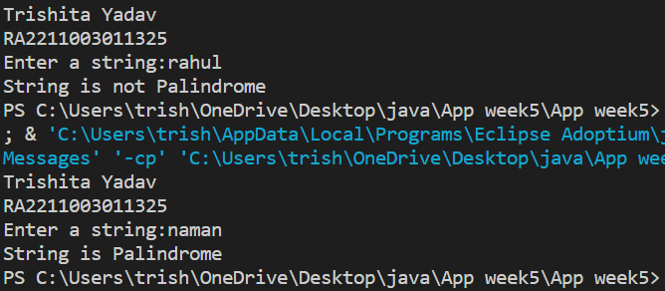

5. Write a Java function (using function) that checks whether a given number is prime or not

(Note : function type - with arguments with return values)

import java.util.Scanner;

public class CheckPrime{

    public static void main(String[] args){

        Scanner sc=new Scanner(System.in);

        System.out.print("Enter a number:"); //input number from user

        int number=sc.nextInt();

        boolean isPrime=checkPrime(number);

        if(isPrime==true) //prints if condition is true

        {

            System.out.println("Number is prime.");

        }

        else //prints if condition is not true

        {

            System.out.println("Number is not prime.");

        }

        sc.close();

    }

    //function to check if number is prime or not

    public static boolean checkPrime(int num)

    {

        if(num<=1){

            return false;

        }

        for (int i=2;i*i<=num;i++){

            if(num%i==0){

                return false;

            }

        }

        return true;

    }

}

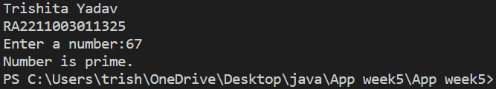

6. Write a Java program to find the digits which are absent in a given mobile number.

import java.util.Scanner;

public class MissingDigits{

    //A function that takes a mobile number as a string and returns a string of the missing digits

    public static String findMissingDigits(String mobile){

        //A boolean array to mark the presence of digits 0-9

        boolean[] present = new boolean[10];

        //Loop through each character of the mobile number and mark the corresponding digit as present

        for (int i=0;i<mobile.length();i++){

            //Get the numeric value of the character

            int digit=Character.getNumericValue(mobile.charAt(i));

            //Mark the digit as present

            present[digit]=true;

        }

        //A string builder to store the missing digits

        StringBuilder missing=new StringBuilder();

        //Loop through the boolean array and append the missing digits to the string builder

        for(int i=0;i<10;i++){

            if(!present[i]){

                missing.append(i+" ");

            }

        }

        //Return the string of missing digits

        return missing.toString();

    }

    public static void main(String[] args){

        System.out.println("Trishita Yadav \nRA2211003011325");

        //Create a scanner object to read user input

        Scanner sc=new Scanner(System.in);

        //Prompt the user to enter a mobile number

        System.out.print("Enter a mobile number:");

        //Read the mobile number as a string

        String mobile=sc.next();

        //Call the function to find the missing digits and print the result

        System.out.println("The missing digits are:"+findMissingDigits(mobile));

        sc.close();

    }

}

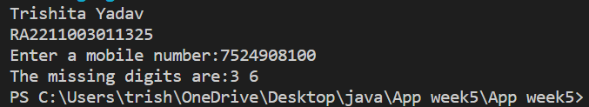

7. Write a Java program using function that will return true if the two given integer values are equal or their sum or difference is 5.

public class CheckIntegerConditions{

    public static void main(String[]args){

        System.out.println("Trishita Yadav \nRA2211003011325");

        Scanner scanner=new Scanner(System.in);

        System.out.print("Enter the first integer:"); //value of first integer is inputed

        int num1=scanner.nextInt();

        System.out.print("Enter the second integer:"); //value of second integer is inputed

        int num2=scanner.nextInt();

        boolean result=checkConditions(num1,num2);

        System.out.println("Result:"+result);

        scanner.close();

    }

    //function to check whether integers are equal,or their sum or difference is 5

    public static boolean checkConditions(int a,int b){

        return a==b||Math.abs(a-b)==5||(a + b)==5;

    }

}

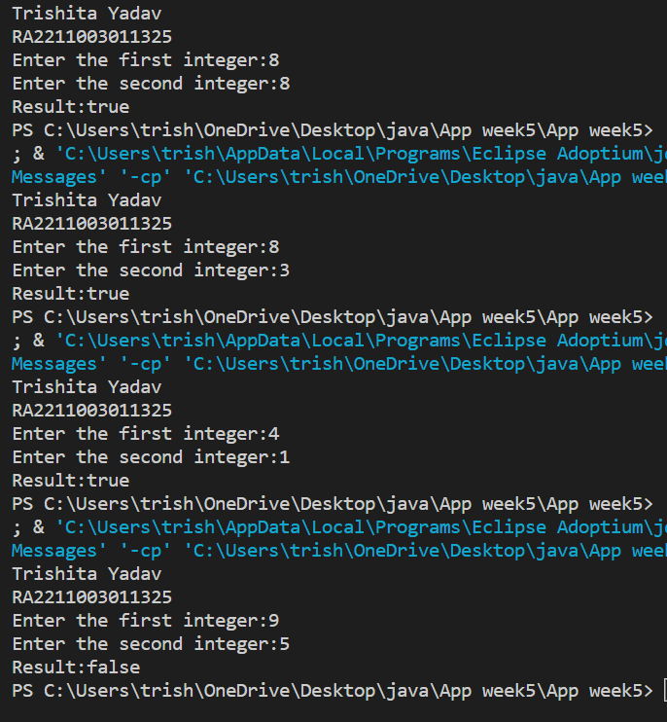

8. Write a Java program using function to count the number of each character of a given

text/string.

import java.util.HashMap;

import java.util.Map;

import java.util.Scanner;

public class CountCharacter{

    public static void main(String[]args){

        System.out.println("Trishita Yadav \nRA2211003011325");

        Scanner sc=new Scanner(System.in);

        System.out.print("Enter a string:"); //string is inputed

        String input=sc.nextLine();

        Map<Character,Integer> characterCountMap=countCharacterOccurrences(input);

        System.out.println("Character occurrences in the string:");

        for(Map.Entry<Character,Integer> entry:characterCountMap.entrySet()){

            System.out.println("'"+entry.getKey()+"': "+entry.getValue());

        }

        sc.close();

    }

    //function to count the number of each character of a given text/string

    public static Map<Character,Integer> countCharacterOccurrences(String str){

        Map<Character, Integer> characterCountMap=new HashMap<>();

        for(char ch:str.toCharArray()){

            characterCountMap.put(ch,characterCountMap.getOrDefault(ch, 0) + 1);

        }

        return characterCountMap;

    }

}

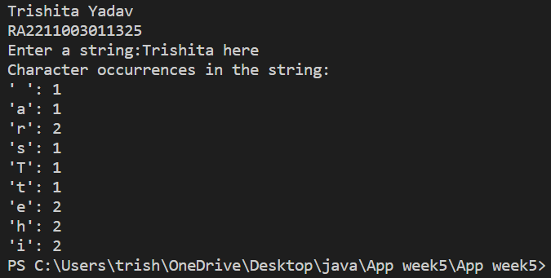

9. Write a Java program using function to print all Possible Combinations from the three

Digits.

public class Combinations{

    public static void main(String[]args){

        System.out.println("Trishita Yadav \nRA2211003011325");

        generateCombinations();

    }

    //function to generate combination of three numbers

    public static void generateCombinations(){

        for(int i=0;i<=9;i++){

            for(int j=0;j<=9;j++){

                for(int k=0;k<=9;k++){

                    System.out.println(i+""+j+""+k); //to print combination

                }

            }

        }

    }

}

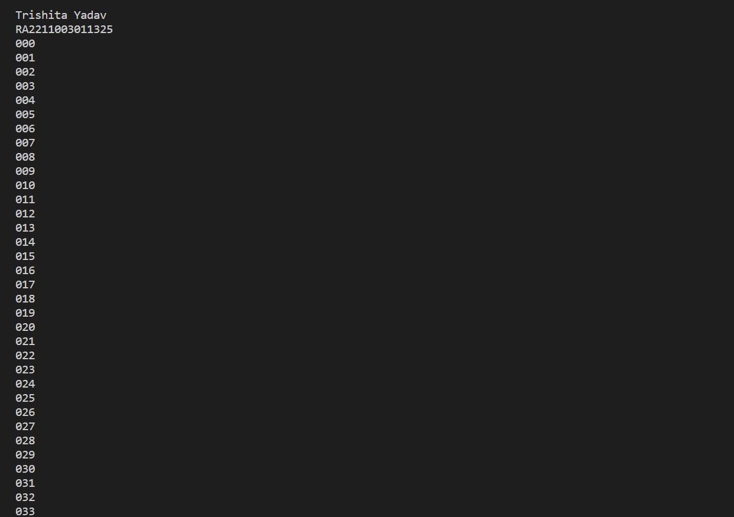

10. Write a Java program using function to count unique values in an array of 15 elements.

import java.util.HashSet;

import java.util.Scanner;

import java.util.Set;

//function to count unique values

public class UniqueValueCount{

    static int countUniqueValues(int[]array){

        Set<Integer> uniqueValues=new HashSet<>();

        for(int num:array){

            uniqueValues.add(num);

        }

        return uniqueValues.size();

    }

    public static void main(String[]args){

        System.out.println("Trishita Yadav \nRA2211003011325");

        Scanner sc=new Scanner(System.in);

        int[] array=new int[15];

        System.out.print("Enter 15 elements:");

        for(int i= 0;i<15;i++) //loop to input 15 elements

        {

            array[i]=sc.nextInt();

        }

        int uniqueCount=countUniqueValues(array);

        System.out.println("Number of unique values:"+uniqueCount);

        sc.close();

    }

}

