Федеральное государственное автономное образовательное
учреждение высшего образования
Университет ИТМО

Дисциплина: Администрирование систем и сетей Лабораторная работа 6
Вариант ???
Работу выполнили студенты:
Трикашный М.Д. P3406
Кравцев В.В. P3414
Желаемая оценка: 3
Преподаватель:
Афанасьев Дмитрий Борисович
2026 г.
Санкт-Петербург

Создание WLAN

Топология
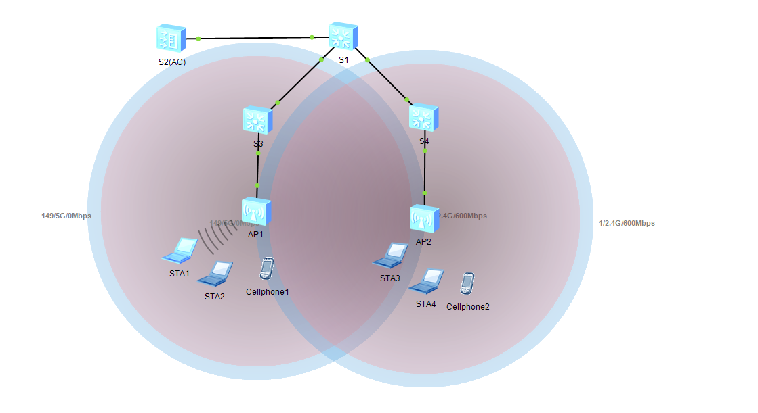

Конфигурирование

Настройка параметров проводной сети
Настройка VLAN:
[S1]vlan batch 100 101
Info: This operation may take a few seconds. Please wait for a moment...done.
[S1]interface g0/0/13
[S1-GigabitEthernet0/0/13]port link-type trunk
[S1-GigabitEthernet0/0/13]port trunk allow-pass vlan 100 101
[S1-GigabitEthernet0/0/13]quit
[S1]interface g0/0/14
[S1-GigabitEthernet0/0/14]port link-type trunk
[S1-GigabitEthernet0/0/14]port trunk allow-pass vlan 100 101
[S1-GigabitEthernet0/0/14]quit
[S1]interface g0/0/10
[S1-GigabitEthernet0/0/10]port link-type trunk
[S1-GigabitEthernet0/0/10]port trunk allow-pass vlan 100 101
[S1-GigabitEthernet0/0/10]quit
[AC]vlan batch 100 101
Info: This operation may take a few seconds. Please wait for a moment...done.
[AC]interface g0/0/10
[AC-GigabitEthernet0/0/10]port link-type trunk
[AC-GigabitEthernet0/0/10]port trunk allow-pass vlan 100 101
[AC-GigabitEthernet0/0/10]quit
[S3]vlan batch 100 101
Info: This operation may take a few seconds. Please wait for a moment...done.
[S3]interface g0/0/1
[S3-GigabitEthernet0/0/1]port link-type trunk
[S3-GigabitEthernet0/0/1]port trunk allow-pass vlan 100 101
[S3-GigabitEthernet0/0/1]quit
[S3]interface g0/0/4
[S3-GigabitEthernet0/0/4]port link-type trunk
[S3-GigabitEthernet0/0/4]port trunk pvid vlan 100
[S3-GigabitEthernet0/0/4]port trunk allow-pass vlan 100 101
[S3-GigabitEthernet0/0/4]quit
[S4]vlan batch 100 101
Info: This operation may take a few seconds. Please wait for a moment...done.
[S4]interface g0/0/1
[S4-GigabitEthernet0/0/1]port link-type trunk
[S4-GigabitEthernet0/0/1]port trunk allow-pass vlan 100 to 101
[S4-GigabitEthernet0/0/1]quit
[S4]interface g0/0/4
[S4-GigabitEthernet0/0/4]port link-type trunk
[S4-GigabitEthernet0/0/4]port trunk pvid vlan 100
[S4-GigabitEthernet0/0/4]port trunk allow-pass vlan 100 to 101
[S4-GigabitEthernet0/0/4]quit
Настройка IP-адресов интерфейсов:
[S1]interface Vlanif 101
[S1-Vlanif101]ip addr 192.168.100.0 24
[S1-Vlanif101]quit
[S1]interface LoopBack 0
[S1-LoopBack0] ip address 10.0.1.1 32
[S1-LoopBack0]quit
[AC]interface Vlanif 100
[AC-Vlanif100]ip addr 192.168.100.254 24
Настройка DHCP:
[S1]dhcp enable
Info: The operation may take a few seconds. Please wait for a moment.done.
[S1]ip pool sta
Info:It's successful to create an IP address pool.
[S1-ip-pool-sta]network 192.168.101.0 mask 24
[S1-ip-pool-sta]gateway-list 192.168.101.254
[S1-ip-pool-sta]quit
[S1]interface Vlanif 101
[S1-Vlanif101]dhcp select global
[S1-Vlanif101]quit
[AC]dhcp enable
Info: The operation may take a few seconds. Please wait for a moment.done.
[AC]ip pool ap
Info: It is successful to create an IP address pool.
[AC-ip-pool-ap]network 192.168.100.254 mask 24
[AC-ip-pool-ap]gateway-list 192.168.100.254
[AC-ip-pool-ap]quit
[AC]interface Vlanif 100
[AC-Vlanif100]dhcp select global
[AC-Vlanif100]quit

Настройка параметров точек доступа для выхода в сеть
Создание группы AP ap-group1:
[AC]wlan
[AC-wlan-view]ap-group name ap-group1
Info: This operation may take a few seconds. Please wait for a moment.done.
[AC-wlan-ap-group-ap-group1]quit
Создание профиля регулирующего домена и настройка кода страны AC в профиле:
[AC]wlan
[AC-wlan-view]regulatory-domain-profile name default
[AC-wlan-regulate-domain-default]country-code on
Error: The country code is invalid.
Установка привязки профиля регулирующего домена к группе AP:
[AC]wlan
[AC-wlan-view]ap-group name ap-group1
[AC-wlan-ap-group-ap-group1]regulatory-domain-profile default
Warning: Modifying the country code will clear channel, power and antenna gain configurations of the radio and reset the AP. Continue?[Y/N]:Y
[AC-wlan-ap-group-ap-group1]quit
Указание интерфейса-источника на AC для установления туннелей CAPWAP:
[AC]capwap source interface Vlanif 100
Импорт точки доступа в AC и добавление их в группу AP с именем ap-group1:
[AC]wlan
[AC-wlan-view]ap auth-mode mac-auth
[AC-wlan-view]ap-id 0 ap-mac 00e0-fc08-2340
[AC-wlan-ap-0]ap-name ap1
[AC-wlan-ap-0]ap-group ap-group1
Warning: This operation may cause AP reset. If the country code changes, it will
clear channel, power and antenna gain configurations of the radio, Whether to continue? [Y/N]:Y

[AC-wlan-ap-0]quit
[AC-wlan-view]ap-id 1 ap-mac 00e0-fceb-6ab0
[AC-wlan-ap-1]ap-name ap2
[AC-wlan-ap-1]ap-group ap-group1
Warning: This operation may cause AP reset. If the country code changes, it will
clear channel, power and antenna gain configurations of the radio, Whether to continue? [Y/N]:Y

[AC-wlan-ap-1]quit
Вывод на экран информации о текущей AP:
[AC]wlan
[AC]dis ap all
Info: This operation may take a few seconds. Please wait for a moment.done.
Total AP information:
nor : normal [2]
--------------------------------------------------------------------------------
-------------
ID MAC Name Group IP Type State STA Upti
me
--------------------------------------------------------------------------------
-------------
0 00e0-fc08-2340 ap1 ap-group1 192.168.100.27 AP2050DN nor 0 4S
1 00e0-fceb-6ab0 ap2 ap-group1 192.168.100.71 AP2050DN nor 0 2S
--------------------------------------------------------------------------------
-------------
Total: 2

Настройка параметров сервисов WLAN
Создание профиля безопасности HCIA-WLAN и настройка политики безопасности:
[AC-wlan-view]security-profile name HCIA-WLAN
[AC-wlan-sec-prof-HCIA-WLAN]security wpa-wpa2 psk pass-phrase HCIA-Datacom aes
[AC-wlan-sec-prof-HCIA-WLAN]quit
Создание профиля SSID HCIA-WLAN и задание имени SSID HCIA-WLAN:
[AC-wlan-view]ssid profile name HCIA-WLAN
[AC-wlan-ssid-prof-HCIA-WLAN]ssid HCIA-WLAN Info: This operation may take a few seconds, please wait.done.
[AC-wlan-ssid-prof-HCIA-WLAN]quit
Создание профиля VAP HCIA-WLAN, настройка режима передачи данных и сервисного VLAN и применение профиля безопасности и профиля SSID к профилю VAP:
[AC-wlan-view]vap-profile name HCIA-WLAN
[AC-wlan-vap-prof-HCIA-WLAN]forward-mode direct-forward
[AC-wlan-vap-prof-HCIA-WLAN]service-vlan vlan-id 101
Info: This operation may take a few seconds, please wait.done. [AC-wlan-vap-prof-HCIA-WLAN]security-profile HCIA-WLAN
Info: This operation may take a few seconds, please wait.done. [AC-wlan-vap-prof-HCIA-WLAN]ssid-profile HCIA-WLAN
Info: This operation may take a few seconds, please wait.done.
[AC-wlan-vap-prof-HCIA-WLAN]quit
Установление привязки профиля VAP к группе AP и применение конфигурации профиля VAP HCIA-WLAN к радиомодулю 0 и радиомодулю 1 точек доступа в группе AP:
[AC-wlan-view]ap-group name ap-group1
[AC-wlan-ap-group-ap-group1]vap-profile HCIA-WLAN wlan 1 radio all Info: This operation may take a few seconds, please wait...done.

Проверка
Перед проверкой нужно подключиться к WLAN!!!
Пароль: HCIA-Datacom
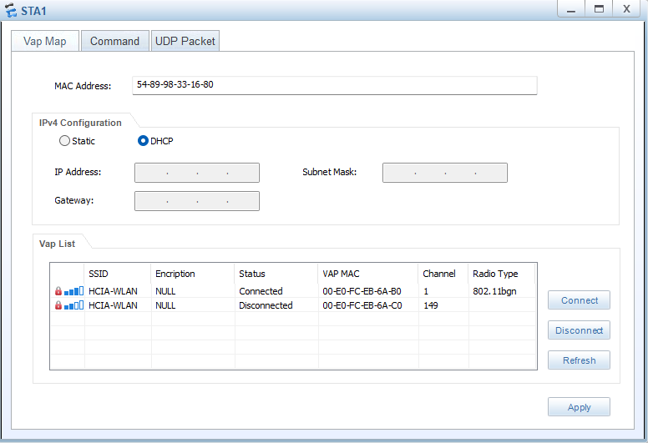
STA>ping 10.0.1.1

Ping 10.0.1.1: 32 data bytes, Press Ctrl_C to break
From 10.0.1.1: bytes=32 seq=1 ttl=255 time=375 ms
From 10.0.1.1: bytes=32 seq=2 ttl=255 time=297 ms
From 10.0.1.1: bytes=32 seq=3 ttl=255 time=297 ms
From 10.0.1.1: bytes=32 seq=4 ttl=255 time=500 ms
From 10.0.1.1: bytes=32 seq=5 ttl=255 time=313 ms

--- 10.0.1.1 ping statistics ---
5 packet(s) transmitted
5 packet(s) received
0.00% packet loss
round-trip min/avg/max = 297/356/500 ms
[AC]dis station all
Rf/WLAN: Radio ID/WLAN ID
Rx/Tx: link receive rate/link transmit rate(Mbps)
--------------------------------------------------------------------------------
----------------------
STA MAC AP ID Ap name Rf/WLAN Band Type Rx/Tx RSSI VLAN IP a
ddress SSID
--------------------------------------------------------------------------------
----------------------
5489-9833-1680 1 ap2 0/1 2.4G - -/- - 101 192.
168.101.253 HCIA-WLAN
--------------------------------------------------------------------------------
----------------------
Total: 1 2.4G: 1 5G: 0

Вывод
В ходе выполнения данной лабораторной работы мы сконфигурировали WLAN с помощью контроллера доступа (AC) и точек доступа AP, чтобы обеспечить доступ STA к WLAN.

