**Problem Description:** According to the description of the thesis I have received, the problem can be defined as follows:

Machine environments: Hybrid Flexible Flow Shop

The processing restrictions and constraints:

* Unrelated machines
* Sequence-dependent setup times
* Intermediate storage availability
* Two stages with skipping
* Machine eligibility restrictions
* Due date
* Blocked pair of jobs

The objective function is to **minimize total tardiness**, as the due dates exist.

**The problem in thesis:** After the implementation of the model in the thesis, some points should be considered as well as their solutions.

The objective function is not linear. To make it linear, I introduced two variables: $t_{i} and t_{i}^{aux}$. The objective function is reformulated into:

$\operatorname{Min}{T=\sum_{i∈I}{t_{i}}}$ with $t_{i}=max⁡(t_{i}^{aux}, 0)$ and $t_{i}^{aux}=C_{i}-d_{i}$.

Constraints (6) and (7) are reformulated as linear. Constraints (7) extend for HFSP-UPM-SDST.

BigM = (number of jobs)*(number of stages)*(max processing time at a machine + max setup-time)

$$s_{ij}^{l}≥f_{ij^{'}}^{l^{'}}-BigM \left(1-x_{ij}^{l}\right), i∈I, l∈L_{i},l'∈L_{i^{'}}, j∈M_{i}^{l}, j^{'}∈M_{i}^{l^{'}}, l^{'}<l$$

$$s_{ij}^{l}≥f_{i^{'}j}^{l}+sdst_{lj}^{i^{'}i}-BigM\left(2-y_{i^{'}jr}^{l}-y_{ij\left(r+1\right)}^{l}\right), i,i^{'}∈I, i≠i^{'}, r=1,..,N-1, l∈L_{i}, j∈M_{i^{'}}^{l}∩M_{i}^{l}$$

Constraints (9) is incorrect and be reformulated into: $C_{i}=\max\left(f_{lj}^{i}\right), i∈I$

Additional constraints (15) ensure jobs must be assigned to the machine positions in sequential order:

$$\sum_{i∈I}{y_{ijr}^{l}}≥\sum_{i∈I}{y_{ij\left(r+1\right)}^{l}}, l∈L_{i}, , j∈M_{i}^{l}, r=1,…,N-1$$

$$\operatorname{Min}{T=\sum_{i∈I}{t_{i}}}$$

(1.1) $t_{i}=\max\left(t_{i}^{aux}, 0\right), i∈I$

(1.2) $t_{i}^{aux}=C_{i}-d_{i}, i∈I$

(2) $\sum_{j=1}^{M_{i}^{l}}{x_{ij}^{l}}=1, i∈I, l∈L_{i}$

(3) $\sum_{r=1}^{N}{y_{ijr}^{l}}=x_{ij}^{l}, i∈I, l∈L_{i}, , j∈M_{i}^{l}$

(4) $\sum_{i=1}^{N}{y_{ijr}^{l}}≤1, r=1,…N, l∈L_{i}, , j∈M_{i}^{l}$

(5) $y_{ijr}^{l}+y_{i'j\left(r+1\right)}^{l}≤1, i,i^{'}∈I, i≠i^{'}, l∈L_{i}∩L_{i^{'}}, j∈M_{i^{'}}^{l}∩M_{i}^{l}, r=1,..,N-1,\left(i,i^{'}\right)∈B$

(6) $s_{ij}^{l}≥f_{ij^{'}}^{l^{'}}-BigM \left(1-x_{ij}^{l}\right), i∈I, l∈L_{i},l'∈L_{i^{'}}, j∈M_{i}^{l}, j^{'}∈M_{i}^{l^{'}}, l^{'}<l$

(7) $s_{ij}^{l}≥f_{i^{'}j}^{l}+sdst_{lj}^{i^{'}i}-BigM\left(2-y_{i^{'}jr}^{l}-y_{ij\left(r+1\right)}^{l}\right), i,i^{'}∈I, i≠i^{'}, r=1,..,N-1, l∈L, j∈M_{i^{'}}^{l}∩M_{i}^{l}$

(8) $f_{ij}^{l}=s_{ij}^{l}+p_{ij}^{l}x_{ij}^{l}, i∈I, l∈L_{i}, , j∈M_{i}^{l}$

(9) $C_{i}=\max\left(f_{lj}^{i}\right), i∈I$

(10) $x_{ij}^{l}∈\left\{0, 1\right\}, i∈I, l∈L_{i}, , j∈M_{i}^{l}$

(11) $y_{ijr}^{l}∈\left\{0, 1\right\}, i∈I, l∈L_{i}, , j∈M_{i}^{l}, r=1,…,N$

(12) $s_{ij}^{l}≥0, i∈I, l∈L_{i}, , j∈M_{i}^{l}$

(13) $f_{ij}^{l}≥0, i∈I, l∈L_{i}, , j∈M_{i}^{l}$

(14) $C_{i}≥0, i∈I$

(15) $\sum_{i∈I}{y_{ijr}^{l}}≥\sum_{i∈I}{y_{ij\left(r+1\right)}^{l}}, l∈L_{i}, , j∈M_{i}^{l}, r=1,…,N-1$

* Ensuring the relation between the two decision variables for machine selection and operation sequencing. (3)
* Ensuring each job at each stage is assigned exactly to one machine. (2)
* Preventing a job from being processed on the same machine multiple times. (3)
* Preventing two jobs from being processed simultaneously on the same machine. (4)
* Preventing incompatible pair of jobs be processed successively in a machine. (5)
* Ensuring jobs must be assigned to the machine positions in sequential order. (15)
* The job’s completion time at a stage is the sum of its start time and processing time. (8)
* Ensuring each operation of a job can only begin after its preceding operation at the previous stage has been completed. (6)
* Ensuring the precedence constraints on each machine. (7)
* The job’s completion time at a stage is the sum of its start time and processing time. (8)
* Calculates the completion time of a job. (9)
* Only positive tardiness values are considered. (1.1 + 1.2)

**Questions:**

* Can the blocked pair of jobs options be integrated into sequence-dependent setup times by setting the very big values of setup times between two blocked pairs?
* Do we have skipping in model? There is a difference between the description in the thesis and the model in the thesis.
* **A group of doors with different colors

  Description automatically generated**The picture above shows instances with 7 jobs (optimal solution with 0 total tardiness). The due date of jobs 3 and 5 is 200. Therefore, the machines did not complete these jobs as soon as possible but waited until close to the due date to process them. Is there any way to fix this?
* 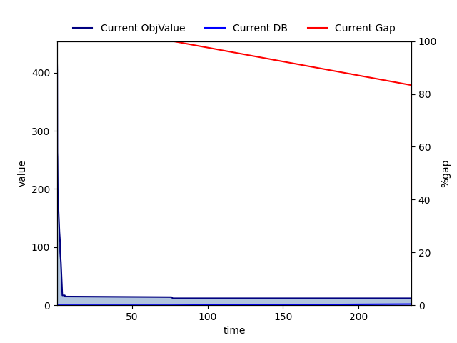Lower bound development seems very slow for the instances that I can solve on my laptop (max 15 jobs). I want to ask if it is special that the objective function is to minimize total tardiness.
* I have received a contract from the chair, is there any way I can use the computer at university remotely?