Lab 8 – ASP.NET Core with Razor Pages / MVC – Code First
School Management – Software Engineering
GitHub: https://github.com/thanhtai1066-debug/SchoolAppCoreMVC..git

1. Introduction
In this lab I built a small School Management app with the Code First approach: I wrote the C# model classes, and Entity Framework Core generated the SQL Server database from them (Add-Migration and Update-Database). I did it twice, with ASP.NET Core Razor Pages (Exercise 1) and ASP.NET Core MVC (Exercise 2), then pushed both projects to GitHub (Exercise 3). Tools: Visual Studio 2022, .NET 8, EF Core 8.0.25, SQL Server Express.

2. Explanation of the models
Both projects use the same 5 models (only the namespace differs): Department, Course, Instructor, Student and Enrollment. Student and Course are many-to-many, and Enrollment is the join table that also stores the grade.
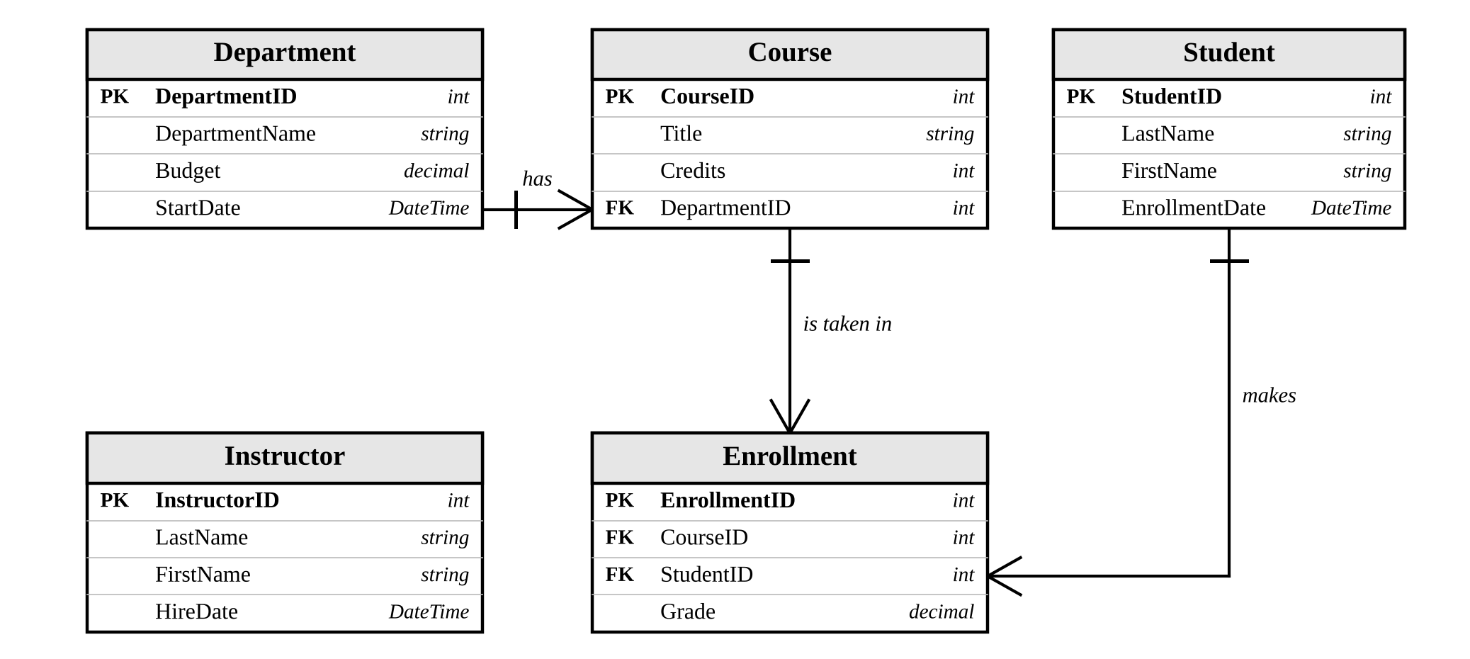
Figure 1. ER diagram of the School database
Model | Properties | Relationships
Department | DepartmentID (PK), DepartmentName (required), Budget, StartDate | 1 department has many courses (Courses)
Course | CourseID (PK), Title (required), Credits, DepartmentID (FK) | belongs to one Department; has many Enrollments
Instructor | InstructorID (PK), LastName, FirstName (required), HireDate | none
Student | StudentID (PK), LastName, FirstName (required), EnrollmentDate | has many Enrollments
Enrollment | EnrollmentID (PK), CourseID (FK), StudentID (FK), Grade | belongs to one Course and one Student

public class Course
{
public int CourseID { get; set; }
public required string Title { get; set; }
public int Credits { get; set; }
public int DepartmentID { get; set; } // foreign key
public Department? Department { get; set; } // navigation property
public ICollection<Enrollment>? Enrollments { get; set; }
}

public class SchoolContext : DbContext
{
public SchoolContext(DbContextOptions<SchoolContext> options) : base(options) { }
public DbSet<Department> Departments { get; set; }
public DbSet<Instructor> Instructors { get; set; }
public DbSet<Course> Courses { get; set; }
public DbSet<Student> Students { get; set; }
public DbSet<Enrollment> Enrollments { get; set; }
}

- Primary keys / foreign keys are found by convention (<Name>ID), so no extra configuration is needed.
- required on strings makes the SQL columns NOT NULL; navigation properties are nullable (Course?) so forms don't need to post them.
- SchoolContext maps each DbSet to a table (Departments, Instructors, Courses, Students, Enrollments).
- Budget and Grade use [Column(TypeName = "decimal(...)")] to fix the decimal precision.
- ErrorViewModel is only used by the error page (RequestId, ShowRequestId), it is not a table.

3. Exercise 1 – Razor Pages (SchoolAppCoreRazor)
Step 1 – Environment. Created the project from the ASP.NET Core Web App (Razor Pages) template, named it SchoolAppCoreRazor, and installed the NuGet packages Microsoft.EntityFrameworkCore.SqlServer and Microsoft.EntityFrameworkCore.Tools.
Step 2 – Menu. Added links for Students, Courses, Instructors, Enrollments and Departments in Pages/Shared/_Layout.cshtml:
<li class="nav-item"><a class="nav-link" asp-page="/Students/Index">Students</a></li>
<li class="nav-item"><a class="nav-link" asp-page="/Courses/Index">Courses</a></li>
<li class="nav-item"><a class="nav-link" asp-page="/Instructors/Index">Instructors</a></li>
<li class="nav-item"><a class="nav-link" asp-page="/Enrollments/Index">Enrollments</a></li>
<li class="nav-item"><a class="nav-link" asp-page="/Departments/Index">Departments</a></li>

Step 3 & 4 – Models and DbContext. Added the Models folder with the 5 entity classes, ErrorViewModel and SchoolContext (see Section 2).
Step 5 – Connection. Connection string in appsettings.json, and the context registered in Program.cs:
"SchoolDBConnectionString": "Server=(local)\\SQLEXPRESS;Database=SchoolDB;Trusted_Connection=True;TrustServerCertificate=True"

builder.Services.AddRazorPages();
builder.Services.AddDbContext<SchoolContext>(options =>
options.UseSqlServer(builder.Configuration.GetConnectionString("SchoolDBConnectionString")));

Step 6 – Migration. Built the project, then in Package Manager Console ran Add-Migration InitialCreate and Update-Database. The database SchoolDB was created with 5 tables.
Step 7 – Razor Pages. Created a folder per entity under Pages and used Add > Razor Page > Razor Pages using Entity Framework (CRUD) with the entity as model class and SchoolContext as data context (Departments, Students, Courses, Instructors, Enrollments).
Step 8 – Testing (F5). Pressed F5 and tested each page from the menu.

4. Exercise 2 – MVC (SchoolAppCoreMVC)
Step 1 – Environment. Created the project from ASP.NET Core Web App (Model-View-Controller), named SchoolAppCoreMVC, installed the same two EF Core packages.
Step 2 – Menu. In Views/Shared/_Layout.cshtml the links use asp-controller / asp-action instead of asp-page:
<li class="nav-item"><a class="nav-link" asp-area="" asp-controller="Students" asp-action="Index">Students</a></li>
<li class="nav-item"><a class="nav-link" asp-area="" asp-controller="Courses" asp-action="Index">Courses</a></li>
<li class="nav-item"><a class="nav-link" asp-area="" asp-controller="Instructors" asp-action="Index">Instructors</a></li>
<li class="nav-item"><a class="nav-link" asp-area="" asp-controller="Enrollments" asp-action="Index">Enrollments</a></li>
<li class="nav-item"><a class="nav-link" asp-area="" asp-controller="Departments" asp-action="Index">Departments</a></li>

Step 3 & 4 – Models and DbContext. Copied the models and SchoolContext from Exercise 1 and changed the namespace to SchoolAppCoreMVC.Models.
Step 5 – Connection. Same connection string (database SchoolDBMVC) and in Program.cs:
builder.Services.AddControllersWithViews();
builder.Services.AddDbContext<SchoolContext>(options =>
options.UseSqlServer(builder.Configuration.GetConnectionString("SchoolDBConnectionString")));

Step 6 – Migration. Built the project and ran Add-Migration InitialCreate then Update-Database in Package Manager Console.
Step 7 – Controllers and views. Add > Controller > MVC Controller with views, using Entity Framework for each entity (e.g. DepartmentsController). It generates the actions Index, Details, Create, Edit, Delete and the views in Views/<Entity>/. I also set ViewData["Title"] in each view and used the same ID - Name dropdown in CoursesController.Create.
Step 8 – Testing (F5). Tested every module from the menu.

5. Razor Pages vs MVC
 | Razor Pages | MVC
Structure | .cshtml page + .cshtml.cs page model (OnGet / OnPost) | Controllers + Views + Models
Per entity here | 5 pages × 2 files | 1 controller + 5 views
Good for | Simple page-based apps, quick CRUD | Larger apps, complex routing, easier unit testing
Drawback | Less control over routing | More boilerplate

For this simple CRUD app Razor Pages was faster to build because each page keeps its logic next to its markup. MVC needs one more layer, but separates concerns better when the app grows. The models, DbContext and database were exactly the same in both.

6. Exercise 3 – Upload to GitHub
Opened the project in Visual Studio, staged the files in Git Changes, committed ("Initial commit for Exercise 1/2") and pushed to GitHub. Then I created the folders Exercise1_RazorPages and Exercise2_MVC, moved each project into its folder, committed ("Organized projects into folders"), pushed, and added a README.md describing both exercises.
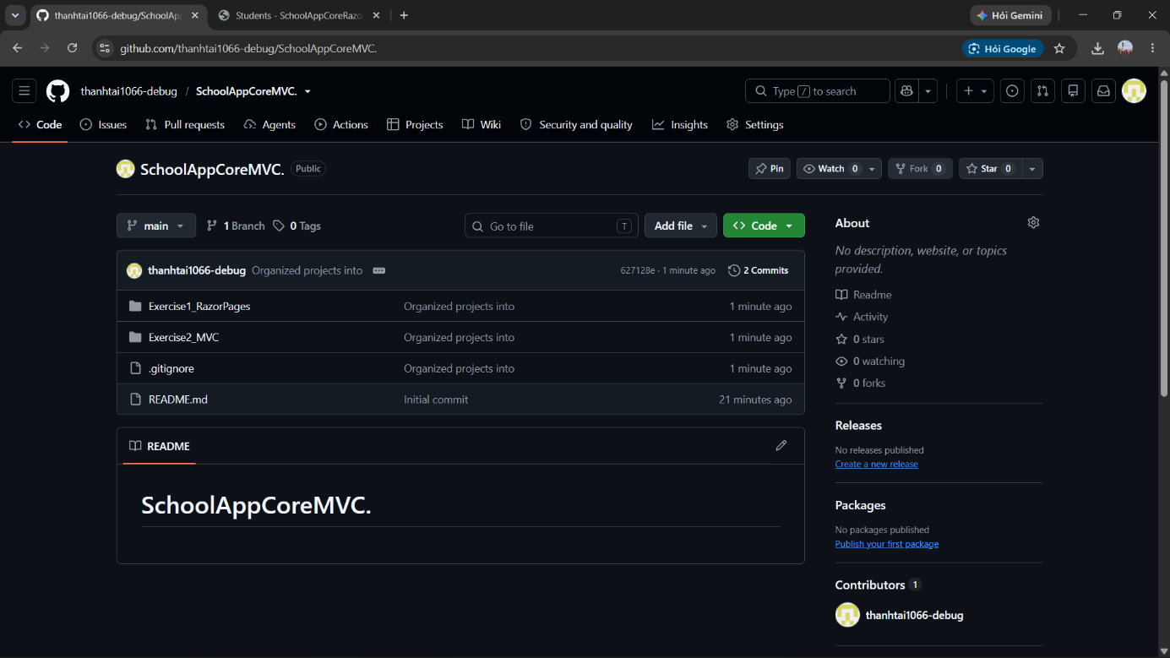
Figure 9. Repository on GitHub

7. Conclusion
I learned the Code First workflow (models → DbContext → migration → database), how to scaffold CRUD in both Razor Pages and MVC, and how to push a project to GitHub from Visual Studio. Things to watch: build the project before Add-Migration, change the namespace when copying models to the MVC project, check the connection string matches the SQL Server instance, and the default dropdown only shows the ID so it needs a custom SelectList.

