Experiment.1
FTK Imager: A Forensic Imaging Tool Overview
Acquiring Volatile Memory (RAM) Using FTK Imager
Link for installation file :- link
Steps to Capture RAM Using FTK Imager
- Run as Administrator
Open FTK Imager with administrative privileges.
Right-click the FTK Imager icon and select Run as administrator

- Initiate Memory Capture
In the top menu bar, click File → Capture Memory from the dropdown list.
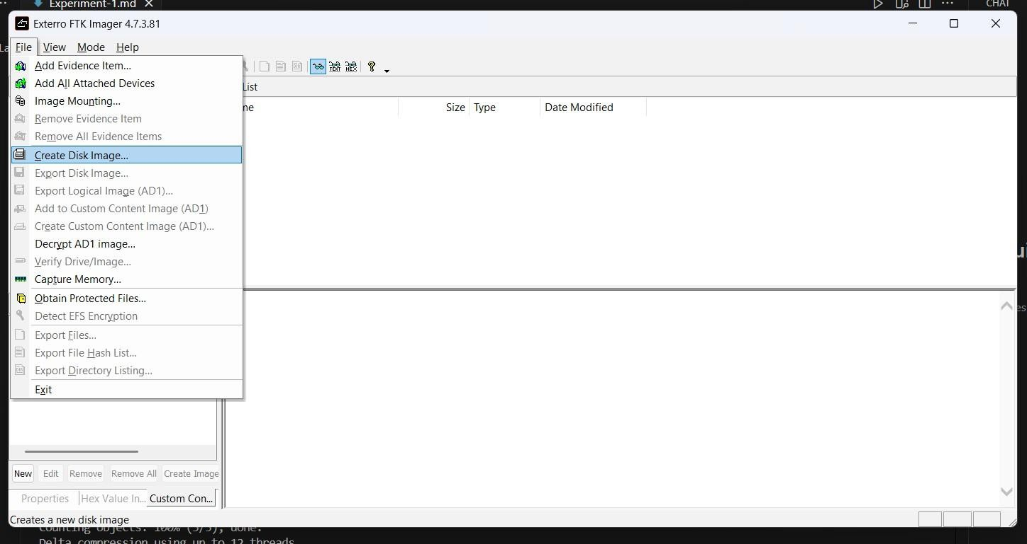

- Configure Destination
A dialog box will appear where you configure where and how the memory will be saved.
Destination Path:
Click Browse to select a folder on an external drive (not the system drive).
Destination Filename:
You can keep the default memdump.mem or assign a more descriptive name.
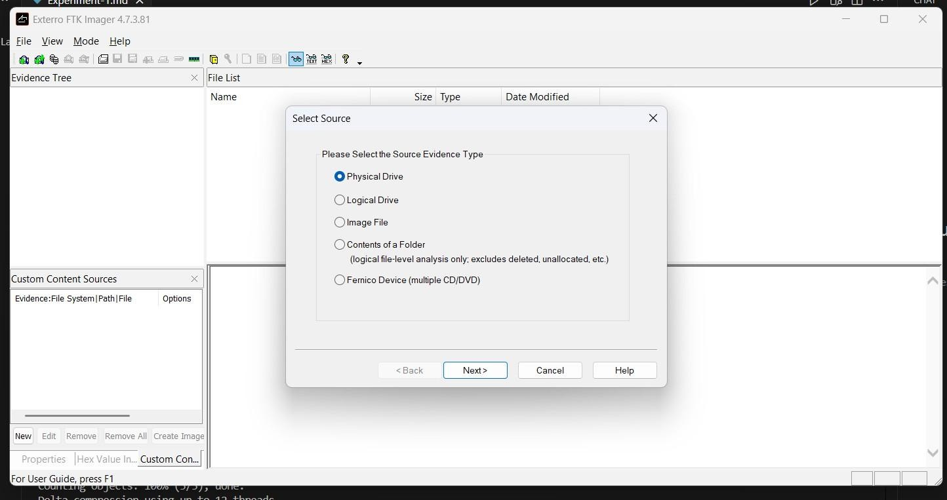

Optional: Include pagefile.sys
Check this box to capture pagefile.sys, which is virtual memory stored on the disk.
Optional: Create AD1 file
Saves the memory dump in an AccessData-specific container file.
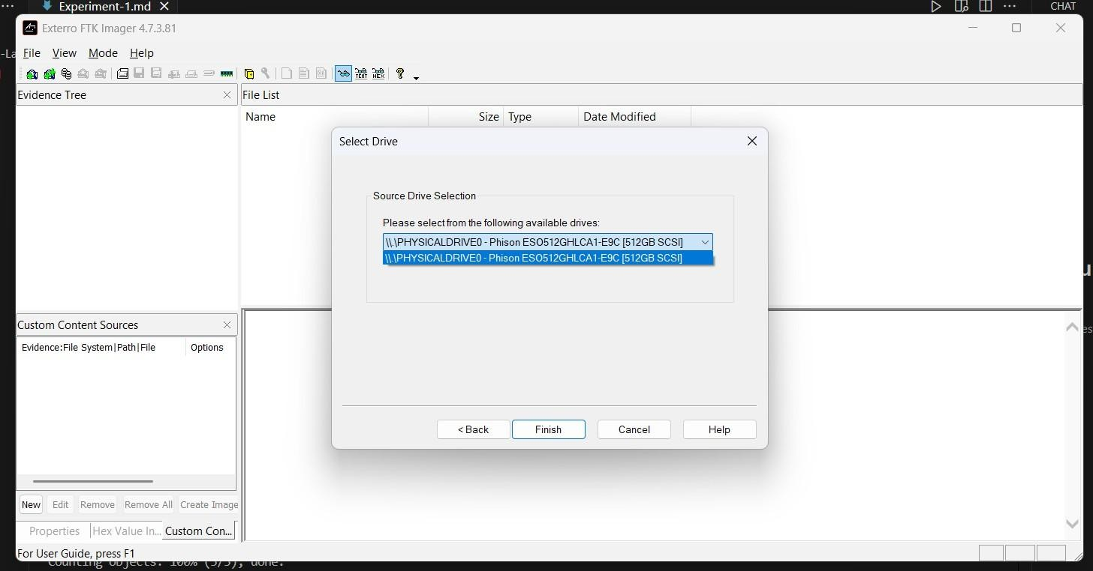

4. Start Capture
Click the Capture Memory button to begin acquisition.
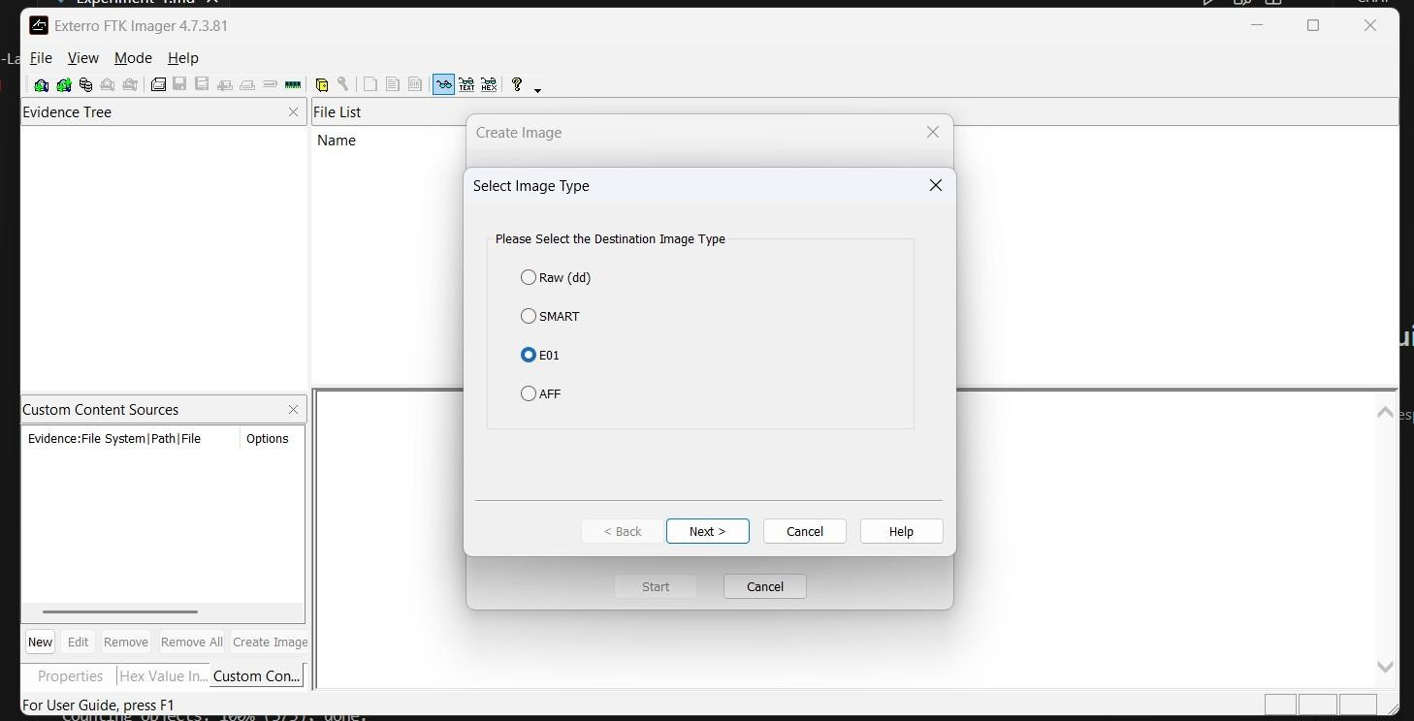

5.

Wait

for

Completion

A progress bar will indicate the capture status.
Capture time depends on the system's RAM size.
Once finished, the memory dump file will be available in the destination folder.

Acquiring Non-Volatile Memory (Disk Image) Using FTK Imager
- Start the Process
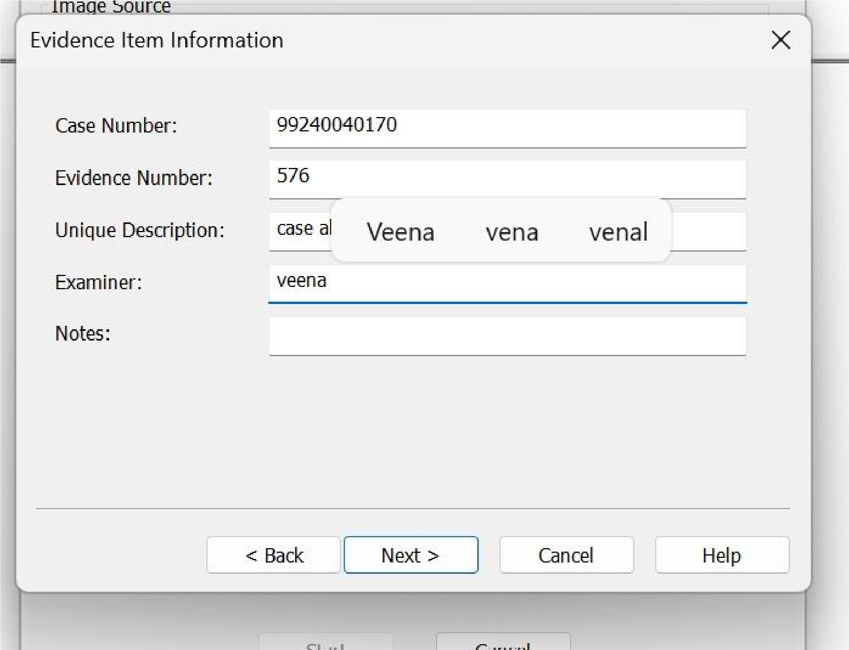
In FTK Imager, go to the top menu bar: File → Create Disk Image....
- Select Source Evidence Type
A window will appear asking you to choose the source type:
Physical Drive: Images the entire disk, including all partitions, unallocated space, and the Master Boot Record (MBR).
Logical Drive: Images a specific partition (e.g., C: drive).
Image File: Converts or copies an existing image file.
Contents of a Folder: Creates an image of a specific folder only.

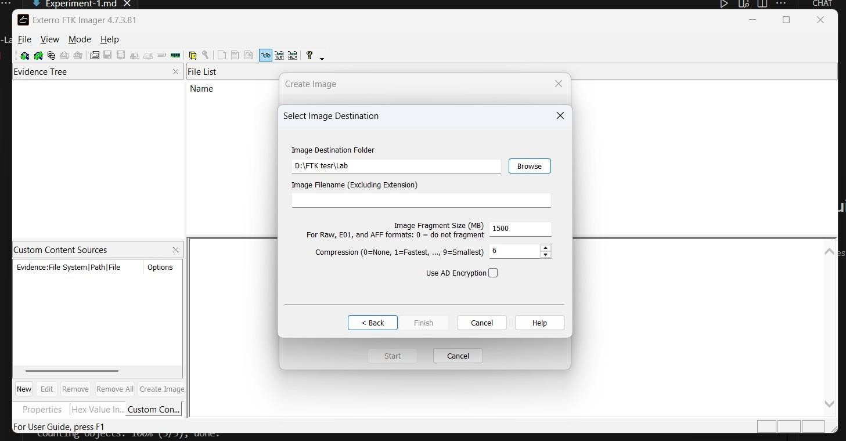

- Select the Source Drive
From the dropdown, choose the physical drive to image (connected via write-blocker).
Click Finish.
- Configure the Image Destination
Click Add... in the "Create Image" window to define the image format and destination.

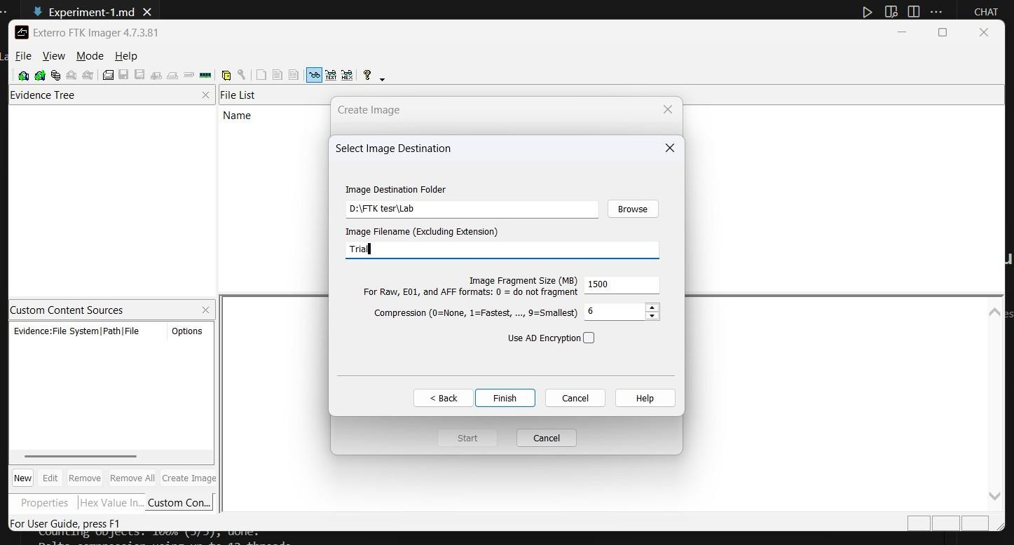

Options:
Image Type:
E01 (EnCase Format): Recommended; includes compression, metadata, and error-checking.
Raw (DD): Bit-for-bit copy with no extra features.

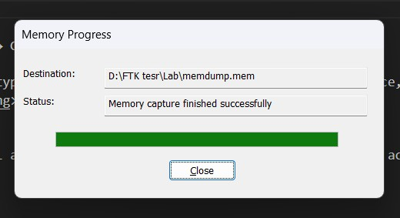

<!
--

--
>

Fill

in Evidence Item
Information:

Enter case details, examiner name, and
description.

This information is stored in the image metadata (important for
documentation).

Choose Destination
Folder:

Must be a different drive from the source.
Name the image file (e.g., Case001_SuspectHDD).
Image Fragment Size:
Set a value to split the image into multiple parts.
Set to 0 for a single image file.
- Start the Imaging Process
Click Finish to return to the "Create Image" screen.
Check "Verify images after they are created" to calculate hash values and ensure integrity.
Click Start.
- Completion and Hash Verification
The imaging process may take time depending on the drive size.
After completion, FTK Imager verifies the hashes automatically.
A final window shows MD5 and SHA1 hashes for both the source drive and image.
Matching hashes confirm the forensic image's integrity.
