

Republic of the Philippines
Bicol University Polangui
Polangui Albay

LAB REPORT

(SINGLY LINKED LIST)

SUBMITTED BY: SUBMIITED TO:

GIAN CARLO TRILLES MELISSA JEANKIE RELLON
BScPE-2A INSTRUCTOR

DATE:
DECEMBER 09,2024

Singly Linked List

MACHINE PROBLEM DESCRIPTION:
This program focuses on the operations of a Singly Linked List, a data structure where each node contains data and a reference to the next node. The list starts with a head node and ends with a node pointing to None. Operations include adding nodes to the end (append), beginning (prepend), deleting nodes, and traversing the list to perform actions like printing data. This program helps us understand how Singly Linked Lists work and their applications in solving real-world problems.

FLOWCHART (SINGLY LINKED LIST):
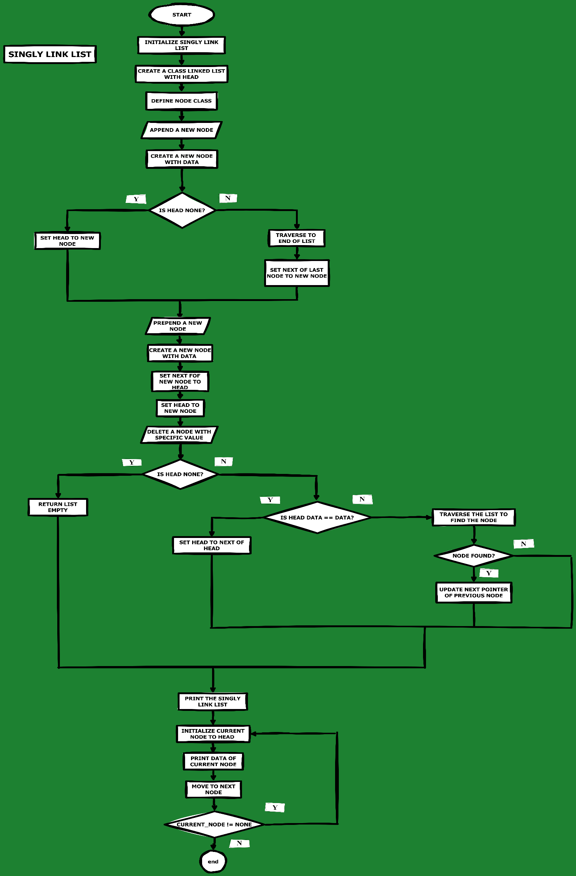
SOURCE CODE (SINGLY LINKED LIST):
The code below demonstrates the application of the algorithm on a Singly Linked List of integers.
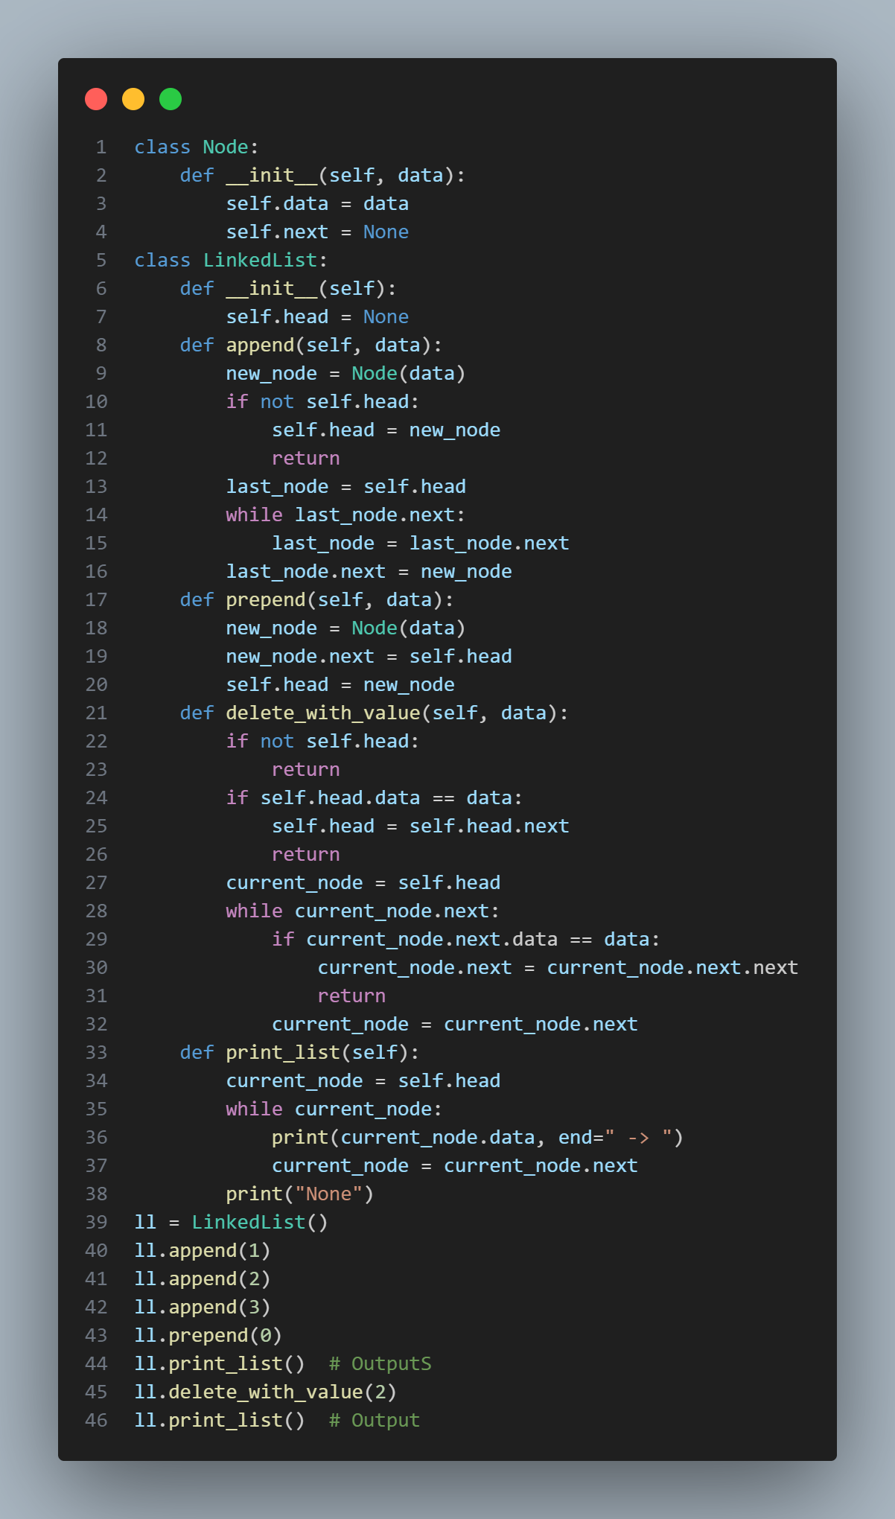

OUTPUT:
The output displays the results of various operations on the Singly Linked List

