

Republic of the Philippines
Bicol University Polangui
Polangui Albay

LAB REPORT
(Bubble sorting)

SUBMITTED BY: SUBMIITED TO:

GIAN CARLO TRILLES MELISSA JEANKIE RELLON
BScPE-2A INSTRUCTOR

DATE:
OCTOBER 10,2024

Machine Problem Description: Faulty Machine Finder in a Factory
In a factory, multiple machines are producing items. Each machine is identified by a unique ID, and most machines produce an even number of items, meaning their IDs appear twice in the list of machines. However, one machine is faulty and produces an odd number of items, which means that the faulty machine's ID appears only once in the list. The goal is to sort the list of machine IDs using different sorting algorithms and then identify the faulty machine by applying the XOR operation to find the ID that appears only once.
Bubble Sort:
This is an algorithm that compares adjacent elements and if they are in incorrect order then exchanges them. It keeps repeating this way until the whole list becomes sorted; it's called "bubbling up" where all the largest elements end up after each pass in their correct positions.

I FLOWCHART (BUBBLE SORT):
In the following flowchart, the program uses Bubble Sort on a single sequence of machine IDs.
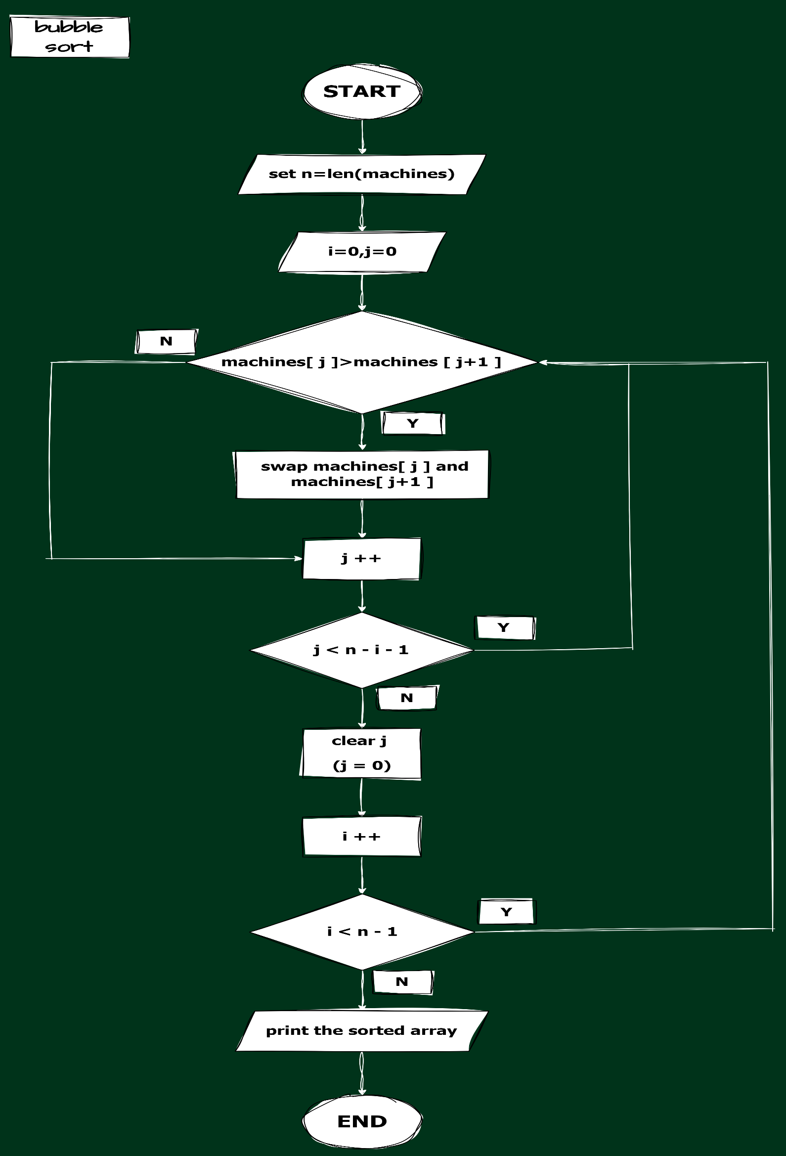

SOURCE CODE:
In the following code, the program uses Bubble Sort on a single sequence of machine IDs.
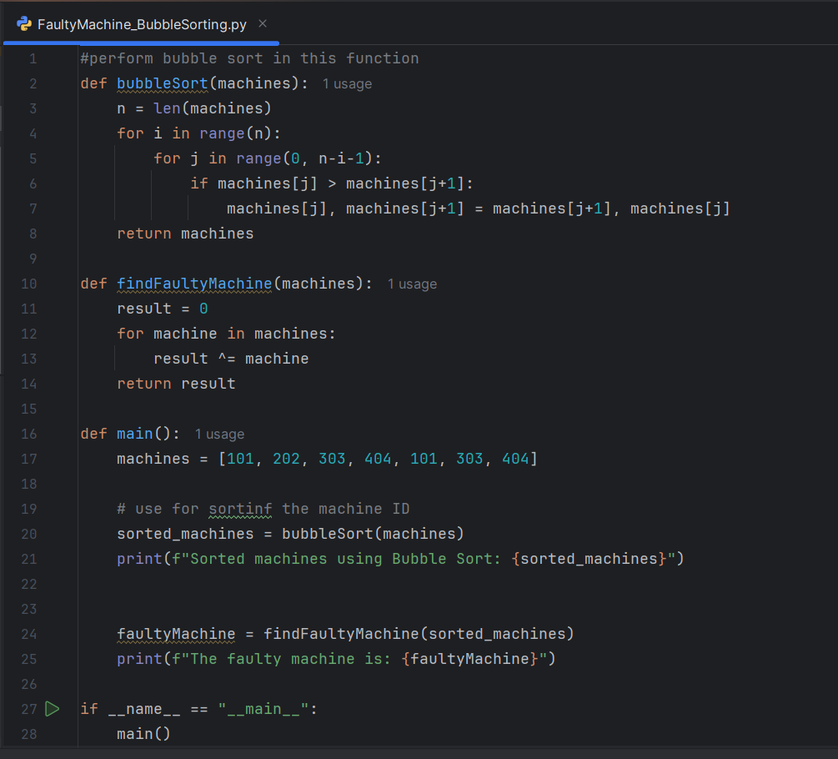

OUTPUT:
In this program, the machine IDs are sorted in ascending order, then printed as an array.
