

Republic of the Philippines
Bicol University Polangui
Polangui Albay

LAB REPORT
(MERGE sorting)

SUBMITTED BY: SUBMIITED TO:

GIAN CARLO TRILLES MELISSA JEANKIE RELLON
BScPE-2A INSTRUCTOR

DATE:
OCTOBER 10,2024

Machine Problem Description: Faulty Machine Finder in a Factory
In a factory, multiple machines are producing items. Each machine is identified by a unique ID, and most machines produce an even number of items, meaning their IDs appear twice in the list of machines. However, one machine is faulty and produces an odd number of items, which means that the faulty machine's ID appears only once in the list. The goal is to sort the list of machine IDs using different sorting algorithms and then identify the faulty machine by applying the XOR operation to find the ID that appears only once.
Merge Sort:
This is a divide-and-conquer algorithm that splits the array into two halves and recursively sorts both halves. After this, merge the
two sorted halves together.

I FLOWCHART (MERGE SORT):
In the following flowchart, the program uses Merge Sort on a single sequence of machine IDs. 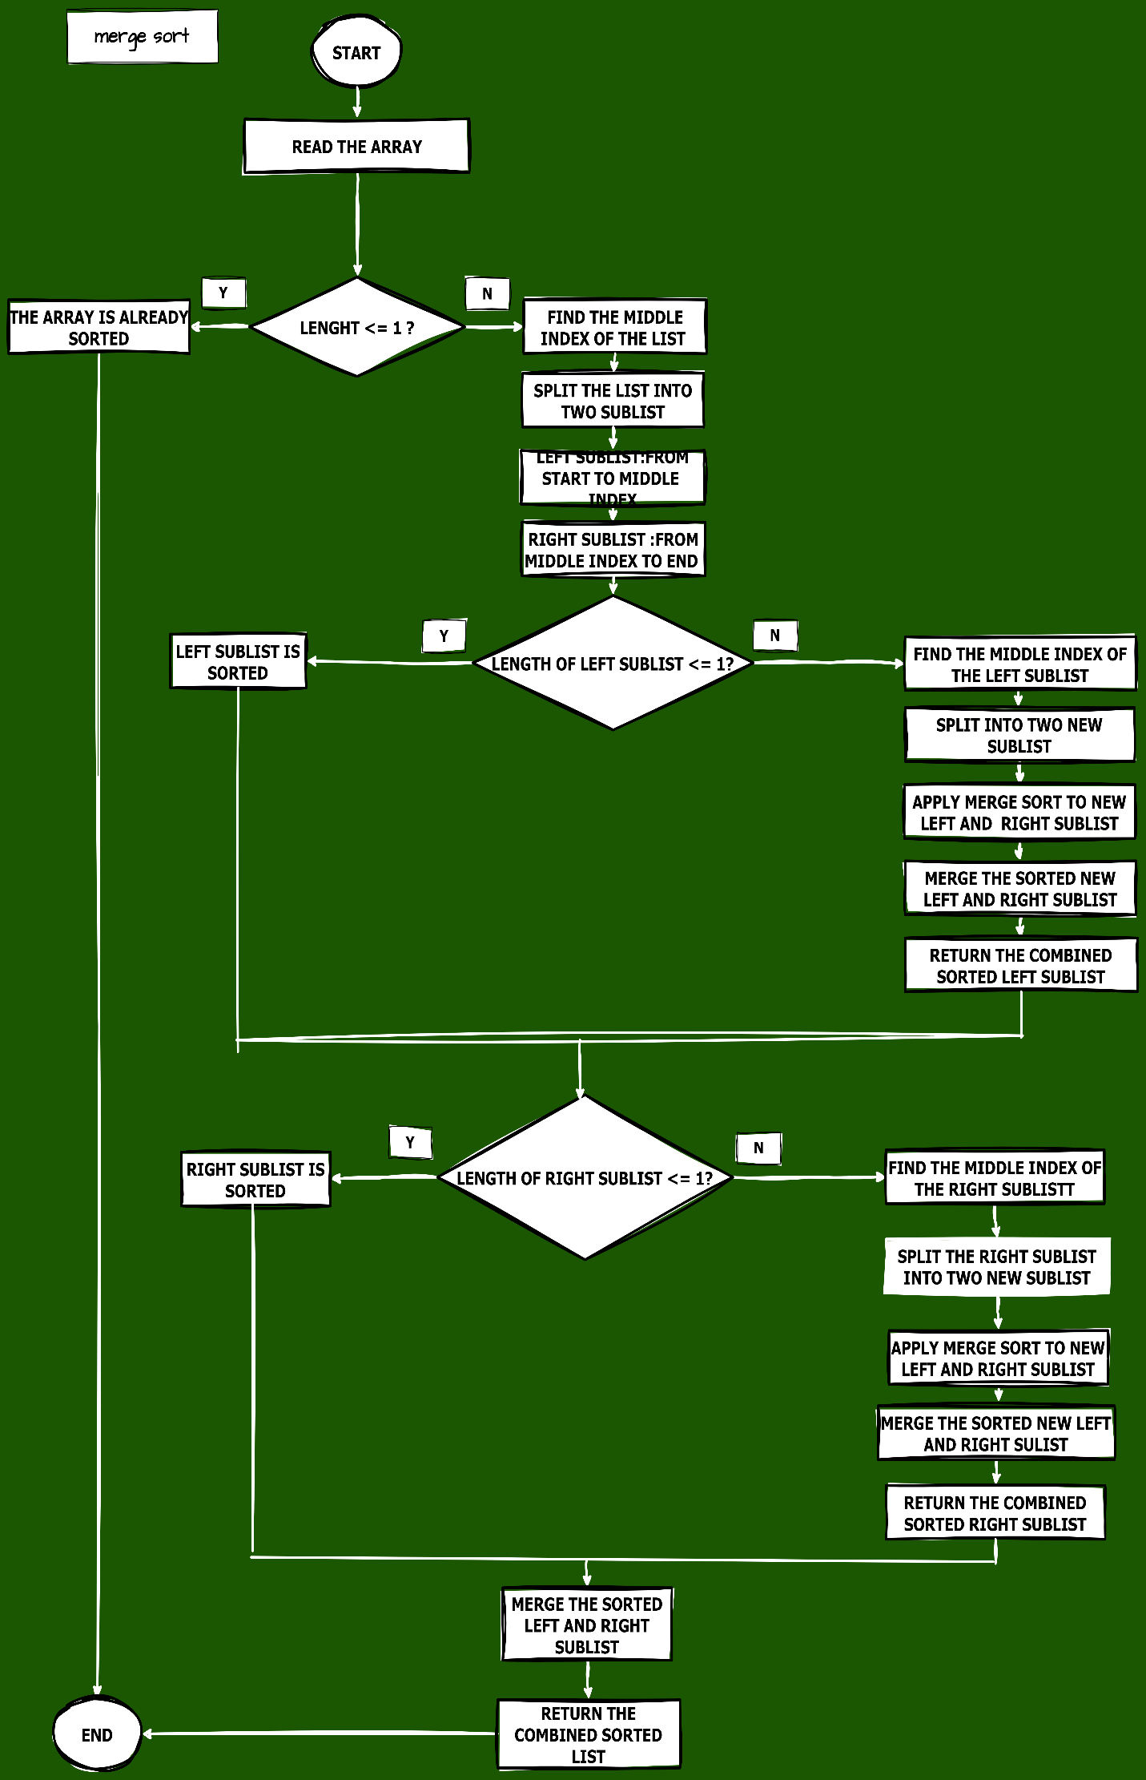

SOURCE CODE:
In the following code, the program uses Quick Sort on a single sequence of machine IDs.
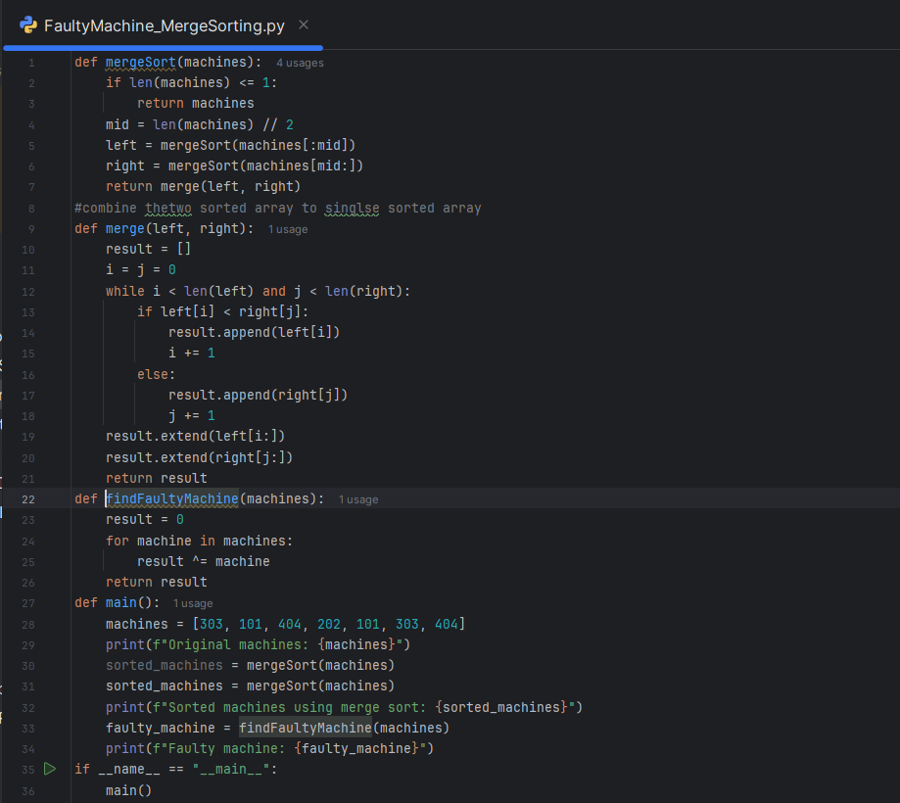

OUTPUT:
In this program, the machine IDs are sorted in ascending order, then printed as an array.
