

Republic of the Philippines
Bicol University Polangui
Polangui Albay

LAB REPORT
(selection sorting)

SUBMITTED BY: SUBMIITED TO:

GIAN CARLO TRILLES MELISSA JEANKIE RELLON
BScPE-2A INSTRUCTOR

DATE:
OCTOBER 10,2024

Machine Problem Description: Faulty Machine Finder in a Factory
In a factory, multiple machines are producing items. Each machine is identified by a unique ID, and most machines produce an even number of items, meaning their IDs appear twice in the list of machines. However, one machine is faulty and produces an odd number of items, which means that the faulty machine's ID appears only once in the list. The goal is to sort the list of machine IDs using different sorting algorithms and then identify the faulty machine by applying the XOR operation to find the ID that appears only once.

Selection Sort:
This algorithm repeatedly chooses the smallest element from the unsorted portion of the list and during each pass swaps it with the current element. It works by placing each smallest element into its correct position along the way, starting at the beginning of the list.

I FLOWCHART (SELECTION SORT):
In the following flowchart, the program uses Selection Sort on a single sequence of machine IDs.
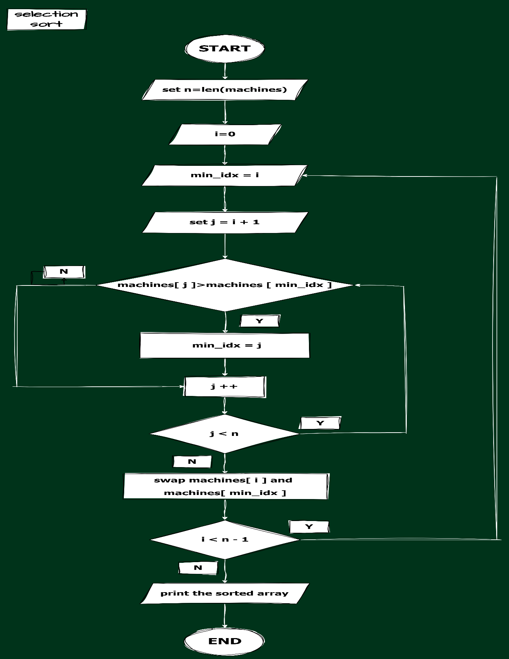

SOURCE CODE:
In the following code, the program uses Selection Sort on a single sequence of machine IDs.
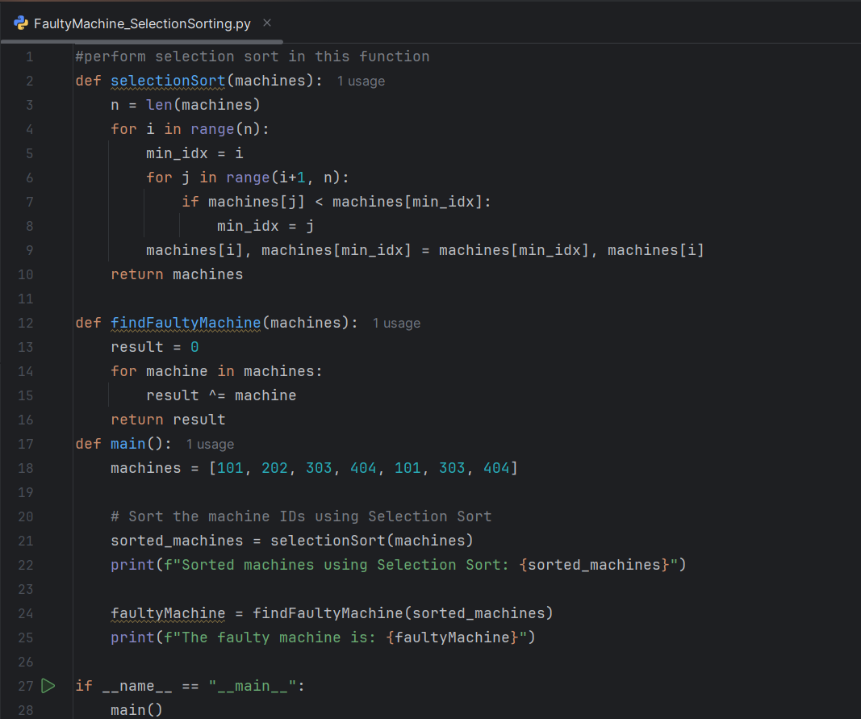

OUTPUT:
In this program, the machine IDs are sorted in ascending order, then printed as an array.
