Joshua Gizaw
Assignment 0
Task 1-
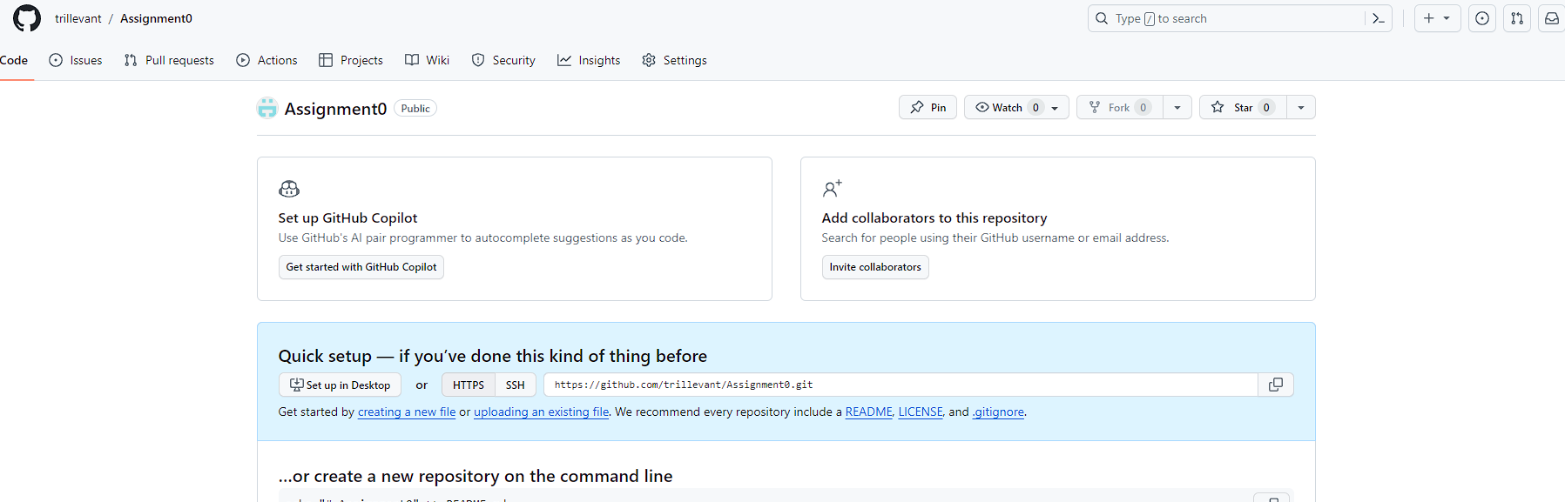
Task 2-
Step 1-
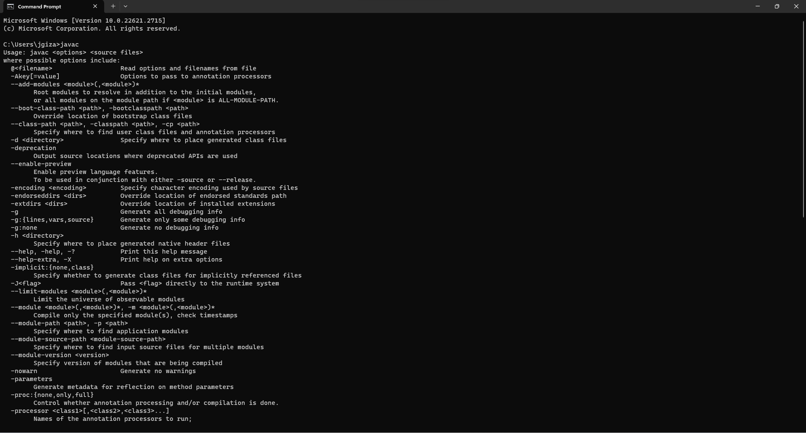
Step 2-