**BOLTS**

In the vast landscape of hardware and construction materials, few components are as ubiquitous and essential as nuts and bolts. These seemingly small pieces play a colossal role in holding together structures, machines, and everyday objects. In this comprehensive guide, we delve into the intricate world of [bolts](https://trilliumnow.com/collections/bolts), focusing on their collections and the suppliers who provide them.

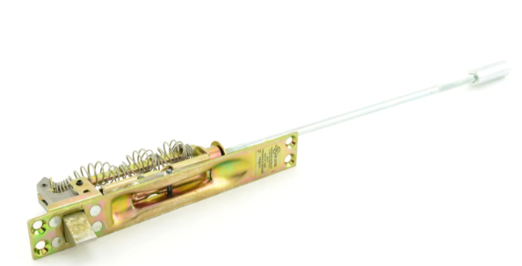

**Understanding Bolts:**

[Bolts](https://trilliumnow.com/collections/bolts) are threaded fasteners typically used with nuts to hold two or more parts together. They come in various sizes, shapes, and materials, each designed for specific applications. From hex bolts to carriage bolts, each type serves a unique purpose, whether it's joining metal, wood, or plastic.

**Collections of Bolts:**

**Hex Bolts:**

Perhaps the most common type, hex [bolts](https://trilliumnow.com/collections/bolts) feature a hexagonal head and are tightened with a wrench or socket. They're widely used in construction, machinery, and automotive industries.

**Carriage Bolts:**

Recognizable by their round heads and square necks beneath, carriage [bolts](https://trilliumnow.com/collections/bolts) are ideal for fastening wood to metal. The square neck prevents the bolt from spinning while tightening the nut.

**Lag Bolts:**

Also known as lag screws, these sturdy fasteners have coarse threads designed to grip into wood or similar materials. They're commonly used in framing, decking, and other outdoor applications.

**Anchor Bolts:**

Used to attach objects or structures to concrete, anchor bolts are embedded in concrete and secured with a nut and washer. They're crucial for anchoring columns, beams, and machinery to concrete foundations.

**Eye Bolts:**

Featuring a circular loop at one end, eye [bolts](https://trilliumnow.com/collections/bolts) are used for lifting heavy loads or securing cables and ropes. They come in various configurations, including shoulder eye bolts and machinery eye bolts.

1. **Bolts:**
2. Shaped like the letter "U," these [bolts](https://trilliumnow.com/collections/bolts) are threaded at both ends and commonly used to clamp pipes, tubes, and other round objects.

**Keyword Nut and Bolt Suppliers:**

When it comes to sourcing quality nuts and [bolts](https://trilliumnow.com/collections/bolts), choosing the right supplier is paramount. Here are some key considerations:

**Product Range:**

Opt for suppliers with a diverse range of bolts to meet your specific needs. Whether you require specialized bolts, a comprehensive collection ensures you'll find the right fit.

**Quality Assurance:**

Look for suppliers that prioritize quality control measures to ensure the durability and reliability of their products. Quality materials and precise manufacturing processes are essential for long-lasting bolts.

**Customization Options:**

In some cases, standard bolts may not suffice for unique applications. Suppliers offering customization services can tailor bolts to your exact specifications, ensuring optimal performance.

**Reliability and Reputation:**

Choose suppliers with a proven track record of reliability and customer satisfaction. Reading reviews, seeking recommendations, and evaluating certifications can help gauge a supplier's reputation.

**Cost and Value:**

While cost is a significant factor, prioritize value over price alone. Consider factors such as product quality, reliability, and customer support when assessing the overall value offered by a supplier.