# 数学实验作业一

|  |  |  |  |
| --- | --- | --- | --- |
| **姓名** | 刘兆宇 | **班级** | 大数据管理与应用4班 |
| **学号** | 202330860601 | **时间** | 2024.03.13 |

1. **实验目的和内容**
2. 学习用**subplot**命令分别在不同的坐标系下画出四条目标函数曲线，并为每幅图形加上标题，美化绘图结果。
3. 用牛顿迭代法求解的值，编写相应函数，保存为a_sqrt.m。
4. **实验过程**
5. **作业1.1：使用subplot绘制如下图像；添加子图标题；美化；**

|  |  |
| --- | --- |
| **曲线** | **函数表达式** |
| 三次函数 |  |
| 四叶玫瑰线 |  |
| 平面参数曲线 |  |
| 周期函数 |  |

1. 问题分析：
   1. **绘图**：plot可以实现单个函数的绘制在此基础上，如果需要在一个窗口中同时绘制多个函数，便需要用到**子图**的绘制**subplot**。通过查阅帮助文档，了解到常用的subplot([m](https://www.mathworks.com/help/releases/R2023b/matlab/ref/subplot.html?doclanguage=zh-CN&nocookie=true&prodfilter=ML%20SL%20BL%20C2%20VP%20CT%20CF%20DA%20DB%20DF%20DD%20DH%20NN%20ET%20EC%20IT%20FI%20FL%20GD%20GC%20IA%20IP%20OT%20IC%20MG%20ME%20CO%20MJ%20MR%20TE%20DX%20MT%20OP%20DM%20PD%20PW%20PM%20RL%20RQ%20RK%20SQ%20SG%20SE%20VV%20CI%20RT%20SK%20SD%20CV%20SO%20DV%20WT%20FA%20PL%20XP%20SR%20SZ%20EL%20SF%20ST%20SM%20ZC%20ID%20TA%20WA%20WB&docviewer=helpbrowser&docrelease=R2023b&s_cid=pl_webdoc&loginurl=https%3A%2F%2F127.0.0.1%3A31515%2Ftoolbox%2Fmatlab%2Flogin%2Fweb%2Findex.html%3Fsnc%3DCDF4SL%26external%3Dtrue%26channel%3D__mlfpmc__&searchsource=mw&snc=GG3DVX&container=jshelpbrowser" \l "btw1t4b-1-m),[n](https://www.mathworks.com/help/releases/R2023b/matlab/ref/subplot.html?doclanguage=zh-CN&nocookie=true&prodfilter=ML%20SL%20BL%20C2%20VP%20CT%20CF%20DA%20DB%20DF%20DD%20DH%20NN%20ET%20EC%20IT%20FI%20FL%20GD%20GC%20IA%20IP%20OT%20IC%20MG%20ME%20CO%20MJ%20MR%20TE%20DX%20MT%20OP%20DM%20PD%20PW%20PM%20RL%20RQ%20RK%20SQ%20SG%20SE%20VV%20CI%20RT%20SK%20SD%20CV%20SO%20DV%20WT%20FA%20PL%20XP%20SR%20SZ%20EL%20SF%20ST%20SM%20ZC%20ID%20TA%20WA%20WB&docviewer=helpbrowser&docrelease=R2023b&s_cid=pl_webdoc&loginurl=https%3A%2F%2F127.0.0.1%3A31515%2Ftoolbox%2Fmatlab%2Flogin%2Fweb%2Findex.html%3Fsnc%3DCDF4SL%26external%3Dtrue%26channel%3D__mlfpmc__&searchsource=mw&snc=GG3DVX&container=jshelpbrowser#btw1t4b-1-n),[p](https://www.mathworks.com/help/releases/R2023b/matlab/ref/subplot.html?doclanguage=zh-CN&nocookie=true&prodfilter=ML%20SL%20BL%20C2%20VP%20CT%20CF%20DA%20DB%20DF%20DD%20DH%20NN%20ET%20EC%20IT%20FI%20FL%20GD%20GC%20IA%20IP%20OT%20IC%20MG%20ME%20CO%20MJ%20MR%20TE%20DX%20MT%20OP%20DM%20PD%20PW%20PM%20RL%20RQ%20RK%20SQ%20SG%20SE%20VV%20CI%20RT%20SK%20SD%20CV%20SO%20DV%20WT%20FA%20PL%20XP%20SR%20SZ%20EL%20SF%20ST%20SM%20ZC%20ID%20TA%20WA%20WB&docviewer=helpbrowser&docrelease=R2023b&s_cid=pl_webdoc&loginurl=https%3A%2F%2F127.0.0.1%3A31515%2Ftoolbox%2Fmatlab%2Flogin%2Fweb%2Findex.html%3Fsnc%3DCDF4SL%26external%3Dtrue%26channel%3D__mlfpmc__&searchsource=mw&snc=GG3DVX&container=jshelpbrowser#btw1t4b-1-p)) 可将当前图窗划分为 m×n 网格，并在 p 指定的位置创建坐标区。MATLAB® 按行号对子图位置进行编号；
   2. **子图标题**：使用title([titletext](https://www.mathworks.com/help/releases/R2023b/matlab/ref/title.html?overload=title%20false&doclanguage=zh-CN&nocookie=true&prodfilter=ML%20SL%20BL%20C2%20VP%20CT%20CF%20DA%20DB%20DF%20DD%20DH%20NN%20ET%20EC%20IT%20FI%20FL%20GD%20GC%20IA%20IP%20OT%20IC%20MG%20ME%20CO%20MJ%20MR%20TE%20DX%20MT%20OP%20DM%20PD%20PW%20PM%20RL%20RQ%20RK%20SQ%20SG%20SE%20VV%20CI%20RT%20SK%20SD%20CV%20SO%20DV%20WT%20FA%20PL%20XP%20SR%20SZ%20EL%20SF%20ST%20SM%20ZC%20ID%20TA%20WA%20WB&docviewer=helpbrowser&docrelease=R2023b&s_cid=pl_webdoc&loginurl=https%3A%2F%2F127.0.0.1%3A31515%2Ftoolbox%2Fmatlab%2Flogin%2Fweb%2Findex.html%3Fsnc%3DPO3DZP%26external%3Dtrue%26channel%3D__mlfpmc__&searchsource=mw&snc=T8G8TW&container=jshelpbrowser" \l "btpi3rq-1-txt)) 将“函数表达式”添加到当前坐标区，作为每张子图的标题；
   3. **美化1**：使用sgtitle([txt](https://www.mathworks.com/help/releases/R2023b/matlab/ref/sgtitle.html?doclanguage=zh-CN&nocookie=true&prodfilter=ML%20SL%20BL%20C2%20VP%20CT%20CF%20DA%20DB%20DF%20DD%20DH%20NN%20ET%20EC%20IT%20FI%20FL%20GD%20GC%20IA%20IP%20OT%20IC%20MG%20ME%20CO%20MJ%20MR%20TE%20DX%20MT%20OP%20DM%20PD%20PW%20PM%20RL%20RQ%20RK%20SQ%20SG%20SE%20VV%20CI%20RT%20SK%20SD%20CV%20SO%20DV%20WT%20FA%20PL%20XP%20SR%20SZ%20EL%20SF%20ST%20SM%20ZC%20ID%20TA%20WA%20WB&docviewer=helpbrowser&docrelease=R2023b&s_cid=pl_webdoc&loginurl=https%3A%2F%2F127.0.0.1%3A31515%2Ftoolbox%2Fmatlab%2Flogin%2Fweb%2Findex.html%3Fsnc%3DY9LZJO%26external%3Dtrue%26channel%3D__mlfpmc__&searchsource=mw&snc=YJPY0K&container=jshelpbrowser#mw_d5b17f9f-cbb9-4657-8825-7e3811dd9387)) 在当前图窗上方添加**整体标题**，在title函数中补充更多参数，同时调整其字号；
   4. **美化2：**对于子图标题“**函数表达式**”，使用**LaTeX解释器**，使表达式更符合数学表达式的呈现格式；
   5. **美化3：**使用grid on命令在坐标图上显示网格，然后使用grid minor来显示较细的网格线，使得图像界面更加美观；
2. 伪代码：

% 函数定义：

x = linspace(x1,x2,n);

y = f(x);

% 函数绘制：

subplot(m, n, p);

plot(x)

plot(x, y, LineSpec, 'LineWidth', value);

% 添加标题 "函数表达式";

title("数学表达式");

% 界面美化:

% 1.函数表达式使用 LaTeX 解释器

title('$数学表达式$', 'Interpreter', 'latex');

% 2.在当前图窗上方添加整体标题，并调整字号

sgtitle('txt');

% 3.绘制网格

grid on; grid minor;

1. 源码：

% 三次函数曲线

x1 = linspace(-5, 5, 1000);

y1 = x1.^3 + 2*x1.^2 - 3*x1 + 4;

% 四叶玫瑰线

theta = linspace(0, 2*pi, 1000);

r = cos(2*theta);

% 平面参数曲线

t = linspace(0, 2*pi, 1000);

x3 = (1 + sin(t) - 2*cos(4*t)) .* cos(t);

y3 = (1 + sin(t) - 2*cos(4*t)) .* sin(t);

% 周期函数

x4 = linspace(0, 4*pi, 1000);

y4 = sin(x4) + sin(2*x4);

% 绘制函数图像

subplot(2, 2, 1);

plot(x1, y1, 'b-', 'LineWidth', 2);

title('$y = x^3 + 2x^2 - 3x + 4$', 'Interpreter', 'latex');

grid on;

grid minor;

subplot(2, 2, 2);

polarplot(theta, r, 'r-', 'LineWidth', 2);

title('$r = \cos(2\theta)$', 'Interpreter', 'latex');

grid on;

grid minor;

subplot(2, 2, 3);

plot(x3, y3, 'k-', 'LineWidth', 2);

% title({'$x = (1 + \sin(t) - 2\cos(4t))\cos(t)$'; '$y = (1 + \sin(t) - 2\cos(4t))\sin(t)$'}, 'Interpreter', 'latex');

title({'$\left\{\begin{array}{l} x=(1 + \sin(t) - 2\cos(4t))\cos(t) \\ y=(1 + \sin(t) - 2\cos(4t))\sin(t) \end{array}\right.$'}, 'Interpreter', 'latex');

% xlabel('X轴'); % 添加坐标轴标签

% ylabel('Y轴');

grid on;

grid minor;

subplot(2, 2, 4);

plot(x4, y4, 'm-', 'LineWidth', 2);

title('$y = \sin(x) + \sin(2x)$', 'Interpreter', 'latex');

grid on;

grid minor;

% 添加整体标题

sgtitle('\bf\fontsize{13}不同类型曲线的绘制');

% 图形美化

axis equal;

1. 运行结果，如下图所示：

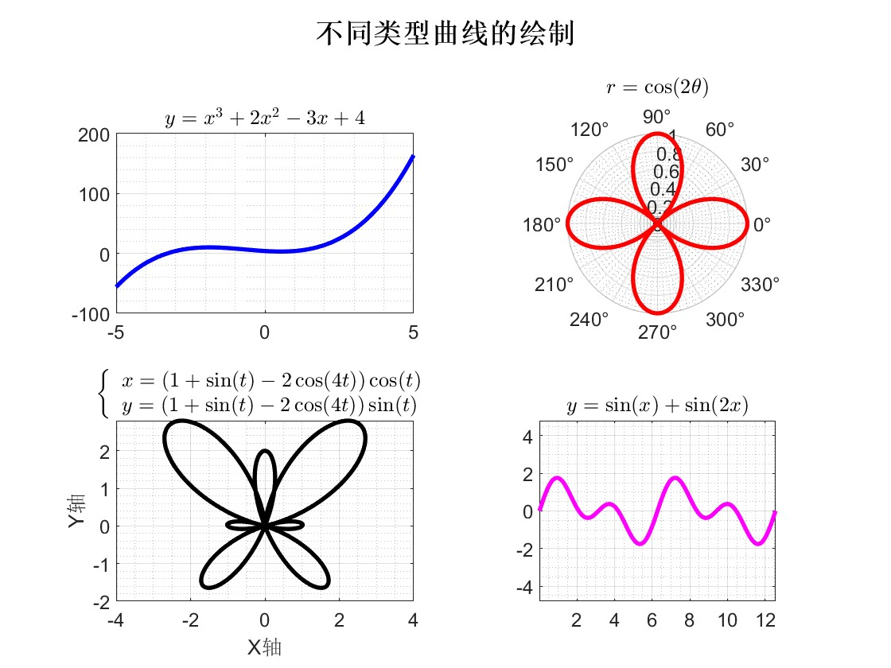

1. 分析阐述：

通过上述过程，绘制了要求的四种函数曲线，并按照问题分析和伪代码中设想的方法，成功以subplot分别绘制窗格中的4张子图，并通过title拓展的参数设置了LaTeX解释数学函数表达式，通过sgtitle添加了窗格整体标题，通过grid命令增加了函数图像中的窗格，使得整体窗口的呈现更加美观。

1. **用牛顿迭代法求解的值，保存为函数形式的.m文件**
   * + 1. 问题分析
   1. 本实验要求使用牛顿迭代法来求解给定数的平方根。迭代法是一种常见的数值计算方法，通过不断迭代逼近目标值，直到满足终止条件。在作业要求中，已经给出平方根的迭代公式：，并规定了终止条件eps＜10-5，在编写函数**function**代码时，首先要符合函数体的语法规范，同时需要使用一些基本的数学运算函数和控制语句，如**while**循环、**abs** 函数用于计算绝对值等，最后可在命令行中通过a_sqrt(x)调用函数求解x的平方根。
   2. **初始值**的确定：初值选择在迭代法中是一个非常重要的问题，它直接影响到迭代的收敛速度和稳定性。在求解平方根的问题中，本实验中选择x0 = a / 2作为初值，是因为在大多数情况下，平方根会落在x的一半和x之间，因此选择x的一半作为初值可以加速收敛速度。
      * 1. 伪代码：

函数 a_sqrt(a):

x0 = a / 2;

循环:

x = 0.5 * (x0 + a / x0)

如果 |x - x0| < 1e-5:

退出循环

x0 = x

返回 x

* + - 1. 源码：

function x = a_sqrt(a)

x0 = a / 2;

while true

x = 0.5 * (x0 + a / x0);

if abs(x - x0) < 1e-5

break;

end

x0 = x;

end

end

* + - 1. 在命令行中调用函数：

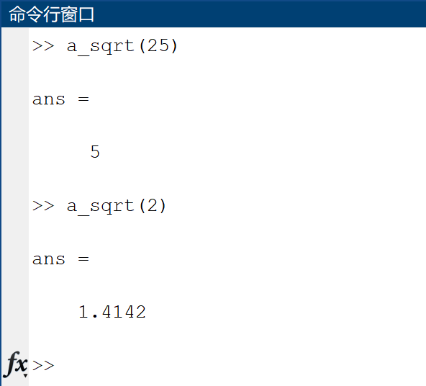

* + - 1. 分析阐述：

迭代法求解平方根的准确性取决于迭代过程中所使用的终止条件以及迭代公式的选择。本次实验中，我们使用的终止条件是当相邻两次迭代得到的值之间的差的绝对值小于设定的误差阈值（1e-5）时退出循环。因此，最终得到的结果应该在误差范围内接近真实的平方根值。