DEPARTMENT OF COMPUTER SCIENCE AND INFORMATION TECHNOLOGY

GURU GHASIDAS VISHWAVIDHALAYA, BILASPUR

(A Central University Established by the Central Universities Act, 2009 No. 25 of 2009)


Minor Project
on
ONLINE VOTING SYSTEM
(MASTER OF COMPUTER APPLICATION)
Session 2020-21

UNDER THE GUIDENCE OF SUBMITTED BY:
DURGA DEWANGAN
Mr. VIVEK SARATHE SIR
Enroll N0. GGV/17/5028
Roll No-20606069
MCA 2nd SEM



Certificate
THIS IS TO CERTIFY THAT Miss DURGA DEWANGAN BEARING ROLL NO. 20606069 ENROLLMENT NO. GGV/17/5028 HAS DEVELOPED SOFTWARE PROJECT ENTITLED “ONLINE VOTING SYSTEM”” FOR MINOR PROJECT AS FULFILLMENT FOR THE AWARD OF THE DEGREE OF MASTER OF COMPUTER APPLICATION.

HEAD OF DEPARTMENT
Dr . A.K. SAXENA SIR
GURU GHASIDAS CENTRAL UNIVERSITY,
KONI, BILASPUR (C.G.)

\
CERTIFICATE BY THE EXAMINER

This is to certified that the project work entitled “ONLINE VOTING SYSTEM” submitted by DURGA DEWANGAN has completed under the guidance of Mr. VIVEK SARATHE SIR , Dept. of CSIT, GGU Bilaspur (C.G.) has been examined by the undersigned as a part of the examination for the award of the MCA Degree in Department of COMPUTER SCIENCE & INFORMATION TECHNOLOGY in GURU GHASIDAS CENTRAL UNIVERSITY, BILASPUR (C.G.).
“Project Examined & Approved”

Internal Examiner External Examiner
Date: Date:

Signature of H.O.D. (CSIT)
Dr. A.K. SAXENA

CERTIFICATE OF THE GUIDE

This is to certify that the project entitled “ONLINE VOTING SYSTEM ’’ s a record of work carried out by DURGA DEWANGAN (Enroll no. GGV/17/5028) under my guidance and supervision for the award of the Degree of MCA(Master of Computer Application), Guru Ghasidas Central University Bilaspur (C.G.).
To the best of my knowledge and belief of the project
- Embodies the work of the candidate him/herself, and has not been submitted for the award of any degree.
- Has duly been completed.
- Fulfills the requirement of the Ordinance relating to the BSc degree of the University and
- Is up to the desired standard in respect of contents and is being referred to the examiners.

(Signature of the Guide)
Mr. VIVEK SARATHE SIR

Recommendation of the Department
The Project work as mentioned above by here by being recommended and forwarded for examination and evaluation.
(Signature of the head of Department with seal)
Dr. A.K. SAXENA
H.O.D, Dept. of CSIT

Chapter | Tittle | Page no.
1. | INTRODUCTION | 12
2. | ABSTRACT | 12
3. | PROJECT ANALYSIS | 13
4. | OBJECTIVE | 13
5. | HARDWARE AND SOFTWARE REQUIREMENT | 13-14
6. | MySQL DATABASE | 14
7. | PURPOSE | 14
8. | SCOPE | 15
9. | ADVANTAGES | 15
10. | DATA FLOW DIAGRAM | 16
11. | SCREENSHOTS | 17-24
12. | CONCLUSION | 25
13. | BIBLIOGRAPHY | 25

Introduction:-

ONLINE VOTING SYSTEM is a website developed using PHP, HTML, CSS and JAVA SCRIPT . this project is based on the concept of giving their votes online, during any elections. The user can register himself by entering details like name, phone number, password etc. on this site, and they can login into this site and can give votes. And same as the party also can register and party can upload their brand logo. For using this website user don’t need to install any application, they can go on any browser like chrome and opera, and type url of this site and they can be able to use this site.

ABSTRACT:-
“ONLINE VOTING SYSTEM” website is general website developed particularly for the online voting. This website also having the details of user with their mobile number , name , address ,id proof. This site becomes useful for all the users in the ONLINE VOTING during all type of elections. since it is developed only for ONLINE VOTING so it is developed by using LAN concepts where multi users can access single server at a same
time.

PROJECT ANALYSIS
In the existing ONLINE VOTING SYSTEM it is just designed and programmed to be offline
And no its data is been uploaded to the server

OBJECTIVE
In offline election, there is a lots of crowd in offline election , it takes lots of social workers , managers and police team to conduct offline election it can be very expensive, and most important people have to stand in a line for very long time to give their vote so people get irritated, so regarding this problem and the reduce this problem we have developed this website. Its very easy to use by user. And it takes very least cost to conduct any election, and most important things that every people can give vote from anywhere. So this can be game changer in our voting system in the country.

HARDWARE AND SOFTWARE REQUIREMENT :-

HARDWARE REQUIREMENT:-
Processor- 1.9 gigahertz (GHz) x86- or x64-bit dual core processor with SSE2 instruction set
Hard Disk - 1 GB
Main Memory- 500 MB RAM
Display Type - Super VGA with a resolution of 1024 x 768

SOFTWARE REQUIREMENT:-
This website can run in any operating system (like window, Linux, mac, android, iOS) with any browser recommended(chrome, Firefox)

MySQL DATABASE:-

MySQL is currently the most popular database management system software used for managing the relational database. It is open-source database software, which is supported by Oracle Company. It is fast, scalable, and easy to use database management system in comparison with Microsoft SQL Server and Oracle Database. It is commonly used in conjunction with PHP scripts for creating powerful and dynamic server-side or web-based enterprise applications. MySQL written in C and C++ programming language.

- It allows us to implement database operations on tables, rows, columns, and indexes.
- It defines the database relationship in the form of tables (collection of rows and columns), also known as relations.
- It provides the Referential Integrity between rows or columns of various tables.
- It allows us to updates the table indexes automatically.
- It uses many SQL queries and combines useful information from multiple tables for the end-users.

Purpose:-
The purpose of ONLINE VOTING SYSTEM is to digitalize our traditional voting system, and reduce the expenses during offline voting sytem. It can be very benefits for voters, they can give votes from anywhere.

Scope And Acceptance:-
This project is very useful for every user, they can give votes by living their home , office and anywhere. They don’t need to wait in a line for a long period of time. This is very helpful and very cost effective to conduct any type of elections.

Advantages:-

- It is very easy to use and user friendly.
- No need to install any application in the system.
- It takes very less amount of time during registration and login.
- User also can see their information after login.
- It can run also in less spacification device.

DATA FLOW DIAGRAM

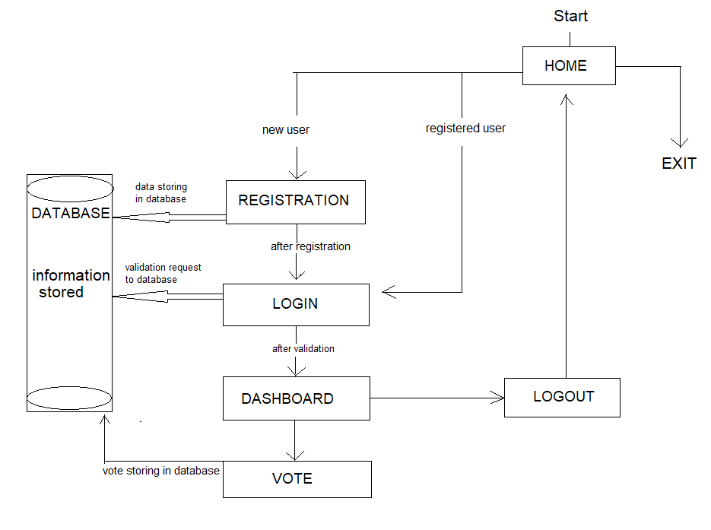

Screenshots

HOME PAGE

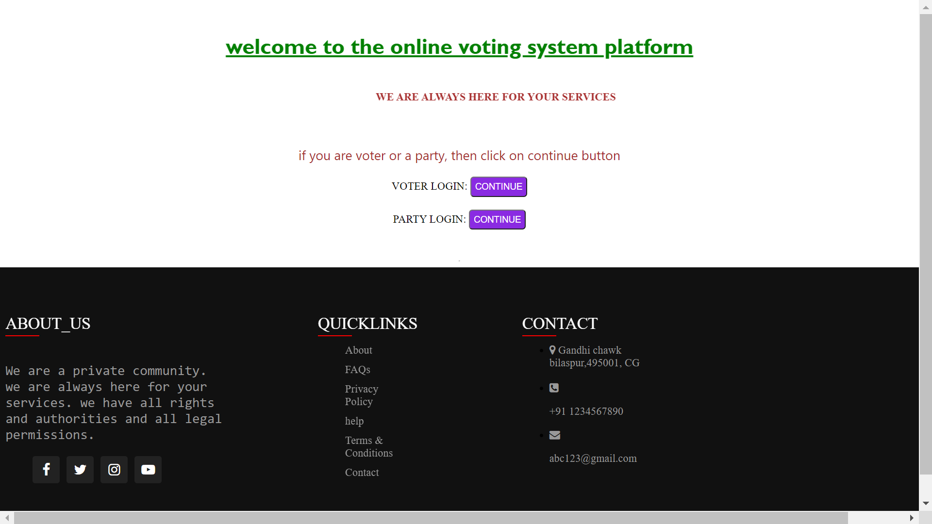

VOTER REGISTRATION PAGE

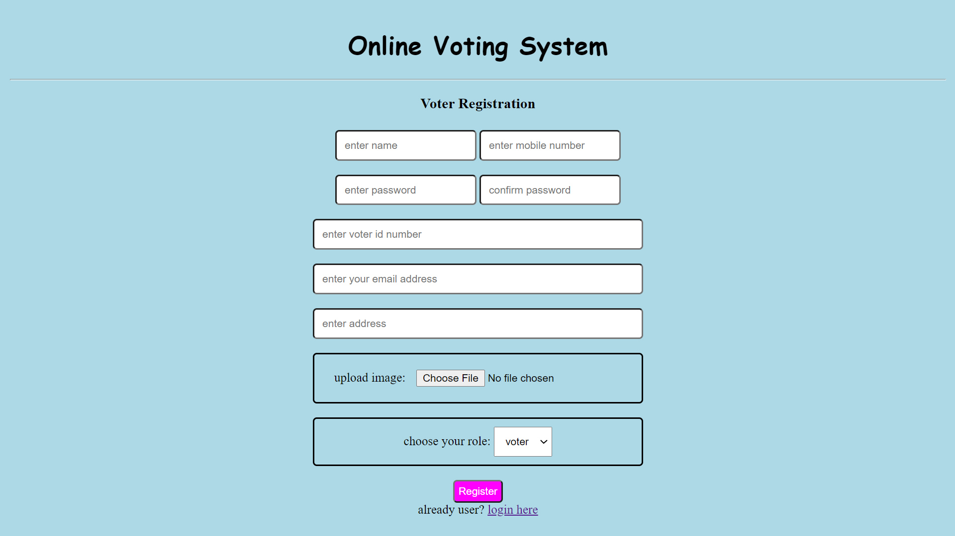
VOTER LOGIN PAGE

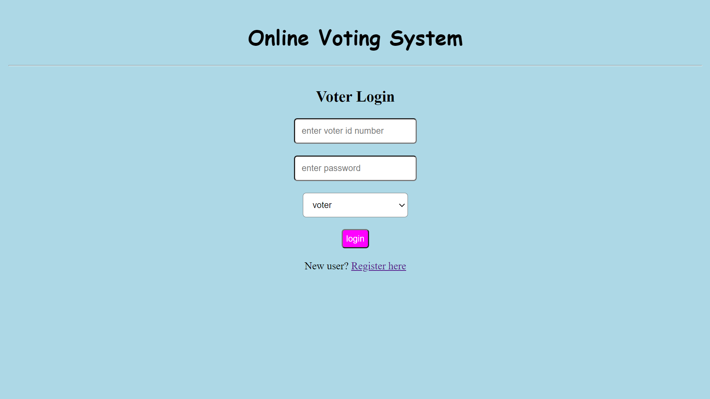

PARTY REGISTRATION PAGE

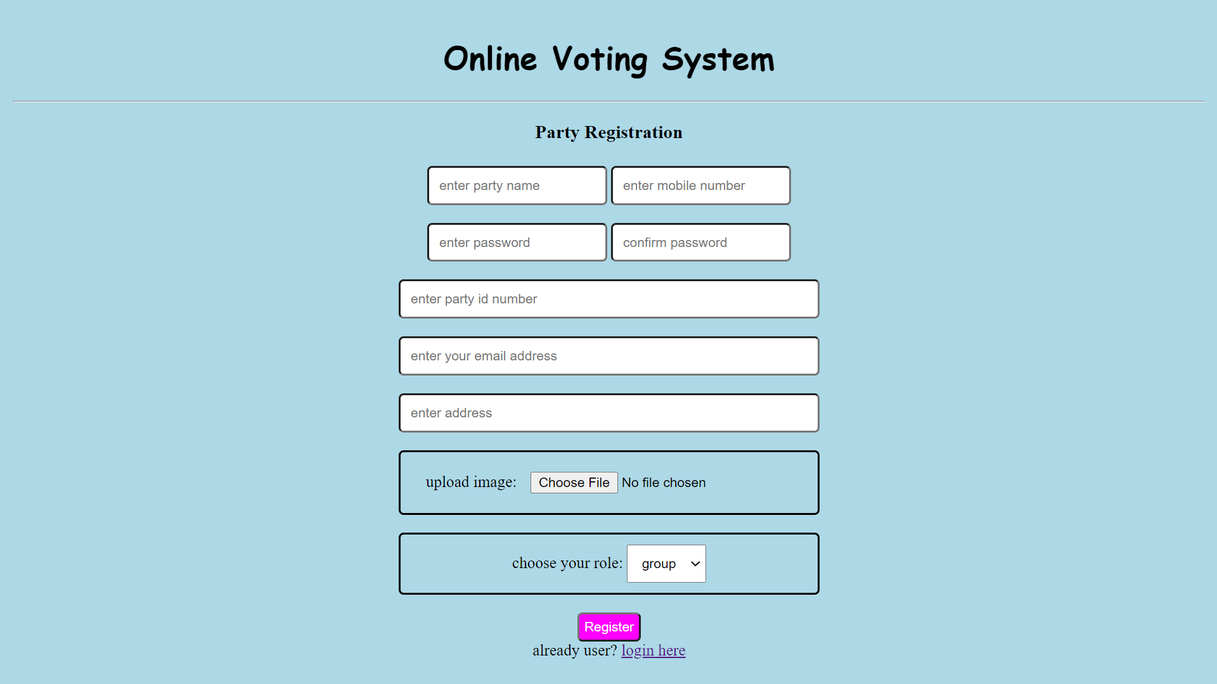

PARTY LOGIN PAGE

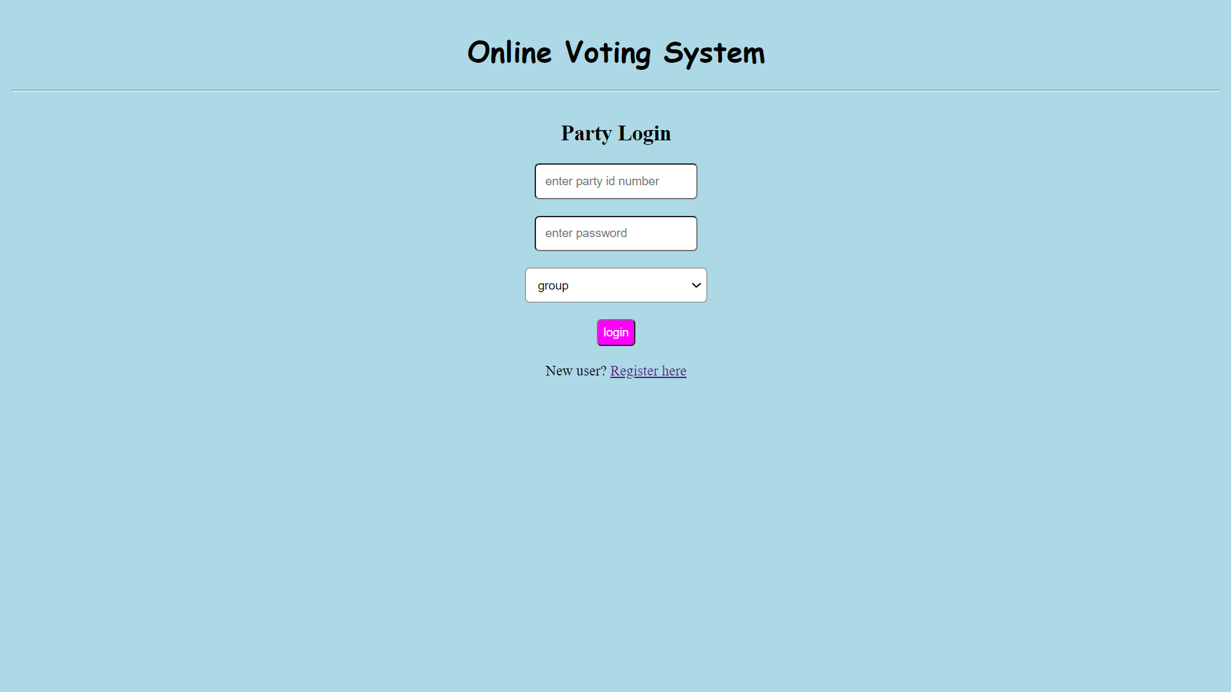

VOTER DASHBOARD

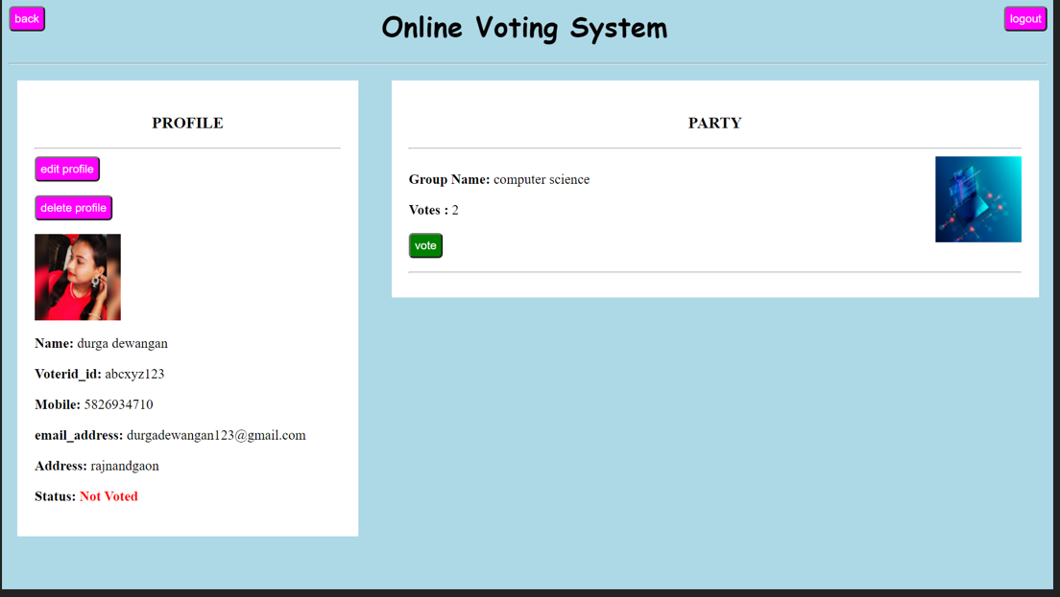

PARTY DASHBOARD

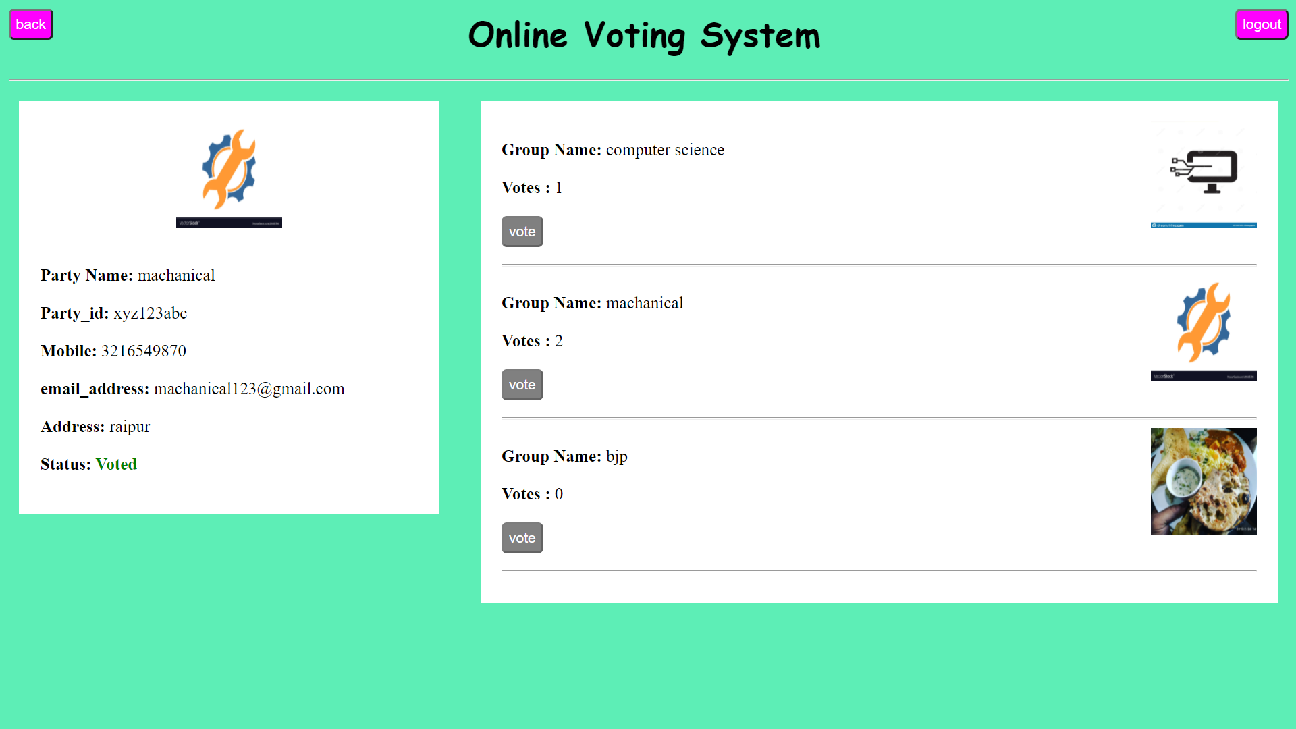

HOME PAGE AFTER LOGOUT

CONCLUSION

- Main purpose of this project is committed to provide online home based services in online voting system, we hope all users love it.
- This online voting system will manage the voter’s information as we as candidate(party) information by which voter can login and they can use their voting rights, the system will incorporate many feature of voting system. It provide tools for maintaining voter’s vote to every party and it count total number of votes every party. There is a database tha will be maintain by ELECTION COMMISION OF INDIA in which all the name of voter with complete information is stored.
- In this user who is above 18 register him/her information on the database. And they can login by their id and password and can vote any party

BIBLIOGRAPHY

- www.youtube.com
- www.bootstrap.com
- www.w3school.com

