# Design requirements for NIOSH VLC power optimized Backscatter

The goal of this design is to build a battery-free retroVLC backscatter system that can work in extremely low light levels. It uses a PV cell as a power supply, which powers a microcontroller and LC shutter.

## Challenge

The primary challenge is to make the circuit as low power as possible. The reason is that in a dusty tunnel, light levels will be extremely low. The voltage of the PV cells drops with increased current. If too much current is drawn too quickly, the PV voltage will tank, causing an unwanted reset cycle.

## Design Overview

There are 4 subsystems.

1. LC shutter
2. The microcontroller
3. Voltage regulation
4. The PV cell and energy storage

### LC Shutter

We will use a 36 pixel twisted nematic shutter from liquidcrystaltechnologies.com, tying all the pixels together to realize a large shutter. This device has been used in our lab previously.

### Microcontroller

Requirements

* >=10 GPIO
* Very low current
* Internal low power oscillator (~5khz)
* DIP for easy prototyping
* 1 ADC
* 2 Timers
* 1 Watchdog timer

I chose the MSP430G2553IN20 since it comes with the TI launchpad. It has 16 GPIO in a 20pin DIP. It draws max 430uA in active mode at 3V,1MHZ (IO HiZ). Ill use this as the upper bound in my analysis, even though it will most likely be less than that. The VLO runs ~12khs, but varies +/- 4khz with temperature.

The plan is to program and analyze power with TI Code Composer studio and the Joulescope.

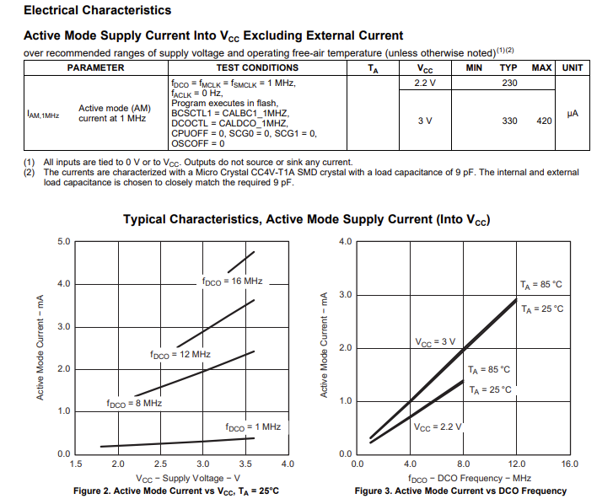

### Supply Regulation

Requirements:

* Efficient at low current
* Max current > 40mA
* Low quiescent current
* Output adjustable from 2V -> 3.6 V
* <200mV dropout voltage
* Low feedback input current (<1uA)
* Active HIGH Enable *OR* built in >300 mV Hysteresis

Solution:

A Linear LDO is chosen since it is simple and good efficiency at low currents. It is EN adjustable regulator with enable pin, so it can be precisely controlled with external resistors.

Options:

|  |  |  |
| --- | --- | --- |
| TPS7A92 | no | https://www.ti.com/lit/ds/symlink/tps7a92.pdf |
| TCRXX | yes | https://www.digikey.com/en/products/detail/toshiba-semiconductor-and-storage/TCR3UG28A-LF/7802136 |

### Energy storage

Now that the rest of the circuit is designed, we can properly size the PV cell circuit. The max active current draw will be <10mA, but average is <300uA. We therefore need to pick a storage cap to accommodate the shutter spike.

We will need a solar cell capable of staying about 2V at max current levels at the light levels we want.

The energy storage capacitor must charge quickly and have enough capacity to sustain continuous operation under low light levels. 47uF, 68uF and 100uF will be tested.

## PV cell

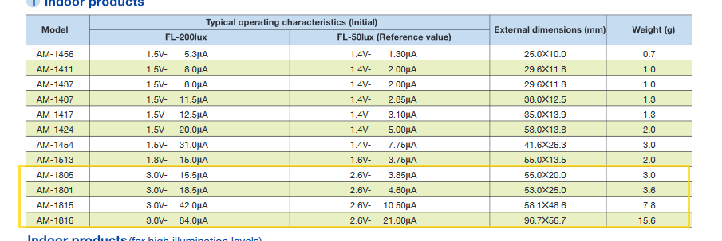

Will purchase the devices in the yellow boxes. There are optimized for indoor light levels and stay within voltage range, and will provide enough current at target lux levels (<100lux).