
IT HELPDESK
TICKET SYSTEM

MISY1102

Advanced Java for Information Management
Project Report-1

SPRING-2026
GROUP MEMBERS:
Ahmet Furkan Poyraz 23MISY1046
SİNA toprak gÜleÇ 23MISY1053

CONTENT
Abstract 2
1. Introduction 3
1.1 Problem Definition 3
1.2 Project Scope 3
1.3 Objectives 3
2. System Analysis 4
2.1 Functional Requirements 4
2.2 Non-Functional Requirements 4
2.3 Use Case Explanation 5
3. Domain Model & UML 6
3.1 UML Class Diagram 6
3.2 Explanation of Domain Classes 6
3.3 Layer Responsibilities 7
4. Architecture Design 8
4.1 Layered Architecture Explanation 8
4.2 MVC Structure 8
4.3 DAO Pattern Usage 8
5. Desktop Application (Phase 1) 9
5.1 Swing Structure 9
5.2 CRUD Screens 9
5.3 JDBC Integration 10
5.4 Screenshots 11
6. Database Design 13
6.1 ER Diagram 13
6.2 Table Structures 13
users 13
tickets 14
comments 14
Other Tables 15
6.3 SQL Scripts 15
7. Testing & Validation 17
7.1 Test Scenarios 17
TicketDAOImplTest (8 test cases) 17
UserDAOImplTest (7 test cases) 17
AuthServiceImplTest (6 test cases) 18
UserServiceImplTest (9 test cases) 18
7.2 Sample Outputs 18
7.3 Error Handling Cases 19
8. Discussion 20
8.1 Reusability Analysis 20
8.2 Challenges Faced 20
9. Conclusion 21
9.1 Achievements 21
9.2 Future Improvements 21
References (APA Format) 22

Abstract
In this project, we built an IT Helpdesk Ticket System as a university course assignment. The main idea is to give organizations a way to handle technical support requests in an organized manner, tracking each ticket from the moment it is created until it gets resolved and closed. We used Java 21 with Spring Boot 3.2 and split the project into four Maven modules: domain, persistence, application, and desktop. The persistence layer uses the DAO pattern with plain JDBC to talk to the database, and the desktop module is a Java Swing GUI where users can actually interact with the system. There are four user roles (Admin, Supervisor, Agent, and Customer) with different permissions, and tickets can be categorized and prioritized based on ITIL guidelines. We also added basic SLA tracking so that response and resolution times can be monitored. On the database side, we went with MySQL 8.0 and designed a normalized schema with eleven tables. We wrote 30 tests in total to make sure the core functionality works as expected. This report goes through the full process: system analysis, domain modeling, architecture, database design, testing, and the challenges we ran into along the way.

1. Introduction

1.1 Problem Definition
Organizations of all sizes face the challenge of managing and resolving IT-related issues reported by their employees, customers, or end users. Without a centralized system, support requests are often communicated through informal channels such as emails, phone calls, or in-person conversations. This lack of structure leads to lost requests, inconsistent response times, duplicated effort, and an inability to track or measure the quality of IT service delivery. A well-designed helpdesk ticket system addresses these problems by providing a unified platform where support requests are logged, categorized, assigned, tracked, and ultimately resolved in a transparent and measurable way.

1.2 Project Scope
This project encompasses the development of a desktop-based IT Helpdesk Ticket System using Java, Spring Boot, and Swing. The scope includes user authentication and session management; ticket creation, assignment, status tracking, and closure; role-based access control with four user roles; category-based ticket classification; SLA-aware priority management; a relational database schema with MySQL; and a Java Swing desktop client for user interaction. The project follows a multi-module Maven structure to enforce architectural separation. This project focuses on the desktop application with JDBC-based persistence.

1.3 Objectives
The primary objectives are: to design and implement a layered software architecture separating domain logic, data access, application services, and user interface into independent modules; to apply the DAO design pattern for database operations; to build a functional Java Swing desktop application supporting full CRUD operations; to implement role-based access control; to design a normalized relational database schema; to write unit tests validating data access and business logic; and to document the system comprehensively.

2. System Analysis

2.1 Functional Requirements
The system satisfies the following functional requirements:
ID | Requirement | Description
FR-01 | User Authentication | Users must log in with username and password to access the system.
FR-02 | Ticket Creation | Authenticated users can create new support tickets with title, description, category, and priority.
FR-03 | Ticket Listing | Users can view a list of tickets based on their role and permissions.
FR-04 | Ticket Assignment | Agents and admins can assign tickets to specific agents or groups.
FR-05 | Status Management | Ticket status can be updated through the lifecycle: NEW, OPEN, IN_PROGRESS, PENDING, RESOLVED, CLOSED.
FR-06 | Comment System | Users can add comments to tickets, with support for internal notes visible only to agents.
FR-07 | Role-Based Access | System enforces permissions based on four roles: Admin, Supervisor, Agent, Customer.
FR-08 | User Management | Admins can create, update, and deactivate user accounts.
FR-09 | Category Management | Tickets are classified under predefined categories for routing and reporting.
FR-10 | Ticket Deletion | Admins can delete tickets from the system permanently.
Table 1: Functional Requirements

2.2 Non-Functional Requirements
ID | Requirement | Description
NFR-01 | Performance | The system should load ticket lists within 2 seconds for up to 10,000 records.
NFR-02 | Security | Passwords must be stored as hashes. Session management must prevent unauthorized access.
NFR-03 | Maintainability | Modular architecture with separated concerns to facilitate future changes.
NFR-04 | Portability | The desktop application must run on any platform with Java 21 JRE installed.
NFR-05 | Reliability | Database transactions must ensure data consistency. Proper error handling must prevent data corruption.
NFR-06 | Usability | The Swing UI should be intuitive, requiring minimal training for end users.
NFR-07 | Scalability | Database schema should support future expansion to web-based interfaces and REST APIs.
Table 2: Non-Functional Requirements

2.3 Use Case Explanation
The primary use cases of the system are organized around the four actor roles:
Customer: The customer logs into the system, creates a new ticket describing their issue, and tracks the progress of their submitted tickets. They can add comments to provide additional information and view the resolution once the ticket is resolved.
Agent: The agent views tickets assigned to them or to their group. They update the ticket status as they work on it, add internal comments for team communication, set the ticket to PENDING if awaiting customer input, and mark it as RESOLVED once the issue is fixed.
Supervisor: The supervisor monitors all tickets within their group, reassigns tickets between agents for workload balancing, reviews SLA compliance, and generates reports on team performance metrics.
Admin: The admin has full system access. They manage user accounts, define roles and permissions, configure categories and groups, and can delete tickets.

3. Domain Model & UML

3.1 UML Class Diagram
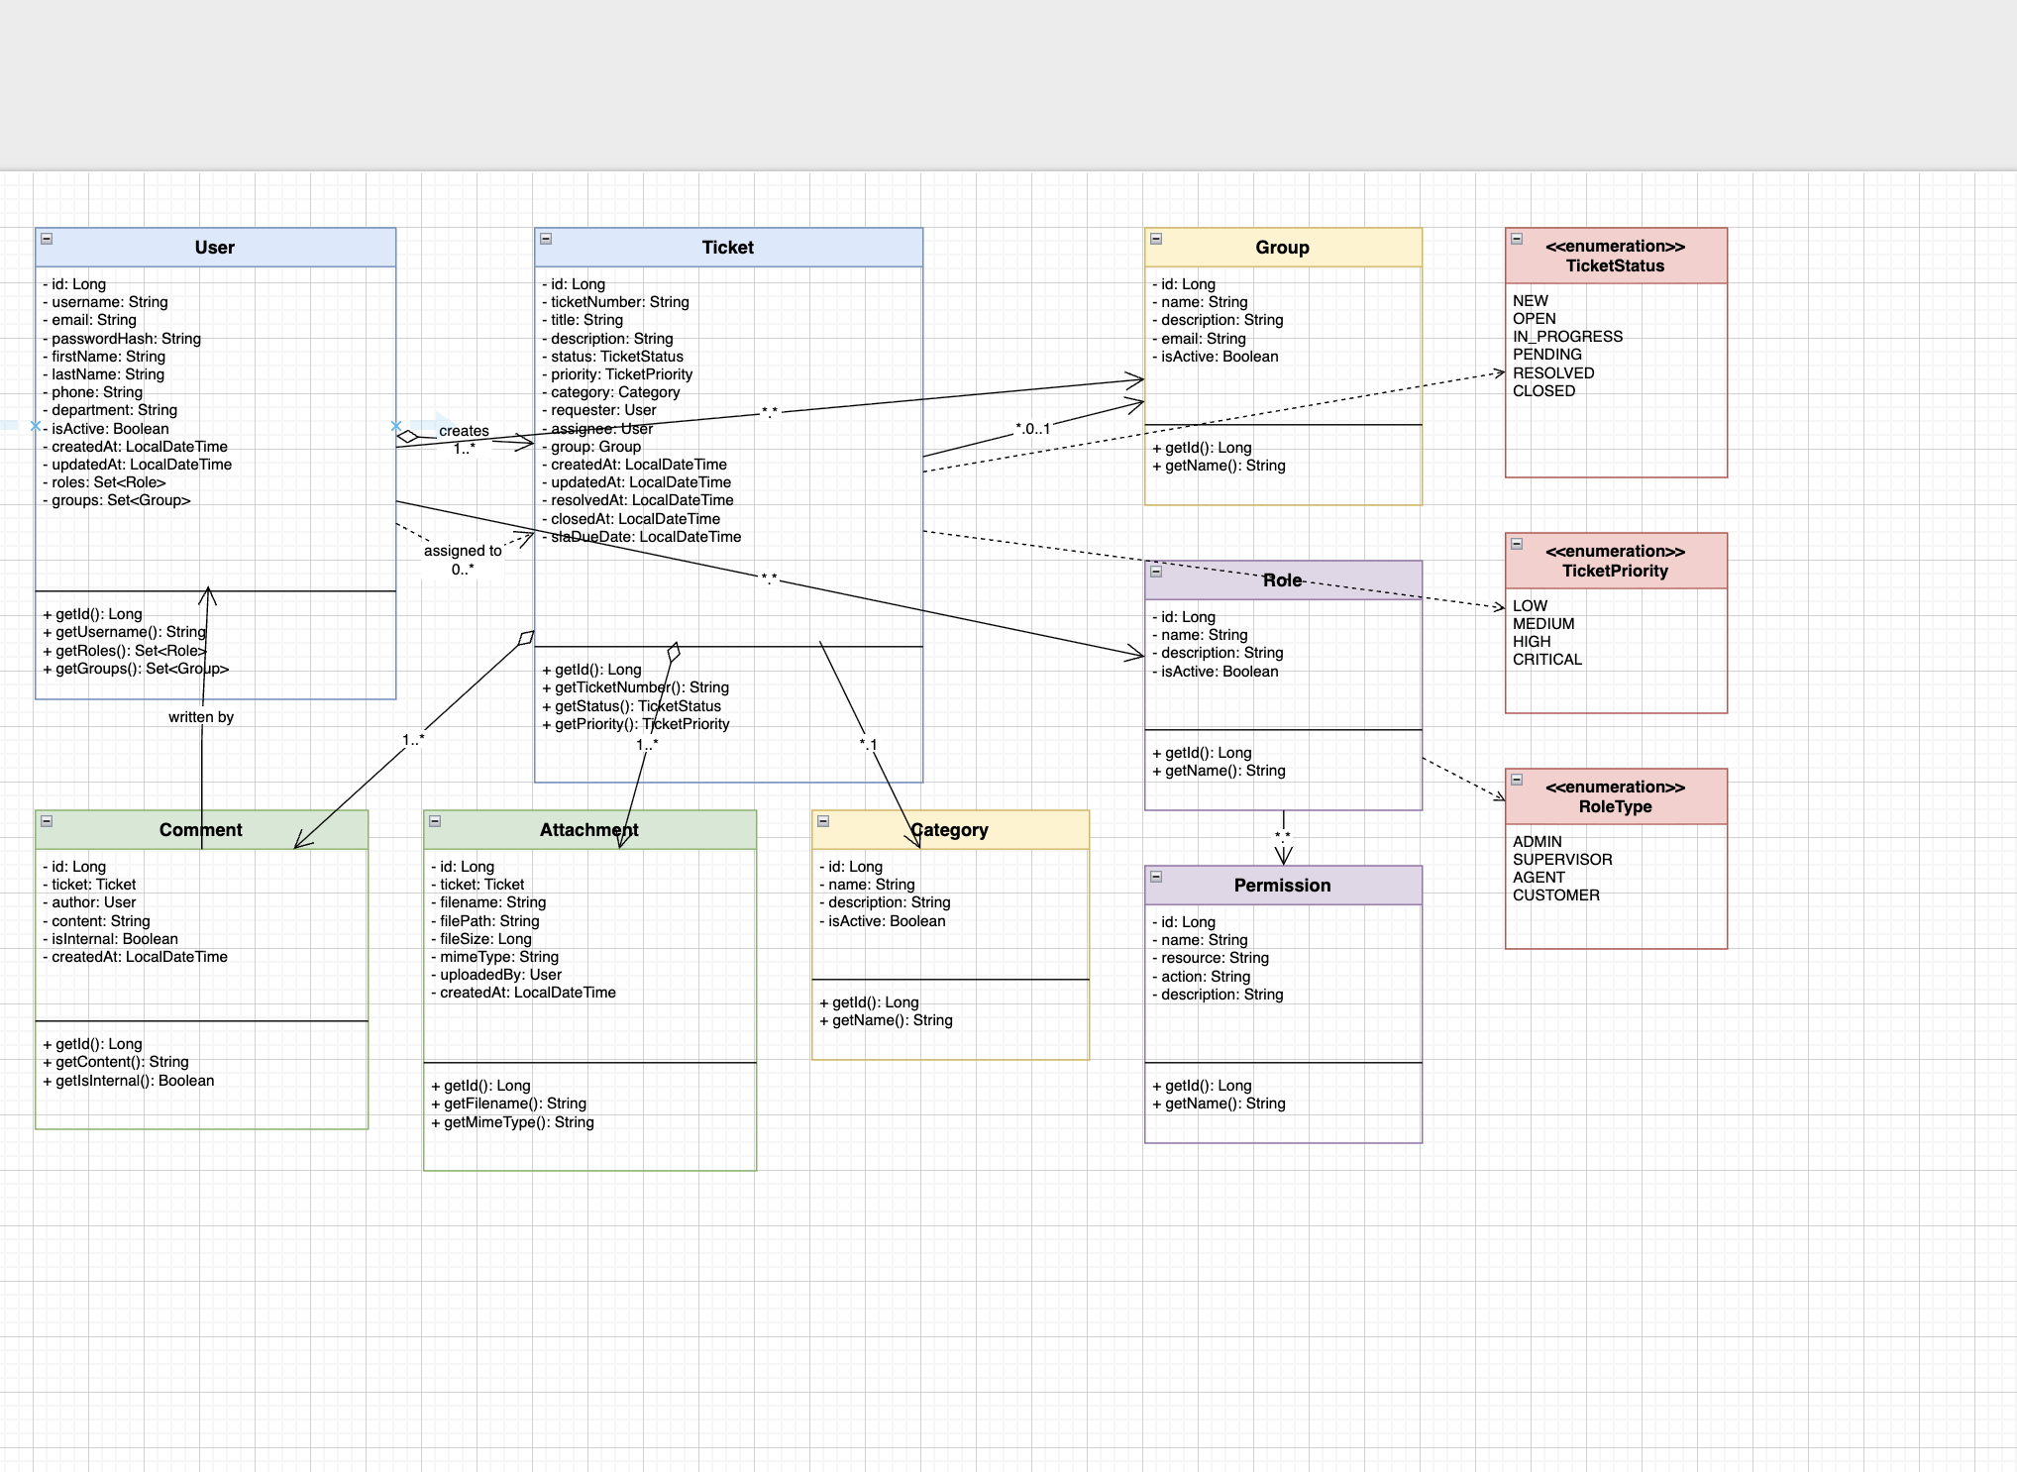
Figure 1: UML Class Diagram

3.2 Explanation of Domain Classes
The domain model consists of eight entity classes in the helpdesk-domain module, all pure Java POJOs with no framework dependencies:
Class | Purpose | Key Attributes
User | Represents all system users. | id, username, email, passwordHash, firstName, lastName, roles (Set), groups (Set)
Ticket | Core entity for support requests. | id, ticketNumber, title, description, status, priority, category, requester, assignee, group, slaDueDate
Comment | Stores comments and internal notes. | id, ticket, author, content, isInternal, createdAt
Attachment | Manages file attachments. | id, ticket, filename, filePath, fileSize, mimeType, uploadedBy
Category | Defines classification categories. | id, name, description, isActive
Group | Represents organizational teams. | id, name, description, email, isActive
Role | Defines system roles. | id, name, description, isActive
Permission | Granular permissions for roles. | id, name, resource, action, description
Table 3: Domain Entity Classes

3.3 Layer Responsibilities
Layer (Module) | Responsibility | Dependencies
Domain (helpdesk-domain) | Entity classes, enums (TicketStatus, TicketPriority, RoleType), custom exceptions. Zero external dependencies. | None (pure Java)
Persistence (helpdesk-persistence) | DAO pattern for database access. DAO interfaces and JDBC-based implementations using Spring JdbcTemplate. | Domain, Spring JDBC
Application (helpdesk-application) | Business logic in service classes, DTOs for data transfer, mappers for entity-DTO conversion. | Domain, Persistence
Desktop (helpdesk-desktop) | Swing-based UI with login and dashboard screens, controllers bridging UI to services. | All modules, Spring Boot
Table 4: Layer Responsibilities

4. Architecture Design

4.1 Layered Architecture Explanation
The system follows a strict layered architecture where each layer communicates only with the layer directly below it. This is enforced at the build level through Maven module dependencies. The Desktop module depends on Application, which depends on Persistence, which depends on Domain. The Domain module has no outward dependencies, making it the most stable and reusable component.

4.2 MVC Structure
Component | Package | Classes | Role
Model | com.helpdesk.domain.entity | Ticket, User, Comment, etc. | Domain entities representing business data and state.
View | com.helpdesk.desktop.view | LoginFrame, DashboardFrame | Swing JFrame classes rendering the user interface.
Controller | com.helpdesk.desktop.controller | AuthController, TicketController | Mediates between views and services.
Table 5: MVC Components

4.3 DAO Pattern Usage
The Data Access Object (DAO) pattern is the primary data access strategy. Each entity has a corresponding DAO interface defining standard CRUD operations. The implementation classes use Spring JdbcTemplate with parameterized SQL queries, custom RowMapper implementations for result set mapping, and proper null handling for nullable foreign keys. The TicketDAO interface defines: findById, findByTicketNumber, findAll, findByRequesterId, findByAssigneeId, findByStatus, findByGroupId, findByCategoryId, save, update, and deleteById.

5. Desktop Application (Phase 1)

5.1 Swing Structure
The desktop application is built using Java Swing and launched via Spring Boot. The DesktopApplication class sets java.awt.headless to false and bootstraps the Spring context. The application launches LoginFrame on the EDT using SwingUtilities.invokeLater. LoginFrame (350x220 pixels) provides username/password fields with error feedback. DashboardFrame (900x600 pixels) shows a JTable with ticket data, refresh and logout buttons.

5.2 CRUD Screens
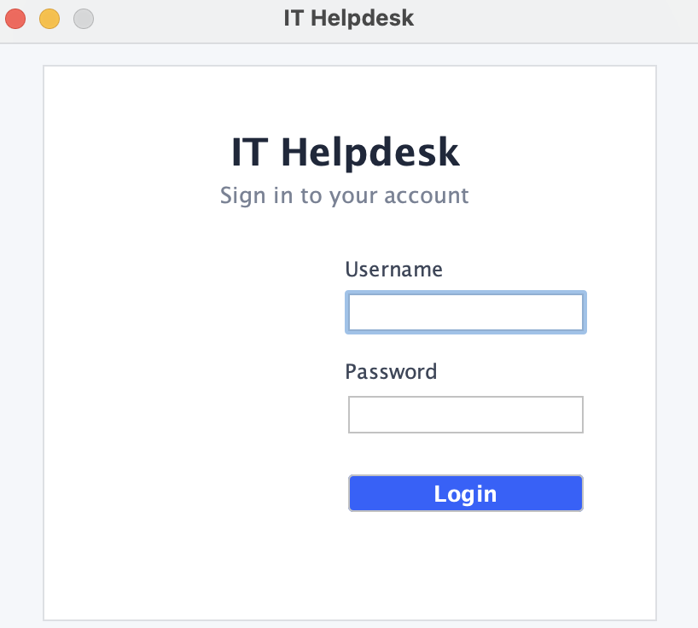
Figure 2: Login Screen
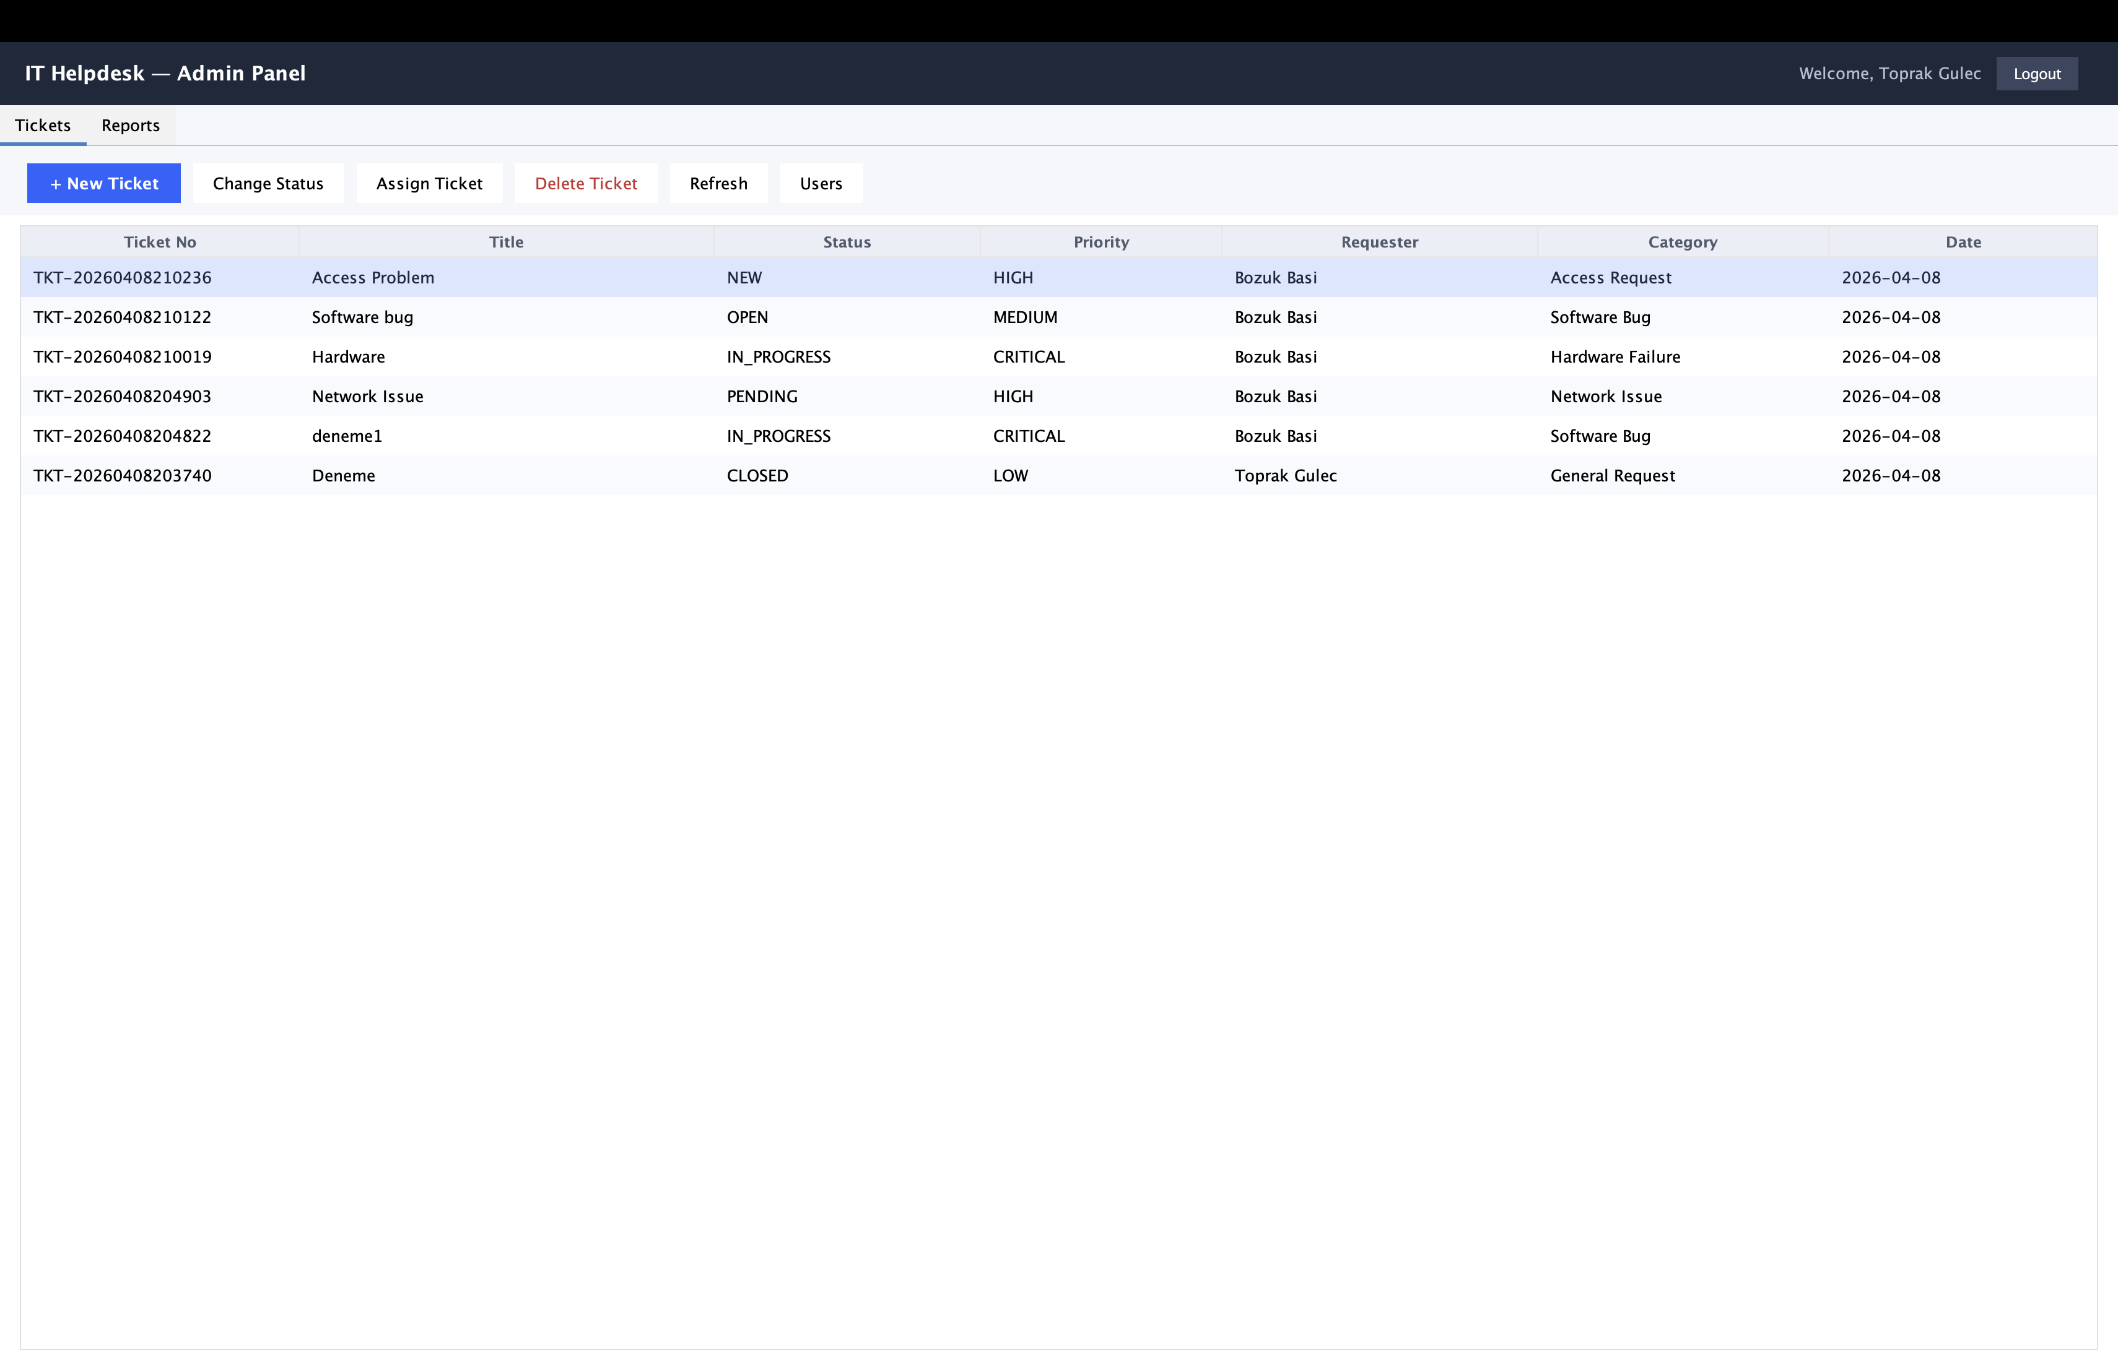Figure 3: Dashboard Screen

5.3 JDBC Integration
The persistence layer uses Spring JdbcTemplate for all database operations. Spring Boot auto-configures a DataSource from application.properties. SQL queries use parameterized strings to prevent injection. The KeyHolder mechanism captures auto-generated primary keys. Custom RowMapper implementations handle ResultSet to domain object mapping with proper null handling for optional foreign keys.

5.4 Screenshots
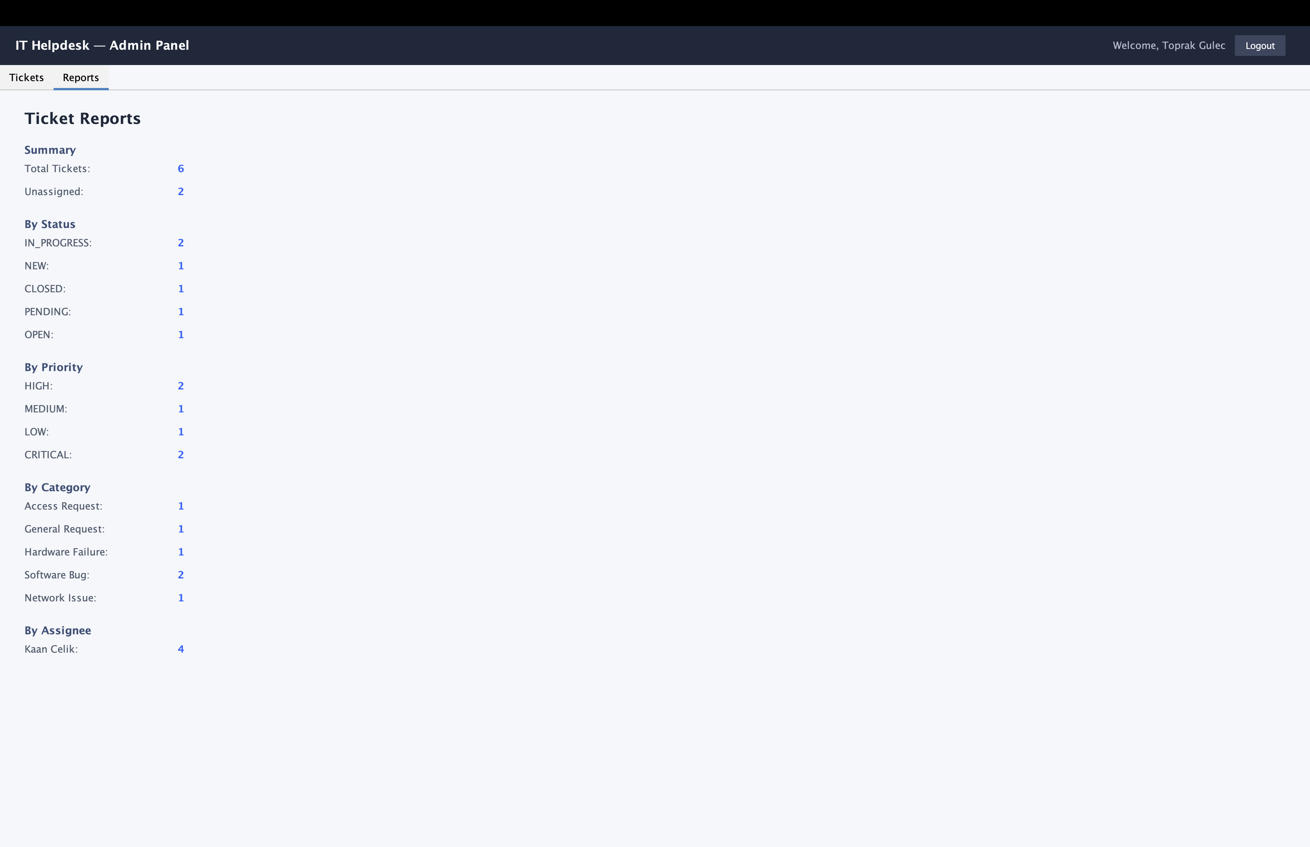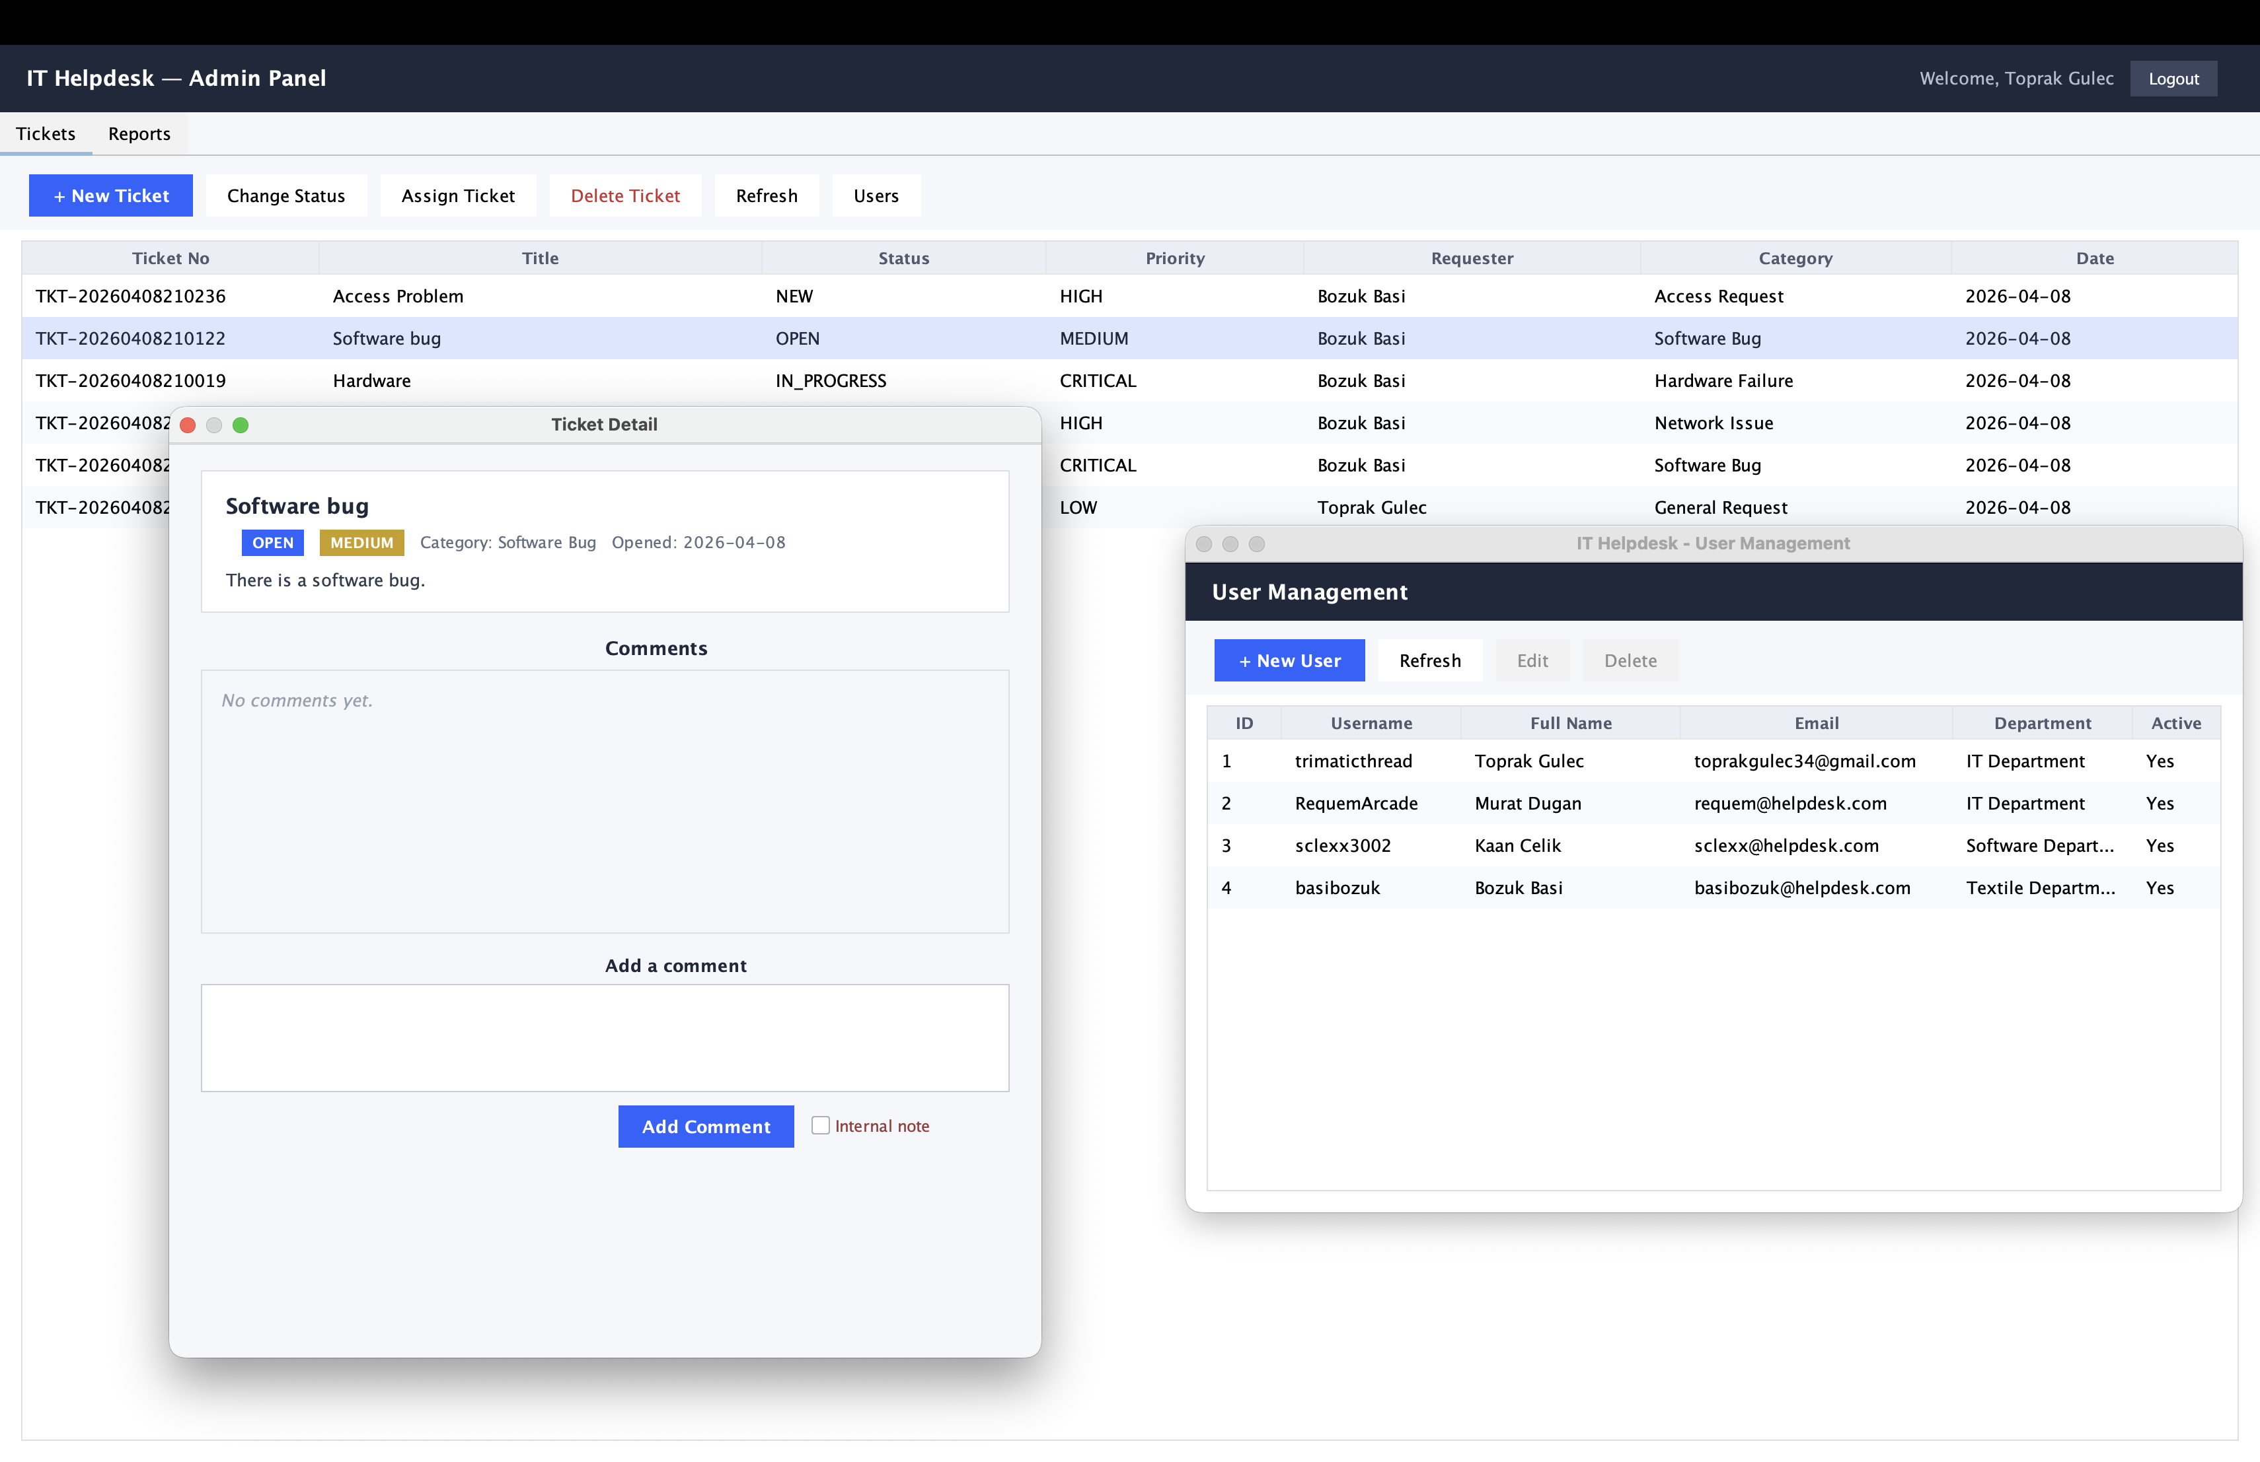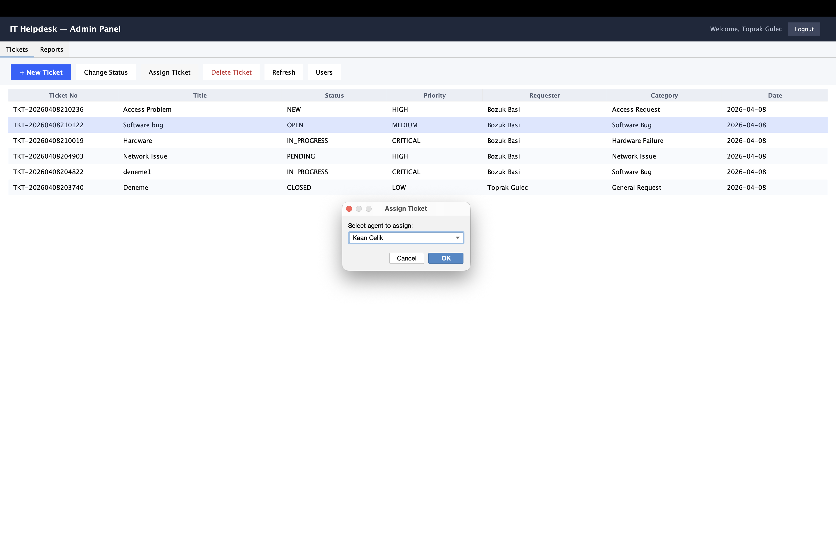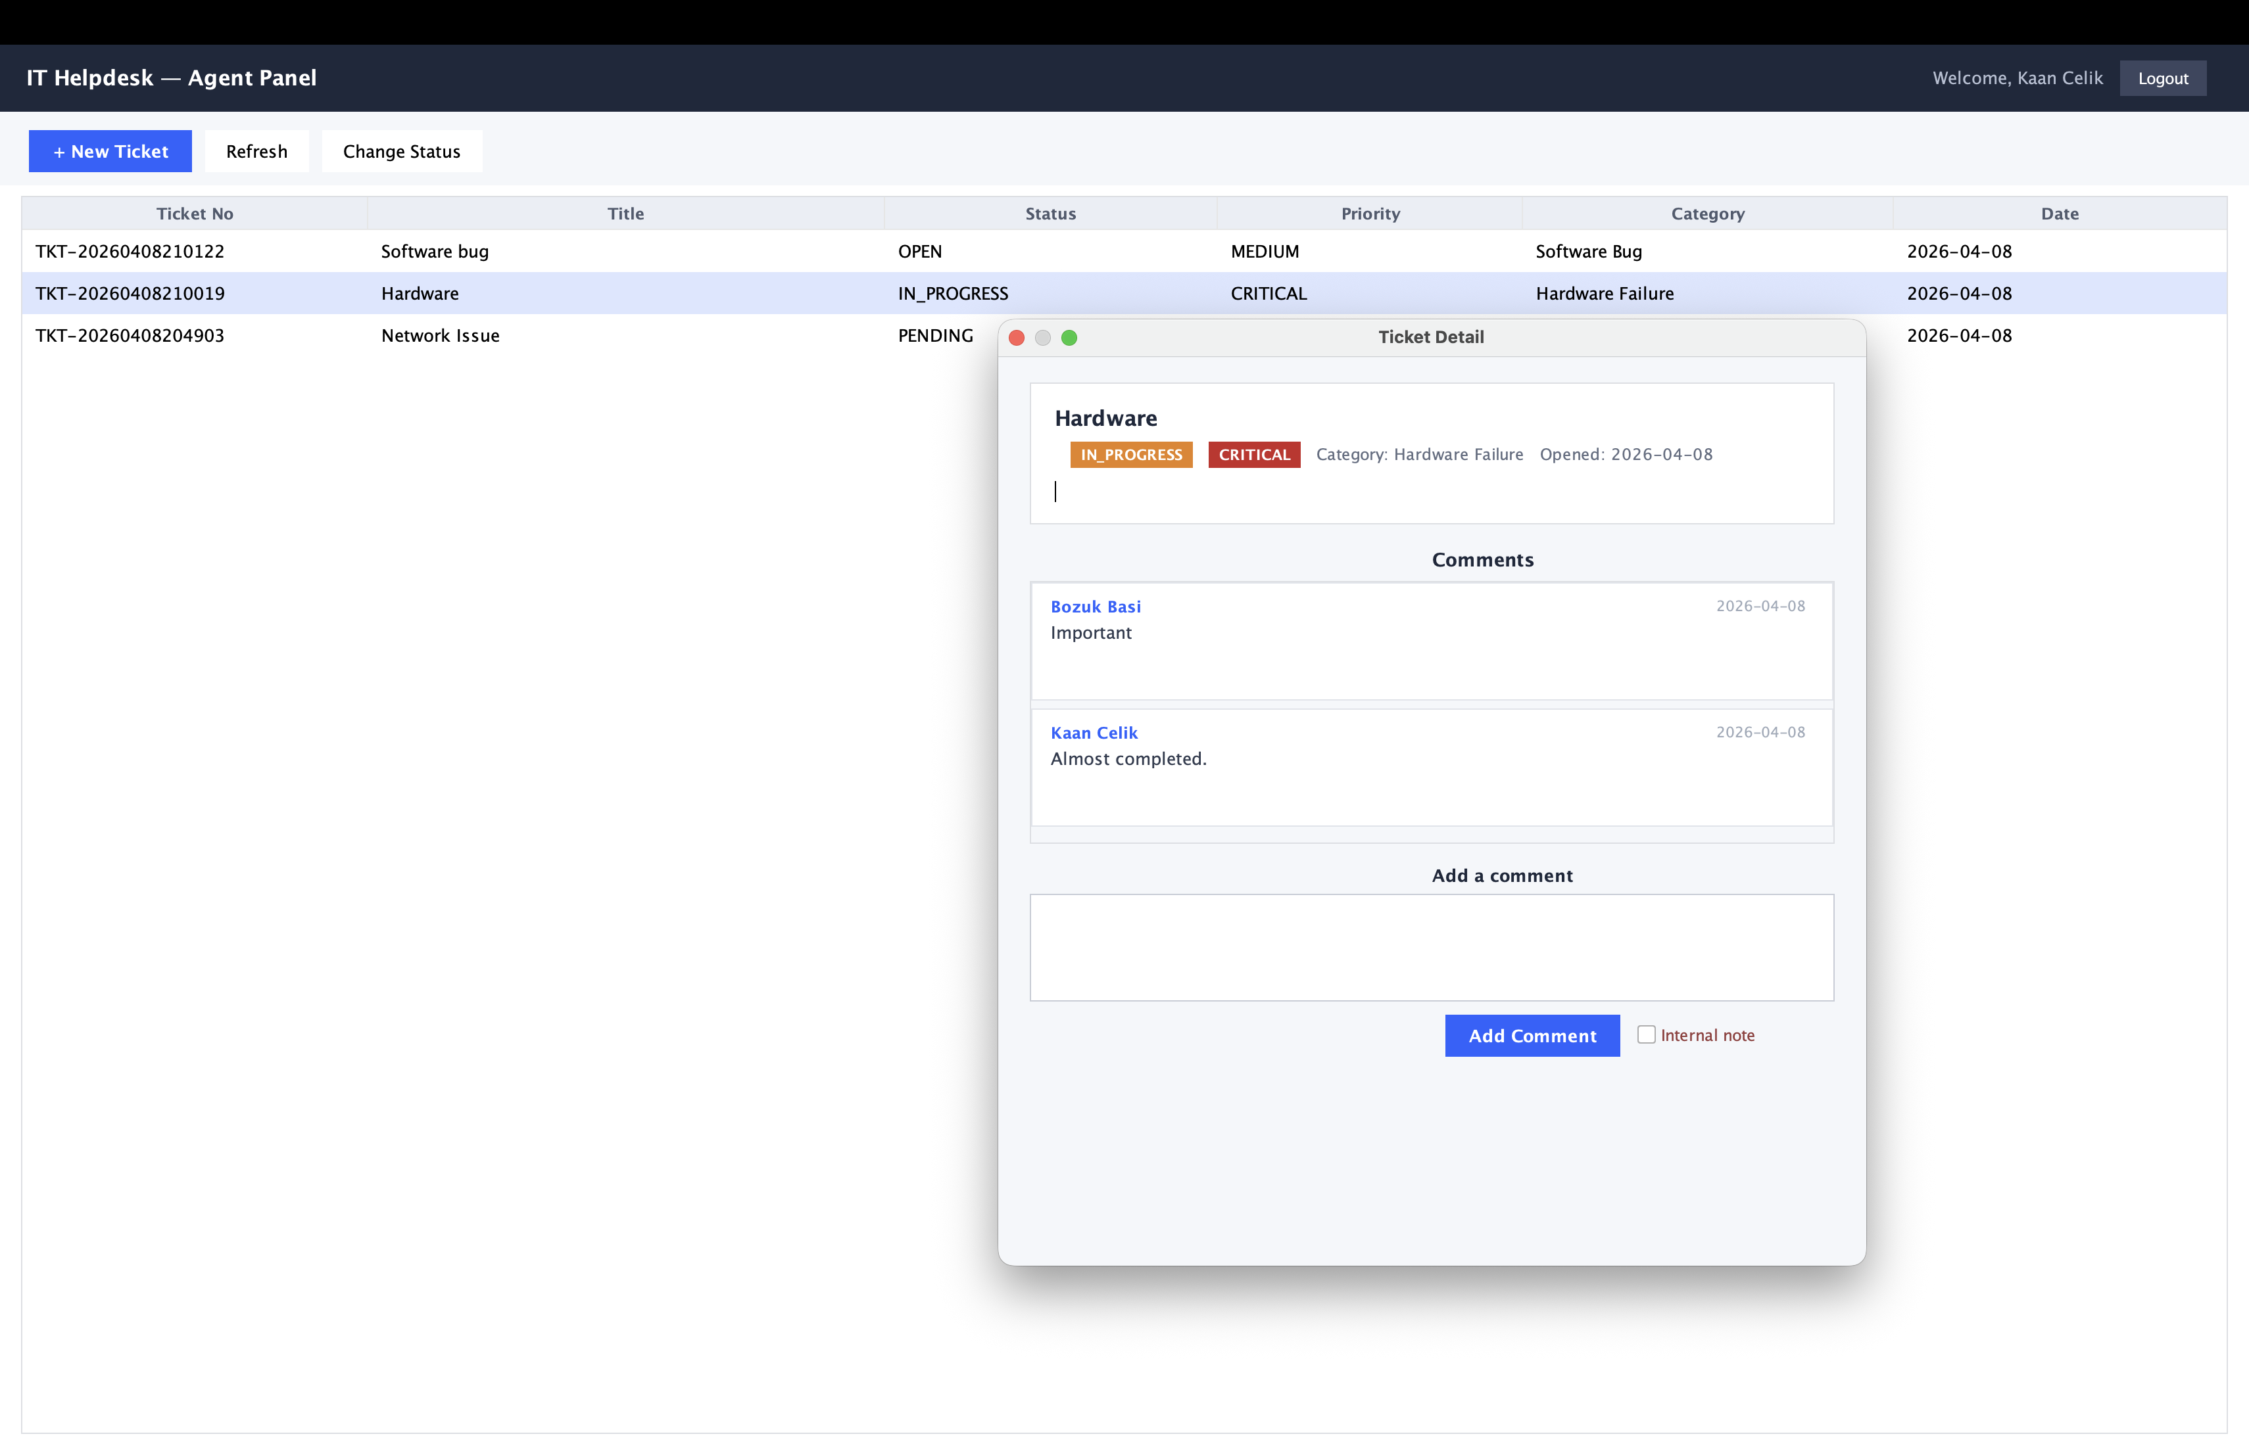
Figure 8: Agent Dashboard with Ticket Detail
Figure 7: Assign Ticket Dialog
Figure 6: Ticket Detail and User Management
Figure 5: Admin Reports Tab

6. Database Design

6.1 ER Diagram
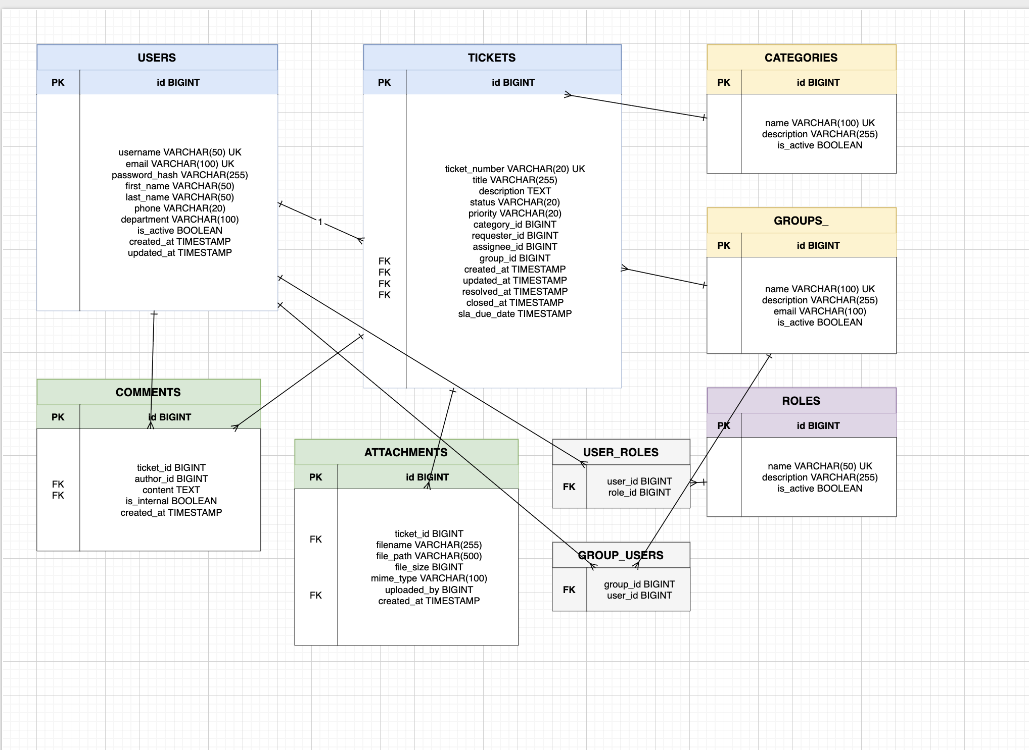Figure 4: Entity-Relationship Diagram

6.2 Table Structures

users
Column | Type | Constraints
id | BIGINT | PK, AUTO_INCREMENT
username | VARCHAR(50) | NOT NULL, UNIQUE
email | VARCHAR(100) | NOT NULL, UNIQUE
password_hash | VARCHAR(255) | NOT NULL
first_name | VARCHAR(50) | NOT NULL
last_name | VARCHAR(50) | NOT NULL
phone | VARCHAR(20) | NULLABLE
department | VARCHAR(100) | NULLABLE
is_active | BOOLEAN | DEFAULT TRUE
created_at | TIMESTAMP | DEFAULT CURRENT_TIMESTAMP
Table 6: users

tickets
Column | Type | Constraints
id | BIGINT | PK, AUTO_INCREMENT
ticket_number | VARCHAR(20) | NOT NULL, UNIQUE
title | VARCHAR(255) | NOT NULL
description | TEXT | NOT NULL
status | VARCHAR(20) | DEFAULT 'NEW'
priority | VARCHAR(20) | DEFAULT 'MEDIUM'
category_id | BIGINT | FK -> categories
requester_id | BIGINT | FK -> users, NOT NULL
assignee_id | BIGINT | FK -> users, NULLABLE
group_id | BIGINT | FK -> groups, NULLABLE
created_at | TIMESTAMP | DEFAULT CURRENT_TIMESTAMP
sla_due_date | TIMESTAMP | NULLABLE
Table 7: tickets

comments
Column | Type | Constraints
id | BIGINT | PK, AUTO_INCREMENT
ticket_id | BIGINT | FK -> tickets, NOT NULL
author_id | BIGINT | FK -> users, NOT NULL
content | TEXT | NOT NULL
is_internal | BOOLEAN | DEFAULT FALSE
created_at | TIMESTAMP | DEFAULT CURRENT_TIMESTAMP
Table 8: comments

Other Tables

roles
Column | Type | Constraints
id | BIGINT | PK, AUTO_INCREMENT
name | VARCHAR(50) | NOT NULL, UNIQUE
description | VARCHAR(255) | NULLABLE
is_active | BOOLEAN | DEFAULT TRUE
Table 9: roles

categories
Column | Type | Constraints
id | BIGINT | PK, AUTO_INCREMENT
name | VARCHAR(100) | NOT NULL, UNIQUE
description | VARCHAR(255) | NULLABLE
is_active | BOOLEAN | DEFAULT TRUE
Table 10: categories

groups_
Column | Type | Constraints
id | BIGINT | PK, AUTO_INCREMENT
name | VARCHAR(100) | NOT NULL, UNIQUE
description | VARCHAR(255) | NULLABLE
email | VARCHAR(100) | NULLABLE
is_active | BOOLEAN | DEFAULT TRUE
Table 11: groups_

attachments
Column | Type | Constraints
id | BIGINT | PK, AUTO_INCREMENT
ticket_id | BIGINT | FK -> tickets, NOT NULL
filename | VARCHAR(255) | NOT NULL
file_path | VARCHAR(500) | NOT NULL
file_size | BIGINT | NOT NULL
mime_type | VARCHAR(100) | NOT NULL
uploaded_by | BIGINT | FK -> users, NOT NULL
created_at | TIMESTAMP | DEFAULT CURRENT_TIMESTAMP
Table 12: attachments

permissions
Column | Type | Constraints
id | BIGINT | PK, AUTO_INCREMENT
name | VARCHAR(100) | NOT NULL, UNIQUE
resource | VARCHAR(100) | NOT NULL
action | VARCHAR(50) | NOT NULL
description | VARCHAR(255) | NULLABLE
Table 13: permissions

Junction Tables
Column | Constraints
user_id (BIGINT) | FK -> users, NOT NULL
role_id (BIGINT) | FK -> roles, NOT NULL
PRIMARY KEY | (user_id, role_id)
Table 14: user_roles
Column | Constraints
group_id (BIGINT) | FK -> groups_, NOT NULL
user_id (BIGINT) | FK -> users, NOT NULL
PRIMARY KEY | (group_id, user_id)
Table 15: group_users
Column | Constraints
role_id (BIGINT) | FK -> roles, NOT NULL
permission_id (BIGINT) | FK -> permissions, NOT NULL
PRIMARY KEY | (role_id, permission_id)
Table 16: role_permissions

6.3 SQL Scripts
CREATE TABLE IF NOT EXISTS roles (
id BIGINT AUTO_INCREMENT PRIMARY KEY,
name VARCHAR(50) NOT NULL UNIQUE,
description VARCHAR(255),
is_active BOOLEAN DEFAULT TRUE
);

CREATE TABLE IF NOT EXISTS groups_ (
id BIGINT AUTO_INCREMENT PRIMARY KEY,
name VARCHAR(100) NOT NULL UNIQUE,
description VARCHAR(255),
email VARCHAR(100),
is_active BOOLEAN DEFAULT TRUE
);

CREATE TABLE IF NOT EXISTS categories (
id BIGINT AUTO_INCREMENT PRIMARY KEY,
name VARCHAR(100) NOT NULL UNIQUE,
description VARCHAR(255),
is_active BOOLEAN DEFAULT TRUE
);

CREATE TABLE IF NOT EXISTS users (
id BIGINT AUTO_INCREMENT PRIMARY KEY,
username VARCHAR(50) NOT NULL UNIQUE,
email VARCHAR(100) NOT NULL UNIQUE,
password_hash VARCHAR(255) NOT NULL,
first_name VARCHAR(50) NOT NULL,
last_name VARCHAR(50) NOT NULL,
phone VARCHAR(20),
department VARCHAR(100),
is_active BOOLEAN DEFAULT TRUE,
created_at TIMESTAMP DEFAULT CURRENT_TIMESTAMP,
updated_at TIMESTAMP DEFAULT CURRENT_TIMESTAMP
);

CREATE TABLE IF NOT EXISTS tickets (
id BIGINT AUTO_INCREMENT PRIMARY KEY,
ticket_number VARCHAR(20) NOT NULL UNIQUE,
title VARCHAR(255) NOT NULL,
description TEXT NOT NULL,
status VARCHAR(20) DEFAULT ‘NEW’,
priority VARCHAR(20) DEFAULT ‘MEDIUM’,
category_id BIGINT,
requester_id BIGINT NOT NULL,
assignee_id BIGINT,
group_id BIGINT,
created_at TIMESTAMP DEFAULT CURRENT_TIMESTAMP,
updated_at TIMESTAMP DEFAULT CURRENT_TIMESTAMP,
resolved_at TIMESTAMP NULL,
closed_at TIMESTAMP NULL,
sla_due_date TIMESTAMP NULL,
FOREIGN KEY (category_id) REFERENCES categories(id),
FOREIGN KEY (requester_id) REFERENCES users(id),
FOREIGN KEY (assignee_id) REFERENCES users(id),
FOREIGN KEY (group_id) REFERENCES groups_(id)
);

CREATE TABLE IF NOT EXISTS comments (
id BIGINT AUTO_INCREMENT PRIMARY KEY,
ticket_id BIGINT NOT NULL,
author_id BIGINT NOT NULL,
content TEXT NOT NULL,
is_internal BOOLEAN DEFAULT FALSE,
created_at TIMESTAMP DEFAULT CURRENT_TIMESTAMP,
FOREIGN KEY (ticket_id) REFERENCES tickets(id),
FOREIGN KEY (author_id) REFERENCES users(id)
);

CREATE TABLE IF NOT EXISTS attachments (
id BIGINT AUTO_INCREMENT PRIMARY KEY,
ticket_id BIGINT NOT NULL,
filename VARCHAR(255) NOT NULL,
file_path VARCHAR(500) NOT NULL,
file_size BIGINT NOT NULL,
mime_type VARCHAR(100) NOT NULL,
uploaded_by BIGINT NOT NULL,
created_at TIMESTAMP DEFAULT CURRENT_TIMESTAMP,
FOREIGN KEY (ticket_id) REFERENCES tickets(id),
FOREIGN KEY (uploaded_by) REFERENCES users(id)
);

CREATE TABLE IF NOT EXISTS user_roles (
user_id BIGINT NOT NULL,
role_id BIGINT NOT NULL,
PRIMARY KEY (user_id, role_id),
FOREIGN KEY (user_id) REFERENCES users(id),
FOREIGN KEY (role_id) REFERENCES roles(id)
);

CREATE TABLE IF NOT EXISTS group_users (
group_id BIGINT NOT NULL,
user_id BIGINT NOT NULL,
PRIMARY KEY (group_id, user_id),
FOREIGN KEY (group_id) REFERENCES groups_(id),
FOREIGN KEY (user_id) REFERENCES users(id)
);

CREATE TABLE IF NOT EXISTS permissions (
id BIGINT AUTO_INCREMENT PRIMARY KEY,
name VARCHAR(100) NOT NULL UNIQUE,
resource VARCHAR(100) NOT NULL,
action VARCHAR(50) NOT NULL,
description VARCHAR(255)
);

CREATE TABLE IF NOT EXISTS role_permissions (
role_id BIGINT NOT NULL,
permission_id BIGINT NOT NULL,
PRIMARY KEY (role_id, permission_id),
FOREIGN KEY (role_id) REFERENCES roles(id),
FOREIGN KEY (permission_id) REFERENCES permissions(id)
);
Code 1: Database Schema (db/init.sql)

7. Testing & Validation

7.1 Test Scenarios
The project includes 30 tests: 15 integration tests in the persistence layer using Spring Boot Test with a real MySQL 8.0 database running in Docker, and 15 unit tests in the application layer using Mockito to isolate business logic from the data access layer.

TicketDAOImplTest (8 test cases)
Test Method | Scenario | Assertion
save_should_assign_generated_id | Save ticket, verify auto-generated ID. | assertNotNull(id), assertTrue(id > 0)
find_by_id_should_return_correct_ticket | Find ticket by primary key. | assertTrue(present), assertEquals ticketNumber
find_by_ticket_number_should_return_correct_ticket | Find by unique ticket number. | assertTrue(present), assertEquals title
find_by_nonexistent_id_should_return_empty | Search for non-existent ID. | assertFalse(present)
find_by_requester_id_should_return_all_requester_tickets | List tickets by requester. | assertEquals(2, tickets.size())
find_by_status_should_return_only_matching_tickets | Filter by NEW status. | All tickets have NEW status
update_should_persist_changed_fields | Update title and status. | assertEquals new title, IN_PROGRESS
delete_by_id_should_remove_ticket | Delete ticket by ID. | assertFalse(findById present)
Table 9: Ticket DAO Tests

UserDAOImplTest (7 test cases)
Test Method | Scenario | Assertion
save_should_assign_generated_id | Save user, verify ID. | assertNotNull, assertTrue(id > 0)
find_by_id_should_return_correct_user | Find user by key. | assertTrue(present), assertEquals username
find_by_username_should_return_user | Find by username. | assertTrue(present)
find_by_nonexistent_id_should_return_empty | Non-existent user. | assertFalse(present)
find_all_should_return_all_saved_users | List all users. | assertEquals(2, size)
delete_by_id_should_remove_user | Delete user. | assertFalse(findById present)
exists_by_username_should_return_correct_result | Check username exists. | assertTrue / assertFalse
Table 10: User DAO Tests

AuthServiceImplTest (6 test cases)
Test Method | Scenario | Assertion
login_with_correct_password_should_succeed | Login with correct password. | assertTrue(present), assertEquals username
login_with_wrong_password_should_return_empty | Login with wrong password. | assertFalse(present)
find_by_nonexistent_id_should_return_empty | Login with non-existent user. | assertFalse(present)
login_with_inactive_account_should_return_empty | Login with inactive account. | assertFalse(present), verify encoder never called
login_should_load_role_into_dto | Role loaded into DTO on login. | assertEquals “ADMIN”
login_should_return_correct_full_name | Full name correct in DTO. | assertEquals “John Doe”
Table 11: Auth Service Tests

UserServiceImplTest (9 test cases)
Test Method | Scenario | Assertion
create_user_should_assign_role | Create user and assign role. | assertNotNull, verify assignRole called
save_should_hash_password_before_persisting | Password hashed before saving. | verify encode called, hash equals
find_by_id_should_return_correct_user | Find user by ID. | assertTrue(present), assertEquals username
find_by_nonexistent_id_should_return_empty | Find non-existent user. | assertFalse(present)
update_nonexistent_user_should_throw_exception | Update non-existent user. | assertThrows ResourceNotFoundException
delete_by_id_should_delegate_to_dao | Delete delegates to DAO. | verify deleteById called
exists_by_username_should_return_true_when_found | Username exists check. | assertTrue
exists_by_username_should_return_false_when_not_found | Username not found. | assertFalse
find_all_should_return_mapped_dtos | List all returns DTOs. | assertEquals(1, size)
Table 12: User Service Tests

7.2 Sample Outputs
-------------------------------------------------------
T E S T S
-------------------------------------------------------
Running com.helpdesk.persistence.dao.UserDAOImplTest
Tests run: 7, Failures: 0, Errors: 0, Skipped: 0, Time elapsed: 1.109 s
Running com.helpdesk.persistence.dao.TicketDAOImplTest
Tests run: 8, Failures: 0, Errors: 0, Skipped: 0, Time elapsed: 0.073 s
Results:
Tests run: 15, Failures: 0, Errors: 0, Skipped: 0
-------------------------------------------------------
T E S T S
-------------------------------------------------------
Running com.helpdesk.application.service.UserServiceImplTest
Tests run: 9, Failures: 0, Errors: 0, Skipped: 0, Time elapsed: 0.482 s
Running com.helpdesk.application.service.AuthServiceImplTest
Tests run: 6, Failures: 0, Errors: 0, Skipped: 0, Time elapsed: 0.009 s
Results:
Tests run: 15, Failures: 0, Errors: 0, Skipped: 0
BUILD SUCCESS
Total time: 2.648 s

7.3 Error Handling Cases
Exception | Extends | Usage
BusinessException | RuntimeException | General business rule violations such as invalid status transitions.
ResourceNotFoundException | BusinessException | Thrown when a requested entity does not exist in the database.
UnauthorizedException | BusinessException | Thrown when a user attempts an action without permission.
Table 17: Custom Exception Hierarchy

8. Discussion

8.1 Reusability Analysis
The multi-module architecture significantly enhances reusability. The helpdesk-domain module (pure Java POJOs) can be reused in any Java project. The helpdesk-persistence module provides a clean DAO contract re-implementable with JPA, MyBatis, or NoSQL. The helpdesk-application module encapsulates business logic behind service interfaces, making it reusable across presentation layers. The same TicketService serves both the Swing client and a future REST API.

8.2 Challenges Faced
We ran into a number of issues while building this project. The biggest headache was getting the multi-module Maven setup to work properly. With four separate modules (domain, persistence, application, desktop), we had to be really careful about which module depends on which. If you get the order wrong in the parent POM, you end up with circular references and things just stop compiling.
Another tricky part was dealing with nullable foreign keys in the DAO layer. For example, a ticket might not have an assignee or a group assigned to it yet, so assignee_id and group_id can be NULL in the database. When we were writing the RowMapper code to convert ResultSet rows into Java objects, we had to check for nulls explicitly with ResultSet.wasNull(), otherwise the app would throw NullPointerExceptions.
Getting Spring Boot and Swing to play nicely together was also not straightforward. Swing needs the AWT Event Dispatch Thread to render UI components, but Spring Boot has its own startup lifecycle. We solved this by setting java.awt.headless to false in the DesktopApplication class and using SwingUtilities.invokeLater to launch the GUI only after Spring had finished loading everything.
For session management, we made a conscious trade-off. The SessionManager class stores the logged-in user in a static field, which means any Swing view can access it without needing Spring injection. It is not thread-safe, but since this is a desktop app used by one person at a time, it works fine for our purposes.
Implementing password security took some effort too. We used BCryptPasswordEncoder from Spring Security to hash passwords. The tricky part was making sure AuthServiceImpl checks the hashed password correctly during login, and UserServiceImpl hashes the raw password before saving a new user to the database.
For test isolation, we used the @Transactional annotation on all integration test classes. This means each test automatically rolls back its database changes when it finishes, so tests never interfere with each other. Since the tests connect to a real MySQL instance through Docker, we get reliable results that match production behavior exactly.

9. Conclusion

9.1 Achievements
This project delivered a functional IT Helpdesk Ticket System with: a four-module layered architecture; a complete DAO-based persistence layer with JDBC; a functional Java Swing desktop application; a comprehensive RBAC model with four roles; a normalized database schema with eleven tables; and 30 tests (15 integration tests and 15 unit tests) validating persistence, business logic, authentication, and user management.

9.2 Future Improvements
There are a few things we would like to improve in future versions. The most obvious one is replacing the Swing desktop client with a web-based frontend, probably using React or Angular. That way, users could access the helpdesk from a browser without needing Java installed on their machine.
We would also like to switch from raw JDBC to Spring Data JPA for the persistence layer. Writing SQL queries by hand works, but JPA would save a lot of boilerplate code and make the entity mappings much cleaner.
Adding a notification system would be a nice improvement as well. For example, sending an email when a ticket status changes or when an SLA deadline is approaching. We could use JavaMail for email alerts and WebSockets for real-time notifications in a future web version.
The reporting side could use more work too. Right now the Admin dashboard shows basic stats, but it would be much more useful to have actual charts showing things like ticket volume over time, average resolution times, and how well the team is meeting SLA targets.
Security-wise, we would want to move to JWT-based authentication if we build the web version. The current static SessionManager works for a desktop app, but a web app would need proper stateless session handling. OAuth 2.0 support would also be nice for integrating with corporate login systems like Active Directory.
Lastly, a knowledge base feature where agents can save solutions to common problems would be really helpful. Customers could search it before opening a new ticket, which would reduce the overall ticket volume.

References (APA Format)
Oracle. (2024). JDK 21 Documentation. https://docs.oracle.com/en/java/javase/21/
Oracle. (2024). JDK 21 Documentation. Oracle. (2024). Java SE 21 API Specification. https://docs.oracle.com/en/java/javase/21/docs/api/index.html
Oracle. (2024). JDK 21 Documentation. Oracle. (2024). Swing Package Reference. https://docs.oracle.com/en/java/javase/21/docs/api/java.desktop/javax/swing/package-use.html
Oracle. (n.d.). JDBC with Swing Tutorial. https://docs.oracle.com/javase/tutorial/jdbc/basics/jdbcswing.html
MySQL. (2025). MySQL Documentation. https://dev.mysql.com/doc/
MySQL. (2025). MySQL Documentation. MySQL. (2025). Docker MySQL Getting Started. https://dev.mysql.com/doc/refman/9.6/en/docker-mysql-getting-started.html
Docker. (2025). Databases Guide. https://docs.docker.com/guides/databases/
Git. (2025). Git Documentation. https://git-scm.com/docs/git
JetBrains. (2025). DataGrip MySQL Features. https://www.jetbrains.com/datagrip/features/mysql/
GeeksforGeeks. (2024). Student Record System Using Java Swing. https://www.geeksforgeeks.org/java/student-record-system-using-java-swing/
Scribd. (n.d.). Block 4. https://www.scribd.com/document/424919904/Block-4
Docker Hub. (2025). DataGrip MSSQL Server. https://hub.docker.com/r/datagrip/mssql-server-linux

