CSPG4 RNA across sarcoma types with an expanded comparison of extraskeletal myxoid chondrosarcoma
Author. Tristan D. McRae
Independent researcher, unaffiliated. Correspondence: trimcrae@gmail.com. ORCID: 0000-0002-1823-1451.
Running title. Comparative CSPG4 RNA in EMC

Abstract
Background: Extraskeletal myxoid chondrosarcoma (EMC) is a rare soft-tissue sarcoma. Chondroitin sulfate proteoglycan 4 (CSPG4) is a cell-surface protein whose expression has been studied across sarcoma types. We examined where EMC lies within a broader tissue RNA landscape and whether its differences from named sarcomas recur across datasets.
Methods: An exploratory extension of a fixed 11-gene analysis compared nine EMC specimens with 393 other specimens from 28 source-defined malignant tumor categories in one RNA-sequencing cohort. All 644 eligible specimens, including other tumor categories, remained in the descriptive atlas. We used an exact rank-sum permutation test with Bonferroni correction for 11 genes, retained the original array comparisons, and characterized additional public collections separately by source and measurement scale.
Results: Median CSPG4 was 54.18 TPM in EMC and 11.87 TPM in the defined malignant reference. The probability of higher EMC expression, allowing half credit for ties, was 0.846; exact two-sided P=0.000130 and adjusted P=0.00143. CSPG4 was higher than low-grade fibromyxoid sarcoma in both RNA sequencing and arrays, with comparison scores of 0.966 and 1.000. Gastrointestinal stromal tumors and dermatofibrosarcoma protuberans had slightly higher medians than EMC in the same RNA-sequencing source. External collections expanded histologic context but supplied no additional explicitly labeled EMC comparison.
Conclusions: These data place EMC toward the higher end of CSPG4 RNA expression within a defined sarcoma reference, with substantial overlap and comparator dependence. They support a broader comparative RNA account, without establishing diagnostic specificity, malignant-cell protein expression or therapeutic suitability.
Keywords. extraskeletal myxoid chondrosarcoma; CSPG4; sarcoma; RNA sequencing; public data; comparative expression

Introduction
Extraskeletal myxoid chondrosarcoma (EMC) is a rare soft-tissue sarcoma characteristically associated with NR4A3 rearrangements.[1] Public expression studies contain few EMC specimens, so comparisons often rely on a small selection of other sarcomas. A difference observed in those comparisons leaves an important question: where does EMC lie within the broader range of tumor types?
CSPG4 encodes a cell-surface proteoglycan studied across sarcomas. Boudin and colleagues described variation in its expression and associations with clinical and immune features in a large soft-tissue sarcoma collection.[2] An earlier fixed-panel analysis identified CSPG4 through comparisons of nine EMC specimens with myxoid liposarcoma, low-grade fibromyxoid sarcoma (LGFMS) and synovial sarcoma, with additional comparisons in an array cohort.[3,4,5]
Here, we expand the same-source reference to eligible source-defined malignant categories and examine how the result changes when intermediate tumors are included. We also compare tumor types shared across RNA sequencing and arrays and describe CSPG4 expression in additional public collections. These analyses place the available EMC specimens within a wider RNA expression landscape and distinguish recurring differences from patterns that depend on the chosen reference.

Methods

Study design and reference groups
This exploratory public-data reanalysis extends an earlier fixed 11-gene study.[4,6] We retained its specimen exclusions, gene panel and array-probe mappings. The broader comparison was specified on 19 September 2026 after the earlier findings were known. An amendment on 21 September specified bootstrap uncertainty and a reference including intermediate tumors before their computation. The supplement records the analysis chronology and original protocol.
The Hofvander collection provides gene-level transcripts per million (TPM), original diagnoses and specimen metadata.[3] We used the original diagnoses and excluded specimens with a nonblank recurrence or metastasis flag. Of 13 source EMC specimens, three previously reported cases and one local recurrence were excluded, leaving nine. Source Table S1 marked all nine as fusion-positive. Filtered fusion records specify seven NR4A3 fusions, one RT-PCR-verified FUS::NR4A2 fusion and no crosswalked fusion for the remaining specimen (Table S6). Membership follows the source EMC diagnosis.
The retained collection contains 644 specimens across 60 original diagnosis labels. The primary reference comprises 393 non-EMC specimens from 28 categories classified as Malignant by the source, excluding melanoma and unclassified spindle-cell tumors. A broader reference adds 96 specimens from nine Intermediate categories, including gastrointestinal stromal tumor (GIST) and dermatofibrosarcoma protuberans (DFSP), for 489 references across 37 labels. All eligible specimens remain in the descriptive atlas.
GSE24369 provides six EMC biopsies, 17 LGFMS, six myxofibrosarcomas (MFS), six desmoids, five solitary fibrous tumors (SFT) and two pooled muscle RNAs.[5] We retained the released GPL6244 robust multi-array average log2 signals and CSPG4 transcript cluster 7990545. Lesion stage was not established. Comparisons were calculated within each dataset, keeping TPM and array signals separate.

Additional public collections
The source search, completed on 19 September, examined public sarcoma compendia, their original accessions and identifiable EMC-containing studies. Records required a usable CSPG4 measurement and traceable diagnosis. We retained source-specific measurement scales: Treehouse Tumor Compendium 25.01 log2(TPM+1), Boudin et al. published normalized log2 values, GSE213065 Salmon TPM, GSE234092 featureCounts-derived counts per million (CPM), and OpenPedCan v15 gene TPM.[2,7,8,9,10] The supplement lists unresolved or inaccessible EMC sources.
Selection used diagnosis and identity metadata rather than CSPG4 values. Treehouse profiles were grouped by donor identifier or conservative specimen prefix; Boudin records were joined to original GEO metadata. TCGA records already represented in Treehouse were omitted from Boudin summaries. GSE213065 contributed one earliest-timepoint T1a profile per explicit patient ID; GSE234092 retained its 69 repository records as a separately defined collection. OpenPedCan used independent-specimen lists, excluded known Treehouse donor aliases and kept one provenance-uncertain parental tumor outside clinical summaries. Analyses retained library-method and original-source strata. Counts describe profiles within resources, not a globally unique patient cohort; detailed selection and overlap ledgers are supplied.

Statistical analysis
We summarized expression by median, quartiles and range. The comparison score A=P(EMC>reference)+0.5P(tie) averages all specimen pairs; A=0.5 denotes neutral ordering. The primary estimate weights reference specimens equally. We also averaged the category-specific scores to give each reference category equal weight and examined deletion of individual EMC specimens.
The primary test used the exact rank-sum distribution for every allocation of nine EMC labels among 402 observations, preserving ties. Its two-sided tail includes sums at least as far from the null expectation as the observed sum. This tests an exchangeable-label, common-distribution null for the observational groups. Bonferroni correction covers the retained 11 genes. Approximate 95% percentile bootstrap intervals for both references used 50,000 independent resamples of specimens within each group at its original size, seed 20260921, with linear-interpolation quantiles.[11] No new hypothesis test was added for the broader reference.
Earlier comparator-specific and sequencing-year-conditioned analyses were retained as sensitivities. External summaries and pairwise A values were calculated within designated source strata. Cross-source descriptive ranges included only within-source contrasts with at least five profiles per diagnosis in each contributing stratum. External measurements were not pooled, and no external P values were calculated. Code, source digests, selection ledgers and complete results accompany the data archive.

Results

EMC within the broader reference
Median CSPG4 was 54.18 TPM in the nine EMC specimens, with an interquartile range of 41.41–63.98 and a range of 10.14–207.08 TPM. The primary reference median was 11.87 TPM. The specimen-weighted A was 0.846 (approximate 95% bootstrap interval 0.709–0.958), with exact two-sided P=0.000130435 and Bonferroni-11 P=0.00143479. Equal weighting of reference categories gave A=0.866. Deleting any one EMC specimen left A between 0.828 and 0.894.
EMC had the highest observed median among the 29 labels in the primary comparison, although distributions overlapped and several groups were small (Figure 1). GIST (n=14) and DFSP (n=10), both source-classified Intermediate, had slightly higher medians of 59.24 and 59.10 TPM. Adding all eligible Intermediate categories gave a reference median of 13.20 TPM and A=0.824 (approximate 95% interval 0.678–0.943); equal-category A was 0.848. Several benign categories also had high values (Figure S1). Table S3 supplies every eligible diagnosis label.
MSLN also had higher ordering against the primary reference (A=0.811; adjusted P=0.00406), while several panel genes had lower ordering. Table S2 reports all 11 genes. These pooled comparisons answer a different question from the original comparator-specific rule, which CSPG4 alone satisfied.

Direct comparisons across assays
CSPG4 was higher in EMC than LGFMS in both the six-EMC versus 17-LGFMS array comparison (A=1.000) and the nine-EMC versus 13-LGFMS RNA-sequencing comparison (A=0.966; Figure 2). Deleting any one EMC or LGFMS array biopsy retained A=1.000. Array scores against MFS, SFT and desmoid were also 1.000; corresponding RNA-sequencing scores were 0.854, 0.879 and 1.000. DFSP supplied a contrary RNA-sequencing comparison (A=0.467).

Patterns in additional collections
The external characterization retained 1,334 Treehouse profiles, 986 Boudin records, 54 GSE213065 profiles, 69 GSE234092 records and 28 OpenPedCan clinical-context profiles. These supplied 304 source-by-diagnosis summaries and 1,480 within-source comparisons, but no additional explicitly labeled EMC group.
Some relative patterns recurred across sources (Figure S2). MFS was lower than leiomyosarcoma (LMS) in all six strata with at least five profiles per group, with A=P(MFS>LMS)+0.5P(tie) ranging from 0.182 to 0.246. Undifferentiated pleomorphic sarcoma was lower than LMS in all five supported strata (A=0.077–0.414). Other comparisons varied: dedifferentiated liposarcoma had A=0.173–0.343 against LMS in four strata but 0.517 in the Nakayama cohort. GIST had A=0.836 against LMS in GSE234092 and 0.502 in Treehouse-processed SRP057793. The complete tables retain each comparison's source, scale and specimen counts.

Less favorable conditional sensitivities
The original three-histology CSPG4 composite was 0.89454 across all years and 0.81111 when conditioned on sequencing year. Only four distinct EMC patients supported the latter. Removing the 2019 sample group left two matchable EMC patients and a conditional score of 0.43333, while the all-year score remained 0.83333. The expanded-reference year-conditioned sensitivity gave P=0.02064 and adjusted P=0.22704, using a different statistic and 319 supported-year references. These sensitivities change the supporting patients and comparison sets; they do not establish a sequencing-year effect. Full conditional results and the separate CHRNA6, normal-tissue and PRAME evidence are retained in the supplement.

Discussion
EMC lay toward the higher end of CSPG4 RNA expression in both the primary malignant reference and the broader reference including intermediate tumors. Four named contrasts recurred across RNA sequencing and arrays. GIST and DFSP nevertheless had slightly higher observed medians than EMC, and several benign categories also had high expression. The findings describe a comparative pattern with substantial overlap and dependence on the chosen reference.
Boudin et al. established broad CSPG4 heterogeneity and prognostic and immune associations across soft-tissue sarcomas.[2] This study adds the explicit placement of a rare histology and a paired view of the available direct EMC comparisons. The additional public collections broadened histologic coverage and showed both recurring and divergent relative patterns. They supplied no further explicitly labeled EMC group, leaving independent replication of the EMC comparison unresolved.
The nine EMC specimens remain the main limit on precision, reflected in the wide bootstrap intervals. Small comparison groups also make median rankings uncertain. The references reflect source classifications and sampling rather than population incidence or a comprehensive clinical taxonomy. Equal-category estimates change the weights but retain this dependence. This exploratory extension followed the identification of CSPG4 as a gene of interest. Correction for 11 genes addresses that family of tests; retrospective selection and unmeasured confounding remain outside both that correction and the approximate bootstrap intervals.
Incomplete specimen identities, clinical histories and historical overlap further limit interpretation. Assays and collections differ in quantification, library construction, disease stage and tissue composition, so cross-source measurements were kept separate. Uniform computational processing alone does not make them directly comparable. Array lesion stage and independence from historical collections remain incompletely established. The bounded source search and unresolved collections are documented in the supplement.
Finally, bulk RNA measures contributions from malignant and nonmalignant cells. Purity estimates were unavailable for all nine EMC specimens, and normal tissues were not matched to tumors. These data leave malignant-cell localization, accessible CSPG4 protein and normal-tissue sparing unresolved. Expression ordering alone cannot establish a diagnostic threshold, therapeutic window or treatment benefit. The study provides a broader RNA comparison and a reproducible reference resource for tissue studies and independently sampled EMC cohorts.

Data code and declarations
Data availability. The original Hofvander data are available through https://doi.org/10.5281/zenodo.17866629. Original array data and annotations are available as GEO GSE24369 and GPL6244. Additional inputs are Treehouse Tumor Compendium 25.01, Boudin et al. Supplementary Table S8, GEO GSE213065 and GSE234092, and OpenPedCan v15. The revision’s data and code package, including exact source URLs, selection ledgers, digests and specimen values, is available at https://github.com/trimcrae/Rare-cancers/blob/1f9f087e2dd666f721bed6c20b8b64d72203c12e/research/release-candidates/cspg4-presubmission-20260921/CSPG4-data-code.zip. The original reproducibility archive remains at https://assets-eu.researchsquare.com/files/rs-10959636/v1/b95606f3a3799c60c8ac4434.zip. That historical archive does not contain the new expanded analyses. Source-specific attribution and reuse terms continue to apply.
Research scope. This study reanalyzes public data and includes no newly collected participant specimens or intervention.
CRediT authorship contribution statement. Tristan D. McRae: Project administration, Supervision. The author is responsible for the final interpretation and manuscript.
Funding. This research received no funding.
Competing interests. No competing financial interests exist. One non-financial interest is declared: the author is a survivor of extraskeletal myxoid chondrosarcoma, the disease this work addresses.
Declaration of generative AI and AI-assisted technologies in the manuscript preparation process. OpenAI Codex assisted with source organization, code implementation, computation, verification and drafting. The author takes responsibility for the article. Data visualizations were generated programmatically from the supplied measurements and estimates with AI-assisted code; no primary experimental image was generated or altered.

References
[1] Dulken BW, Kingsley L, Zdravkovic S, Cespedes O, Qian X, Suster DI, et al. CHRNA6 RNA In Situ Hybridization Is a Useful Tool for the Diagnosis of Extraskeletal Myxoid Chondrosarcoma. Mod Pathol. 2024;37:100464. https://doi.org/10.1016/j.modpat.2024.100464.
[2] Boudin L, de Nonneville A, Finetti P, Mescam L, Le Cesne A, Italiano A, et al. CSPG4 expression in soft tissue sarcomas is associated with poor prognosis and low cytotoxic immune response. J Transl Med. 2022;20:464. https://doi.org/10.1186/s12967-022-03679-y.
[3] Hofvander J, Köster J, Sydow S, Piccinelli P, Vult von Steyern F, Tsagkozis P, et al. Transcriptomic Subgroups in Soft Tissue Tumors Correlate with Morphologic Subtype, Genomic Features, and Outcome. Clin Cancer Res. 2026;32:1825–1834. https://doi.org/10.1158/1078-0432.CCR-25-3740.
[4] McRae TD. Fixed-panel tissue RNA prioritization in extraskeletal myxoid chondrosarcoma: CSPG4 evidence across cohorts with comparator and sequencing-year limits. Research Square. 2026. Version 1 and accompanying code/data supplement. https://doi.org/10.21203/rs.3.rs-10959636/v1.
[5] National Center for Biotechnology Information. GEO series GSE24369 and platform GPL6244. https://www.ncbi.nlm.nih.gov/geo/query/acc.cgi?acc=GSE24369; https://www.ncbi.nlm.nih.gov/geo/query/acc.cgi?acc=GPL6244.
[6] McRae TD. EMC research program expression-panel definitions. Pinned revision 81d2931733aae640220c042039d0c53efed1690a. https://github.com/trimcrae/Rare-cancers/blob/81d2931733aae640220c042039d0c53efed1690a/research/modalities/emc_expression_panels.py.
[7] Beale HC, Learned K, Kephart ET, et al. Consistently processed RNA sequencing data from 50 sources enriched for pediatric data. Sci Data. 2025;12:1134. https://doi.org/10.1038/s41597-025-05376-z.
[8] Subramanian A, Nemat-Gorgani N, Ellis-Caleo TJ, et al. Sarcoma microenvironment cell states and ecosystems are associated with prognosis and predict response to immunotherapy. Nat Cancer. 2024;5:642–658. https://doi.org/10.1038/s43018-024-00743-y.
[9] Seligson ND, Asmann YW, Almerey T, et al. Molecular markers of proliferation, DNA repair, and immune infiltration defines high-risk subset of resectable retroperitoneal sarcomas. Surg Oncol. 2024;56:102125. https://doi.org/10.1016/j.suronc.2024.102125.
[10] Geng Z, Wafula E, Corbett RJ, et al. The Open Pediatric Cancer Project. GigaScience. 2025;14:giaf093. https://doi.org/10.1093/gigascience/giaf093.
[11] Efron B. Bootstrap methods: another look at the jackknife. Ann Statist. 1979;7:1–26. https://doi.org/10.1214/aos/1176344552.

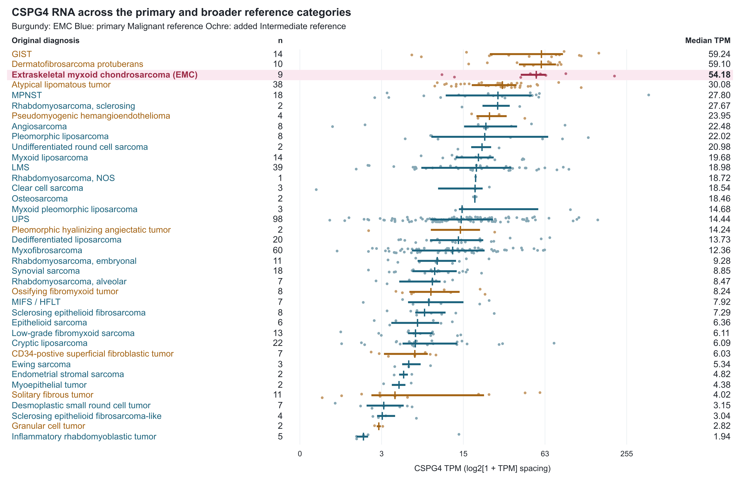
Figure 1. CSPG4 RNA in EMC and the primary and broader references. The 498 specimens span 38 source diagnosis labels: nine EMC (burgundy), 393 Malignant-category references (blue) and 96 additional Intermediate-category references (ochre). Dots show specimens, segments interquartile ranges and vertical marks medians. The axis uses log2(1+TPM) spacing with TPM labels; categories are ordered by observed median. Other eligible contexts appear in Figure S1. MIFS/HFLT, myxoinflammatory fibroblastic sarcoma/hemosiderotic fibrolipomatous tumor; NOS, not otherwise specified.

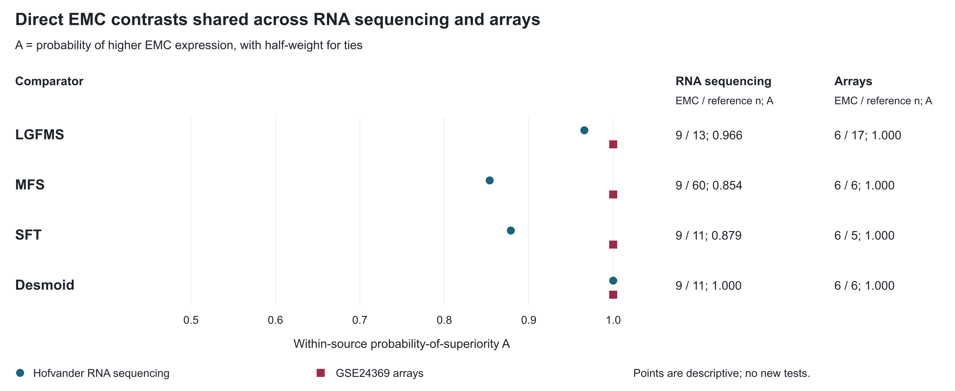
Figure 2. Direct EMC comparisons shared across two assays. Points show A=P(EMC>comparator)+0.5P(tie) for the four diagnosis groups measured in both Hofvander RNA sequencing and GSE24369 arrays. The table supplies specimen counts and scores. Each score is calculated within its source. LGFMS, low-grade fibromyxoid sarcoma; MFS, myxofibrosarcoma; SFT, solitary fibrous tumor.

