CSPG4 RNA across sarcoma types with an expanded comparison of extraskeletal myxoid chondrosarcoma
Author. Tristan D. McRae
Independent researcher, unaffiliated. Correspondence: trimcrae@gmail.com. ORCID: 0000-0002-1823-1451.
Running title. Comparative CSPG4 RNA in EMC

Abstract
Background: Extraskeletal myxoid chondrosarcoma (EMC) is a rare soft-tissue sarcoma. Chondroitin sulfate proteoglycan 4 (CSPG4) is a cell-surface protein whose expression has been studied across sarcoma types. We examined where EMC lies within a broader tissue RNA landscape and whether its differences from named sarcomas recur across datasets.
Methods: An exploratory extension of a fixed 11-gene analysis compared nine EMC specimens with 393 other specimens from 28 source-defined malignant tumor categories in one RNA-sequencing cohort. All 644 eligible specimens, including other tumor categories, remained in the descriptive atlas. We used an exact rank-sum permutation test with Bonferroni correction for 11 genes, retained the original array comparisons, and characterized additional public collections separately by source and measurement scale.
Results: Median CSPG4 was 54.18 TPM in EMC and 11.87 TPM in the defined malignant reference. The probability of higher EMC expression, allowing half credit for ties, was 0.846; exact two-sided P=0.000130 and adjusted P=0.00143. CSPG4 was higher than low-grade fibromyxoid sarcoma in both RNA sequencing and arrays, with comparison scores of 0.966 and 1.000. Gastrointestinal stromal tumors and dermatofibrosarcoma protuberans had slightly higher medians than EMC in the same RNA-sequencing source. External collections expanded histologic context but supplied no additional explicitly labeled EMC comparison.
Conclusions: These data place EMC toward the higher end of CSPG4 RNA expression within a defined sarcoma reference, with substantial overlap and comparator dependence. They support a broader comparative RNA account, without establishing diagnostic specificity, malignant-cell protein expression or therapeutic suitability.
Keywords. extraskeletal myxoid chondrosarcoma; CSPG4; sarcoma; RNA sequencing; public data; comparative expression

Introduction
Extraskeletal myxoid chondrosarcoma (EMC) is a rare soft-tissue sarcoma for which individual public expression studies contain few specimens. Comparing those specimens with a small set of other sarcomas can reveal a reproducible difference, but leaves a broader question unanswered: is the observed RNA expression unusual across the available sarcoma landscape, or mainly unusual relative to the chosen comparison types?
CSPG4 encodes a cell-surface proteoglycan already studied in sarcoma. Boudin and colleagues described its expression and clinical and immune associations in a large collection of soft-tissue sarcomas.[10] Thus, a new comparative study should not claim to discover CSPG4 expression in sarcoma. Its useful contribution is to locate the uncommon EMC specimens within a clearly defined reference, preserve differences between tumor types, and identify the limits of replication across public datasets.
RNA abundance also needs to be distinguished from other kinds of evidence. Bulk tissue includes malignant cells and nonmalignant components; a tissue RNA measurement does not identify the cells producing the signal or establish cell-surface protein density. CHRNA6 illustrates that distinction. Dulken et al. identified CHRNA6 using GSE24369 and subsequently demonstrated strong, diffuse RNA staining in 25 EMC cases by chromogenic in situ hybridization.[1] That work established an RNA tissue assay, not a protein-targeting result. Here, CHRNA6 remains a separate, previously supported RNA-marker control.
An earlier fixed-panel analysis compared nine EMC specimens with myxoid liposarcoma (MLPS), low-grade fibromyxoid sarcoma (LGFMS) and synovial sarcoma in a public RNA-sequencing cohort, and retained same-histology comparisons in an array cohort.[2,4,5] The present exploratory extension expands the same-source reference to all eligible source-defined malignant categories and describes additional public sarcoma collections. The all-specimen comparison leads this revision. Sequencing year is not treated as an established biological exposure or technical effect.

Methods

Study design and direct EMC comparisons
We retained the original 11-gene panel, specimen exclusions and array-probe mappings.[3,4] The panel comprised CD276, SSTR2, PRAME, FAP, CD248, CSPG4, MSLN, L1CAM, GPC3, ALPP and CDH17. CHRNA6 was analyzed separately. The earlier panel and operational selection rule were frozen before inspecting the new cohort's target values; this was not public preregistration. The broader reference and external characterization reported here were documented on 19 September 2026 after earlier results were known. They are exploratory extensions, not prospectively independent discovery analyses.
The Hofvander release contains gene-level transcripts per million (TPM) for 704 source patients, original diagnoses and clinical specimen metadata.[2] Its reported processing used STAR 2.7.10b with GRCh38 and RSEM 1.3.3 with Ensembl 104. We used the original Table S1 diagnoses rather than replacing them with expression-informed revisions. The existing policy excluded specimens with a nonblank recurrence or metastasis flag and preserved specified exclusions for previously reported EMC cases. Nine of 13 EMC specimens remained: three explicitly overlapping historical cases and one local recurrence were excluded. A blank prior-publication field does not establish complete independence from every historical series.
Applying the retained specimen policy across the source yielded 644 eligible specimens spanning 60 original diagnosis labels. This is a count of retained labels, not a claim to enumerate 60 distinct diseases or every sarcoma type. The source article reports 56 tumor types under its own classification. The inferential reference contained 393 non-EMC specimens across 28 categories classified as Malignant in the original source, excluding melanoma and the unclassified spindle-cell category. All other eligible specimens remained visible in the atlas. This reference follows the source taxonomy; in particular, its Intermediate category includes GIST and dermatofibrosarcoma protuberans (DFSP). These tumors were not omitted from the descriptive results because of their expression values.
GSE24369 supplied 42 original GPL6244 array records: six EMC biopsies, 17 LGFMS, six myxofibrosarcomas (MFS), six desmoids, five solitary fibrous tumors (SFT) and two pooled skeletal-muscle RNAs.[5] Lesion stage was not established, so these biopsies were not assumed to be primary tumors. The two muscle pools were not counted as two individual healthy controls. We retained released robust multi-array average (RMA) log2 signals and the original, uniquely assigned transcript cluster for each gene; CSPG4 used probe 7990545. The same-histology contrasts were calculated within each dataset, without pooling TPM and array signals.

Broader public-source characterization
We examined large public sarcoma compendia, their original accessions and identifiable EMC-containing studies. The search was a bounded source-recovery exercise completed on 19 September 2026, not a systematic review or evidence that every possible public dataset had been exhausted. Eligibility required a usable CSPG4 measurement and a traceable specimen-to-diagnosis mapping. Identified inaccessible or unresolved sources remain in the availability table. The external data contributed expression context; none of the selected external records had an explicit EMC diagnosis.
Treehouse Tumor Compendium 25.01 provided consistently processed gene-symbol log2(TPM+1) values and source metadata.[11] We used the human tumor PolyA and ribosomal-depletion collections, excluding cell-line and xenograft compendia. An explicit diagnosis map included sarcoma and related mesenchymal categories, with benign or intermediate context separated. Gliosarcoma and uterine carcinosarcoma were excluded. We selected one profile per source-supplied donor identifier where available, otherwise conservatively grouped repeated Treehouse specimen prefixes. PolyA was preferred, followed by lexicographic specimen identifier, without consulting CSPG4 values.
The initial 1,446 Treehouse candidate profiles reduced to 1,335 selected identity groups after metadata review. Eleven NCI donors occurred in two projects; original ENA experiment aliases confirmed the reuse. One donor had conflicting Ewing and CIC-associated diagnoses and was excluded from histology summaries, leaving 1,334 profiles. Of these, 860 had source-supplied donor keys and 474 relied on unverified specimen-prefix grouping. Source-supplied identifiers themselves were not universally independently established patient identities. Analyses were stratified by library method, source and study accession; a single Treehouse project label could contain more than one original study.
We also recovered Boudin et al.'s published 1,378-record CSPG4 table and joined its specimen identifiers to original GEO metadata.[10] We retained 986 mapped records across nine cohorts after two conservative repeated-specimen exclusions; 166 records lacked a resolved diagnosis, and 224 TCGA records were omitted because TCGA was represented through Treehouse. Explicit old GSM aliases did not recur elsewhere in the selected published table and were not subtracted twice. A GEO UPS label was corrected from the primary Renner paper while preserving its original text.[15] These values remain on their published normalized scale, labeled CSPG4 mRNA (log2), not TPM. Historical two-color and mixed-platform collections supply qualified published-signal context, not newly established abundance replication.
Two additional clinical cohorts were analyzed separately. GSE213065 contains 87 profiles from 54 identified patients; we selected the first region of the earliest sampled timepoint, T1a, for each patient.[12] The deposited values are Salmon/Gencode 27 protein-coding gene TPM. These specimens include advanced disease and treatment histories. The supplement establishes 14 primary anatomical sites, seven metastases and one local recurrence among the selected specimens; 32 lack a T1 location classification in that table. GSE234092 contains 69 distinct surgical records with diagnosis labels, beyond the 34 retroperitoneal RNA cases described in the linked article.[13] We retained all repository records as a separately defined collection, separating two desmoids and one paraganglioma as context and retaining unresolved abbreviations. For each sample we divided CSPG4 featureCounts by the sum across all 64,253 supplied gene rows and multiplied by one million. These values are counts per million (CPM), not TPM.
OpenPedCan v15 supplied additional CNS-enriched context.[14] We used its independent-specimen lists, preferring primary-list representatives and adding only previously unrepresented donors from primary-plus. We excluded TCGA, TARGET, xenografts, hematologic entities and identified Treehouse donor aliases. Twenty-nine profiles were extracted; one source-labeled parental tumor associated with a chordoma cell-line family remained provenance-uncertain and was retained outside the clinical summaries. The other 28 had distinct source participant IDs. Library methods were analyzed separately, and source collection-event descriptors were preserved. Neither an Initial CNS Tumor descriptor nor primary-list membership was interpreted as proof of untreated primary systemic sarcoma.

Statistical summaries and inference
The probability-of-superiority score was A=P(EMC>reference)+0.5P(tie), calculated across all available specimen pairs. A=0.5 denotes neutral ordering. For the pooled Hofvander reference, each of its 393 specimens had equal weight. We also report the mean of the 28 type-specific scores, which gives each source-defined reference category equal weight. These answer different questions; neither represents the population incidence of sarcoma types. A is not a fold change or externally validated diagnostic accuracy.
The expanded all-specimen test used the exact rank-sum null distribution for every allocation of nine EMC labels among the 402 included observations, preserving ties. The two-sided tail included rank sums at least as far from their null expectation as the observed sum. Bonferroni adjustment retained the original family of 11 genes. This adjustment addresses that gene family but does not erase retrospective choices of question, comparator set or analysis. The exchangeable-label null is a modeling assumption for observational specimens, not randomized assignment of tumor diagnoses. A small P value is not the probability that the result is false or the probability that EMC arose by chance.
We retained all original comparator-specific results, the original operational rule and its adverse sensitivity checks in Supplementary Information. Removing one EMC at a time describes dependence on individual specimens; those ranges are not confidence intervals. Earlier sequencing-year-conditioned analyses remain secondary. No demonstrated CSPG4 year effect motivated adjustment, and sparse matching does not establish control of technical confounding. Those analyses change the supporting patients and comparison sets and therefore do not replace the all-specimen question.
For external collections, we report the number of profiles, median, linear-interpolation quartiles and range on the original measurement scale for each source and diagnosis. The complete table of within-source pairwise A values is provided on each source’s designated measurement scale, retaining the qualifications for historical mixed-platform cohorts. Cross-source descriptive ranges include only pairs with at least five profiles of each diagnosis in each contributing stratum. The external figure uses LMS as a frequently represented reference; all other pairs remain available. No external P values, pooled cross-platform expression test or synthetic nine-EMC-versus-all-databases comparison was calculated. Uniform computational processing does not remove differences in specimen composition, library construction, disease stage or collection practice.

Verification and contextual evidence
Source files, selection ledgers, code and result tables have cryptographic digests. Independent implementations checked original values, specimen mapping, quartiles and rank probabilities. The expanded CSPG4 exact tail was reproduced using a different integer-count algorithm. Additional small exhaustive controls checked the exact-test implementation. These checks establish computational consistency, not external expert endorsement or biological validity.
Human Protein Atlas normal-tissue RNA and protein records remained separate context, with assay reliability and missingness retained.[6,7] Historical GSE28866 3SEQ peaks and independent PRAME immunohistochemistry were not pooled with tumor RNA.[8,9] We did not calculate a safety ratio between HPA normalized TPM and tumor TPM.
Use of artificial intelligence. OpenAI Codex assisted with source recovery and organization, analysis-code implementation, computation, verification and drafting. The author is responsible for the final interpretation and manuscript. AI assistance and independent code checks do not establish biological validity.

Results

EMC was toward the higher end of the defined malignant reference
The nine EMC specimens had median CSPG4 expression of 54.18 TPM, an interquartile range of 41.41–63.98 TPM and a range of 10.14–207.08 TPM. The 393 reference specimens had a median of 11.87 TPM. The patient-weighted score was A=0.84648, and the equal-type score was 0.86556. The exact two-sided P value was 0.000130435; the Bonferroni-11 adjusted value was 0.00143479.
EMC had the highest observed median among the 29 labels in this defined malignant comparison, including EMC itself (Figure 1). Several groups were very small; this sample ordering is not an established population ranking. Individual distributions overlapped. Removing any one EMC specimen left the pooled A between 0.82761 and 0.89408, so the ordering was not dependent on the largest value alone. The analysis still contained only nine EMC specimens.
CSPG4 was not the only panel gene departing from the pooled reference. MSLN also had higher ordering, A=0.811, with adjusted P=0.00406, whereas several genes had lower ordering. The full 11-gene table is retained in the supplement. These pooled results do not replace the original comparator-specific rule, which CSPG4 alone satisfied, or promote another gene as a treatment target.

High expression was not unique to EMC
The full 644-specimen atlas changes the interpretation of the malignant-only summary. GIST (n=14) had a median of 59.24 TPM and DFSP (n=10) a median of 59.095 TPM, both slightly above the EMC median. They were classified as Intermediate in the source and remain visible with all other contextual groups in Figure S1 and the complete 60-label table. Several benign categories also had high values. Thus, the data do not support an EMC-specific expression threshold or uniquely high CSPG4 RNA across all soft-tissue tumors.
The original same-histology comparisons remained informative. Against LGFMS, CSPG4 A was 1.000 in the six-EMC versus 17-LGFMS arrays and 0.96581 in the nine-EMC versus 13-LGFMS RNA-sequencing comparison. Removing any one EMC or LGFMS array biopsy retained A=1. The array scores against MFS, SFT and desmoid were also 1.000; the corresponding Hofvander scores were 0.85370, 0.87879 and 1.000. DFSP supplied a contrary Hofvander comparison, A=0.46667. These results establish recurrence of particular observed contrasts, rather than universal specificity or complete patient independence between historical collections.

Broader collections showed histology-dependent and source-dependent patterns
The external characterization retained 1,334 Treehouse profiles, 986 mapped published-array records, 54 GSE213065 profiles, 69 GSE234092 records and 28 OpenPedCan clinical-context profiles. These resource counts must not be added as independently verified patients. Treehouse already includes TCGA, TARGET and several original GEO/SRA cohorts, and it shares a pediatric source family with OpenPedCan. Known donor aliases were handled explicitly, but undisclosed overlap remains possible. The final external tables contain 304 source-by-diagnosis summaries and 1,480 within-source pairwise comparisons.
Some relative patterns recurred (Figure 2). MFS was lower than LMS in all six source strata supporting at least five profiles per group, with A=P(MFS>LMS)+0.5P(tie) ranging from 0.182 to 0.246. UPS was lower than LMS in all five supported strata, A=0.077–0.414. Other patterns were less uniform. Dedifferentiated liposarcoma had A=0.173–0.343 in four strata but 0.517 in Nakayama's 15-versus-six comparison. GIST had A=0.836 in GSE234092 (19 versus nine) and 0.502 in the Treehouse-processed SRP057793 collection (12 versus 40). These descriptive differences are not cross-study treatment effects or proof of the mechanism producing the RNA signal.
The added collections broadened representation of adult, pediatric and bone sarcomas, but did not provide a further identified EMC group. For example, the retained Treehouse records included 279 osteosarcoma and 115 Ewing profiles across qualified source strata. Those larger comparator collections cannot independently replicate an EMC contrast when EMC is not measured in them. They also cannot be attached numerically to the nine Hofvander EMC values as if all measurements came from a single assay.

Retained sensitivity and tissue-context findings
The original three-histology CSPG4 composite remained 0.89454 using all years and 0.81111 under the earlier year-conditioned calculation. Only four distinct EMC patients supported the latter. Removing the 2019 sample group left two matchable EMC patients and a conditioned score of 0.43333, while the all-year score remained positive at 0.83333. The expanded-reference year-conditioned sensitivity likewise gave a larger P value, 0.02064, with adjusted P=0.22704. It used a different statistic and only 319 supported-year reference specimens. These adverse results are preserved, but neither establishes a year effect or isolates technical variation from specimen composition and chance.
The separate tissue evidence remained limiting. HPA records do not establish EMC cell-surface density or normal-tissue sparing; normal-tissue IHC and cell-localization assays examine different compartments.[6,7] A normal-colon record exceeded the lowest EMC library value in the separate GSE28866 3SEQ context.[8] In the PRAME protein study, all five EMC cases were negative in both readers' columns with antibody QR005, despite favorable PRAME RNA ordering against LGFMS in the retained RNA analyses.[9] These are different specimens and assays, not paired RNA–protein measurements.

Discussion
Expanding the same-source reference materially broadens the CSPG4 RNA comparison in EMC. The nine eligible EMC specimens tended to have higher expression than a defined mixture of 393 other malignant-category specimens, with a small exact rank-sum P value under the stated null. The result complements the recurring comparison with LGFMS in a second measurement platform. The complete tumor atlas also shows why that statement must remain qualified: GIST, DFSP and several benign groups can have comparably high or higher expression, and individual values overlap.
The additional public collections are valuable because they show how much the reference choice matters. They reveal recurring ordering for some sarcoma pairs and divergent ordering for others, while retaining the source, diagnosis and assay behind each estimate. This contribution is an EMC-centered comparative extension, not a rediscovery of broad CSPG4 heterogeneity, which Boudin et al. had already described.[10] It does not repeat or extend their prognostic and immune analyses to EMC.
More comparator specimens improve coverage of the reference landscape, but do not solve the small EMC sample size. The nine EMC observations still determine the case distribution. The 393-specimen pool reflects the source collection's proportions, not an epidemiologically representative mixture. Its source-based Malignant definition also differs from a comprehensive clinical sarcoma taxonomy. Consequently, the pooled P value answers a specific distributional question and should not be presented as the probability that nine randomly selected tumors from all sarcomas everywhere would be this extreme. The equal-type score and full category tables make the dependence on reference composition visible without claiming to remove it.
Cross-study scale differences are a separate issue from calendar year. Treehouse's consistently processed data, Hofvander TPM, protein-coding Salmon TPM, transcriptome-capture CPM and historical array signals differ in quantification and specimen context. Some historical collections also combine platforms or reference preparations. A shared gene symbol or the word TPM is not sufficient calibration for pooling these measurements. We therefore retained within-source descriptions and rank contrasts rather than manufacturing a larger cross-database EMC test.
The study has further limits. It is an exploratory public-data reanalysis after CSPG4 had already been identified as a gene of interest. Multiplicity correction for 11 genes does not account for every possible retrospective choice. Small and uneven groups limit precision, and the deletion range is not a confidence interval. Some specimen identities, clinical states and historical overlaps cannot be fully resolved. The broader search identified additional EMC-containing articles, but not another open, qualified EMC-versus-sarcoma expression matrix: controlled-access data, missing deposited EMC records and reuse of earlier specimens are concrete boundaries, documented in the supplement. This is not evidence that no further usable cohort exists.
Finally, bulk RNA does not localize CSPG4 to malignant cells or measure accessible protein. Purity and grade were unavailable for EMC adjustment, and normal tissues were not matched to tumors. Neither statistical separation nor relative rank among sarcomas establishes a therapeutic window, safety, diagnostic performance or treatment benefit. The revised analysis provides a more complete RNA comparison and a reproducible reference resource for subsequent tissue studies and independently sampled EMC cohorts.

Data code and declarations
Data availability. The original Hofvander data are available through https://doi.org/10.5281/zenodo.17866629. Original array data and annotations are available as GEO GSE24369 and GPL6244. Additional inputs are Treehouse Tumor Compendium 25.01, Boudin et al. Supplementary Table S8, GEO GSE213065 and GSE234092, and OpenPedCan v15. The revision’s data and code package, including exact source URLs, selection ledgers, digests and specimen values, is available at https://github.com/trimcrae/Rare-cancers/blob/974e8d88a771cf018135242ab88dddc82f6bc2b2/research/release-candidates/cspg4-broad-20260919/CSPG4-data-code.zip. The original reproducibility archive remains at https://assets-eu.researchsquare.com/files/rs-10959636/v1/b95606f3a3799c60c8ac4434.zip. That historical archive does not contain the new expanded analyses. Source-specific attribution and reuse terms continue to apply.
Author and correspondence. Tristan D. McRae, independent researcher, unaffiliated, is the corresponding author at trimcrae@gmail.com; ORCID 0000-0002-1823-1451. The author has no institutional affiliation.
Research scope. This work reanalyzes public data and reports no newly collected participant specimens, intervention, protein experiment or clinical treatment. No new ethics approval, exemption or waiver is asserted.
CRediT authorship contribution statement. Tristan D. McRae: Project administration, Supervision. AI-assisted implementation, execution, verification and drafting are disclosed in Methods. The author is responsible for the final interpretation and manuscript.
Funding. This research received no funding.
Competing interests. No competing financial interests exist. One non-financial interest is declared: the author is a survivor of extraskeletal myxoid chondrosarcoma, the disease this work addresses.
Declaration of generative AI and AI-assisted technologies. OpenAI Codex assisted with source organization, code implementation, computation, verification and drafting, as described in Methods. The author takes responsibility for the article; AI assistance is not biological validation.

References
[1] Dulken BW, Kingsley L, Zdravkovic S, Cespedes O, Qian X, Suster DI, et al. CHRNA6 RNA In Situ Hybridization Is a Useful Tool for the Diagnosis of Extraskeletal Myxoid Chondrosarcoma. Mod Pathol. 2024;37:100464. https://doi.org/10.1016/j.modpat.2024.100464.
[2] Hofvander J, Köster J, Sydow S, Piccinelli P, Vult von Steyern F, Tsagkozis P, et al. Transcriptomic Subgroups in Soft Tissue Tumors Correlate with Morphologic Subtype, Genomic Features, and Outcome. Clin Cancer Res. 2026;32:1825–1834. https://doi.org/10.1158/1078-0432.CCR-25-3740.
[3] McRae TD. EMC research program expression-panel definitions. Pinned revision 81d2931733aae640220c042039d0c53efed1690a. https://github.com/trimcrae/Rare-cancers/blob/81d2931733aae640220c042039d0c53efed1690a/research/modalities/emc_expression_panels.py.
[4] McRae TD. Fixed-panel tissue RNA prioritization in extraskeletal myxoid chondrosarcoma: CSPG4 evidence across cohorts with comparator and sequencing-year limits. Research Square. 2026. Version 1 and accompanying code/data supplement. https://doi.org/10.21203/rs.3.rs-10959636/v1.
[5] National Center for Biotechnology Information. GEO series GSE24369 and platform GPL6244. https://www.ncbi.nlm.nih.gov/geo/query/acc.cgi?acc=GSE24369; https://www.ncbi.nlm.nih.gov/geo/query/acc.cgi?acc=GPL6244.
[6] Uhlén M, Fagerberg L, Hallström BM, Lindskog C, Oksvold P, Mardinoglu A, et al. Tissue-based map of the human proteome. Science. 2015;347:1260419. https://doi.org/10.1126/science.1260419.
[7] Thul PJ, Åkesson L, Wiking M, Mahdessian D, Geladaki A, Ait Blal H, et al. A subcellular map of the human proteome. Science. 2017;356:eaal3321. https://doi.org/10.1126/science.aal3321.
[8] Brunner AL, Beck AH, Edris B, Sweeney RT, Zhu SX, Li R, et al. Transcriptional profiling of long non-coding RNAs and novel transcribed regions across a diverse panel of archived human cancers. Genome Biol. 2012;13:R75. https://doi.org/10.1186/gb-2012-13-8-r75.
[9] Cammareri C, Beltzung F, Michal M, Vanhersecke L, Coindre JM, Velasco V, et al. PRAME immunohistochemistry in soft tissue tumors and mimics: a study of 350 cases highlighting its imperfect specificity but potentially useful diagnostic applications. Virchows Arch. 2023;483:145–156. https://doi.org/10.1007/s00428-023-03606-6.
[10] Boudin L, de Nonneville A, Finetti P, Mescam L, Le Cesne A, Italiano A, et al. CSPG4 expression in soft tissue sarcomas is associated with poor prognosis and low cytotoxic immune response. J Transl Med. 2022;20:464. https://doi.org/10.1186/s12967-022-03679-y.
[11] Beale HC, Learned K, Kephart ET, et al. Consistently processed RNA sequencing data from 50 sources enriched for pediatric data. Sci Data. 2025;12:1134. https://doi.org/10.1038/s41597-025-05376-z.
[12] Subramanian A, Nemat-Gorgani N, Ellis-Caleo TJ, et al. Sarcoma microenvironment cell states and ecosystems are associated with prognosis and predict response to immunotherapy. Nat Cancer. 2024;5:642–658. https://doi.org/10.1038/s43018-024-00743-y.
[13] Seligson ND, Asmann YW, Almerey T, et al. Molecular markers of proliferation, DNA repair, and immune infiltration defines high-risk subset of resectable retroperitoneal sarcomas. Surg Oncol. 2024;56:102125. https://doi.org/10.1016/j.suronc.2024.102125.
[14] Geng Z, Wafula E, Corbett RJ, et al. The Open Pediatric Cancer Project. GigaScience. 2025;14:giaf093. https://doi.org/10.1093/gigascience/giaf093.
[15] Renner M, et al. Integrative DNA methylation and gene expression analysis in high-grade soft tissue sarcomas. Genome Biol. 2013;14:R137. https://doi.org/10.1186/gb-2013-14-12-r137.

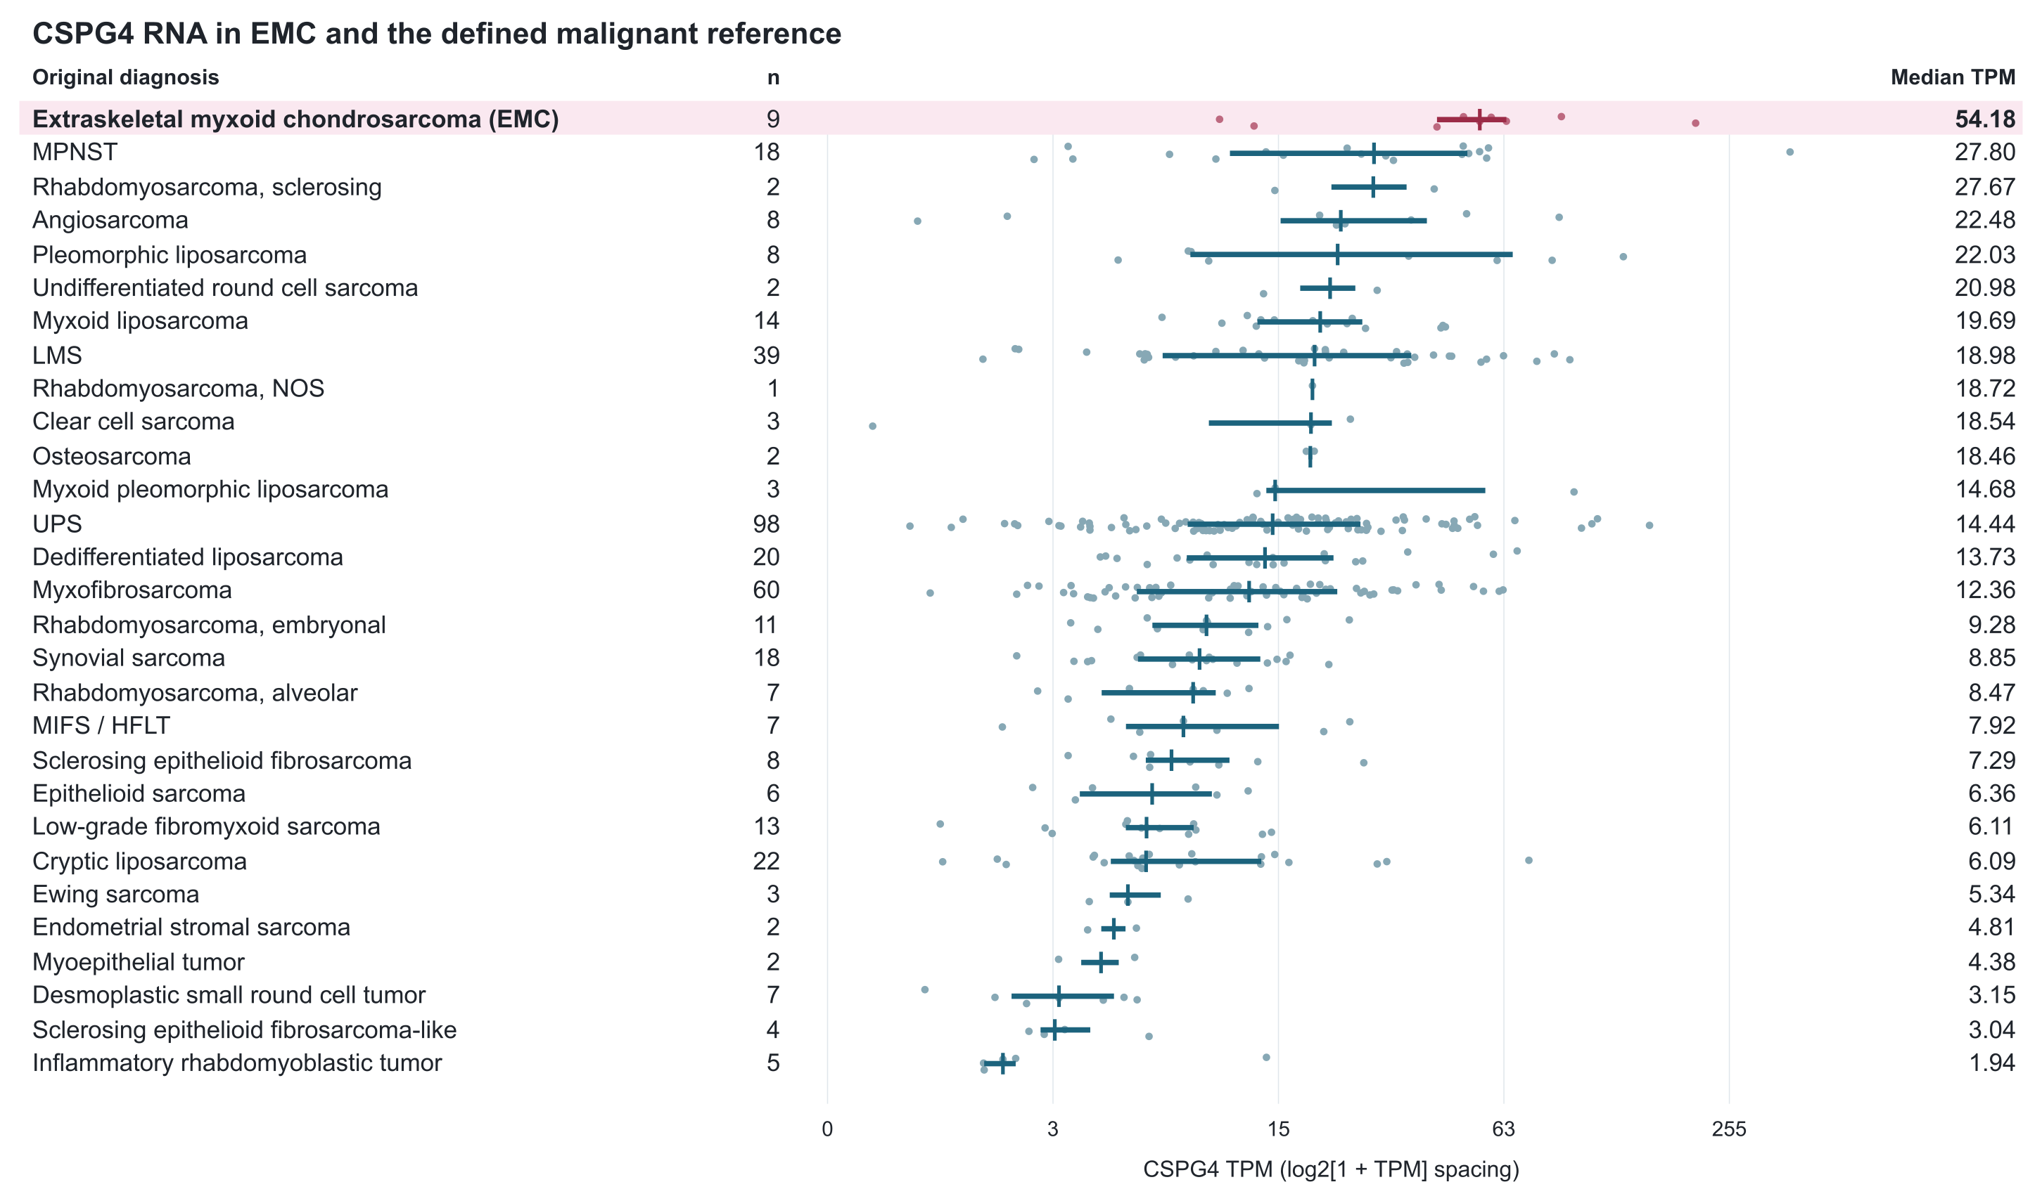
Figure 1. CSPG4 RNA in the expanded same-source malignant reference. The nine retained EMC specimens and 393 reference specimens span 29 original source diagnosis labels. Dots show specimens; horizontal segments show the interquartile range and vertical marks the median. The axis uses log2(1+TPM) spacing with TPM labels. Categories are ordered by observed median; small groups remain descriptive and do not establish a population ranking. The reference uses the source's Malignant category, excluding melanoma and unclassified spindle-cell tumors. The other 242 eligible specimens, including GIST and DFSP, appear in Figure S1. Abbreviations: LMS, leiomyosarcoma; MPNST, malignant peripheral nerve sheath tumor; UPS, undifferentiated pleomorphic sarcoma; MIFS/HFLT, the source's combined myxoinflammatory fibroblastic sarcoma/hemosiderotic fibrolipomatous tumor label; NOS, not otherwise specified.

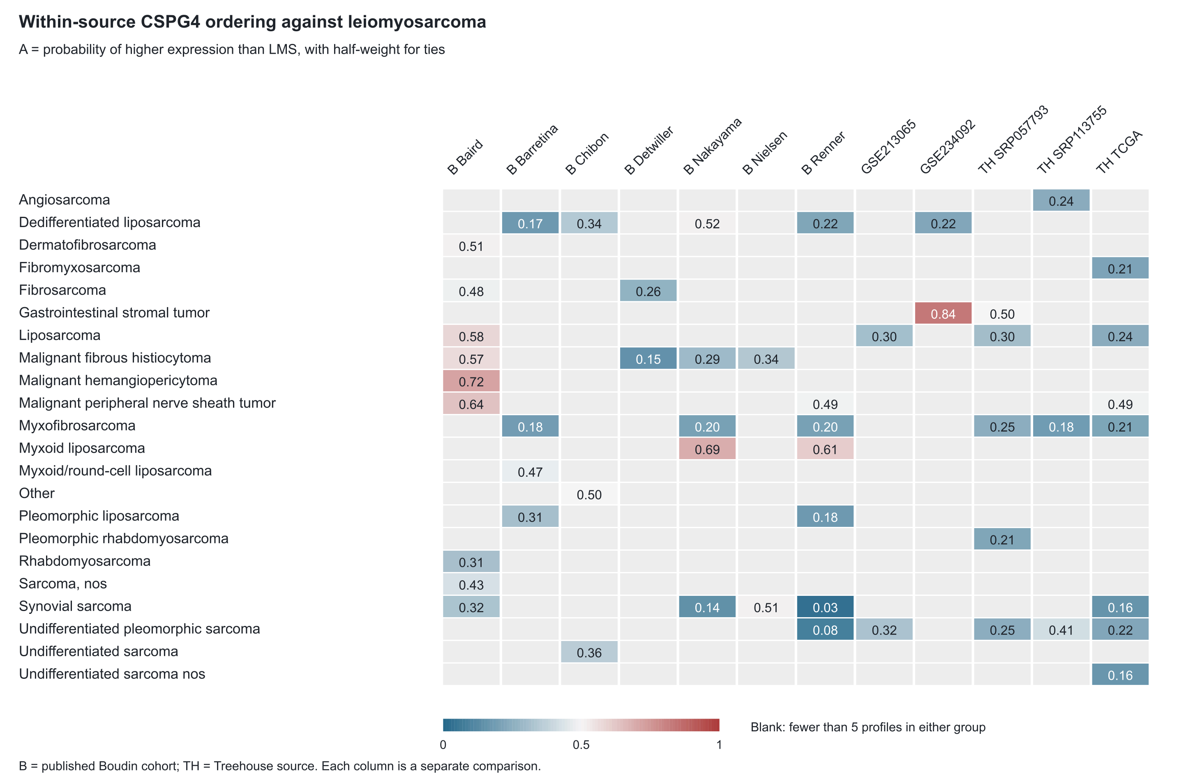
Figure 2. External within-source CSPG4 ordering against LMS. Each cell is A=P(the row diagnosis>LMS)+0.5P(tie), calculated within its stated source; values above 0.5 favor the row diagnosis. Cells require at least five profiles of each type. Blank cells lack that support and are not negative results. Each source retains its own expression units. Treehouse columns separate original accessions; the historical Boudin columns retain published cohort-normalized values, including qualified two-color or mixed-platform collections. There is no pooled expression scale or external EMC estimate. The full 304-row descriptive table and all 1,480 within-source comparisons, including small groups and pairs not involving LMS, accompany the supplement.

