Supplementary information for CSPG4 RNA across sarcoma types
This supplement supplies the methods, specimen definitions and complete results for the panel comparisons, expanded same-source reference and public-source characterization. The accompanying data and code package contains the protocols, source ledgers, measurements and analysis outputs described here.

Panel and comparator provenance
The 11-gene panel was inherited from a manually curated assessment of proposed therapeutic routes. It combined candidate surface antigens (CD276, SSTR2, CSPG4, MSLN, L1CAM, GPC3, ALPP and CDH17), stromal/pericyte-associated targets (FAP and CD248), and PRAME as an intracellular peptide–HLA candidate. CD276 reflected a B7-H3-targeting concept; SSTR2 a receptor/theranostic hypothesis; FAP and CD248 the need to include stromal compartments; and CSPG4 a proteoglycan-related targeting hypothesis and a gap in earlier candidate reporting. The remaining surface antigens were inherited candidates, with epithelial-associated entries also used as specificity checks. These are nomination rationales, not demonstrations of EMC target biology. No external standard defines exactly this set of 11; it was a practical working list, not an exhaustive surfaceome or a ranked top-11 signature. Every member had a unique measured gene row and array annotation and was retained regardless of its result.
Myxoid liposarcoma (MLPS), low-grade fibromyxoid sarcoma (LGFMS) and synovial sarcoma were investigator-selected for morphological and diagnostic relevance. No scoring system established them as the three closest EMC mimics. The array comparisons were determined by available tumor types: LGFMS, MFS, desmoid and SFT were present in both collections. Broader references instead applied the source-class rules to every eligible category. The full atlas preserves all 60 labels, including the categories outside those references.
The panel and initial comparator rule were fixed before inspection of Hofvander target values, but earlier array findings were already known. The broader reference and uncertainty analyses were later exploratory extensions; the study was not preregistered. Source selection used diagnosis and identity metadata, not favorable CSPG4 expression. The source search was completed on 19 September 2026. Dated plans, amendments, identity corrections and complete historical results are retained in the data archive, including the author-requested all-12-primary-EMC sensitivity of 22 September 2026 and all-13-EMC sensitivity of 23 September 2026.

Table S1 Source inventory and independent-patient limits
Collection | Retained analytic scope | Measurement | Main qualification
Hofvander | 644 specimens; 9 EMC and 393 defined malignant references; 242 other contexts | Gene TPM | Fixed specimen exclusions; 60 original labels, not all sarcoma types
GSE24369 | 6 EMC, 17 LGFMS, 6 MFS, 6 desmoid, 5 SFT, 2 muscle pools | GPL6244 RMA log2 | Unknown lesion stage; muscle pools are not individual controls
Treehouse 25.01 | 1,334 histology-eligible profiles in 35 assay/source/accession strata | Gene-symbol log2(TPM+1) | 860 source donor keys and 474 unverified prefix groups; not universally verified patients
Boudin S8 | 986 mapped records in 9 historical cohorts | Published normalized log2 scale | Possible unresolved patient reuse and mixed platforms; not TPM
GSE213065 | 54 T1a profiles from 54 explicit patient IDs | Salmon protein-coding TPM | Advanced-disease context; T1 does not establish untreated primary disease
GSE234092 | 69 surgical records including 3 non-sarcoma contexts | FeatureCounts CPM | Source cohort exceeds linked paper subset; clinical state and some labels unresolved
OpenPedCan v15 | 28 clinical-context profiles in 2 library strata | RSEM collapsed gene TPM | CNS-enriched PBTA source family; aliases excluded; not general sarcoma sampling

Resource counts are not summed as a unique global patient count. They represent different selection policies and measurement scales. In particular, TCGA is already represented in Treehouse; it is not also counted as 224 additional Boudin cases. Original GEO/SRA studies within Treehouse are not added again as separate datasets. OpenPedCan and Treehouse share CBTN/PBTA source families even after known patient aliases are excluded.

Fixed Hofvander specimen policy and quantities
The retained EMC IDs are 11881-19, 3371-22, 3372-22, 4716-22, 4840-13, 5149-18, 5241-06, 7931-19 and 8102-22. Hofvander reports 704 specimens from 704 patients. The three exclusions below address patient reuse across studies, not duplicate rows or poor-quality specimens within Hofvander. The 2017 primary article states that its six EMC array profiles reused the earlier published expression data.[S6] Its clinical table connects the same historical cases to those in Hofvander. Individual EMC1–EMC6 and exact aliquot mappings remain unresolved. Source Excel row numbers include headers.
Specimen ID | Hofvander S1 row | Historical crosswalk or lesion | Reason
104-92 | 189 | MDB9736:3; 2017 case 46, row 53 | Reduce known patient overlap with arrays
168-97 | 191 | MDB9736:4; 2017 case 48, row 55 | Reduce known patient overlap with arrays
536-00 | 199 | MDB9736:7; 2017 case 49, row 56 | Reduce known patient overlap with arrays
5081-14 | 196 | Samplef=LR; footnote f defines local recurrence | Apply the primary-lesion rule consistently

The three overlapping cases are valid source-primary tumors. Their CSPG4 values are 36.56, 53.49 and 5.99 TPM, respectively. Including them gives 12 primary EMCs with median 51.205 TPM (51.21 rounded), quartiles 30.6125 and 59.645 TPM, and range 5.99–207.08 TPM. Against the unchanged 393 references, 3,810 of 4,716 pairs favor EMC and none tie, giving A=0.8078880. Against the unchanged 489 references, 4,606 of 5,868 pairs favor EMC and none tie, giving A=0.7849352. This descriptive sensitivity tests the effect of the overlap-reduction policy among primary lesions. The original nine-case analysis is preserved. No patient date is inferred from an identifier suffix.
A second exclusion sensitivity includes all 13 original EMC specimens by adding local recurrence 5081-14, whose CSPG4 value is 29.38 TPM. The 13-specimen median is 48.92 TPM, with quartiles 29.38 and 58.20 TPM and range 5.99–207.08 TPM. Against the unchanged 393 references, 4,133 of 5,109 pairs favor EMC and none tie (A=0.8089646). Against the unchanged 489 references, 4,986 of 6,357 pairs favor EMC and none tie (A=0.7843322). The reference specimens remain primary lesions in both comparisons. These results show the effect of retaining this one recurrence; they do not estimate a general effect of recurrence on CSPG4.
EMC analysis set | n | Median TPM | A vs 393 references | A vs 489 references
Overlap-reduced primary group | 9 | 54.18 | 0.8464801 | 0.8243581
All source-primary EMC | 12 | 51.21 | 0.8078880 | 0.7849352
All source EMC, including local recurrence | 13 | 48.92 | 0.8089646 | 0.7843322

The TPM source SHA256 is b0d665d1bd1d96ace1faf66cc5a4d7ab7e41cb487c8f0f61734f102a1f9a7af3. The original GSE24369 family gzip SHA256 is 98c83c8ca23b7052cf0d4d0099a7bf1af6c3c972276038c3a633e2a5349b3c37. Source precision is preserved. The expanded specimen file contains all 7,084 reported values for the 11 genes across 644 specimens; zeros remain zeros and are not interpreted as biological absence.
For EMC values x and reference values y, A is the average of I(x>y)+0.5I(x=y) over specimen pairs. For the rank-sum test, equal values receive the mean of their occupied ranks. The exact calculation doubles these midranks to use integer arithmetic and counts every observation separately, including observations sharing a value. The observed doubled-rank sum is 6,078 and the null center is 3,627. The two-sided tail contains 90,052,879,544,272 label allocations out of 690,402,510,704,386,700. This is an exact combinatorial calculation, not a Monte Carlo estimate. The source pool is a chosen observational reference; these allocations do not describe randomized assignment of diagnoses.
The patient-weighted A for CSPG4 is 0.8464801. Giving each of the 28 reference labels equal weight gives 0.8655617. Single-EMC deletion gives 0.8276081–0.8940840. These deletion limits are not a confidence interval. The approximate 95% percentile bootstrap interval for this pooled A was 0.7090755–0.9575912. The broader source Malignant-or-Intermediate reference contains 489 specimens in 37 labels, with median 13.20 TPM, specimen-weighted A=0.8243581 (interval 0.6778005–0.9427403) and equal-category A=0.8479346. Both references retain the exclusions of melanoma and unclassified spindle-cell tumors. No new P value was calculated for the broader reference. The nine observed CSPG4 values in increasing order are 10.14, 12.77, 41.41, 48.92, 54.18, 58.20, 63.98, 90.14 and 207.08 TPM.
The two-sample specimen bootstrap used 50,000 replicates, seed 20260921 and NumPy PCG64, restarting the generator for each reference. Independent multinomial multiplicities for nine EMC and n reference specimens were applied to the pairwise comparison matrix in 50 blocks of 1,000 draws. Each bootstrap A equals w-transpose C v divided by 9n. This exactly represents ordinary specimen resampling with replacement; dependent pairs are not independently resampled. Limits are NumPy linear-interpolation 2.5th and 97.5th percentiles. The nominal pointwise intervals are approximate and conditional on the observed specimen/reference design, not corrected for retrospective selection, unknown overlap, assay confounding or population sampling. The two overlapping-reference intervals do not test the difference between reference definitions. The plan, code and exact outputs accompany the archive.

Table S6 Source-reported molecular support for retained EMC
EMC membership follows the unchanged original source diagnosis. Table S1 marks all nine retained specimens Fusion=Yes; its footnote permits evidence from current RNA sequencing or previous methods. Grade and ASCAT ploidy/purity are NA for all nine. Table S3 supplies filtered RNA-sequencing fusion records, summarized below with source qualifiers. Source Excel row numbers include the header.
Specimen ID | S3 fusion | S3 row | Source qualification
11881-19 | TCF12::NR4A3 | 69 | High confidence; in-frame
3371-22 | No filtered record | — | S1 Fusion=Yes; exact fusion not crosswalked
3372-22 | HSPA8::NR4A3 | 71 | High confidence; in-frame; prior MDB15434 report
4716-22 | TAF15::NR4A3 | 72 | Medium confidence; source frame label stop-codon
4840-13 | EWSR1::NR4A3 | 73 | High confidence; in-frame
5149-18 | FUS::NR4A2 | 75 | High confidence; in-frame; RT-PCR verified
5241-06 | EWSR1::NR4A3 | 76 | High confidence; in-frame
7931-19 | EWSR1::NR4A3 | 78 | High confidence; in-frame
8102-22 | EWSR1::NR4A3 | 79 | High confidence; in-frame

Source Table S4 row58 reports all 13 original EMC as fusion-positive, including one FUS::NR4A2 and an additional RT-PCR-confirmed TAF15::NR4A3 missed by both callers. That comment has no specimen-level crosswalk and is not assigned here to 3371-22. Seven retained cases have explicit NR4A3 fusions in filtered S3. The FUS::NR4A2 case is preserved under its source EMC diagnosis, not reclassified from a gene name alone. The source describes morphological/IHC rereview of selected cases, not documented rereview of every retained EMC. Molecular-support differences do not change the frozen specimen policy. The source workbooks, hashes and a machine-readable extraction accompany this revision.

Historical panel rule and sequencing-year sensitivity
Sequencing year was an early technical-proxy sensitivity, not an adjustment for a demonstrated laboratory change. The Hofvander report uses a common computational pipeline, and its Supplementary Figure S1 reports no significant sequencing-year effect in global expression clustering across six illustrated tumor types, including EMC. The inspected source does not document year-specific wet-lab protocol changes. This does not exclude gene-specific technical variation, but matching on year discards many otherwise eligible comparisons and changes the group being estimated. The all-year analysis is therefore emphasized; all historical conditional results, including adverse results, are retained below.
The three-histology composite gives equal weight to myxoid liposarcoma, low-grade fibromyxoid sarcoma and synovial sarcoma. The all-year composite averages their three A scores. For the year-conditioned composite, each within-year A is first weighted by the number of retained EMC specimens in that supported year, normalized within the comparator histology; the three histology scores are then averaged equally. Deletion analyses recompute year support and weights. Lost cells are omitted and weights renormalized; an absent histology comparison is recorded as missing and cannot satisfy the decision rule.
The original operational rule required a marginal equal-histology score of at least 0.70; A>0.50 for each primary histology in both marginal and supported-year comparisons; and both composites above 0.50 after each single EMC and histology deletion. The threshold was an operational benchmark, not a clinical cutoff. Year removal, comparator-patient removal and revised-diagnosis checks qualified interpretation but were not additional pass conditions. All original results remain in the preserved tables; no gene is reclassified by the new pooled test.
The nine EMC specimens fall in sequencing years 2019 (two), 2020 (one), 2021 (one), 2022 (two) and 2023 (three). The original matched MLPS and LGFMS comparisons use 2019/2021; synovial sarcoma uses 2019/2020. Each uses three EMC specimens, with only four distinct EMC patients across the comparisons. The two 2019 specimens supply two-thirds of each matched histology's EMC weight. Year labels are incomplete proxies, not demonstrated assay changes or biological exposures.
For CSPG4, the original marginal/matched composites are 0.89454/0.81111. Single-EMC deletion ranges are 0.88136–0.94035/0.71667–0.94444; single-histology deletion ranges are 0.85891–0.94896/0.75000–0.88333. Removing the 2019 group removes two EMC and 19 original comparator specimens. Seven EMC remain in the all-year estimate, but only two matchable EMC remain in the conditional estimate, which becomes 0.43333; the marginal value is 0.83333. Revised diagnoses give 0.89475/0.81111, but those labels were partly informed by expression and are not independent confirmation.
The earlier conditional bootstrap used 2,000 draws with seed 20260906, resampling within histology/year groups and sharing each EMC resample across comparisons. Its intervals are pointwise and conditional on the observed support; singleton groups remain fixed. The matched MLPS interval for CSPG4 is [0.66667, 0.66667], a sparse-design artifact rather than absence of biological uncertainty. The original composite intervals were 0.86614–0.91806 marginal and 0.75278–0.86111 matched. They do not describe uncertainty in the new pooled 393-specimen reference.
The expanded-reference conditional sensitivity used 199,999 permutations, seed 20260919, and 319 references in supported years. Its statistic weights each within-year A by the number of EMC specimens in that year divided by nine. Labels are permuted within year with group sizes fixed. The two-sided tail compares absolute distance from 0.5; the Monte Carlo P value is (b+1)/(B+1), where b is the number of permutations at least as extreme as observed and B=199,999. Its statistic was 0.8212599, with P=0.02064 and Bonferroni-11 P=0.22704. In 2023, three EMC specimens had only one reference, giving that sparse comparison one-third of the EMC weight. This separate estimand and its limitations remain reported. Neither agreement nor disagreement with the all-year calculation establishes an effect of sequencing year.

Array and normal-tissue measurements
The GPL6244 transcript clusters were CD276 7984743, SSTR2 8009526, PRAME 8074856, FAP 8056257, CD248 7949588, CSPG4 7990545, MSLN 7992071, L1CAM 8175871, GPC3 8175234, ALPP 8049123, CDH17 8151795 and the separate CHRNA6 control 8150550. Each was uniquely assigned under the retained annotation policy; no best-probe search or cross-gene standardization was performed. Finite negative log-array values are valid signals. TPM values must be finite and nonnegative. Missing or duplicate measurements are not imputed.
The original LGFMS-specific CSPG4 scores are 1.00000 in arrays and 0.96581 in Hofvander. The original separate matched RNA-sequencing value is 0.93333. Positive array scores against MFS, SFT and desmoid are retained with all other panel genes, including unfavorable or reversed contrasts. The separate CHRNA6 control had A=1.000 in the original marginal and matched three-histology composites and against LGFMS in both assays. CHRNA6 was discovered using GSE24369 (Dulken et al.[S7]), so its reanalysis there is not independent discovery validation.
HPA records distinguish normal RNA, IHC and ICC/IF, with reliability warnings and missing records preserved.[S2,S3] HPA normalized TPM is not directly divided into tumor TPM to estimate safety. GSE28866 contains four EMC library/STT records whose patient independence is not established; its selected 3SEQ peaks are a different quantity.[S4] A normal-colon value exceeds the lowest EMC library value. The PRAME workbook SHA256 is 20b4bd1243be22e4eee2da7470da986091f91cc4959fa416708748ba99187ca7. Sheet 1 rows 128–132 contain five EMC cases, all negative in both reader columns with antibody QR005.[S5] Four have recorded molecular support; the fifth lacks a recorded ancillary method. Blank percentage fields were not turned into measurements.

Source processing and supporting literature
The Hofvander release contains 704 source patients and reports STAR 2.7.10b alignment to GRCh38 and RSEM 1.3.3 quantification with Ensembl 104. The supplied panel contains CD276, SSTR2, PRAME, FAP, CD248, CSPG4, MSLN, L1CAM, GPC3, ALPP and CDH17; CHRNA6 is separate. The muscle measurements in GSE24369 are pooled RNAs, not individual healthy controls.
Treehouse selection used the human tumor PolyA and ribosomal-depletion collections, excluding cell-line and xenograft compendia, gliosarcoma and uterine carcinosarcoma. Its initial 1,446 candidate profiles reduced to 1,335 identity groups before exclusion of the unresolved NCI0165 diagnosis. GSE213065 supplied 87 profiles before selection of 54 T1a specimens; 32 selected specimens lack a T1 location classification in inspected Supplement S14. Values are Salmon/Gencode 27 protein-coding TPM. GSE234092 CPM denominators sum all 64,253 supplied featureCounts rows. Its 69 repository records exceed the linked article's 34 retroperitoneal RNA cases; two desmoids and one paraganglioma remain context. OpenPedCan selection excluded TCGA, TARGET, xenografts and hematologic entities. Neither primary-list membership nor an Initial CNS Tumor descriptor establishes untreated primary systemic sarcoma.
The Renner diagnosis correction is supported by its primary article.[S1] Human Protein Atlas records distinguish normal-tissue RNA, immunohistochemistry and cell-localization assays.[S2,S3] Historical GSE28866 3SEQ measurements and the PRAME immunohistochemistry study provide separate contextual evidence.[S4,S5] They are not paired RNA–protein measurements for the retained EMC specimens.

External source selection and corrections
Treehouse candidates were selected from explicitly declared diagnosis labels, with other mesenchymal categories retained as context. Original donor identifiers were source-qualified. Exact NCI aliases were NCI0039, NCI0041, NCI0047, NCI0071, NCI0097, NCI0115, NCI0135, NCI0150, NCI0165, NCI0167 and NCI0198. ENA metadata connected SRP083915 with SRP069338, the SRA study behind phs000768.v2.p1. Ten pairs shared an experiment alias; NCI0097 represented different tumor specimens from the same donor. The same PolyA-first, lexicographic selection rule retained one profile per identity. NCI0165's Ewing/CIC diagnosis conflict was excluded from histology summaries rather than resolved using expression.
The 1,334 eligible Treehouse profiles comprise 1,098 PolyA and 236 ribosomal-depletion profiles; 1,280 are in the declared sarcoma/related scope and 54 in other mesenchymal context. The 35 analysis strata use library method, source name and original accession, with Treehouse project ID only as a fallback. THR52 contains two original accessions, SRP057793 and SRP113755, which remain separate. Source keys do not uniformly prove distinct patients, and clinical stage and treatment are not available in the clinical tables. The TCGA-derived label fibromyxosarcoma is not reclassified as LGFMS.
Boudin S8 contains 1,022 distinct GSM identifiers. Its actual Gobble and Guibault counts are 140 and 34, whereas Table S1 lists the corresponding inclusion counts in the opposite order. Selection used the actual S8 identifier joins. Of its 1,378 records, 986 remain, 166 lack an established diagnosis in inspected metadata, 224 TCGA records are represented through Treehouse, and two Nielsen records are alternative conservative STT-prefix identities. Forty-four Gobble and 183 Chibon old-accession aliases do not also occur as separate S8 records. The corrected Renner UPS label is supported by its primary paper, separately from pleomorphic liposarcoma. Historical MFH is not silently converted to modern UPS, nor malignant hemangiopericytoma to SFT. The unqualified Round cell label remains unspecified.
The Nielsen normalized cohort includes seven GPL versions and Beck two. Nielsen, Baird and Beck include historical two-color measurements with source-specific reference preparations. Their published-normalized distributions and numerical ranks are retained as qualified context; they are not new demonstrations of cross-assay RNA abundance. Four excluded West experiment identifiers match Stanford image IDs in retained Nielsen records; these would need resolution before any later recovery.
For GSE213065, T1a provides exactly one record per explicit patient ID. Supplement S14 describes selected T1 locations for 22 patients: 14 primary, seven metastatic and one local recurrence. Its SRC95 and SRC183 entries begin at T2, so those locations were not transferred to T1. Treatment between longitudinal specimens is not evidence that the first specimen was untreated. For GSE234092, all 69 MSB identifiers map uniquely to count columns using the MSB number and specimen identifier. MSB40 uses number 40 plus prefix agreement between GEO 13172022 and matrix 1317202224; this is not a complete TA-identifier match. Count denominators range from 9,350,062 to 68,678,731. Source labels AS and PLS remain unresolved abbreviations; PLS is not silently merged with PLPS.
OpenPedCan's 28 clinical-context records consist of 11 source-classified Ewing, 10 Sarcoma, three chordoma, three MPNST and one rhabdomyosarcoma; 17 use stranded libraries and 11 poly-A stranded libraries. Original free-text diagnoses and sampling events are preserved without retrospectively imposing a finer taxonomy. Six records enter only through primary-plus and represent recurrence, progression or second malignancy context. Known Treehouse donor aliases, myeloid and histiocytic sarcomas were excluded. BS_28GPVQAA, labeled Mug-CC1-T, is retained in the extraction ledger with 96.02 TPM but outside clinical summaries because the uncultured-parental-specimen crosswalk remains unverified. The source distinguishes it from derived cell-line records; it is not relabeled a proven cell line.
The OpenPedCan RDS was read on a remote runner after a storage check, not copied to the local workspace. Its actual dimensions were 60,325 genes by 4,124 profiles; exactly one row named CSPG4 and each of the 29 requested columns were present. The source MD5 was 5e17af159401140c5946dd0517d03015 and SHA256 57b803d2dbc8fc61ec324a3a2c37d06205ea21c07ba2d14e83f0b6e7e3f5933e. Only the selected gene row, schema and receipt were exported.

Additional EMC source availability
Source | Verified lead | Reason not counted as a new direct EMC replication
GSE4303 | 10 EMC arrays; some same-platform sarcoma comparators | Two-color reference compatibility and specimen provenance remain unresolved
Arbajian 2017 and GSE103677 | Published EMC discussion and new SEF arrays | EMC comparison reuses the six GSE24369 biopsies
Watson 2018, DOI 10.1002/path.5053 | Four EMC among study controls | Only controlled EGA raw data verified; no open processed matrix and EMC crosswalk recovered
Zullow 2022, DOI 10.1016/j.molcel.2022.03.019 | Article describes seven EMC | Retained deposited-data audit finds MLS/Ewing records, not the EMC measurements
Chaiboonchoe 2026, DOI 10.7717/peerj.21497; PRJNA1357027 | 12 molecularly confirmed EMC in targeted TempO-Seq source | No same-study non-EMC comparator set; not a direct broad comparison
Racanelli 2019, DOI 10.1093/annonc/mdz283.054 | Abstract describes 12 EMC and 7 myoepithelial tumors | No public measurement accession verified; independence unresolved

GSE6481 contains 19 myxoid liposarcomas, not 19 EMC. Selection followed its original diagnosis metadata rather than an inconsistent secondary description. GSE71118 reuses 303 of 312 records from GSE21050 and was not counted as 312 additional independent tumors. The ORIEN sarcoma collection (DOI 10.1038/s41467-025-58678-6) is a specific request-only lead; no correspondence or controlled-access request was made. These are source-specific availability findings, not a claim that all remaining computational work or all public data are exhausted.

Reproducibility and supplied tables
The source/data package includes the original expanded Hofvander selection, reported panel values, exact-test outputs and complete category summaries; external selection and alias ledgers; the preserved CSPG4 extracts; original-unit summary tables; and scripts. Every external pair is within its designated source stratum. Cross-source A ranges are descriptive, not a meta-analysis, and no transitive EMC contrasts are inferred through shared comparator types.
Table S2 below reports every original panel gene under the expanded reference test. Table S3 reports all 60 original Hofvander labels. The accompanying machine-readable Table S4 is external-type-summaries.csv (304 rows); Table S5 is external-within-source-pairs.csv (1,480 rows). External-pair-cross-source-ranges.csv and external-LMS-reference.csv retain the complete supported descriptive comparisons and figure inputs. Panel effects and all deletion results are supplied in the historical-analysis subfolder of the accompanying data and code package.
Independent new checks verified the Treehouse query-to-specimen alignment, Boudin row joins, both modern GEO source matrices and count denominators, and all new summary/rank arithmetic. OpenPedCan's large-matrix extraction is verified by its committed guarded script, actual runner receipt, exact source checksum and exported schema; it was not independently downloaded and re-extracted a second time.

Figure S2 External within-source CSPG4 ordering against LMS
The former external heatmap is retained as Figure S2. Each cell is A=P(row diagnosis>LMS)+0.5P(tie), within the labeled source, and requires at least five profiles of each type. Blank cells lack that support and are not negative results. Each source retains its measurement scale; historical Boudin cohorts retain the two-color or mixed-platform qualifications. There is no external EMC estimate or pooled expression scale. The 304 summaries and 1,480 pairwise comparisons remain in the accepted final tables.

Figure S1 Other eligible tumors in the Hofvander source
The 242 eligible specimens outside the defined malignant comparison remain visible, including source-classified benign and intermediate tumors, melanoma and unclassified tumors. The display uses the same specimen values and graphical conventions as Figure S3; its Intermediate groups overlap the broader reference now shown there. This retained panel still gives all 242 specimens outside the primary comparison. No high-expression category was omitted because it weakens an EMC-specific interpretation. Original source diagnoses and classes, including any historical spelling, are retained in Table S3.

Table S2 Expanded reference results for all 11 genes
Gene | A | Exact two-sided P | Bonferroni-11 P
CD276 | 0.1781 | 0.000473071 | 0.00520378
SSTR2 | 0.6125 | 0.25305 | 1
PRAME | 0.3565 | 0.134548 | 1
FAP | 0.1090 | 6.87292e-06 | 7.56022e-05
CD248 | 0.0905 | 1.43057e-06 | 1.57363e-05
CSPG4 | 0.8465 | 0.000130435 | 0.00143479
MSLN | 0.8107 | 0.000369283 | 0.00406212
L1CAM | 0.5638 | 0.519536 | 1
GPC3 | 0.1928 | 0.00093797 | 0.0103177
ALPP | 0.5448 | 0.462165 | 1
CDH17 | 0.4047 | 0.307226 | 1

Table S3 All eligible original Hofvander diagnosis labels
Classes and labels follow the original source. A compares EMC with the row category and is descriptive; sparse groups do not establish population ordering. The EMC row has no self-comparison.
Original diagnosis | Class | n | Median TPM | Q1 to Q3 | A
Angiofibroma of soft tissue | Benign | 2 | 10.66 | 7.59–13.72 | 0.889
Angiolipoma | Benign | 3 | 24.56 | 20.05–25.20 | 0.778
Angiosarcoma | Malignant | 8 | 22.48 | 15.21–38.86 | 0.736
Atypical lipomatous tumor | Intermediate | 38 | 30.08 | 17.47–38.48 | 0.737
Benign fibrous histiocytoma | Benign | 5 | 12.59 | 9.47–13.04 | 0.889
CD34-postive superficial fibroblastic tumor | Intermediate | 7 | 6.03 | 3.17–7.76 | 1.000
Clear cell sarcoma | Malignant | 3 | 18.54 | 9.43–21.22 | 0.852
Cryptic liposarcoma | Malignant | 22 | 6.09 | 4.71–13.39 | 0.904
Dedifferentiated liposarcoma | Malignant | 20 | 13.73 | 8.11–21.45 | 0.822
Dermatofibrosarcoma protuberans | Intermediate | 10 | 59.10 | 40.12–76.16 | 0.467
Desmoid | Benign | 11 | 7.11 | 5.10–7.84 | 1.000
Desmoplastic fibroblastoma | Benign | 2 | 24.68 | 18.71–30.65 | 0.833
Desmoplastic small round cell tumor | Malignant | 7 | 3.15 | 2.10–4.82 | 1.000
Endometrial stromal sarcoma | Malignant | 2 | 4.82 | 4.38–5.25 | 1.000
Epithelioid sarcoma | Malignant | 6 | 6.36 | 3.72–9.62 | 0.981
Ewing sarcoma | Malignant | 3 | 5.34 | 4.67–6.76 | 1.000
Extraskeletal myxoid chondrosarcoma | Malignant | 9 | 54.18 | 41.41–63.98 | —
GIST | Intermediate | 14 | 59.24 | 24.10–85.81 | 0.500
Granular cell tumor | Intermediate | 2 | 2.82 | 2.68–2.95 | 1.000
Hamartomatous fibroma | Benign | 2 | 28.58 | 22.98–34.19 | 0.778
Hibernoma | Benign | 16 | 10.33 | 6.50–13.14 | 0.910
Inflammatory rhabdomyoblastic tumor | Malignant | 5 | 1.94 | 1.62–2.18 | 0.956
LMS | Malignant | 39 | 18.98 | 6.85–35.21 | 0.775
Lipoblastoma | Benign | 7 | 23.42 | 15.57–55.52 | 0.635
Lipoma | Benign | 20 | 43.97 | 25.14–67.62 | 0.539
Lipoma, spindle cell/pleomorphic | Benign | 10 | 24.22 | 13.34–30.66 | 0.711
Low-grade fibromyxoid sarcoma | Malignant | 13 | 6.11 | 5.26–8.50 | 0.966
MPNST | Malignant | 18 | 27.80 | 10.87–50.12 | 0.722
Melanoma | Malignant | 5 | 22.16 | 19.59–71.77 | 0.511
Myoepithelial tumor | Malignant | 2 | 4.38 | 3.76–4.99 | 1.000
Myxofibrosarcoma | Malignant | 60 | 12.36 | 5.70–21.97 | 0.854
Myxoid liposarcoma | Malignant | 14 | 19.68 | 13.06–25.79 | 0.786
Myxoid pleomorphic liposarcoma | Malignant | 3 | 14.68 | 13.85–56.09 | 0.556
Myxoinflammatory fibroblastic sarcoma/hemosiderotic fibrolipomatous tumor | Malignant | 7 | 7.92 | 5.27–15.05 | 0.937
Myxoma Class 1 | Benign | 5 | 12.01 | 10.29–12.17 | 0.867
Myxoma Class 2 | Benign | 4 | 11.10 | 7.70–15.86 | 0.917
Neurofibroma | Benign | 4 | 66.26 | 30.57–103.73 | 0.444
Neurofibroma, atypical | Benign | 1 | 119.11 | 119.11–119.11 | 0.111
Neurofibroma, diffuse | Benign | 1 | 281.63 | 281.63–281.63 | 0.000
Neurofibroma, plexiform | Benign | 2 | 78.35 | 42.73–113.97 | 0.556
Nodular fasciitis | Benign | 3 | 29.14 | 23.79–32.67 | 0.778
Ossifying fibromyxoid tumor | Intermediate | 8 | 8.24 | 5.41–14.03 | 0.917
Osteosarcoma | Malignant | 2 | 18.46 | 18.23–18.70 | 0.778
Pleomorphic hyalinizing angiectatic tumor | Intermediate | 2 | 14.24 | 8.22–20.25 | 0.889
Pleomorphic liposarcoma | Malignant | 8 | 22.02 | 8.31–66.57 | 0.681
Pseudomyogenic hemangioendothelioma | Intermediate | 4 | 23.95 | 19.00–32.40 | 0.750
Rhabdomyosarcoma, NOS | Malignant | 1 | 18.72 | 18.72–18.72 | 0.778
Rhabdomyosarcoma, alveolar | Malignant | 7 | 8.47 | 4.40–9.88 | 0.968
Rhabdomyosarcoma, embryonal | Malignant | 11 | 9.28 | 6.37–13.14 | 0.929
Rhabdomyosarcoma, sclerosing | Malignant | 2 | 27.67 | 21.16–34.18 | 0.778
Schwannoma | Benign | 13 | 31.75 | 26.34–45.62 | 0.709
Sclerosing epithelioid fibrosarcoma | Malignant | 8 | 7.29 | 6.08–10.84 | 0.944
Sclerosing epithelioid fibrosarcoma-like | Malignant | 4 | 3.04 | 2.71–4.03 | 1.000
Solitary fibrous tumor | Intermediate | 11 | 4.02 | 2.37–21.75 | 0.879
Spindle cell tumor NOS | Intermediate; Malignant | 12 | 15.06 | 11.75–26.43 | 0.741
Synovial chondromatosis | Benign | 6 | 100.65 | 59.99–195.56 | 0.278
Synovial sarcoma | Malignant | 18 | 8.85 | 5.75–13.31 | 0.932
Tenosynovial giant cell tumor | Benign | 12 | 18.20 | 12.91–20.00 | 0.824
UPS | Malignant | 98 | 14.44 | 8.16–25.49 | 0.824
Undifferentiated round cell sarcoma | Malignant | 2 | 20.98 | 17.29–24.67 | 0.778

Source methods and additional comparative context
The gene TPM collection is described by Hofvander et al.[S10] GSE24369 is the original Möller et al. array collection.[S11] Its six EMC biopsies, 17 LGFMS, six MFS, six desmoids, five SFT and two pooled muscle RNAs were analyzed using the released GPL6244 robust multi-array average log2 signals; CSPG4 maps to transcript cluster 7990545. Lesion stage was not established. The approximate percentile bootstrap intervals follow the general resampling framework described by Efron.[S16]
The source search examined public sarcoma compendia, their original accessions and identifiable EMC-containing studies. Records required a usable CSPG4 measurement and traceable diagnosis. Each collection retained its source-specific measurement scale: Treehouse Tumor Compendium 25.01 log2(TPM+1), Boudin et al. published normalized log2 values, GSE213065 Salmon TPM, GSE234092 featureCounts-derived counts per million (CPM), and OpenPedCan v15 gene TPM.[S9,S12,S13,S14,S15] The supplement lists unresolved or inaccessible EMC sources.
Selection used diagnosis and identity metadata. Within each resource, donor identifiers, specimen aliases and explicit patient IDs guided retention of one eligible profile per supported identity. Known reuse across Treehouse, Boudin and OpenPedCan was removed; unresolved identities remain qualified in the supplied ledgers. Library-method and original-study strata were retained. Counts describe profiles within resources, not a globally unique patient cohort.
The broader reference and the 12- and 13-specimen EMC sensitivities were summarized descriptively. External summaries and pairwise A values were calculated within designated source strata. Cross-source descriptive ranges included only within-source contrasts with at least five profiles per diagnosis in each contributing stratum. Code, source digests, selection ledgers and complete results accompany the data archive.
OpenAI Codex (OpenAI; GPT-6-family models identified in retained execution records) assisted with source organization, analysis-code implementation, computation and verification. Exact model versions were not retained for every session. Data visualizations were generated programmatically from the reported measurements and estimates using reproducible Python code supplied with the data archive.
CSPG4 encodes a cell-surface proteoglycan, also known as NG2, with an established role in experimental cancer biology. In melanoma cells, CSPG4 enhances integrin-dependent cell spreading and activation of focal adhesion kinase (FAK) and ERK1/2 signaling.[S8] Boudin and colleagues described heterogeneous CSPG4 expression and associations with prognosis and immune features across soft-tissue sarcomas.[S9] This provides a biological context for examining the small EMC groups available in public RNA-sequencing and array collections.[S10,S11]
CSPG4 is already being investigated as a therapeutic target. A CSPG4-directed antibody inhibited breast-cancer cell growth in culture and reduced experimental lung metastases in mice.[S17] In sarcoma models, cytokine-induced killer cells carrying a CSPG4-directed chimeric antigen receptor (CAR) showed activity in culture and in xenografts of leiomyosarcoma, undifferentiated pleomorphic sarcoma and fibrosarcoma.[S18] A CSPG4-directed CAR-T approach has also entered phase I testing in recurrent or refractory head-and-neck squamous-cell carcinoma (NCT06096038), with safety and tolerability as the primary objective.[S19] These studies place the EMC expression finding within an existing experimental targeting field, without establishing a treatment for EMC.
The external characterization retained 1,334 Treehouse profiles, 986 Boudin records, 54 GSE213065 profiles, 69 GSE234092 records and 28 OpenPedCan clinical-context profiles. These supplied 304 source-by-diagnosis summaries and 1,480 within-source comparisons, but no additional explicitly labeled EMC group.
Some relative patterns recurred across sources (Figure S2). MFS was lower than leiomyosarcoma (LMS) in all six strata with at least five profiles per group, with A=P(MFS>LMS)+0.5P(tie) ranging from 0.182 to 0.246. Undifferentiated pleomorphic sarcoma was lower than LMS in all five supported strata (A=0.077–0.414). Other comparisons varied: dedifferentiated liposarcoma had A=0.173–0.343 against LMS in four strata but 0.517 in the Nakayama cohort. GIST had A=0.836 against LMS in GSE234092 and 0.502 in Treehouse-processed SRP057793. The complete tables retain each comparison's source, scale and specimen counts.
Incomplete specimen identities, clinical histories and historical overlap further limit interpretation. Applicability across sex and gender groups was not evaluated. Assays and collections differ in quantification, library construction, disease stage and tissue composition, so cross-source measurements were kept separate. Uniform computational processing alone does not make them directly comparable. The known shared patients were excluded from the nine-case comparison, but incomplete array identifiers leave further historical overlap unresolved. The bounded source search and unresolved collections are documented in the supplement.

Supplementary references
[S1] Renner M, Wolf T, Meyer H, Hartmann W, Penzel R, Ulrich A, et al. Integrative DNA methylation and gene expression analysis in high-grade soft tissue sarcomas. Genome Biol. 2013;14:R137. https://doi.org/10.1186/gb-2013-14-12-r137.
[S2] Uhlén M, Fagerberg L, Hallström BM, Lindskog C, Oksvold P, Mardinoglu A, et al. Tissue-based map of the human proteome. Science. 2015;347:1260419. https://doi.org/10.1126/science.1260419.
[S3] Thul PJ, Åkesson L, Wiking M, Mahdessian D, Geladaki A, Ait Blal H, et al. A subcellular map of the human proteome. Science. 2017;356:eaal3321. https://doi.org/10.1126/science.aal3321.
[S4] Brunner AL, Beck AH, Edris B, Sweeney RT, Zhu SX, Li R, et al. Transcriptional profiling of long non-coding RNAs and novel transcribed regions across a diverse panel of archived human cancers. Genome Biol. 2012;13:R75. https://doi.org/10.1186/gb-2012-13-8-r75.
[S5] Cammareri C, Beltzung F, Michal M, Vanhersecke L, Coindre JM, Velasco V, et al. PRAME immunohistochemistry in soft tissue tumors and mimics: a study of 350 cases highlighting its imperfect specificity but potentially useful diagnostic applications. Virchows Arch. 2023;483:145–156. https://doi.org/10.1007/s00428-023-03606-6.
[S6] Arbajian E, Puls F, Antonescu CR, Amary F, Sciot R, Debiec-Rychter M, et al. In-depth Genetic Analysis of Sclerosing Epithelioid Fibrosarcoma Reveals Recurrent Genomic Alterations and Potential Treatment Targets. Clin Cancer Res. 2017;23:7426–7434. https://doi.org/10.1158/1078-0432.CCR-17-1856.
[S7] Dulken BW, Kingsley L, Zdravkovic S, Cespedes O, Qian X, Suster DI, et al. CHRNA6 RNA In Situ Hybridization Is a Useful Tool for the Diagnosis of Extraskeletal Myxoid Chondrosarcoma. Mod Pathol. 2024;37:100464. https://doi.org/10.1016/j.modpat.2024.100464.
[S8] Yang J, Price MA, Neudauer CL, Wilson C, Ferrone S, Xia H, et al. Melanoma chondroitin sulfate proteoglycan enhances FAK and ERK activation by distinct mechanisms. J Cell Biol. 2004;165:881–91. https://doi.org/10.1083/jcb.200403174.
[S9] Boudin L, de Nonneville A, Finetti P, Mescam L, Le Cesne A, Italiano A, et al. CSPG4 expression in soft tissue sarcomas is associated with poor prognosis and low cytotoxic immune response. J Transl Med. 2022;20:464. https://doi.org/10.1186/s12967-022-03679-y.
[S10] Hofvander J, Köster J, Sydow S, Piccinelli P, Vult von Steyern F, Tsagkozis P, et al. Transcriptomic Subgroups in Soft Tissue Tumors Correlate with Morphologic Subtype, Genomic Features, and Outcome. Clin Cancer Res. 2026;32:1825–34. https://doi.org/10.1158/1078-0432.CCR-25-3740.
[S11] Möller E, Hornick JL, Magnusson L, Veerla S, Domanski HA, Mertens F. FUS-CREB3L2/L1-positive sarcomas show a specific gene expression profile with upregulation of CD24 and FOXL1. Clin Cancer Res. 2011;17:2646–56. https://doi.org/10.1158/1078-0432.CCR-11-0145.
[S12] Beale HC, Learned K, Kephart ET, Lyle AG, van den Bout A, McCabe M, et al. Consistently processed RNA sequencing data from 50 sources enriched for pediatric data. Sci Data. 2025;12:1134. https://doi.org/10.1038/s41597-025-05376-z.
[S13] Subramanian A, Nemat-Gorgani N, Ellis-Caleo TJ, van IJzendoorn DGP, Sears TJ, Somani A, et al. Sarcoma microenvironment cell states and ecosystems are associated with prognosis and predict response to immunotherapy. Nat Cancer. 2024;5:642–58. https://doi.org/10.1038/s43018-024-00743-y.
[S14] Seligson ND, Asmann YW, Almerey T, Zayas YC, Edgar MA, Attia S, et al. Molecular markers of proliferation, DNA repair, and immune infiltration defines high-risk subset of resectable retroperitoneal sarcomas. Surg Oncol. 2024;56:102125. https://doi.org/10.1016/j.suronc.2024.102125.
[S15] Geng Z, Wafula E, Corbett RJ, Zhang Y, Jin R, Gaonkar KS, et al. The Open Pediatric Cancer Project. GigaScience. 2025;14:giaf093. https://doi.org/10.1093/gigascience/giaf093.
[S16] Efron B. Better bootstrap confidence intervals. J Am Stat Assoc. 1987;82:171–85. https://doi.org/10.1080/01621459.1987.10478410.
[S17] Wang X, Osada T, Wang Y, Yu L, Sakakura K, Katayama A, et al. CSPG4 protein as a new target for the antibody-based immunotherapy of triple-negative breast cancer. J Natl Cancer Inst. 2010;102:1496–512. https://doi.org/10.1093/jnci/djq343.
[S18] Leuci V, Donini C, Grignani G, Rotolo R, Mesiano G, Fiorino E, et al. CSPG4-Specific CAR.CIK Lymphocytes as a Novel Therapy for the Treatment of Multiple Soft-Tissue Sarcoma Histotypes. Clin Cancer Res. 2020;26:6321–34. https://doi.org/10.1158/1078-0432.CCR-20-0357.
[S19] National Cancer Institute. iC9-CAR.CSPG4 T-Cells for the Treatment of Patients with Recurrent or Refractory Head and Neck Squamous Cell Carcinoma. NCT06096038; NCI-2024-01228. https://www.cancer.gov/research/participate/clinical-trials-search/v?id=NCI-2024-01228. Accessed 23 September 2026.

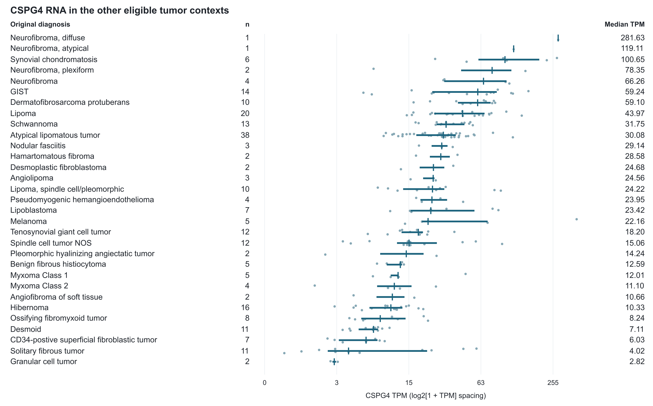
Figure S1. Other eligible tumors in the Hofvander source. The 242 specimens outside the defined malignant comparison span 31 source labels. Dots show specimens, segments show interquartile ranges, and vertical marks show medians. The axis uses log2(1+TPM) spacing with TPM labels. GIST, gastrointestinal stromal tumor; NOS, not otherwise specified.

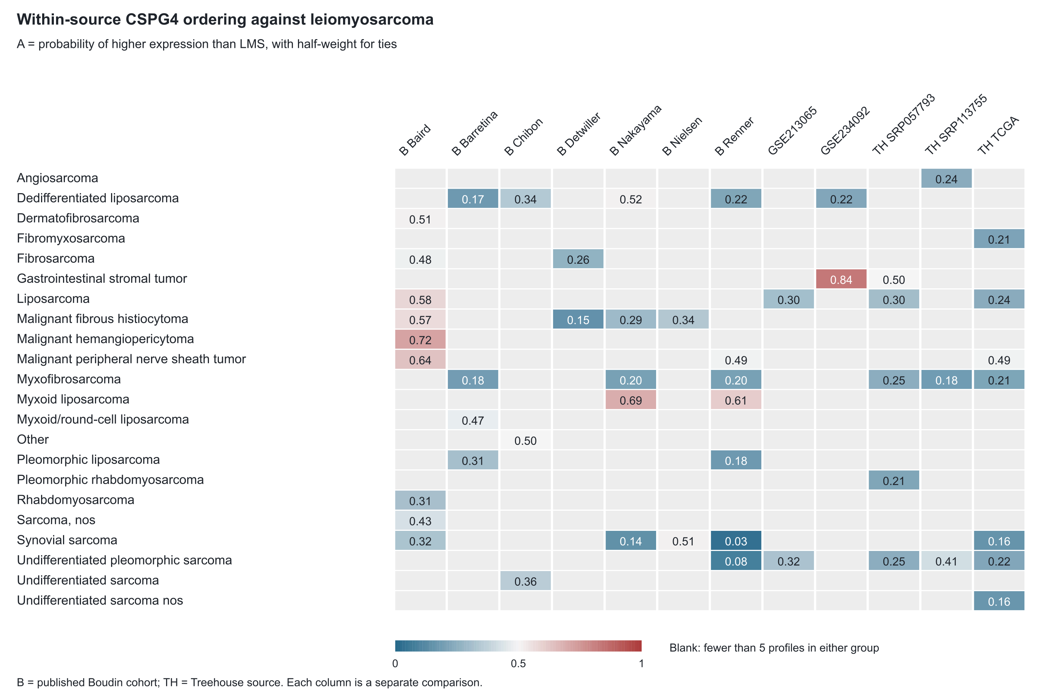
Figure S2. External within-source CSPG4 ordering against LMS. Each cell compares the row diagnosis with LMS within its source and requires at least five profiles per group; blanks lack that support. B denotes published Boudin cohorts; TH denotes Treehouse original accessions. Each retains its measurement scale and historical mixed-platform qualifications.

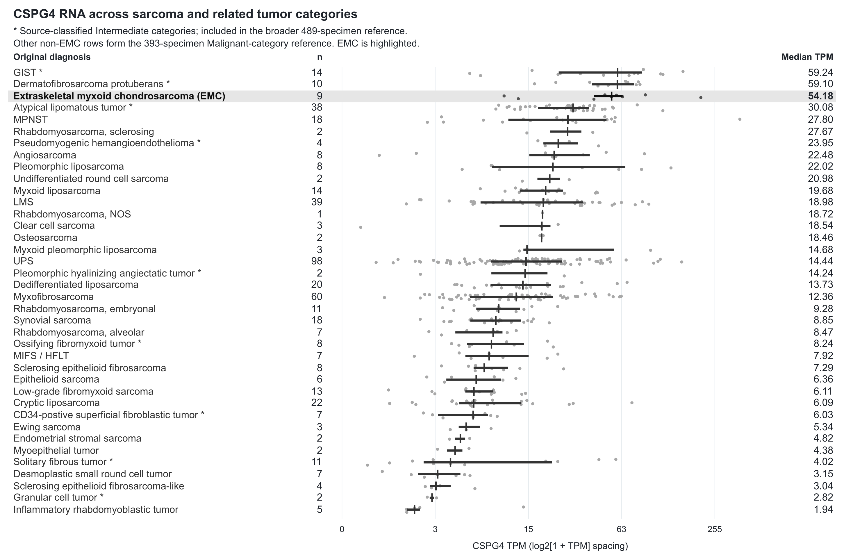
Figure S3. CSPG4 RNA across sarcoma and related tumor categories. The 498 specimens span 38 source diagnosis labels: nine EMC, 393 primary-reference specimens and 96 additional specimens marked by asterisks. Asterisks identify categories classified as Intermediate in the source; all other non-EMC rows form the Malignant-category reference. The broader reference includes both sets. Dots show specimens, horizontal segments interquartile ranges and vertical marks medians. The axis uses log2(1+TPM) spacing with TPM labels; categories are ordered by observed median. Other eligible contexts appear in Figure S1. MIFS/HFLT, myxoinflammatory fibroblastic sarcoma/hemosiderotic fibrolipomatous tumor; NOS, not otherwise specified.

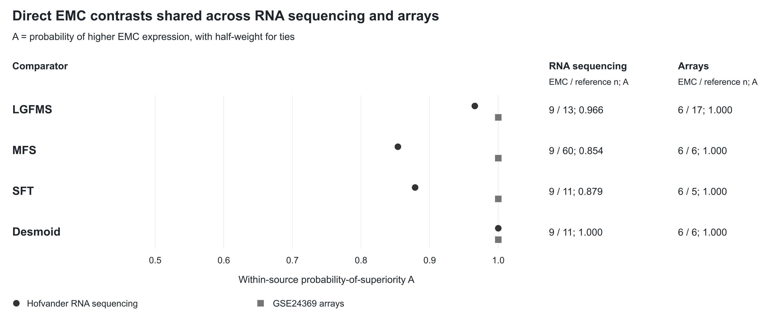
Figure S4. Direct EMC comparisons shared across two assays. Points show A=P(EMC>comparator)+0.5P(tie) for the four diagnosis groups measured in both Hofvander RNA sequencing and GSE24369 arrays. The table supplies specimen counts and scores. Each score is calculated within its source. LGFMS, low-grade fibromyxoid sarcoma; MFS, myxofibrosarcoma; SFT, solitary fibrous tumor.

