 | MINISTRY OF EDUCATION AND TRAINING

FPT UNIVERSITY
Capstone Project Document
[Project name]

<Group Name>
Group Members | < Lê Đức Trí > < Leader >< SE180473 >  < Nguyễn Đặng Đăng Quan >< Member >< SE182747 >  <Trần Bá Huy> < Member >< SE180058 >  < Lê Thị Minh Thư > < Member >< SE185044 >
Supervisor | Đỗ Phúc Thịnh
Ext Supervisor
Capstone Project code | SU26SE071

-Ho Chi Minh, August 2026 -

Table of Contents

Acknowledgement 4
Definition and Acronyms 4
I. Project Introduction 5
1. Overview 5
2. Product Background 5
3. Existing Systems 5
4. Business Opportunity 5
5. Software Product Vision 5
6. Project Scope & Limitations 5
II. Project Management Plan 6
1. Overview 6
2. Management Approach 6
3. Master Schedule 6
4. Project Organization 6
5. Project Communication 6
6. Configuration Management 6
III. Software Requirement Specification 7
1. Overall Description 7
2. User Requirements 7
3. Functional Requirements 7
4. Non-Functional Requirements 7
5. Other Requirements 7
IV. Software Design Description 8
1. Overall Description 8
2. System Architecture Design 8
3. System Detailed Design 8
4. Class Specification 8
5. Data & Database Design 8
V. Software Testing Documentation 9
1. Overall Description 9
2. Test Plan 9
3. Test Cases 9
4. Test Reports 9
VI. Release Package & User Guides 10
1. Deliverable Package 10
2. Installation Guides 10
3. User Manual 10
VII. Appendix 10
1. Glossary [Optional] 10
2. References [Optional] 10
3. Others [Optional] 10

Acknowledgement
[Fill team’s acknowledgement here…]

Definition and Acronyms
[Fill all the definitions, acronyms,… used within the document] in the table format as below]
Acronym | Definition
PWM | Psychology website
AWS | Amazon Web Services
BA | Business Analysis
BR | Business Rule
ERD | Entity Relationship Diagram
GUI | Graphical User Interface
PM | Project Manager
SDD | Software Design Description
SPMP | Software Project Management Plan
SRS | Software Requirement Specification
UAT | User Acceptance Test
UC | Use Case
API | Application Program Interface

I. Project Introduction
[Provide final project introduction information follow the template as part II in the Report #1]

1. Overview

1.1 Project Information
[Provide the brief information of the project: project name, project code, group name, etc.]
Project name: FoodResQ - Volunteer-based Food Rescue Platform
- Project code: SU26SE071
- Group name: GSU26SE54
- Software type: Mobile app, Web app

1.2 Project Team
[List out the details of the project team and stakeholders…]
Full Name | Role | Email | Phone
Đỗ Phúc Thịnh | Lecturer | thinhdp2@fpt.edu.vn
Lê Đức Trí | Leader | leductri12321@gmail.com | 0345142309
Nguyễn Đặng Đăng Quan | Member | quannddse182747@fpt.edu.vn | 0367321523
Lê Thị Minh Thư | Member | lethiminhthu.18012004@gmail.com | 0364694725
Trần Bá Huy | Member | huytbse180058@fpt.edu.vn | 0947942640

2. Product Background
[This section summarizes the rationale for the new product. Provide a general description of the history or situation that leads to the recognition that this product should be built. You should also mention here the information on the customer /the people who raise project idea/request]
Food waste remains a critical social and environmental issue in Vietnam, especially in large urban areas such as Ho Chi Minh City, where restaurants, supermarkets, bakeries, hotels, and community kitchens may generate surplus edible food every day. At the same time, many low-income individuals, students, workers, elderly people, and charity beneficiaries still face difficulties accessing affordable and safe meals. This creates a major paradox: usable food is discarded due to short shelf life, lack of coordination, and limited logistics, while vulnerable receivers continue to experience food insecurity.
Current food donation activities are often handled manually through phone calls, social media posts, charity groups, or direct relationships between donors and volunteers. These approaches are meaningful but fragmented. Providers may not know who can collect food quickly; receivers may not know where available food is located; volunteers may lack real-time task assignment; and charities may struggle to plan community kitchen campaigns with transparent tracking. In addition, food safety, pickup verification, trust management, and delivery coordination are difficult to control without a centralized system.
FoodResQ introduces a digital food rescue ecosystem that connects food providers, receivers, volunteers, charity organizations, and administrators in one unified platform. The system supports nearby food listing discovery, reservation with QR verification, volunteer delivery coordination, bulk food rescue runs, charity kitchen campaigns, meal distribution tracking, notifications, trust-score management, and ESG impact reporting. By combining location-based search, role-based workflows, QR confirmation, real-time delivery updates, and administrative moderation, FoodResQ aims to reduce food waste while improving access to safe and timely food support.

3. Existing Systems
[Add the system which might help solving the problems you listed above or the systems in which you can learn/refer the features for your system design]
3.1 Food Bank Vietnam
Description: Food Bank Vietnam is a non-profit food banking network that collects and distributes food through social programs, charity kitchens, and community initiatives.
Link: https://foodbankvietnam.com/
System Actors: Food donors, volunteers, charity organizations, beneficiaries, food bank coordinators.
Features:
- Food collection and redistribution programs.
- Community kitchen and meal support activities.
- Awareness campaigns related to food waste and food security.
- Partnerships with organizations and local communities.
Pros: Strong social mission, real-world food rescue experience, and established community trust in Vietnam.
Cons: The model is mainly organization-driven and may not provide a fully self-service digital platform for real-time food listing, receiver reservations, QR pickup verification, volunteer task matching, provider dashboards, or automated ESG reporting for individual businesses.
3.2 VietHarvest
Description: VietHarvest focuses on rescuing quality surplus food from businesses and redistributing it to people in need through a food rescue operation model.
Link: https://www.vietharvest.com/en/about-us/our-solution/
System Actors: Food businesses, rescue coordinators, charities, beneficiaries.
Features:
- Business surplus food donation.
- Food rescue coordination.
- Redistribution to community organizations.
- Emphasis on quality excess food.
Pros: Clear focus on safe surplus food recovery from businesses and strong alignment with sustainability goals.
Cons: It is not designed as a multi-role application where providers can instantly publish listings, receivers can reserve nearby food, volunteers can accept delivery tasks, and admins can manage trust scores, reports, system configurations, and campaign operations in one platform.
3.3 OLIO
Description: OLIO is an international food-sharing application that allows people and local businesses to share surplus food and household items with nearby users.
Link: https://olioapp.com/en/
System Actors: Food sharers, nearby receivers, volunteers, local businesses.
Features:
- Local food sharing.
- Surplus food collection by volunteers.
- Nearby listing discovery.
- Community-based requesting and pickup arrangement.
Pros: Simple peer-to-peer food sharing model, strong community orientation, and convenient local discovery.
Cons: OLIO is not specifically localized for Vietnamese charity workflows, trust-score penalties, provider reservation limits, QR-based pickup proof, shipper assignment, charity campaign kitchen operations, or administrative compliance workflows required by FoodResQ.
3.4 Too Good To Go
Description: Too Good To Go is a global surplus food marketplace where users purchase discounted surplus meals or food bags from restaurants, bakeries, cafes, and stores.
Link: https://www.toogoodtogo.com/
System Actors: Food businesses, paying customers, platform administrators.
Features:
- Discounted surplus food marketplace.
- Surprise bags or food parcels.
- In-app reservation and pickup.
- Store-based discovery.
Pros: Proven business model for reducing food waste, convenient purchase flow, and strong consumer adoption in supported markets.
Cons: Too Good To Go focuses on discounted commercial sales, while FoodResQ focuses on social-impact food rescue, free or donation-based reservations, charity distribution, volunteer delivery, trust-score governance, and ESG reporting for providers.

4. Business Opportunity
[Describe the market opportunity that exists or the business problem that is being solved. Describe the market in which a commercial product will be competing or the environment in which an information system will be used. This may include a brief comparative evaluation of existing products and potential solutions, indicating why the proposed product is attractive. Identify the problems that cannot currently be solved without the product, and how the product fits in with market trends or corporate strategic directions]
FoodResQ operates in the food rescue, social impact, and sustainability technology sector. The system targets a practical gap in Vietnam: surplus food exists, but the process of matching it with the right receivers or charity organizations is still slow, fragmented, and manually coordinated. FoodResQ creates value by transforming scattered donation activities into a structured digital workflow.
Compared with informal Facebook/Zalo groups or manual charity coordination, FoodResQ provides several advantages:
- Location-based food discovery: receivers can search nearby available food listings using coordinates and radius filtering.
- Reservation control: the system limits daily reservations, prevents overbooking, and updates remaining quantity atomically.
- QR verification: receivers present QR codes and providers confirm pickup, reducing fraud and duplicate collection.
- Volunteer delivery flow: shippers receive offers, accept tasks, update delivery status, and provide proof photos.
- Charity campaign management: charity organizations can create kitchen campaigns, manage menus, shifts, volunteer assignments, donations, transports, distributions, and handoff records.
- Trust-score governance: late cancellation, no-show, late pickup, food safety issues, or successful rescue can affect user trust score.
- ESG reporting: providers can view rescued food impact, such as kilograms saved and sustainability contribution.
- Admin moderation: administrators manage users, reports, verification requests, food categories, campaigns, configurations, and platform statistics.
Problems solved and strategic alignment:
- Food waste reduction: surplus food is listed and reserved before expiration.
- Food access improvement: receivers and charity beneficiaries can access food more easily.
- Operational transparency: QR codes, delivery status, pickup proof, and distribution records create traceable workflows.
- Volunteer coordination: task offers and real-time updates reduce manual phone-based coordination.
- Business sustainability value: providers gain ESG metrics and social impact visibility.
- Safety and accountability: trust scores, reports, admin review, and verification workflows discourage abuse.

5. Software Product Vision
[Write a concise vision statement that summarizes the purpose and intent of the new product and describes what the world will be like when it includes the product. The vision statement should reflect a balanced view that will satisfy the needs of diverse customers as well as those of the developing organization. It may be somewhat idealistic, but it should be grounded in the realities of existing or anticipated customer markets, enterprise architectures, organizational strategic directions, and cost and resource limitations]
For food providers, receivers, volunteers, and charity organizations in Vietnam who need a reliable way to rescue edible surplus food and distribute it to people in need, FoodResQ is a location-based food rescue and charity coordination platform that provides real-time food listings, reservation management, QR pickup verification, volunteer delivery assignment, campaign kitchen operations, trust-score governance, and ESG impact reporting.
Unlike fragmented social media groups or manual charity coordination, FoodResQ offers a centralized and traceable system where food providers can publish surplus food, receivers can reserve nearby listings, volunteers can deliver food, charities can manage community kitchen campaigns, and administrators can monitor platform safety and performance. The product vision is to build a sustainable food rescue ecosystem that reduces food waste, supports vulnerable communities, improves donation transparency, and encourages businesses to participate in measurable social impact activities.

6. Project Scope & Limitations
[The project scope defines the concept and range of the proposed solution. It’s also important to define what will not be included in the product. Clarifying the scope and limitations helps to establish realistic expectations of the many stakeholders. It also provides a reference frame against which proposed features and requirements changes can be evaluated. Proposed requirements that are out of scope for the envisioned product must be rejected, unless they are so beneficial that the scope should be enlarged to accommodate them (with accompanying changes in budget, schedule, and/or resources)]
6.1 Major Features
Guest:
- FE-01: Register account.
- FE-02: Login.
- FE-03: View public food listings.
- FE-04: View public charity campaigns.
- FE-05: Search and filter available listings.
Receiver:
- FE-06: Manage profile.
- FE-07: Search nearby food using map/location.
- FE-08: Reserve food listing.
- FE-09: View reservation QR code.
- FE-10: Track reservation status.
- FE-11: Cancel reservation.
- FE-12: Submit pickup proof.
- FE-13: Rate completed reservation.
- FE-14: View reservation history.
- FE-15: Receive notifications.
- FE-16: Submit reports.
Provider:
- FE-17: Manage provider profile.
- FE-18: Create food listing.
- FE-19: Edit, publish, cancel, or duplicate listing.
- FE-20: Manage provider orders/reservations.
- FE-21: Scan receiver QR code.
- FE-22: Confirm pickup.
- FE-23: Request bulk rescue run.
- FE-24: Donate supplies to charity campaigns.
- FE-25: View ESG impact report.
- FE-26: Receive provider notifications.
Volunteer:
- FE-27: Manage volunteer profile.
- FE-28: Set availability and current location.
- FE-29: Receive shipper delivery offers.
- FE-30: Accept or reject delivery tasks.
- FE-31: Update delivery status with proof photo.
- FE-32: View active deliveries.
- FE-33: View delivery history and stats.
- FE-34: Apply for charity campaign roles.
- FE-35: Check in to campaign assignments.
- FE-36: Complete assigned tasks.
- FE-37: Receive volunteer notifications.
Charity Organization:
- FE-38: Create charity kitchen campaign.
- FE-39: Manage campaign details.
- FE-40: Manage menu items and recipes.
- FE-41: Manage volunteer shifts.
- FE-42: Review volunteer applications.
- FE-43: Send provider supply requests.
- FE-44: Confirm received donations.
- FE-45: Manage meal distributions.
- FE-46: Track handoff QR and beneficiary feedback.
- FE-47: Complete or cancel campaigns.
Admin:
- FE-48: Manage users and account status.
- FE-49: Review provider, charity, volunteer, and receiver verification requests.
- FE-50: Manage reports and resolutions.
- FE-51: Manage food categories and food catalog.
- FE-52: Manage campaigns and assignments.
- FE-53: Manage system configurations.
- FE-54: View platform statistics.
- FE-55: Monitor reservations, listings, trust scores, and ESG data.
6.2 Limitations & Exclusions
Limitations:
- LI-01: Geographic Limitation: FoodResQ is designed primarily for Vietnam, with default map behavior centered around Ho Chi Minh City.
- LI-02: Food Safety Dependency: The system can validate workflow evidence but cannot physically inspect food quality before pickup.
- LI-03: Real-Time Dependency: Delivery tracking, notifications, and task offers depend on stable internet connection and WebSocket availability.
- LI-04: Location Accuracy: Nearby search and shipper matching depend on accurate GPS/location data from users.
- LI-05: Third-Party Dependency: Push notifications, maps, file storage, and external authentication depend on configured third-party services.
- LI-06: Operational Capacity: Very high traffic may reduce performance if deployment resources are limited.
- LI-07: Trust Score Accuracy: Trust score is rule-based and depends on recorded user actions; it cannot fully judge intent or context.
Exclusions:
- EX-01: No Physical Food Inspection: FoodResQ does not directly inspect or certify the physical condition of food.
- EX-02: No International Service: The system does not support cross-border food rescue or international delivery.
- EX-03: No Full Payment Gateway: The main rescue flow focuses on donation/free reservation, not commercial food purchasing.
- EX-04: No Tax or Accounting System: ESG reports are informational and do not replace official accounting, tax, or audit systems.
- EX-05: No Guaranteed Delivery: Volunteer delivery depends on available shippers and successful task acceptance.
- EX-06: No Medical/Nutrition Guarantee: The platform does not provide medical dietary advice or certify meals for specific health conditions.

II. Project Management Plan
[Provide final project plan information follow the template as part II in the Report #2]

1. Overview

1.1 Scope & Estimation
[Create/Provide the list of software product following the table template as below. In this table, we categorize each software function into three levels of complexity (Simple, Medium, Complex) and estimate the total effort to complete each one in man-day]

1.2 Project Objectives
[Provide the overall project objective description and then the specific target metrics of your project in term of quality, time, and cost (allocated effort distribution for project activities: requirement, design, coding, testing, project management, etc)]

1.3 Project Risks
[List out the details on project risks in the table below]

2. Management Approach
[Describe the approach you would use the manage and implement your project]

2.1 Project Process
[Draw and describe the software development process model that the team would apply into the project implementation]

2.2 Quality Management
[Provide the approach you would apply to improve the project quality, reach the project quality objectives

2.3 Training Plan
[You need to plan the training activities in case any of your team member lack of knowledge/skills to handle the project works]

3. Project Deliverables
[Given the main project deliverables. Those can be internal and/or external deliverables]

4. Responsibility Assignments
[Describe the main responsibilities in your project (to complete the outputs as defined in the above section), in the format as the sample below]

5. Project Communications
[Provide the details of project communication plan, the to-be-used tools, the project interface, etc.]

6. Configuration Management

6.1 Document Management
[Describe how you would manage project documents & their changes/versions]

6.2 Source Code Management
[Describe how you would manage project source codes & their changes/versions]

6.3 Tools & Infrastructures
[List out the tools & infrastructure that you would use in the software development and deployment]

III. Software Requirement Specification
[Provide final software requirement specification follow the template as part II in the Report #3]

1. Product Overview
[This section presents a high-level overview of the product and the environment in which it will be used, the anticipated users, and known constraints, assumptions, and dependencies]
FoodResQ is a volunteer-based digital platform designed to rescue surplus food from restaurants, bakeries, supermarkets, and individual donors, redistributing it to those in need through a structured network of food receivers, verified organizations, and volunteers.

The platform addresses two simultaneous urban challenges: the massive daily generation of food waste from commercial food outlets, and the persistent food insecurity faced by low-income individuals and communities. FoodResQ closes this gap by providing real-time coordination tools for food listing, reservation, pickup, volunteer delivery, and charity meal production.

FoodResQ provides:
A mobile application and web application for Food Providers, Receivers, and Volunteers.
A web-based Admin Portal for platform management, analytics, and moderation.
A backend API powered by NestJS with a PostgreSQL data layer.
Real-time notifications for food availability, reservation confirmations, and pickup reminders.
A trust-score and point system to ensure fair distribution and encourage active participation.
AI-assisted location-based matching to connect nearby providers and receivers efficiently.

The system supports six user roles: Food Provider, Food Receiver, Organization, Volunteer Chef, Volunteer Shipper, Volunteer Server, and Admin. Each role has a tailored interface and distinct functional access..
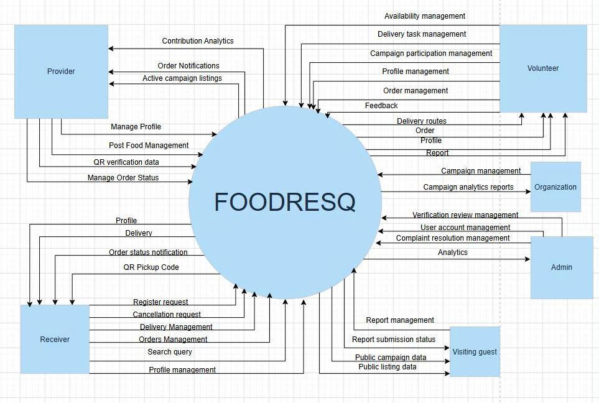

2. User Requirements
[Provide specification of the user requirement: actor, use case diagram(s), use case description, etc.]

2.1 Actors
# | Actor | Description
1 | Admin | Manages the overall FoodResQ platform. Responsible for approving/rejecting accounts, moderating food listings, handling complaints, and monitoring platform-wide analytics and statistics
2 | Food Provider | Restaurants, bakeries, supermarkets, or individuals that have surplus food to donate. Providers create listings, manage reservations, and track pickup outcomes.
3 | Food Receiver | Individual users or verified organizations that search for and reserve available food. Receivers confirm pickup via QR code and can rate providers after collection.
4 | Organization | Verified charitable organizations that can reserve larger quantities of food, manage group pickups for beneficiaries, and host distribution events such as soup kitchens.
5 | Volunteer Chef | Volunteers who accept cooking tasks from organizations, processing donated raw ingredients into safe, ready-to-eat meals for distribution.
6 | Volunteer Shipper | Volunteers who pick up rescued food from providers and deliver it to receivers or distribution points.
7 | Volunteer Server | Volunteers who assist at meal distribution events by confirming beneficiary attendance and tracking meals distributed.
8 | System | Background automated processes that manage expiry enforcement, reservation locking, fair distribution logic, and notification dispatching.

2.2 Use Cases

2.2.1 Use Case Diagram(s)
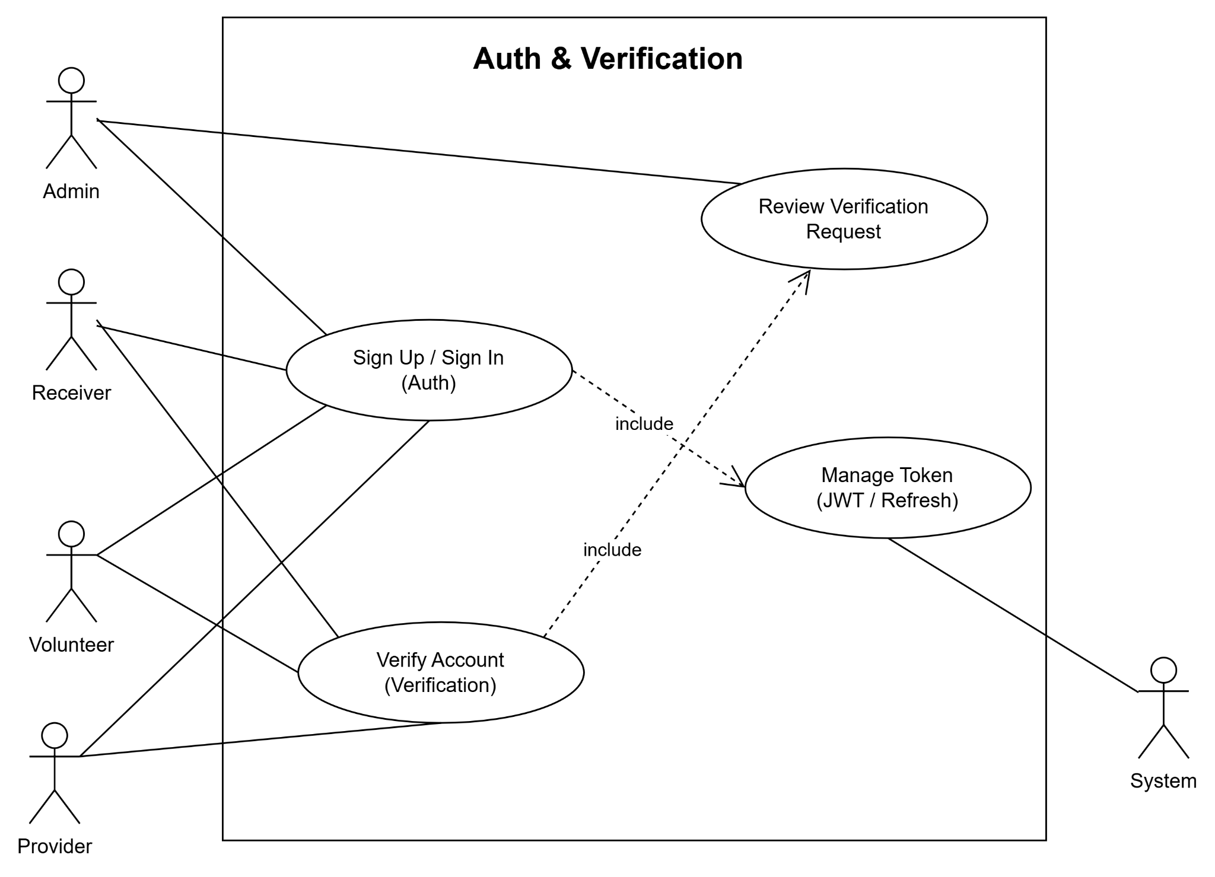
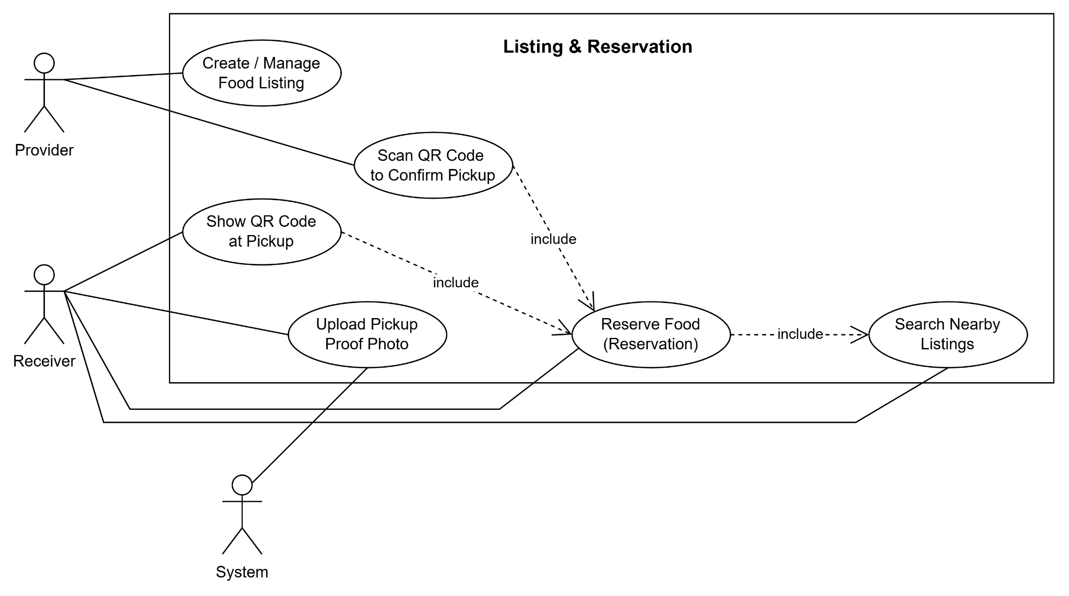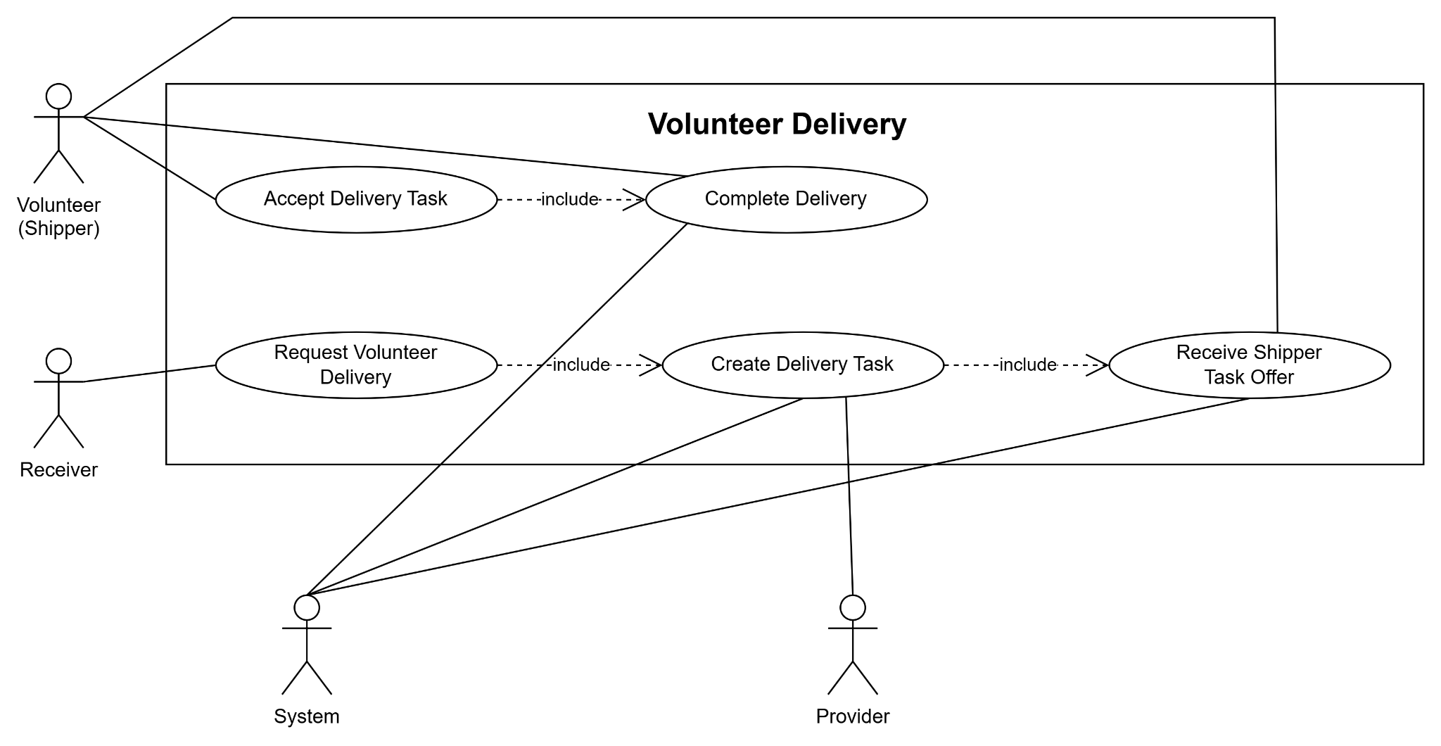

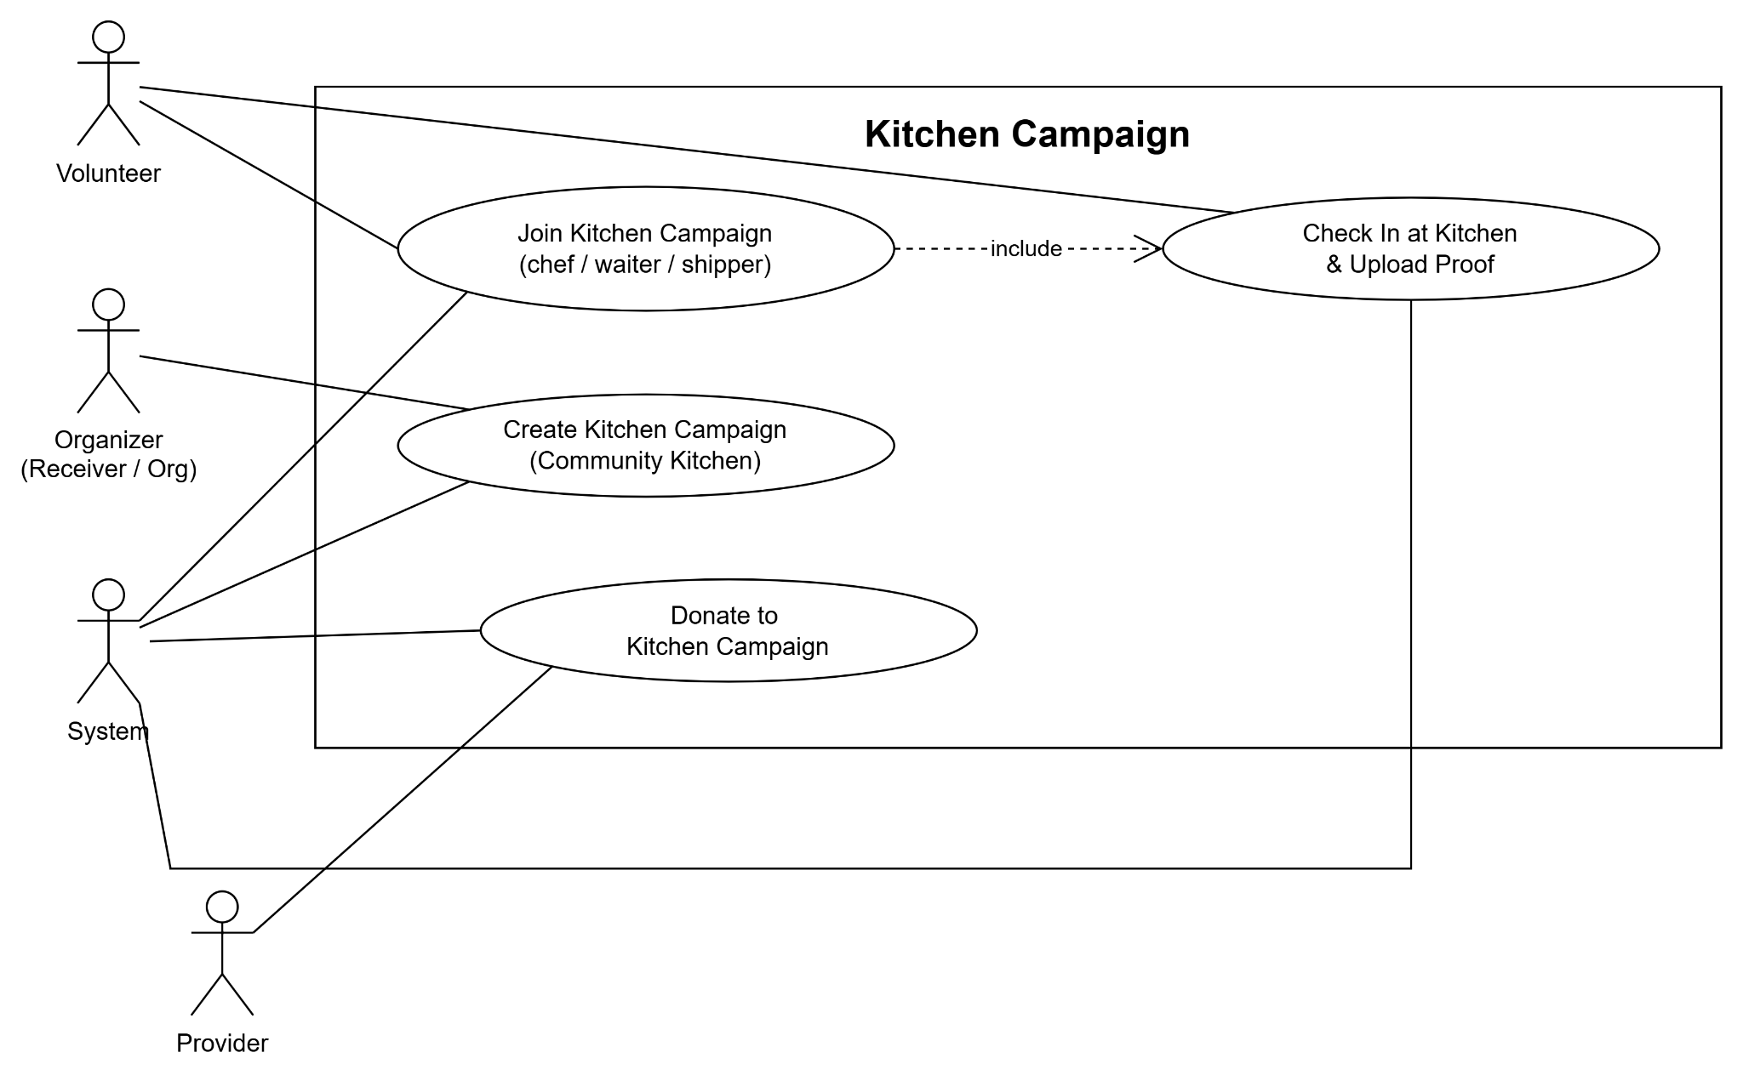
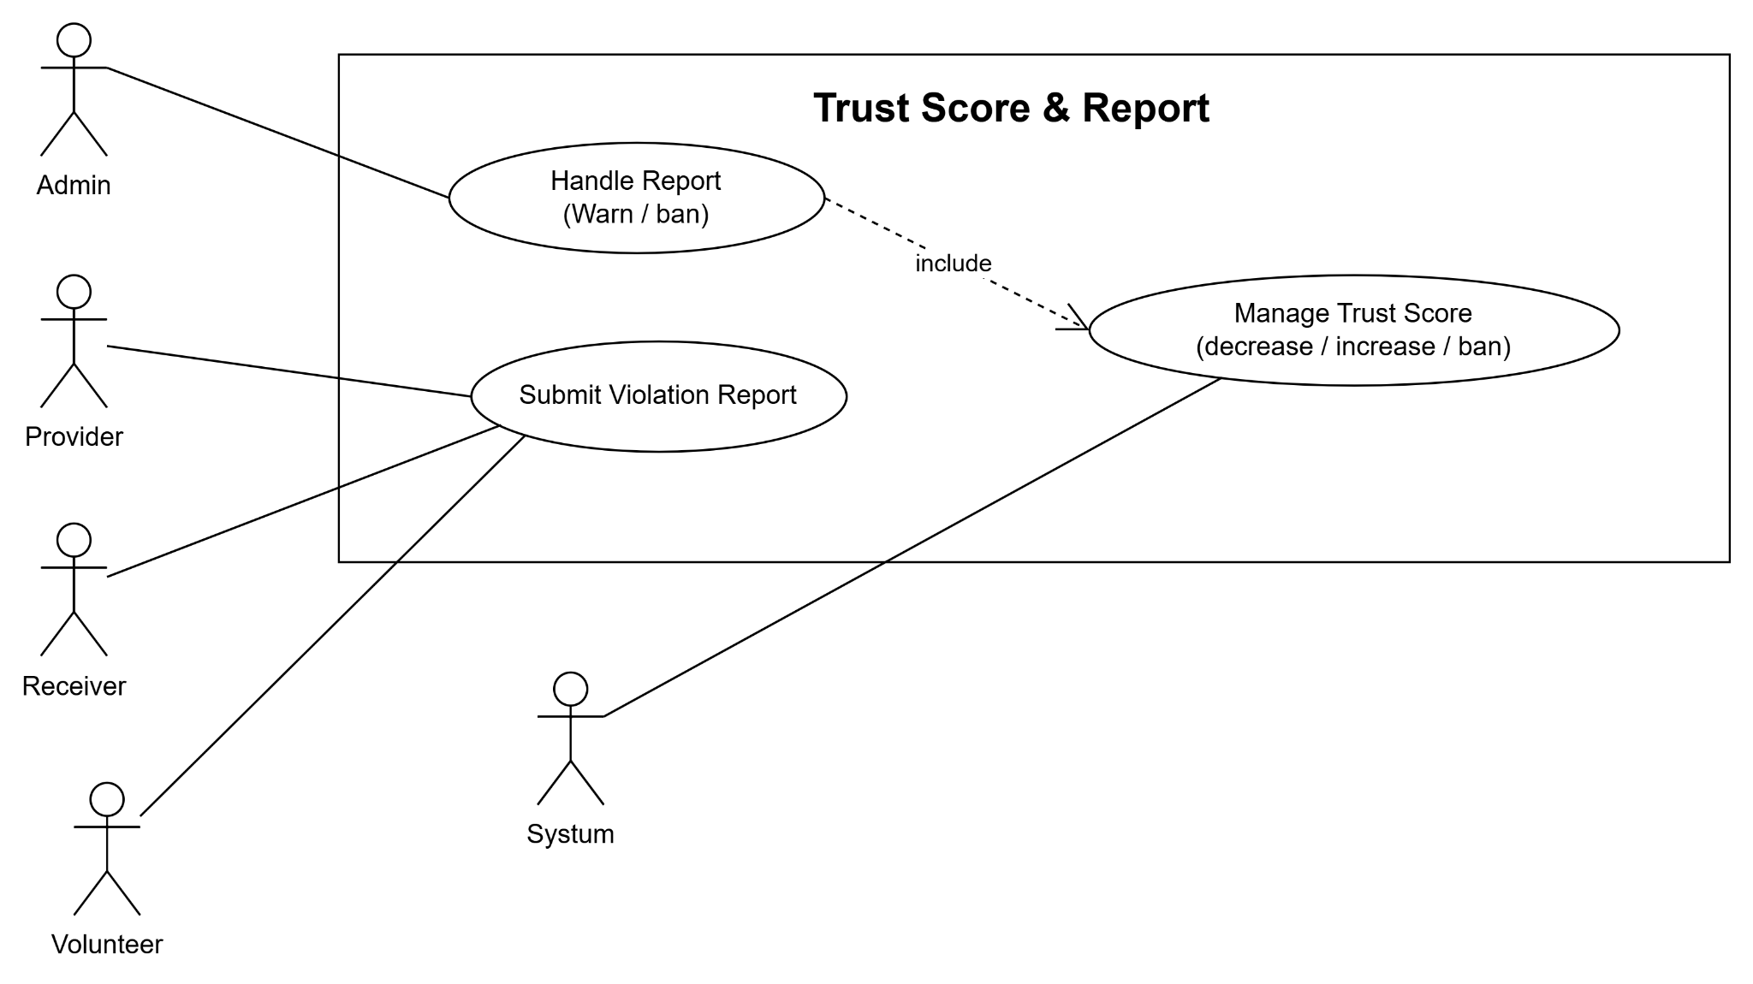
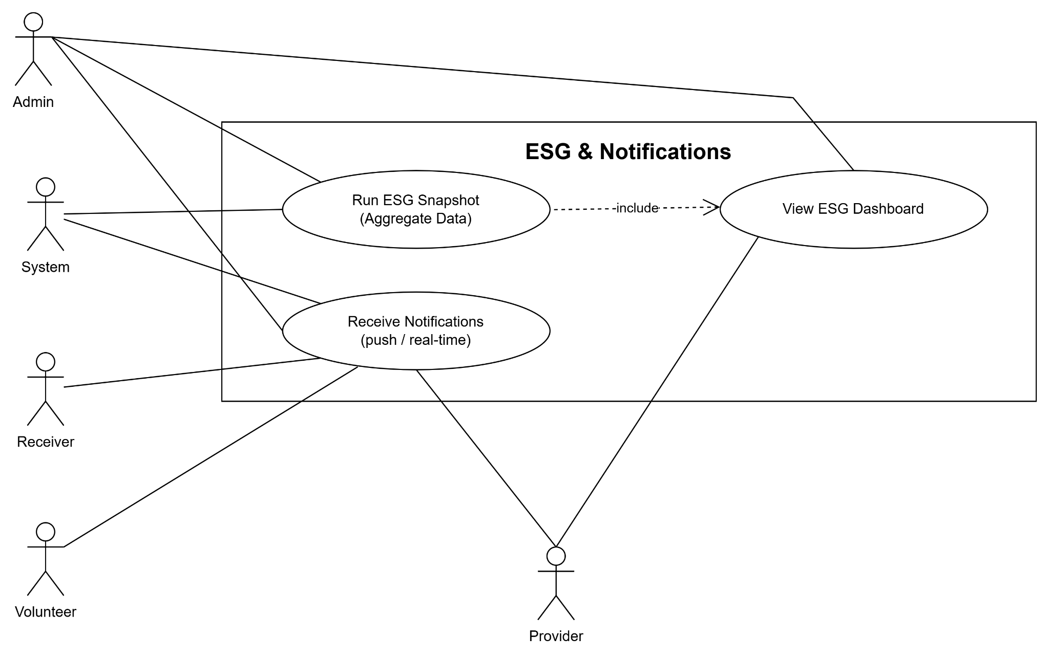

2.2.2 Descriptions

ID | Use Case | Actors | Use Case Description
01 | Login | Guest | Authenticate to access the FoodResQ system.
02 | Register | Guest | Create a new account as Receiver, Charity Organization, Provider, or Volunteer.
03 | Forget Password | Guest | Reset account password through reset token/email flow.
04 | Logout | All Users | End the current session and revoke active refresh tokens.
05 | Update Profile | All Users | Update personal, receiver, provider, or volunteer profile information.
06 | View Notifications | All Users | View system notifications and unread notification count.
07 | Mark Notification as Read | All Users | Mark one notification or all notifications as read.
08 | Submit Report | All Users | Submit a report about a user, listing, delivery, reservation, or campaign.
09 | View Trust History | All Users | View trust score history and reasons for trust score changes.
10 | Upload Image | All Users | Upload images for listings, reports, profile evidence, recipes, or campaign proof.
11 | Enroll Face | Receiver, Volunteer | Submit face image for identity verification and pickup/delivery validation.
12 | Create Food Listing | Provider | Provider creates a surplus food listing with food details, quantity, pickup time, address, and images.
13 | Update Food Listing | Provider | Provider updates an existing listing before or during listing management.
14 | Publish Food Listing | Provider | Provider publishes a draft listing so receivers can reserve it.
15 | Cancel Food Listing | Provider | Provider cancels a food listing and records the cancellation reason.
16 | Duplicate Food Listing | Provider | Provider duplicates an existing listing to create a similar listing faster.
17 | View Own Listings | Provider | Provider views all listings created by their account.
18 | View Listing Statistics | Provider | Provider views listing performance and reservation statistics.
19 | View Provider Reservations | Provider | Provider views all reservations made for their listings.
20 | Scan Reservation QR | Provider | Provider scans receiver QR code to validate pickup.
21 | Confirm Pickup | Provider | Provider confirms that the correct receiver has picked up the reserved food.
22 | Cancel Reservation | Provider | Provider cancels a confirmed reservation without penalizing the receiver.
23 | View Provider ESG | Provider | Provider views rescued food and CO2 saving statistics for their business.
24 | View Provider Requests | Provider | Provider views cooperation requests sent by charity organizations.
25 | Review Provider Request | Provider | Provider accepts or rejects a charity cooperation request.
26 | Pledge Campaign Donation | Provider | Provider pledges ingredients or supplies to a kitchen campaign.
27 | View Bulk Run Requests | Provider | Provider views bulk delivery requests submitted by shippers.
28 | Approve Bulk Run | Provider | Provider approves a shipper request to distribute food in bulk.
29 | Reject Bulk Run | Provider | Provider rejects a bulk run request and provides a reason.
30 | Search Food Listings | Receiver | Receiver searches for available food listings by location, category, distance, and availability.
31 | View Food Listing Detail | Receiver | Receiver views detailed information about a selected food listing.
32 | Reserve Food | Receiver | Receiver reserves a quantity of food from an active listing.
33 | Request Delivery | Receiver | Receiver requests volunteer delivery when creating a reservation.
34 | View My Reservations | Receiver | Receiver views active, completed, cancelled, expired, and no-show reservations.
35 | View Reservation Detail | Receiver | Receiver views QR code, provider details, pickup information, and delivery information.
36 | Cancel Reservation | Receiver | Receiver cancels a reservation before pickup or delivery completion.
37 | Cancel Delivery Search | Receiver | Receiver cancels volunteer delivery search and keeps the reservation for self-pickup.
38 | Track Delivery | Receiver | Receiver tracks delivery status, shipper information, route, and live location.
39 | Submit Pickup Proof | Receiver | Receiver submits proof after provider scans QR if additional verification is required.
40 | Rate Provider | Receiver | Receiver rates and comments on the provider after a completed reservation.
41 | Register Charity Organization | Receiver | Receiver registers or acts as a charity organization to manage food support campaigns.
42 | Create Kitchen Campaign | Charity Organization | Charity organization creates a kitchen campaign with schedule, location, expected servings, and volunteer slots.
43 | View Own Campaigns | Charity Organization | Charity organization views campaigns created by its account.
44 | Update Campaign | Charity Organization | Charity organization updates campaign information through management screens or change requests.
45 | Start Campaign | Charity Organization | Charity organization starts an open campaign and changes its status to in progress.
46 | Complete Campaign | Charity Organization | Charity organization completes a campaign and records actual servings.
47 | Cancel Campaign | Charity Organization | Charity organization cancels an open campaign.
48 | Submit Campaign Change Request | Charity Organization | Charity organization submits a request to change campaign schedule, location, or volunteer slots.
49 | Cancel Campaign Change Request | Charity Organization | Charity organization cancels a pending campaign change request.
50 | Review Volunteer Assignment | Charity Organization | Charity organization approves or rejects volunteers who apply to join a campaign.
51 | Create Campaign Shift | Charity Organization | Charity organization creates working shifts for campaign volunteers.
52 | Update Campaign Shift | Charity Organization | Charity organization updates campaign shift information.
53 | Delete Campaign Shift | Charity Organization | Charity organization deletes a campaign shift if no volunteer is assigned.
54 | Manage Campaign Menu | Charity Organization | Charity organization adds recipes or custom dishes to campaign menu.
55 | Manage Campaign Supplies | Charity Organization | Charity organization adds required supplies or ingredients to a campaign.
56 | Confirm Campaign Donation | Charity Organization | Charity organization confirms that pledged provider donations have been received.
57 | Create Meal Distribution Record | Charity Organization | Charity organization records a distribution round, servings served, people served, and leftovers.
58 | Send Provider Cooperation Request | Charity Organization | Charity organization sends a cooperation request to a provider.
59 | View Sent Provider Requests | Charity Organization | Charity organization views provider requests it has already sent.
60 | Submit Provider Proposal | Charity Organization | Charity organization proposes a new provider when no suitable provider exists in the system.
61 | View Volunteer Profile | Volunteer | Volunteer views verification status, specializations, points, rating, and availability.
62 | Set Availability | Volunteer Shipper | Shipper turns availability on or off and shares current location.
63 | Update Location | Volunteer Shipper | Shipper updates live location while performing delivery tasks.
64 | View Delivery Offers | Volunteer Shipper | Shipper views pending delivery offers assigned by the system.
65 | Accept Delivery Offer | Volunteer Shipper | Shipper accepts a delivery task.
66 | Reject Delivery Offer | Volunteer Shipper | Shipper rejects a delivery task and the system may offer it to another shipper.
67 | View Active Delivery | Volunteer Shipper | Shipper views the current active delivery task.
68 | Update Delivery Status | Volunteer Shipper | Shipper updates delivery status from assigned to heading, QC completed, in transit, and delivered.
69 | Upload Delivery Proof | Volunteer Shipper | Shipper uploads QC, pickup, or delivery proof images.
70 | Cancel Delivery Assignment | Volunteer Shipper | Shipper cancels an accepted delivery before pickup.
71 | Report Failed Delivery | Volunteer Shipper | Shipper reports a failed delivery after pickup with a required reason.
72 | View Delivery History | Volunteer Shipper | Shipper views completed and failed delivery history.
73 | View Shipper Statistics | Volunteer Shipper | Shipper views completed deliveries, failed deliveries, distance, completion rate, rating, and points.
74 | Request Bulk Run | Volunteer Shipper | Shipper requests permission to distribute a large quantity from a provider listing.
75 | Add Bulk Run Stop | Volunteer Shipper, Provider | User adds distribution stops for a bulk run.
76 | Pickup Bulk Run | Volunteer Shipper | Shipper marks a bulk run as picked up and uploads QC proof.
77 | Serve Bulk Run Stop | Volunteer Shipper | Shipper records served quantity and proof at a bulk run stop.
78 | Complete Bulk Run | Volunteer Shipper | Shipper completes the bulk delivery trip.
79 | Cancel Bulk Run | Volunteer Shipper | Shipper cancels a bulk run before completion.
80 | View Campaign Tasks | Volunteer Chef, Volunteer Waiter, Volunteer Shipper | Volunteer views campaign tasks and assignments.
81 | Apply To Campaign | Volunteer Chef, Volunteer Waiter, Volunteer Shipper | Volunteer applies for a role in an open kitchen campaign.
82 | Apply To Campaign Shift | Volunteer Chef, Volunteer Waiter, Volunteer Shipper | Volunteer applies to a specific shift in a campaign.
83 | Advance Campaign Task | Volunteer Chef, Volunteer Waiter, Volunteer Shipper | Volunteer updates task progress and uploads proof images.
84 | Submit Kitchen Safety Log | Volunteer Chef | Chef records food safety checks such as temperature, hygiene, storage, or cross-contamination.
85 | View Kitchen Safety Logs | Volunteer, Charity Organization | User views safety logs for a campaign.
86 | Record Meal Distribution | Volunteer Waiter, Charity Organization | Volunteer or charity records meals served during a campaign distribution round.
87 | Submit Distribution Feedback | User | User submits satisfaction feedback for a meal distribution round.
88 | Add Campaign Experience | Volunteer | Volunteer shares experience, rating, and images after campaign completion.
89 | View Recipes | All Users | User views public recipes and recipe details.
90 | Create Recipe | Volunteer Chef, Admin | Chef or admin creates a cooking recipe.
91 | Update Recipe | Recipe Owner, Admin | Recipe owner or admin updates recipe information.
92 | Delete Recipe | Recipe Owner, Admin | Recipe owner or admin deletes a recipe.
93 | Upload Recipe Image | Volunteer Chef, Admin | User uploads an image for a recipe.
94 | View Admin Dashboard | Admin | Admin views platform statistics, users, listings, reservations, reports, and pending verifications.
95 | View Platform Overview | Admin | Admin views rescued food, CO2 saved, ESG impact, trends, categories, donations, and reports.
96 | View Verification Requests | Admin | Admin views pending provider and volunteer verification requests.
97 | Review Verification Request | Admin | Admin approves or rejects provider and volunteer profiles.
98 | View Users | Admin | Admin views the list and details of user accounts.
99 | Create User | Admin | Admin creates a new account manually.
100 | Update User Status | Admin | Admin activates, suspends, or bans a user account.
101 | View Reports | Admin | Admin views user-submitted reports and complaints.
102 | Resolve Report | Admin | Admin resolves or dismisses a report and records resolution notes.
103 | View Campaigns | Admin | Admin views all kitchen campaigns in the system.
104 | Create Campaign | Admin | Admin creates a campaign for a selected charity receiver.
105 | Update Campaign | Admin | Admin updates campaign information.
106 | Update Campaign Status | Admin | Admin changes campaign status.
107 | Assign Volunteer To Campaign | Admin | Admin manually assigns a volunteer to a campaign role.
108 | Remove Campaign Assignment | Admin | Admin removes a volunteer assignment from a campaign.
109 | View Pending Campaign Assignments | Admin | Admin views campaign volunteer assignments awaiting review.
110 | Review Campaign Assignment | Admin | Admin approves or rejects pending volunteer assignments.
111 | View Campaign Change Requests | Admin | Admin views change requests submitted by charity organizations.
112 | Review Campaign Change Request | Admin | Admin approves or rejects campaign change requests.
113 | View Food Listings | Admin | Admin views and filters food listings by status, category, group, or search keyword.
114 | Update Food Category | Admin | Admin updates the category of a food listing.
115 | View Frequent Cancellers | Admin | Admin views receivers with frequent cancellations or no-shows.
116 | View Recent Reservations | Admin | Admin views recent reservation and donation activity.
117 | View System Configuration | Admin | Admin views configurable system settings.
118 | Update System Configuration | Admin | Admin updates reservation limits, QR validity, search radius, and trust score thresholds.
119 | View Platform ESG | Admin | Admin views platform-wide ESG and food rescue impact statistics.

3. Functional Requirements

3.1 System Functional Overview
[Provide functionality overview of software system: screen flow, screen descriptions, system user roles, screen authorization, non-screen functions, ERD]
This section provides an overview of the primary functionalities of the FoodResQ system, covering screen flows, screen descriptions, system user roles, authorization, non-screen functions, food rescue workflows, volunteer delivery operations, charity campaign management, and the entity-relationship structure.

3.1.1 Screens Flow
Guest / Authentication

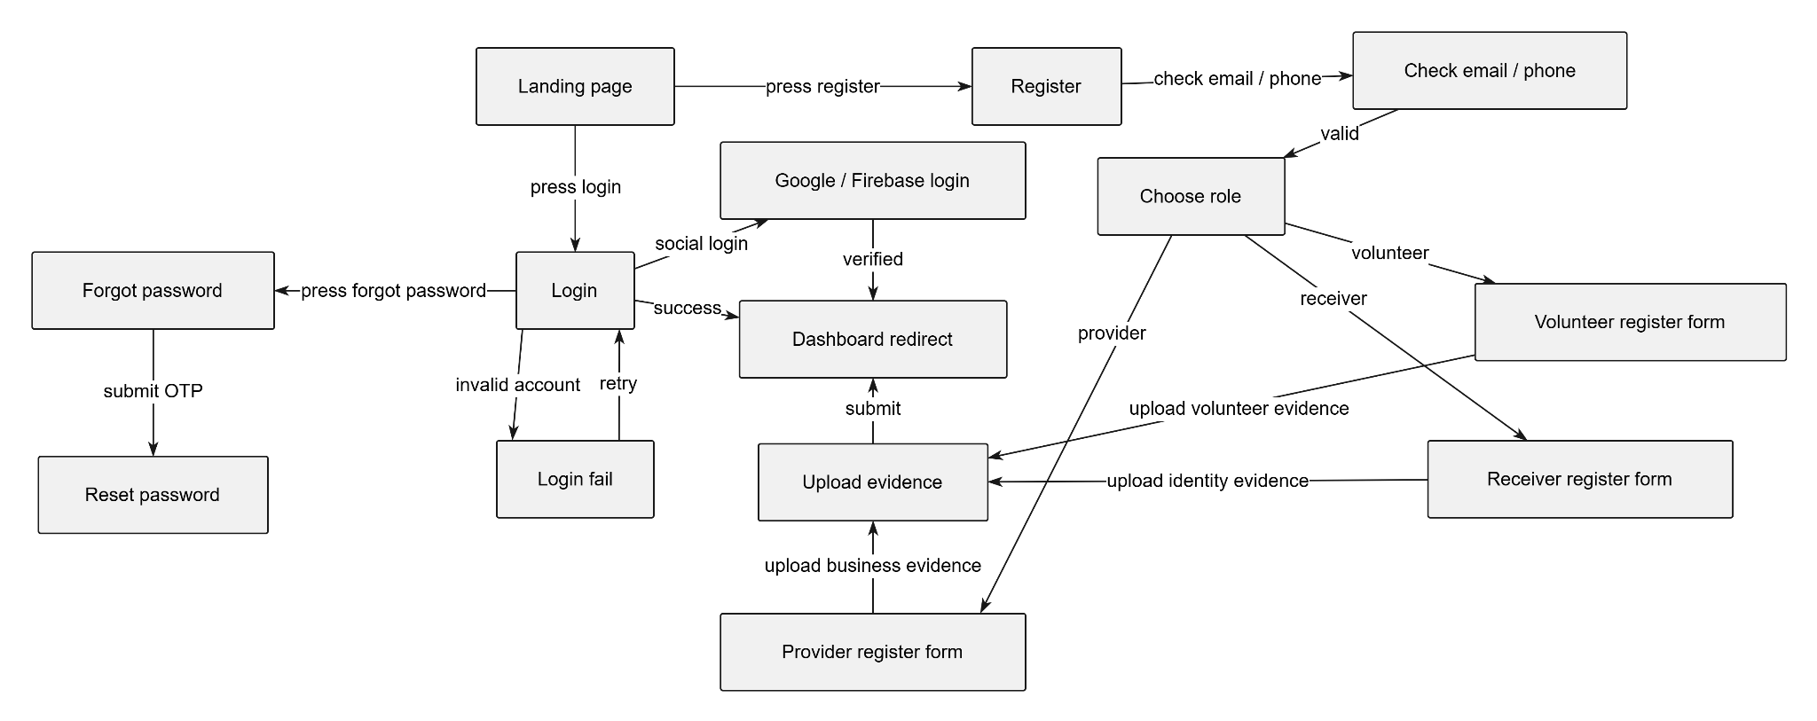

Provider
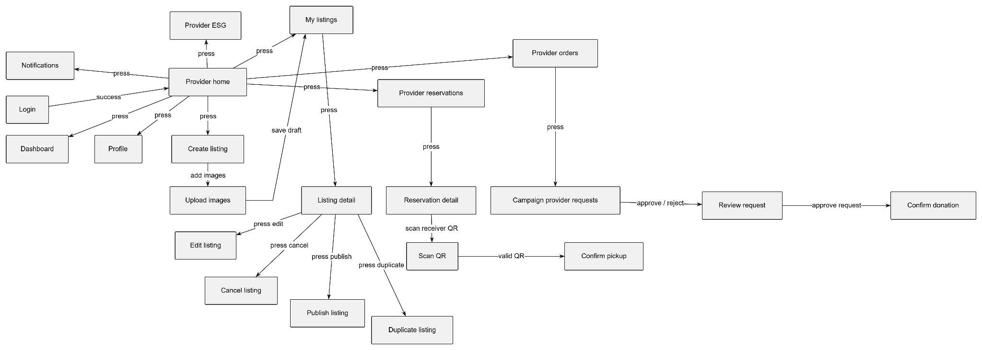
Receiver
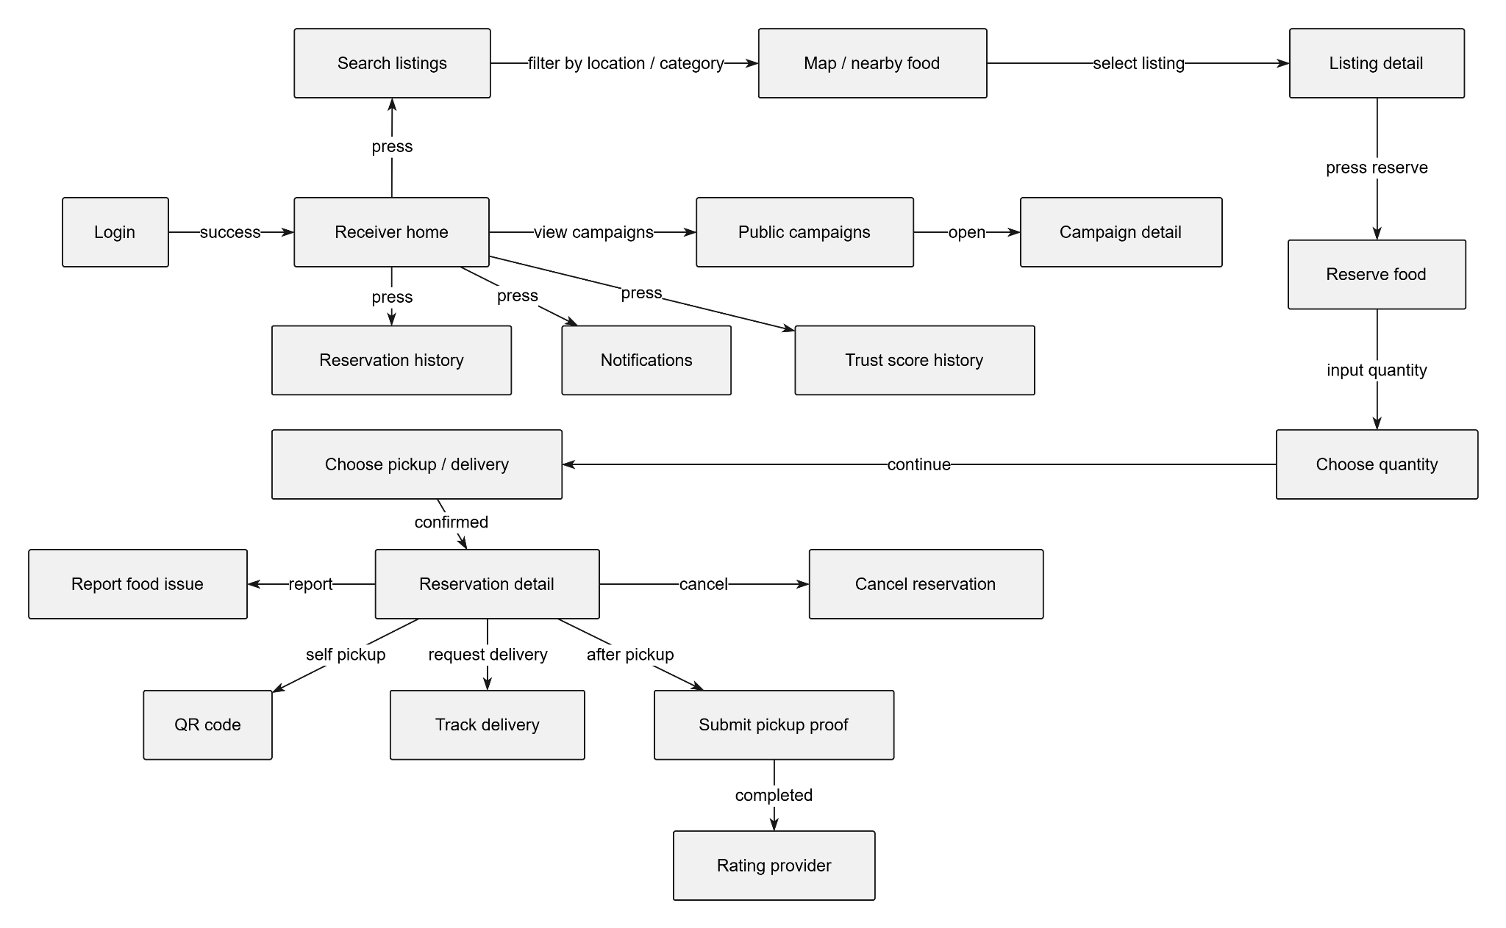

Volunteer Shipper
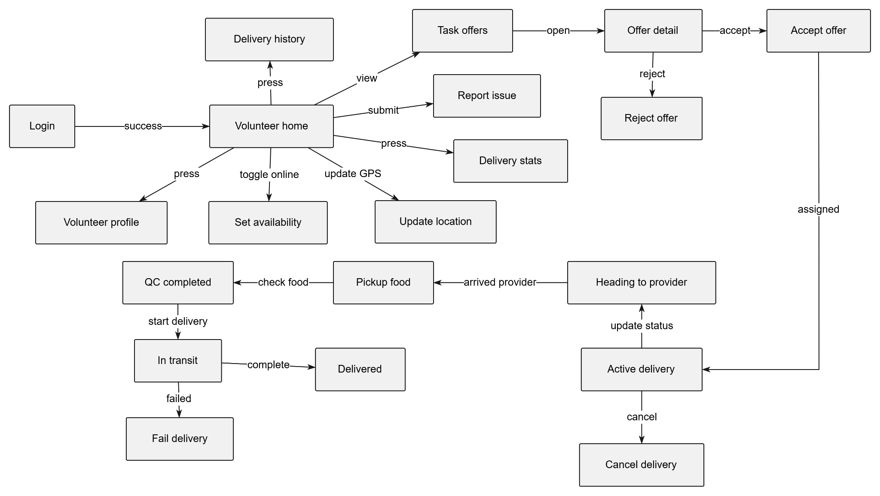

Charity / Campaign Owner
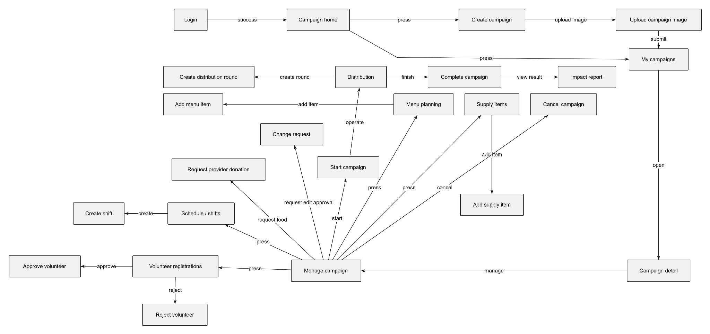

Volunteer Chef / Server Campaign

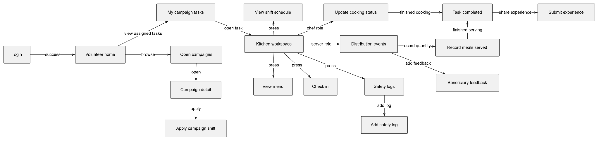

Admin
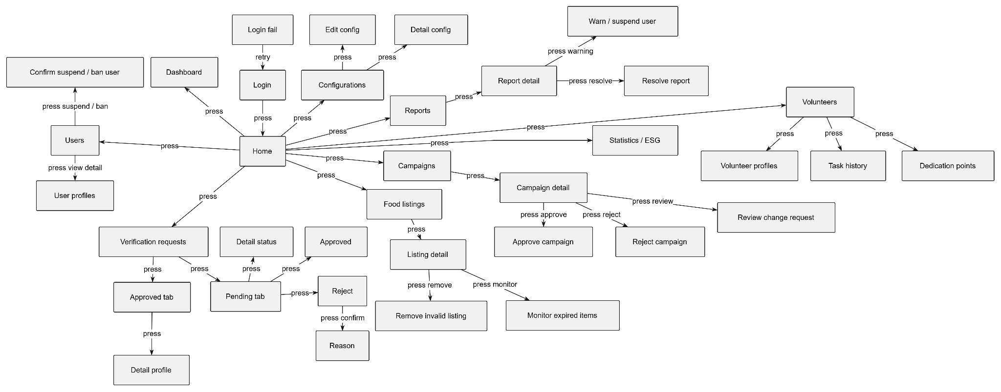

3.1.2 Screen Descriptions
Admin Screen Descriptions
# | Feature | Screen | Description
1 | Authentication | Login | Screen where the admin enters email and password to access the FoodResQ system; displays an error message when authentication fails.
2 | Authentication | Login Fail | Screen state displayed when the admin enters invalid credentials or the account does not have permission to access the admin dashboard.
3 | Home Navigation | Home | Main admin navigation screen that allows access to Dashboard, Users, Verification Requests, Food Listings, Reports, Campaigns, Volunteers, Configurations, and Statistics / ESG.
4 | Dashboard | Dashboard | Displays an overview of the system, including total users, active listings, reservations, campaigns, volunteer activity, and recent platform activities.
5 | User Management | Users | Displays the list of all registered users in the system, including providers, receivers, volunteers, and admins.
6 | User Management | User Profiles | Shows detailed information of a selected user, including personal information, role, status, profile type, trust score, and activity history.
7 | User Management | Confirm Suspend / Ban User | Confirmation screen shown before the admin suspends, bans, or reactivates a user account due to violations or abnormal behavior.
8 | Verification Management | Verification Requests | Displays all profile verification requests submitted by providers, receivers, and volunteers.
9 | Verification Management | Pending Tab | Shows verification requests that are waiting for admin review.
10 | Verification Management | Approved Tab | Shows profiles that have already been reviewed and approved by the admin.
11 | Verification Management | Detail Status | Shows the detailed status of a pending verification request, including submitted documents, evidence, and profile information.
12 | Verification Management | Approved | Screen or action used by the admin to approve a valid provider, receiver, or volunteer profile.
13 | Verification Management | Reject | Screen or action used by the admin to reject an invalid or incomplete verification request.
14 | Verification Management | Reason | Screen where the admin enters or views the reason for rejecting a verification request.
15 | Verification Management | Detail Profile | Shows the full profile details of an approved provider, receiver, or volunteer.
16 | Food Listing Management | Food Listings | Displays all food listings created by providers, including active, draft, completed, expired, cancelled, or fully reserved listings.
17 | Food Listing Management | Listing Detail | Shows detailed information about a selected food listing, including title, category, quantity, pickup address, expiry time, provider, and reservation status.
18 | Food Listing Management | Remove Invalid Listing | Screen or action used by the admin to remove inappropriate, unsafe, duplicated, or invalid food listings.
19 | Food Listing Management | Monitor Expired Items | Screen used to monitor listings that have exceeded their pickup or expiry time and may require administrative action.
20 | Report Management | Reports | Displays complaints and reports submitted by users, such as food safety issues, incorrect listing information, no-show cases, or delivery problems.
21 | Report Management | Report Detail | Shows detailed information of a selected report, including reporter, reported user/listing, issue type, description, evidence, and current status.
22 | Report Management | Warn / Suspend User | Screen or action used by the admin to issue a warning or suspend a user after reviewing a valid complaint.
23 | Report Management | Resolve Report | Screen or action used by the admin to mark a report as resolved after investigation.
24 | Campaign Management | Campaigns | Displays all charity kitchen campaigns in the system, including draft, open, in-progress, completed, and cancelled campaigns.
25 | Campaign Management | Campaign Detail | Shows detailed information about a selected campaign, including campaign owner, schedule, kitchen address, target meals, volunteers, donations, and current status.
26 | Campaign Management | Approve Campaign | Screen or action used by the admin to approve a valid campaign so it can be opened for volunteers and providers.
27 | Campaign Management | Reject Campaign | Screen or action used by the admin to reject a campaign that does not meet system requirements.
28 | Campaign Management | Review Change Request | Screen used by the admin to review campaign update requests submitted after a campaign has already been created or approved.
29 | Volunteer Management | Volunteers | Displays the list of volunteers in the system, including shipper, chef, server, and coordinator roles.
30 | Volunteer Management | Volunteer Profiles | Shows detailed information of a selected volunteer, including specialization, availability, verification status, delivery history, and dedication points.
31 | Volunteer Management | Task History | Displays volunteer task history, including delivery tasks, campaign shifts, completed assignments, failed tasks, and attendance.
32 | Volunteer Management | Dedication Points | Shows the volunteer’s dedication point history, rank, earned points, and contribution records.
33 | Configuration | Configurations | Displays the list of system configuration items, such as reservation limits, search radius, QR validity, trust score rules, and platform settings.
34 | Configuration | Detail Config | Shows detailed information of a selected configuration item, including key, value, description, and last updated time.
35 | Configuration | Edit Config | Screen used by the admin to update system configuration values.
36 | Statistics / ESG | Statistics / ESG | Shows aggregated platform statistics, including rescued food quantity, completed reservations, meals distributed, active users, completed campaigns, and estimated CO2 saved.

Guest / Authentication Screen Descriptions

# | Feature | Screen | Description
1 | Entry | Landing Page | Public entry screen that introduces FoodResQ and allows guests to login, register, or view public campaign information.
2 | Authentication | Login | Guest enters email and password to access the system.
3 | Authentication | Login Fail | Displays an error when the email, password, or account status is invalid.
4 | Authentication | Register | New user starts account creation.
5 | Authentication | Check Email / Phone | Validates whether the email or phone number is already used before account creation.
6 | Role Selection | Choose Role | User selects a role such as Provider, Receiver, or Volunteer during registration.
7 | Provider Onboarding | Provider Register Form | Provider enters business information, address, contact details, and food donation profile information.
8 | Receiver Onboarding | Receiver Register Form | Receiver enters personal or organization information needed to reserve rescued food.
9 | Volunteer Onboarding | Volunteer Register Form | Volunteer enters personal information, availability, and selected volunteer specialization.
10 | Verification | Upload Evidence | User uploads required evidence or documents for profile verification.
11 | Password Recovery | Forgot Password | User requests password recovery using registered email or phone.
12 | Password Recovery | Reset Password | User resets password after OTP or reset verification succeeds.
13 | Social Authentication | Google / Firebase Login | User signs in using Google or Firebase authentication.
14 | Navigation | Dashboard Redirect | Redirects the user to the correct dashboard based on role and account status.

Provider Screen Descriptions

# | Feature | Screen | Description
1 | Authentication | Login | Provider enters email and password to access the provider portal.
2 | Provider Dashboard | Provider Home | Main provider screen showing listing activity, reservations, food rescue statistics, and shortcuts.
3 | Provider Dashboard | Dashboard | Displays provider performance metrics such as shared food, completed pickups, reservations, and ESG impact.
4 | Provider Profile | Profile | Shows provider business profile, contact information, address, and verification status.
5 | Listing Management | Create Listing | Provider creates a surplus food listing by entering food name, category, quantity, pickup time, expiry time, and address.
6 | Listing Management | Upload Images | Provider uploads food images for a listing.
7 | Listing Management | My Listings | Displays all listings created by the provider with their current statuses.
8 | Listing Management | Listing Detail | Shows details of a selected listing, including quantity remaining, reservations, pickup window, and status.
9 | Listing Management | Edit Listing | Provider updates listing information before or while it is still manageable.
10 | Listing Management | Publish Listing | Action used to make a draft listing visible to receivers.
11 | Listing Management | Cancel Listing | Provider cancels a listing that is no longer available.
12 | Listing Management | Duplicate Listing | Provider duplicates an existing listing to create a similar new listing faster.
13 | Reservation Management | Provider Reservations | Displays reservations made by receivers for the provider listings.
14 | Reservation Management | Reservation Detail | Shows reservation details, receiver information, quantity, pickup status, and verification status.
15 | Pickup Verification | Scan QR | Provider scans the receiver QR code to verify pickup.
16 | Pickup Verification | Confirm Pickup | Confirms that the receiver has collected the reserved food.
17 | Campaign Support | Provider Orders | Shows food requests or campaign-related orders sent to the provider.
18 | Campaign Support | Campaign Provider Requests | Displays requests from charity campaigns asking the provider to contribute food.
19 | Campaign Support | Review Request | Provider approves or rejects a campaign food request.
20 | Campaign Support | Confirm Donation | Provider confirms pledged food donation for a campaign.
21 | ESG Reporting | Provider ESG | Shows provider impact statistics such as rescued food amount, completed donations, and estimated CO2 saved.
22 | Notification | Notifications | Shows alerts about reservations, campaign requests, listing status, and system updates.

Receiver Screen Descriptions

# | Feature | Screen | Description
1 | Authentication | Login | Receiver enters email and password to access the system.
2 | Receiver Dashboard | Receiver Home | Main receiver screen for searching food, viewing reservations, campaigns, notifications, and trust score.
3 | Food Search | Search Listings | Receiver searches available food listings by keyword, location, category, distance, or expiry time.
4 | Food Search | Map / Nearby Food | Displays nearby available food listings on a map.
5 | Food Listing | Listing Detail | Shows listing details such as provider, food description, image, remaining quantity, pickup address, and expiry time.
6 | Reservation | Reserve Food | Receiver starts a reservation for the selected food listing.
7 | Reservation | Choose Quantity | Receiver selects the quantity to reserve within the allowed limit.
8 | Reservation | Choose Pickup / Delivery | Receiver chooses self-pickup or volunteer delivery if delivery is available.
9 | Reservation | Reservation Detail | Shows reservation status, QR code, delivery status, pickup window, and related actions.
10 | Pickup Verification | QR Code | Displays the QR code used by the provider to confirm pickup.
11 | Delivery Tracking | Track Delivery | Shows the volunteer delivery status for a reservation that requires delivery.
12 | Pickup Verification | Submit Pickup Proof | Receiver uploads proof after collecting food.
13 | Reservation | Cancel Reservation | Receiver cancels a reservation before the restricted cancellation window.
14 | Feedback | Rating Provider | Receiver rates the provider after a completed pickup or delivery.
15 | Report | Report Food Issue | Receiver reports food quality problems, incorrect information, or pickup/delivery issues.
16 | Reservation History | Reservation History | Displays active, completed, cancelled, expired, and no-show reservations.
17 | Notification | Notifications | Shows alerts such as reservation confirmation, pickup deadline, delivery updates, and nearby food notifications.
18 | Trust Score | Trust Score History | Shows receiver trust score changes caused by successful pickups, cancellations, no-shows, or violations.
19 | Campaign Discovery | Public Campaigns | Shows public charity kitchen campaigns available for viewing or participation.
20 | Campaign Discovery | Campaign Detail | Shows campaign information such as schedule, kitchen address, target meals, required volunteers, and donation needs.

Volunteer Shipper Screen Description

# | Feature | Screen | Description
1 | Authentication | Login | Volunteer shipper enters email and password to access delivery features.
2 | Volunteer Dashboard | Volunteer Home | Main volunteer screen showing active delivery, task offers, availability, statistics, and history.
3 | Volunteer Profile | Volunteer Profile | Shows volunteer information, specialization, verification status, dedication points, and rank.
4 | Availability | Set Availability | Volunteer turns availability on or off to receive delivery task offers.
5 | Location | Update Location | Volunteer updates current GPS location for nearby delivery assignment.
6 | Delivery Offer | Task Offers | Shows available delivery offers assigned to nearby volunteer shippers.
7 | Delivery Offer | Offer Detail | Shows pickup location, receiver location, listing information, distance, and offer expiry time.
8 | Delivery Offer | Accept Offer | Volunteer accepts a delivery task before the offer expires.
9 | Delivery Offer | Reject Offer | Volunteer rejects a delivery offer.
10 | Delivery Execution | Active Delivery | Shows the currently assigned delivery task and available status updates.
11 | Delivery Execution | Heading To Provider | Status screen showing that the shipper is going to the provider pickup location.
12 | Delivery Execution | Pickup Food | Screen used when the shipper picks up food from the provider.
13 | Delivery Execution | QC Completed | Screen or status confirming that the food quality check has been completed.
14 | Delivery Execution | In Transit | Status showing that the food is being delivered to the receiver.
15 | Delivery Execution | Delivered | Final delivery completion screen.
16 | Delivery Exception | Fail Delivery | Screen used to mark a delivery as failed with a reason.
17 | Delivery Exception | Cancel Delivery | Screen used to cancel an assigned delivery when necessary.
18 | Delivery History | Delivery History | Displays completed, cancelled, and failed delivery tasks.
19 | Delivery Statistics | Delivery Stats | Shows delivery performance, completed tasks, dedication points, and activity metrics.
20 | Report | Report Issue | Allows the shipper to report delivery problems, unreachable users, or food safety concerns.

Charity Organization / Campaign Owner Screen Descriptions

# | Feature | Screen | Description
1 | Authentication | Login | Campaign owner logs in to access campaign management features.
2 | Campaign Dashboard | Campaign Home | Main campaign workspace showing created campaigns, volunteer registrations, campaign progress, and impact data.
3 | Campaign Creation | Create Campaign | Campaign owner creates a kitchen campaign by entering title, schedule, location, target meals, required roles, and description.
4 | Campaign Creation | Upload Campaign Image | Uploads an image used for the campaign banner or public campaign page.
5 | Campaign Management | My Campaigns | Displays campaigns created or managed by the organization.
6 | Campaign Management | Campaign Detail | Shows campaign schedule, kitchen address, target meals, volunteers, food supplies, donations, and campaign status.
7 | Campaign Management | Manage Campaign | Main management screen for operating a selected campaign.
8 | Volunteer Registration | Volunteer Registrations | Displays volunteers who applied to join the campaign.
9 | Volunteer Registration | Approve Volunteer | Campaign owner approves a volunteer application for a campaign shift.
10 | Volunteer Registration | Reject Volunteer | Campaign owner rejects an unsuitable or unavailable volunteer application.
11 | Schedule Management | Schedule / Shifts | Shows all campaign shifts and assigned volunteer roles.
12 | Schedule Management | Create Shift | Creates a new volunteer shift with role, time, and required number of slots.
13 | Menu Management | Menu Planning | Displays planned meals or recipes for the campaign.
14 | Menu Management | Add Menu Item | Adds a recipe or custom meal item to the campaign menu.
15 | Supply Management | Supply Items | Displays ingredients, donated food, and supplies used for the campaign.
16 | Supply Management | Add Supply Item | Adds supply items including name, quantity, unit, and source.
17 | Provider Collaboration | Request Provider Donation | Sends a request to a provider asking for food contribution to the campaign.
18 | Campaign Change | Change Request | Allows the campaign owner to request changes that require admin approval.
19 | Campaign Operation | Start Campaign | Changes campaign status to in-progress when the campaign begins.
20 | Distribution | Distribution | Manages meal distribution activity during the campaign.
21 | Distribution | Create Distribution Round | Creates a distribution round with location, number of meals, and notes.
22 | Campaign Operation | Complete Campaign | Marks the campaign as completed after meal preparation and distribution finish.
23 | Campaign Operation | Cancel Campaign | Cancels a campaign when it cannot proceed.
24 | Impact Reporting | Impact Report | Shows campaign result metrics such as meals distributed, volunteers joined, supplies used, and community impact.

Volunteer Chef / Server Campaign Screen Descriptions

# | Feature | Screen | Description
1 | Authentication | Login | Volunteer chef or server logs in to access assigned campaign tasks.
2 | Volunteer Dashboard | Volunteer Home | Main volunteer screen for browsing campaigns, viewing assigned tasks, and checking contribution status.
3 | Campaign Discovery | Open Campaigns | Shows campaigns that are open for volunteer registration.
4 | Campaign Discovery | Campaign Detail | Shows campaign information, available shifts, required roles, location, and schedule.
5 | Campaign Registration | Apply Campaign Shift | Volunteer applies for a campaign shift based on role and availability.
6 | Campaign Task | My Campaign Tasks | Displays campaign shifts and tasks assigned to the volunteer.
7 | Kitchen Operation | Kitchen Workspace | Main screen used during campaign execution for kitchen tasks, menu, safety, and distribution.
8 | Kitchen Operation | View Menu | Shows meals or recipes planned for the campaign.
9 | Shift Schedule | View Shift Schedule | Shows assigned shift time, role, and campaign location.
10 | Attendance | Check In | Volunteer confirms attendance for an assigned campaign shift.
11 | Food Safety | Safety Logs | Displays food safety logs recorded during campaign operation.
12 | Food Safety | Add Safety Log | Volunteer records food safety information such as temperature, hygiene check, or quality result.
13 | Cooking Task | Update Cooking Status | Chef updates cooking progress such as receiving ingredients, cooking, or finished meal preparation.
14 | Distribution | Distribution Events | Server views meal distribution rounds and on-site distribution activities.
15 | Distribution | Record Meals Served | Server records the number of meals distributed to beneficiaries.
16 | Feedback | Beneficiary Feedback | Server records beneficiary feedback, satisfaction, or additional needs.
17 | Volunteer Experience | Submit Experience | Volunteer submits campaign experience, rating, or images after participation.
18 | Campaign Task | Task Completed | Final state showing that the assigned campaign task has been completed.

3.1.3 Screen Authorization
Only Admin can log in and view the web admin dashboard: view statistics, configure the system, approve profile verification, moderate food listings, manage reports, manage users, manage campaigns, manage volunteers, and view platform overview. Admin cannot use operational mobile screens such as reserving food, creating provider listings, accepting delivery tasks, or joining campaign shifts. In FoodResQ, charity campaign owner functions are implemented under the Receiver role when the account represents an organization or charity profile. The screen authorization table below shows the role-based screen access list

# | Screen | Guest | Admin | Provider | Receiver | Volunteer Shipper | Charity / Campaign Owner | Volunteer Chef / Server
1 | Landing Page | x |  | x | x | x | x | x
2 | Login | x | x | x | x | x | x | x
3 | Register | x
4 | Choose Role | x
5 | Forgot Password | x | x | x | x | x | x | x
6 | Reset Password | x | x | x | x | x | x | x
7 | Google / Firebase Login | x |  | x | x | x | x | x
8 | Upload Verification Evidence |  |  | x | x | x | x | x
9 | Dashboard Redirect |  | x | x | x | x | x | x
10 | Admin Home |  | x
11 | Admin Dashboard / Overview |  | x
12 | Statistics / ESG |  | x
13 | System Configurations |  | x
14 | Edit Config |  | x
15 | Users Management |  | x
16 | User Profile Detail |  | x
17 | Suspend / Ban / Reactivate User |  | x
18 | Verification Requests |  | x
19 | Approve / Reject Profile |  | x
20 | Food Listing Moderation |  | x
21 | Remove Invalid Listing |  | x
22 | Reports / Complaints Management |  | x
23 | Resolve Report |  | x
24 | Campaign Approval |  | x
25 | Review Campaign Change Request |  | x
26 | Volunteer Management |  | x
27 | Provider Home |  |  | x
28 | Provider Profile |  |  | x
29 | Create Food Listing |  |  | x
30 | Upload Listing Images |  |  | x
31 | My Listings |  |  | x
32 | Listing Detail |  |  | x | x
33 | Edit Listing |  |  | x
34 | Publish Listing |  |  | x
35 | Cancel Listing |  |  | x
36 | Duplicate Listing |  |  | x
37 | Provider Reservations |  |  | x
38 | Provider Reservation Detail |  |  | x
39 | Scan QR / Confirm Pickup |  |  | x |  | x
40 | Provider Orders |  |  | x
41 | Campaign Provider Requests |  |  | x
42 | Review Campaign Food Request |  |  | x
43 | Confirm Campaign Donation |  |  | x
44 | Provider ESG Report |  |  | x
45 | Receiver Home |  |  |  | x
46 | Search Food Listings |  |  |  | x
47 | Map / Nearby Food |  |  |  | x
48 | Reserve Food |  |  |  | x
49 | Choose Quantity |  |  |  | x
50 | Choose Pickup / Delivery |  |  |  | x
51 | Reservation Detail |  |  |  | x
52 | QR Code |  |  |  | x
53 | Track Delivery |  |  |  | x
54 | Submit Pickup Proof |  |  |  | x
55 | Cancel Reservation |  |  |  | x
56 | Rating Provider |  |  |  | x
57 | Report Food Issue |  |  |  | x
58 | Reservation History |  |  |  | x
59 | Trust Score History |  |  |  | x | x |  | x
60 | Notifications |  |  | x | x | x | x | x
61 | Volunteer Home |  |  |  |  | x |  | x
62 | Volunteer Profile |  |  |  |  | x |  | x
63 | Set Availability |  |  |  |  | x
64 | Update Location |  |  |  |  | x
65 | Task Offers |  |  |  |  | x
66 | Offer Detail |  |  |  |  | x
67 | Accept Delivery Offer |  |  |  |  | x
68 | Reject Delivery Offer |  |  |  |  | x
69 | Active Delivery |  |  |  |  | x
70 | Heading To Provider |  |  |  |  | x
71 | Pickup Food / QC Completed |  |  |  |  | x
72 | In Transit |  |  |  |  | x
73 | Delivered |  |  |  |  | x
74 | Fail Delivery |  |  |  |  | x
75 | Cancel Delivery |  |  |  |  | x
76 | Delivery History |  |  |  |  | x
77 | Delivery Stats |  |  |  |  | x
78 | Public Campaigns | x |  | x | x | x | x | x
79 | Public Campaign Detail | x |  | x | x | x | x | x
80 | Campaign Home |  |  |  |  |  | x
81 | Create Campaign |  |  |  |  |  | x
82 | Upload Campaign Image |  |  |  |  |  | x
83 | My Campaigns |  |  |  |  |  | x
84 | Campaign Detail |  |  |  |  |  | x | x
85 | Manage Campaign |  |  |  |  |  | x
86 | Volunteer Registrations |  |  |  |  |  | x
87 | Approve / Reject Volunteer |  |  |  |  |  | x
88 | Schedule / Shifts |  |  |  |  |  | x | x
89 | Create Shift |  |  |  |  |  | x
90 | Menu Planning |  |  |  |  |  | x | x
91 | Add Menu Item |  |  |  |  |  | x
92 | Supply Items |  |  |  |  |  | x
93 | Request Provider Donation |  |  |  |  |  | x
94 | Campaign Change Request |  |  |  |  |  | x
95 | Start Campaign |  |  |  |  |  | x
96 | Distribution Management |  |  |  |  |  | x | x
97 | Create Distribution Round |  |  |  |  |  | x
98 | Complete Campaign |  |  |  |  |  | x
99 | Cancel Campaign |  |  |  |  |  | x
100 | Impact Report |  |  |  |  |  | x
101 | Open Campaigns |  |  |  |  | x |  | x
102 | Apply Campaign Shift |  |  |  |  | x |  | x
103 | My Campaign Tasks |  |  |  |  | x |  | x
104 | Kitchen Workspace |  |  |  |  |  |  | x
105 | View Menu |  |  |  |  |  |  | x
106 | View Shift Schedule |  |  |  |  | x |  | x
107 | Check In |  |  |  |  | x |  | x
108 | Safety Logs |  |  |  |  |  |  | x
109 | Add Safety Log |  |  |  |  |  |  | x
110 | Update Cooking Status |  |  |  |  |  |  | x
111 | Distribution Events |  |  |  |  |  |  | x
112 | Record Meals Served |  |  |  |  |  |  | x
113 | Beneficiary Feedback |  |  |  |  |  |  | x
114 | Submit Experience |  |  |  |  | x |  | x
115 | Task Completed |  |  |  |  | x |  | x

3.1.4 Non-Screen Functions
[Provide the descriptions for the non-screen system functions, i.e batch/cron job, service, API, etc.]
# | Feature | System Function | Description
1 | User Authentication | Password Hashing Service | Encrypts user passwords with bcrypt during registration, admin user creation, Google/Firebase account creation, and password reset before saving them to the database.
2 | User Authentication | JWT Access Token Service | Generates short-lived access tokens after successful login so authenticated users can access protected APIs.
3 | User Authentication | Refresh Token Rotation Service | Rotates refresh tokens when users request a new access token and stores refresh tokens securely for session continuity.
4 | User Authentication | Token Revocation Service | Revokes refresh tokens when users log out, reset password, or are banned by admin or trust score rules.
5 | User Authentication | Google / Firebase Verification Service | Verifies Google or Firebase ID tokens before allowing social login or Firebase-based authentication.
6 | Password Recovery | Password Reset Token Service | Creates a hashed password reset token with an expiry time and validates it before allowing password reset.
7 | Input Validation | DTO Validation Pipeline | Validates and sanitizes incoming request data using DTOs and validation rules before business logic is executed.
8 | File Upload | Image Storage Service | Stores uploaded images for listings, avatars, verification evidence, campaign images, recipe images, and volunteer experience photos.
9 | Static Assets | Uploaded File Serving Service | Serves uploaded files through the backend static assets route so web and mobile clients can display uploaded images.
10 | Reservation | Reservation Lock Service | Uses Redis and Redlock to prevent multiple receivers from reserving the same listing quantity at the same time.
11 | Reservation | Quantity Transaction Service | Updates listing quantity and creates reservation records inside a database transaction to keep reservation data consistent.
12 | Reservation | Daily Reservation Limit Checker | Checks receiver daily reservation limits before allowing a new reservation.
13 | Reservation | QR Token Generator | Generates QR tokens and expiration time for reservation pickup verification.
14 | Reservation | Reservation Expiry Cron | Automatically expires reservations or QR pickup windows when users do not complete pickup before the deadline.
15 | Reservation | No-Show Processor | Marks overdue reservations as no-show when applicable and applies trust score penalties based on business rules.
16 | Reservation | Pickup Completion Service | Completes reservations after valid QR scan or pickup proof and updates trust score or related records.
17 | Delivery | Delivery Creation Service | Creates a delivery record when a receiver requests volunteer delivery for a reservation.
18 | Delivery | Nearest Shipper Matching Service | Finds available nearby volunteer shippers based on location and sends delivery offers.
19 | Delivery | Shipper Offer Expiry Service | Expires shipper task offers when volunteers do not accept them within the allowed time window.
20 | Delivery | Delivery Status Engine | Controls delivery status transitions such as assigned, heading to provider, QC completed, in transit, delivered, failed, or cancelled.
21 | Delivery | Delivery Tracking Service | Provides delivery tracking data to receivers while a volunteer shipper is handling the order.
22 | Notification | Real-Time Notification Gateway | Sends real-time notification events to users through Socket.IO user rooms.
23 | Notification | Notification Persistence Service | Stores notifications in the database so users can view unread and historical notifications.
24 | Notification | Notification Queue Service | Uses BullMQ to queue notification jobs such as pickup reminders and asynchronous system alerts.
25 | Notification | Device Token Service | Stores user device tokens for push notification delivery.
26 | Food Listing | Listing Expiry Cron | Automatically marks food listings as expired when pickup or expiry time has passed.
27 | Food Listing | Listing Status Synchronization | Updates listing status when quantities are fully reserved, completed, expired, cancelled, or restored after reservation cancellation.
28 | Food Listing | Spatial Search Service | Uses location-based queries to find nearby active food listings within a configured search radius.
29 | Trust Score | Trust Score Adjustment Service | Adjusts user trust score after successful pickups, late cancellations, no-shows, or food safety violations.
30 | Trust Score | Trust Score History Service | Records each trust score change with before and after values, reason, source, and reference object.
31 | Trust Score | Automatic Restriction / Ban Service | Restricts or bans users when their trust score falls below configured thresholds and revokes active refresh tokens when banned.
32 | Volunteer | Volunteer Availability Service | Updates volunteer availability so the delivery matching system can include or exclude them from task offers.
33 | Volunteer | Volunteer Location Service | Stores volunteer location updates for distance-based delivery assignment.
34 | Volunteer | Dedication Points Service | Awards dedication points to volunteers after completed deliveries, bulk runs, or campaign assignments.
35 | Volunteer | Dedication Points History Service | Records volunteer point changes with before and after values and the reason for the reward.
36 | Campaign | Campaign Status Scheduler | Uses scheduled jobs to remind campaign participants, detect overdue campaign tasks, and update campaign-related status when required.
37 | Campaign | Campaign Volunteer Assignment Service | Handles volunteer applications, admin or owner review, assignment status changes, check-in, and task progression.
38 | Campaign | Campaign Change Request Service | Stores campaign edit requests and waits for admin approval before applying sensitive campaign changes.
39 | Campaign | Campaign Donation Service | Handles provider donations to campaigns and notifies campaign owners when donations are created or confirmed.
40 | Campaign | Provider Request Service | Allows campaign owners to send food contribution requests to providers and records provider acceptance or rejection.
41 | Campaign | Kitchen Safety Log Service | Records food safety checks such as temperature, hygiene, quality result, notes, and proof photos during campaign operations.
42 | Campaign | Meal Distribution Aggregation | Aggregates meal distribution records and feedback to summarize actual servings and campaign impact.
43 | Bulk Run | Bulk Run Lock Service | Uses distributed locking to avoid conflicting updates when bulk rescue runs are approved, picked up, served, completed, or cancelled.
44 | Bulk Run | Bulk Run Expiry Cron | Automatically checks pending or overdue bulk-run requests and updates their status when needed.
45 | Bulk Run | Bulk Run Stop Service | Tracks each stop in a bulk rescue run and records served quantities for group pickup or multi-stop distribution.
46 | Admin | Audit Log Service | Records important admin actions such as user status changes, campaign reviews, report handling, and configuration updates.
47 | Configuration | System Configuration Cache | Loads and caches system configuration values such as reservation limits, QR validity, search radius, and trust score rules.
48 | ESG Reporting | Platform ESG Calculator | Calculates platform-level impact metrics such as rescued food quantity, meals distributed, completed reservations, campaigns, and estimated CO2 saved.
49 | ESG Reporting | Provider ESG Calculator | Calculates provider-level impact metrics based on completed listings, donations, rescued food, and environmental impact.
50 | Security | CORS and Static Upload Security | Applies backend security settings so frontend origins can access APIs and uploaded proof images safely in development and production.
51 | Security | Role Guard Authorization | Checks JWT identity and role permissions before protected APIs are executed.
52 | Reporting | Complaint Routing Service | Links submitted reports to users, listings, reservations, or deliveries so admins can review and resolve complaints.
53 | Recipe | Recipe Image Upload Service | Handles image uploads for campaign recipes and stores the image URL for menu planning.
54 | Recipe | Recipe Ingredient Management | Stores recipe ingredients and menu item data used by campaign kitchen planning.
55 | Campaign Experience | Experience Image Upload Service | Stores volunteer experience images and links them to public campaign experience posts.

3.1.5 Entity Relationship Diagram
[Provide the entity relationship diagram and the entity descriptions in the table format as below]
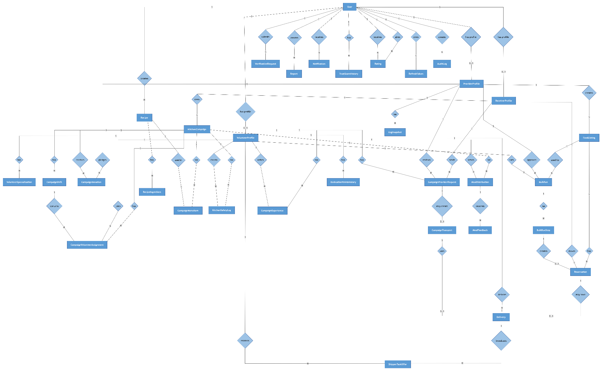

Entities Description
# | Entity | Description
1 | User | Stores core account information for all system users, including email, phone, password hash, full name, role, account status, trust score, FCM token, login time, and soft-delete status.
2 | ProviderProfile | Represents food providers such as restaurants, bakeries, supermarkets, hotels, or other businesses. It stores business information, address, location, verification status, ESG totals, and average rating.
3 | ReceiverProfile | Represents food receivers, including individual receivers and charity organizations. It stores receiver identity data, charity organization information, address, location, face enrollment data, verification status, daily reservation count, and rating.
4 | VolunteerProfile | Represents volunteers who support delivery or campaign operations. It stores identity verification data, current location, availability, vehicle information, dedication points, rank, verification status, and rating.
5 | VolunteerSpecialization | Stores volunteer roles or skills such as shipper, chef, and waiter. It also tracks whether each specialization has been verified.
6 | FoodListing | Represents a food donation listing created by a provider. It includes food title, description, category, quantity, pickup time, expiry time, pickup address, location, storage conditions, allergens, images, and listing status.
7 | Reservation | Records a receiver’s reservation for a food listing. It stores reserved quantity, reservation status, QR token, QR expiry time, pickup proof, cancellation data, receiver notes, and trust penalty flag.
8 | Delivery | Represents a delivery task for either a reservation or a campaign provider request. It stores assigned shipper, delivery status, proof images, pickup and delivery locations, distance, timestamps, and failure reason.
9 | ShipperTaskOffer | Stores delivery offers sent to nearby volunteer shippers. It tracks delivery, shipper, offer status, offered time, response time, expiry time, and rejection reason.
10 | KitchenCampaign | Represents a charity kitchen campaign organized by a receiver organization. It stores campaign title, description, kitchen address, location, schedule, required volunteer slots, filled slots, expected servings, actual servings, images, notes, menu items, supply items, and campaign status.
11 | CampaignVolunteerAssignment | Links volunteers to kitchen campaigns. It records volunteer role, assignment status, check-in/check-out time, proof images, awarded points, notes, and optional shift assignment.
12 | CampaignShift | Represents working shifts inside a kitchen campaign. It stores shift label, role, start time, end time, required slots, filled slots, and related volunteer assignments.
13 | CampaignDonation | Records ingredients or supplies pledged by providers for kitchen campaigns. It stores campaign, provider, item name, quantity, notes, donation status, and received time.
14 | CampaignProviderRequest | Represents cooperation requests sent by charity receivers to providers. It stores campaign, receiver, provider, message, selected listing IDs, duration, pickup schedule, transport requirement, review status, and review note.
15 | CampaignTransport | Links a campaign provider request with a delivery task when transportation is required. It tracks provider request, delivery, transport status, and creation time.
16 | BulkRun | Represents a bulk delivery trip where a shipper picks up a large quantity from a provider listing and distributes it across multiple stops. It stores listing, provider, shipper, quantity, distributed quantity, status, notes, rejection reason, QC proof, and lifecycle timestamps.
17 | BulkRunStop | Represents a distribution stop within a bulk run. It stores stop label, address, location, planned quantity, served quantity, proof photo, notes, creator type, order index, and served time.
18 | Recipe | Stores cooking recipes contributed by qualified users such as chefs or admins. It includes recipe name, description, servings, preparation time, cooking time, difficulty, instructions, images, visibility, rating, and usage count.
19 | RecipeIngredient | Stores ingredients required for a recipe, including ingredient name, quantity, unit, note, and the related recipe.
20 | CampaignMenuItem | Represents menu items planned for a kitchen campaign. It can reference an existing recipe or store a custom dish name, planned servings, and display order.
21 | KitchenSafetyLog | Stores food safety checks during campaign kitchen operations. It records campaign, checking volunteer, check type, measured value, result, photo evidence, note, and checked time.
22 | MealDistribution | Records each meal distribution round in a campaign. It stores campaign, serving volunteer, round label, servings served, people served, leftover servings, location, photo, note, and distribution time.
23 | MealFeedback | Stores feedback for a meal distribution round, including satisfaction score, comment, and creation time.
24 | CampaignExperience | Stores volunteer experience posts after campaign participation. It includes campaign, volunteer, written content, images, rating, and timestamps.
25 | CampaignChangeRequest | Stores charity requests to modify campaign details. It includes requested schedule, location, volunteer slot changes, reason, review status, reviewer, review note, and timestamps.
26 | ProviderProposal | Stores charity proposals for adding new providers to the platform. It includes proposed business information, contact details, duration, status, reviewer, review note, and optionally the created provider profile.
27 | VerificationRequest | Stores submitted verification documents for provider registration, charity registration, volunteer certification, or receiver income proof. It tracks request type, documents, status, reviewer, notes, and review timestamps.
28 | Notification | Stores in-app notifications sent to users. It includes notification type, title, body, attached data, read status, read time, and creation time.
29 | Report | Stores user-submitted reports about users, listings, deliveries, or campaigns. It records reporter, target type, target ID, reason, description, evidence URLs, status, resolver, resolution note, and resolution time.
30 | Rating | Stores ratings between users for reservations or campaigns. It records reference type, reference ID, rater, ratee, score, comment, and creation time.
31 | TrustScoreHistory | Records every trust score change for a user. It stores score delta, reason, reference type, reference ID, score before, score after, creator, note, and creation time.
32 | DedicationPointsHistory | Records dedication point changes for volunteers. It stores volunteer, point delta, reason, reference type, reference ID, points before, points after, and creation time.
33 | RefreshToken | Stores hashed refresh tokens for authenticated sessions. It tracks user, token hash, device info, IP address, revocation status, revocation time, expiry time, and creation time.
34 | LiabilityWaiver | Records user acceptance of liability waivers. It stores user, waiver version, acceptance time, and IP address.
35 | AuditLog | Stores administrative and system audit records. It tracks actor, action, target type, target ID, payload, IP address, user agent, and creation time.
36 | SystemConfig | Stores configurable system settings such as reservation limits, QR validity, and trust score thresholds. It includes config key, value, description, updater, and update time.
37 | EsgSnapshot | Stores ESG impact snapshots for the platform or individual providers. It tracks rescued food weight, CO2 saved, reservation count, active volunteers, active providers, snapshot date, and provider reference.

3.2 <Feature Name 1>
[Profile functional specification for the feature, with the details on each function]

3.2.1 <Function Name 1.1>
…

3.3 <Feature Name 2>

3.3.1 <Function Name 2.1>
…

4. Non-Functional Requirements

4.1 External Interfaces
[This section provides information to ensure that the system will communicate properly with users and with external hardware or software elements.]

4.2 Quality Attributes
[List all the required system characteristics (quality attributes) specification]

5. Requirement Appendix
[List out other requirements, appendix information etc. in this part]

5.1 Business Rules
[Provide common business rules that you must follow. The information can be provided in the table format as the sample below]

5.2 Common Requirements
[Fill all the common requirements here..]

5.3 Application Messages List

5.4 Other Requirements…

IV. Software Design Description
[Provide final software design information follow the template as part II in the Report #4]

1. System Design

1.1 System Architecture
[The content of this section includes the overall diagram which includes the sub-systems, the external systems, and the relationship/connection among them. You need also provide the explanation for each of the diagram components (modules, sub-systems, external systems, etc.)].

1.2 Package Diagram
[Provide the package diagram for each sub-system. The content of this section includes overall package diagram(s) and the explanation for each package (or namespace)]

2. Database Design
[Provide the files description, database table relationship & table descriptions]

3. Detailed Design

3.1 <Feature/Function Name1>
[Provide the detailed design for the feature <Feature Name1>. It includes Class Diagram, Class Specifications, and Sequence Diagram(s); For the features/functions with the same structure of class & sequence diagrams, you need to provide the diagrams once for one feature/function and refer to those diagrams from other features/functions]

3.1.1 Class Diagram
[This part presents the class diagram for the relevant feature]
3.1.2 <Sequence Diagram Name1>
[Provide the sequence diagram(s) for the feature]
3.1.2 <Sequence Diagram Name2>
3.1.3 …

3.2 <Feature/Function Name2>
…

V. Software Testing Documentation

1. Scope of Testing
The testing activities cover the main functional workflows and key non-functional requirements of the FoodResQ system. FoodResQ is a food rescue and donation coordination platform that connects receivers, providers, volunteers/shippers, charity organizations, and administrators. Testing focuses on verifying safe food listing, reservation, pickup, delivery, campaign kitchen operation, bulk distribution, trust-score control, realtime notification, and administration workflows.
Feature and Function to be tested:
User authentication, registration with eKYC, logout, password recovery, token refresh, and role-based access control.
Food listing browsing, nearby search, listing detail viewing, provider listing creation, image upload, publishing, updating, cancellation, and pickup-window validation.
Reservation workflow, including stock validation, daily reservation limit, Redis lock behavior, QR generation, QR scan confirmation, cancellation, no-show handling, and pickup completion.
Delivery workflow, including nearest shipper assignment, offer broadcast, offer acceptance/rejection/expiry, delivery lifecycle, QC photo, live tracking, and receiver QR handoff proof.
Bulk run workflow, including bulk request, provider approval/rejection, pickup, stop logging, served portion tracking, completion, and leftover stock return.
Campaign and kitchen operation workflow, including campaign creation, admin approval/rejection, volunteer staffing, shift management, menu management, dish preparation, safety logs, meal distribution, beneficiary QR handoff, provider supply request, and transport receipt.
Profile, trust-score, notification, admin, KYC review, user governance, violation handling, and operational monitoring functions.
Feature and Function not to be tested:
Large-scale production stress testing beyond the controlled capstone demonstration workload.
Production disaster recovery, multi-region failover, and incident-response drills.
Third-party infrastructure reliability testing, such as external push notification, geocoding, object storage, or hosting provider outages.
Formal biometric face-matching accuracy benchmarking; testing only verifies that the eKYC and face-enrollment gates work correctly in the system workflow.
Online payment settlement because FoodResQ focuses on food donation, reservation, delivery, and distribution workflows.

2. Test Strategy

2.1 Testing Types
Functional Testing
Objective: Ensure that FoodResQ functions comply with requirement specifications and business rules.
Technique: Black-box and scenario-based testing from each user role.
Completion Criteria: All critical functional test cases pass without major defects.
Integration Testing
Objective: Verify that frontend/mobile screens, NestJS APIs, PostgreSQL/PostGIS, Redis locks, queues, and Socket.IO events work together correctly.
Technique: Execute cross-module workflows and check UI, API response, database state, and notification behavior.
Completion Criteria: No broken state transition or data mismatch remains.
System Testing
Objective: Validate the complete FoodResQ system against end-to-end user workflows.
Technique: Execute receiver, provider, volunteer/shipper, charity, and admin scenarios.
Completion Criteria: Main workflows operate correctly without blocking errors.
User Acceptance Testing
Objective: Ensure that the system satisfies realistic food-rescue operation needs.
Technique: Team members perform role-based demo scenarios using prepared accounts and seeded data.
Completion Criteria: Required user stories and acceptance criteria are met.
Security Testing
Objective: Validate authentication, authorization, banned/restricted account behavior, upload validation, and protected route access.
Technique: Test invalid credentials, expired tokens, wrong-role access, unauthenticated access, and invalid inputs.
Completion Criteria: Unauthorized requests are rejected and protected operations require a valid role/session.

2.2 Test Levels
Type of Tests | Unit | Integration | System | Acceptance
Functionality | X | X | X | X
User Interface |  |  | X | X
Data Validation | X | X | X | X
Role-based Access | X | X | X | X
Realtime/Notification |  | X | X | X
Performance |  | X | X
Table 36. Test levels table

2.3 Supporting Tools
Purpose | Tool | Vendor/In-house | Version
Test case management | Microsoft Excel | Microsoft | Desktop / latest
Manual test execution | Chrome, Edge, Android Emulator, Expo Go | Microsoft / Google / Expo | Latest
API verification | Swagger / Postman | In-house / Postman | Latest
Defect tracking | GitHub Issues | GitHub | Cloud version
Table 37. Supporting tools table

3. Test Plan

3.1 Human Resources
Worker/Doer | Role | Specific Responsibilities/Comments
QA Team | Tester | Prepare manual test cases, execute system and acceptance tests, record actual results
Backend Developer | Developer | Support API, service rule, database, queue, and realtime issue investigation
Web/Mobile Developer | Developer | Support UI, form validation, map, QR, and role-based screen issue investigation
Project Lead | Reviewer | Review scope, milestones, defect severity, and final report consistency
Table 38. Human resources table

3.2 Test Environment
Purpose | Tool | Provider | Version
Web application testing | Chrome / Edge | Google / Microsoft | Latest
Mobile application testing | Expo Go / Android Emulator | Expo / Google | Latest
Backend API | NestJS API Server | In-house | Latest project build
Database | PostgreSQL + PostGIS | Open-source | 15.x+
Realtime and background jobs | Socket.IO, Redis, BullMQ | Open-source | Latest
Source control | Git | Open-source | Latest
Table 39. Test environment table

3.3 Test Milestones
Milestone Task | Start Date | End Date
Test planning | 01/08/2026 | 03/08/2026
Test case development | 04/08/2026 | 08/08/2026
Manual system testing | 09/08/2026 | 12/08/2026
Acceptance testing | 13/08/2026 | 14/08/2026
Testing closure and reporting | 15/08/2026 | 15/08/2026
Table 40. Test milestones table

4. Test Cases
Manual System and Acceptance Test Cases: Refer to FoodResQ_Report5_Test_Report_v11.xlsx.
The workbook contains 104 test cases covering Login, Register eKYC, Logout, Password, Profile Trust, Admin Controls, Food Listings, Reservations QR, Delivery Shipper, Campaign Kitchen Ops, and Bulk Notifications.
Each feature sheet is divided into smaller business sections and includes internal links from the Test Cases sheet to the detailed feature sheets.

5. Test Reports
System Testing, Acceptance Testing
Test Statistics
Project Name | FoodResQ | Creator | FoodResQ QA Team
Project Code | SP26SE088 | Reviewer/Approver | Capstone Supervisor
Document Code | SP26SE088_Test Report_v1.0 | Issue Date | 15-08-2026
No | Module code | Passed | Failed | Pending | N/A | Number of test cases
1 | Login | 6 | 0 | 0 | 0 | 6
2 | Register eKYC | 8 | 0 | 0 | 0 | 8
3 | Logout | 1 | 0 | 0 | 0 | 1
4 | Password | 2 | 0 | 0 | 0 | 2
5 | Profile Trust | 10 | 0 | 0 | 0 | 10
6 | Admin Controls | 8 | 0 | 0 | 0 | 8
7 | Food Listings | 14 | 0 | 0 | 0 | 14
8 | Reservations QR | 7 | 0 | 0 | 0 | 7
9 | Delivery Shipper | 14 | 0 | 0 | 0 | 14
10 | Campaign Kitchen Ops | 28 | 0 | 0 | 0 | 28
11 | Bulk Notifications | 6 | 0 | 0 | 0 | 6
Sub total |  | 104 | 0 | 0 | 0 | 104
Metric | Value
Test coverage | 100.00%
Test successful coverage | 100.00%
Table 41. Test statistics report table

VI. Release Package & User Guides
[Provide final software testing information follow the template as part II in the Report #6]

1. Deliverable Package
[The section will list all source programs, scripts, documents with version number in this release. You can see the example following table for reference, can customize or delete if not using belong to each project characteristics]
No. | Deliverable Item | Description
1 | Schedule/Task Tracking
2 | Project Backlog
3 | Source Codes
4 | Database Script(s)
5 | Final Report Document
6 | Test Cases Document
7 | Defects List
8 | Issues List
9 | Slide

2. Installation Guides

2.1 System Requirements
[Define any system requirements necessary to support the application, including the software and relevant configurations]

2.2 Installation Instruction
[Includes installation instructions and configuration guidelines]

3. User Manual

3.1 Overview
[Descript the overview of the application and if could, insert the features workflow to help user has the overview of all the features in this application]

3.2 Workflow 1
[Describe the purpose of this workflow, draw workflow diagram and other relevant diagrams]
[Describe the detailed guides for the workflow by providing the brief description, step by step guides (attached with user interface) of how to use that function]

3.3 Workflow 2
…

