**Resource**: You are supported the materials. They include:

1. The java web project named “studentname_studentid_PRJ301”. It contains some files (.java,.html,…).

* Some classes in the package “studentname.dao” are used to access the database
* Some classes in the package “studentname.dto” are used to create basic objects
* The class studentname .DBUtils.java is used to make a connection to the database
* Some classes in the package “pe.controllers” to handle request , then forward the results to one of a number of different JSP pages

1. The file “database.sql” is used to create a database

**Database**: You must run codes in the given file “database.sql” to create the database [WS_PRJ301] and use it in the practical exam.   
  
Caterories Table

|  |  |  |
| --- | --- | --- |
| Field name | datatype | Note |
| CateId | int | Primary key |
| CateName | varchar(50) |  |
| Status | int | It contains the value 1 or 0 ( 1: available; 0:unavailable) |

Items table

|  |  |  |
| --- | --- | --- |
| Field name | datatype | Note |
| ItemId | int | Primary key |
| ItemName | varchar(50) |  |
| Price | int |  |
| CateId | int | Foreign key references to the Categories table |

FAQ table

|  |  |  |
| --- | --- | --- |
| Field name | datatype | Note |
| Id | int | Identity(1,1), Primary key |
| CustName | varchar(50) | Not null |
| CustContent | varchar(100) | Not null |
| ItemId | int | Foreign key references to the Items table |

Workshop 2:

**Requirements**: use MVC2

1. You need get some categories that are available( status = 1 ). And then, transfer the result (these categories) to the given page “index.jsp” to display

After run the project, the result might look something like:

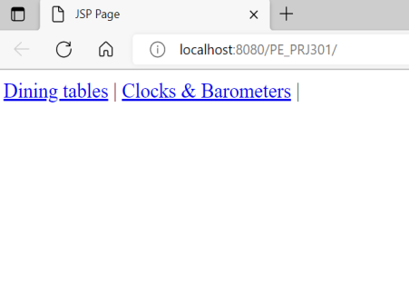

Figure 1: index.jsp

2. In the page “index.jsp”. When the user clicks the link (Figure 1), the website will display all items that belong to the selected category on the page “detail.jsp”

After click the link “Dining tables”, the result might look something like

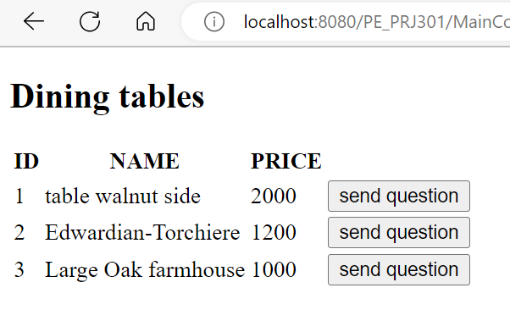  
Figure 2: detail.jsp

1. When the user clicks the button **“Send question”(Figure 2).** The website will open the form, the user fills out all controls, and then click the **“Save”** button to save data that is entered from the user to the FAQ table . **You must validate data before saving it to the FAQ table.**

When user clicks the “send question” button at row 1, the result might look like:

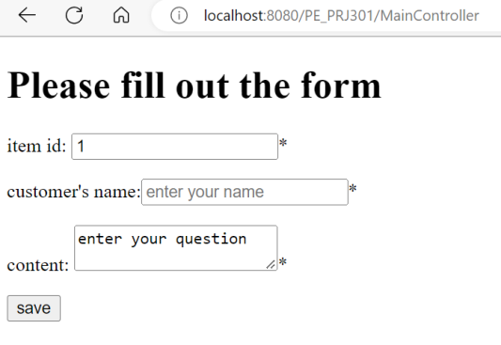   
Figure 3: questionPage.jsp

When user clicks the “save” button, if any text control is empty, the result might look something like:

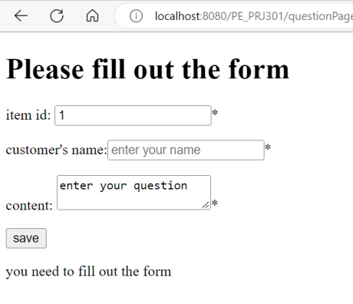

Figure 3: questionPage.jsp  
If all text controls are NOT empty, the result might look below and a new record is inserted to the FAQ table: [3 marks]

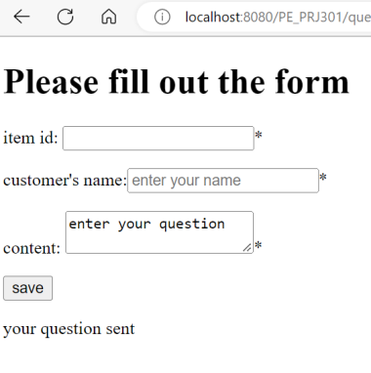

Figure 4: questionPage.jsp

The End