**KIM-MHO 手工物料作業檢核表**

**臨場健康守護犬  
www.ohsdog.com**

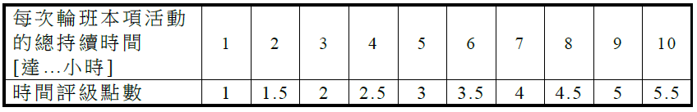

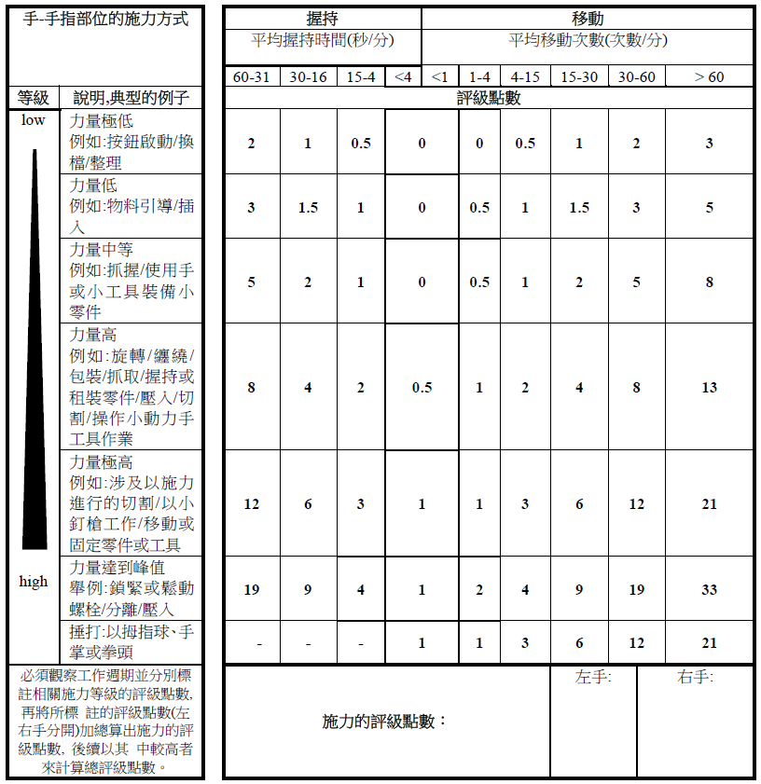

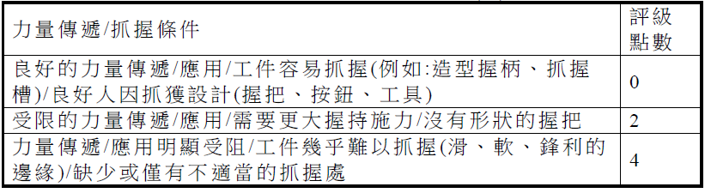

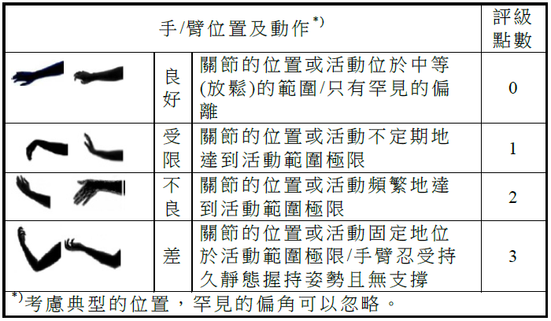

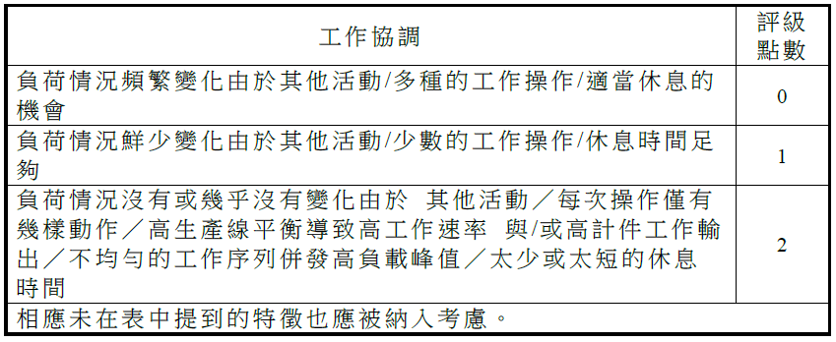

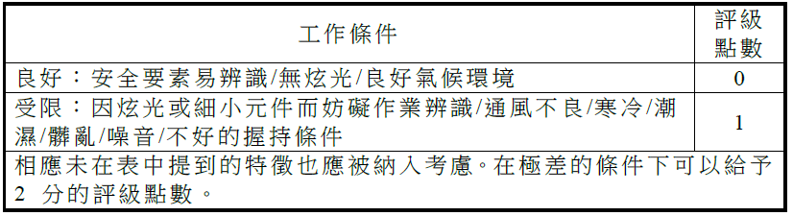

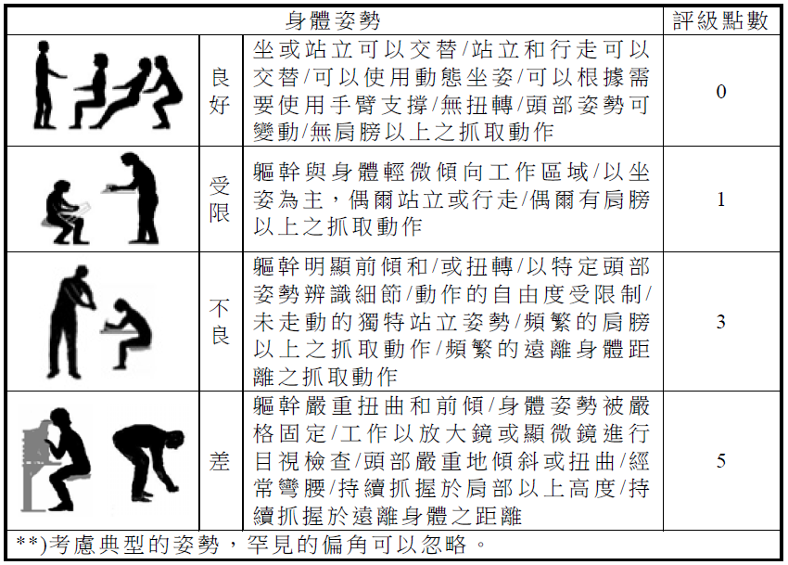

|  |  |  |  |
| --- | --- | --- | --- |
| **姓名** |  | **評估日期** |  |
| **部門單位** |  | **員工編號** |  |
| **性別** | **□男 □女** | **年齡** |  |

**________ × ( ____+ ____ + ____ + ____ + ________ + ____ )=_____**

**時間評級×(施力＋抓握＋位置＋協調＋工作條件＋姿勢)＝風險值**

