**KIM-LHC 抬舉握持搬運作業檢核表**

**臨場健康守護犬  
www.ohsdog.com**

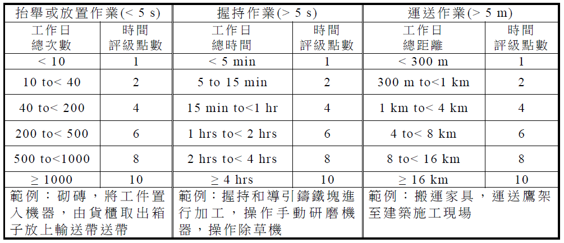

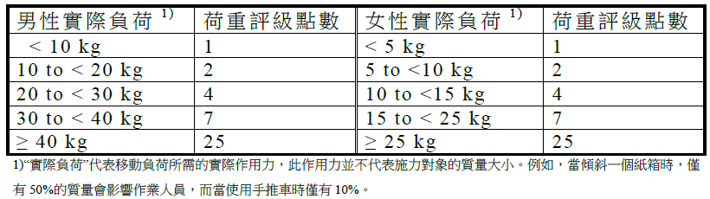

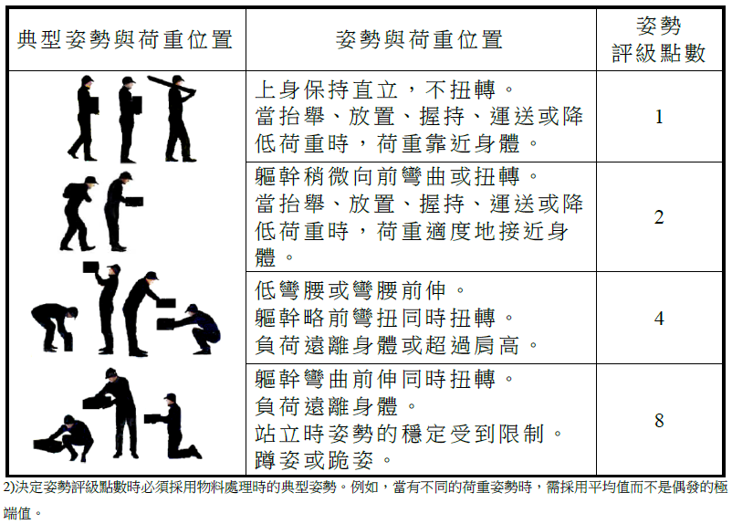

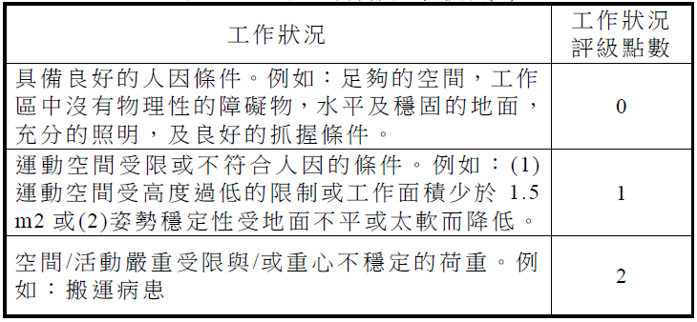

|  |  |  |  |
| --- | --- | --- | --- |
| **姓名** |  | **評估日期** |  |
| **部門單位** |  | **員工編號** |  |
| **性別** | **□男 □女** | **年齡** |  |

**_______×( ________ + ________ + _______) = _______**

**時間評級×(荷重評級+姿勢評級+工作狀況) = 風險值**

